Lab 2

Introduction to Python (Part 2)

Background

This lab provides basic knowledge that you will need in order to complete future Python lab assignments. Note that we will not focus learning Python in general, rather we will focus on utilizing Python capabilities for various image processing tasks.

The most important and central Python package for doing scientific computing is ‘NumPy’. This package provides convenient and fast arbitrary-dimensional array manipulation routines. Another very important package is ‘PIL’ which is used for performing various image processing tasks.

For starter, you would need Python 2.7 or higher. Some packages like, Numpy, PIL, os, glob, etc. You may install further Python packages when required.

Task #1: Reading and writing images with Python Imaging Library (PIL)

The most important class in the Python Imaging Library is the [**Image**](http://effbot.org/imagingbook/image.htm) class, defined in the module with the same name. You can create instances of this class in several ways; either by loading images from files, processing other images, or creating images from scratch.

To load an image from a file, use the **open** function in the **Image** module.

>>> import PIL

(Python Imaging Library)

>>> from PIL import Image

>>> im = Image.open("lena.ppm")

If successful, this function returns an **Image** object. You can now use instance attributes to examine the file contents.

>>> print im.format, im.size, im.mode

PPM (512, 512) RGB

Once you have an instance of the **Image** class, you can use the methods defined by this class to process and manipulate the image. For example, let’s display the image we just loaded:

>>> im.show()

The Python Imaging Library supports a wide variety of image file formats. To read files from disk, use the [**open**](http://effbot.org/imagingbook/image.htm#image-open-function) function in the **Image** module. You don’t have to know the file format to open a file. The library automatically determines the format based on the contents of the file.

To save a file, use the [**save**](http://effbot.org/imagingbook/image.htm#image-save-method) method of the **Image** class. When saving files, the name becomes important. Unless you specify the format, the library uses the filename extension to discover which file storage format to use.

**Converting files to JPEG**

import os, sys

from PIL import Image

for infile in sys.argv[1:]:

// command line ye code execute krein g

// Command line s jo input dein g wo argv mein ata ha.

f, e = os.path.splitext(infile)

outfile = f + ".jpg"

if infile != outfile:

try:

Image.open(infile).save(outfile)

except IOError:

print "cannot convert", infile

**CMD command**



**Output Converted**



A second argument can be supplied to the **save** method which explicitly specifies a file format.

Important: For further details and playing around with different functions available in PIL, follow the link: <http://effbot.org/imagingbook/introduction.htm>

Task #2: Please follow the tutorial available at <http://www.python-course.eu/numpy.php> for a quick review of numpy arrays.

**Task #3: Play around with Python (PIL, numpy, etc.)**

1. **Convert RGB to Greyscale**
2. **Apply Smoothing filter (of your choice)**
3. **Apply Sharpening filter (of your choice)**
4. **Convert an RGB image to Greyscale (without using any Python package)**

**Part a**

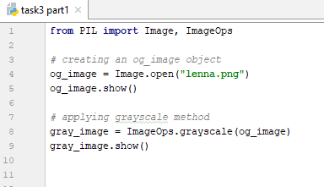

**Output**

**Original Image Converted Gray Scale Image**

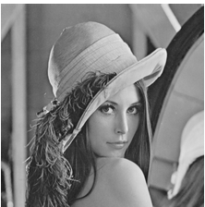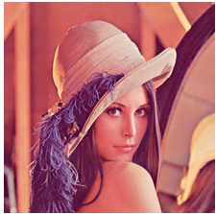

**Part b**

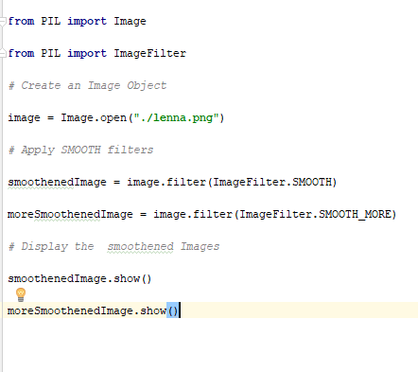

**Output**

**Smooth Smooth More**

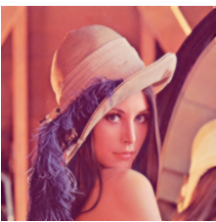

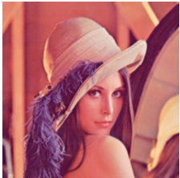

**Part c**

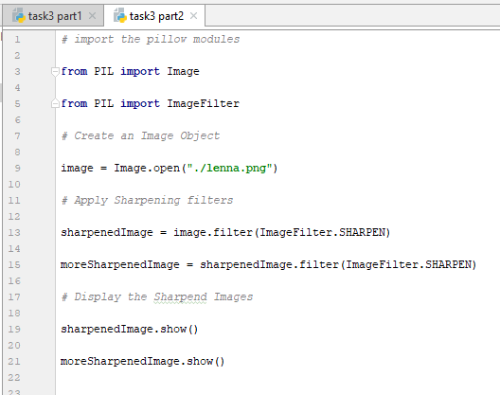

**Outputs**

**Original sharpening once sharpening twice**



**Part d**

**Code:**

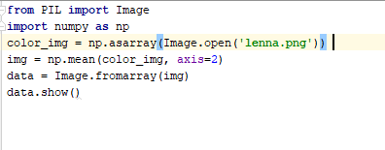

**Output**

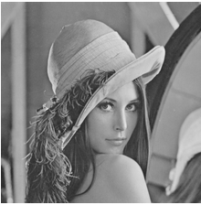

Skim Python Tutorial

Bob Dowling has written a very nice introduction to Python for absolute beginners at: <http://www.ucs.cam.ac.uk/docs/course-notes/unix-courses/PythonAB/files/handout.pdf>

**Note:**

Visit the following link to download pip.

<https://bootstrap.pypa.io/get-pip.py>

all the whl files are available here :-

https://www.lfd.uci.edu/~gohlke/pythonlibs/

**Hand in**

To Receive Credit

1. A lab report containing code and screenshots of the outputs. Do include the screenshots of output of read and write part of image as well.