

# Department of Computing

**CS-344: Web Engineering**

**Class: BSCS-9AB**

# Lab 10: Advanced Angular

**Date: May 06, 2021**

# Instructor: Mr. Mujtaba Haider

**Submitted by:**

Fatima Seemab

291310

**ALBUMS COMPONENT**

**HTML**

<div>

    <h3> Albums collection</h3>

    <div class="row">

      <div class="col-sm-4" *ngFor="let album of albums | async">

        <div class="card">

          <div class="card-body">

            <a routerLink="photos/:{{album.id}}">{{album.title}}</a>

          </div>

        </div>

      </div>

    </div>

  </div>

**TS FILE**

<div>

    <h3> Albums collection</h3>

    <div class="row">

      <div class="col-sm-4" *ngFor="let album of albums | async">

        <div class="card">

          <div class="card-body">

            <a routerLink="photos/:{{album.id}}">{{album.title}}</a>

          </div>

        </div>

      </div>

    </div>

  </div>

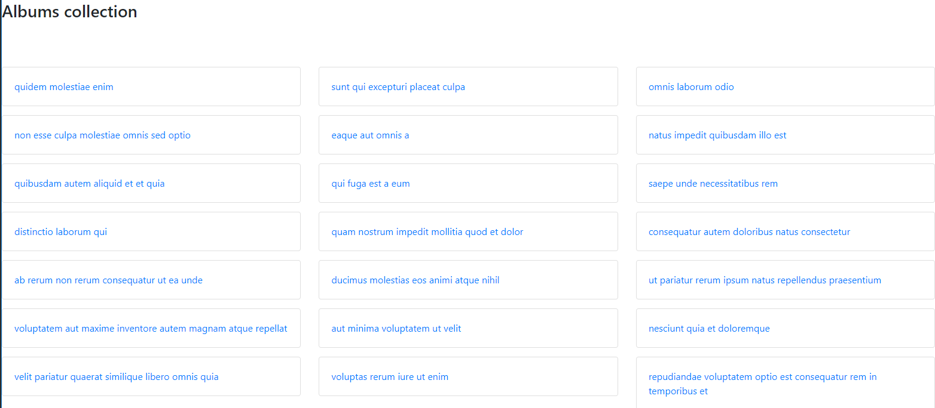

**Photos Component**

**HTML FILE**

<div>

    <button routerLink="/" class="btn btn-light">Go back</button>

    <button routerLink="/addphoto" class="btn btn-light" style="margin-left: 93%; margin-top: 0%;" >Add Photo</button>

    <h3> Album {{albumId}}</h3>

    <div class="row">

      <div class="col-md-3 photo" *ngFor="let photo of photos | async">

        <img src={{photo.url}} class="img-fluid" />

         <button routerLink="/editphoto/:{{photo.id}}" class="btn btn-light"> edit </button>

        <button  (click)=del(photo.id) class="btn btn-light" style="margin-left: 63%;">delete</button>

       <!-- <p> {{photo.title}}</p> -->

      </div>

    </div>

  </div>

**TS FILE**

import { PhotosService } from './../services/photos.service';

import { Component, OnInit } from '@angular/core';

import { ActivatedRoute } from '@angular/router';

// import { ThisReceiver } from '@angular/compiler';

@Component({

  selector: 'app-photos',

  templateUrl: './photos.component.html',

  styleUrls: ['./photos.component.css']

})

export class PhotosComponent implements OnInit {

  photos;

  // photoId;

   albumId;

  constructor(

    private photosService: PhotosService,

    private route: ActivatedRoute,

  ) { }

  ngOnInit() {

    this.albumId = this.route.snapshot.params.albumId;

    this.photos = this.photosService.getPhotos(this.albumId);

  }

  del(photo){fetch(`https://jsonplaceholder.typicode.com/photos/{{photo.id}}`, {

  method: 'DELETE',

});}

}

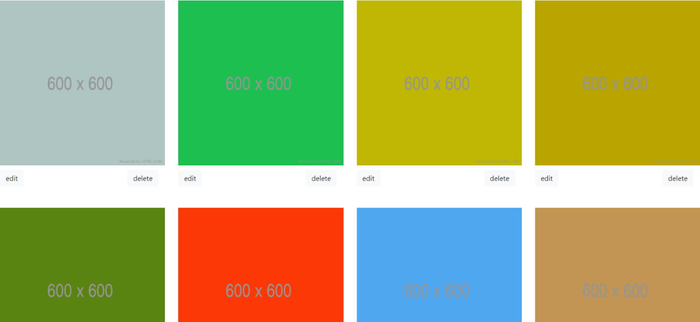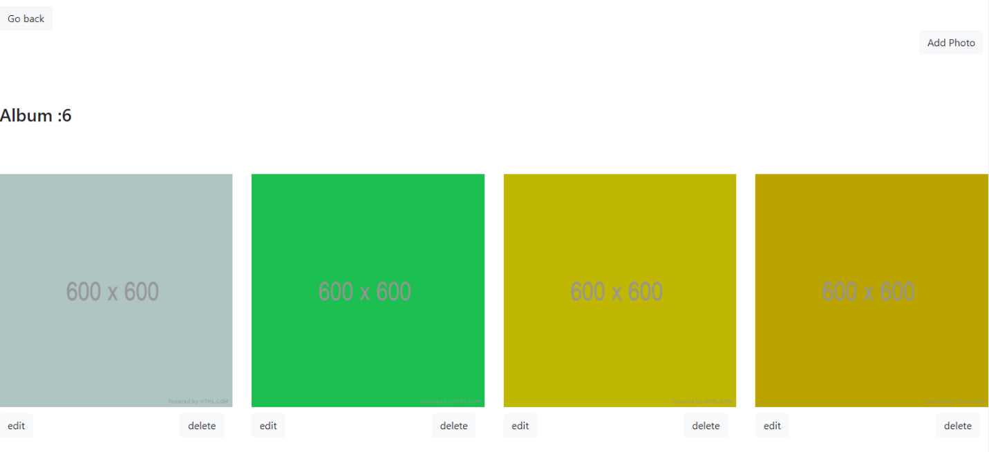

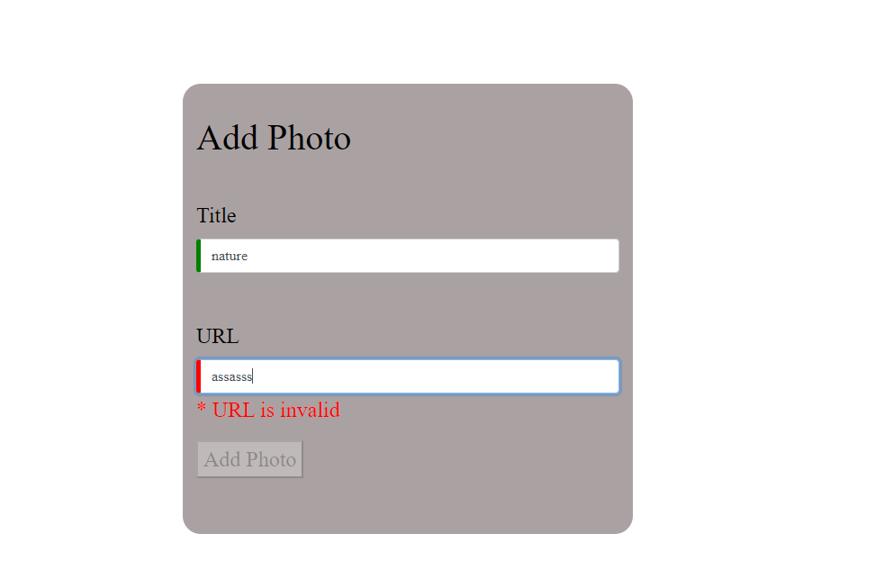**Form Validation**

**ADD PHOTO COMPONENT**

**HTML FILE**

form [formGroup]="add">

    <div class="container">

        <br>

        <h1>Add Photo</h1>

        <br>

        <div class="form-group">

       <label>Title</label>

       <input type="text" class="form-control" formControlName="title" placeholder="Enter the title here">

       <span *ngIf="cntrl.title.invalid && cntrl.title.touched" style="font-size: 4px;"style="color:red">* title is required</span>

        </div>

    <br>

       <div class="form-group">

       <label>URL</label>

       <input type="URL"class="form-control" formControlName="url" placeholder="Enter the URL here">

       <!-- <span *ngIf="cntrl.url.invalid && cntrl.url.touched" style="color:red">* URL is required</span> -->

       <span *ngIf="cntrl.url.errors.required" style="color:red">* URL is required</span>

       <span *ngIf="cntrl.url.errors.pattern" style="color:red">* URL is invalid</span>

        </div>

        <button  type="submit" [disabled]=!add.valid (click)=Add()> Add Photo </button>

    </div>

</form>

**TS FILE**

import { Component, OnInit } from '@angular/core';

import { FormBuilder,FormControl,FormGroup,Validators} from '@angular/forms';

@Component({

  selector: 'app-addphoto',

  templateUrl: './addphoto.component.html',

  styleUrls: ['./addphoto.component.css']

})

export class AddphotoComponent implements OnInit {

  constructor(private fb: FormBuilder) {

   const reg = '(https?://)?([\\da-z.-]+)\\.([a-z.]{2,6})[/\\w .-]*/?';

    this.add = fb.group({

      url: ['', [Validators.required,, Validators.pattern(reg)]],title:new FormControl('',Validators.required),

    })

  }

    add:FormGroup=new FormGroup

    ({});

    get cntrl(){return this.add.controls;}

  ngOnInit(): void {

}

  Add()

  {fetch('https://jsonplaceholder.typicode.com/photos?albumId=6`', {

    method: 'POST',

    body: JSON.stringify({

      albumid: 6,

      id: 301,

      title:this.cntrl.title.value,

      url:this.cntrl.url.value,

      // thumbnailUrl:'"https://via.placeholder.com/150'

    }),

    headers: {

      'Content-type': 'application/json; charset=UTF-8',

    },

  })

    .then((response) => response.json())

    .then((json) => console.log(json));

}

}

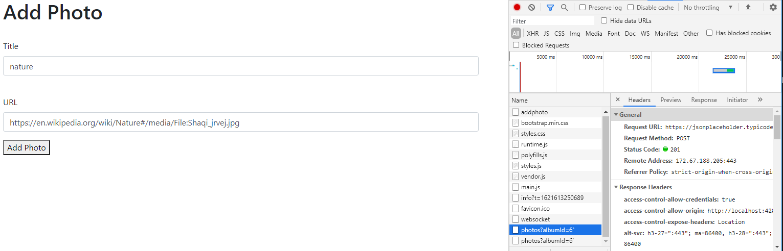**Add Photo Functionality**

**Closer View**

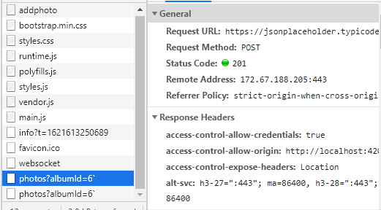

**Edit Photo Component**

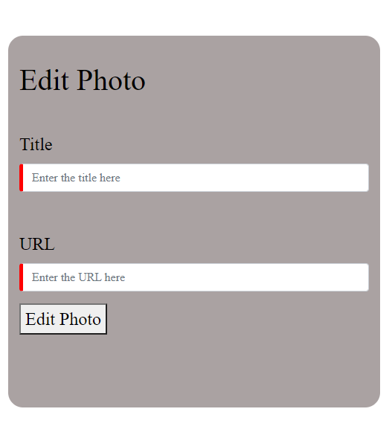**Edit Photo**

**HTML FILE**

<form [formGroup]="edit">

    <div class="container">

        <br>

        <h1>Edit Photo</h1>

        <br>

        <div class="form-group">

       <label>Title</label>

       <!-- <label>{{photoid}}</label> -->

       <input type="text" class="form-control" formControlName="title" placeholder="Enter the title here">

       <span *ngIf="cntrl.title.invalid && cntrl.title.touched" style="font-size: 4px;"style="color:red">* title is required</span>

        </div>

    <br>

       <div class="form-group">

       <label>URL</label>

       <input type="URL"class="form-control" formControlName="url" placeholder="Enter the URL here">

        <span *ngIf="cntrl.url.invalid && cntrl.url.touched" style="color:red">* URL is required</span>

       <!-- <span *ngIf="cntrl.url.errors.required" style="color:red">* URL is required</span>

       <span *ngIf="cntrl.url.errors.pattern" style="color:red">* URL is invalid</span> -->

        </div>

        <button type="submit" click=editCall(photo.id) > Edit Photo </button>

    </div>

</form>

**TS FILE:**

import { Component, OnInit } from '@angular/core';

import { FormBuilder,FormControl,FormGroup,Validators} from '@angular/forms';

@Component({

  selector: 'app-editphoto',

  templateUrl: './editphoto.component.html',

  styleUrls: ['./editphoto.component.css']

})

export class EditphotoComponent implements OnInit {

  constructor(private fb: FormBuilder) {

    this.edit = fb.group({

      url: ['', [Validators.required]],title:new FormControl('',Validators.required),

    })

  }

    edit:FormGroup=new FormGroup

    ({});

    get cntrl(){return this.edit.controls;}

  ngOnInit(): void {

  }

  editCall(photo)

  {  fetch('https://jsonplaceholder.typicode.com/photos/{{photo.id}}', {

  method: 'PUT',

  body: JSON.stringify({

    id: photo.id,

    title: this.cntrl.title.value,

    url: this.cntrl.title.value,

  }),

  headers: {

    'Content-type': 'application/json; charset=UTF-8',

  },

})

  .then((response) => response.json())

  .then((json) => console.log(json));

}

}

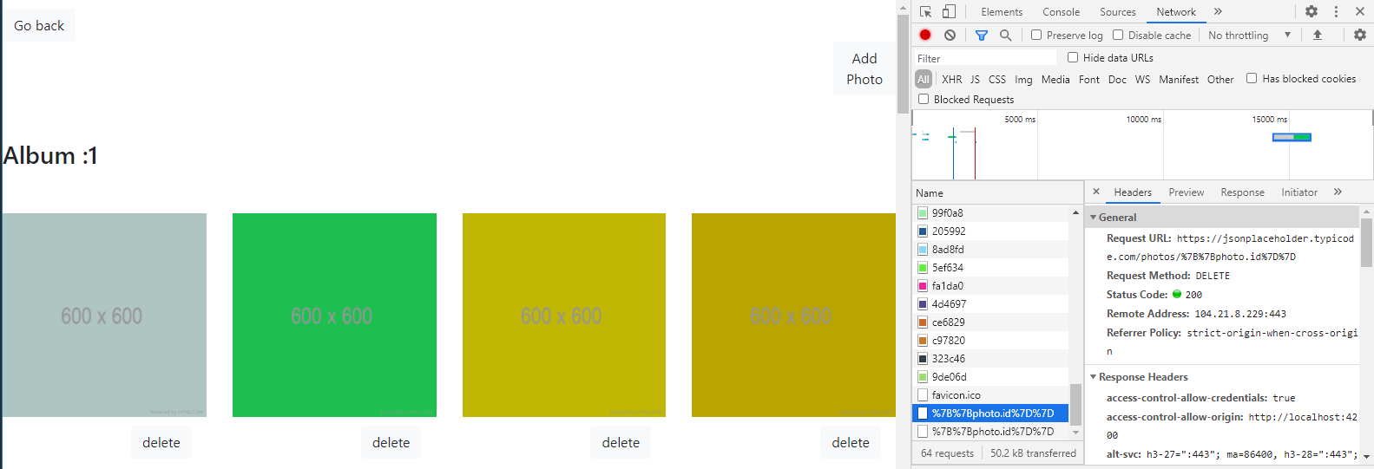**Delete Photo**

