

# Department of Computing

**CS-344: Web Engineering**

**Class:** BSCS-9AB

# Lab 12: Advanced PHP

**Date: May 27, 2021**

# Instructor: Mr. Mujtaba Haider

Submitted By: Fatima Seemab

CMS ID:291310

**TASK 1**

**Display Html**

<!DOCTYPE html>

<html lang="en">

<head>

    <meta charset="UTF-8">

    <meta http-equiv="X-UA-Compatible" content="IE=edge">

    <meta name="viewport" content="width=device-width, initial-scale=1.0">

    <title>Document</title>

    <style>

    table{

        border-color: coral;

        border-width: 4px;

    }

    th{background-color: gray;}

    button{

        background-color: black;

        border-radius: 10px;

        color:cornsilk;

        height:40px;

        width:100px;

    }

    </style>

</head>

<body>

    <a href="create.php"><button align="center">Create Employee</button></a>

    <br><br>

    <a href="Display.php"><button align="center">Display Data</button></a>

</body>

</html>

**Display PHP:**

<?php

include_once("connect.php");

$query="select e1.firstName as fn,e1.lastName as ln,

e1.employeeNumber as id ,e1.email,e1.jobTitle ,

e2.firstName as ReportsTO, e2.lastName as Report2,

o.addressLine1 as EmployeeOffice, o.addressLine2 as Add2,o.state as state,o.country as country

from employees as e1, employees as e2,offices as o

where e1.officeCode=o.officeCode and e1.reportsTo=e2.employeeNumber";

echo"<style>

th{background-color: gray;}

</style>";

$result=mysqli_query($mysqli,$query);

if($result->num_rows>0)

{echo"<table width='70%' border='12px  black'>

    <th> Employee Number</th>

    <th> Employee Name</th>

    <th> Email</th>

    <th> Job Title</th>

    <th> Report To</th>

    <th> Office Address</th>

    <th > Update</th>

    ";

    echo"<br>";

while($row=$result->fetch_assoc())

 {  echo "<tr align='center'  border-color='black'>

    <td>".$row['id']."</td><td>".$row['fn'].$row['ln']."</td>";

    echo "<td>".$row['email']."</td>";

    echo "<td>".$row['jobTitle']."</td>";

    echo "<td>".$row['ReportsTO']."  ".$row['Report2']."</td>";

    echo "<td>".$row['EmployeeOffice']."  ".$row['state']." ".$row['country']." ".$row['Add2']."</td>";

    echo "<td><a href=\"edit.php?id=$row[id]\"><button>edit</button>|<a href=\"del.php?id=$row[id]\"><button>delete</button></td><tr>";

}

echo"</table>";

}

?>

**Task 1 Screenshots:**



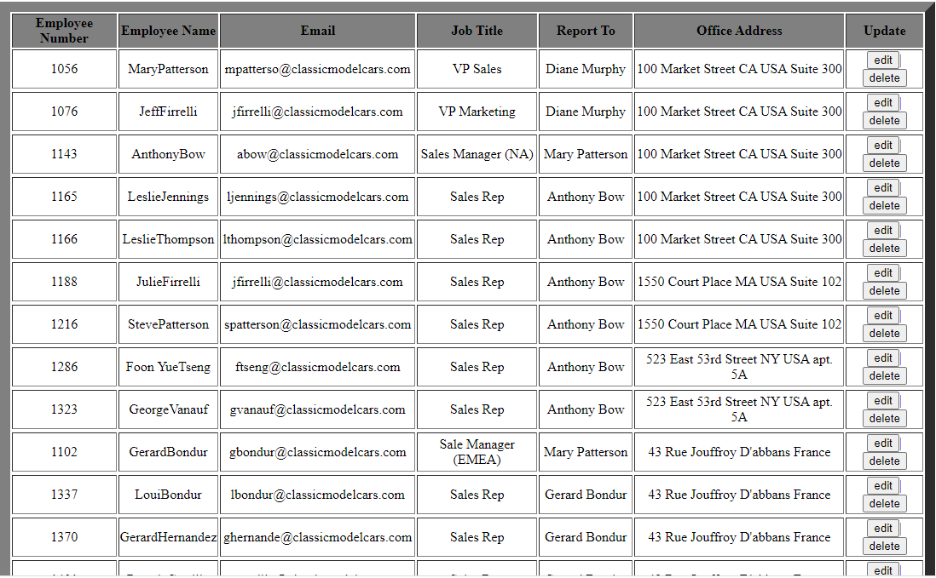

**TASK 2 CRUD OPERATION**

**Create Employee**

<?php

include_once("connect.php");

$query="CREATE TABLE IF NOT EXISTS `employees` (

    `employeeNumber` int(11) NOT NULL,

    `lastName` varchar(50) NOT NULL,

    `firstName` varchar(50) NOT NULL,

    `extension` varchar(10) NOT NULL,

    `email` varchar(100) NOT NULL,

    `officeCode` varchar(10) NOT NULL,

    `reportsTo` int(11) DEFAULT NULL,

    `jobTitle` varchar(50) NOT NULL,

    PRIMARY KEY (`employeeNumber`))

    -- KEY `reportsTo` (`reportsTo`),

    -- KEY `officeCode` (`officeCode`))

  ";

  if(mysqli_query($mysqli,$query))

  {echo"employee table is created";}

**Before Creation**

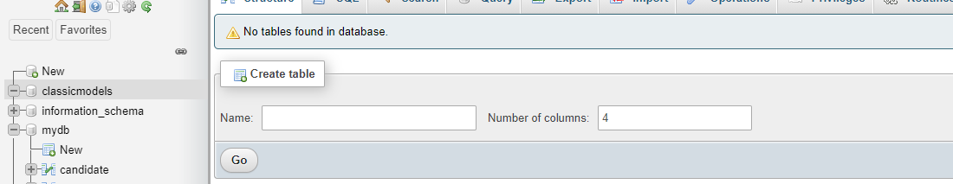

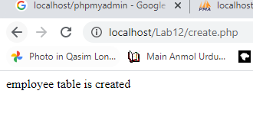**On Display Page After Clicking create**

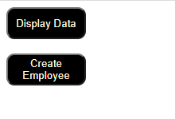

**Database after command**

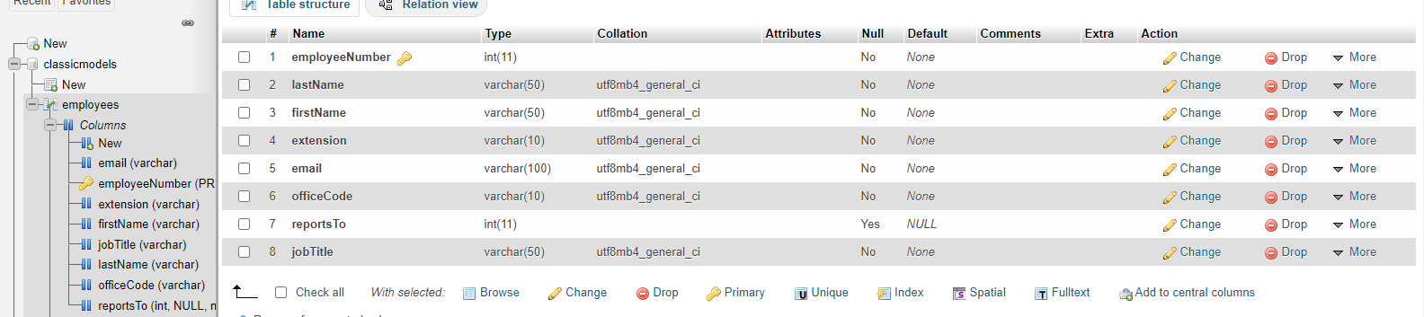

**UPDATE OPERATION**

<?php

include_once("connect.php");

if(isset($_POST['update'])){

    $id = mysqli_real_escape_string($mysqli, $_POST['id']);

    $name = mysqli_real_escape_string($mysqli, $_POST['name']);

    $jobtitle = mysqli_real_escape_string($mysqli, $_POST['jobtitle']);

    $email = mysqli_real_escape_string($mysqli, $_POST['email']);

    $reportsTo = mysqli_real_escape_string($mysqli, $_POST['reports']);

    $officeCode = mysqli_real_escape_string($mysqli, $_POST['office']);

    // echo $id;

    // checking empty fields

    if(empty($name) || empty($jobtitle) || empty($email)) {

        $_GET['id'] = $id;

        if(empty($name)) {

            echo "<font color='red'>Name field is empty.</font><br/>";

        }

        if(empty($jobtitle)) {

            echo "<font color='red'>Job Title field is empty.</font><br/>";

        }

        if(empty($email)) {

            echo "<font color='red'>Email field is empty.</font><br/>";

        }

    }

    else {

        //updating the table

        if(mysqli_query($mysqli, "UPDATE employees SET firstName='$name',jobTitle='$jobtitle',email='$email',reportsTo='$reportsTo',officeCode='$officeCode' WHERE employeeNumber=$id"))

        {

        }

        else

        { echo "Information entered for Reports To and Office might be incorrect";}

        $mysqli->close();

        // //redirectig to the display page. In our case, it is index.php

        header("Location:display.php");

    }

}

?>

<?php

//getting id from url

$id = $_GET['id'];

//selecting data associated with this particular id

$result = mysqli_query($mysqli, "SELECT * FROM employees WHERE employeeNumber=$id");

while($res = mysqli_fetch_array($result)){

    $name = $res['firstName'];

    $JobTitle = $res['jobTitle'];

    $email = $res['email'];

    $ReportsTo = $res['reportsTo'];

    $OfficeCode = $res['officeCode'];

}

$mysqli->close();

?>

<html>

<head>

    <title>Edit Data</title>

</head>

<body>

    <a href="add.php">Home</a>

    <br/><br/>

   <label> For office enter office code. For Supervisor enter supervisor number</label><br><br>

    <form name="form1" method="post" action="edit.php">

        <table border="0">

            <tr>

                <td>Name</td>

                <td><input type="text" name="name" value="<?php echo $name;?>"></td>

            </tr>

            <tr>

                <td>Job Title</td>

                <td><input type="text" name="jobtitle" value="<?php echo $JobTitle;?>"></td>

            </tr>

            <tr>

                <td>Email</td>

                <td><input type="text" name="email" value="<?php echo $email;?>"></td>

            </tr>

            <tr>

                <td>Reports To</td>

                <td><input type="text" name="reports" value="<?php echo $ReportsTo;?>"></td>

            </tr>

            <tr>

                <td>Office Code</td>

                <td><input type="text" name="office" value="<?php echo $OfficeCode;?>"></td>

            </tr>

            <tr>

                <td><input type="hidden" name="id" value=<?php echo $_GET['id'];?>></td>

                <td><input type="submit" name="update" value="Update"></td>

            </tr>

        </table>

    </form>

</body>

</html>

**Before Editing**



**In Editing**

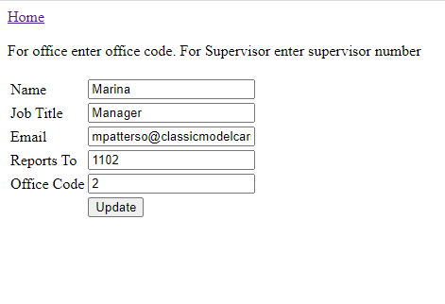

**After Editing**



**DELETE OPERATION**

**Del.php**

<?php

include_once("connect.php");

//getting id of the data from url

$id = $_GET['id'];

$query="DELETE FROM employees WHERE employeeNumber=$id";

//deleting the row from table

if(mysqli_query($mysqli,$query))

{echo "Employee is successfully deleted from database";}

else{echo"Foreign Key Constraint. Other Records depends on this employees record.Deleting this u might loss some other information";}

echo"<br><a href='Display.php'><button> Go Back </button></a>"

?>

**Case 1**

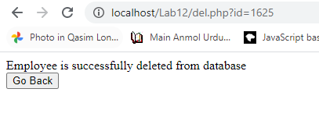

**Case 2**

