# Department of Computing

**CS-344: Web Engineering**

**Class:** BSCS-9ABC

# Lab 02: HTML Basics

**Date: March 4, 2021**

**Submitted By:**

Fatima Seemab

291310

BSCS 9B

**TASK 1**

**CODE**

<html>

<head>

<h1>Lists and Links</h1>

</head

<body>

<p>There are two types of list in HTML</p>

<ol>

<li>Unordered List</li>

<li>Ordered List</li>

</ol>

<p>This is an ordered list</p>

<ol>

<li>Ordered list item 1</li>

<li>Ordered list item 2</li>

<li>Ordered list item 3</li>

<li>Ordered list item 4</li>

<li>Ordered list item 5</li>

</ol>

<ul>

<li>Unordered list item 1</li>

<li>Unordered list item 2</li>

<li>Unordered list item 3</li>

<li>Unordered list item 4</li>

<li>Unordered list item 5</li>

</ul>

<p> This is a nested unordered list of links</p>

<ul>

<li>Online validator</li>

<ul>

<li>W3C Online HTML Validator @ <a href>https://validator.w3.org/.</a> </li>

<li>W3C Online CSS Validator @ <a href>https://jigsaw.w3.org/css-validator/.</a></li>

</ul>

<li>Specifications</li>

<ul>

<li> HTML5 @ <a href>https://www.w3.org/TR/html5/.</a> </li>

<li> CSS3 Selectors @ <a href>http://www.w3.org/TR/css3-selectors/.</a></li>

</ul>

</ul>

</body>

</html>

**Output:**

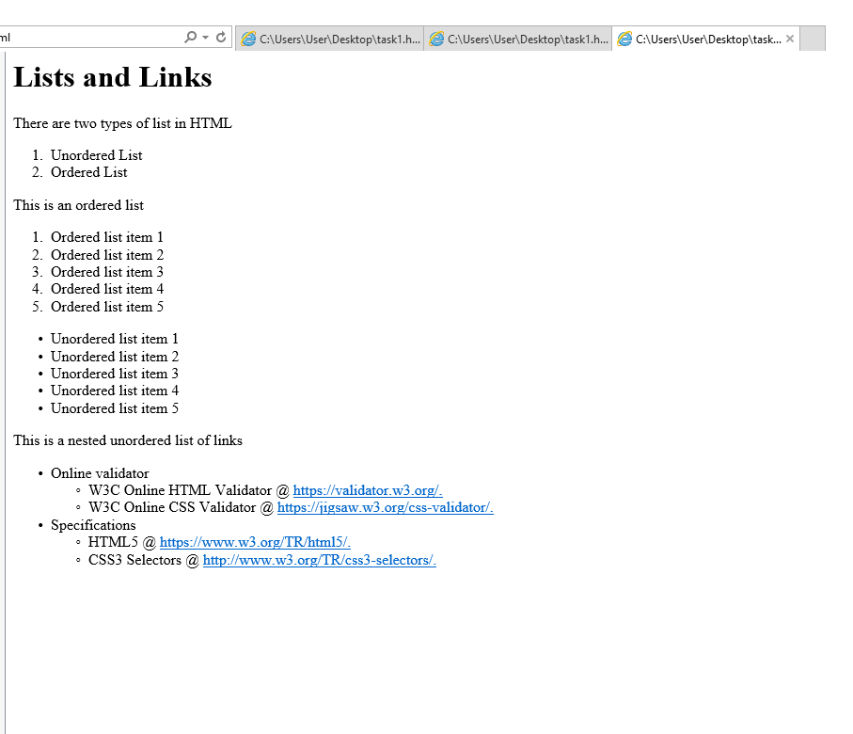

**TASK 2**

**CODE**

<html>

<head>

<h1>My Schedule</h1>

</head

<body>

<table>

<tr><th>Subject</th><th>Day</th><th>Time</th><th>Instructor</th></tr>

<tr><td>CAO</td><td>Monday</td><td>9:00-11:00</td><td>Instructor A</td></tr>

<tr><td>CAO</td><td>Tuesday</td><td>10:00-11:00</td><td>Instructor A</td></tr>

<tr><td>CAO</td><td>Wednesday</td><td>14:00-15:00</td><td>Instructor A</td></tr>

<tr><td>WE</td><td>Wednesday</td><td>9:00-10:00</td><td>Instructor B</td></tr>

<tr><td>WE</td><td>Thursday</td><td>9:00-10:00</td><td>Instructor B</td></tr>

<tr><td>WE</td><td>Friday</td><td>9:00-10:00</td><td>Instructor B</td></tr>

</table>

</body>

</html>

**OUTPUT**

