# Department of Computing

# MATH 333: Numerical Analysis

# Class: BSCS-9ABC

# Lab 3: Bisection Method Using Function

# Date: Feb 18, 2022

# Lab Engineer: Anum Asif

|  |
| --- |
| **Fatima Seemab**  **291310**  **BSCS 9B** |

# Lab 3: Bisection Method Using Function

**Introduction**

MATLAB, which stands for MATrix LABoratory, is a state-of-the-art mathematical software package, which is used extensively in both academia and industry.

**Objectives**

The purpose of this lab is to get familiar with Bisection Method

**Tools/Software Requirement**

Matlab R2016a

**Description**

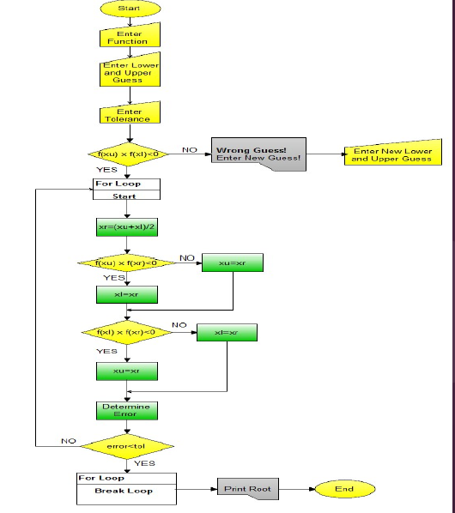

**Take Input**

a=input('Enter function’);

f=inline(a);

xl=input('Enter lower guess:') ;

xu=input('Enter upper guess:');

tol=input('Enter tolerance(recommended 0.001):');

**Checking First Condition**

while true

if f(xu)*f(xl) <0

break;

else

fprintf('Wrong Guess! Enter new guess\n');

xl = input('Enter Lower Guess:');

xu = input('Enter Upper Guess:');

end

end

for i=2:1000

%write missing part of code by following and understanding the flow chart

% xnew(1)=0;

xnew(i)=xr;

if abs(xnew(i)-xnew(i-1)/xnew(i))<tol,break,end

end

str = ['The required root of the equation is: ', num2str(xr), '']

**CODE:**

|  |
| --- |
| function [xr] = bisection()  a=input('Enter function','s');  f=inline(a);  xl=input('Enter lower guess:') ;  xu=input('Enter upper guess:');  tol=input('Enter tolerance(recommended 0.001):');  while true  if f(xu)*f(xl) <0  break;  else  fprintf('Wrong Guess! Enter new guess\n');  xl = input('Enter Lower Guess:');  xu = input('Enter Upper Guess:');  end  end    for i=2:1000  %write missing part of code by following and understanding the flow chart  xr = (xu+xl)/2  if f(xu)*f(xr) <0  xl = xr  else  xu = xr  end    % xnew(1)=0;  xnew(i)=xr;  if abs(xnew(i)-xnew(i-1)/xnew(i))<tol,break,end  end  str = ['The required root of the equation is: ', num2str(xr), '']  end |

**OUTPUT:**

|  |
| --- |
|  |

**Lab Task**

The bisection method in mathematics is a root-finding method that repeatedly bisects an interval and then selects a subinterval in which a root must lie for further processing. It is a very simple and robust method, but it is also relatively slow.

* Implement the bisection method using functions.

**Deliverables**

Submit single word file with matlab code and screen shot of Output.