**Industrial Internship Report on Creation of audience for Meta Ad for an EdTech company’s Digital marketing course and** **Planning a Social media Awareness Campaign for new Smartwatch Launch**

**Prepared by,**

**FATIMA SHABBIR**

|  |
| --- |
| ***Executive Summary*** |
| This report provides details of the Industrial Internship provided by upSkill Campus and The IoT Academy in collaboration with Industrial Partner UniConverge Technologies Pvt Ltd (UCT).  This internship was focused on a project/problem statement provided by UCT. We had to finish the project including the report in 6 weeks’ time.  I had undertaken two projects; the first one was about determining how to create an audience for Meta ads for an EdTech company named ‘Digihub Academy’, on basis of suitable location, age, language and the three detailed targeting categories, i.e., demographics, interest and behavior, second project was regarding planning a social media Awareness Campaign for new Smartwatch Launch by an Electronics company.  Through this internship, I got an excellent opportunity to get practical exposure to various real world Industrial problems, plan and implement solution for that. It was overall a great learning experience to during the entire journey of this Internship. |

**TABLE OF CONTENTS**

1 Preface… 3

2 Introduction 4

2.1 About UniConverge Technologies Pvt Ltd 4

2.2 About upskill Campus 8

2.3 The Iot Academy………………………………………………………………………………………………………………………….10

2.4 UCT Consulting……………………………………………………………………………………………………………………………10

2.5 Objective………………………………………………………………………………………………………………………….…………10

2.6 Reference……………………………………………………………………………………………………………………..……………10

2.7 Glossary 11

2.8 Report submission link (GitHub)……………………………………………………………………………………….………….11

3 Problem Statement 11

4 Solution…………………………………………………………………………………………………………………………………..………12

5 Sample social media posts which can be posted on Instagram, Facebook, LinkedIn and X (twitter) (Project 2)……………………………………………………………………………………………………………………….………………………21

7 My learnings…………………………………………………………………………………………………………………………….……..26

8 Future work scope 30

# *Preface*

This internship was focused on a project/problem statement provided by UCT. We had to finish the project including the report in 6 weeks’ time.

The project progress included relevant information about my work during the week. Highlighting the tasks I completed, milestones achieved, and any significant contributions I made to the project, mentioned specific details and examples to illustrate my progress.

I also discussed about the challenges and hurdles faced during the week, described the nature of the difficulties and I approached them and included any strategies or solutions that I implemented to overcome these hurdles.

It reflected on the lessons that I learned from the challenges encountered. I shared insights gained from tackling these obstacles, such as new skills acquired, problem-solving techniques, or valuable experiences that will benefit me in my future endeavors.

I had undertaken two projects; the first one was about determining how to create an audience for Meta ads for an EdTech company named ‘Digihub Academy’, on basis of suitable location, age, language and the three detailed targeting categories, i.e., demographics, interest and behavior, second project was regarding planning a social media Awareness Campaign for new Smartwatch Launch.

As a Digital Marketing enthusiast, this valuable internship opportunity is considered as a strong foundation stone in my career as all the practical experience gained in this journey, has given me an excellent learning opportunity which will strongly shape my career ahead.

I would like to extend my sincere thanks to the Founder of UniConverge Technology Pvt. Ltd., Kaushlendra sir entire upSkill campus team, all the mentors, specially to Santosh sir, who has continuously guided me throughout my internship journey and have always given quick response to all my queries.

My heartfelt gratitude to UCT and Upskill Campus for giving me this wonderful Internship opportunity in Digital Marketing. It has been a valuable learning experience and I have developed several skills during my journey.

I would recommend to all those aspiring young individuals who are looking forward to build a successful career ahead in the field of Digital marketing, Python, Machine learning, Data science, Core java, Iot etc to join this Internship program and enhance their skills.

# Introduction

## About UniConverge Technologies Pvt Ltd

A company established in 2013 and working in Digital Transformation domain and providing Industrial solutions with prime focus on sustainability and ROI.

For developing its products and solutions it is leveraging various**Cutting Edge Technologies e.g., Internet of Things (IoT), Cyber Security, Cloud computing (AWS, Azure), Machine Learning, Communication Technologies (4G/5G/LoRaWAN), Java Full Stack, Python, Front end**etc.



1. UCT IoT Platform

**UCT Insight** is an IOT platform designed for quick deployment of IOT applications on the same time providing valuable “insight” for your process/business. It has been built in Java for backend and ReactJS for Front end. It has support for MySQL and various number of SQL Databases.

* It enables device connectivity via industry standard IoT protocols - MQTT, CoAP, HTTP, Modbus TCP, OPC UA
* It supports both cloud and on-premises deployments.

Its features are as follows:  
• Build Your own dashboard  
• Analytics and Reporting  
• Alert and Notification  
• Integration with third party application (Power BI, SAP, ERP)  
• Rule Engine



1. **Smart Factory Platform (****)**

Factory watch is a platform for smart factory needs.

It provides Users/ Factory

* with a scalable solution for their Production and asset monitoring
* OEE and predictive maintenance solution scaling up to digital twin for your assets.
* to unleased the true potential of the data that their machines are generating and helps to identify the KPIs and also improve them.
* A modular architecture that allows users to choose the service that they what to start and then can scale to more complex solutions as per their demands.

Its unique SaaS model helps users to save time, cost and money.

 

1. 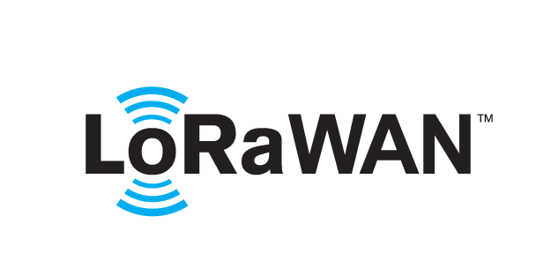 based Solution

UCT is one of the early adopters of LoRAWAN technology and providing solution in Agritech, Smart cities, Industrial Monitoring, Smart Street Light, Smart Water/ Gas/ Electricity metering solutions etc.

1. Predictive Maintenance

UCT is providing Industrial Machine health monitoring and Predictive maintenance solution leveraging Embedded system, Industrial IoT and Machine Learning Technologies by finding Remaining useful life time of various Machines used in production process.



## About upskill Campus (USC)

upskill Campus along with The IoT Academy and in association with UniConverge Technologies has facilitated the smooth execution of the complete internship process.

USC is a career development platform that delivers **personalized executive coaching** in a more affordable, scalable and measurable way.



Seeing need of upskilling in self-paced manner along-with additional support services e.g., Internship, projects, interaction with Industry experts, Career growth Services

<https://www.upskillcampus.com/>

upSkill Campus aiming to upskill 1 million learners in next 5 year

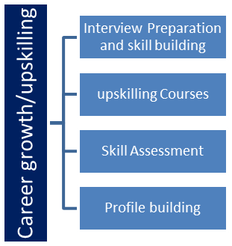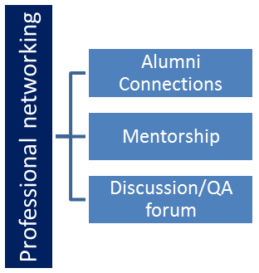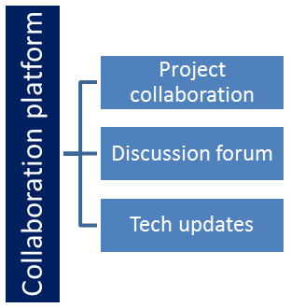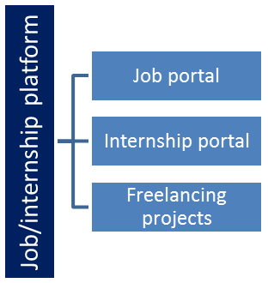

## The IoT Academy

The IoT academy is EdTech Division of UCT that is running long executive certification programs in collaboration with EICT Academy, IITK, IITR and IITG in multiple domains.

## UCT Consulting

It is a fast-growing company providing consultancy, staffing, and recruitment services to clients in Indian as well as abroad. We are working with niche technologies e.g., Pega, Java-Full stack, Angular, React, Data Science, Machine learning, AI, Telecom, Embedded, IoT, Big Data, cloud computing, security, etc.

## Objectives of this Internship program

The objective for this internship program was to:

 ☛ Gain practical experience of working in the industry.

 ☛ To determine and solve real world problems.

 ☛ To be able to obtain improved job prospects.

 ☛ To obtain Improved understanding of my field (Digital Marketing) and its applications.

 ☛ To enhance skills and achieve personal growth like better communication, problem solving, creative thinking, critical decision making, risk analysis etc.

**2.6 REFERENCE**

[1] <https://www.facebook.com/business/ads?content_id=UVPsp9NMrDhgF3H&refsem_smb&utm_termdsa-1627345090764&gclidEAIaIQobChMIxrib5sCnhAMVMKRmAh1iTgB_EAAYASAAEgI16PD_BwE&gad_source=1&gclid=EAIaIQobChMIxrib5sCnhAMVMKRmAh1iTgB_EAAYASAAEgI16PD_BwE>

[2] <https://www.youtube.com/>

[3] <https://www.google.com/>

**2.7 Glossary**

|  |  |
| --- | --- |
| **Term** | **Definition/ explanation** |
| 1. Google Algorithm | Google's algorithm is a complex system that retrieves data from pages and seeks to understand what searchers are looking for and rank pages according to relevance, content and quality. |
| 1. Internet of Things (IoT) | The Internet of Things (IoT) describes the network of physical objects(things), that are embedded with sensors, software, and other technologies for the purpose of connecting and exchanging data with other devices and systems over the internet. |
| 1. Machine Learning | It is a field of study in artificial intelligence concerned with the development and study of statistical algorithms that can learn from data and generalize to unseen data, and thus perform tasks without explicit instructions. |
| 1. Meta | Meta Platforms, Inc., doing business as Meta, and formerly named Facebook, Inc, is an American multinational technology conglomerate based in Menlo Park, California. The company owns and operates Facebook, Instagram, Threads, and WhatsApp. |
| 1. Tech-savvy | Someone having a good knowledge and understanding of modern technology. |

## Report submission (GitHub link):

<https://github.com/FatimaShabbir15/upskillcampus.git>

**3. Problem Statement**

Project 1: To determine creation of an audience for Meta ads for an EdTech company, on basis of suitable location, age, language and the three detailed targeting categories, i.e., demographics, interest and behavior. Also mention the reason for selection.

Such that the company is able to create an optimized and effective audience for their Meta advertisements, which further enables them to generate a favorable ROI.

Project 2: Formulate a social media strategy for a new product launch.

You are in an Electronics company and your company is planning to launch a new product in the market, which is a smartwatch.

You can assume all its unique features and also identify on which social media platform you will post about it and the also include captions, creative lines and themes.

Such that you will be able to formulate and implement an effective social media campaign which will increase awareness for your new product.

**4. Proposed solution**

PROJECT 1:

It’s a well-known fact that, in this recent era, Due to evolution of technology and many advancements in Digital world, Digital marketing is considered better than traditional marketing. This transformation from traditional marketing to digital marketing was done due to several benefits of Digital marketing in terms of, better ROI, cost-effective, measurable results, wider reach, greater engagement, precise targeting, cyber security etc.

Facebook Ads, a powerful tool in the digital marketing arsenal, has revolutionized the way businesses reach out to their target audience. With its wide reach and precise targeting capabilities, Facebook Ads has become an indispensable platform for businesses worldwide. After the Broad audience targeting feature, Meta has come up with narrow audience targeting, also known as Detailed targeting, based on demographics, interest and behavior, this allows advertisers to reach a largely specific and applicable audience, increasing the liability of engaging implicit customers. It helps in effective maintenance of ad budget and increases Return on Ad Spent.

During times when organic reach has become challenging and social media algorithms are changing more often than the weather, one way to stay ahead of the game is by using Facebook Ads. **However, before you start pouring money into Meta’s advertising panel, you should first define whom you’ll spend that money on.**

Getting to know your audience is one of the first and the most important pieces of this puzzle, and it’s also one of the most overlooked parts when setting up a Meta Ads campaign.

It's essential to analyze and select your specific audience based on your EdTech company's goals & budget. It can be done by analyzing your existing customer base, conducting market research, and using [Meta Business Suite Insights](https://www.facebook.com/business/help/700570830721044) to gather data on your target audience. Once you have a clear understanding of your target audience, you can create ads and place them on the right platform in order to achieve your marketing objective.

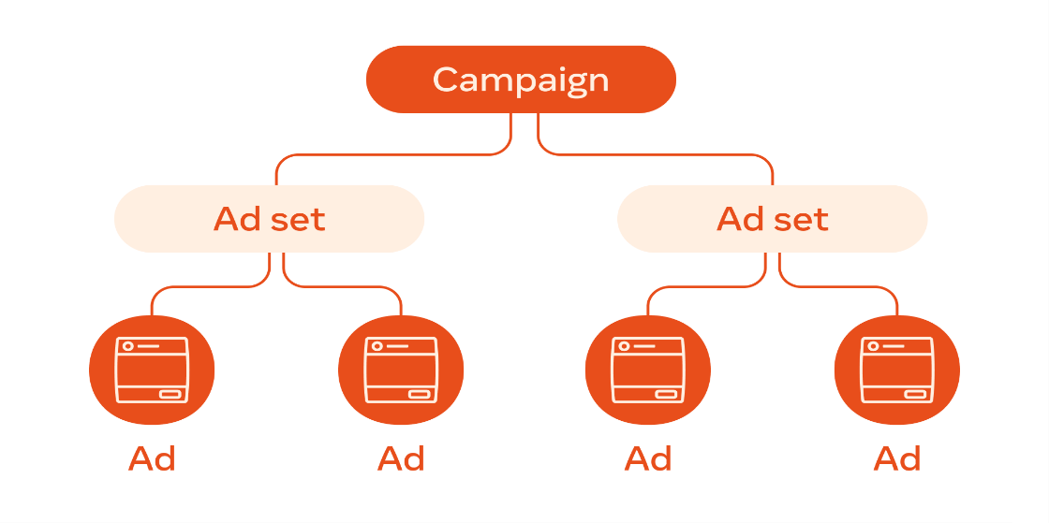Meta Ads Campaign structure

At this level, Campaign objective is determined.

It can be categorized based on budget, audience targeting, bidding and placement

Ad can be in from of images, videos, infographics,corousels etc.

Campaign objective: Lead generation

Ad sets:

I’ve created Ad sets on the following basis:

1. CUSTOM AUDIENCE

It helped me in re-targeting all those people who have taken some action on my Meta and Non-meta business accounts (Digihub Academy) with the help of Facebook Pixel.

I picked my target audience from the following:

**#1 My sources** – Website ([www.digihubacademy.com](http://www.digihubacademy.com))

**#2 Meta Sources**– Facebook page and Instagram Account of Digihub Academy

**Custom Audience Ad sets**

|  |  |  |
| --- | --- | --- |
| Ad set 1 | Ad set 2 | Ad set 3 |
| Website | Facebook Page | Instagram Account |
| Audience name: Website CA | Audience name: Facebook CA | Audience name: Instagram CA |
| option selected: everyone who visited the website | option selected: Everyone who engaged with your page | option selected: Everyone who engaged with this professional account |

1. SAVED AUDIENCE

In this, I’ve created ad sets by categorizing the audience based on demographics and Interest and behavior, through detailed targeting.

|  |  |
| --- | --- |
| Ad set 4 | Ad set 5 |
| Audience name: Audience based on Demographics | Audience name: Audience based on Interest and behavior |
| exclude: website CA, Facebook CA & Instagram CA | exclude: website CA, Facebook CA & Instagram CA |
| Location: India | Location: India |
| Age: 18-35 | Age: 18-35 |
| Gender: All | Gender: All |
| Language: English and Hindi | Language: English and Hindi |
| Behaviors > Digital activities > Internet browser used | Behaviors > Digital activities > Internet browser used |
| Facebook access (browser): Microsoft Edge | Facebook access (browser): Microsoft Edge |
| Behaviors > Digital activities > Operating system used | Behaviors > Digital activities > Operating system used |
| Facebook access (OS): Windows 10 | Facebook access (OS): Windows 10 |
| Behaviors > Mobile Device User | Behaviors > Mobile Device User |
| Facebook access (mobile): all mobile devices | Facebook access (mobile): all mobile devices |
| At university (postgraduate) | Behaviors > Purchase behavior |
| High school leaver | Engaged shoppers |
| Master's degree | Interests > Business and industry > Online (computing) |
| Demographics > Education > Fields of study | Digital marketing (marketing) |
| Affiliate Marketing | Email marketing (marketing) |
| Marketing/Advertising | Search engine optimization (software) |
| Sales management | Social media marketing (marketing) |
| Search engine optimization | Interests > Additional interests |
| Social media marketing | Content management system |
| Web Content Developer | Content marketing (marketing) |
| Web Design and Development | Educational technology (education) |
| Web Design/Web Development | Google Analytics |
| Web development | Lead generation |
| Graphic Design | Affiliate marketing (marketing) |
|  | Search engine marketing |
|  | Brand (marketing) |
|  | Influencer marketing |
|  | Mobile marketing |
|  | Online marketplace |
|  | Promotion (marketing) |
|  | AdWords |
|  | MailChimp |
|  | Moz (marketing software) |
|  | SEMrush |
|  | Neil Patel |
|  | Avinash Kaushik |

I’ve created different Ad sets to analyze and identify which of the specific ad sets and particular ads, based on different criteria of audience targeting perform the best in terms of reduced cost per lead and a favorable conversion rate.

PROJECT 2:

The top management planned to expand product line and decided to enter into the wearable segment, our R&D team, conducted an intense market research to identify various gaps existing in the consumer electronics market in the wearable segment.

It was found out that many brands lagged behind in terms of limited Battery Life, affordable pricing, limited functions, health accuracy, privacy concerns, compatibility, fragility, size and style. The existing smartwatches were unable to offer either one or more of these features and they were not appealing enough, in terms of its design and style.

We have exclusively designed our new masterpiece with a variety of unique features and it looks ultra-modern and elegant, making it a style statement for everyone who wears it.

By launching Alpha Pro in the market, under wearable segment, Electro Spectrum aims to target the trend setters, that is, the urban youth of the nation. We have launched the new smartwatch under the fash-tech portfolio.

By introducing Alpha Pro*,* we have taken a step forward and aim to delight our customers who are fitness freaks, fashionably forward, tech-savvy and opt for minimalism.

The current dynamics call for an accessory that is not only a fashion statement but also a multi-functional device. To make your everyday living effortless with a touch of fine designs, Electro Spectrum presents you with ***Best Smartwatches for Men and Women,*** like our new Alpha Pro that not only keeps you sorted with your daily tasks with their extraordinary smart features but also keep the texture of luxury intact at a very affordable price of only Rs 4,999. This is the best price when compared with similar smartwatches offered by other brands.

Key features of Alpha Pro

* **Slim & Stylish Design with Stainless Steel**: The classy square-curved Alpha Pro, 1.69” always-on AMOLED Display with high 326 PPI Resolution for a crystal-clear image and sharp details; 2GB RAM AND 16GB ROM.
  + Get rid of scratches because of sapphire crystal glass screen, which is ready for anything whether rain or shine.
  + At a super-slim 9.25mm and lightweight 24.6g, Alpha Pro not only looks compact, but is also very comfortable to wear thanks to its skin-friendly silicone strap.
* **Long Battery Life**: Empowered by the Zepp OS 2.0 and dual-core Huangshan 2S chip, the Alpha Pro packs the self-developed software and hardware to conserve the battery power you need to crush your goals for up to two weeks at a time. Basic Usage Battery Life: 14 days 280 MAH
* **24/7 Heart Rate, SpO₂ & Stress Monitoring and 5 ATM water resistant**: The Alpha Pro uses the Bio Tracker 3.0 advanced biosensor to automatically monitor your SpO2 level 24 hours a day (once enabled). The watch will also send a reminder if it detects your SpO2 level is too low while in a non-sleep state. Alternatively, whenever you’re engaged in intense mental or physical activity, or even just feeling uneasy during your day, initiate a manual SpO2 test for result in as little as 15 seconds.
* **5 Satellite Positioning Systems**: From cycling through city streets to walking through wild woodland - wherever your travels take you, support for five satellite systems means the Alpha Pro will be able to pinpoint your position with precision.
* **120+ Sports Modes & Smart Recognition**: Whatever workout gets you pumped; the Alpha Pro can likely track data for it. Check your steps, calories burned, and more for over 120 different sports, and get a post-workout report when you're done.
* Single Sync BT Calling with Favorite Contacts storage (Android - 100, iOS - 50) and Quick Replies.
* **Safety features for your peace of mind**: Your watch is on standby in case of an emergency. Should you take a tumble, Fall Detection will catch it and ask if you need help. For other emergencies, simply press the home button 3 times to send SOS to emergency services. When help arrives, quickly access your medical info from the lock screen with a single tap.
* Customizable watch faces.
* **Personal Assistance**: make quick notes on the command of your voice with the smart feature of Voice Recording and know everything about anything with the even smarter feature of Voice Assistance.

In the dynamic landscape of the digital age, one tool has emerged as a game-changer for businesses – social media marketing. The impact of social media on brand visibility and engagement cannot be overstated. As millions connect, share and discover content daily, brands leveraging this powerful tool find themselves at the forefront of consumer's minds.

Social media provides a unique way for brands to showcase their personality and tell their story. Through visually appealing content, relatable narratives and behind-the-scenes glimpses, brands can humanize themselves, connecting emotionally with their audience. This personal touch can create a genuine connection, enhancing brand recall and influencing purchasing decisions.

Social media platforms offer advertising tools that allow brands to precisely target their desired audience by understanding their buyer persona (demographics, interests and behavior). This targeted approach ensures that marketing efforts are directed toward those most likely to convert into customers.

* **Best suited social media platforms for posting about new Alpha Pro launch**

1. **Instagram and Facebook**

Meta ads cover Instagram and Facebook audiences through detailed targeting and helps in reaching to a large audience and build an awareness about the new product in an effective manner. It displays ads in form of sponsored ads across meta platforms

Brand’s product launch ads can be run on Instagram business pages

Instagram and Facebook Stories and posts and reels lets you:

* **Engage better with your audience**: Impressions, like, comment and sharing posts and reels paves a way for increasing brand’s reach.

Brands can set up polls, ask their audience questions, are being asked, conduct contests and giveaways, gather valuable feedback from customers.

Using eye-catchy and creative Hashtags and a good amount of brand mention also plays an important role in building brand awareness.

* **Drive traffic to your website**: Mentioning website link in bio, stories and captions leads to increase in website traffic.
* **Post a variety of content**: There are various visually-appealing content that can be posted on Instagram in many different ways. Images, videos, carousel, infographics etc. Sticking to IG feeds usually means you have to always stick to your brand’s aesthetic so it remains appealing to viewers.

When it comes to Insta stories, the brand can also include the ‘Swipe Up’ or ‘Shopping bag’ feature for pre-booking.

Brand’s product launch ads can be run on Facebook business pages as well on Facebook marketplace.

Awareness Campaigns nearly works the same across Facebook as on Instagram. In fact, Meta has made it easy to post ads across its various platforms simultaneously, saving precious time.

**b. LinkedIn**

LinkedIn marketing solution offers brands to share insights about the smartwatch's technology, target corporate wellness programs and business professionals involved in technological developments and innovation. Everyday members come to LinkedIn with a purpose. It’s what makes them more likely to view, engage with your brand, enjoy your content, and start a relationship.

* 1. **X (Twitter)**

X can be considered as one the social media marketing platform for Alpha Pro launch as it includes many benefits, it is desirable to reach larger audience. It provides **Real-time information, excellent customer service, repost feature, customer engagement and multiple ad formats.**

* **Hashtags and Creative captions**

Hashtags on Instagram and X are important as they enable your content to be found by the right people. Using relevant hashtags helps give context to your content and drives traffic so that you can boost views, likes, and shares.

On Instagram, a stunning photo can entice people to “slow their scroll” and stay focused on your post, but a well-thought-out caption can do a lot heavier lifting in terms of promotion and sales.

Many brands focus on their Instagram captions. Engaging captions may increase interaction, which is important when it comes to Instagram’s algorithm. Strong caption language defines your brand’s story and personality, which helps your fans understand they need what you’re offering. Instagram captions may assist boost your company’s social media success, which can boost your result.

Electro Spectrum has listed out few hashtags and captions for the new Alpha Pro’s launch ad on social media platforms keeping in mind the brand voice, product features and the target customers.

*Hashtags*:

#TimeToThrive: Emphasize how the smartwatch helps users thrive in their daily lives by prioritizing health, fitness, and productivity.

#WatchMeMove: Highlight the high-tech GPS and waterproof design, promoting the smartwatch as the perfect companion for active lifestyles.

#SleepSmart: Showcase the advanced sleep monitoring features with a focus on improving overall well-being.

#TechRevolution: Position the smartwatch as a revolutionary device that seamlessly blends cutting-edge technology with a stylish design.

Try grabbing the attention of audience by highlighting the exclusive design and features of fash-tech smartwatch:

#Upgradeyourlifestyle

#Investsmartly

#Elevateyourstylequotient

#Makeatopnotchchoice

Captions

* "Experience time like never before with our new smartwatch, where style meets innovation."
* "Your health, your time, our innovation. Unleash the potential with our latest smartwatch."
* "Stay connected, stay active, stay ahead. It's not just a watch; it's a lifestyle."

## 

## Sample social media posts which can be posted on Instagram, Facebook, LinkedIn and X(twitter) (Project 2)

Running contests and giveaways on social media is ideal for engaging the audience, raising new product launch awareness and attracting potential customers. Plus, it gives you everything you need to accomplish your giveaway goals, whether to grow your email list, increase website traffic, or boost social media followers.

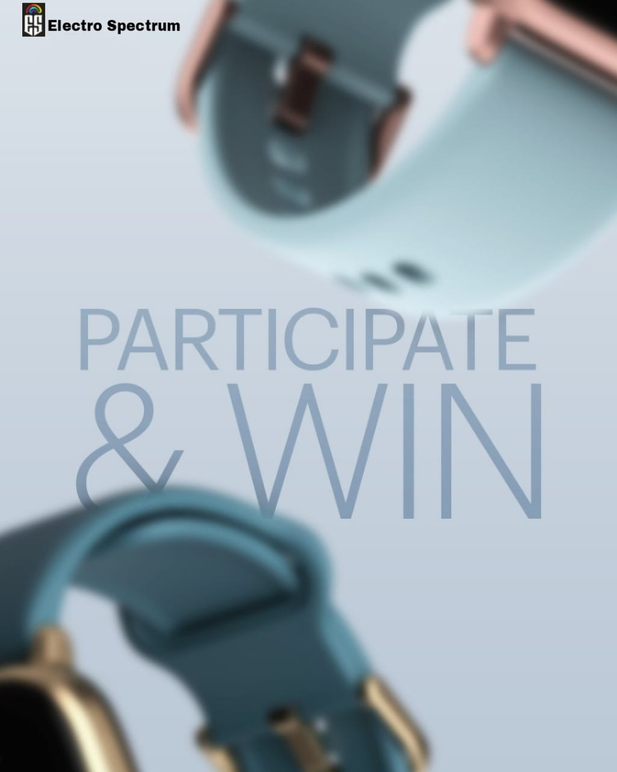**I.**

Get ready to experience time like never before with our new smartwatch, where style meets innovation.

Want to win our upcoming smartwatch? Comment 'SMARTWATCH' one letter at a time without getting interrupted and stand a chance to win it. Don’t forget to follow us, like our post, share our post on your story and tag your friends.

#ContestAlert #Upgradeyourlifestyle #InvestSmartly #Elevateyourstylequotient #Makeatopnotchchoice #TechRevolution

**II.**

"Stay connected, stay active, stay ahead. It's not just a watch; it's a lifestyle."

Guess the top 4 features of our upcoming smartwatch and stand a chance to win it. All you have to do is like our post, follow us and share our post on your story and tag 3 of your friends. Let the contest begin!

#ContestAlert #Upgradeyourlifestyle #TimeToThrive #Elevateyourstylequotient #Makeatopnotchchoice #TechRevolution #AlphaPro

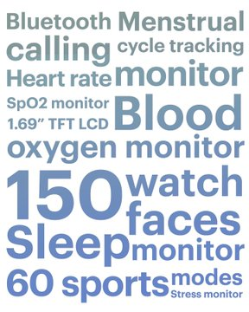**III.**

Participate in the contest & stand a chance to win our smart new offering. Here's what you have to do, see the word mesh, find out the 2 top USPs of our upcoming smartwatch & share it with us in the comments below. Also like our post, Tag 2 of your friends, and follow us and share this post on your story.

#ContestAlert #Upgradeyourlifestyle #InvestSmartly #Elevateyourstylequotient #Makeatopnotchchoice #TechRevolution #AlphaPro

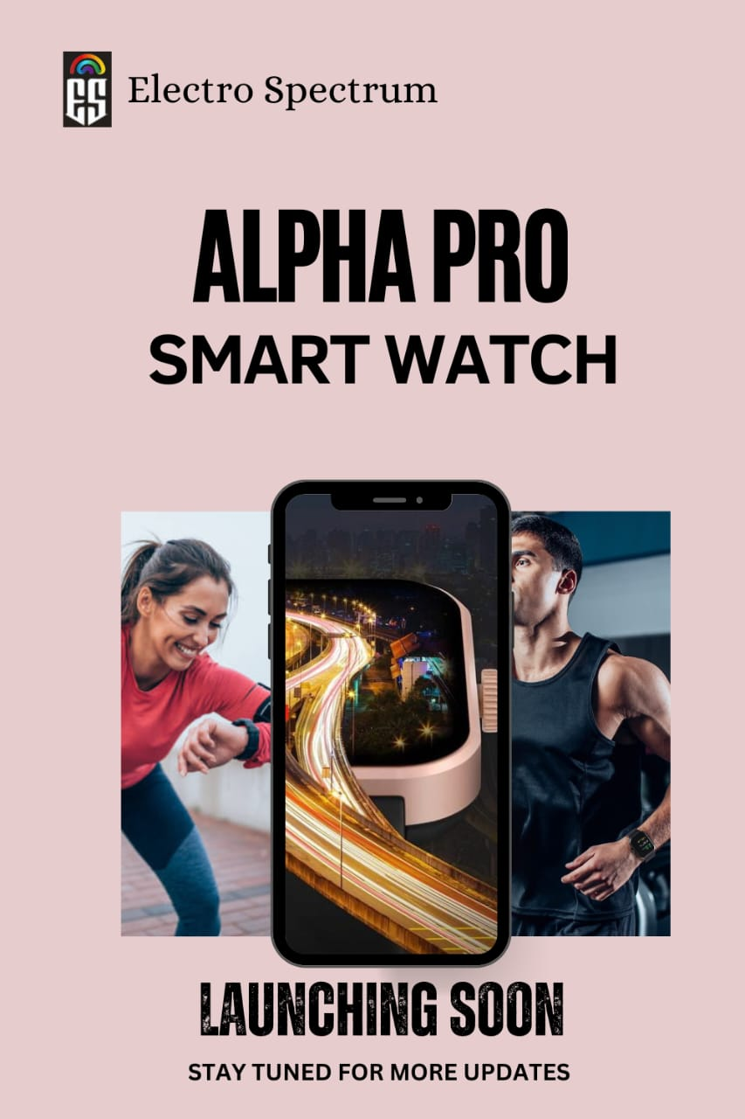**IV.**

Your health, your time, our innovation. Get ready to unleash the potential with our latest smartwatch, Alpha Pro.

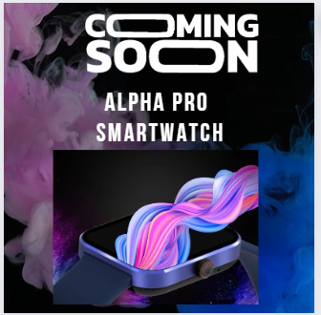#Launchingsoon #Upgradeyourlifestyle #InvestSmartly #Elevateyourstylequotient #Makeatopnotchchoice #TechRevolution #AlphaPro #StayTuned #TimetoThrive #WatchmeMove

**V.**

# Alpha Pro smartwatch is launching soon…stay tuned for mote updates.

#Upgradeyourlifestyle #InvestSmartly #Elevateyourstylequotient #Makeatopnotchchoice #TechRevolution #AlphaPro

**6. My Learnings**

I’ve attempted 2 out of 5 projects offered by upSkill campus. As a digital marketing enthusiast, I feel I would never have been able to learn so much in such a productive manner if I hadn’t worked on these projects.

While working for the project, I not only understood the core concepts under study but also gained a clear understanding of various other concepts related to the study. For example, while creating Meta ads target audience for Digihub Academy’s Digital marketing course, I got to know about various other campaign objectives, setting ads budget, ad placement, ad performance monitoring tools etc. When I got my hands on second project, while planning a social media campaign for new smartwatch launch, I have done SWOT analysis of my company and other players in the market, studied the market trends, recent technological advancements etc.

I also learned about other Sub-categories under Digital Marketing such as SEO,

I consider myself very lucky that I got an excellent learning opportunity, all credit goes to upskill campus team.

*Project 1:*

**Key takeaways:**

While exploring the different methods of creating an Audience for Meta ads, I came across some of the new concepts which further enhanced my understanding of the core subject.

I gained some knowledge related to designing the structure of lead ads, such as

* One should include an offer to draw attention of audience towards the ad.
* Focus on drawing attention to the benefits your customers are going to get from connecting with you.
* Integrate your lead ads with your sales funnel**.**
* Make sincere efforts to engage with your followers.

Some other valuable insights are as follows:

* Facebook pixel- It’s a piece of code that has to integrated with the website & lets you measure, optimize and build audiences for your ad campaigns. It acts as an important source in case of creating custom audience.
* Set an optimal ad budget and incorporate automatic placement to extend the reach of Campaign.
* Leverage a Lookalike Audience to reach people with characteristics similar to your current customers.

Over all I’ve learned that one should conduct thorough audience research (through brainstorming & using appropriate tools), design relevant ads, engage with audiences and regularly monitor their Ad performance as well as competitor’s marketing strategies. One major thing I’ve observed is that it's important to remember that Meta Ads' algorithms are constantly evolving with many AI tools being implemented, Meta Ads regularly updates its algorithms to enhance the user experience and respond to new trends and behaviors. This means you need to be constantly on top of updates and target the right type of audience to maximize reach and achieve campaign objective effectively.

* **Glance of some important noted key points from Search Engine Optimization (SEO) study**
* Basically, Search Engine Optimization is the process of optimizing a website/webpage so that it can rank higher on the SERP, enabling a business to reach favorable amount of conversion rate and helping them in achieving their desired objectives.
* Just like there are 2 sides to a coin, there are 2 sides of SEO; technical side, is related to the structure/layout of the website which includes proper website navigation, making sure the website is secured with https protocol, website loading speed optimization etc., while the other is content side which focuses on framing the content of the web pages (of a website) based on targeted keywords and user’s search intent.
* As an SEO expert, one should always focus on optimizing the webpages (of a website) for targeted keywords because always the webpages are ranked for search query and not the entire website.
* Two types of results appear on SERP. One is paid result which appears on the top and the other results below the paid results are organic search results. Paid results are a part of Search Engine Marketing.
* While doing keyword research, a balance should be maintained between the long-tail keywords and short-tail keywords. Consider using short-tail keywords for main topics, categories, and pages to rank for broad terms and attract a wide range of visitors. Whereas, long-tail keywords should be used for subtopics, subcategories, and posts to rank for specific terms and draw in a more engaged and loyal audience.
* Utilize keyword research tools such as Google Keyword Planner, SEMrush, or Ahrefs to find and analyze both types of keywords.
* Always build your SEO strategy by following white-hat SEO techniques and never follow any black-hat SEO techniques for short term gains.
* Google search console and Google analytics are two important tools which helps in monitoring the website and its interaction with the users as well as the search engine bots, both the tools serve as an importance source for decisional making.
* It is not one size fits all approach, unique SEO strategy has to be developed by each and every business organization that needs to have a strong digital presence to reach new customers.

SEO is a continuous process due to the constantly changing algorithms, dynamic user search behavior, changes in business and cut-throat competition so it is very important for SEO experts to stay updated with any changes that takes place which might affect their SEO efforts and webpage rankings.

*Project 2:*

* **KEY LEARNINGS:**

**In a Brand’s digital space, social media Marketing is challenging yet interesting business process which the marketer continuously faces in every step that he takes to leverage the brand presence among the target audience.**

While I was doing an in-depth exploration of the new product launch campaign on social media, I have noted the following important points:

* **Collaborate with Influencers**: Select certain number of Influencers which best suits with your brand personality and ask them to review and promote your product.
  + Partner with fitness influencers to showcase the smartwatch's health features.
  + Collaborate with tech enthusiasts for detailed reviews on YouTube and Instagram.
  + Leverage lifestyle influencers to demonstrate how the smartwatch seamlessly fits into everyday routines.

Influencer marketing helps to create a sense of excitement about the products specially among the youngsters who are more tech-savvy and prefer stylish wearables.

* **Brand voice matters a lot**: The brand voice of Electro Spectrum is encouraging and inspirational, helping to uplift and encourage the tech-savvy urban youth to up their style game by wearing stylish smartwatch while also keeping a track on their health.

Electro Spectrum instead uses its brand voice to appeal and helps encourage them to try new things while supporting them with messages of comfort.

Brand voice should also be consistent across all of the platform. It matters because it is what makes you stand out and rise above the ever-increasing noise that consumers find online today. It makes you identifiable and recognizable on an ongoing basis. Brand voice can help to quickly connect and make a lasting impression that wins consumers over, continues to entice already paying customers, and creates a loyal following.

* **Focus on Key Performance Indicators (KPIs)**: It is very important for a brand to continuously monitor how well is their social media marketing campaign performing. In case of a new product launch awareness campaign, key metrics would be reach KPIs, engagement rate KPIs, Website visit from social media KPI etc.
* **Develop a Content calendar**: A social media calendar helps formalize the process of creating and publishing content by giving you a structured schedule to work with. It helps in [saving time and organizing processes](https://buffer.com/library/social-media-calendar/#save-time-and-organize-your-processes), [identify and execute more ambitious social media campaigns](https://buffer.com/library/social-media-calendar/#identify-and-execute-more-ambitious-social-media-campaigns), [improves posting consistency](https://buffer.com/library/social-media-calendar/#improve-posting-consistency), [creating higher-quality content](https://buffer.com/library/social-media-calendar/#create-higher-quality-content), [improve tracking and analysis of performance](https://buffer.com/library/social-media-calendar/#improve-tracking-and-analysis-of-performance).
* **Social listening**: Social listening helps companies understand the conversation surrounding their brand and the products and services they offer. Customer complaints, feedback queries and suggestions are known. It provides valuable [consumer data](https://www.techtarget.com/searchcio/definition/consumer-data) that companies can use to gauge brand awareness and improve their products and services.
* Identify best time to post on social media to achieve the desired objective.
* Fix a budget for social media marketing. It also helps to determine Return on Ad Spent (ROAS).
* **User-generated content:** UGC is original, brand-specific content created by customers and published on social media or other channels. UGC comes in many forms, including images, videos, reviews, a testimonial, or even a podcast.
* **Offers and Discounts**: offering smart watches at special discounts or have a special pre-book offer, brand needs to market it well. Do a special campaign for pre-sale hype. The buzz will give you more attraction and better conversions.

The power of social media marketing for brands lies in its ability to amplify reach, foster engagement, target effectively and adapt to changing trends. It's not just a tool but a force that shapes the future of brand and consumer relationships. As businesses navigate the digital landscape, embracing the potential of social media marketing is not an option, it’s a strategy that is important for sustainable success in the long term.

**7. Future Work Scope**

Project 1:

After creating different categories of audiences in different ad sets, and performing other necessary actions, and actually running the ad, I will also monitor the performance of each of the ad and analyze it in terms of conversion rate, effective cost per lead and ROI and if the results are not positive, then I will plan improvement actions to be taken.

From SEO point of view, I want to do a Keyword Research for Digihub Academy’s website.

Project 2:

After planning a social media campaign strategy for new smartwatch launch, I will analyze the campaign performance on each of the social media platforms and determine whether or not successfully it has been able to spread awareness among the target audience.