FINAL YEAR PROJECT MANAGEMENT SYSTEM

Software Requirements Specification

Version 1.0



Group Id: F2202E93DE
Supervisor Name: Fizzah

Revision History

Date (dd/mm/yyyy) | Version | Description | Author
19/01/2023 | 1.0 | A software requirements specification (SRS) is a document that captures complete description about how the system is expected to perform. It is usually signed off at the end of requirements engineering phase. | Mc210401279

TABLE OF CONTENTS

1 SCOPE OF PROJECT 4

2 FUNCTIONAL AND NON- FUNCTIONAL REQUIREMENTS 5
2.1 Functional Requirements 5
2.2 Non Functional Requirements 6

3 USE CASE DIAGRAM(S) 7

4 USAGE SCENARIOS 8

5 ADOPTED METHODOLOGY 17
5.1 Waterfall Model 17
5.2 Spiral model 18
5.3 VU Process Model 19

6 WORK PLAN 20

LIST OF FIGURES

Figure 3-1 Use case diagram for Final Year Project Management System (FYPMS) 4
Figure 5-1 Waterfall Model 15
Figure 5-2 Spiral Model 15
Figure 5-3 VU Process Model 16
Figure 6-1 Work Plan 17

SCOPE OF PROJECT

Final Year Project management has been in a more traditional way for all these years. It is done manually. This management system has several disadvantages. It is time-consuming, it has communication and interaction difficulties and the previous data is hard to search.

The scope of Final Year Project Management System (FYPMS) is very diverse. It will be based upon knowledge and experimentation of web design setup and development, database design and management and server design.

The World Wide Web (WWW) is a platform for all the people from all around the world to acquire and convey knowledge and information. The Web is also becoming more popular because of the effectiveness in the use as an administrative and management tool. This technology is the main key in the idea of developing FYPS. Website programming and web design technique is used which will give it a user-friendly interface. The complete programmed web application will be secure, flexible, and scalable to meet spikes in demand.

The FYP Management System is set to achieve five properties:

Scalability: The system should be scalable which means that it should be able to accommodate a large number of participations and monitor large numbers of data attributes.

Flexibility: The system should be flexible enough with dynamic changes within the data in the system.

Administrative Isolation: As in UTP environment that involve large scope of participants, the system should provide administration isolation to arrange nodes in more organized hierarchy.

Robust: The system must be robust. It also should be able to adapt accordingly to reconfigurations and provide ways to counter when reconfigurations occur. There will be some testing to make sure that the system is robust

Enable easy backup: The backup of data should be easy and accurate.

FUNCTIONAL AND NON- FUNCTIONAL REQUIREMENTS

Functional Requirements

The functional requirements can be divided into three categories i.e., requirements as per the admin, supervisor and student.

Following are functional requirements as per the admin:

- Admin can login to the system;
- Admin can delete the supervisor and student account that have not been used for more than a year; and
- Admin can manage the user’s account.

Following are the functional requirements as per the supervisor:

- Supervisor can register in the system;
- Supervisor can upload the projects;
- Supervisor can upload the documents i.e., task related document or any helping material;
- Supervisor can assign the task to individual student or as a group;
- Supervisor can schedule meeting i.e., physical meeting or meeting on skype with the individual student or with the group;
- Supervisor can upload the result;
- Supervisor can review the task;
- Supervisor can review the document;
- Supervisor can send messages to the student;
- Supervisor can do audio/video conferencing (The proposed system will provide this facility by embedding the API of skype);
- Supervisor can view progress of individual student or a group;
- Supervisor can upload time table; and
- Supervisor can view upcoming meeting.

Following are the functional requirements as per the student:

- Student can register into the system;
- Student can view projects;
- Student can send request to supervisor for project;
- Student can send messages to the supervisor;
- Student can view assigned tasks;
- Student can download the task;
- Student can upload the task solution or deliverable which has been assigned by the supervisor;
- Student can view messages;
- Student can view result;
- Student can do audio/video conference (The proposed system will provide this facility by embedding the API of skype);
- Student can upload his/her time table;
- Student can view their own time table as well as his/her supervisor timetable;
- Student can view document;
- Student can send meeting request with supervisor; and
- Student can upload task progress.

Non Functional Requirements

Non-functional requirements can be divided into following categories:

Operating System: It will be Open Source Operating System. It is cost-minimized. Software will be easier and value developer independence.

Usability: Usability of software will be easy so that supervisor and students can use it without any difficulty.

Maintainability: Software would build up in such a way that classifications of errors and maintenance of mechanism become easy.

Flexibility: Software would be flexible so that it can easily accept all changes at low cost, time and experience.

Security: Software will be secure. No one can use this application without a registered username and password.

Reliability: Software will perform its intended function adequately, or will operate in a defined environment without failure.

Performance: Authorization will complete within one minute 90% of the time.
Average authorization confirmation time will not exceed 30 seconds.

Access: Software will accessible over the internet.

USE CASE DIAGRAM(S)

The figure below (Figure 3.1) represents the use case diagram for the Final Year Project Management System.

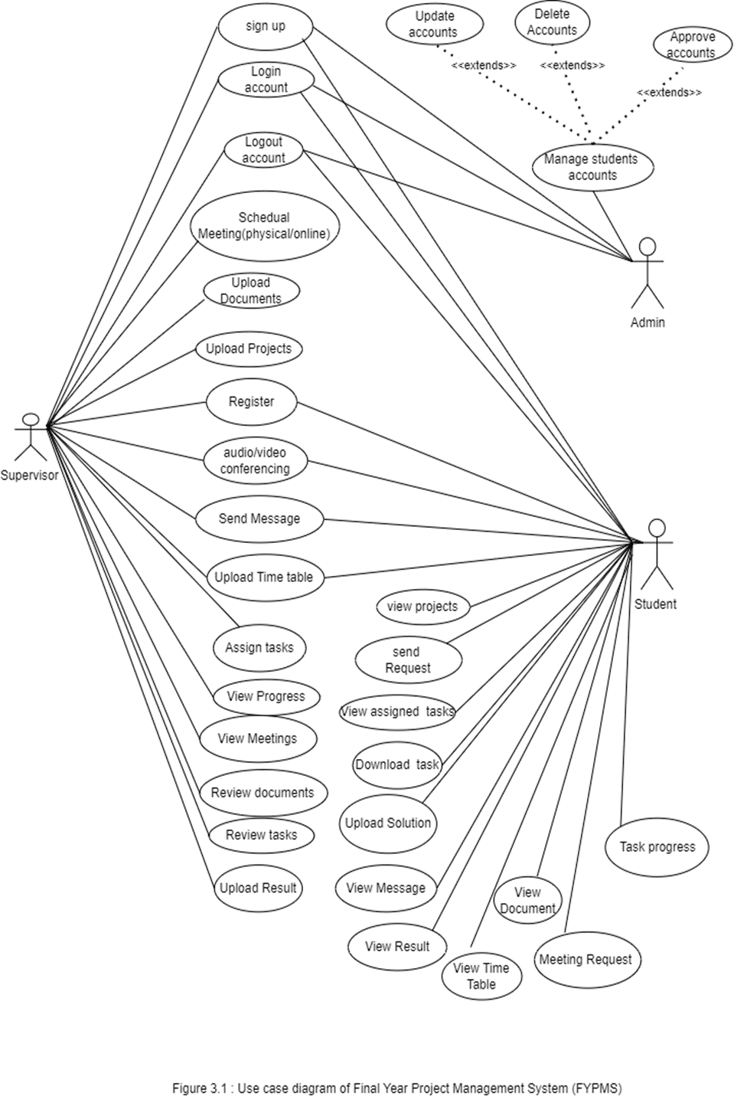
Figure 3-1 Use case diagram for Final Year Project Management System (FYPMS)

USAGE SCENARIOS

Use Case Title | Signup
Use Case Id | 01
Actors | Student, Admin, supervisor
Description | Student/admin/ supervisor can create New account to login to application
Pre-Conditions | Web Application should in running condition, Create New Account page should available
Exceptions | None
Post Condition | Action performed successfully
Author | MC210401279
Modification History | 1.0
Modification Date | 19-01-2023

Use Case Title | Login
Use Case Id | 02
Actors | Student, Admin, supervisor
Description | Student, Admin, supervisor shall need to login to use the application
Pre -Conditions | Application should in running condition. Login page should available
Exceptions | None
Post Condition | Action performed successfully
Author | MC210401279
Modification History | 1.0
Modification Date | 19-01-2023

Use Case Title | Manage Students Accounts
Use Case Id | 03
Actors | Admin
Description | Admin will manage students and supervisor accounts. Admin can delete, update and approve students and supervisor accounts.
Pre-Conditions | Manage students and supervisor accounts page should available.
Exceptions | None
Post Condition | Action performed successfully
Author | MC210401279
Modification History | 1.0
Modification Date | 19-01-2023

Use Case Title | Schedule Meetings (Physical or Online)
Use Case Id | 04
Actors | Supervisor
Description | Supervisor can schedule meetings in application. Meetings can be physical or online depending upon supervisor will.
Pre-Conditions | Web Application should run well and supervisor should schedule meetings without errors.
Exceptions | None
Post Condition | Meetings scheduled successfully.
Author | MC210401279
Modification History | 1.0
Modification Date | 19-01-2023

Use Case Title | Upload Documents
Use Case Id | 05
Actors | Supervisor
Description | Supervisor can upload documents using upload document option on application.
Pre-Conditions | Documents should upload without errors.
Exceptions | None
Post Condition | Documents uploaded successfully.
Author | MC210401279
Modification History | 1.0
Modification Date | 16-01-2023

Use Case Title | Upload Projects
Use Case Id | 06
Actors | Supervisor
Description | Supervisor can upload Projects using upload projects option on application.
Pre-Conditions | Projects should upload without errors.
Exceptions | None
Post Condition | Project uploaded successfully.
Author | MC210401279
Modification History | 1.0
Modification Date | 19-01-2023

Use Case Title | Register
Use Case Id | 07
Actors | Supervisor, Student.
Description | Supervisor and Students can register themselves on application.
Pre-Conditions | Registration page should appear.
Exceptions | None
Post Condition | Registration done successfully by supervisor/ student.
Author | MC210401279
Modification History | 1.0
Modification Date | 19-01-2023

Use Case Title | Audio/ Video conferencing
Use Case Id | 08
Actors | Supervisor, Student.
Description | Supervisor and Students can conference that could be audio or video.
Pre-Conditions | Conference page should appear.
Exceptions | None
Post Condition | Conference done successfully by supervisor/ student.
Author | MC210401279
Modification History | 1.0
Modification Date | 19-01-2023

Use Case Title | Send Message
Use Case Id | 09
Actors | Supervisor, Student.
Description | Supervisor and Students both can send message to each other.
Pre-Conditions | Messenger should appear.
Exceptions | None
Post Condition | Action performed successfully by supervisor/ student.
Author | MC210401279
Modification History | 1.0
Modification Date | 19-01-2023

Use Case Title | Upload Time Table
Use Case Id | 10
Actors | Supervisor, Student.
Description | Supervisor and Students both can upload their own time table on two different pages.
Pre-Conditions | Separate pages for time table should appear.
Exceptions | None
Post Condition | Action performed successfully by supervisor/ student.
Author | MC210401279
Modification History | 1.0
Modification Date | 19-01-2023

Use Case Title | Assign tasks
Use Case Id | 11
Actors | Supervisor
Description | Supervisor can assign different course related tasks to student in application.
Pre-Conditions | Assignment page should appear.
Exceptions | None
Post Condition | Action performed successfully by supervisor.
Author | MC210401279
Modification History | 1.0
Modification Date | 19-01-2023

Use Case Title | View Progress
Use Case Id | 12
Actors | Supervisor
Description | Supervisor can view progress of the student.
Pre-Conditions | View progress page should appear.
Exceptions | None
Post Condition | Action performed successfully by supervisor.
Author | MC210401279
Modification History | 1.0
Modification Date | 19-01-2023

Use Case Title | View Meetings
Use Case Id | 13
Actors | Supervisor
Description | Supervisor can upcoming/previous meetings.
Pre-Conditions | View Meetings page should appear.
Exceptions | None
Post Condition | Action performed successfully by supervisor.
Author | MC210401279
Modification History | 1.0
Modification Date | 19-01-2023

Use Case Title | Review documents
Use Case Id | 14
Actors | Supervisor
Description | Supervisor can review documents on application.
Pre-Conditions | Application should be connected to network.
Exceptions | None
Post Condition | Action performed successfully by supervisor.
Author | MC210401279
Modification History | 1.0
Modification Date | 19-01-2023

Use Case Title | Review Tasks
Use Case Id | 15
Actors | Supervisor
Description | Supervisor can review tasks.
Pre-Conditions | Review tasks page should appear.
Exceptions | None
Post Condition | Action performed successfully by supervisor.
Author | MC210401279
Modification History | 1.0
Modification Date | 19-01-2023

Use Case Title | Upload Result
Use Case Id | 16
Actors | Supervisor
Description | Supervisor can upload result of the student on application.
Pre-Conditions | Upload Result page should appear.
Exceptions | None
Post Condition | Action performed successfully by supervisor.
Author | MC210401279
Modification History | 1.0
Modification Date | 19-01-2023

Use Case Title | View Projects
Use Case Id | 17
Actors | Students
Description | Student can view projects uploaded by supervisor on application.
Pre-Conditions | Internet connection should be fine.
Exceptions | None
Post Condition | Action performed successfully.
Author | MC210401279
Modification History | 1.0
Modification Date | 19-01-2023

Use Case Title | Request to supervisor
Use Case Id | 18
Actors | Students
Description | Student can send request to supervisor on application.
Pre-Conditions | Internet connection should be fine.
Exceptions | None
Post Condition | Action performed successfully.
Author | MC210401279
Modification History | 1.0
Modification Date | 19-01-2023

Use Case Title | View Assigned tasks
Use Case Id | 19
Actors | Students
Description | Student can view Assigned tasks uploaded by supervisor on application.
Pre-Conditions | Internet connection should be fine.
Exceptions | None
Post Condition | Action performed successfully.
Author | MC210401279
Modification History | 1.0
Modification Date | 19-01-2023

Use Case Title | Download tasks
Use Case Id | 20
Actors | Students
Description | Student can view Assigned tasks uploaded by supervisor on application.
Pre-Conditions | Internet connection should be fine.
Exceptions | None
Post Condition | Action performed successfully.
Author | MC210401279
Modification History | 1.0
Modification Date | 19-01-2023

Use Case Title | Upload Solution
Use Case Id | 21
Actors | Student
Description | Student can upload solutions of the assigned tasks on application.
Pre-Conditions | Internet connection should be available.
Exceptions | None
Post Condition | Action performed successfully.
Author | MC210401279
Modification History | 1.0
Modification Date | 19-01-2023

Use Case Title | View Message
Use Case Id | 22
Actors | Student
Description | Student can view messages by supervisor on application.
Pre-Conditions | Internet connection should be fine.
Exceptions | None
Post Condition | Action performed successfully.
Author | MC210401279
Modification History | 1.0
Modification Date | 19-01-2023

Use Case Title | View Result
Use Case Id | 23
Actors | Student
Description | Student can view his result on application.
Pre-Conditions | Internet connection should be fine.
Exceptions | None
Post Condition | Action performed successfully.
Author | MC210401279
Modification History | 1.0
Modification Date | 19-01-2023

Use Case Title | View Time Table
Use Case Id | 24
Actors | Student
Description | Student can view his time table on the application.
Pre-Conditions | Internet connection should be fine.
Exceptions | None
Post Condition | Action performed successfully.
Author | MC210401279
Modification History | 1.0
Modification Date | 19-01-2023

Use Case Title | View Documents
Use Case Id | 25
Actors | Students
Description | Student can view documents uploaded by supervisor on application.
Pre-Conditions | Internet connection should be fine.
Exceptions | None
Post Condition | Action performed successfully.
Author | MC210401279
Modification History | 1.0
Modification Date | 19-01-2023

Use Case Title | Meeting Request
Use Case Id | 26
Actors | Students
Description | Student can send meeting request to the supervisor on application.
Pre-Conditions | Internet connection should be fine.
Exceptions | None
Post Condition | Action performed successfully.
Author | MC210401279
Modification History | 1.0
Modification Date | 19-01-2023

Use Case Title | Task Progress
Use Case Id | 27
Actors | Students
Description | Student can upload his tasks progress on application.
Pre-Conditions | Internet connection should be fine.
Exceptions | None
Post Condition | Action performed successfully.
Author | MC210401279
Modification History | 1.0
Modification Date | 19-01-2023

Use Case Title | Logout
Use Case Id | 28
Actors | Student, Admin, supervisor
Description | Student, Admin, supervisor can logout to this application
Pre- Conditions | Application should in running condition.
Actions | Select the option of logout
Exceptions | None
Post Condition | Action performed successfully
Author | MC170402257
Modification History | 1.0
Modification Date | 19-01-2023

ADOPTED METHODOLOGY

A systems development life cycle (SDLC), is an application development methodology, this term is used by software engineers and IT professionals to describe the process used to plan, design, develop, test, and deploy software applications. It is the process of controlling software development.

There are several models for such processes which include:

- Agile software Development;
- Incremental model;
- Crystal Methods;
- Extreme programming;
- Waterfall model; and
- Spiral model.

My adopted methodology is vu process model which is a combination of waterfall and spiral model.

Waterfall Model

The waterfall method is a rigid linear model. It is a sequential development process that flows like a waterfall through all phases of a project.

Phases of this model are:

- Requirements;
- Design;
- Implementation;
- Verification; and
- Maintenance.
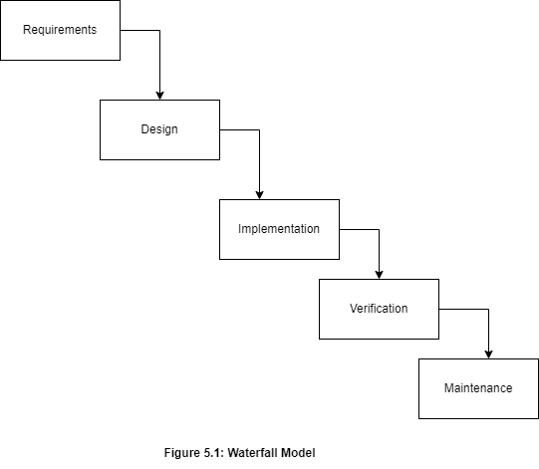
Figure 5-1 Waterfall Model

Spiral model

The spiral model is a systems development lifecycle (SDLC) method which is used for risk management and it combines the iterative development process model with elements of the Waterfall model.

It has four phases:

- Plan objectives and find alternative solutions
- Risk Analysis
- Product Development
- Next phase Planning

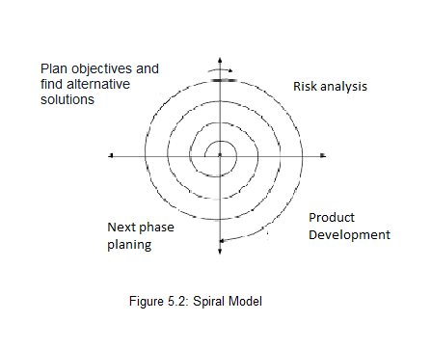
Figure 5-2 Spiral Model

VU Process Model

It is the combination of waterfall model and spiral model. It is also called Hybrid approach of system development.

It has five phases:

- Gathering and Analyzing requirement;
- Planning;
- Analysis and Design;
- Development; and
- Final Report.

It maximizes the quality of system and minimizes any risks and errors.
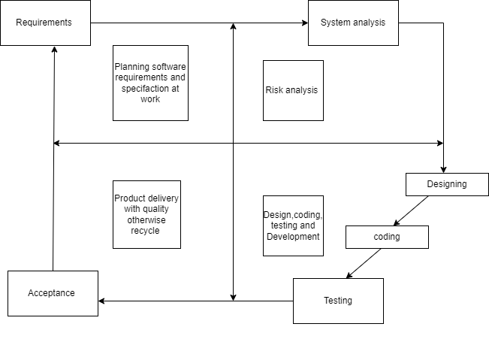
Figure 5-3 VU Process Model

REASONS TO CHOOSE VU PROCESS MODEL:

1: We select this method to utilize both waterfall model and spiral model.

2: This is a sequential model.

3: It has backward iteration.

4: The project will have spiral nature. It will correct mistakes through suggestions and improve project.

5: All activities are performed in phases and sequence.

Hence, both these models are compressed in a single vu process model. It will provide error free result as it is sequential.

WORK PLAN

MS Project was used to create Schedule/Work Plan which as follows:

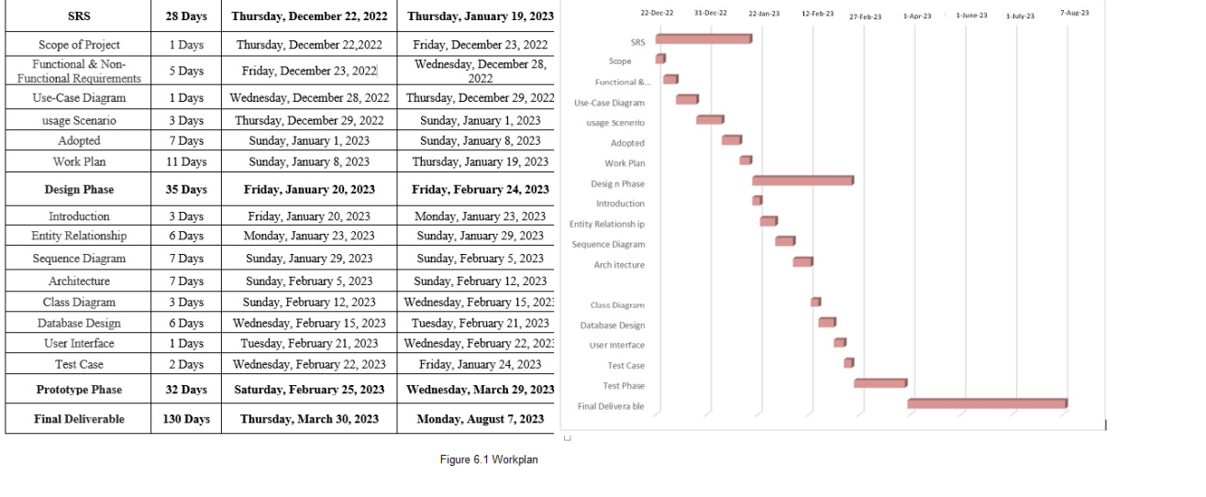
Figure 6-1 Work Plan

