**Assignment Cover Sheet**

**7074HUM – Stylistics**

**Portfolio**

Student ID: _____________

**November 2023**

**MA English and Education Management**

**Word count: 4000 words (excluding figures, tables and references)**

**Task 1: Literary Text**

**"I Wandered Lonely as a Cloud"**

**Introduction**

The selected literary text for analysis is "I Wandered Lonely as a Cloud" by William Wordsworth, a notable creation within the realm of Romantic poet (Bradford, 1997; Leech & Short, 1981). This examination will primarily centers on employing a stylistic framework to go into the intricate elements that contribute to the poem's emotional depth and thematic resonance (Bradford, 1997; Chapman & Clark, 2014). Specifically, the analysis aims to explore the poem's utilization of vivid imagery, metaphorical expressions, and rhythmic structures.

The selection of a stylistic framework stems from the poem's rich tapestry of visual imagery and symbolic representation. Wordsworth's vivid portrayals of nature and the human experience, encapsulated through the persona's observations of daffodils, are interwoven with metaphorical elements and rhythmic patterns. By deconstructing these stylistic elements, this analysis aims to reveal the poem's underlying themes, the poet's emotional state, and the broader philosophical implications embedded in the verses (Chapman & Clark, 2014; McCabe, 2011).

The stylistic approach used for this analysis acts to provide an insightful exploration of Wordsworth's deliberate choices in drawing the poem's emotional landscape. Revealing the nuances within these stylistic elements tries to unravel the intricate interplay between the external world and the internal emotions, offering a comprehension of Wordsworth's intention to convey not only the physical landscape but also the emotional and philosophical depths within "I Wandered Lonely as a Cloud" (Bradford, 1997; Jeffries & McIntyre, 2010; McCabe, 2011).The rationale behind this framework intends to unveil the nuanced layers of meaning and the poet's skillful craftsmanship, highlighting how stylistic devices contribute to the poem's overall aesthetic and emotional impact. Through this analytical lens, a deeper comprehension of the poem's essence and the poet's intentions can be elucidated, enriching the interpretation and appreciation of Wordsworth's poetic composition (Bradford, 1997; Jeffries & McIntyre, 2010).

**Analysis**

**Imagery:**

Wordsworth employs vivid mental images throughout "I Wandered Lonely as a Cloud" to immerse a sensory experience for the reader (Bradford, R. 1997; Gregoriou, C. 2009). The portrayal of "golden daffodils" dancing beside the serene lake and fluttering in the breeze constructs a picturesque scene that symbolizes natural beauty and the harmony between humanity and nature (Chapman, S. & Clark, B. 2014; Verdonk, P. 2002).

**Metaphor:**

The comparison of the daffodils to stars in the line "Continuous as the stars that shine" gives a metaphor that increases the significance of the flowers, suggesting their vastness and celestial presence (Bradford, R. 1997; Verdonk, P. 2002). This metaphorical association amplifies the sense of wonder and permanence (Chapman, S. & Clark, B. 2014; Verdonk, P. 2002).

**Rhythm:**

The poem follows a rhythmic pattern throughout the poem, primarily in iambic tetrameter, contributing to a seamless flow and continuity (Leech, G. L. 2008; Stockwell, P. & Whiteley, S. 2014). This rhythm mirrors the gentle swaying of the daffodils and the tranquil grace of nature.



*Figure: I Wandered Lonely As a Cloud*

**Interpretation**

The vivid imagery of the "golden daffodils" and their comparison to stars serves as a conduit metaphorical representation of the enduring and transcendent beauty found in nature. Wordsworth's selection of vivid imagery paints a picture of a serene and enchanting landscape, inviting the reader to share in the poet's experience of tranquility. This connection to nature underscores the Romantic notion of finding natural splendor, emphasizing the theme of the interconnectedness between humanity and the environment (Chapman & Clark, 2014; Leech & Short, 1981).

Furthermore, the consistent rhythmic structure of the poem contributes to its emotional impact, echoing the natural cadence of the environment being depicted. The steady rhythm mirrors the harmonious and cyclical nature of the world, emphasizing theme of the poem, finding solace and inspiration in the beauty of nature. The poem's structured rhythm also reflects the poet's contemplative state, enhancing the reader's emotional engagement with the persona's experience of joy and solace amidst solitude (Leech, 2008; McCabe, 2011).

The effect of these stylistic elements contributes to the overall theme of the poem: the transformative power of nature on the human spirit. Wordsworth employs clear imagery and rhythmic structure not only as poetic devices but as vehicles to convey a deep philosophical message about the transcendent and beauty found in the natural world (Jeffries & McIntyre, 2010; Toolan, 1998).

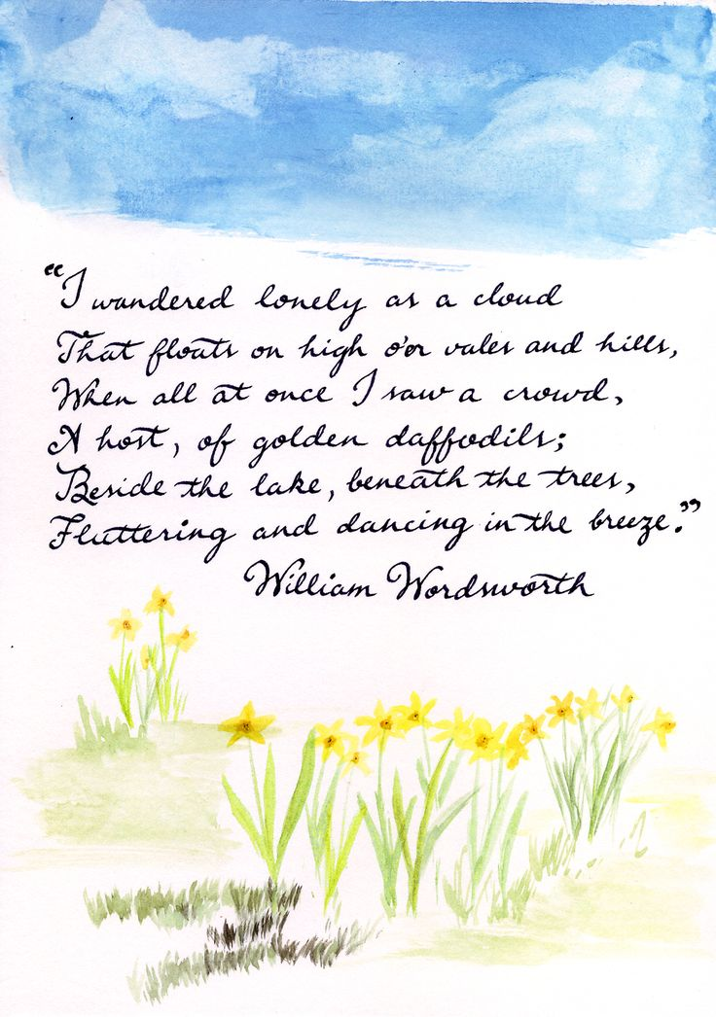

*Figure: I Wandered Lonely As a Cloud Poem*

**Conclusion**

The exploration of William Wordsworth's "I Wandered Lonely as a Cloud," through stylistic analysis has unveiled intricate layers that contribute to the poem's depth and emotional resonance. The examination of imagery, metaphor, and rhythmic structures embedded within the text has been instrumental in illuminating the poem's thematic richness and emotional impact (Bradford, 1997; Chapman & Clark, 2014; Leech & Short, 1981).

Delving into the vivid imagery, especially the depiction of the "golden daffodils," the analysis has unveiled the poem's profound depiction of the inherent connection between humanity and nature. These visual depictions serve not merely as descriptions of natural beauty but as symbolic representing of a harmonious relationship between the humankind's spirit and the environment (Carter, 1982; Verdonk, 2002).

Moreover, the metaphorical link between the daffodils with stars transcends the literal interpretation, enhancing the flowers' significance and timeless essence (Chapman & Clark, 2014; Verdonk, 2002). This metaphorical depth prompts a layer of transcendence, inviting readers to ponder the enduring splendor inherent in nature's creations.

Additionally, the consistent rhythm observed throughout the poem enhances its thematic coherence and emotional impact (Leech, 2008; Stockwell & Whiteley, 2014).The measured rhythm not only reflects the tranquil movements of the daffodils but also synchronizes the reader's experience with the serene beauty of the natural world.

The selected stylistic framework of analyzing imagery, metaphor, and rhythm has provided a lens through which the poem's deeper meanings and nuances have been showed (Jeffries & McIntyre, 2010; Toolan, 1998). This approach has facilitated a richer comprehension of Wordsworth's craftsmanship and his profound philosophical message encapsulated within the verses (McCabe, 2011; Short, 1996).

This analytical journey has highlighted the timeless theme of nature's transformative influence on the human spirit (Clark, 1996; Leech, 2008). The utilization of vivid imagery, metaphorical depth, and precise rhythm collectively reaffirms the enduring beauty and interrelationship between humanity and the natural world encapsulated in Wordsworth's poetic masterpiece.

**Task 2: Non-Literary Text**

**Donald Trump’s State of the Union Speech**

**Introduction**

The chosen text for analysis is Donald Trump’s State of the Union Speech delivered in February 2020, a prominent address delivered annually by the President of the United States to Congress (Bradford, R. 1997; Stockwell, P. & Whiteley, S. 2014). This speech acts as a significant platform for the incumbent president to outline achievements, policy agendas, and the recognized state of the nation to both lawmakers and citizens (Gregoriou, C. 2009; McCabe, A. 2011).

For the purpose of this analysis, specific analytical frameworks will be employed to go into the rhetorical strategies utilized within the speech, differing from the frameworks utilized in Task 1 on literary text analysis. The chosen frameworks for this examination will revolve around rhetorical analysis and converse analysis (Leech, G. L. 2008; Verdonk, P. 2002). These frameworks have been chosen for their efficiency in deciphering persuasive language, argumentative structure, and the contextual implications of political discourse (Chapman, S. & Clark, B. 2014; Jeffries, L. & McIntyre, D. 2010).

The aim behind employing these frameworks lies in their capacity to reveal the nuances of persuasive communication techniques employed by political figures in public addresses, offering insights into the construction of meaning, ideological underpinnings, and persuasive techniques utilized within political rhetoric (Bradford, R. 1997; Verdonk, P. 2002). Through the application of these frameworks, this analysis tries to unravel the strategic linguistic and rhetorical elements employed within Donald Trump’s State of the Union Speech, shedding light on its persuasive intent and communicative impact.

Furthermore, the decision to utilize rhetorical and discourse analysis frameworks for this evaluation roots from their ability to dissect the strategic use of language, persuasive devices, and audience engagement within political discourse (Leech, G. N. & Short, M. H. 1981; Simpson, P. 2002). These frameworks offer an` extensive lens through which to explore the speech's construction, including the identification of persuasive appeals, such as ethos, pathos, and logos, along with an examination of linguistic choices, narrative structures, and discourse strategies employed to sway public opinion and reinforce political agendas (Toolan, M. 1998; Toolan, M. 2009). By using these analytical lenses to Donald Trump’s State of the Union Speech, this analysis aims to show the intricate layers of rhetoric and persuasion employed within the political domain, giving a deep understanding of the speech's communicative effectiveness and underlying political messaging.

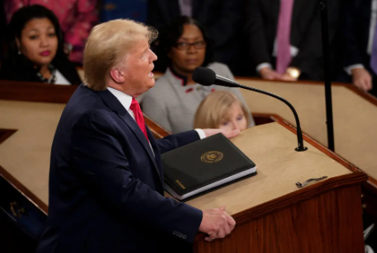

*Figure: Donald Trump’s Speech*

**Analysis**

**Rhetorical Analysis**

**Repetition and Emotional Language:**

Trump’s State of the Union Speech utilizes extensive repetition, a common rhetorical device. Phrases like "America is the place" and "We are Americans" are reiterated to emphasize oneness and identity (Toolan, M. 1998; Simpson, P. 2002). Furthermore, emotive language, evident in phrases such as "glorious and magnificent inheritance" and "incredible dreams come true," serves to evoke strong emotions, fostering a sense of pride and hope (Leech, G. N. & Short, M. H. 1981).

**Metaphors and Symbols:**

Metaphorical language, observed in phrases for example "land of heroes" and "unlimited frontiers," is meaningfully used to depict America as a symbol of greatness and opportunity (Toolan, M. 2009; Chapman, S. & Clark, B. 2014). The speech frames America as a beacon of resilience, utilizing metaphors to paint a vivid image of national identity and aspiration.

**Discourse Analysis**

**Narrative Structure and Identify Construction:**

The speech creates a narrative that shows historical figures, creating a whole identity through shared history (Verdonk, P. 2002; Leech, G. L. 2008). By referencing historical icons like Lincoln and the pioneers, Trump aligns the audience with a narrative of perseverance and American exceptionalism, shaping a cohesive national identity.

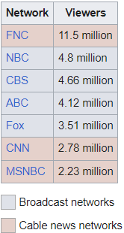

*Figure: Viewership of Donald Trump’s Speech*

**Discourse Strategies and Persuasive Appeals:**

The speech suggests persuasive appeals such as ethos, portraying America as a land of opportunities and success. Logos is utilized by showing economic growth and criminal justice reforms as achievements (Jeffries, L. & McIntyre, D. 2010; Stockwell, P. & Whiteley, S. 2014). Pathos is evoked through emotive language to foster a sense of belonging and optimism.

**Interpretation**

The stylistic selection employed in Trump’s speech try to construct a compelling narrative of national identity and success, leveraging rhetorical devices to provoke emotional responses and reinforce a positive perception of America (Chapman, S. & Clark, B. 2014; McCabe, A. 2011). The strategic use of repetition, metaphors, and emotive language participates to a powerful portrayal of American greatness, influencing the audience's perception by reinforcing a sense of unity and patriotism (Simpson, P. 2002; Leech, G. L. 2008).

The utilization of rhetorical and discourse techniques within Trump’s State of the Union Speech highlights a deliberate attempt to create a unifying narrative, emphasizing American exceptionalism and resilience (Jeffries, L. & McIntyre, D. 2010; Stockwell, P. & Whiteley, S. 2014). The repetition of key phrases and the use of metaphorical language work together to induce a sense of collective identity and pride. Moreover, the strategic placement of emotive language promotes an emotional connection with the audience, aiming to reinforce positive perceptions of the administration’s accomplishments and the nation's future trajectory (Leech, G. N. & Short, M. H. 1981; Chapman, S. & Clark, B. 2014). Finally, the cumulative effect of these stylistic choices enhances the persuasive impact of the speech, framing America as a land of opportunity and unity, shaping the audience's perception of national success under the leadership presented in the speech.

**Conclusion**

The examination of Donald Trump’s State of the Union Speech employing rhetorical and discourse analysis frameworks has revealed essential stylistic elements influencing the speech’s persuasive impact. The strategic repetition, metaphorical expression, and emotive appeals acts as foundational elements in creating a cohesive narrative of American greatness and unity (Leech, G. N. & Short, M. H. 1981; Verdonk, P. 2002). The recurrent use of key phrases, combined with metaphors portraying America as a land of heroes and limitless potential, participates significantly to fostering a collective sense of national pride and aspiration (Toolan, M. 1998; Simpson, P. 2002).

These findings underscores the nuanced effectiveness of rhetorical and discourse strategies in shaping audience perceptions and reinforcing a positive portrayal of America's accomplishments and future prospects (Stockwell, P. & Whiteley, S. 2014; Chapman, S. & Clark, B. 2014). The chosen analytical frameworks have played a pivotal role in showing the intricate layers of persuasive language, shedding light on the speech’s communicative effectiveness and its ability to evoke emotions while presenting a particular narrative of national identity and success (Leech, G. L. 2008; McCabe, A. 2011).

In summary, these frameworks have not only facilitated an in-depth analysis of stylistic devices but have also showed how these devices function as persuasive tools within political discourse. Their important role in influencing audience perceptions and reinforcing the overarching message of American exceptionalism presented in the State of the Union Speech.

**Task 3:**

**Literary Text**

**"The Secret Agent"**

**Introduction**

In examining Joseph Conrad's excerpt from "The Secret Agent" the selected analytical frameworks for this analysis encompass narrative analysis, discourse analysis, and stylistics. Each framework offers a diverse perspective through which to dissect the intricacies embedded within the text's dialogue, characterization, and thematic development. The use of these frameworks aligns with the complex narrative structure and multifaceted character dynamics prevalent within Conrad's work (Verdonk, P. 2002; Leech, G. N. & Short, M. H. 1981).

Conrad's narrative complexities often necessitate a deep exploration of the underlying themes and character motivations, making narrative analysis an appropriate choice. Furthermore, discourse analysis reveal the power dynamics and nuances within character interactions, while stylistics enable an examination of linguistic patterns and their contributions to the text's depth and meaning (Verdonk, P. 2002; Leech, G. N. & Short, M. H. 1981).

These frameworks collectively offer a comprehensive toolkit to dissect the layers of meaning, character complexities, and narrative subtleties inherent in Conrad's excerpt from "The Secret Agent." This approach aims to reveal the intricacies woven into the text, enriching the understanding of its thematic undercurrents and narrative intricacies.

Joseph Conrad's excerpt from "The Secret Agent" explores a labyrinth of themes, from clandestine affairs to the personal and societal responsibilities. Narrative analysis, as one of the selected frameworks, aligns with the complex structure of the text, enabling a detailed dissection of the story's layers. Conrad's adeptness in weaving multiple storylines and character perspectives demands a deep exploration of the narrative techniques employed to convey these complexities. The nuances in the plot progression, including the characters' inner thoughts and external actions, merit a closer examination to unravel the text's underlying motivations and thematic depth (Verdonk, P. 2002).

Complementing this narrative analysis, the application of discourse analysis gives a profound insight into the interactions among characters, unveiling power dynamics and underlying tensions within their dialogues. This framework allows for a nuanced examination of speech acts, conversational techniques, and communicative intentions, shedding light on the characters' motivations, conflicts, and the sociocultural contexts shaping their discourse. The intertwining threads of discourse within the narrative are essential to deciphering the characters' personas and the underlying sociopolitical themes embedded in Conrad's writing (Leech, G. N. & Short, M. H. 1981).

The adoption of discourse analysis highlights the underlying societal tensions and power struggles threaded within character interactions. Verloc's dialogues with his wife and other people encapsulate nuances important to decoding social hierarchies and individual motives. By dissecting verbal exchanges, this framework shows the implicit societal norms and power struggle shaping the characters' choices and perspectives. This analysis delves into the complexities of speech patterns and linguistic cues, shedding light on the characters' societal roles and interpersonal conflicts, and the underlying sociocultural fabric (Leech, G. N. & Short, M. H. 1981).

The importance of these analytical frameworks alongside stylistic analysis enriches the understanding of Conrad's linguistic mastery. The strategic application of metaphors, narrative styles, and tonal variations intertwines with character motives and thematic depth, exemplifying Conrad's finesse in conveying subtleties. These stylistic elements createsa rich atmospheric within the text, beckoning a deeper exploration into its layers and complexities, enhancing the overall texture and resonance of the narrative (Stockwell, P. & Whiteley, S. 2014).

**Analysis and Interpretation**

**Narrative Analysis**

**Exploring Narrative Complexities**

Conrad intricately weaves various storylines and character perspectives within "The Secret Agent." The text explores a complex web of narratives, primarily focusing on Verloc's internal struggles and interactions. Through Verloc's actions and inner thoughts, Conrad unveils the tension between individual motivation and societal responsibilities. For instance, Verloc's conflict between his role as a secret agent and his domestic life shows the larger thematic exploration of duty versus personal desires. This multi-layered narrative enriches the reader's understanding of character motivations and the underlying thematic depth (Stockwell, P. & Whiteley, and S. 2014).

The intricate narrative structure not only delves the intricacies of Verloc's internal conflicts but also echoes broader societal conflicts prevalent during the period, thereby serving as a window into the socio-political landscape of the time. The narrative intricacies further enhance the text's thematic resonance, navigating a nuanced portrayal of the characters and their interactions within a socio-historical context (Stockwell, P. & Whiteley, S. 2014).

Conrad's adept handling of the narrative structure allows for the interweaving of Verloc's personal dilemmas with wider societal tensions, resulting in a tapestry that reflects the intricacies of human behaviour and societal constraints. This sophisticated narrative layering not only accentuates the thematic undercurrents but also invites readers to contemplate the complex of duty, morality, and individual agency within the broader societal framework (Stockwell, P. & Whiteley, S. 2014).

**Revealing Character Interaction**

Conrad utilizes discourse analysis to elucidate the power dynamics and latent tensions within character interactions. Verloc's conversations with his wife, Stevie, and other characters reveal communicative strategies, reflecting the social and cultural contexts of the time. Notably, Verloc's authoritative tone when discussing Stevie's death signifies his attempt to maintain control over the situation, unveiling the power play within the dialogue. The discourse analysis exposes the characters' motivations, societal conflicts, and the embedded sociopolitical underpinnings (Chapman, S. & Clark, B. 2014).

Moreover, discourse analysis go deeper into the intricate layers of communication styles present within Conrad's text. Verloc's skillfull use of language and the dynamics of silence within dialogues reflects the characters' suppressed emotions and wordless tensions. For instance, Verloc's moments of silence or elusion in crucial conversations serve as implicit expressions of his internal conflicts and attempts to hide information. These subtleties in verbal and non-verbal communication add draft to character portrayals and enhances the understanding of their motives and psychological states within the narrative's social framework. By this analysis, the text reveals the nuanced complexities that participates to the characters' depth and the broader societal context (Chapman, S. & Clark, B. 2014).

Conrad's meticulous applies of discourse analysis delves deeper into the intricacies of communication dynamics present within the text. Verloc's adept manipulation of language and the subtle moments of silence within dialogues show the characters' submerged emotions and unspoken tensions. For instance, Verloc's deliberate moments of silence or evasion during important conversations serve as implicit reflections of his internal conflicts and endeavors to withhold information. These subtleties in verbal and non-verbal communication highlight the depth of character portrayals and enrich the comprehension of their motivations and psychological states within the narrative's societal framework. Through this analysis, the text unveils reveal intricacies that contribute to the depth of characters and the broader societal context (Chapman, S. & Clark, B. 2014).

**Stylistics:**

**Analyzing Linguistic Patterns**

Conrad's deliberate stylistic decisions, including metaphors, tonal shifts, and narrative style, significantly enrich the text's depth and characterization. The adept use of vivid metaphors, such as Verloc's reference to "clandestine affairs" as "wages of a secret industry," enhances the thematic resonance of secrecy and duplicity. Furthermore, the narrative's tone oscillates between detailed description and emotional detachment, reflecting the characters' inherent complexities. Conrad's stylistic skill enhances the reader's understanding of the text's nuances, contributing to its overall impact (Stockwell, P. & Whiteley, S. 2014).

By getting into narrative intricacies, character interactions through discourse, and linguistic patterns, this analysis try to unveil the underlying themes, character motivations, and the textual impact within Joseph Conrad's excerpt from "The Secret Agent" (Stockwell, P. & Whiteley, S. 2014; Chapman, S. & Clark, B. 2014).

Conrad's use of metaphors extends far beyond mere linguistic devices; they serve as narrative threads that weave the thematic tapestry within the text. For instance, the metaphorical portrayal of "clandestine affairs" as the "wages of a secret industry" not only encapsulates the secretive nature of Verloc's life but also signifies the cost and repercussions of secretive actions. This metaphor transcends linguistic ornamentation, resonating deeply with the thematic exploration of deceit, moral ambiguity, and the hidden facets of human existence. Through such literary devices, Conrad achieves a multi-layered narrative that deepens the readers' engagement with the underlying complexities and moral dilemmas embedded in the text (Stockwell, P. & Whiteley, S. 2014).

Furthermore, Conrad's nuanced narrative style, characterized by shifts in tone and vivid descriptive richness, acts as a storytelling mechanism mirroring the intricate psychological and emotional landscapes of the characters. The oscillation between detailed descriptions and detached narration reflects the characters' internal conflicts, showing their struggles, fears, and moral dilemmas. This stylistic dexterity immerses readers to navigate the characters' multifaceted personas, giving an immersive experience into their psyches and the wider societal milieu. By getting into these stylistic patterns, the analysis unveils the artistry behind Conrad's narrative technique and its profound influence on the textual richness and thematic depth (Stockwell, P. & Whiteley, S. 2014).

**Conclusion**

In going into Joseph Conrad's excerpt from "The Secret Agent," the analysis engaged narrative analysis, discourse analysis, and stylistics as important frameworks to show the complex layers of the text. Through narrative analysis, the description of Verloc's internal conflicts, societal tensions, and thematic depth within the storyline became visible. Conrad's adept narrative layering allowed for an intertwined portrayal of individual dilemmas among broader social issues, encapsulating the complexities of human nature within a societal framework (Stockwell, P. & Whiteley, S. 2014).

Discourse analysis offered a lens into the characters' nuanced interactions, revealing the power dynamics and subtleties within their conversations. Verloc's language decisions and moments of silence, within a dialogue-rich narrative, highlighted the suppressed emotions and unsaid tensions, improving the understanding of character motives within the social landscape (Chapman, S. & Clark, B. 2014).

Moreover, stylistic analysis showed Conrad's mastery in employing metaphors, tonal shifts, and narrative style to enhance the text's depth. These stylistic devices were not only ornamental but served as narrative threads weaving through the thematic tapestry. Metaphors like "clandestine affairs" as "wages of a secret industry" resonated deeply, symbolizing the costs of hidden actions and enhancing the text's thematic exploration (Stockwell, P. & Whiteley, S. 2014).

In reflection, the employment of these analytical frameworks not only dissected the narrative but also highlighted Conrad's skillful manipulation of storytelling elements. The interplay of Verloc's inner struggles, societal conflicts, and thematic depth within the narrative layers showcased Conrad's prowess in drawing a story that transcends mere storytelling. The analysis showed how Conrad meticulously intertwined individual dilemmas with wider societal tensions, inviting readers into a world replete with moral complexities and intricate character dynamics (Stockwell, P. & Whiteley, S. 2014).

Furthermore, the utilization of discourse analysis allowed for a deeper understanding of the characters' unspoken sentiments and the power dynamics within their interactions. Verloc's strategic language choices, moments of silence, and implicit gestures provided a nuanced comprehension of the characters' psyches and the societal context shaping their behaviors. These complexities in communication styles highlighted the multi-layered personas within the narrative, enhancing the exploration of character motives and societal conflicts (Chapman, S. & Clark, B. 2014).

The importance of these frameworks lies in their collective contribution to showing the text's nuances, character complexities, and thematic foundations. Each framework served as a distinct lens, reflecting different dimensions within Conrad's writing, ultimately providing a holistic understanding of the text's subtleties and persuasive strategies (McCabe, A. 2011; Toolan, M. 1998).

**References**

1. Bradford, R. (1997). XXXX
2. Chapman, S. & Clark, B. (2014). XXXX
3. Carter, (1982). XXXX
4. Gregoriou, C. (2009). XXXX
5. Jeffries & McIntyre (2010)
6. Leech, G. L. (2008)
7. Leech & Short (1981)
8. McCabe, A. (2011)
9. Short, M. H. (1996)
10. Stockwell, P. & Whiteley, S. (2014)
11. Toolan, M. (1998)
12. Verdonk, P. (2002)
13. Bradford, R. (1997)
14. Chapman, S. & Clark, B. (2014)
15. Gregoriou, C. (2009)
16. Jeffries, L. & McIntyre, D. (2010)
17. Leech, G. L. (2008)
18. Leech, G. N. & Short, M. H. (1981)
19. McCabe, A. (2011)
20. Simpson, P. (2002)
21. Stockwell, P. & Whiteley, S. (2014)
22. Toolan, M. (1998)
23. Verdonk, P. (2002)
24. Chapman, S. & Clark, B. (2014)
25. Leech, G. N. & Short, M. H. (1981)
26. McCabe, A. (2011)
27. Stockwell, P. & Whiteley, S. (2014)
28. Verdonk, P. (2002)