**The Attendance Register**

**Conceptual design**

1. **Identify entity types**

In conceptual model, entity type shows structures and concepts. It is a template for entities.

With reference to given information, the Attendance Register we have following entity types:

1. Teacher
2. Pupil
3. Lesson
4. Attendance Record
5. **Identify relationship types**

The type of association that can exist between two entity types is called relationship types.

In case of Attendance Register we have following relationships:

1. A Teacher teaches Lessons.
2. Pupils attend Lessons.
3. Pupils has attendance record.
4. Lessons has attendance record.
5. **Identify and associate attributes with entity or relationship types**

For each entity type we have attributes associated with them.

For example:

**Teacher:**

|  |
| --- |
| StaffNo. |
| firstname |
| surname |
| forename |

**Pupil:**

|  |
| --- |
| Id |
| pupilId |
| firstname |
| surname |
| forename |
| StartAcademicYear |
| EndAcademicYear |
| DOB |
| TelephoneNO |

**Lesson:**

|  |
| --- |
| LessonId |
| LessonTime |

**Attendance Record:**

|  |
| --- |
| attendanceId |
| LessonId |
| pupilId |
| status |

pupilId (Foreign Key)

LessonId (Foreign Key)

1. **Determine attribute domains**

Data types and domain of attributes for each entity type is:

staffId: Integer

name: string

pupilId: integer

StartAcademicYear: date

EndAcademicYear: date

DOB: date

TelephoneNO: string

lessonId: integer

lessonTime: time

attendanceId: integer

status: string

1. **Determine candidate, primary and alternate key attributes**

Here candidate keys are:

Teacher: StaffId

Pupil: pupilId

Lesson: lessonId

Attendance: attendenceId

Primary keys:

Primary key is the candidate key. It uniquely identifies the entity instance.

Teacher: StaffId

Pupil: pupilId

Lesson: lessonId

Attendance: attendenceId

Alternate key: There exist no alternate key in the given scenario.

1. **Check your model for redundancy**

There is no data redundancy because entity and relationship type is important to represent the given requirements of the attendance register.

1. **Validate against user transactions**

Validate if the database can tackle transactions for example adding new teachers, pupils, lessons, and recording attendance for each pupil in different lessons.

**Data dictionary**

**Teacher**

|  |  |  |  |  |
| --- | --- | --- | --- | --- |
| Field Name | Caption | Data Type | Field Size | Examples |
| TeacherId | Teacher | Integer |  |  |
| StaffNo. | Teacher | Integer |  | 12345 |
| firstname | Name | Varchar(50) | 30 | John |
| surname | surname | Varchar(50) | 30 | Davis |
| forename | forename | Varchar(50) | 30 | Kin |

**Pupil:**

|  |  |  |  |  |
| --- | --- | --- | --- | --- |
| Field Name | Caption | Data Type | Field Size | Examples |
| Id | Pupil | Integer |  |  |
| pupilId | Pupil | Integer |  | 12345 |
| firstname | Name | Varchar(50) | 30 | Fawn |
| surname | surname | Varchar(50) | 30 | Hedrick |
| forename | forename | Varchar(50) | 30 | William |
| StartAcademicYear | Year | Date | 20 | mm/dd/yyyy |
| EndAcademicYear | Year | Date | 20 | mm/dd/yyyy |
| DOB | dateOfBirth | Date/time | 20 | mm/dd/yyyy |
| TelephoneNO | ContactNo. | Integer | 20 | 12345 |

**Lesson:**

|  |  |  |  |  |
| --- | --- | --- | --- | --- |
| Field Name | Caption | Data Type | Field Size | Examples |
| Id | Lesson | Integer |  |  |
| LessonId | Lesson | Integer |  |  |
| LessonDate | date | date | 30 | mm/dd/yyyy |

**AttendanceRecord:**

|  |  |  |  |  |
| --- | --- | --- | --- | --- |
| Field Name | Caption | Data Type | Field Size | Examples |
| Id | Attendance | Integer |  |  |
| attendanceId | Attendance | Integer |  |  |
| LessonId | Lesson | Integer |  |  |
| pupilId | Pupil | Integer |  |  |
| status | Absent/Present | Integer | 20 |  |

**ER diagram**

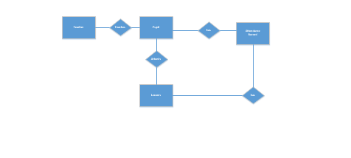

**Logical design**

1. **Derive relations for the logical data model**

Teachers

|  |  |  |  |  |
| --- | --- | --- | --- | --- |
| StaffID | Forename | Surname | Subject |  |
| 1 | John | Doe | Mathematics | |
| 2 | Jane | Smith | English |  |
| 3 | Michael | Johnson | Science |  |
| 4 | Emily | Brown | History |  |
| 5 | David | Wilson | Physics |  |
| 6 | Sarah | Taylor | Art |  |
| 7 | Robert | Anderson | Music |  |
| 8 | Laura | Thomas | Geography | |
| 9 | Daniel | Clark | Computer Science | |
| 10 | Emma | Roberts | French |  |
|  |  |  |  |  |

**Pupils**

|  |  |  |  |  |  |  |
| --- | --- | --- | --- | --- | --- | --- |
| PupilID | Forename | Surname | DateOfBirth | NextOfKinTelephone | StartAcademicYear | EndAcademicYear |
| 1 | John | Doe | 5/12/2009 | 1.23E+09 | 2021 | 2023 |
| 2 | Jane | Smith | 8/27/2010 | 9.88E+09 | 2021 | 2023 |
| 3 | Michael | Johnson | 3/18/2011 | 5.55E+09 | 2021 | 2023 |
| 4 | Emily | Brown | 11/5/2012 | 7.78E+09 | 2021 | 2023 |
| 5 | Daniel | Wilson | 6/30/2010 | 4.45E+09 | 2021 | 2023 |
| 6 | Sophia | Taylor | 12/15/2009 | 2.22E+09 | 2018 | 2024 |
| 7 | Matthew | Anderson | 8/2/2011 | 6.67E+09 | 2021 | 2023 |
| 8 | Olivia | Thomas | 4/20/2013 | 1E+10 | 2018 | 2024 |
| 9 | Christopher | Martinez | 1/10/2012 | 1.11E+09 | 2021 | 2023 |
| 10 | Ava | Harris | 9/18/2010 | 5.55E+09 | 2021 | 2023 |
| 11 | Ethan | Jones | 7/19/2009 | 3.33E+09 | 2021 | 2023 |
| 12 | Mia | Miller | 4/6/2010 | 6.67E+09 | 2021 | 2023 |
| 13 | Alexander | Davis | 1/24/2011 | 2.22E+09 | 2021 | 2023 |
| 14 | Abigail | Wilson | 9/11/2009 | 5.56E+09 | 2021 | 2023 |
| 15 | William | Taylor | 5/30/2010 | 8.89E+09 | 2021 | 2023 |
| 16 | Samantha | Anderson | 2/17/2011 | 2.22E+09 | 2021 | 2023 |
| 17 | James | Thomas | 10/5/2009 | 5.56E+09 | 2021 | 2023 |
| 18 | Lily | Martinez | 6/22/2010 | 8.89E+09 | 2018 | 2024 |
| 19 | Benjamin | Brown | 3/12/2011 | 2.22E+09 | 2018 | 2024 |
| 20 | Avery | Johnson | 11/29/2009 | 5.56E+09 | 2021 | 2023 |
| 21 | Oliver | Lee | 12/16/2009 | 1.11E+09 | 2021 | 2023 |
| 22 | Emily | Gonzalez | 8/2/2010 | 4.45E+09 | 2021 | 2023 |
| 23 | Daniel | Clark | 5/21/2011 | 1E+10 | 2021 | 2023 |
| 24 | Madison | Walker | 1/7/2009 | 3.33E+09 | 2018 | 2024 |
| 25 | Aiden | Hall | 9/25/2010 | 6.67E+09 | 2021 | 2023 |
| 26 | Scarlett | Lopez | 7/13/2011 | 2.22E+09 | 2021 | 2023 |
| 27 | Matthew | Green | 2/28/2009 | 5.56E+09 | 2021 | 2023 |
| 28 | Chloe | Adams | 10/16/2010 | 8.89E+09 | 2021 | 2023 |
| 29 | Lucas | Harris | 8/4/2011 | 2.22E+09 | 2018 | 2024 |
| 30 | Aubrey | King | 4/21/2009 | 5.56E+09 | 2018 | 2024 |

**Lessons**

|  |  |  |  |  |  |  |  |
| --- | --- | --- | --- | --- | --- | --- | --- |
| LessonID | LessonDate | LessonTime | StaffID | PupilID | AttendanceStatus | |  |
| 31 | 1/1/2023 | Morning | 1 | 1 | Present |  |  |
| 32 | 1/1/2023 | Morning | 2 | 2 | Present |  |  |
| 33 | 1/1/2023 | Morning | 3 | 3 | Authorised Absence | | |
| 34 | 1/1/2023 | Morning | 4 | 4 | Present |  |  |
| 35 | 1/1/2023 | Morning | 5 | 5 | Unauthorised Absence | | |
| 36 | 1/2/2023 | Afternoon | 6 | 1 | Present |  |  |
| 37 | 1/2/2023 | Afternoon | 7 | 2 | Authorised Absence | | |
| 38 | 1/2/2023 | Afternoon | 8 | 3 | Present |  |  |
| 39 | 1/2/2023 | Afternoon | 9 | 4 | Present |  |  |
| 40 | 1/2/2023 | Afternoon | 10 | 5 | Unauthorised Absence | | |
| 41 | 2/3/2023 | Morning | 1 | 11 | Present |  |  |
| 42 | 1/4/2023 | Morning | 2 | 12 | Unauthorised Absence | | |
| 43 | 4/3/2023 | Morning | 3 | 13 | Present |  |  |
| 44 | 7/1/2023 | Morning | 4 | 14 | Present |  |  |
| 45 | 4/1/2023 | Morning | 5 | 15 | Present |  |  |
| 46 | 6/1/2023 | Morning | 6 | 16 | Authorised Absence | | |
| 47 | 5/1/2023 | Morning | 7 | 17 | Present |  |  |
| 48 | 3/8/2023 | Morning | 8 | 18 | Unauthorised Absence | | |
| 49 | 2/2/2023 | Afternoon | 9 | 19 | Present |  |  |
| 50 | 1/8/2023 | Afternoon | 10 | 20 | Authorised Absence | | |
| 51 | 2/1/2023 | Morning | 1 | 21 | Present |  |  |
| 52 | 3/1/2023 | Morning | 2 | 22 | Present |  |  |
| 53 | 4/9/2023 | Morning | 3 | 23 | Authorised Absence | | |
| 54 | 5/1/2023 | Morning | 4 | 24 | Present |  |  |
| 55 | 6/7/2023 | Morning | 5 | 25 | Unauthorised Absence | | |
| 56 | 7/4/2023 | Afternoon | 6 | 26 | Present |  |  |
| 57 | 8/7/2023 | Afternoon | 7 | 27 | Authorised Absence | | |
| 58 | 6/5/2023 | Morning | 8 | 28 | Present |  |  |
| 59 | 5/6/2023 | Morning | 9 | 29 | Present |  |  |
| 60 | 1/17/2023 | Morning | 10 | 30 | Authorised Absence | | |

**AttendanceRecord**

|  |  |  |  |  |  |
| --- | --- | --- | --- | --- | --- |
| AttendanceID | LessonID | PupilID | AttendanceStatus | |  |
| 1 | 31 | 1 | Present |  |  |
| 2 | 32 | 2 | Authorised Absence | | |
| 3 | 33 | 3 | Unauthorised Absence | | |
| 4 | 34 | 4 | Present |  |  |
| 5 | 35 | 5 | Present |  |  |
| 6 | 36 | 6 | Authorised Absence | | |
| 7 | 37 | 7 | Unauthorised Absence | | |
| 8 | 38 | 8 | Present |  |  |
| 9 | 39 | 9 | Present |  |  |
| 10 | 40 | 10 | Authorised Absence | | |
| 11 | 41 | 11 | Unauthorised Absence | | |
| 12 | 42 | 12 | Present |  |  |
| 13 | 43 | 13 | Present |  |  |
| 14 | 44 | 14 | Authorised Absence | | |
| 15 | 45 | 16 | Unauthorised Absence | | |
| 17 | 47 | 17 | Present |  |  |
| 18 | 48 | 18 | Present |  |  |
| 19 | 49 | 19 | Authorised Absence | | |
| 20 | 50 | 20 | Unauthorised Absence | | |
| 21 | 51 | 21 | Present |  |  |
| 22 | 52 | 22 | Present |  |  |
| 23 | 53 | 23 | Authorised Absence | | |
| 24 | 54 | 24 | Unauthorised Absence | | |
| 25 | 55 | 25 | Present |  |  |
| 26 | 56 | 26 | Present |  |  |
| 27 | 57 | 27 | Present |  |  |
| 28 | 58 | 28 | Authorised Absence | | |
| 29 | 59 | 29 | Unauthorised Absence | | |
| 30 | 60 | 30 | Present |  |  |

1. **Validate relations using normalization**

There is no data redundancy, partial dependency and no transitive redundancy in the relations of the attendance register database.

These relations are in 3NF(third nor mal form)

1. **Validate relations against user transactions**
2. **Get the names of all pupils who are registered for the current academic year ordered by surname then forename**

SELECT Forename

FROM pupils

WHERE StartAcademicYear = 2021

ORDER BY Forename, surname;

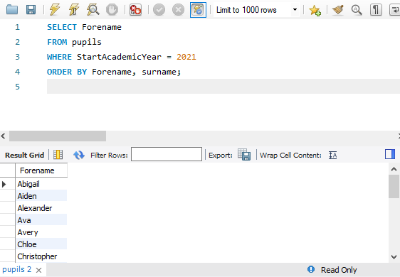

1. **Get the names of all pupils who are present in class for a specific lesson ordered by surname then forename**

SELECT Forename

FROM pupils

JOIN attendancerecord ON Pupils.pupilID = attendancerecord.pupilID

JOIN Lessons ON attendancerecord.lessonID = Lessons.lessonID

WHERE Lessons.lessonDate = '2023-01-01'

AND Lessons.lessonTime = 'Morning'

AND attendancerecord.AttendanceStatus = 'present'

ORDER BY Pupils.Surname, Pupils.Forename;

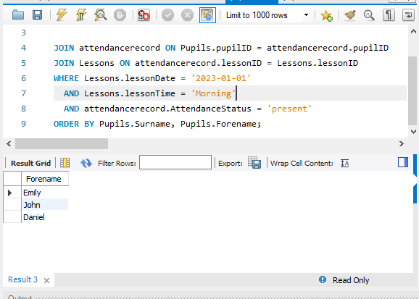

1. **Get the number of unauthorised absences for a specific pupil in an academic year**

SELECT COUNT(*) AS UnauthorisedAbsence

FROM attendancerecord

JOIN Pupils ON attendancerecord.pupilId = Pupils.pupilID

JOIN Lessons ON attendancerecord.LessonID = Lessons.lessonID

WHERE Pupils.Forename = 'Mathew'

AND Lessons.lessonDate BETWEEN '2021' AND '2023'

AND Attendancerecord.AttendanceStatus = 'Unauthorised Absence';

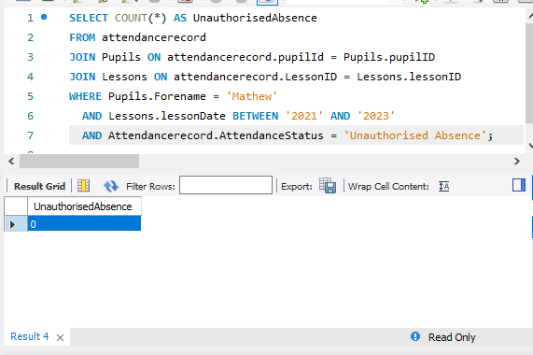

SELECT COUNT(*) AS UnauthorisedAbsences

FROM attendancerecord

JOIN Pupils ON attendancerecord.pupilID = Pupils.pupilID

JOIN Lessons ON attendancerecord.LessonID = Lessons.LessonID

WHERE Pupils.PupilID = '4'

AND Lessons.lessonDate BETWEEN '2021' AND '2023'

AND attendancerecord.AttendanceStatus = 'Unauthorised Absence';

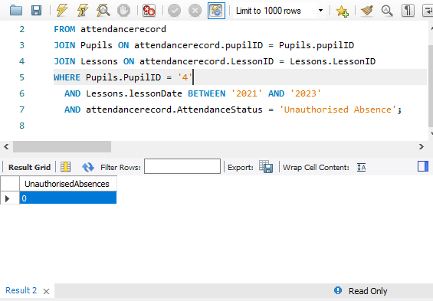

1. **get all the present students with pupilID and lessonId**

SELECT attendancerecord.lessonID, attendancerecord.pupilID, attendancerecord.AttendanceStatus

FROM attendancerecord

WHERE attendancerecord.AttendanceStatus = 'present';

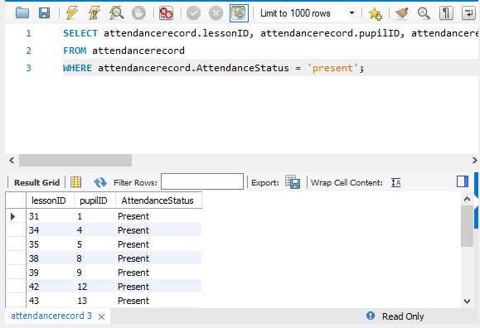

1. **List of teachers and what subject they taught ordered by the teacher’s surname then forename**

SELECT teachers.Surname, teachers.Forename, teachers.subject

FROM teachers

JOIN Lessons ON Teachers.StaffID = Lessons.StaffID

ORDER BY Teachers.surname, Teachers.forename;

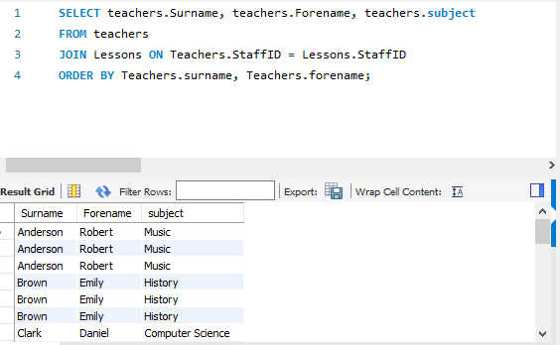

1. **Check integrity constraints**
2. **Foreign key Constraint**

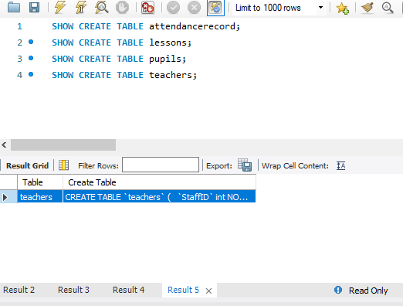

1. **Primary key Constraint**

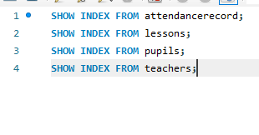

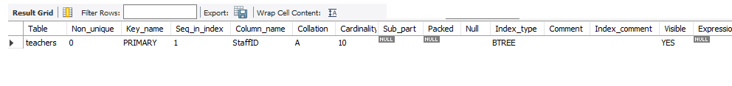

1. **Referential key Constraint**

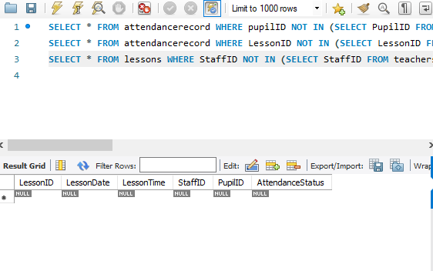

**Produce the following**:

1. **List of relations**

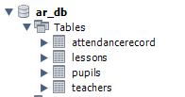

**Attributes and keys**

**Teachers:**



StaffID is a primary key.

**Pupils:**



PupilID is a primary key.

**Lessons:**



LessonID is a primary key.

**AttendanceRecord:**



AttendanceID is a primary key.

**Referential integrity constraints**

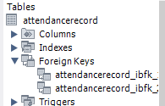

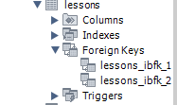

**2) A relation diagram**

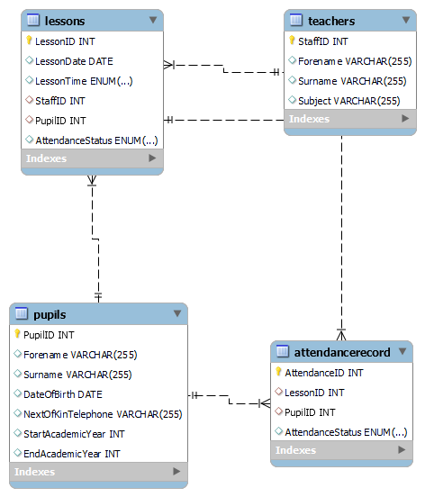

1. **Updated Data Dictionary:**

**Teachers:**

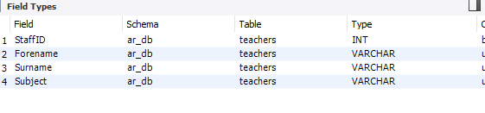

**Pupils:**

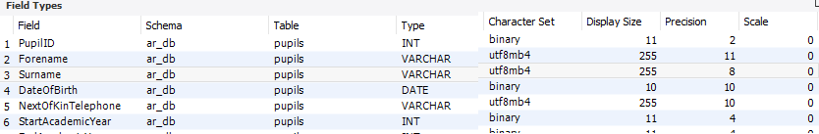

**Lessons:**

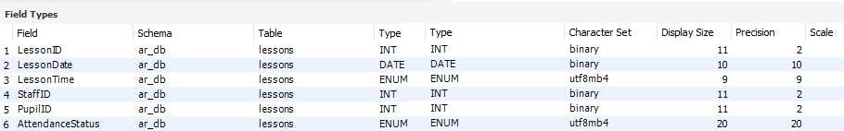

**AttendanceRecord:**

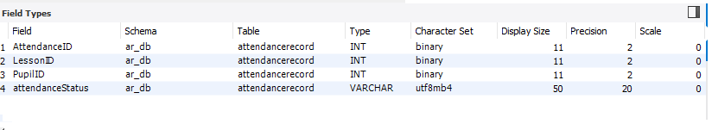

**Physical design and implementation**

1. **Translate your logical design in to a model for MySQL**

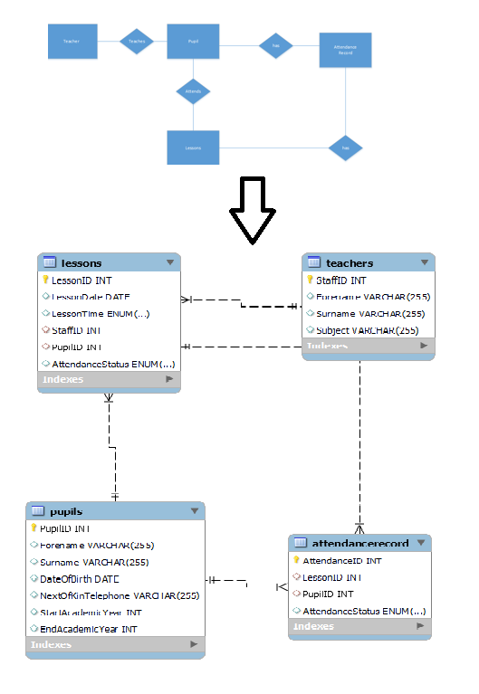

1. **Design file organisation and indexes**

These are clustered and non-clustered indexes of the tables.

**Teachers:**

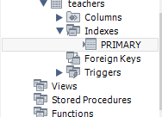

**Pupils:**

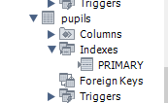

**Lessons:**

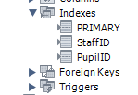

**AttendanceRecord:**

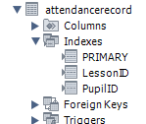

**3) Take your physical design and implement it in MySQL Produce the following:**

1) An SQL script that will create the tables and SQL script to insert some sample data

-- MySQL dump 10.13 Distrib 8.0.33, for Win64 (x86_64)

--

-- Host: localhost Database: ar_db

-- ------------------------------------------------------

-- Server version 8.0.33

/*!40101 SET @OLD_CHARACTER_SET_CLIENT=@@CHARACTER_SET_CLIENT */;

/*!40101 SET @OLD_CHARACTER_SET_RESULTS=@@CHARACTER_SET_RESULTS */;

/*!40101 SET @OLD_COLLATION_CONNECTION=@@COLLATION_CONNECTION */;

/*!50503 SET NAMES utf8 */;

/*!40103 SET @OLD_TIME_ZONE=@@TIME_ZONE */;

/*!40103 SET TIME_ZONE='+00:00' */;

/*!40014 SET @OLD_UNIQUE_CHECKS=@@UNIQUE_CHECKS, UNIQUE_CHECKS=0 */;

/*!40014 SET @OLD_FOREIGN_KEY_CHECKS=@@FOREIGN_KEY_CHECKS, FOREIGN_KEY_CHECKS=0 */;

/*!40101 SET @OLD_SQL_MODE=@@SQL_MODE, SQL_MODE='NO_AUTO_VALUE_ON_ZERO' */;

/*!40111 SET @OLD_SQL_NOTES=@@SQL_NOTES, SQL_NOTES=0 */;

--

-- Table structure for table `attendancerecord`

--

DROP TABLE IF EXISTS `attendancerecord`;

/*!40101 SET @saved_cs_client = @@character_set_client */;

/*!50503 SET character_set_client = utf8mb4 */;

CREATE TABLE `attendancerecord` (

`AttendanceID` int NOT NULL AUTO_INCREMENT,

`LessonID` int DEFAULT NULL,

`PupilID` int DEFAULT NULL,

`attendanceStatus` varchar(50) DEFAULT NULL,

PRIMARY KEY (`AttendanceID`),

KEY `LessonID` (`LessonID`),

KEY `PupilID` (`PupilID`),

CONSTRAINT `attendancerecord_ibfk_1` FOREIGN KEY (`LessonID`) REFERENCES `lessons` (`LessonID`),

CONSTRAINT `attendancerecord_ibfk_2` FOREIGN KEY (`PupilID`) REFERENCES `pupils` (`PupilID`)

) ENGINE=InnoDB AUTO_INCREMENT=31 DEFAULT CHARSET=utf8mb4 COLLATE=utf8mb4_0900_ai_ci;

/*!40101 SET character_set_client = @saved_cs_client */;

--

-- Dumping data for table `attendancerecord`

--

LOCK TABLES `attendancerecord` WRITE;

/*!40000 ALTER TABLE `attendancerecord` DISABLE KEYS */;

INSERT INTO `attendancerecord` VALUES (1,31,1,'Present'),(2,32,2,'Authorised Absence'),(3,33,3,'Unauthorised Absence'),(4,34,4,'Present'),(5,35,5,'Present'),(6,36,6,'Authorised Absence'),(7,37,7,'Unauthorised Absence'),(8,38,8,'Present'),(9,39,9,'Present'),(10,40,10,'Authorised Absence'),(11,41,11,'Unauthorised Absence'),(12,42,12,'Present'),(13,43,13,'Present'),(14,44,14,'Authorised Absence'),(15,45,16,'Unauthorised Absence'),(17,47,17,'Present'),(18,48,18,'Present'),(19,49,19,'Authorised Absence'),(20,50,20,'Unauthorised Absence'),(21,51,21,'Present'),(22,52,22,'Present'),(23,53,23,'Authorised Absence'),(24,54,24,'Unauthorised Absence'),(25,55,25,'Present'),(26,56,26,'Present'),(27,57,27,'Present'),(28,58,28,'Authorised Absence'),(29,59,29,'Unauthorised Absence'),(30,60,30,'Present');

/*!40000 ALTER TABLE `attendancerecord` ENABLE KEYS */;

UNLOCK TABLES;

--

-- Table structure for table `lessons`

--

DROP TABLE IF EXISTS `lessons`;

/*!40101 SET @saved_cs_client = @@character_set_client */;

/*!50503 SET character_set_client = utf8mb4 */;

CREATE TABLE `lessons` (

`LessonID` int NOT NULL AUTO_INCREMENT,

`LessonDate` date DEFAULT NULL,

`LessonTime` enum('Morning','Afternoon') DEFAULT NULL,

`StaffID` int DEFAULT NULL,

`PupilID` int DEFAULT NULL,

`AttendanceStatus` enum('Present','Authorised Absence','Unauthorised Absence') DEFAULT NULL,

PRIMARY KEY (`LessonID`),

KEY `StaffID` (`StaffID`),

KEY `PupilID` (`PupilID`),

CONSTRAINT `lessons_ibfk_1` FOREIGN KEY (`StaffID`) REFERENCES `teachers` (`StaffID`),

CONSTRAINT `lessons_ibfk_2` FOREIGN KEY (`PupilID`) REFERENCES `pupils` (`PupilID`)

) ENGINE=InnoDB AUTO_INCREMENT=61 DEFAULT CHARSET=utf8mb4 COLLATE=utf8mb4_0900_ai_ci;

/*!40101 SET character_set_client = @saved_cs_client */;

--

-- Dumping data for table `lessons`

--

LOCK TABLES `lessons` WRITE;

/*!40000 ALTER TABLE `lessons` DISABLE KEYS */;

INSERT INTO `lessons` VALUES (31,'2023-01-01','Morning',1,1,'Present'),(32,'2023-01-01','Morning',2,2,'Present'),(33,'2023-01-01','Morning',3,3,'Authorised Absence'),(34,'2023-01-01','Morning',4,4,'Present'),(35,'2023-01-01','Morning',5,5,'Unauthorised Absence'),(36,'2023-01-02','Afternoon',6,1,'Present'),(37,'2023-01-02','Afternoon',7,2,'Authorised Absence'),(38,'2023-01-02','Afternoon',8,3,'Present'),(39,'2023-01-02','Afternoon',9,4,'Present'),(40,'2023-01-02','Afternoon',10,5,'Unauthorised Absence'),(41,'2023-02-03','Morning',1,11,'Present'),(42,'2023-01-04','Morning',2,12,'Unauthorised Absence'),(43,'2023-04-03','Morning',3,13,'Present'),(44,'2023-07-01','Morning',4,14,'Present'),(45,'2023-04-01','Morning',5,15,'Present'),(46,'2023-06-01','Morning',6,16,'Authorised Absence'),(47,'2023-05-01','Morning',7,17,'Present'),(48,'2023-03-08','Morning',8,18,'Unauthorised Absence'),(49,'2023-02-02','Afternoon',9,19,'Present'),(50,'2023-01-08','Afternoon',10,20,'Authorised Absence'),(51,'2023-02-01','Morning',1,21,'Present'),(52,'2023-03-01','Morning',2,22,'Present'),(53,'2023-04-09','Morning',3,23,'Authorised Absence'),(54,'2023-05-01','Morning',4,24,'Present'),(55,'2023-06-07','Morning',5,25,'Unauthorised Absence'),(56,'2023-07-04','Afternoon',6,26,'Present'),(57,'2023-08-07','Afternoon',7,27,'Authorised Absence'),(58,'2023-06-05','Morning',8,28,'Present'),(59,'2023-05-06','Morning',9,29,'Present'),(60,'2023-01-17','Morning',10,30,'Authorised Absence');

/*!40000 ALTER TABLE `lessons` ENABLE KEYS */;

UNLOCK TABLES;

--

-- Table structure for table `pupils`

--

DROP TABLE IF EXISTS `pupils`;

/*!40101 SET @saved_cs_client = @@character_set_client */;

/*!50503 SET character_set_client = utf8mb4 */;

CREATE TABLE `pupils` (

`PupilID` int NOT NULL AUTO_INCREMENT,

`Forename` varchar(255) DEFAULT NULL,

`Surname` varchar(255) DEFAULT NULL,

`DateOfBirth` date DEFAULT NULL,

`NextOfKinTelephone` varchar(255) DEFAULT NULL,

`StartAcademicYear` int DEFAULT NULL,

`EndAcademicYear` int DEFAULT NULL,

PRIMARY KEY (`PupilID`)

) ENGINE=InnoDB AUTO_INCREMENT=31 DEFAULT CHARSET=utf8mb4 COLLATE=utf8mb4_0900_ai_ci;

/*!40101 SET character_set_client = @saved_cs_client */;

--

-- Dumping data for table `pupils`

--

LOCK TABLES `pupils` WRITE;

/*!40000 ALTER TABLE `pupils` DISABLE KEYS */;

INSERT INTO `pupils` VALUES (1,'John','Doe','2009-05-12','1234567890',2021,2023),(2,'Jane','Smith','2010-08-27','9876543210',2021,2023),(3,'Michael','Johnson','2011-03-18','5551234567',2021,2023),(4,'Emily','Brown','2012-11-05','7779876543',2021,2023),(5,'Daniel','Wilson','2010-06-30','4448889999',2021,2023),(6,'Sophia','Taylor','2009-12-15','2223334444',2018,2024),(7,'Matthew','Anderson','2011-08-02','6665554444',2021,2023),(8,'Olivia','Thomas','2013-04-20','9998887777',2018,2024),(9,'Christopher','Martinez','2012-01-10','1112223333',2021,2023),(10,'Ava','Harris','2010-09-18','5554443333',2021,2023),(11,'Ethan','Jones','2009-07-19','3334445555',2021,2023),(12,'Mia','Miller','2010-04-06','6667778888',2021,2023),(13,'Alexander','Davis','2011-01-24','2223334444',2021,2023),(14,'Abigail','Wilson','2009-09-11','5556667777',2021,2023),(15,'William','Taylor','2010-05-30','8889990000',2021,2023),(16,'Samantha','Anderson','2011-02-17','2223334444',2021,2023),(17,'James','Thomas','2009-10-05','5556667777',2021,2023),(18,'Lily','Martinez','2010-06-22','8889990000',2018,2024),(19,'Benjamin','Brown','2011-03-12','2223334444',2018,2024),(20,'Avery','Johnson','2009-11-29','5556667777',2021,2023),(21,'Oliver','Lee','2009-12-16','1112223333',2021,2023),(22,'Emily','Gonzalez','2010-08-02','4445556666',2021,2023),(23,'Daniel','Clark','2011-05-21','9998887777',2021,2023),(24,'Madison','Walker','2009-01-07','3334445555',2018,2024),(25,'Aiden','Hall','2010-09-25','6667778888',2021,2023),(26,'Scarlett','Lopez','2011-07-13','2223334444',2021,2023),(27,'Matthew','Green','2009-02-28','5556667777',2021,2023),(28,'Chloe','Adams','2010-10-16','8889990000',2021,2023),(29,'Lucas','Harris','2011-08-04','2223334444',2018,2024),(30,'Aubrey','King','2009-04-21','5556667777',2018,2024);

/*!40000 ALTER TABLE `pupils` ENABLE KEYS */;

UNLOCK TABLES;

--

-- Table structure for table `teachers`

--

DROP TABLE IF EXISTS `teachers`;

/*!40101 SET @saved_cs_client = @@character_set_client */;

/*!50503 SET character_set_client = utf8mb4 */;

CREATE TABLE `teachers` (

`StaffID` int NOT NULL AUTO_INCREMENT,

`Forename` varchar(255) DEFAULT NULL,

`Surname` varchar(255) DEFAULT NULL,

`Subject` varchar(255) DEFAULT NULL,

PRIMARY KEY (`StaffID`)

) ENGINE=InnoDB AUTO_INCREMENT=11 DEFAULT CHARSET=utf8mb4 COLLATE=utf8mb4_0900_ai_ci;

/*!40101 SET character_set_client = @saved_cs_client */;

--

-- Dumping data for table `teachers`

--

LOCK TABLES `teachers` WRITE;

/*!40000 ALTER TABLE `teachers` DISABLE KEYS */;

INSERT INTO `teachers` VALUES (1,'John','Doe','Mathematics'),(2,'Jane','Smith','English'),(3,'Michael','Johnson','Science'),(4,'Emily','Brown','History'),(5,'David','Wilson','Physics'),(6,'Sarah','Taylor','Art'),(7,'Robert','Anderson','Music'),(8,'Laura','Thomas','Geography'),(9,'Daniel','Clark','Computer Science'),(10,'Emma','Roberts','French');

/*!40000 ALTER TABLE `teachers` ENABLE KEYS */;

UNLOCK TABLES;

/*!40103 SET TIME_ZONE=@OLD_TIME_ZONE */;

/*!40101 SET SQL_MODE=@OLD_SQL_MODE */;

/*!40014 SET FOREIGN_KEY_CHECKS=@OLD_FOREIGN_KEY_CHECKS */;

/*!40014 SET UNIQUE_CHECKS=@OLD_UNIQUE_CHECKS */;

/*!40101 SET CHARACTER_SET_CLIENT=@OLD_CHARACTER_SET_CLIENT */;

/*!40101 SET CHARACTER_SET_RESULTS=@OLD_CHARACTER_SET_RESULTS */;

/*!40101 SET COLLATION_CONNECTION=@OLD_COLLATION_CONNECTION */;

/*!40111 SET SQL_NOTES=@OLD_SQL_NOTES */;

-- Dump completed on 2023-06-03 20:47:16

1. **SQLs to execute all of the example queries in the data requirement**

a.

SELECT Forename

FROM pupils

WHERE StartAcademicYear = 2021

ORDER BY Forename, surname;

b.

SELECT Forename

FROM pupils

JOIN attendancerecord ON Pupils.pupilID = attendancerecord.pupilID

JOIN Lessons ON attendancerecord.lessonID = Lessons.lessonID

WHERE Lessons.lessonDate = '2023-01-01'

AND Lessons.lessonTime = 'Morning'

AND attendancerecord.AttendanceStatus = 'present'

ORDER BY Pupils.Surname, Pupils.Forename;

c.

SELECT COUNT(*) AS UnauthorisedAbsence

FROM attendancerecord

JOIN Pupils ON attendancerecord.pupilId = Pupils.pupilID

JOIN Lessons ON attendancerecord.LessonID = Lessons.lessonID

WHERE Pupils.Forename = 'Mathew'

AND Lessons.lessonDate BETWEEN '2021' AND '2023'

AND Attendancerecord.AttendanceStatus = 'Unauthorised Absence';

d.

SELECT COUNT(*) AS UnauthorisedAbsences

FROM attendancerecord

JOIN Pupils ON attendancerecord.pupilID = Pupils.pupilID

JOIN Lessons ON attendancerecord.LessonID = Lessons.LessonID

WHERE Pupils.PupilID = '4'

AND Lessons.lessonDate BETWEEN '2021' AND '2023'

AND attendancerecord.AttendanceStatus = 'Unauthorised Absence';

e.

SELECT attendancerecord.lessonID, attendancerecord.pupilID, attendancerecord.AttendanceStatus

FROM attendancerecord

WHERE attendancerecord.AttendanceStatus = 'present';

SELECT teachers.Surname, teachers.Forename, teachers.subject

FROM teachers

JOIN Lessons ON Teachers.StaffID = Lessons.StaffID

ORDER BY Teachers.surname, Teachers.forename;