Travel Portal

Part A
Question No.1
Entity Relationship Diagram (ERD) of Travel Portal:
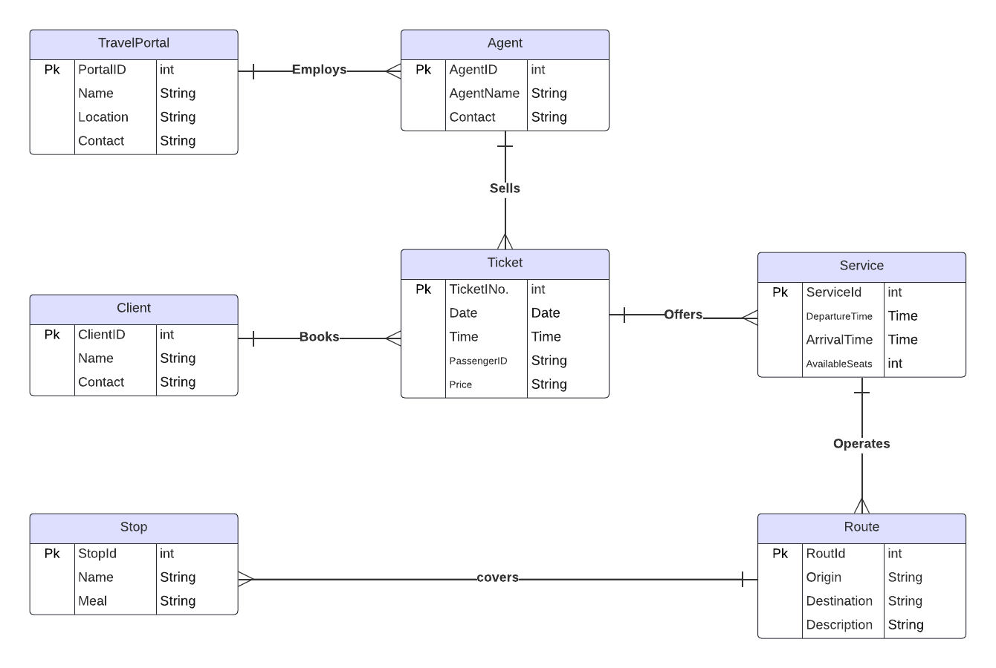

Question No.2
ER Diagram to Relations Mapping to obtained normalized relations

- Travel Portal employs the Agent (1 to many relationship)
Mapping:
TravelPortal
AgentId | PortalId | Name | Location | Contact

Agent
AgentID | AgentName | Contact

- Agent sells Ticket (1 to many relationship)
Mapping:
Agent
TicketINo. | AgentID | AgentName | Contact

Ticket
TicketINo. | Date | Time | PassengerID | Price

- Client books tickets (1 to many relationship)
Mapping:
Client
TicketINo. | ClientId | Name | Contact

Ticket
TicketINo. | Date | Time | PassengerID | Price

- Ticket offers service (1 to many relationship)
Mapping:

Ticket
ServiceId | TicketINo. | Date | Time | PassengerID | Price

Service
ServiceId | DepartureTime | ArrivalTime | AvailableSeats

- Service operates route (1 to many relationship)
Mapping:

Service
RouteId | ServiceId | DepartureTime | ArrivalTime | AvailableSeats

Route
RouteId | Origin | Destination | Description

- Route covers stop (1 to many relationship)
Mapping:

Route
StopId | RouteId | Origin | Destination | Description

Stop
StopId | Name | Meals

Third Normal Form (3NF):

All these relations are in 3NF, which means they met following criteria:

- 1NF: Each relation contains only one atomic domain per column.
- 2NF: There are no functional dependencies.
- 3NF: There are no transitive dependencies.

Question No.3
Data Dictionary

Table Name | Column Name | Data Types | Description
TravelPortal | PortalId | int | The unique identifier for the travel portal.
TravelPortal | Name | String | The name of the travel portal.
TravelPortal | Location | String | The location of the travel portal.
TravelPortal | Contact | String | The contact information for the travel portal.
Agent | AgentID | int | The unique identifier for the agent.
Agent | AgentName | String | The name of the agent.
Client | ClientId | int | The unique identifier for the client.
Client | Name | String | The name of the client.
Client | Contact | String | The contact information for the client.
Ticket | TicketID | Int | The unique identifier for the ticket.
Ticket | TDate | Date | The date of the ticket.
Ticket | TTime | Time | The time of the ticket.
Ticket | Price | String | The price of the ticket.
Service | ServiceId | int | The unique identifier for the service.
Service | DepartureTime | Time | The departure time of the service.
Service | ArrivalTime | Time | The arrival time of the service.
Service | AvailableSeats | String | The number of available seats on the service.
Route | RouteId | int | The unique identifier for the route.
Route | Origin | String | Starting point of route
Route | Destination | String | Ending point of route
Route | Description | String | The description of the route.
Stop | StopId | int | The unique identifier for the stop.
Stop | Name | String | The name of the stop.
Stop | Meal | String | The meals that are served at the stop.
Part 1B
-- Create the Route table with origin and destination
CREATE TABLE Route (
RouteID NUMBER PRIMARY KEY,
Origin VARCHAR2(100) NOT NULL,
Destination VARCHAR2(100) NOT NULL,
Description VARCHAR2(255)
);

-- Create the Agent table
CREATE TABLE Agent (
AgentID NUMBER PRIMARY KEY,
AgentName VARCHAR2(50) NOT NULL,
Contact VARCHAR2(50) NOT NULL UNIQUE
);

-- Create the Client table
CREATE TABLE Client (
ClientID NUMBER PRIMARY KEY,
Name VARCHAR2(50),
Contact VARCHAR2(50)
);

-- Create the Service table
CREATE TABLE Service (
ServiceID NUMBER PRIMARY KEY,
DepartureTime TIMESTAMP NOT NULL,
ArrivalTime TIMESTAMP NOT NULL,
AvailableSeats NUMBER CHECK (AvailableSeats >= 0),
RouteID NUMBER NOT NULL,
CONSTRAINT fk_service_route FOREIGN KEY (RouteID) REFERENCES Route(RouteID)
);

-- Create the Ticket table
CREATE TABLE Ticket (
TicketID NUMBER PRIMARY KEY,
TDate DATE NOT NULL,
TTime TIMESTAMP NOT NULL,
PassengerID NUMBER NOT NULL,
Price NUMBER CHECK (Price > 0),
ServiceID NUMBER NOT NULL,
CONSTRAINT fk_ticket_service FOREIGN KEY (ServiceID) REFERENCES Service(ServiceID),
CONSTRAINT fk_client_ticket FOREIGN KEY (PassengerID) REFERENCES Client(ClientID)
);

-- Create the TravelPortal table
CREATE TABLE TravelPortal (
PortalID NUMBER PRIMARY KEY,
Name VARCHAR2(50),
Location VARCHAR2(50),
Contact VARCHAR2(50),
AgentID NUMBER,
CONSTRAINT fk_travelportal_agent FOREIGN KEY (AgentID) REFERENCES Agent(AgentID)
);

-- Create the Stop table
CREATE TABLE Stop (
StopID NUMBER PRIMARY KEY,
StopName VARCHAR2(100) NOT NULL,
RouteID NUMBER NOT NULL,
Meal VARCHAR2(100),
CONSTRAINT fk_stop_route FOREIGN KEY (RouteID) REFERENCES Route(RouteID)
);

