**Design document**

**Online shopping store**

**Authors: Amila Bahor, Fatima Velic, Ilma Zolota, Nina Mucibabic, Refija Numanovic**

**Group number: 3**

**Due date: April 16th, 2019.**

**1. Document Revision History**

Version 0 (Project Proposal - March 7th, 2019) – content: description, list of functions and user roles

Version 1 (Requirements Document – March 21st, 2019) – adding features to could have and would have categories, adding non- functional features, detailed description of roles and features, activity bar chart or Gantt chart.

Version 2 (Design Document – current version) – tasks overview, system design, additional specifications, Dynamic model, UI screenshots.

**2. Objectives**

The aim of the website is to be functional online shopping store.

Users of website will be able to create an account which will supply them with an easy to

use interface in order to purchase items. Users will also be able to navigate through available products by categories.

**3. System Decomposition/Design**

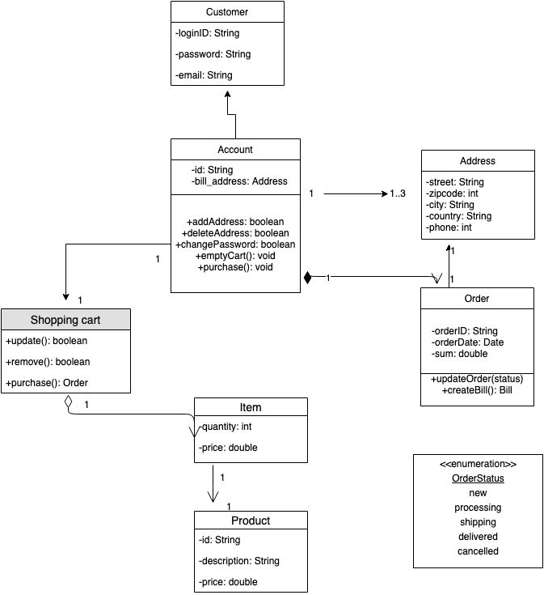

**4. Dynamic Model: Sequence diagram**

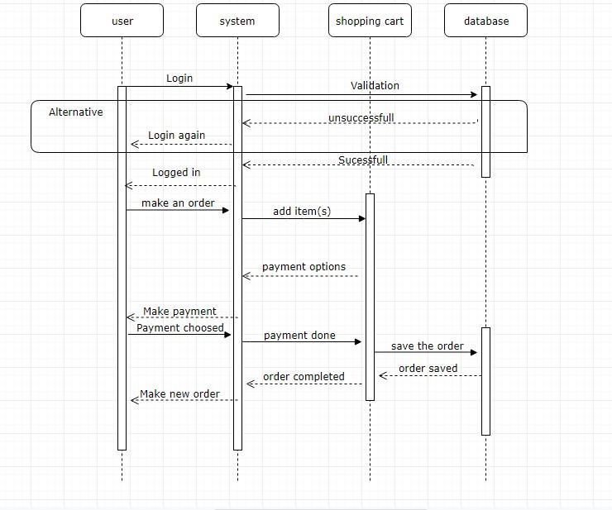

**5. User Interface**

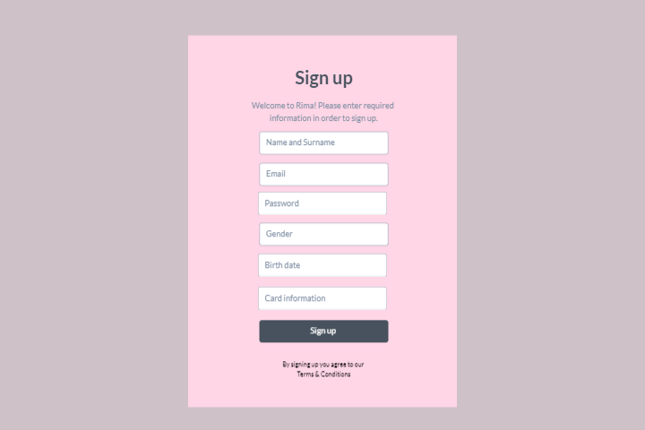

Illustration 1: Sign up page

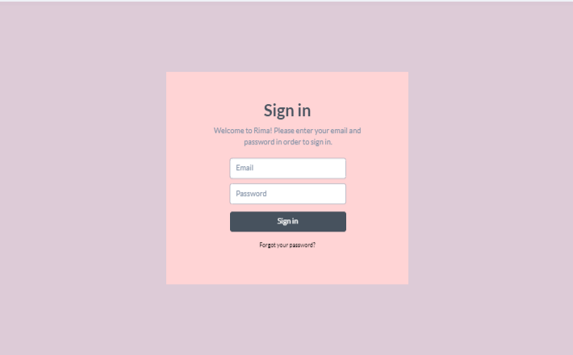

Illustration 2: Sign in page

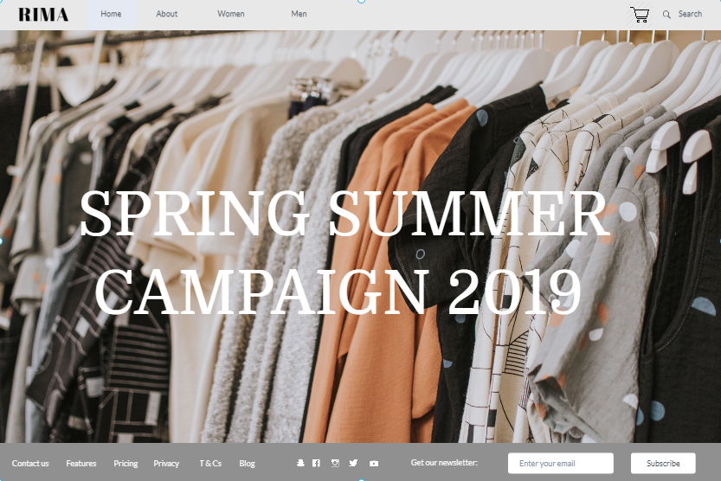

Illustration 3: Home page