VII. User manual: Description of menus, forms, screens’ snapshots...

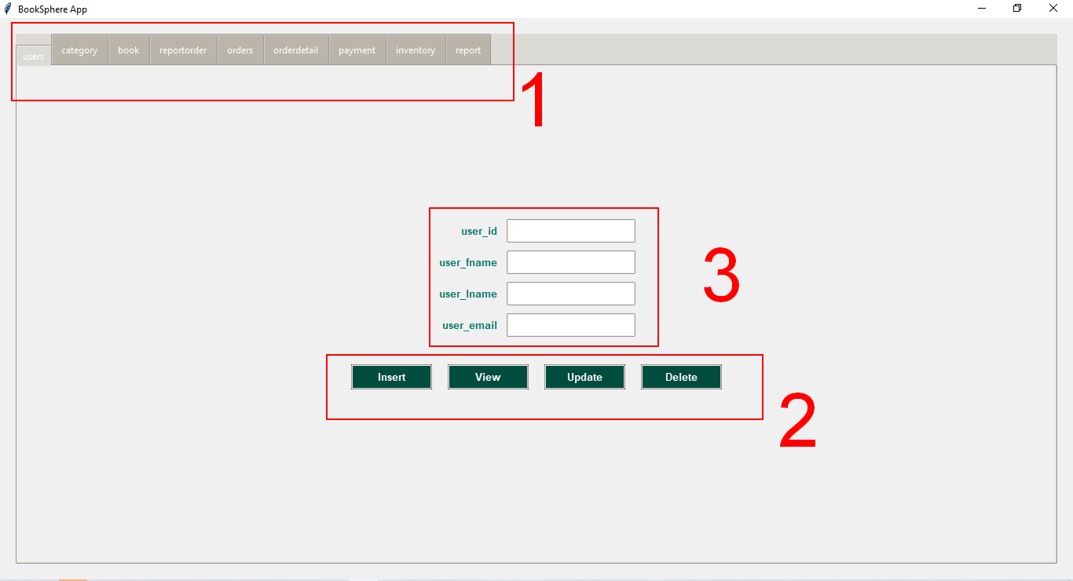

**1.MENU:**

The menu of the application consists of nine buttons that represent each table of our database. (User, Category, Book , Orders, OrderDetail, Payment, Inventory, Report, ReportOrder).

**2.ACTIONS:**

The four buttons (Insert,View,Update,Delete) represent the four actions that can be performed on each of our tables.

**3.ATTRIBUTE FIELDS:**

Represent the field of attributes of each table that we can fill up with data before performing any of the four actions.

**4.Tables :**

The table are represented as the following:

