Fatima Zahra Zhiri Oumaima Ouajjou
IoT-Based Simulated Smart Energy Monitoring System Using Photon Particle
School of Science and School of Science and
Engineering Engineering
Al Akhawayn University Al Akhawayn University
Ifrane ,Morocco Ifrane, Morocco
F.Zhiri@aui.ma O.Ouajjou@aui.ma

Abstract—This paper presents an IoT-based simulated smart energy monitoring system designed to replicate the behaviour of real-world appliances without physical hardware loads. The system is implemented using the Particle Photon microcontroller, Particle Cloud platform, and a responsive web dashboard. Key features include real-time appliance control, potentiometer-based temperature simulation, continuous power monitoring, overload warning via LED blinking, scheduling of device actions, live data visualization, cost estimation, and smart energy-saving tips generation. This project showcases the capabilities of IoT in energy management and demonstrates cloud-based embedded system integration.
Index Terms—Cloud computing, Embedded systems, IoT, Photon Particle, Smart energy monitoring.

INTRODUCTION
Energy consumption optimization is a critical focus in the modern world due to increasing environmental concerns, rising energy costs, and the growing demand for sustainable living. Traditional energy meters typically provide aggregated, delayed feedback, often limited to monthly billing cycles. Such delays hinder the ability of consumers and businesses to understand their consumption habits and make timely adjustments to improve efficiency.
With the advancement of the Internet of Things (IoT), new possibilities have emerged for dynamic, real-time energy monitoring and management. IoT allows seamless connectivity between sensors, devices, and cloud platforms, enabling users to access instant consumption data, receive alerts, and automate appliances based on usage patterns. These
capabilities lead to smarter decision-making, better resource utilization, and ultimately, a significant reduction in energy waste.
However, real-world implementation of IoT-based energy monitoring systems can be expensive, requiring the installation of smart meters, specialized hardware, and complex infrastructure. Prior research efforts, such as [1], [2], have explored related systems, but there remains a gap for affordable, simulated systems accessible for academic training and prototyping purposes.

Kenza Toreis
School of Science and
Engineering,
Al Akhawayn University
Ifrane, Morocco
K.Toreis@aui.ma

This project introduces a simulated smart energy monitoring system using a Particle Photon microcontroller, cloud APIs, and a web dashboard. It simulates high-energy-consuming appliances (heater, fridge, AC) without real loads, offering a practical, scalable educational platform.
Key technical contributions:

- Real-time appliance control and monitoring.
- Dynamic visualization of simulated power consumption.
- Automated overload detection and scheduling.
- Historical data export capability.

SYSTEM DESIGN AND ARCHITECTURE
The system architecture is structured into three primary layers: data acquisition, cloud communication, and user interaction.
At the hardware layer, the Particle Photon microcontroller monitors the simulated appliances, tracking their active status and estimating total power consumption. Two LEDs are utilized: the onboard Status LED (D7) lights up when any appliance is active, while the external Overload Warning LED (D3) flashes to indicate when the total simulated load exceeds a predefined threshold. Additionally, a potentiometer connected to analog pin A0 is used to simulate temperature input. Its manually adjustable voltage is interpreted as ambient temperature, which controls the automatic activation of the heater and AC based on defined thresholds.
The cloud communication layer leverages the Particle Cloud platform, where real-time data from the Photon is published through device variables and functions [3]. This ensures seamless synchronization between the microcontroller and the web-based dashboard, enabling remote control and instant status updates.
At the user interaction layer, a responsive dashboard built with HTML, CSS, and JavaScript allows users to monitor appliance states, visualize live energy consumption graphs, schedule device operations, receive overload alerts, and download historical usage logs. This interface bridges the hardware and cloud services, offering an intuitive and dynamic user experience accessible from any internet-connected device.

Fig. 1. System diagram showing communication between dashboard, cloud, microcontroller, and potentiometer.

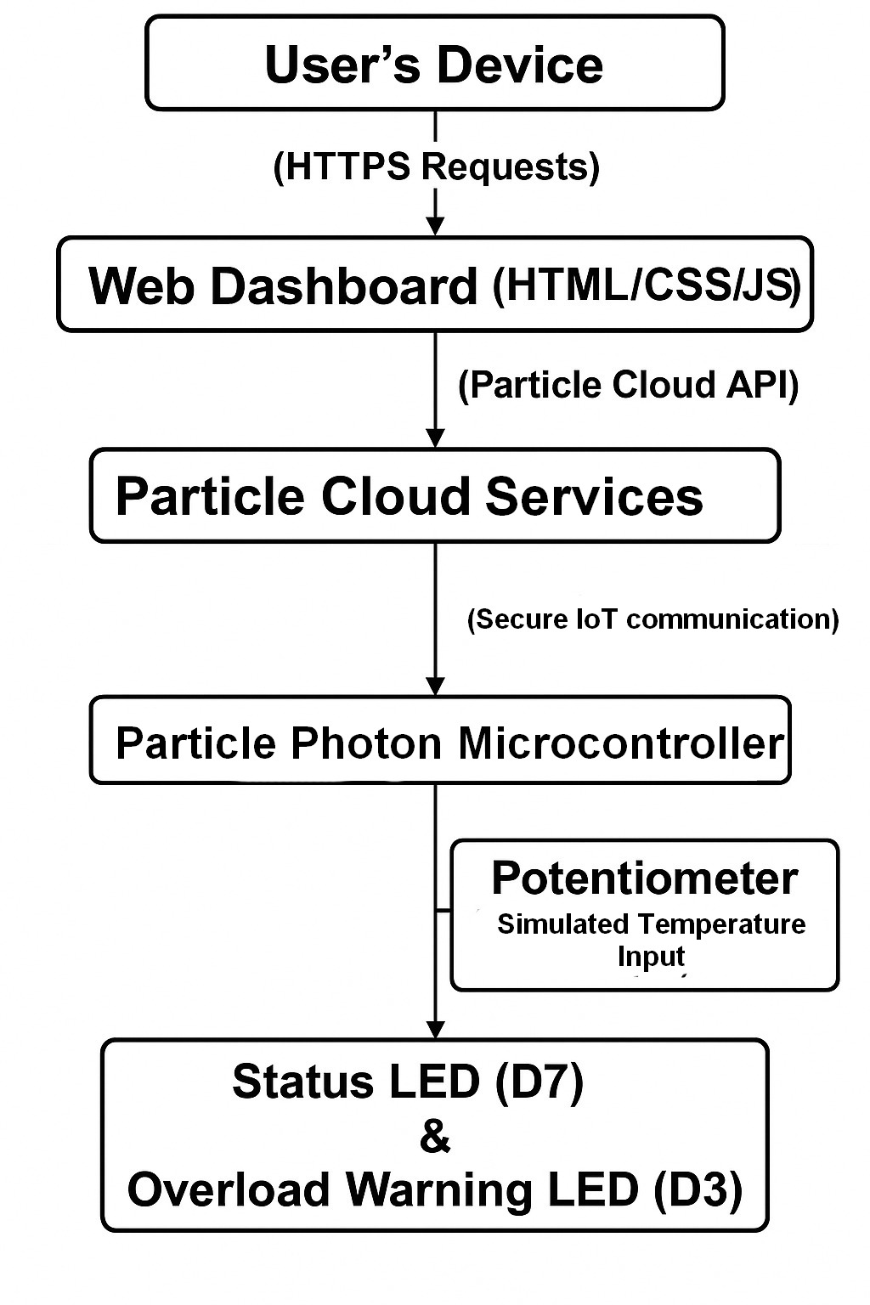

Fig. 2. Hardware setup using the Particle Photon microcontroller on a breadboard for simulated appliance control. 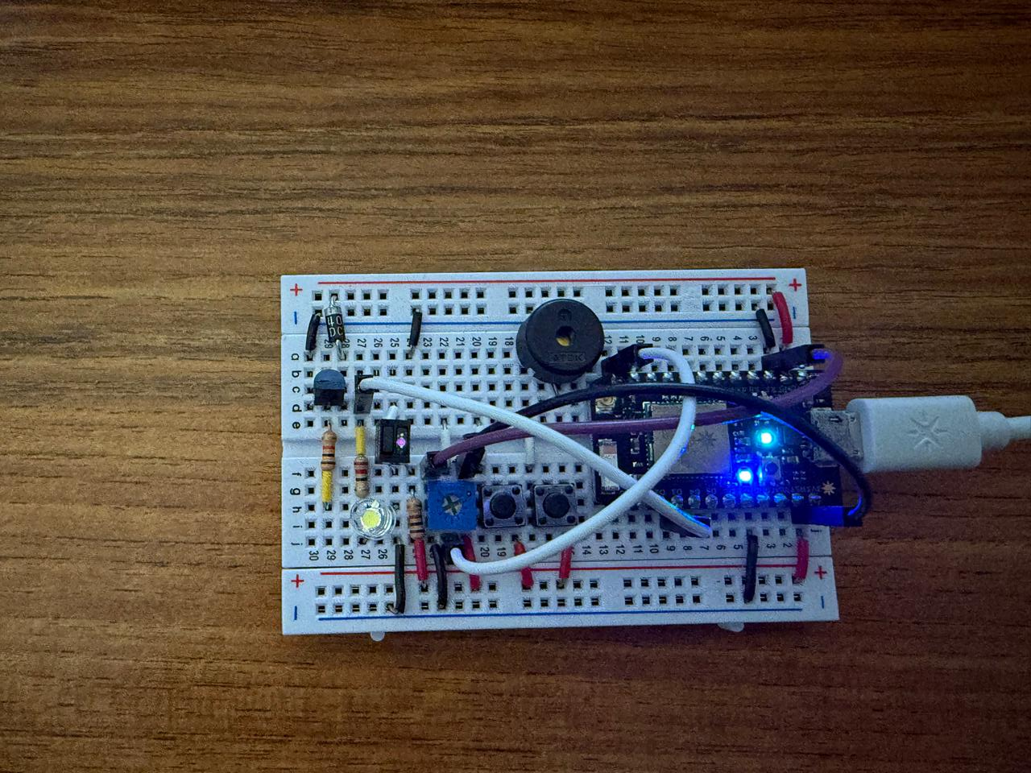

- Key Components:
- Photon Particle Microcontroller
- Status LED (D7)
- Overload Warning LED (D3)
- Potentiometer (A0)
- Particle Cloud API
- Web-based Dashboard (HTML, CSS, JavaScript)

METHODOLOGY AND IMPLEMENTATION

- Hardware Setup:

- Photon connects to Wi-Fi.
- D7 LED signals appliance activity.
- D3 LED blinks on overload (>2000W simulated).
- A potentiometer on pin A0 simulates temperature: turning right triggers AC, left triggers the heater.
The firmware and frontend communicate through Particle Cloud services.
A. Firmware Implementation
Key functionalities are defined using Particle functions and variables These include temperature-based automation, appliance state control, and overload detection, as shown in Listing 1.

Listing 1. Firmware logic for temperature-driven appliance control and overload detection.

const int tempSensorPin = A0;
const int STATUS_LED = D7;
const int OVERLOAD_LED = D3;

int heaterState = 0, fridgeState = 0, acState = 0;
int totalPower = 0, temperature = 0;

void loop() {
temperature = analogRead(tempSensorPin);
temperature = map(temperature, 0, 4095, 0, 100);

if (temperature > 70) {
acState = 1; heaterState = 0;
} else if (temperature < 30) {
heaterState = 1; acState = 0;
} else {
heaterState = 0; acState = 0;
}

totalPower = heaterState * 1000 + fridgeState * 200 + acState * 1500;
digitalWrite(STATUS_LED, heaterState || fridgeState || acState);

if (totalPower > 2000) {
digitalWrite(OVERLOAD_LED, HIGH);
delay(250);
digitalWrite(OVERLOAD_LED, LOW);
delay(250);
} else {
digitalWrite(OVERLOAD_LED, LOW);
delay(1000);
}
}

The controlAppliance() function enables remote device control via dashboard commands, as illustrated in Listing 2.

Listing 2. Cloud-triggered function to control appliance states from the dashboard via Particle.function()

int controlAppliance(String command) {
if (command == "heater_on") heaterState = 1;
else if (command == "heater_off") heaterState = 0;
else if (command == "fridge_on") fridgeState = 1;
else if (command == "fridge_off") fridgeState = 0;
else if (command == "ac_on") acState = 1;
else if (command == "ac_off") acState = 0;
else return -1;
return 1;
}

B. Web Dashboard Implementation

The dashboard uses JavaScript to fetch real-time power data and control appliances.

Listing 3. Key JavaScript Fetch Code
async function getPower() {
const res = await fetch(`https://api.particle.io/v1/devices/${deviceID}/totalPower?access_token=${accessToken}`);
const data = await res.json();
document.getElementById("power").innerText = parseInt(data.result);
}
setInterval(getPower, 1000);

- Features include live power visualization using Chart.js, appliance toggling, scheduled automation, and CSV export of logs.
C. Communication Protocols:
- HTTP API calls to Particle Cloud endpoints
- Fetch API in JavaScript

IV. FRONTEND INTERFACE
The web-based dashboard serves as the user-facing component of the energy monitoring system. Designed with an intuitive layout and interactive features, it enables real-time control and visualization. The dashboard displays:
- Real-time Appliance Status: Indicates which appliances are currently active.
- Live Energy Consumption Graph: Uses Chart.js to display real-time power usage trends[4].
- Estimated Daily Cost: Calculates cost based on power consumption and local tariffs.
- Overload Warnings: Shows warning messages when power exceeds a defined threshold.
- Smart Energy-Saving Tips: Analyzes appliance usage and suggests tips to optimize energy.
- Scheduling Controls: Allows users to schedule on/off actions for appliances.
- CSV Log Export Capability: Provides the ability to download historical data in CSV format for further analysis.
Fig. 3. Web-based user interface for real-time appliance control and status monitoring.
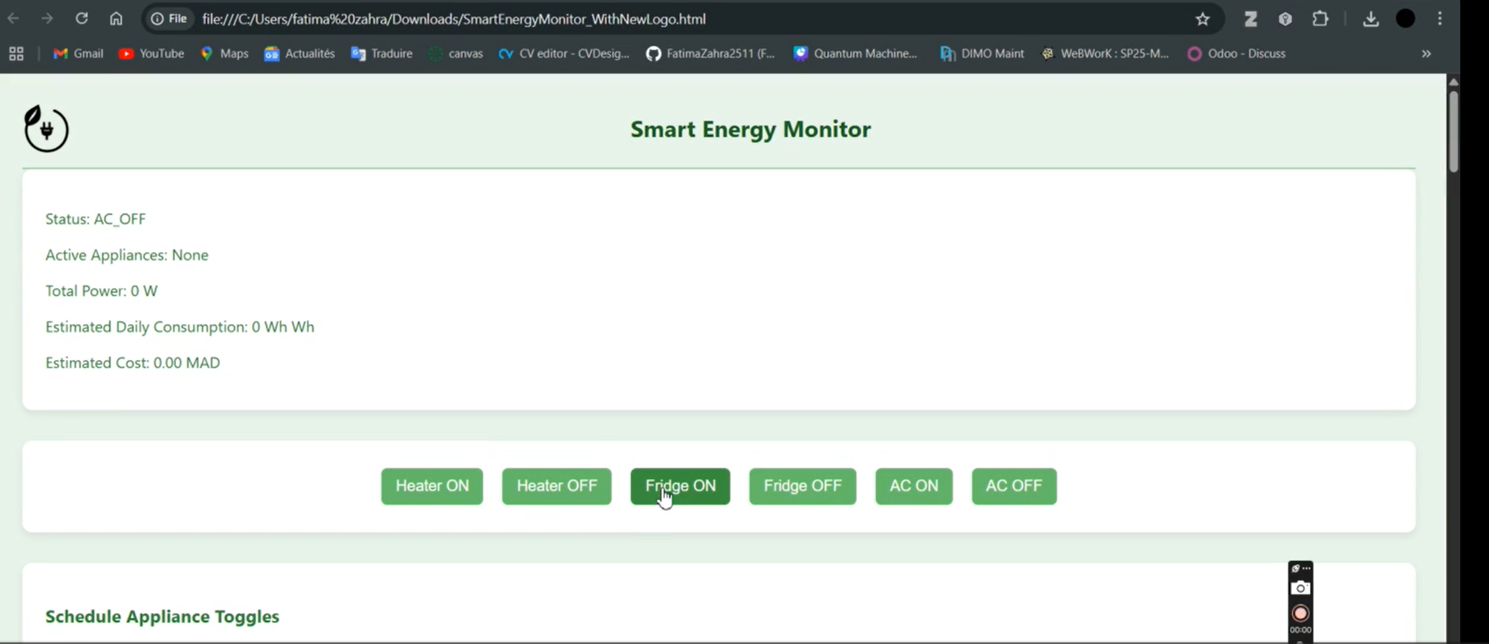

V.EXPERIMENTAL RESULTS AND ANALYSIS

A.Testing. Conditions:
The system was tested in a controlled laboratory setting using a Particle Photon microcontroller connected to a breadboard circuit. No physical high-load appliances were used; instead, the system simulated appliance behavior (heater, fridge, AC) through internal logic. The potentiometer was used to simulate ambient temperature changes. Turning it to the right mimicked high temperatures, triggering AC activation and heater shutdown. Turning it to the left simulated a drop in temperature, activating the heater and disabling the AC. LEDs were used as status indicators, and an overload was represented via a blinking warning LED when the simulated power exceeded a predefined threshold. Communication with the Particle Cloud was established via Wi-Fi, and interaction with the dashboard was conducted on a local browser.

B. Performance Metrics

Response Time: The dashboard-to-device communication was responsive, with toggling actions reflected on the hardware (LED changes) and the dashboard within approximately 1 second.

Accuracy: Simulated power values (e.g., 1000W for heater, 200W for fridge, 1500W for AC) were correctly summed and displayed. The overload detection threshold (2000W) was triggered precisely during multi-device activation scenarios.

Power Consumption Calculation: The estimated daily consumption and cost output were dynamically updated based on real-time simulation values, helping users understand their virtual usage.

C. System Features Observed During Testing

Overload Detection: When users toggled on all devices, the system consistently detected the total simulated power exceeding 2000W and activated the blinking warning LED. This validated the load management logic.

Scheduling Functionality: The scheduling module accurately activated appliance toggles at the scheduled times with negligible drift (~1 second), confirming timing precision in dashboard-to-cloud-to-device communication.

Appliance State Feedback: The dashboard consistently displayed correct appliance statuses and corresponding cost and consumption calculations

D. Comparison with Existing Solutions

Unlike traditional home energy meters, which only provide delayed or aggregated readings, this system delivers real-time, appliance-level feedback. Compared to commercial smart systems that require actual power sensors and complex setups, this simulation is safer, cost-effective, and ideal for educational use. Its integration of scheduling, warnings, and live control offers functionality comparable to basic smart home interfaces but within a simplified, cloud-based prototype.

.
VI. CHALLENGES AND LIMITATIONS

A.-Hardware.Limitations
As a simulation-based prototype, the system does not utilize real power sensors for current or voltage measurement. This limits its ability to measure actual energy consumption or detect hardware-level anomalies like voltage fluctuations or short circuits. The Particle Photon board, while effective for basic IoT tasks, offers limited I/O pins and power-handling capability, restricting scalability for more complex hardware integration.

B.-Software-Challenges
The system relies on the Particle Cloud API to expose variables and functions to the web dashboard. During testing, occasional delays were observed in data refresh or control acknowledgment due to internet latency or cloud-side processing delays. Additionally, Particle’s free tier limits the number of API requests per second, which can constrain responsiveness during high-frequency polling.

C.-Scalability.Issues
The system currently handles a small set of simulated appliances (heater, fridge, AC). If scaled to accommodate multiple users or a full smart home environment, the centralized architecture may become a bottleneck. Device ID management, rate-limited API usage, and UI complexity would all need to be redesigned for larger deployments.

D.-Security.Concerns
Although the Particle Cloud includes built-in authentication, the web dashboard does not implement user login or access control mechanisms. As a result, in its current form, the system is vulnerable to unauthorized access if deployed publicly. For a real-world application, secure communication protocols (e.g., HTTPS), user authentication, and role-based access control would be essential to protect sensitive usage data.

VII. CONCLUSION AND FUTURE WORK
This project successfully demonstrated the feasibility, functionality, and educational value of an IoT-based simulated smart energy monitoring system using the Particle Photon and Particle Cloud platform. Through a cloud-connected microcontroller, a responsive web dashboard, and real-time appliance simulation, the system enables users to monitor energy usage, detect overload conditions, automate appliance schedules, and export consumption logs. The fast response time, reliable overload detection, and intuitive visualization features highlight the system’s robustness and usability.
Potential applications for this system include educational labs for IoT and embedded systems training, prototype development for smart home energy solutions, and cost-effective simulations for testing cloud-based IoT architecture without physical appliances.
Future improvements could include integrating real power sensors to monitor actual voltage and current, developing a mobile application for more versatile control, adding user authentication for secure dashboard access, and incorporating machine learning algorithms for predictive energy management and anomaly detection. These expansions would make the system suitable for deployment in real-world smart home and industrial environments.
Acknowledgment
The authors would like to thank Dr. Fiaz Ahmed for his valuable mentorship, guidance, and technical resources throughout the development of this project.

VIII. REFERENCES

[1] I. F. Akyildiz, W. Su, Y. Sankarasubramaniam, and E. Cayirci, “Wireless sensor networks: a survey,” Computer Networks, vol. 38, no. 4, pp. 393–422, Mar. 2002.
[2] M. Patel and J. Wang, “Applications, challenges, and prospective in emerging body area networking technologies,” IEEE Wireless Communications, vol. 17, no. 1, pp. 80–88, Feb. 2010.
[3] Particle.io, "Photon Development Board," [Online]. Available: https://docs.particle.io, Accessed: April, 2025.
[4] Chart.js, "Chart.js Documentation," [Online]. Available: https://www.chartjs.org Accessed: April, 2025.

BIOGRAPHIES

Oumaima Ouajjou is a Computer Science student at Al Akhawayn University, Ifrane, Morocco, specializing in Advanced Computer Science.
Kenza Toreis is a Computer Science student at Al Akhawayn University, Ifrane, Morocco, specializing in Advanced Computer Science.
Fatima Zahra Zhiri is a Computer Science student at Al Akhawayn University, Ifrane, Morocco, specializing in Advanced Computer Science.

 

