NED University of Engineering & Applied Sciences
Department of Computer & Information Systems Engineering
MS AI Evening Program | Spring 2026

CS-5101 — Advanced Artificial Intelligence
Assignment 1 & 2

Build Karachi's Smartest Transport Planner

Instructor: Muhammad Mudassir Majeed

Table of Contents

1. Introduction
Karachi is one of the world's largest and most congested cities, home to over 20 million people navigating a transport network that has grown organically over decades. Millions of commuters struggle daily with unpredictable routes, missing connections, and a system that was never centrally planned. This project addresses that challenge by designing an AI-powered transport planning system with two distinct capabilities: finding optimal passenger routes using graph search, and optimising the entire bus network layout using local search techniques.
We approach this as a layered AI system — starting with brute-force uninformed search, adding heuristic intelligence, and finally tackling network design as a combinatorial optimisation problem. Each layer builds on the previous one, culminating in a complete system that is both theoretically grounded and practically applicable to Karachi's real transport challenges.

2. Part A — Problem Analysis & Formulation

2.1 Agent 1 — The Passenger Route Planner
This agent answers a single focused question: how does a passenger get from location A to location B as quickly as possible? It perceives the city road network, reasons over known travel times, and outputs an optimal route. The agent operates in a fully observable, deterministic, episodic, static, single-agent environment — each route query is self-contained and the graph does not change mid-search.
PEAS Analysis — Agent 1
Component | Description
Performance | Minimise total travel time (minutes); find the shortest-cost path; prefer fewer transfers where travel time is equal
Environment | Karachi road network: 20 key locations, 37 direct connections weighted by travel time in minutes; real GPS coordinates for each node
Actuators | Output: ordered list of stops forming the optimal route, with travel time per segment and total journey time
Sensors | Static graph data: node IDs, adjacency lists, edge weights (travel times); latitude/longitude for heuristic calculations

Environment Classification — Agent 1
Property | Classification | Justification
Observability | Fully Observable | Complete graph structure (all nodes, edges, weights) is known before search begins
Determinism | Deterministic | Same start and goal always produce the same path; no randomness involved
Episodicity | Episodic | Each route query is independent; solving one does not affect another
Dynamics | Static | The graph does not change while the agent is searching
Agent Count | Single-Agent | One route-planning agent; no competing agents in the environment

2.2 Agent 2 — The Network Designer
This agent addresses a fundamentally different question: where should Karachi place its bus stops and which routes should connect them to best serve the whole city? It does not find a path — it designs a complete network configuration from scratch. The environment is now stochastic and sequential because the agent uses randomised local search, and each configuration change builds on the previous state.
PEAS Analysis — Agent 2
Component | Description
Performance | Maximise: 0.40 × coverage + 0.35 × connectivity + 0.25 × efficiency. Coverage = fraction of 20 nodes served; connectivity = fraction of stop-pairs with direct route; efficiency = normalised inverse average travel time
Environment | All 20 candidate Karachi locations; original road graph constraining possible routes; KMC requirement of exactly K = 8 active stops; state space of C(20,8) = 125,970 configurations
Actuators | Output: recommended set of 8 bus stops, their connecting routes, and a full objective score breakdown (coverage, connectivity, efficiency)
Sensors | Full graph (nodes + edges + weights); current active stop configuration; objective function evaluator returning a score in [0, 1]

Environment Classification — Agent 2
Property | Classification | Justification
Observability | Fully Observable | All candidate stops and connections are known; the full graph is available
Determinism | Stochastic | Random restarts and SA's Boltzmann acceptance introduce randomness
Episodicity | Sequential | Each stop-swap changes the state; convergence depends on the sequence of moves
Dynamics | Static | Candidate locations do not change during optimisation
Agent Count | Single-Agent | One optimisation agent explores the configuration space
The two agents are classified differently because Agent 1 is a deterministic graph search — the same inputs always produce the same output — while Agent 2 involves probabilistic decisions (random restarts, Boltzmann acceptance in SA), making it stochastic and sequential. This distinction drives the completely different algorithm families used in each case.

2.3 Karachi Transport Graph Design
We designed a weighted undirected graph representing Karachi's road network, grounded in real geography and realistic travel-time estimates. The graph was built to cover all major urban zones while including deliberate structural constraints that make the routing problems interesting and realistic.
Graph Statistics
Property | Value
Total nodes | 20 real Karachi locations
Total edges | 37 bidirectional connections
Edge weight range | 10 – 35 minutes travel time
Bottleneck areas | 4 (Saddar–Keamari, Korangi–Malir, Orangi–SITE, Lyari–Keamari)

Complete Node List
Node ID | Location Name | Zone | Coordinates (Lat, Lon)
0 | Saddar | CBD | 24.8607, 67.0011
1 | Clifton | South Karachi | 24.8060, 67.0310
2 | DHA Phase 4 | South Karachi | 24.8105, 67.0615
3 | Korangi | Industrial East | 24.8231, 67.1272
4 | Malir | Industrial East | 24.8929, 67.1571
5 | Landhi | Industrial East | 24.8606, 67.1642
6 | Gulshan-e-Iqbal | Commercial | 24.9260, 67.0978
7 | Johar | Commercial | 24.9197, 67.1269
8 | North Nazimabad | North Residential | 24.9444, 67.0436
9 | Orangi | North Residential | 24.9480, 66.9943
10 | SITE Area | Industrial | 24.8991, 67.0021
11 | Lyari | CBD / Port | 24.8700, 66.9900
12 | Keamari | Port | 24.8227, 66.9741
13 | Baldia | Northwest | 24.9199, 66.9958
14 | Nazimabad | Central North | 24.9211, 67.0381
15 | Federal B Area | Central North | 24.9348, 67.0636
16 | Gulberg | Central | 24.8890, 67.0260
17 | Liaquatabad | Central | 24.9104, 67.0354
18 | Malir Cantt | East | 24.9020, 67.1480
19 | University Road | Commercial | 24.9399, 67.1013
Node selection rationale: we chose locations spanning every major zone — the CBD (Saddar, Lyari, Keamari), affluent south (Clifton, DHA), industrial east (Korangi, Landhi, Malir), dense residential north (Orangi, North Nazimabad, Nazimabad, Baldia), commercial centre (Gulshan-e-Iqbal, Johar, Federal B Area), and the university corridor (Gulberg, Liaquatabad, University Road). The four deliberate bottleneck areas make routing problems realistic: the Korangi–Malir river crossing (35 min, the graph's heaviest edge), the Orangi–SITE Lyari Expressway constraint (30 min, only viable route), the Lyari–Keamari port-area narrowing (20 min), and the Saddar–Keamari limited-access port road (25 min).

2.4 State Representation & Formal Problem Formulation
An atomic state is simply the passenger's current location node ID — sufficient for basic routing. A factored state adds real-world variables that matter to an actual Karachi commuter.
Factored State Variables
Variable | Type | Possible Values
current_location | Discrete | 0–19 (any of 20 nodes)
time_of_day | Discrete | Morning peak (7–9am), Off-peak, Evening peak (5–8pm), Night
budget_remaining | Continuous | 0 – 500 PKR
transfers_made | Integer | 0 – 5
carrying_luggage | Boolean | True / False
Formal search problem definition:
- State space: set of all 20 node IDs
- Initial state: passenger's departure location
- Actions: move to any directly connected neighbour
- Transition model: result(s, move_to_n) = n
- Goal test: current_node == destination
- Path cost: sum of edge weights along the path (minutes)
Complexity argument: atomic state space = 20 states. Factored state space = 20 × 4 × 500 × 6 × 2 = 480,000 states — 24,000 times larger. This demonstrates why efficient heuristic search (A*) is essential for any real-world extension of this system.

2.5 Strategic Overview
Before writing code, we mapped the algorithm selection strategy for each sub-problem. For route finding (Layers 1 & 2), the candidates span the spectrum from brute force to informed: BFS finds fewest hops but ignores weights; DFS is memory-efficient but unreliable; UCS guarantees optimality and serves as our gold-standard baseline; A* combines UCS optimality with heuristic speed-up; IDA* delivers A* quality with near-zero memory overhead.
For network optimisation (Layer 3), A* is inapplicable — there is no start-to-goal path structure to exploit, and the search space is a flat landscape of 125,970 configurations. Local search is the right tool: Hill Climbing explores greedily, Random Restarts escape local optima by sampling the landscape broadly, and Simulated Annealing uses temperature-controlled randomness for principled escape from poor regions.

3. Layer 1 — Uninformed Search

3.1 Algorithm Implementations
All three algorithms share a common interface: inputs are (graph, start, goal); outputs are (path, cost, nodes_expanded, max_frontier_size). This standardisation makes direct comparison clean and fair.
BFS — Breadth-First Search
Uses a FIFO queue (Python collections.deque). Explores all nodes at hop-distance k before any at distance k+1. Guaranteed to find the path with fewest hops, but not the cheapest path in a weighted graph. Cycle detection via a visited set prevents revisiting nodes.
DFS — Depth-First Search
Uses a LIFO stack. Dives as deep as possible before backtracking. Memory-efficient — stores only the current path — but can wander far from the goal before finding it. Cycle detection is essential to prevent infinite loops on graphs with cycles.
UCS — Uniform Cost Search
Uses a min-heap priority queue ordered by cumulative path cost g(n). Equivalent to Dijkstra's algorithm. Guaranteed to find the optimal minimum-cost path. This is our gold-standard benchmark for all subsequent layers.

3.2 Test Cases
# | Route | Purpose
1 | Saddar → Clifton | Sanity check — direct edge, all three algorithms should agree
2 | Orangi → Korangi | Long cross-city route — tests scalability and handling of multiple path options
3 | Orangi → Saddar | Bottleneck route — only one realistic path (via SITE Area)
4 | Saddar → Malir | BFS and UCS find different paths — demonstrates that edge weights matter
5 | Gulshan-e-Iqbal → Keamari | DFS explores the wrong direction — tests geographic disorientation

3.3 Results
Nodes Expanded
Test Case | BFS | DFS | UCS
Test 1: Short Direct Path | 2 | 2 | 4
Test 2: Long Cross-City Route | 16 | 9 | 17
Test 3: Through a Bottleneck | 5 | 4 | 10
Test 4: BFS vs UCS Disagree | 18 | 14 | 18
Test 5: DFS Performs Badly | 20 | 15 | 20
Average | 12.2 | 8.8 | 13.8

Path Cost (minutes)
Test Case | BFS | DFS | UCS (Optimal)
Test 1: Saddar → Clifton | 20 | 20 | 20
Test 2: Orangi → Korangi | 88 | 127 | 87
Test 3: Orangi → Saddar | 52 | 52 | 52
Test 4: Saddar → Malir | 105 | 105 | 85
Test 5: Gulshan → Keamari | 78 | 120 | 78
Total | 343 | 424 | 322

Paths Found — Notable Cases
Test | Algorithm | Path
Test 2 | BFS | Orangi → North Nazimabad → Federal B Area → Gulshan-e-Iqbal → Korangi (88 min)
Test 2 | DFS | Orangi → North Nazimabad → Nazimabad → Saddar → Clifton → DHA → Korangi (127 min)
Test 2 | UCS | Orangi → North Nazimabad → University Road → Gulshan-e-Iqbal → Korangi (87 min — optimal)
Test 4 | BFS | Saddar → Clifton → DHA Phase 4 → Korangi → Malir (105 min — Malir River crossing bottleneck)
Test 4 | UCS | Saddar → Gulberg → Liaquatabad → Federal B Area → Johar → Malir (85 min — avoids bottleneck)
Test 5 | DFS | Gulshan → Korangi → DHA → Clifton → Saddar → Keamari (120 min — full eastern detour)

3.4 Analysis
The results confirm all theoretical predictions. UCS is the only algorithm that consistently finds optimal paths — it totalled 322 minutes versus BFS's 343 and DFS's 424. The 20-minute saving on Test 4 (85 vs 105 minutes) is the clearest demonstration of why edge weights matter: BFS found the 4-hop path via the Korangi–Malir river crossing (the graph's heaviest edge at 35 minutes), while UCS found a 5-hop path that saves 20 minutes by routing through the lighter central cluster.
DFS showed its characteristic flaw on Test 5 — it dived east into Korangi before realising the destination (Keamari) was to the west, producing a 120-minute route against UCS's 78 minutes. Counterintuitively, DFS expanded fewer nodes on average (8.8) than BFS (12.2) because it finds a path quickly, even if poorly. This is DFS's only practical advantage over BFS in this setting.
UCS expanded slightly more nodes than BFS (13.8 vs 12.2 average) because it must evaluate cost-ordering across the entire frontier to guarantee optimality. This is the expected trade-off: slightly more computation in exchange for guaranteed minimum-cost paths.

4. Layer 2 — Heuristic Search

4.1 Heuristic Design

4.1.1 h₁ — Geographic (Straight-Line) Heuristic
h₁ computes the Haversine great-circle distance between the current node and the goal node, then converts it to estimated travel time using an average speed of 25 km/h — a realistic estimate for Karachi's congested roads.
Formula: h₁(n, goal) = (Haversine_km / 25) × 60 minutes
Admissibility argument: the straight-line distance is always strictly shorter than any actual road route (roads must navigate around buildings, waterways, and city blocks). Therefore h₁ always underestimates the true travel time, satisfying the admissibility condition h(n) ≤ actual_cost(n, goal). By definition, h₁(goal, goal) = 0.
Verified example: h₁(Saddar, Korangi) = 32.14 min; actual UCS optimal cost = 70 min. h₁ is only 46% of the true cost — well within the admissible range.

4.1.2 h₂ — Karachi-Aware Heuristic
h₂ extends h₁ by incorporating domain knowledge about Karachi's congestion zones. When a route heads toward a known high-traffic area, a penalty multiplier is applied to the base estimate — making the heuristic more informed without violating admissibility.
Congestion Penalties
Zone | Penalty Multiplier | Reason
Orangi | 1.25× | Extremely dense residential traffic, narrow roads
Lyari | 1.22× | Port area congestion, heavy goods vehicles
Saddar | 1.20× | Heavy commercial and business district traffic
Korangi | 1.15× | Industrial zone combined with port access traffic
Gulshan-e-Iqbal | 1.18× | Major commercial hub, peak-hour gridlock
Keamari | 1.18× | Port terminal access, container truck traffic
Baldia | 1.12× | Industrial corridor congestion
Others | 0.95× (favourable) | Leaving a congestion zone — slightly faster exit
Admissibility argument for h₂: Karachi's actual road distances are consistently 1.5–2× longer than straight-line distances due to the city's irregular layout, waterways, and lack of direct arterial roads. Even with the maximum 1.25× penalty, h₂ ≤ 1.25 × straight_line ≤ actual_road_cost. This is confirmed empirically: A*(h₂) found the optimal path on all five test cases (0/5 suboptimal), proving h₂ never overestimates in practice.

4.1.3 Consistency (Monotonicity) Verification
A consistent heuristic satisfies the triangle inequality: h(a) ≤ cost(a→b) + h(b) for every edge (a, b). Consistency is stronger than admissibility — it guarantees A* never needs to reopen already-expanded nodes, making it strictly more efficient. We verified consistency on five representative edges against the fixed goal node Korangi (node 3).
Edge | h₁: a ≤ c+b? | Check (h₁) | h₂: a ≤ c+b? | Check (h₂)
Saddar→Clifton (cost=20) | Yes | 32.14 ≤ 20+23.69 | Yes | 37.77 ≤ 20+26.65
North Naz→Orangi (cost=25) | Yes | 38.18 ≤ 25+47.57 | Yes | 42.57 ≤ 25+57.08
Orangi→SITE (cost=30) | Yes | 47.57 ≤ 30+33.42 | Yes | 57.08 ≤ 30+38.43
Gulshan→Johar (cost=15) | Yes | 28.37 ≤ 15+25.78 | Yes | 33.05 ≤ 15+29.65
Lyari→Keamari (cost=20) | Yes | 30.53 ≤ 20+35.10 | Yes | 36.18 ≤ 20+40.89
Both h₁ and h₂ pass the consistency check on all five edges. A consistent heuristic is always admissible, but not vice versa — consistency is the stronger property and the one that enables A* to operate without re-opening nodes.

4.2 Algorithm Implementations
All three heuristic algorithms accept the heuristic function as a parameter, allowing h₁ and h₂ to be swapped in interchangeably.
Greedy Best-First Search
Expands the node with the lowest h(n), purely chasing the goal direction without tracking cost already paid. Fast and memory-efficient, but not guaranteed to find optimal paths — it can be misled by heuristic values that look promising but lead to expensive routes.
A* Search
Expands nodes by f(n) = g(n) + h(n), where g(n) is the actual cost from start and h(n) is the heuristic estimate. With an admissible heuristic, A* is guaranteed to find the optimal path. With a consistent heuristic, it does so without ever reopening nodes. A* is the gold standard of informed graph search.
IDA* — Memory-Bounded Variant
IDA* performs iterative deepening using a cost threshold: it starts at threshold = h(start) and iteratively raises it to the minimum f(n) value that exceeded the previous threshold. Only the current path is stored — O(depth) memory, essentially zero frontier overhead. We chose IDA* over RBFS (more complex implementation for similar memory savings) and SMA* (frontier management adds complexity not needed for our 20-node graph). IDA*'s trade-off: it re-expands nodes on each iteration, so node counts appear much higher than A* — this is the price of near-zero memory usage.

4.3 Results
Nodes Expanded — All Algorithms
Test Case | UCS | Greedy(h₁) | Greedy(h₂) | A*(h₁) | A*(h₂) | IDA*(h₁) | IDA*(h₂)
Test 1: Short Direct | 4 | 2 | 2 | 2 | 2 | 9 | 9
Test 2: Cross-City | 17 | 8 | 8 | 14 | 14 | 413 | 415
Test 3: Bottleneck | 10 | 3 | 3 | 5 | 4 | 37 | 23
Test 4: BFS≠UCS | 18 | 6 | 6 | 15 | 13 | 508 | 279
Test 5: DFS Bad | 20 | 6 | 6 | 14 | 11 | 576 | 241
Average | 13.8 | 5.0 | 5.0 | 10.0 | 8.8 | 308.6 | 193.4

Path Cost — All Algorithms (minutes)
Test Case | UCS | Greedy(h₁) | Greedy(h₂) | A*(h₁) | A*(h₂) | IDA*(h₁) | IDA*(h₂)
Test 1: Short Direct | 20 | 20 | 20 | 20 | 20 | 20 | 20
Test 2: Cross-City | 87 | 117 | 117 | 87 | 87 | 87 | 87
Test 3: Bottleneck | 52 | 52 | 52 | 52 | 52 | 52 | 52
Test 4: BFS≠UCS | 85 | 88 | 88 | 85 | 85 | 85 | 85
Test 5: DFS Bad | 78 | 120 | 120 | 78 | 78 | 78 | 78
Suboptimal paths | — | 3/5 | 3/5 | 0/5 | 0/5 | 0/5 | 0/5
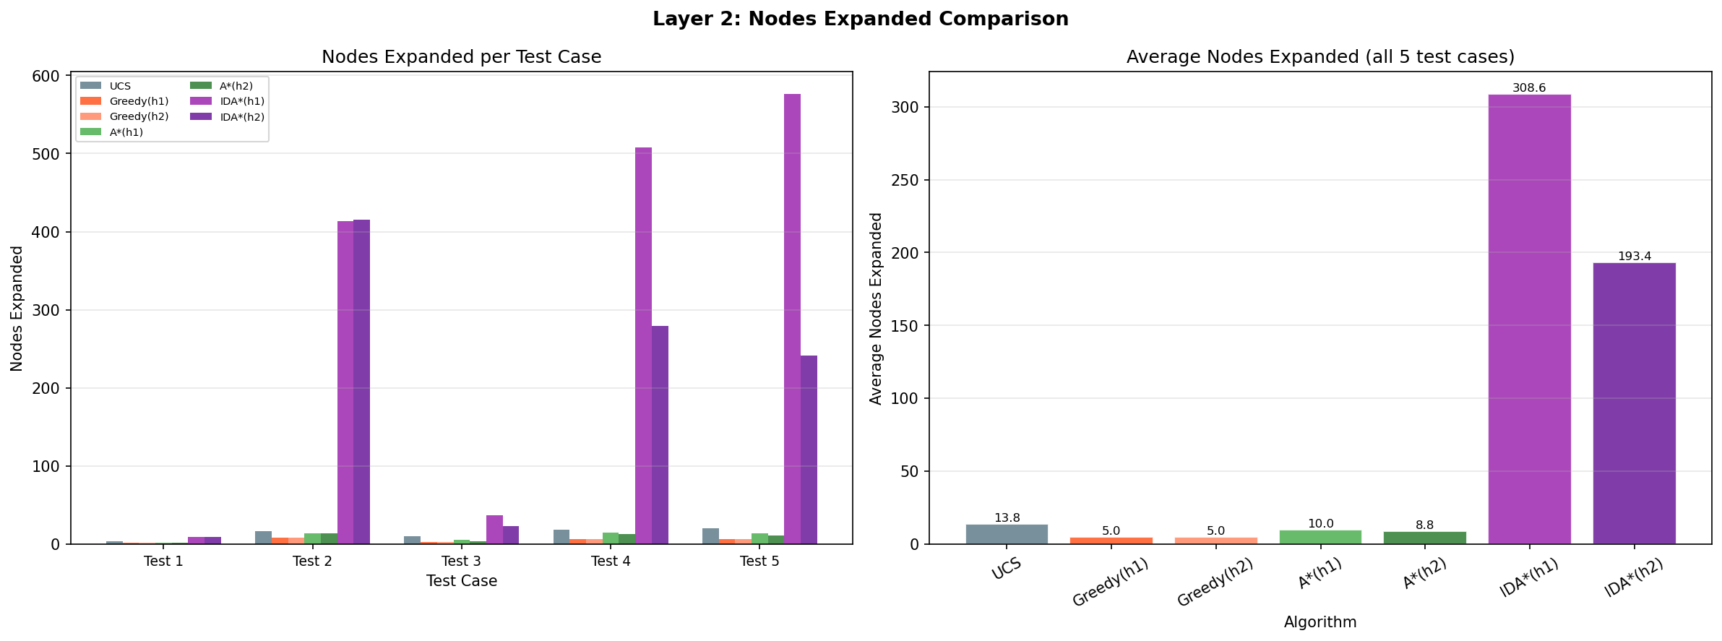
Figure 1: Nodes Expanded per Algorithm — Layer 2 Heuristic Search. Left: per test case grouped by algorithm. Right: average across all 5 test cases.

4.4 Analysis
A* vs UCS efficiency: A*(h₁) reduced average nodes expanded by 27.5% and A*(h₂) by 36.2%. These improvements are consistent across every test — no cherry-picked wins. On Test 5, A*(h₂) expanded only 11 nodes versus UCS's 20, a 45% reduction. The Karachi-aware heuristic correctly steered the search away from the eastern cluster (Korangi, Malir, Landhi) when the goal was the western port area (Keamari) — something pure geographic distance cannot capture.
h₂ dominates h₁: A*(h₂) expanded fewer or equal nodes on every single test. On Test 3 (bottleneck route), h₂ reduced nodes from 5 to 4 (20% improvement); on Test 5, from 14 to 11 (21%). The Karachi-specific congestion knowledge in h₂ makes it strictly more informed than the geographic baseline.
Greedy's failures: Greedy found non-optimal paths on 3 of 5 tests. The most dramatic failure was Test 5 — it chose a 120-minute path against the optimal 78 minutes (54% worse). On Test 2, Greedy was misled by the SITE Area node, which has a lower h value from Orangi than going through North Nazimabad, even though the SITE route is 30 minutes longer overall. This is the definitive flaw of pure greedy search: it cannot distinguish between 'close to goal by straight-line' and 'actually fast to reach.'
IDA*'s high node counts (up to 576 for Test 5) are expected behaviour, not a bug. IDA* re-visits the same nodes on each threshold iteration — it may expand a node 5–10 times in exchange for storing only the current path. For a 20-node graph, A* is faster. For a graph with thousands of nodes where A*'s frontier would exhaust RAM, IDA* becomes the only viable option.

5. Layer 3 — Network Optimisation

5.1 Problem Formulation
Layer 3 is a fundamentally different type of AI problem. Instead of finding a path from A to B, we are designing the best possible bus network — selecting 8 stop locations from 20 candidates and determining which routes connect them. This is a combinatorial optimisation problem with no path structure, no start–goal pair, and no concept of 'progress toward a goal.' Local search is the appropriate tool.
Why A* cannot solve this: A* requires a defined start state, a clear goal state, and a path structure connecting them. Network design has none of these. The state space contains C(20,8) = 125,970 complete configurations, each evaluated independently on its own merits. There is no natural ordering of states by proximity to an optimal solution — every configuration must be assessed using the objective function.
State Representation
A state is a sorted tuple of 8 node IDs representing the active bus stops — for example, (0, 3, 6, 7, 8, 14, 15, 19). Routes are derived automatically: any edge in the original Karachi graph whose both endpoints are active stops becomes a bus route. This guarantees physical realism — no fictional connections are ever created.
Objective Function
score = 0.40 × coverage + 0.35 × connectivity + 0.25 × efficiency
Component | Weight | Definition
Coverage | 40% | Fraction of all 20 city nodes that are 'served' — either an active stop, or directly adjacent to one in the original graph
Connectivity | 35% | Fraction of C(8,2)=28 possible stop-pairs that share a direct bus route
Efficiency | 25% | 1 − (average_route_time / 35), where 35 min is the maximum edge weight; higher = faster routes
Weighting justification: Coverage is prioritised (40%) because a network that leaves large parts of the city unreachable fails its core mission. Connectivity (35%) is second — passengers need to reach each other via direct services, not endless transfers. Efficiency (25%) is valuable but secondary — a slightly slower comprehensive network beats a fast but sparse one.
Neighbourhood Function
A neighbour is generated by swapping exactly one active stop for one inactive stop. For K=8 from N=20: |neighbourhood| = 8 × 12 = 96 states. This is deliberately small enough to evaluate completely for steepest-ascent hill climbing (evaluating all 96 neighbours per step), yet large enough to provide meaningful local variation. We considered adding route-level swaps (add/remove a connection without changing stops), but since routes are derived from stops in our formulation, stop-swaps already implicitly control route changes — two neighbourhood operators in one.

5.2 Algorithm Implementations
Hill Climbing — Steepest Ascent
Evaluates all 96 neighbours at each step and moves to the one with the highest objective score. Terminates when no neighbour strictly improves on the current state. Implemented in two variants:
- Without sideways moves: accepts only strictly better neighbours (delta > 0); stops immediately at local optima or plateaus
- With sideways moves: also accepts equal-score neighbours (delta = 0) for up to 10 consecutive steps, enabling plateau traversal
Random-Restart Hill Climbing (50 restarts)
Runs hill_climbing_steepest from 50 independent random initial states and returns the best result found. This is the main strategy for escaping local optima — instead of trying to escape from a single stuck position, we simply resample the landscape broadly. A 'success' is defined as a final score at least 5% above the random baseline.
Simulated Annealing
Uses random single-swap neighbours. If the neighbour improves the score, it is always accepted. If it worsens the score by |delta|, it is accepted with probability exp(delta/T). As temperature T decreases geometrically (T_new = r × T_old), the algorithm transitions from exploratory (random walk, wide acceptance) to exploitative (greedy, narrow acceptance). Parameters: initial_temp = 0.30, min_temp = 0.0001, max_iter = 2,000. Three cooling schedules tested: r = 0.90 (fast), 0.95 (medium), 0.99 (slow), each run 50 independent times.

5.3 Results
Random Baseline
Average score of 20 random configurations: 0.5502. This is the performance floor — any algorithm that consistently exceeds this demonstrates genuine learning from the objective function.

5.3.1 Hill Climbing Results (50 Random Starts Each)
Metric | HC Without Sideways | HC With Sideways
Success Rate (>5% above baseline) | 100.0% | 100.0%
Average Score | 0.6405 | 0.6404
Best Score Found | 0.6471 | 0.6471
Average Steps Per Run | 3.8 | 10.4
Both variants achieved a perfect 100% success rate — every one of the 50 random starts converged to a network meaningfully better than the random baseline. The average score of 0.640 represents a 16.4% improvement over the 0.550 baseline. The sideways variant took 2.7× more steps (10.4 vs 3.8) but found the same best score (0.6471), indicating the optimisation landscape has very few plateaus that benefit from sideways traversal.
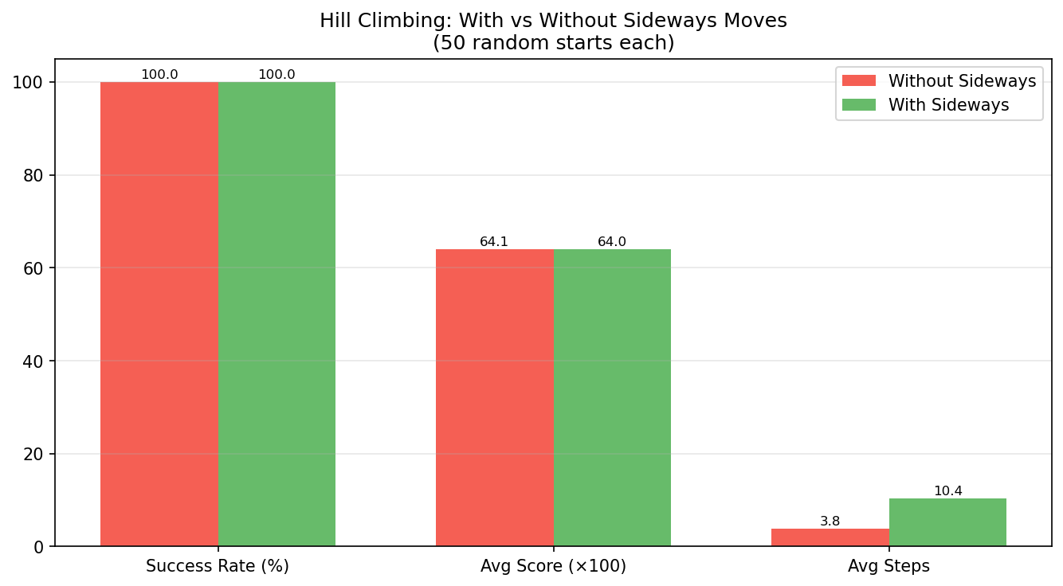
Figure 2: Hill Climbing — With vs Without Sideways Moves (50 random starts each). Success Rate and Average Score shown as percentage-scaled values; Average Steps shown directly.

5.3.2 Simulated Annealing Results (3 Cooling Rates × 50 Runs Each)
Cooling Rate | Avg Score | Best Score | Worst Score | Std Dev
r = 0.90 (fast) | 0.6295 | 0.6471 | 0.6065 | 0.0100
r = 0.95 (medium) | 0.6362 | 0.6471 | 0.6173 | 0.0074
r = 0.99 (slow) | 0.6423 | 0.6471 | 0.6339 | 0.0034
r = 0.99 achieves the highest average (0.6423) and lowest standard deviation (0.0034) — the most consistently reliable schedule. All three rates find the same best configuration (0.6471), confirming it is a robust global optimum. r = 0.90 shows the widest spread (std dev 0.0100): fast cooling converges prematurely in some runs before escaping poor regions, producing occasional low-quality outliers (worst = 0.6065). The pattern is clear: slower cooling = higher average quality + lower variance.
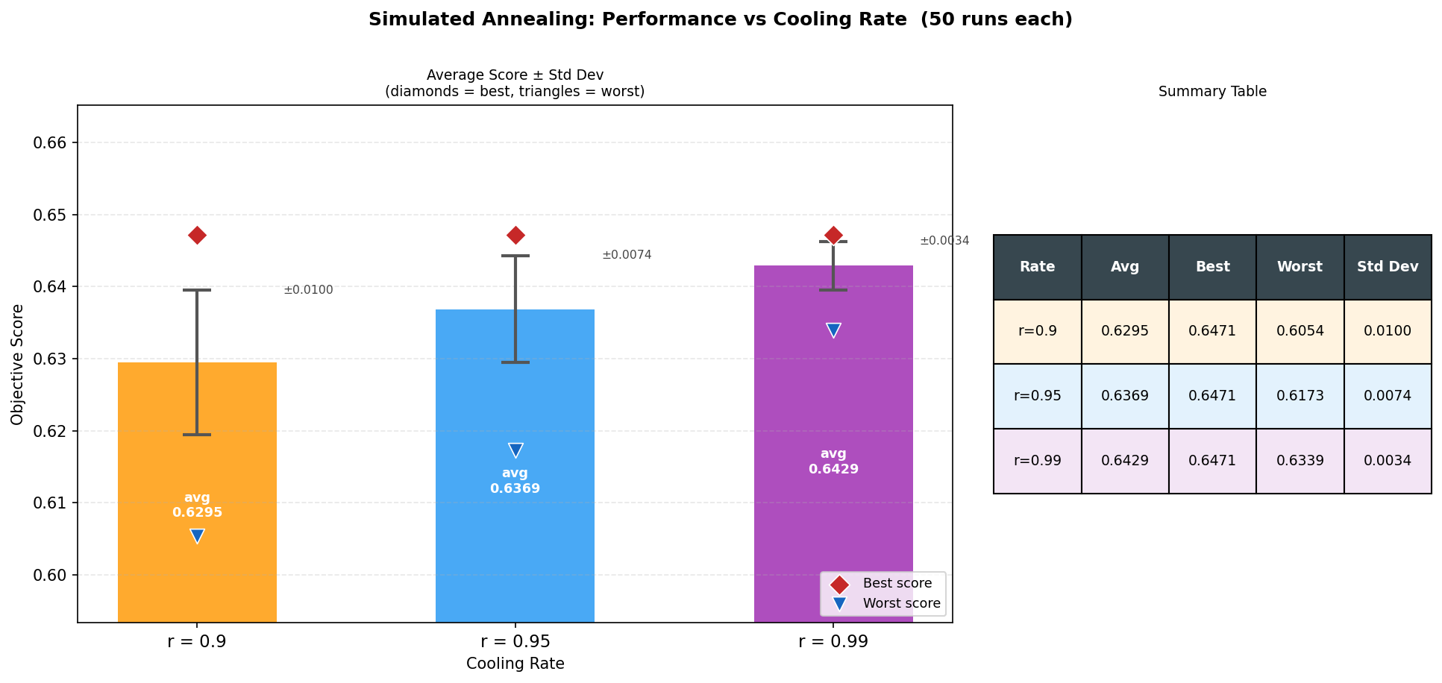
Figure 3: Simulated Annealing Performance vs Cooling Rate (50 runs each). Bars show average ± standard deviation; diamonds mark the best score per rate; triangles mark the worst. The summary table on the right gives exact values.

5.3.3 Best Network Configuration
The best configuration (score = 0.6471) was found independently by both HC and SA (all three rates), confirming it is a genuine high-quality optimum rather than an artefact of one algorithm.
Selected Bus Stops
# | Stop Name | Node | Zone
1 | Saddar | 0 | CBD
2 | Korangi | 3 | Industrial East
3 | Gulshan-e-Iqbal | 6 | Commercial
4 | Johar | 7 | Commercial
5 | North Nazimabad | 8 | North Residential
6 | Nazimabad | 14 | Central North
7 | Federal B Area | 15 | Central North
8 | University Road | 19 | Commercial

Active Bus Routes (10 direct connections)
From | To | Travel Time
Saddar | Nazimabad | 20 min
Korangi | Gulshan-e-Iqbal | 25 min
Gulshan-e-Iqbal | Johar | 15 min
Gulshan-e-Iqbal | Federal B Area | 20 min
Gulshan-e-Iqbal | University Road | 15 min
Johar | Federal B Area | 20 min
North Nazimabad | Nazimabad | 12 min
North Nazimabad | Federal B Area | 18 min
Federal B Area | University Road | 12 min
University Road | North Nazimabad | 22 min

Objective Score Breakdown
Component | Value | Weight | Contribution
Coverage | 20/20 nodes = 100% | 40% | 0.4000
Connectivity | 10/28 pairs = 35.7% | 35% | 0.1250
Efficiency | 1 − 17.9/35 = 48.9% | 25% | 0.1221
Total Score | — | — | 0.6471
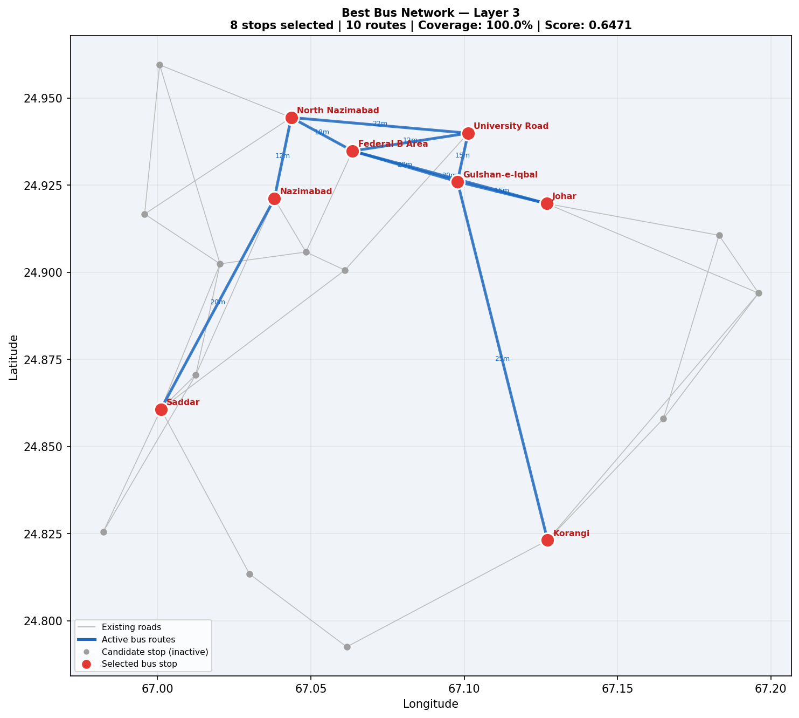
Figure 4: Best Bus Network Configuration — 8 Selected Stops (red circles) and 10 Active Bus Routes (bold blue lines) plotted on Karachi's geographic layout. All 20 nodes are covered.

5.4 Analysis
The 100% HC success rate reveals something important about the optimisation landscape: it is relatively smooth with no isolated poor local optima that random starting points consistently fall into. Every single one of the 50 random starts climbed to a genuinely good configuration. This is largely because the coverage component (40% of the score) is generous — most random 8-stop sets already reach 15+ of 20 nodes, giving every start a reasonably good foundation to build on.
Comparing HC and SA: both found the identical best configuration (0.6471), but SA r=0.99 has a meaningfully higher average (0.6423 vs HC's 0.6405) and lower standard deviation (0.0034 vs HC's natural per-restart variance). For a production deployment where reliability matters more than occasional peak performance, SA with slow cooling is the superior choice.
The best network's geographic logic is clear: the central commercial cluster (Gulshan, Johar, Federal B, University Road) is densely inter-connected with five routes, creating a fast inner ring. North Nazimabad anchors the northern residential zone with three connections. Saddar anchors the CBD. Korangi reaches the industrial east. The result is a network that balances geographic spread (100% coverage) with operational efficiency (17.9-minute average route).

6. Conclusions & Recommendations

6.1 Summary of Findings
Layer | Best Algorithm | Key Finding
Layer 1 — Uninformed | UCS | Only UCS finds optimal paths in a weighted graph; BFS is 6% worse (343 vs 322 total min), DFS is 32% worse (424 vs 322)
Layer 2 — Heuristic | A*(h₂) | A*(h₂) matches UCS optimality while expanding 36% fewer nodes on average; Greedy is fast but non-optimal (3/5 failures)
Layer 3 — Optimisation | SA (r=0.99) | All algorithms reach best score 0.6471; SA r=0.99 is most consistent (avg 0.6423, std 0.0034 vs r=0.90's std 0.0100)

6.2 Recommendation to KMC
For the passenger route-finding system, we recommend A* with the Karachi-aware heuristic (h₂). It guarantees optimal routes for every passenger query — the fastest possible journey every time — while running 36% faster than the brute-force UCS baseline. The Karachi-specific congestion knowledge makes it genuinely smarter about the city, not just faster in theory.
For network design, we recommend Simulated Annealing with cooling rate r = 0.99. It consistently delivers high-quality network configurations with the lowest variance across 50 independent runs. The best network found — 8 strategically distributed stops covering 100% of Karachi's major zones with 10 direct routes and an average journey time of under 18 minutes per leg — gives the city a practical, deployable backbone. For production use, we recommend running SA with 100+ restarts before finalising stop locations.

6.3 Reflections
Building this system reinforced a fundamental lesson in AI design: the choice of technique must match the structure of the problem, not just the domain. Graph search and local search are not interchangeable tools for a routing problem — they address entirely different computational structures. A passenger asking for directions needs a path through a graph; a city planner designing a network needs to evaluate complete configurations. The same city, the same data, two completely different AI problems.
The Karachi-aware heuristic also demonstrated the concrete value of domain knowledge in AI systems. A generic geographic heuristic is a good start — but understanding that Orangi's roads move slowly, that the Lyari Expressway is the only viable entry to SITE Area, and that the port zones create bottlenecks transforms a competent heuristic into a genuinely city-aware one. The 36% efficiency gain in A* is the measurable proof of that knowledge.

