Table of Contents
1.PROBLEM DESCRIPTION: 1
2. ABSTRACT: 2
3. DISTINGUISHING FEATURES OF OUR PROJECT: 2
3.1 Graphical Chessboard Simulation 2
3.2 Multiple AI Algorithms 2
3.3 Real-Time Conflict Visualization 2
3.4 Algorithm Comparison Mode 3
3.5 Dynamic GUI 3
3.6 Interactive Buttons and Navigation 3
3.7 Detailed Algorithm Metrics 3
3.8 Efficiency Computation 3
4. MOST CHALLENGING PART OF THE PROJECT: 3
4.1 Visualizing Attack Paths Clearly 3
4.2 Managing a Multi-Algorithm Framework 4
4.3 Dynamic GUI Scaling 4
4.4 Handling Large N in Real Time 4
4.5 Generating Comparison Charts 4
4.6 CSP Optimization 4
5. NEW LEARNINGS FROM THE PROJECT: 4

5.1 Optimization & Code Structuring 4
5.2 Understanding Search Algorithms 5
5.3 Performance Visualization 5
6. FUTURE EXPANSIONS: 5
6.1 Step-by-Step Algorithm Visualization 5
6.2 Real-Time Search Tree Viewer 6
6.3 Manual Board Editing and Validation Mode 6
6.4 Algorithm Explainability Panel 6
7. Execution Scenarios: 6
7.1General Features 6
1) Interactive Home Screen 6
2) Algorithm List Panel 7
3) Dynamic Chessboard Visualization 8
4) Real-Time Conflict Display 9
5) Easy-to-Use Buttons 9
6) Keyboard and Mouse Interaction 9
7) N Selection Window 9
8) Professional and Clean UI Layout 9
7.2 Comparison Mode 11

1.PROBLEM DESCRIPTION:

The N-Queens problem challenges us to place N queens on an N×N chessboard such that no two queens attack each other. Queens can attack horizontally, vertically, and diagonally — making this a well-known constraint satisfaction and optimization problem in computer science.

Although the rules are simple, the problem becomes exponentially complex as N increases. The difficulty and the nature of the solution space make N-Queens an excellent playground for exploring:

Uninformed search

Informed search

Local search

CSP techniques

However, students often struggle to visualize how these algorithms behave internally, how they differ, and how efficient they actually are.

This project bridges the gap by building a complete GUI-based N-Queens solver with real-time visualization and algorithm comparison tools, enabling users to understand and analyze algorithm behavior interactively.

2. ABSTRACT:

This project presents an interactive AI-based N-Queens Solver using Python and Pygame, offering users the ability to visualize solutions, evaluate AI algorithms, and compare their performance in real time.

The solver integrates:

Local Search (Hill Climbing, Simulated Annealing)

Uninformed Search (BFS, DFS, IDS, UCS)

Informed Search (Greedy Best-First, A*)

CSP Backtracking with MRV and Forward Checking

A dynamic GUI provides a chess-style visualization of queen placements, attack paths, algorithm results, and performance metrics such as time, iterations, conflicts, and efficiency.

A dedicated Comparison Mode allows parallel analysis of two algorithms using identical starting boards, supported by automatically generated performance charts through Matplotlib.

The project emphasizes visualization, accessibility, and educational value, serving as a practical tool for learning artificial intelligence techniques.

3. DISTINGUISHING FEATURES OF OUR PROJECT:

3.1 Graphical Chessboard Simulation:
The board is drawn with alternating colors, and queens are assigned unique color. Attack paths are also highlighted in matching colors, improving clarity and visualization.

3.2 Multiple AI Algorithms
The system supports:
- Hill Climbing
- Simulated Annealing
- BFS, DFS, IDS, UCS
- Greedy Best-First
- A*
- CSP Backtracking
This allows broad experimentation with search and optimization strategies.
3.3 Real-Time Conflict Visualization
The GUI visually marks conflict paths and updates them instantly as algorithms generate new boards.
3.4 Algorithm Comparison Mode
Two algorithms can be run on the same starting board, and the system displays:
- Final board
- Success status
- Time
- Iterations/Nodes
- Efficiency score
- Side-by-side visual boards
- Automatic performance charts using Matplotlib
3.5 Dynamic GUI :
The interface adjusts dynamically to window size, ensuring readability and aesthetic consistency.
3.6 Interactive Buttons and Navigation:
Includes:
- Randomize
- Run Algorithm
- Compare Algorithms
- Exit
User interaction is simple and efficient.

3.7 Detailed Algorithm Metrics:
Algorithm outputs include:
- Execution time
- Node expansions
- Number of conflicts
- Solution validity
3.8 Efficiency Computation
Efficiency = 1 / (time × (1 + conflicts))
This enables fair comparison across algorithms.

4. MOST CHALLENGING PART OF THE PROJECT:

4.1 Visualizing Attack Paths Clearly

Displaying every queen’s attack range while maintaining board clarity was challenging. We implemented per-queen color-coding for both queen and path.

4.2 Managing Multiple Algorithms in One Framework

Different algorithms require different inputs (e.g., local search uses full board while BFS builds row-by-row). Creating a uniform interface was difficult.

4.3 GUI Layout Scaling
Ensuring that the board, text, buttons, and charts remained readable during dynamic resizing required pixel-perfect adjustments.

4.4 Handling Large N Values in Real Time

Algorithms like BFS or IDS become computationally expensive for larger N. We had to define limits on node expansions (MAX_NODES) to avoid freezing.

4.5 Implementing Comparison Charts

Integrating Matplotlib with Pygame windows and ensuring synchronized updates posed technical complexities.

4.6 CSP Optimization

Ensuring domains shrink correctly without breaking recursive backtracking required careful debugging.

5. NEW LEARNINGS FROM THE PROJECT:

5.1 Optimization & Code Structuring

Keeping algorithms modular while supporting GUI integration improved our architectural design skills.

5.2 Understanding Search Algorithms

Implementing BFS, DFS, UCS, IDS deepened understanding of tree search and complexity analysis.

5.3 Performance Visualization

Using NumPy and Matplotlib taught us how to generate comparative bar charts programmatically.5.4 Frontend-Backend Communication

6. FUTURE EXPANSIONS:

6.1 Solve-Visualization Step Mode

Show algorithms step-by-step (backtracking steps, search tree visualization, etc.)

6.2 Real-Time Search Tree Viewer
Display nodes, pruning, heuristics, and decision paths.

6.3 Board Editing Mode

Let users manually place queens and test validity.

6.4 Difficulties Heatmap

Show which squares are most/least likely to cause conflicts.

6.5 Explainability Module

Provide textual explanations of decisions made by algorithms like A* or Hill Climbing.

6.6 Export Results

Allow exporting:

Board images

Metrics

Comparison charts

7. Execution Scenarios:

Given below are the different scenarios that a user is a buyer, a freelancer or non-authenticated.

General Features visible to all

1) The home page:
This is the home page which is visible to a user who has not logged in .


- The Login page:

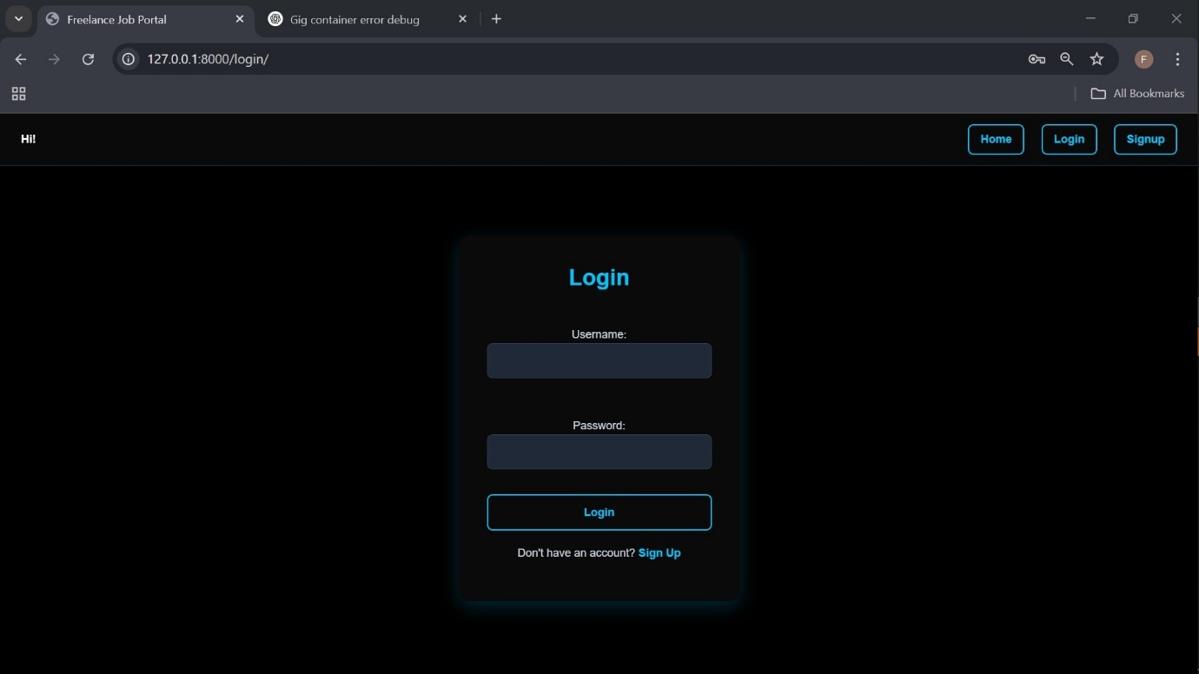

The Signup page:

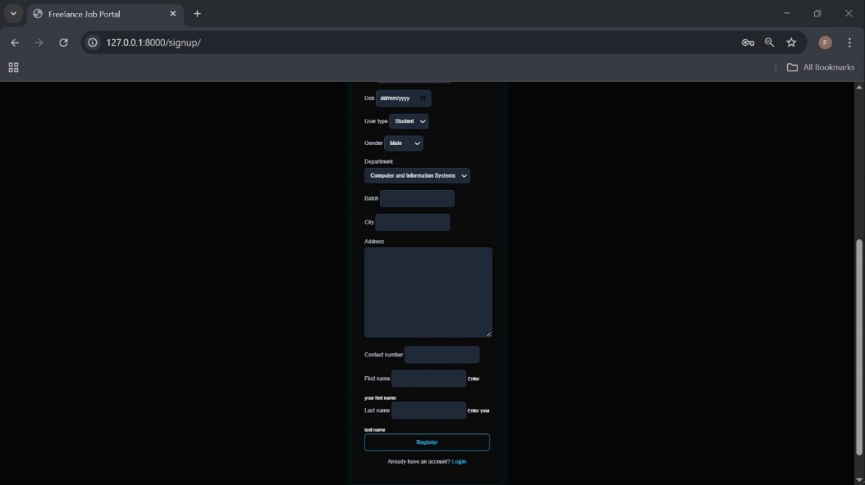
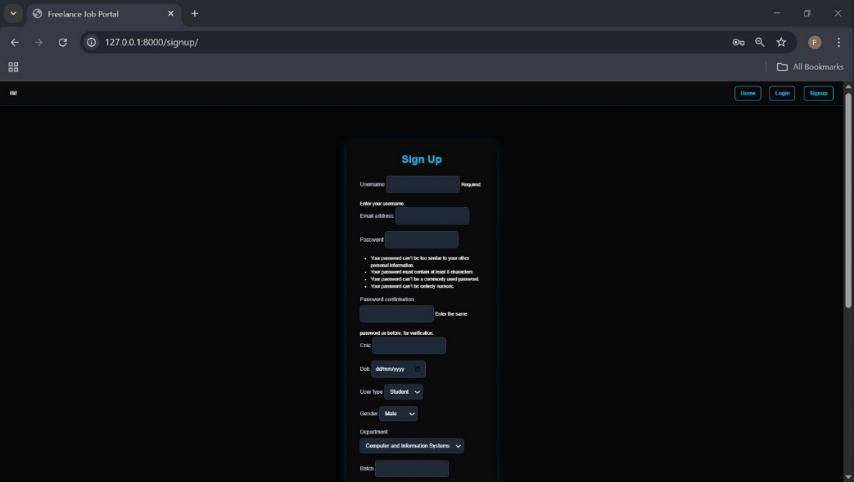

Freelancer Public Profile:
The public profile of the freelancer which everyone can see when they click on the owner’s gig’s username, it shows all the gigs created by the freelancer, their skills and qualifications as well.

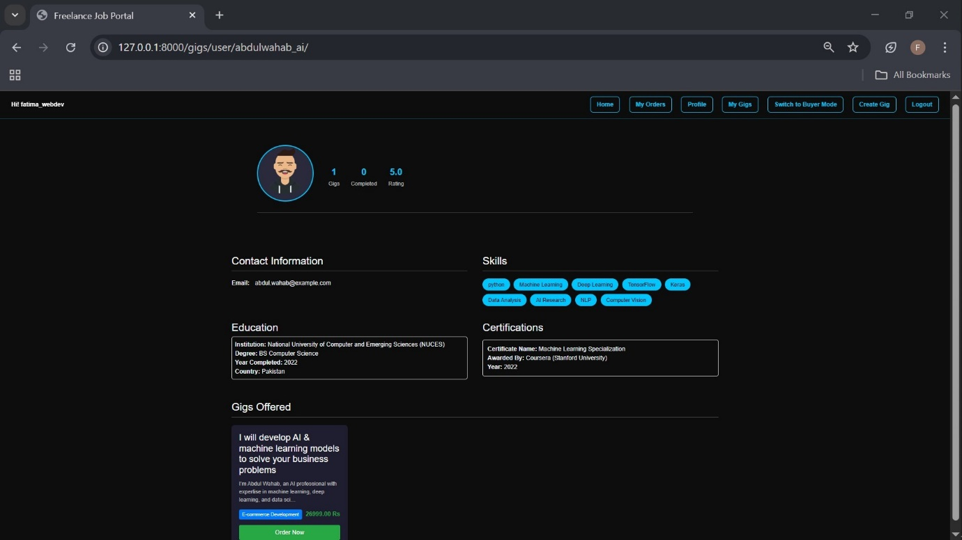

Category Filter:
Users can filter gig’s categories to help them find a certain gig easier and more efficiently.
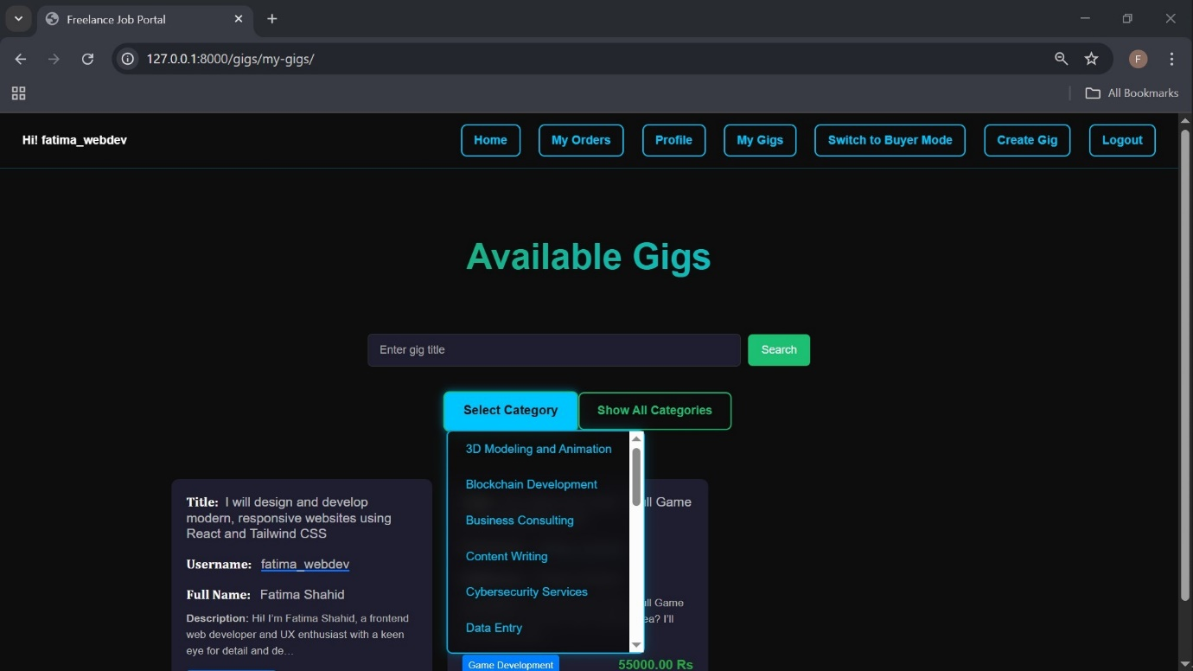

- About the creators:




As a non-authenticated User:

1 ) Error handling (Pop Up Messages)
The pop up message is shown to the user if the user tries to order a gig while not logged in.
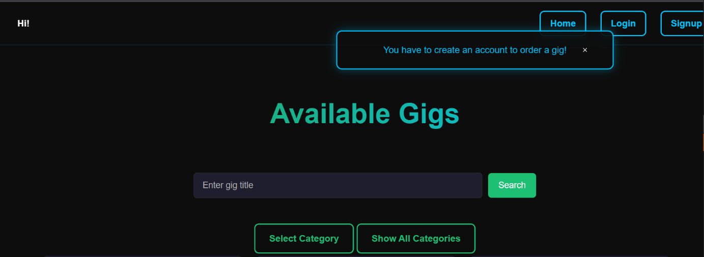

As a Buyer:

1) Home Page



2) Profile page of Buyer:
The profile page contains all the necessary information related to the buyer including the email, gender, Department, Batch and City.

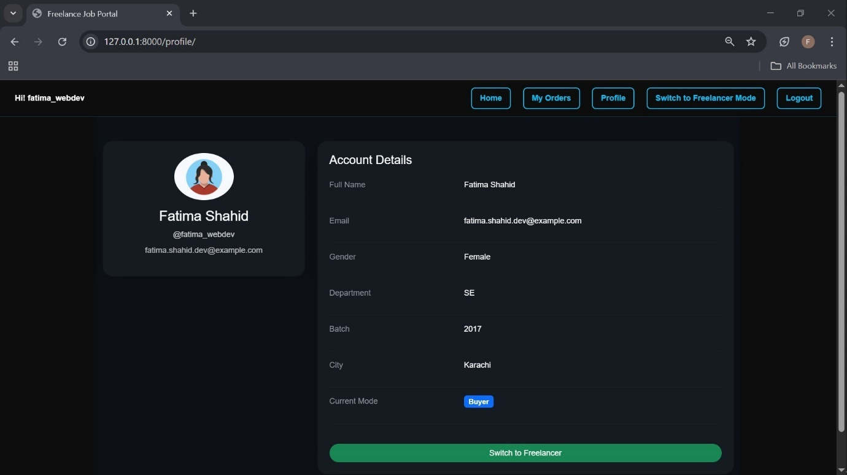

7.4 As a Freelancer:

3) Error Handling:
The buyer cannot buy his/her own gig.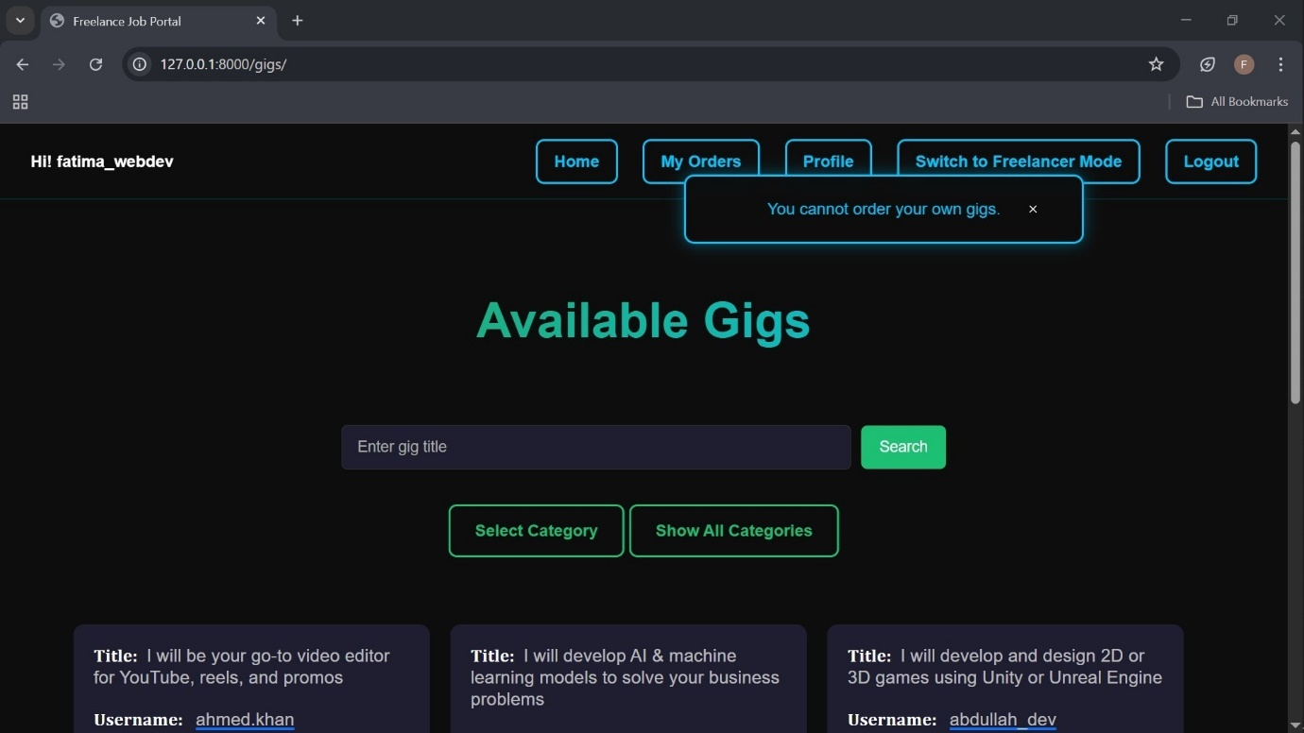

4) Order Summary Page:

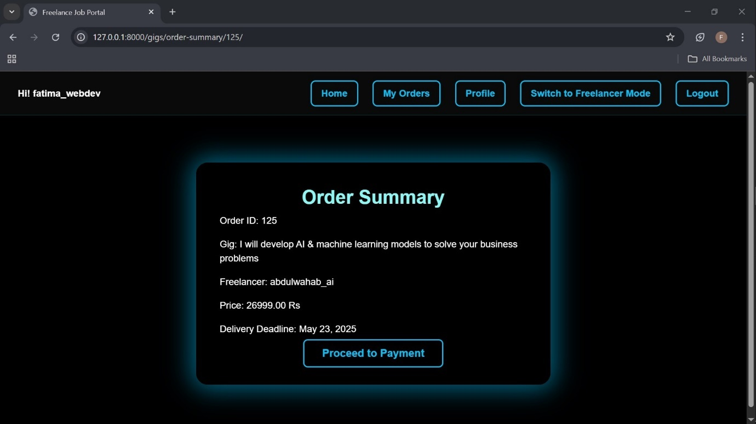

5)Payment Page
It includes the information about the payment method.
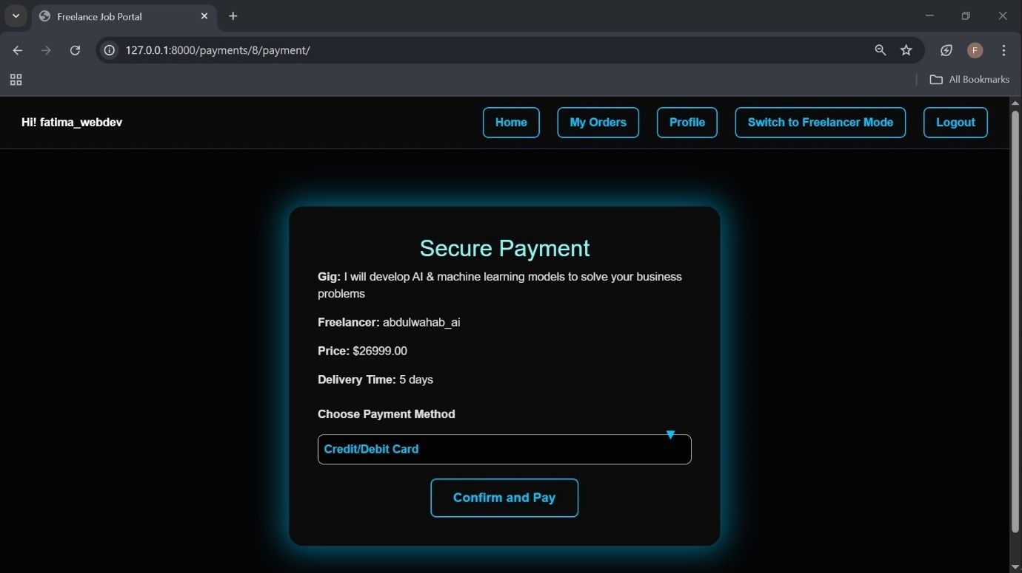

Order Confirmation Page:

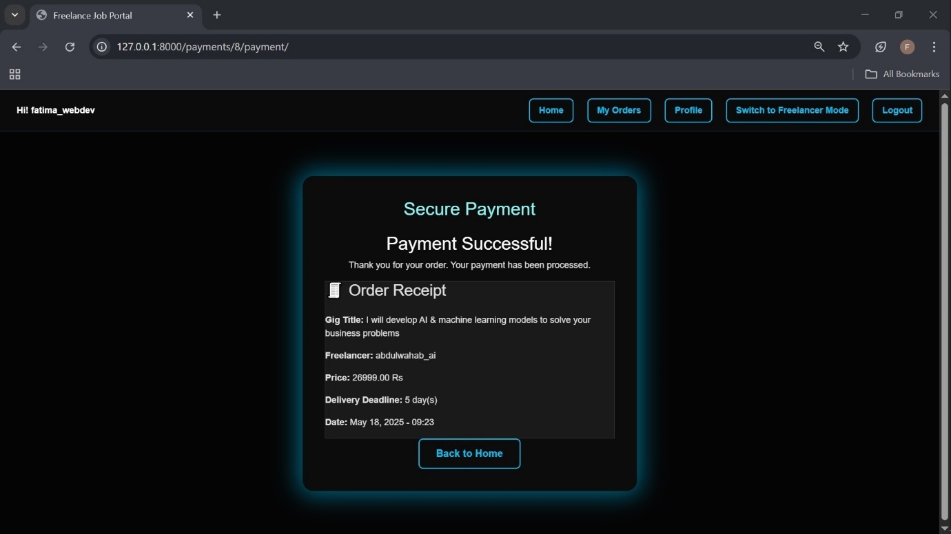

My Orders Page:
The buyer can view all his/her received/not received orders in this page.

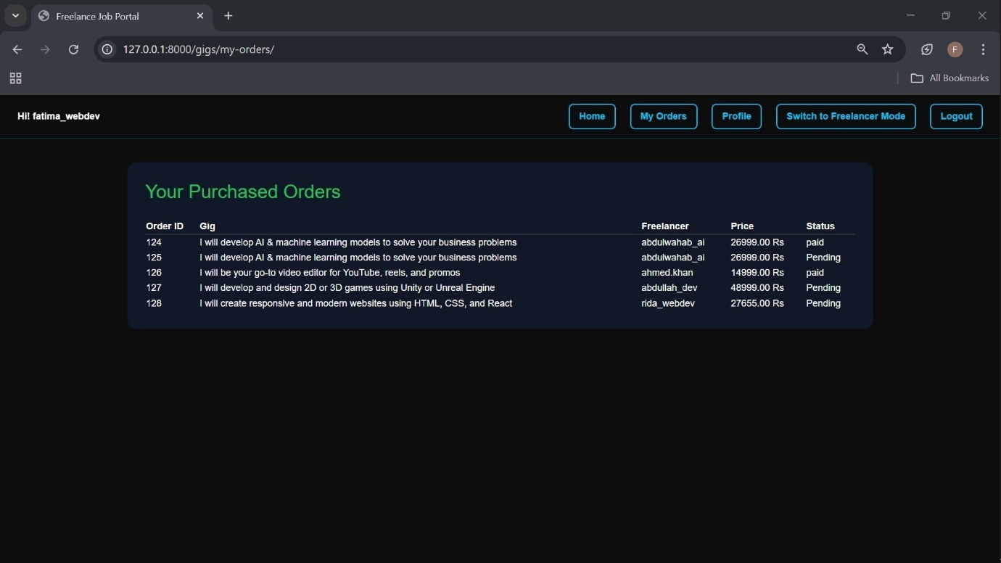

As Freelancer:

1)Freelancer’s Profile Page:
It contains all the necessary information related to the freelancer including education and certification.
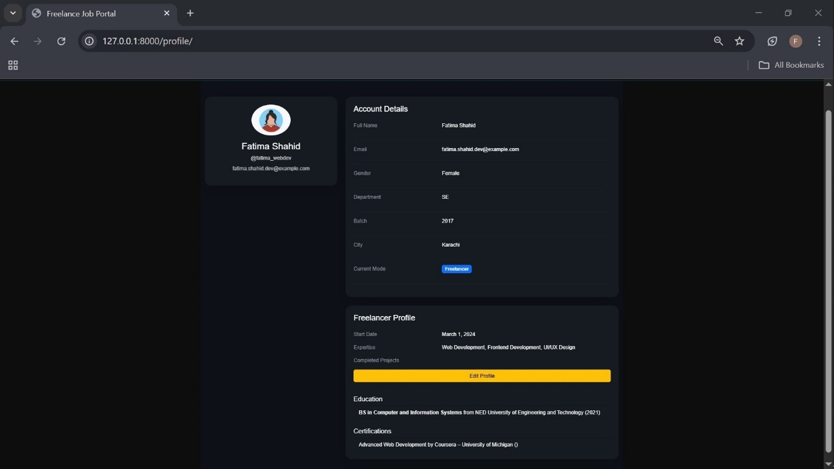

2)Gigs Page for Freelancer:
The freelancer cannot buy any gig unless it switches to buyer mode.
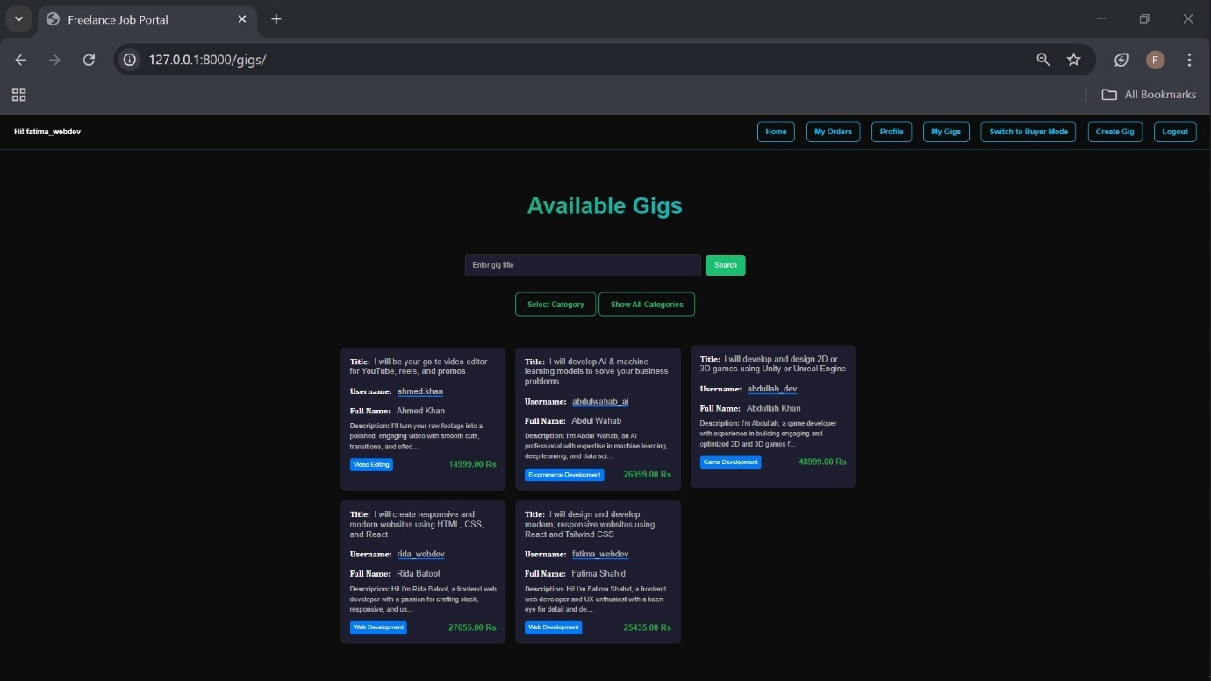

3)Gigs created by Freelancer:

A freelancer can view his/her created gigs on a separate page.
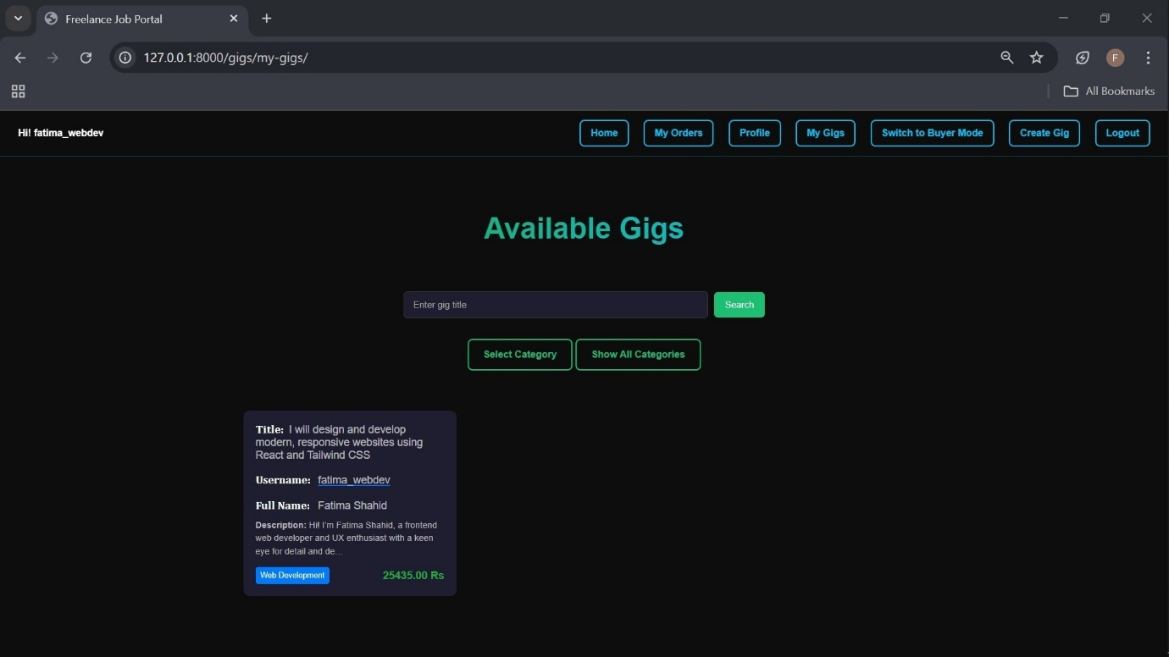

4)Gig Creation (Step 1):
In this step, freelancer will enter the title and category for the gig to be created.
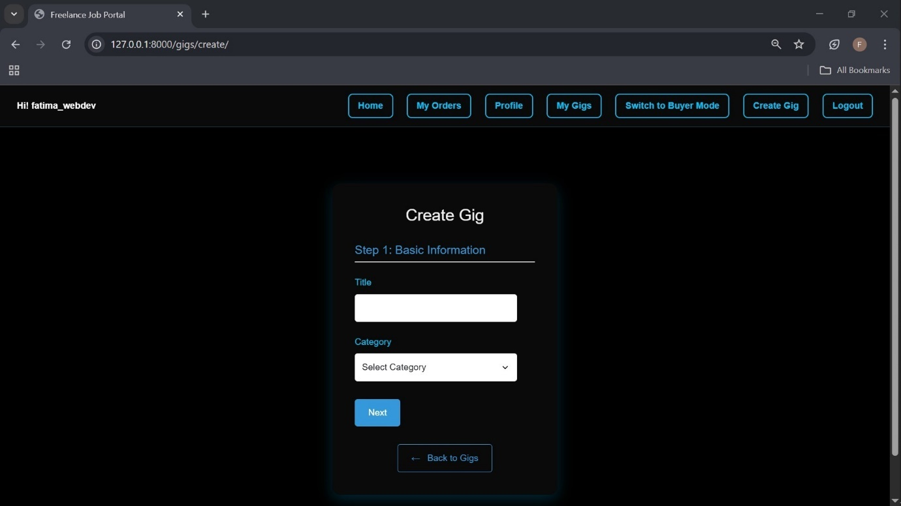

5)Gig Creation (Step 2):
In this step, the freelancer will enter the description for the gig to be created.
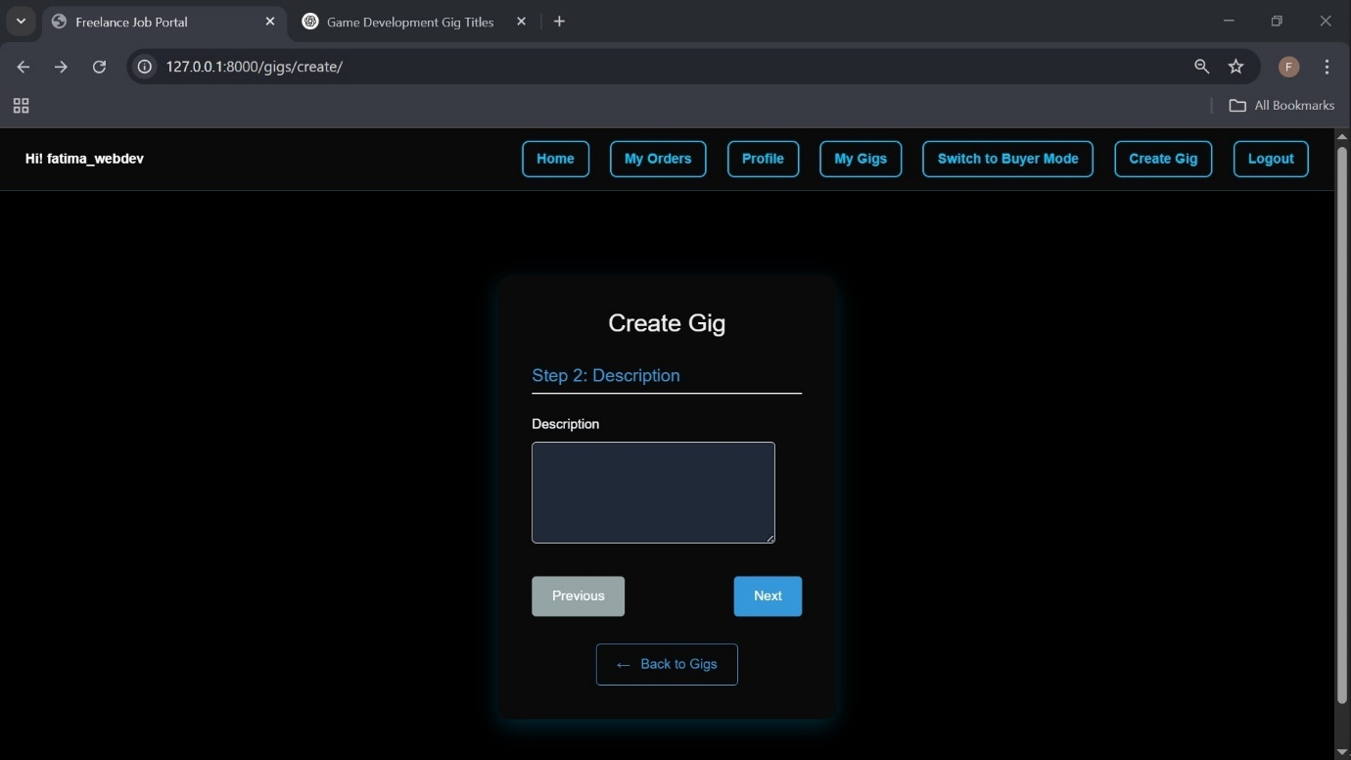

6)Gig Creation (Step 3):
In this step, the freelancer will decide the price and delivery time for the gig.
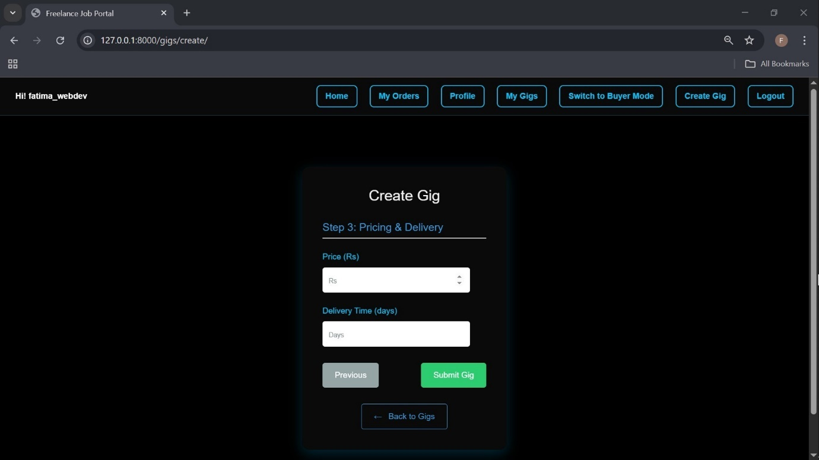

7)My Orders – Freelancer’s received orders page:
Here, freelancer can view all the received and delivered orders .
- Update Status Button: To update the status of order from pending to paid.
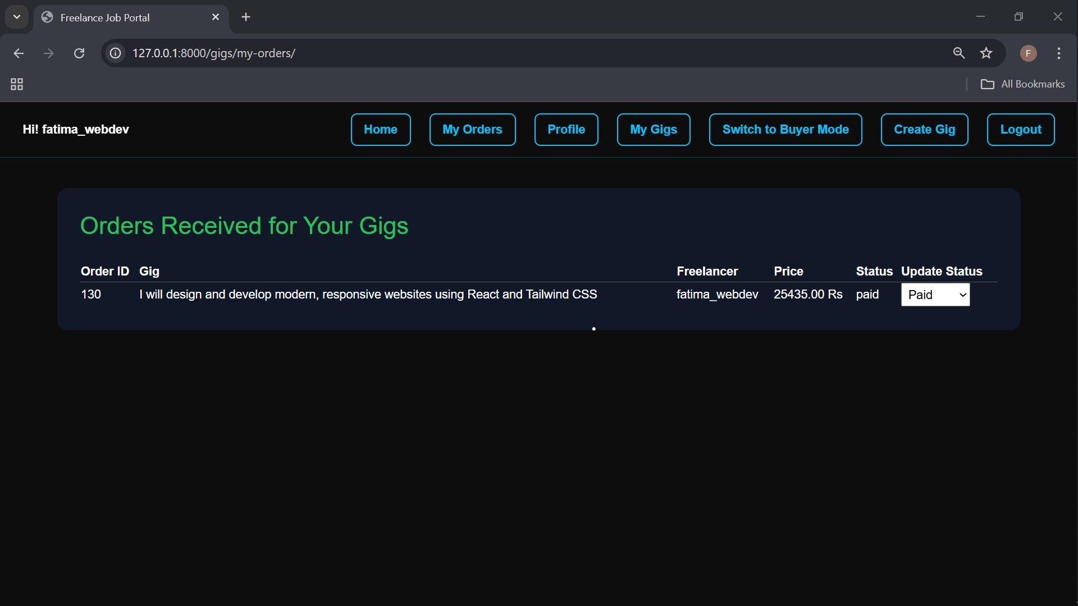

8)Freelancer Registration Form:

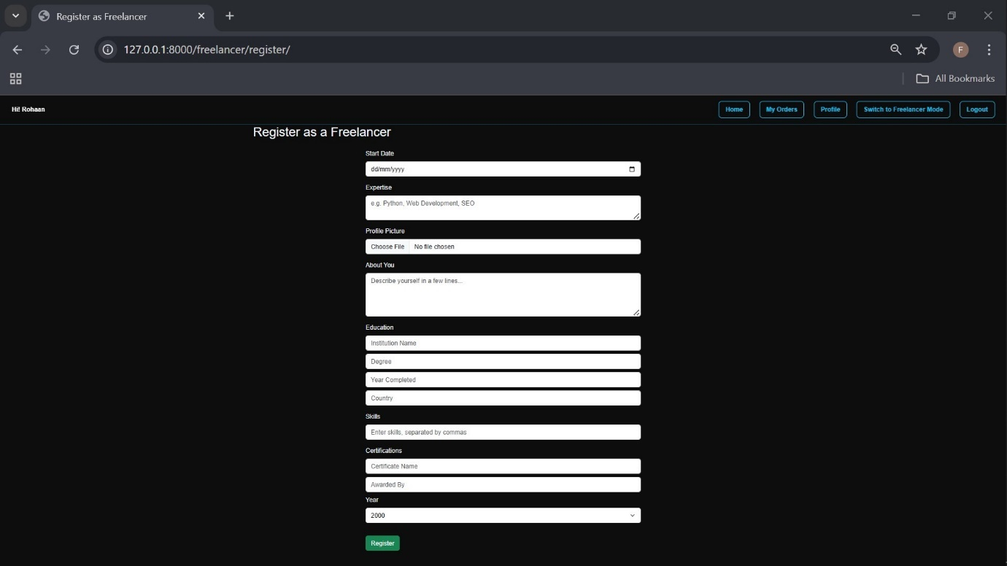

8. ER – Diagram :
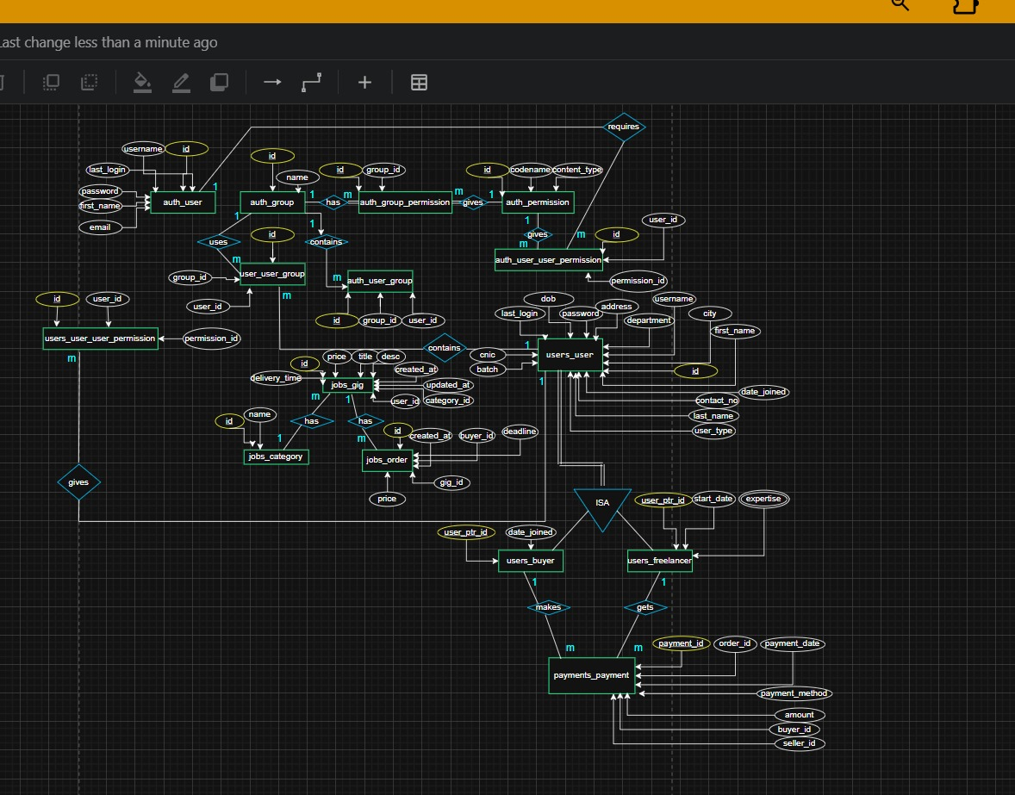

9. Normalization :
The tables are already normalized.

