

Computer Communication Networks (CS-327)
Department of Computer Systems Engineering

Name: Fatima Shahid

Roll No.: CS-23007

Section: A

Submitted to: Sir Nabeel

ASSIGNMENT 01

Q. No. 01 (CLO 1): Identify and illustrate the type of physical media used for your home internet connection
The image below shows the physical media used for my home internet connection. The connection uses fiber optic technology, which is evident from the yellow fiber optic cable plugged into the PON (Passive Optical Network) port of the modem.
Fiber optic cables provide high-speed, reliable internet and are commonly used in modern broadband setups.
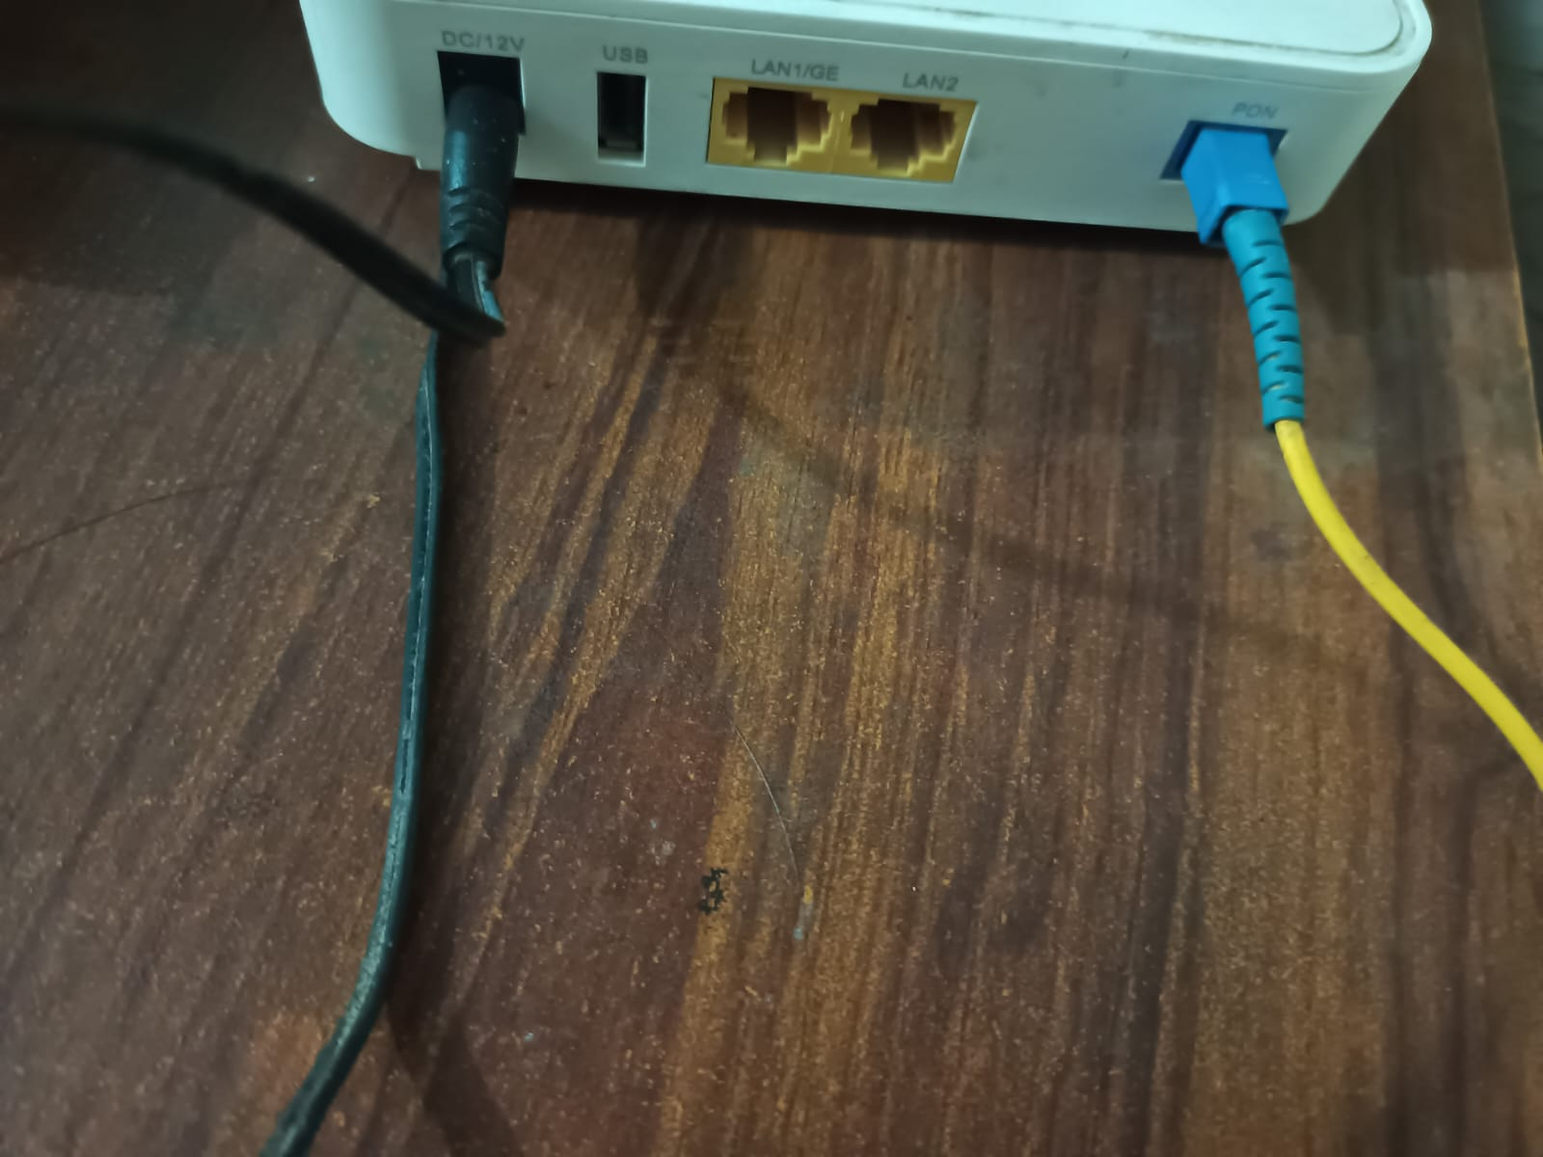
Snapshot of Physical Media

Communication Links in My Home Network Setup:
- Fiber Optic Line (PON) – Internet from ISP
- Ethernet cables (LAN1/GE, LAN2) – To desktop/laptop
- Wi-Fi – To mobile devices, smart TVs, etc.
- USB Port – Optional connection for shared storage
- Power Cable (DC/12V) – Power supply to modem

Illustration:

iintern Fiber Optic line
Internet Service Provider
Edge Router

Wireless (Wifi):
Smart phone
Laptops
Smart tv

Q. No. 02 (CLO 2): Explain at least five commonly used network services
- Web (HTTP/HTTPS)
Allows users to access websites via browsers. HTTPS ensures encrypted, secure communication.
- Email (SMTP, POP3, IMAP)
Enables sending (SMTP : Simple Mail Transfer Protocol) and receiving (POP3 : Post Office Protocol version 3, IMAP : Internet Message Access Protocol) of emails over the network.
- DNS (Domain Name System)
It is a network service that converts human-friendly domain names (e.g., google.com) into IP addresses.
- File Transfer Service (FTP : File Transfer Protocol)
Used to transfer files between client and server over a network.
- VoIP (Voice over IP)
Allows voice communication over the internet (e.g., Skype, WhatsApp calls).

Q. No. 03 (CLO 3): Compare at least 3 server and 3 desktop machines from different vendors
Servers Comparison
Server | CPU | RAM | Storage | Networking | Price | Features
Dell PowerEdge R650 | Xeon Gold | 128GB | 2TB SSD | Dual 10GbE | $5,000 | Scalable and modular
HP ProLiant DL380 Gen10 | Xeon Silver | 64GB | 1.2TB SAS | Dual 1GbE | $4,200 | High-security infrastructure
Lenovo ThinkSystem SR650 | Xeon Gold | 96GB | 2TB HDD | Dual 10GbE | $4,800 | Energy efficient
Desktops Comparison
Desktop | CPU | RAM | Storage | Networking | Price | Features
Dell OptiPlex 7000 | Intel i7 | 16GB | 512GB SSD | Gigabit LAN | $1,000 | Compact, business-ready
HP EliteDesk 800 G6 | Intel i5 | 8GB | 256GB SSD | Gigabit LAN | $850 | Secure, space-saving design
Lenovo ThinkCentre M80t | Intel i7 | 16GB | 1TB HDD | Gigabit LAN | $950 | Energy Star Certified

Q. No. 04: List down host devices (10)
- Laptop
- Desktop PC
- Smartphone
- Tablet
- Smart TV
- Wi-Fi Printer
- Smart Speaker
- Gaming Console
- IP Camera
- Smart watch

