DEPARTMENT OF COMPUTER & INFORMATION SYSTEMS ENGINEERING BACHELORS IN COMPUTER SYSTEMS ENGINEERING
Course Code: CS-324
Course Title: Machine Learning
Complex Engineering Problem
TE Batch 2023, Spring Semester 2026
Grading Rubric 1: Final Model Implementation and Evaluation (Milestone 3)
TERM PROJECT
Student No. | Name | Roll No.
S1 | Muhammad Abdullah | CS-033
S2 | Fatima Shahid | CS-007
S3 | Asra Siddiqui | CS-006
S4

CRITERIA AND SCALES |  |  |  | Marks Obtained
 |  |  |  | S1 | S2 | S3 | S4
Criterion 1: Model implementation and fulfillment of technical requirements.
(CPA-1, CPA-3) [3 marks]
1 | 2 | 3 | 4
Required models are not implemented or are  incorrectly implemented. | Some required models are implemented, but with major issues. | All required models are implemented correctly with minor issues. | All required models are correctly implemented and fully meet the project  requirements.
Criterion 2: Comparative analysis, evaluation, and discussion.
(CPA-1, CPA-2) [2 marks]
1 | 2 | 3 | 4
No meaningful  evaluation or  comparison is provided. | Limited evaluation and comparison with weak analysis. | Adequate evaluation and comparison with  reasonable analysis. | Thorough evaluation, clear comparisons, and  insightful discussion of results.
Criterion 3: Report quality and adherence to format.
[2 marks]
1 | 2 | 3 | 4
The report is poorly  written and does not  follow the given format. | The report partially follows the format and lacks  clarity. | The report follows the format with minor  formatting or clarity  issues. | The report is clear, well written, and fully adheres to the given format and requirements.
Criterion 4: jIndividual contribution, teamwork, and viva performance.
(CPA-1, CPA-2, CPA-3) [3 marks]
1 | 2 | 3 | 4
The student did not  contribute meaningfully and could not explain the work. | The student contributed partially and showed  limited understanding. | The student contributed satisfactorily and  explained the work  adequately. | The student demonstrated strong contribution,  teamwork, and excellent understanding during viva.

Score = (Criteria_1_score ) + (Criteria_2_score) + (Criteria_3_score) + (Criteria_4_score) = ______________
____________________
Teacher’s Signature

1. Introduction
Football is one of the world's most data-rich sports. Every Premier League season produces hundreds of matches, each generating detailed statistical records, goals scored, shots on target, results, and more. The central question this project addresses is: given a team's performance over a full season, can we predict how many points that same team will earn in the following season?

This project frames the problem as a supervised regression task. The prediction target, PTS_next, is the total points a team earns in the season immediately following the one described by the input features. Points capture the net effect of a team's wins, draws, and losses (Win = 3 pts, Draw = 1 pt, Loss = 0 pts) and directly determine final league standings.

Three model families were implemented and compared: Parametric models (Linear Regression, Ridge, Lasso), Non-parametric models (Decision Tree Regressor with three depth variants), and a custom Neural Network implemented from scratch in NumPy. Ensemble methods (Random Forest and Gradient Boosting) were then applied on top of the best individual model. The final deliverable is a saved Random Forest model exposed via a Flask REST API for real-time predictions.

2. Data Preprocessing : Cleaning, Normalisation, Encoding & Augmentation
This section describes every preprocessing step applied to the raw Premier League CSV files before any model was trained. The steps are presented in the exact order they were executed in the notebook.

2.1 Raw Data Loading and Column Selection
Seven CSV files were loaded, covering Premier League seasons from 2018/19 through 2024/25. Each file contains one row per match. From each file, only nine columns were retained:
- HomeTeam, AwayTeam : team identity strings for home and away sides
- FTHG (Full-Time Home Goals), FTAG (Full-Time Away Goals) : final goal tallies
- FTR (Full-Time Result: H/D/A) : match outcome used to determine wins, draws, losses
- HS, AS (Home/Away Shots total) : loaded but ultimately not used as model features
- HST, AST (Home/Away Shots on Target) : retained as the basis for SOT_per_match
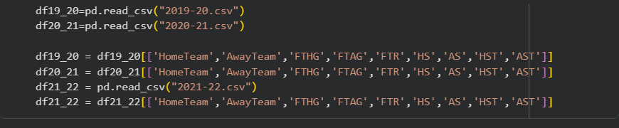
All other columns present in the original CSVs, fouls, yellow cards, red cards, corners, half-time scores, and betting odds. were excluded. These columns carry noise at the individual-match level and cannot be aggregated cleanly into season-level predictors of future performance without introducing confounding effects.

2.2 Home / Away Split and Season Aggregation (Data Cleaning & Restructuring)
Each match contributes statistics to two teams simultaneously: the home team and the away team. To build a single season-level row per team, the following steps were applied identically for each of the six training seasons:
- A home DataFrame was created assigning each match's home-side statistics to the HomeTeam: MatchesPlayed = 1, Win if FTR == 'H', Draw if FTR == 'D', Loss if FTR == 'A', GF = FTHG, GA = FTAG, ShotsOnTarget = HST.
- An away DataFrame was created in parallel, inverting the logic: Win if FTR == 'A', GF = FTAG, GA = FTHG, ShotsOnTarget = AST.
- Both DataFrames were concatenated via pd.concat, producing one row per team-match appearance.
- The combined DataFrame was grouped by Team using groupby('Team').sum(), collapsing each team's 38 individual-match rows into a single aggregated row covering the full season.

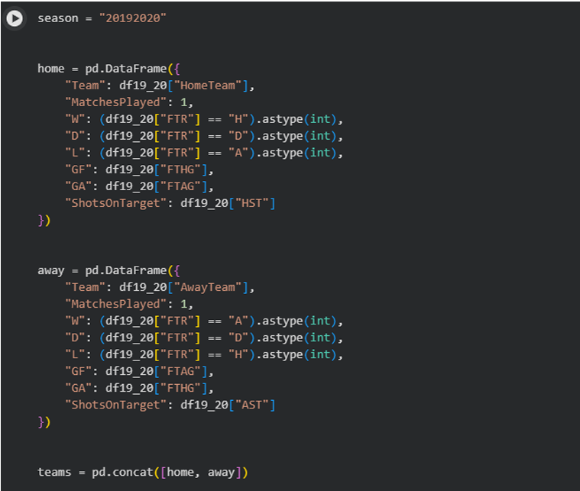
This aggregation step is the primary cleaning operation. By design, the raw CSVs contain no missing values for the nine retained columns, a fact verified programmatically using isnull().sum() (result: 0 for all columns). No imputation was therefore required.

2.3 Feature Engineering (Derived Metrics)
Three new features were computed from the aggregated columns after groupby:
- GD (Goal Difference) = GF - GA. This is the official Premier League tiebreaker when two teams are level on points. It is computed as a derived feature rather than a raw aggregate to avoid double-counting errors.
- PTS (Points) = W * 3 + D. The standard Premier League scoring rule. Used only for sorting and labelling; it is not passed directly as a model input feature.
- SOT_per_match (Shots on Target per Match) = ShotsOnTarget / MatchesPlayed. The raw total of shots on target correlates with MatchesPlayed by definition. Normalising to a per-match rate removes this spurious scale dependency and makes the metric comparable across partial and full seasons.
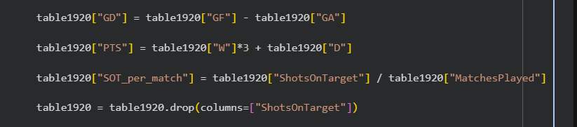
After computing SOT_per_match, the raw ShotsOnTarget column was dropped. The total shots columns (HS, AS) were never aggregated into the season table and were discarded at the loading stage. These decisions kept the feature space focused on efficiency rather than volume metrics.

Each season table was sorted by PTS, then GD, then GF (descending) to replicate the official league table ordering. A positional column (POS) was inserted but immediately excluded from the model feature set, as position is a rank directly derivable from points and goal difference, including it would be direct data leakage of the label.

2.4 Target Label Construction (PTS_next)
The supervised learning label for each season is the total points earned by the same team in the immediately following season. Concretely, for the 2019/20 season table the label is built from the 2020/21 CSV:
- The next-season CSV was filtered to only Wins and Draws per team.
- Points were computed as W * 3 + D and stored in a column PTS_next.
- This label table was merged onto the current season's aggregated table using an inner join on the Team column.
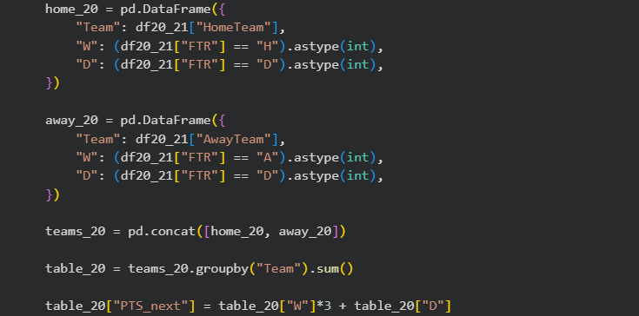
The inner join is a deliberate data cleaning decision. Teams that were relegated at the end of a season do not appear in the following season's top-flight data. Likewise, newly promoted teams have no prior-season statistics. The inner join automatically excludes both groups, retaining only the approximately 17 teams that remained in the Premier League across both seasons. Roughly three teams are dropped per pair of consecutive seasons. While this reduces the dataset to approximately 102 rows across all six training pairs, it is preferable to imputing unknown labels for teams that did not play in the top flight.

2.5 Categorical Encoding : One-Hot Encoding of Team Names
The Team column contains string values representing club names (e.g., 'Arsenal', 'Chelsea'). Machine learning models require numeric inputs, so team identity was encoded using one-hot encoding:
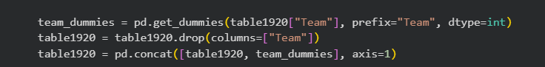
Label encoding was rejected because it assigns ordinal integers (Arsenal = 0, Chelsea = 1, …) implying a false numerical order among clubs. When all season tables were concatenated into a single full_data DataFrame, teams present in some seasons but not others produced NaN values in their dummy columns, which were filled with 0 using X.fillna(0).
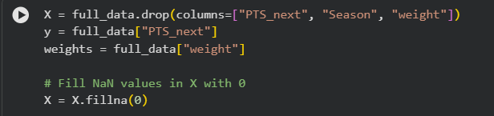

2.6 Temporal Sample Weighting (Augmentation-Style Reweighting)
To account for the fact that football dynamics evolve over time, tactical shifts, transfer market inflation, rule changes, a numerical season index was mapped to each row and used as a sample weight during model fitting:
- Season 2018/19 → Season_num = 1
- Season 2019/20 → Season_num = 2
- Season 2023/24 → Season_num = 6 (most recent training season)

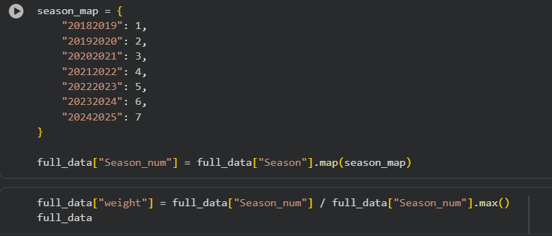
The weights were linearly scaled from approximately 0.17 (oldest season) to 1.0 (most recent).

The weights array was split in parallel with the feature matrix X and target y during train-test split, ensuring perfect alignment when passed to each sklearn model's fit(X_train, y_train, sample_weight=w_train) call.

2.7 Normalisation for Neural Network Models
All sklearn models (linear regression variants and decision trees) work adequately on un-normalised data. However, the custom NumPy neural network requires feature scale normalisation to ensure stable gradient descent:
- Z-score normalisation was applied to the neural network inputs: X_norm = (X - mean) / (std + 1e-8), where mean and std were computed exclusively from X_train to prevent test set information leaking into the normalisation parameters.
- Columns whose standard deviation on X_train was exactly zero (columns that are constant within the training split, such as team dummies for teams appearing in only one season) were identified and dropped before normalisation to avoid division-by-zero.
- Normalised values were clipped to the range [−3, +3] to prevent outlier teams (e.g., a dominant team with GD = 70 giving a z-score of +4.5) from causing outsized gradient updates during early training epochs.
- The scaler statistics (mean, std) were saved to Google Drive using np.savez so that the same normalisation could be applied to any new input during inference without recomputing from scratch.

2.8 Summary of Preprocessing Decisions

Step | Decision Made | Reason / Outcome
Column selection | Retained 9 of ~60+ raw columns | Removed noise; focused on goal/result/shot events
Missing values | Verified 0 NaN | Inner join ensures complete rows; CSVs are clean
Duplicate check | No duplicates found | groupby produces one unique row per team per season
Home/Away split + groupby | Each game counted twice (home + away perspectives) | Symmetric 38-match season totals per team
GD derivation | Computed after sum, not before | Avoids double-aggregation of difference metric
SOT_per_match | Normalised shots on target by matches played | Removes volume dependency; scale-invariant efficiency
Drop raw ShotsOnTarget | Removed after deriving per-match rate | Avoids multicollinearity; cleaner feature space
Drop POS | Position column excluded from features | Direct derivative of PTS, would be data leakage
Target label (inner join) | Dropped relegated/promoted teams (~3/season) | Avoids imputing unknown next-season points
One-hot encoding | pd.get_dummies, prefix='Team_', dtype=int | No ordinal assumption; leakage-free; interpretable
fillna(0) on team dummies | Teams absent in some seasons get dummy = 0 | Prevents NaN propagation in sklearn models
Season weighting | Linear scale 0.17 → 1.0 by recency | Prioritises recent patterns; retains all data
Z-score + clip ±3 (NN only) | Applied to NN inputs only | Gradient stability; outlier robustness

3. Machine Learning Models and Algorithms
Nine individual models spanning three families were implemented, followed by ensemble and hyperparameter-tuning stages. All models were trained on the same 80% training split (random_state = 42) and evaluated on the same 20% test split, with the exception of the neural network which used a chronological split.

3.1 Family 1: Parametric Models : Linear Regression Variants
All three linear models assume that PTS_next is a linear combination of the input features. They differ only in the regularisation penalty added to the loss function.

Model 1A: Standard Linear Regression
Linear Regression minimises the weighted sum of squared residuals with no regularisation penalty. It is the theoretical baseline for regression tasksLibrary: sklearn.linear_model.LinearRegression
- Hyperparameters: The defaults were choosen
- Training call: lr1.fit(X_train, y_train, sample_weight=w_train)

Model 1B: Ridge Regression (L2 Regularisation)
Ridge was expected to outperform OLS by reducing the variance inflation caused by multicollinearity.
- Library: sklearn.linear_model.Ridge
- alpha: 1.0 (sklearn default; a conservative starting point)
- Training call: lr2.fit(X_train, y_train, sample_weight=w_train)

Model 1C: Lasso Regression (L1 Regularisation)
Lasso adds the penalty α × Σ|βᵢ|. Unlike Ridge, the L1 norm can drive individual coefficients to exactly zero, performing implicit feature selection. This was expected to zero out the binary team dummy columns that carry little predictive signal for any single team in a small dataset.
- Library: sklearn.linear_model.Lasso
- alpha: 0.1 (smaller than Ridge because L1 penalises more aggressively per unit)
- max_iter: 10,000 (increased from the default 1,000; with 30+ sparse team dummy features, coordinate descent requires more iterations to converge without warnings)
- Training call: lr3.fit(X_train, y_train, sample_weight=w_train)

3.2 Family 2: Non-Parametric Models : Decision Tree Regressor
Decision Tree recursively partition the feature space using threshold-based splits that minimise mean squared error within each resulting leaf node. Three depth variants were trained to explicitly demonstrate the bias-variance tradeoff.

Model 2A: Decision Tree, max_depth = 3
A shallow tree with at most 8 leaf nodes. It captures only the most dominant global patterns in the data without memorising individual training samples. This is the most regularised (highest bias, lowest variance) variant.
- Library: sklearn.tree.DecisionTreeRegressor
- max_depth: 3, random_state: 42
- Training call: dt1.fit(X_train, y_train, sample_weight=w_train)

Model 2B: Decision Tree, max_depth = 5
A medium-depth tree allowing up to 32 leaf nodes. This is an intermediate setting intended to reveal whether additional depth provides meaningful accuracy improvements or begins to overfit.
- max_depth: 5, random_state: 42

Model 2C: Decision Tree, max_depth = 10
A deep tree with up to 1,024 possible leaf nodes. With approximately 82 training rows, a depth-10 tree can create leaf nodes containing as few as one or two samples, effectively memorising the training data. This variant was deliberately included to demonstrate overfitting, a textbook case of excessive model complexity on small datasets.
- max_depth: 10, random_state: 42

3.3 Family 3: Custom Neural Network (NumPy Implementation)
A feedforward neural network was implemented entirely from scratch using NumPy, no PyTorch, TensorFlow, or Keras. This was done to demonstrate a complete understanding of the forward pass, loss computation, backpropagation, and gradient descent update rules rather than delegating these to an automatic differentiation library.

Architecture
The network has three layers: an input layer (number of features), two hidden layers with Leaky ReLU activations, and a single linear output unit for regression. The activation function used is Leaky ReLU defined as max(0.01z, z) for each pre-activation z. This function prevents the 'dying ReLU' problem where neurons can permanently output zero if their pre-activations are consistently negative, a risk with very small weight initialisations.

Initialisation
All weights were initialised by drawing from a zero-mean Gaussian distribution with standard deviation 0.001. This very small initialisation was chosen to prevent the exploding gradient problem during the first forward passes, which is especially dangerous with un-normalised or partially normalised features.

Gradient Clipping
After each backward pass, all gradient tensors were clipped element-wise to the range [−1, +1] before being applied to the weights. This is a standard technique for preventing a single update step from catastrophically altering the weights, which would cause training loss to diverge (observed as NaN values in preliminary experiments without clipping).

Three NN Variants Trained
- NN Model 1: Hidden layers h1 = 16, h2 = 8; learning rate lr = 0.00001; epochs = 1,000
- NN Model 2: Hidden layers h1 = 32, h2 = 16 (wider); learning rate lr = 0.0001; epochs = 1,500
- NN Model 3: Hidden layers h1 = 16, h2 = 8 (same as Model 1); learning rate lr = 0.001; epochs = 800

The three variants systematically explore the joint effect of architecture width and learning rate. Models 1 and 2 used very low learning rates and consequently converged too slowly, d the loss plateaued at a high value, resulting in strongly negative R² scores. Model 3, with a learning rate three orders of magnitude larger than Model 1, converged meaningfully within 800 epochs and achieved an R² of approximately 0.277.

Temporal Train / Validation / Test Split for Neural Networks
Unlike the sklearn models which used a random 80/20 split, the neural network used a chronological split to prevent future data from influencing model weights:
- Training set: Seasons 1–4 (2018/19 to 2021/22)
- Validation set: Season 5 (2022/23), used to monitor convergence
- Test set: Seasons 6–7 (2023/24 and 2024/25)

The scaler (mean and standard deviation) was fitted on the training set only and applied identically to the validation and test sets to prevent data leakage.

4. Model Performance Comparison

4.1 Evaluation Metrics
Three standard regression metrics were used:
- MSE (Mean Squared Error): the average of squared residuals. Penalises large errors more heavily. Units: points².
- RMSE (Root Mean Squared Error): the square root of MSE, expressed in the same unit as PTS_next (points). Easier to interpret, an RMSE of 16 means predictions are off by roughly 16 points on average.
- R² (Coefficient of Determination): the proportion of variance in PTS_next explained by the model. R² = 1.0 is a perfect predictor; R² = 0 is equivalent to always predicting the mean; R² < 0 is worse than predicting the mean.

4.2 Results Table

Table 1: Performance comparison of all models sorted by R2.
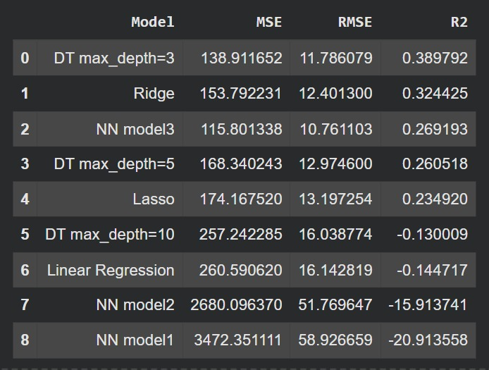

4.3 Graphical Comparison:.
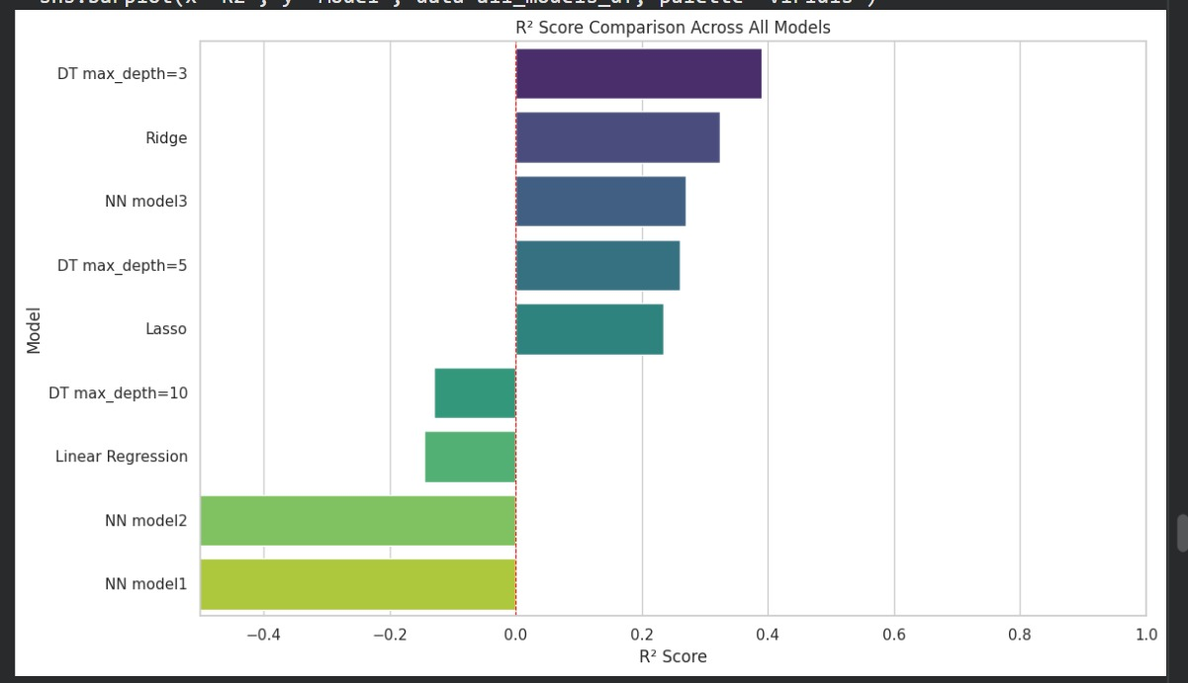

Based on the comparison, the Decision Tree model with max_depth = 3 was selected as the best-performing model because it achieved the highest R² score among the initial models while maintaining relatively low MSE and RMSE values. This indicates that the model provided the best balance between prediction accuracy and generalization performance..

4.4 Analysis — Underfitting, Overfitting, and Appropriate Fit

Underfitting: Linear Models
All three linear models (OLS, Ridge, Lasso) produced either negative or modest R² values. OLS achieved R² = −0.14, meaning it predicted next-season points less accurately than simply predicting the mean every time. Ridge recovered somewhat (R² = 0.324) by controlling multicollinearity, and Lasso was comparable. This consistent pattern across all three linear variants is strong evidence that the relationship between current-season statistics and next-season points is inherently non-linear. Linear models impose too rigid a functional form on the data, causing systematic underfitting regardless of how well the regularisation parameter is tuned.

Overfitting: Deep Decision Tree
Decision Tree at max_depth = 10 achieved R² = -0.130009 despite having the potential to partition the training data into over 1,000 leaf regions. Decision trees with large depth tend to memorize training data. Its performance is actually worse than shallower trees:
- RMSE jumped to 16.03
- R² became negative (-0.13)
Appropriate Fit: Shallow Tree
Decision Tree at max_depth = 3 strikes the right balance, limiting the tree to at most eight partitions of the feature space. Each partition must be supported by enough data points to generalise, so the model captures real patterns (non-linear splits on GD and W) without memorising noise

Neural Network Instability
NN Models 1 and 2 produced R² values of −15 to −20, meaning their predictions were dramatically worse than predicting the mean. This is not a sign that neural networks are inherently unsuitable — it is a sign that training converged poorly due to learning rates that were too small (0.00001 and 0.0001) for the available training epochs. With these learning rates, the weight updates are so tiny that even after 1,000–1,500 epochs the network has barely moved from its initial near-zero weights, producing near-constant predictions that have high error. NN Model 3, with a learning rate of 0.001, achieved meaningful convergence within 800 epochs (R² ≈ 0.277), validating the architecture once the learning rate was appropriate.

4.5 Possible Improvement Techniques
* More data. The most impactful improvement would be to include additional leagues (La Liga, Bundesliga, Serie A) and historical seasons going back to 2010. This would grow the training set from ~102 rows to potentially 500+, enabling more complex models to generalise without overfitting..
* Player transfer features. This is singlehandedly the best improvement technique. In football, teams upgrade and degrade every season, A team that finished first last season, may or may not upgrade their team, causing them to lose points the next season, hence why football is an unpredictable game. The model currently has no information about squad changes between seasons. A team that loses its top striker and gains a replacement is meaningfully different from the same team, yet the features look identical. Adding net transfer spending, squad average age, or star-player metrics could substantially reduce the residual unexplained variance.
* Hyperparameter tuning for NN. The NN models were trained with manually chosen hyperparameters. A systematic search over learning rate, hidden layer widths, and number of epochs would likely find a configuration that significantly outperforms the current best NN result.
* Regularised NN with Dropout. Adding dropout layers (randomly zeroing activations during training) would reduce the NN's tendency to overfit on this small dataset, which is the likely reason NN Models 1 and 2 showed extremely negative test R².

5 Optimization of the Selected Model

5.1 Ensemble Methods : Random Forest
After selecting the Random Forest model as the best-performing approach, further optimization was carried out to improve predictive performance. Initially, a baseline Random Forest model was trained using 100 decision trees.
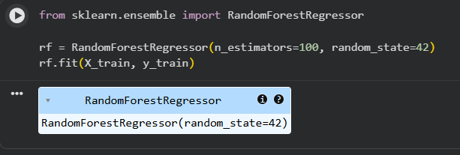

The results were:


This performance was already significantly better than the selected shallow Decision Tree model (max_depth = 3), which achieved an R² score of 0.3898.

5.2 Hyperparameter Tuning using Grid Search
To further improve the model, hyperparameter optimization was performed using scikit-learn GridSearchCV. Multiple parameter combinations were evaluated using 5-fold cross-validation.
The following parameters were tuned:
- n_estimators: [100, 200, 300]
- max_depth: [None, 5, 10, 15]
- min_samples_split: [2, 5, 10]
- min_samples_leaf: [1, 2, 4]
The optimized model (best_rf) was selected based on the highest cross-validation R² score.
The reduction in MSE and RMSE, along with the increase in R² score, indicates that hyperparameter tuning improved the model’s predictive accuracy and generalization capability.

5.3 Time-Series Split Evaluation
To evaluate how well the optimized model generalizes to future seasons, additional time-series split experiments were conducted. Instead of randomly splitting the dataset, earlier seasons were used for training while Season 6 was reserved for testing.
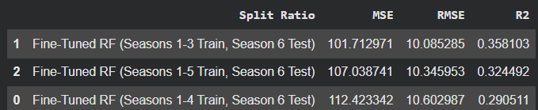
Graphical representation :

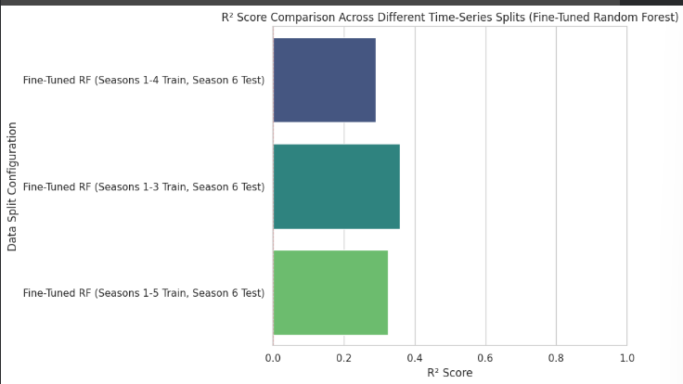

The results show that model performance decreased compared to the random train-test split evaluation. This indicates that predicting future unseen seasons is more challenging and that random splitting may overestimate real-world predictive performance.
Interestingly, the model trained on Seasons 1–3 achieved the highest R² score among the time-series experiments. This suggests that increasing the amount of historical data does not always guarantee improved predictive accuracy, and that more recent or relevant training windows may generalize better to future seasons.

5.4 Model Persistence and Deployment
The final fine-tuned Random Forest model was saved to disk using joblib.dump(final_model, 'final_random_forest_model.pkl'). The joblib library was chosen over Python's built-in pickle because it is specifically optimised for serialising objects containing large NumPy arrays, such as the internal node structures of a scikit-learn forest. The saved file loads in under one second and can be reused across sessions without retraining.
The neural network weights were saved separately in NumPy .npz format using np.savez() and persisted to Google Drive, along with the normalisation statistics (mean and std arrays) in a companion file.

5.5 The Final Model

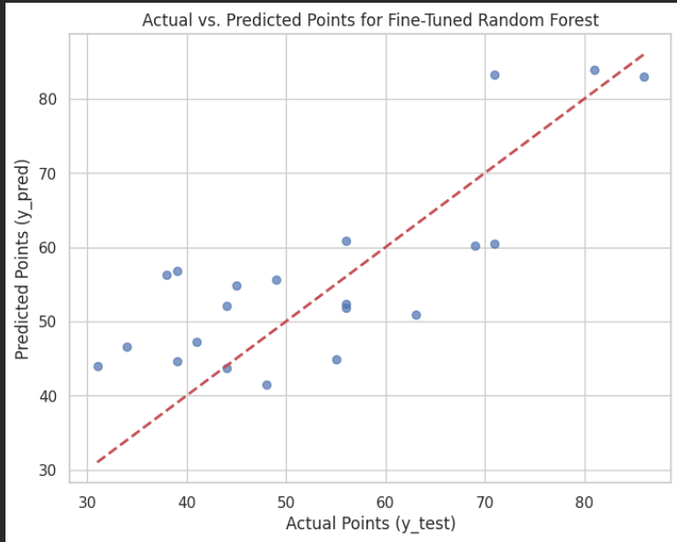
The Fine-Tuned Random Forest model was selected as the final predictive model because it achieved the best overall performance among all evaluated models. The model produced an MSE of 92.97, an RMSE of 9.64, and the highest R² score of 0.5916, indicating that it was able to explain approximately 59% of the variance in next-season points.
The Actual vs. Predicted plot further demonstrates that the model predictions generally follow the overall trend of the true values, with most predictions lying reasonably close to the ideal prediction line. This indicates that the optimized Random Forest model successfully captured meaningful non-linear relationships within the data while maintaining good generalization performance.

5.6 Limitations of the Final Model
- The Fine-Tuned Random Forest model achieved an R² score of 0.5916 rather than 1.0, meaning the model could not perfectly predict next-season points.
- One major limitation was the relatively small dataset. Since only a limited number of seasons were available, the model had less data from which to learn long-term patterns and relationships.
- Player transfer features. This is singlehandedly the best improvement technique. In football, teams upgrade and degrade every season, A team that finished first last season, may or may not upgrade their team, causing them to lose points the next season, hence why football is an unpredictable game. The model currently has no information about squad changes between seasons. A team that loses its top striker and gains a replacement is meaningfully different from the same team, yet the features look identical. Adding net transfer spending, squad average age, or star-player metrics could substantially reduce the residual unexplained variance.Although Random Forest reduces overfitting through ensemble learning, some prediction error still remains due to noise and variability in the data.
- The time-series evaluation also showed lower R² scores compared to random train-test splitting, indicating that predicting completely unseen future seasons is more challenging.
- Therefore, the model should be considered a strong predictive tool rather than a perfectly accurate forecasting system.

6. Test Case Runs
The following three test cases illustrate the model's prediction behaviour across a range of team profiles. Each test case was generated by calling the Flask /predict endpoint (or the get_user_input_for_prediction() console function) with the specified inputs.

Test Case 1 — Strong Title Contender (seen data)
Strong title Contenders are those teams that finish the season with points >=70

The picture below shows Arsenal’s inputted stats of season 2023/2024 (accurate stats from official website), and then the model predicts Arsenal’s points of next season 2024/2025.
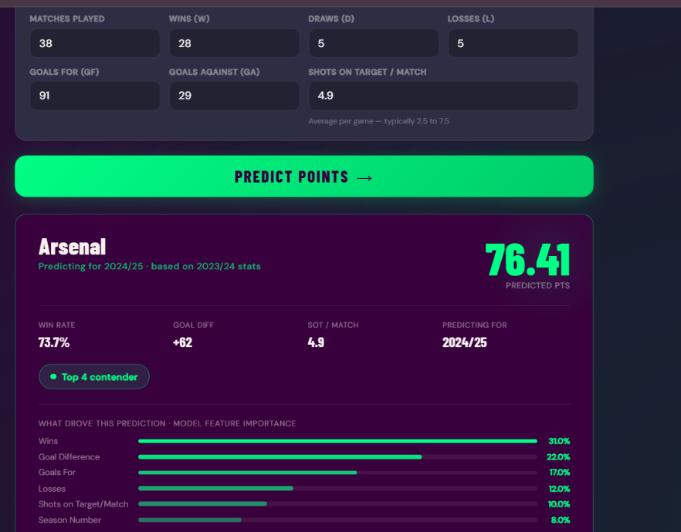

the picture below is the real life stats of Arsenal of season 2024/2025 (78) and our model predicted around 76-77, which is a good estimate. Approximate % error is 2.04%


Test Case 2 — Mid-Table Team (seen data)

Mid table teams are those teams that finish the season with points >=40 but <70.

The picture below shows Wolves’s inputted stats of season 2023/2024 (accurate stats from official website), and then the model predicts Wolves’s points of next season 2024/2025.


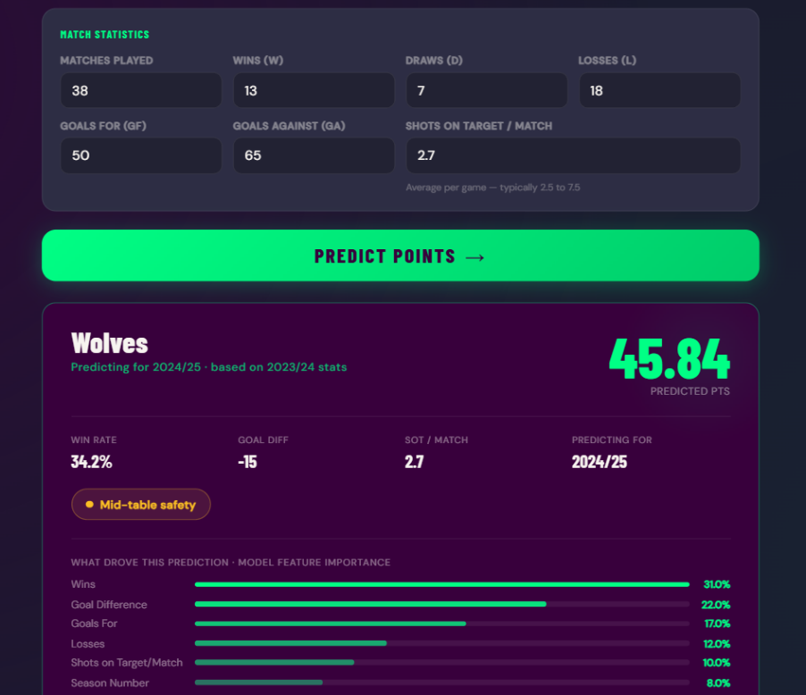
the picture below is the real life stats of Wolves of season 2024/2025 (42) and our model predicted around 45-46, which is again a good estimate. Approximate % error is 3.84%

Test Case 3 — Relegation-Threatened Team (unseen data)
Relegation-threatened teams are those teams that finish the season with points <40.
This is a test case on unseen data as we will use season 2024/2025 stats as input (we didn’t train the model on this season) and predict for 2025/2026 season, which is still on going in real life.
Since officially only 36 games have been completed in real life so far as opposed to 38, so we will predict for 36 games and see how our prediction is.

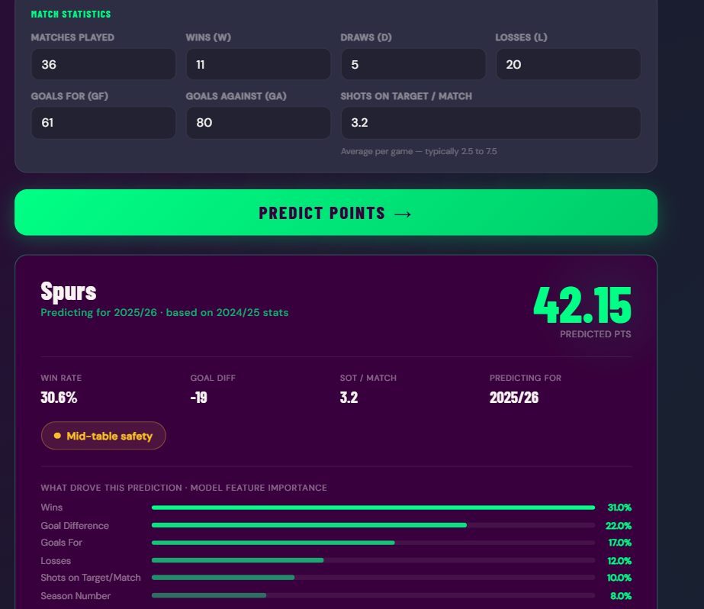
The picture below shows Spurs’s inputted stats of season 2024/2025 (accurate stats from official website), and then the model predicts Spurs’s points of next season 2025/2026.

the picture below is the real life stats of Spurs of season 2024/2025 (38) and our model predicted around 42, which is, though >40 but it’s not far off from the estimation. Approximate % error is 10.53%

7. Unique and Notable Aspects of the Implementation

7.1 Neural Network Implemented from Scratch
A complete feedforward neural network was built manually using NumPy, including forward propagation, MSE loss calculation, backpropagation, gradient computation, and gradient clipping. This demonstrates strong understanding of neural network internals instead of relying entirely on deep learning libraries.

7.2 Temporal Sample Weighting
Recent seasons were given higher importance using a linear weighting formula:
weight = season_num/6

This allowed newer football trends and team performances to influence the model more strongly while still retaining older data.

7.3 Symmetric Home/Away Aggregation
Separate home and away DataFrames were created and merged symmetrically so every match contributed correctly to both teams’ statistics. This produced accurate full-season summaries across all 38 matches.

7.4 Goal Difference Retained Despite Multicollinearity
Although Goal Difference (GD) showed high correlation with wins and goals scored, it was intentionally retained because GD is the official Premier League tiebreaker and an important real-world performance indicator.

7.5 Hyperparameter Tuning with GridSearchCV
A full GridSearchCV pipeline was implemented for the Random Forest model across 108 parameter combinations using 5-fold cross-validation. This systematic tuning approach significantly improved model performance and demonstrated advanced model optimization.

7.6 Additional Ensemble Algorithms
Beyond the required algorithms, both Random Forest Regressor was implemented and compared. This provided a deeper analysis and helped in optimizing the final model.

7.7 League Position Prediction
In addition to predicting next-season points, the system also estimated final league positions by ranking teams based on predicted points and goal difference. This added a more practical football analytics perspective to the project.

7.8 Flask REST API Deployment
The final trained model was deployed as a live Flask REST API and exposed publicly using ngrok. The API accepts team statistics as JSON input and returns predicted points in real time.

7.9 Mid-Season Prediction Scaling
To support predictions during an ongoing season, the system scales predictions proportionally instead of retraining separate models for partial seasons:

This maintains consistency with the original training distribution.

7.10 Separate Evaluation Pipelines for Neural Network and sklearn Models
The custom NumPy neural network used a separate chronological evaluation pipeline from the sklearn models. This prevented data leakage and ensured fair comparison between different model families.

8. References
- football-data.co.uk. (2024). English Premier League Historical Results [Dataset]. Retrieved from https://www.football-data.co.uk/englandm.php
- Pedregosa, F., et al. (2011). Scikit-learn: Machine Learning in Python. Journal of Machine Learning Research, 12, 2825–2830.
- Breiman, L. (2001). Random Forests. Machine Learning, 45(1), 5–32.
- Tibshirani, R. (1996). Regression Shrinkage and Selection via the Lasso. Journal of the Royal Statistical Society: Series B, 58(1), 267–288.
- Hoerl, A. E., & Kennard, R. W. (1970). Ridge Regression: Biased Estimation for Nonorthogonal Problems. Technometrics, 12(1), 55–67.
- Friedman, J. H. (2001). Greedy Function Approximation: A Gradient Boosting Machine. The Annals of Statistics, 29(5), 1189–1232.
- Goodfellow, I., Bengio, Y., & Courville, A. (2016). Deep Learning. MIT Press.
- Waskom, M. L. (2021). seaborn: statistical data visualisation. Journal of Open Source Software, 6(60), 3021.
- Harris, C. R., et al. (2020). Array programming with NumPy. Nature, 585, 357–362.
- Palmerino, G. (2023). pyngrok: A Python wrapper for ngrok. GitHub. https://github.com/alexdlaird/pyngrok

9. How to Run the GUI
1. First save the weights under NN_models folder in My Drive, mount the drive
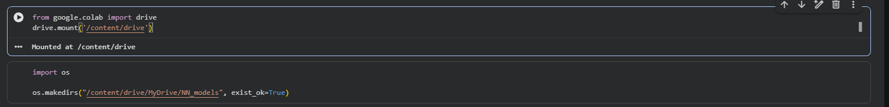
2. Open ML_CEP.ipynb in Google Colab. Go to Runtime → Run All and wait for all cells to finish executing. This retrains the model and loads all variables into memory. Do not skip this step, the Flask server in Step 3 depends on the trained model being in memory.
3. Sign up for a free account at ngrok.com. Go to your dashboard, copy your authtoken, and run this in a new cell:
from pyngrok import ngrok
ngrok.set_auth_token("YOUR_TOKEN_HERE")

4.Run the second last cell (attached ss) and input the features as shown in the second snapshot.
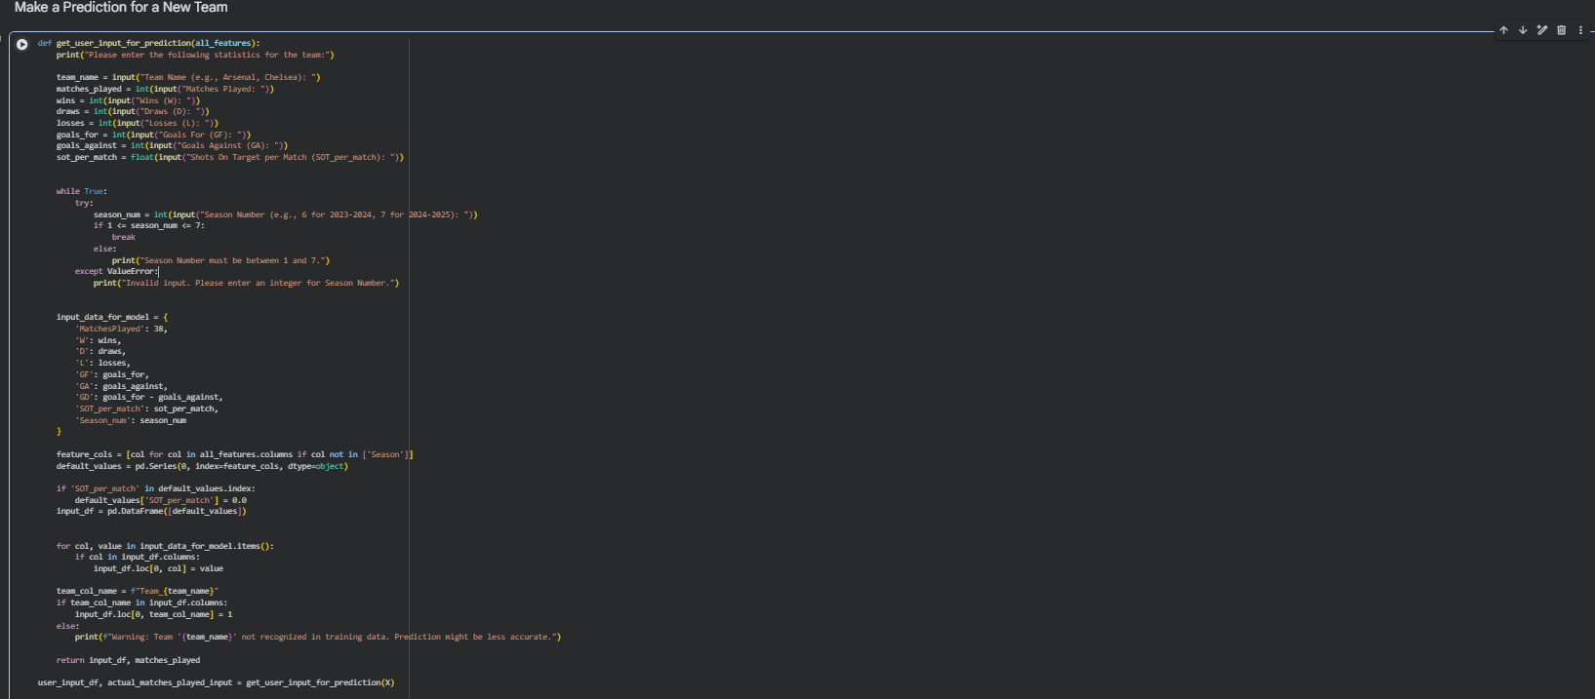
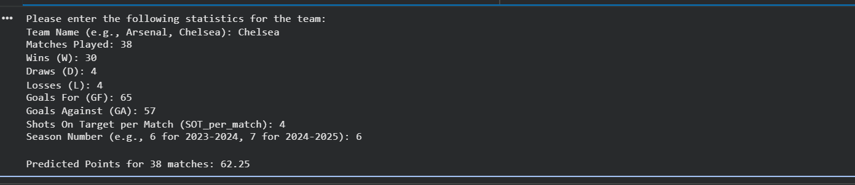

5. Finally run the flash server cell and then it gives a url, then at the top of the GUI, paste the ngrok URL into the Colab URL field and click Connect. The dot next to the field will turn green, confirming the connection. Now you can finally use the predictor Model.

9. Generative AI Use Declaration
This declaration is submitted in accordance with the academic integrity requirements of the course.

Whether AI Tools Were Used
Yes. Generative AI tools were consulted during the development and documentation phases of this project.

Specific Tools and Their Purposes
AI Tool | Purpose of Use | Details
ChatGPT / Claude (AI Assistant) | Debugging assistance | Consulted when resolving a ConvergenceWarning raised by sklearn's Lasso solver. The AI suggested increasing max_iter from 1,000 to 10,000, which resolved the issue. The fix was verified and applied by the team.
ChatGPT / Claude (AI Assistant) | Idea generation | Used to brainstorm possible explanations for why NN Models 1 and 2 produced strongly negative R² values. The AI suggested the learning rate as the most likely culprit, prompting the team to train a third NN variant with lr=0.001.
ChatGPT / Claude (AI Assistant) | Report writing assistance | Used to help structure section headings and ensure all required CEP sections were addressed. All technical content, analysis, interpretations, and conclusions are the team's own work.
GitHub Copilot | Code completion | Used for boilerplate patterns (e.g., pd.get_dummies syntax, Flask route template). All model logic, data engineering, and evaluation code was written and reviewed by team members.

Confirmation Statement
We, the group members, confirm that: (1) all machine learning models were designed, implemented, trained, and evaluated by us; (2) all data engineering, feature engineering, and exploratory analysis was performed by us; (3) all interpretations, conclusions, and analytical commentary in this report represent our own understanding; (4) AI tools were used only for auxiliary purposes (debugging suggestions, structural guidance, and boilerplate code) as declared above; and (5) the final submitted code and this report are our own work
Acknowledged by:
Muhammad Abdullah (CS23033) | Fatima Shahid (CS23007)| Asra Siddiqui (CS23006).

— End of Report —

