

Data Technician

Name: Alaa Mostafa
Course Date: 16/12/24
Table of contents
Day 1: Task 1 2
Day 2: Task 1 2
Day 2: Task 2 3
Day 2: Task 3 4
Day 3: Task 1 4
Day 3: Task 2 5
Dataset: 5
Step 1: Create a Pivot Table 5
Step 2: Use the SWITCH Function 5
Submission: 6
Day 3: Task 3 6
Day 4: Task 1 7
Course Notes 9
Additional Information 10

Day 1: Task 1

Please complete the below boxes on commons laws and regulations that must be followed when working with customers data, use the below bulleted list to support your answers.

- What is it
- Why is it important
- Provide a real-world example of how you can follow it
- How does it impact working with data
- What could happen if you breached it

Data Protection Act | The Data Protection Act is a law that controls how personal information is collected, stored, used, and shared. It ensures organisations handle people’s data safely  It’s important because it protects individual’s privacy and prevents their personal information from being misused, lost, or accessed without permission.  A real world example is if a doctor’s office keeps patient records on a computer. Under the Data Protection Act, the staff must keep this information secure, only share it with authorised people (like another doctor or hospital), and not leave files where anyone can see them. If they shared patient details without permission, it would break the law.  It impacts working with data by setting strict rules on how data can be collected, processed, stored, and deleted. You can only use customer data for the purpose it was originally collected for.  If breached your organisation could face fines, legal action, and loss of customer trust. Employees could also face disciplinary action or dismissal.
GDPR | GDPR is a set of EU-wide rules that control how organisations collect, use, store, and protect personal data. The UK follows these rules through the UK GDPR.  It’s important because it gives individuals strong rights over their data and ensures organisations handle personal information safely, legally, and transparently.  An example of this is a coffee shop collects customer email addresses to send newsletters. Under GDPR, they must ask customers for clear consent before adding them to the mailing list. Customers also have the right to ask for their data to be deleted at any time. If the coffee shop ignores this, they could face fines for breaking GDPR rules.  It impacts data as you must have a valid reason (lawful basis) for using customer data, keep it secure, minimise the data you collect, and only keep it for as long as necessary.  If breached it can result in large fines, legal consequences, investigations by the ICO, reputational damage, and loss of customer trust.
Freedom of Information Act | The Freedom of Information Act is a law that gives the public the right to request information held by public authorities, such as government departments, councils, schools, and the NHS.  It is important because it promotes transparency and accountability by allowing people to see how public organisations make decisions and use public money.  An example of this is if a local resident wants to know how much their council spent on repairing a nearby road. They send an freedom of information (FOI) request to the council asking for the costs. The council checks the records and then replies within 20 working days, giving the total amount spent. They share this information because it’s not personal, confidential, or sensitive.  If you work in a council office and someone sends an FOI request asking for the number of complaints made about a local park, you must search your organisation’s records, gather the relevant information, and prepare it for release.  While doing this, you must remove any personal details (like names, phone numbers, or addresses) so that only the non-personal information is shared. This ensures you follow the FOI Act and protect people’s privacy.  If breached It can lead to complaints to the Information Commissioner’s Office (ICO), enforcement action, reputational damage, and potential legal consequences for the organisation.
Computer Misuse Act | The Computer Misuse Act is a law that protects computers and digital systems from unauthorised access, hacking, and malicious activity.  It is important because it helps prevent cybercrime, protects sensitive information, and ensures computer systems are used safely and legally.  An example is if you work in an office, and a colleague leaves their computer logged in. You decide to open their files without asking. Even if you don’t steal anything, this is illegal under the Computer Misuse Act because you accessed their computer without permission.  You must only access and modify data you are authorised to use. All passwords and security measures must be respected, and you must not attempt to bypass systems or security protocols.  If breached it can lead to criminal charges, fines, or even imprisonment. Organisations could also suffer data breaches, loss of trust, and legal consequences.

Day 2: Task 1

Please research and complete the following tasks within the retail-sales_dataset.xlsx document, paste a print screen into the provided boxes below:

- In the sheet ‘retail_sales_dataset’ add all available data between columns A –J into a ‘table’
- Using the ‘sort’ function, sort ‘Age’ to ‘largest to smallest’
- Using the ‘SUM’ function, show me the commission total in cell ‘L10’
- Using the ‘AVERAGE’ function, show me the average commission in cell ‘L11’

Print screen 1 | 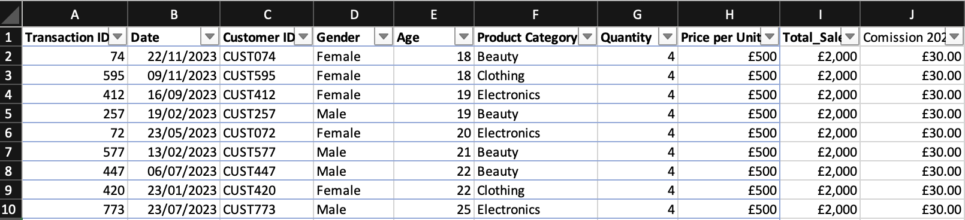
Print screen 2 | 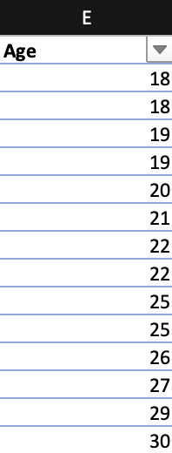
Print screen 3 | 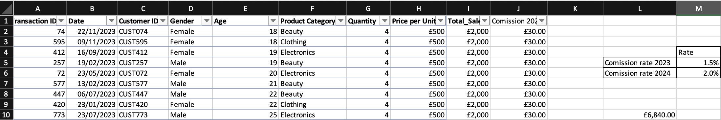
Print screen 4 | 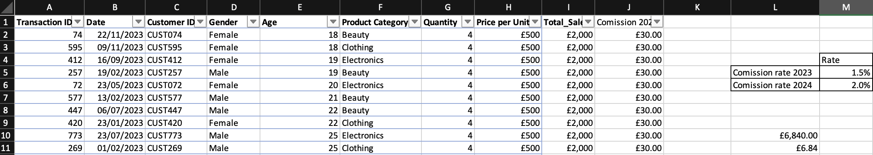

Day 2: Task 2

Please research and complete the following tasks within the retail-sales_dataset.xlsx document, paste print screens into the provided box below:



Print screen 1 | 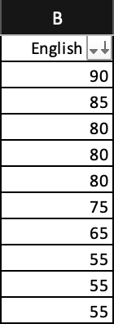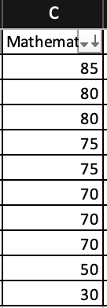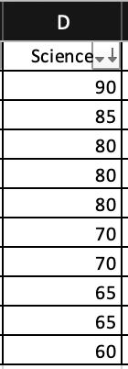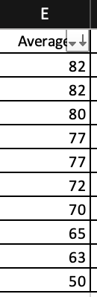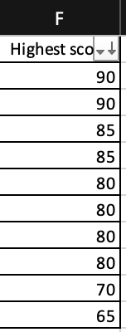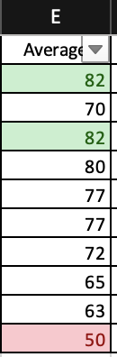

Day 2: Task 3

Using the skills developed today, have some fun with the data set you have imported. Paste your work below and enjoy!

Print screen 1 | 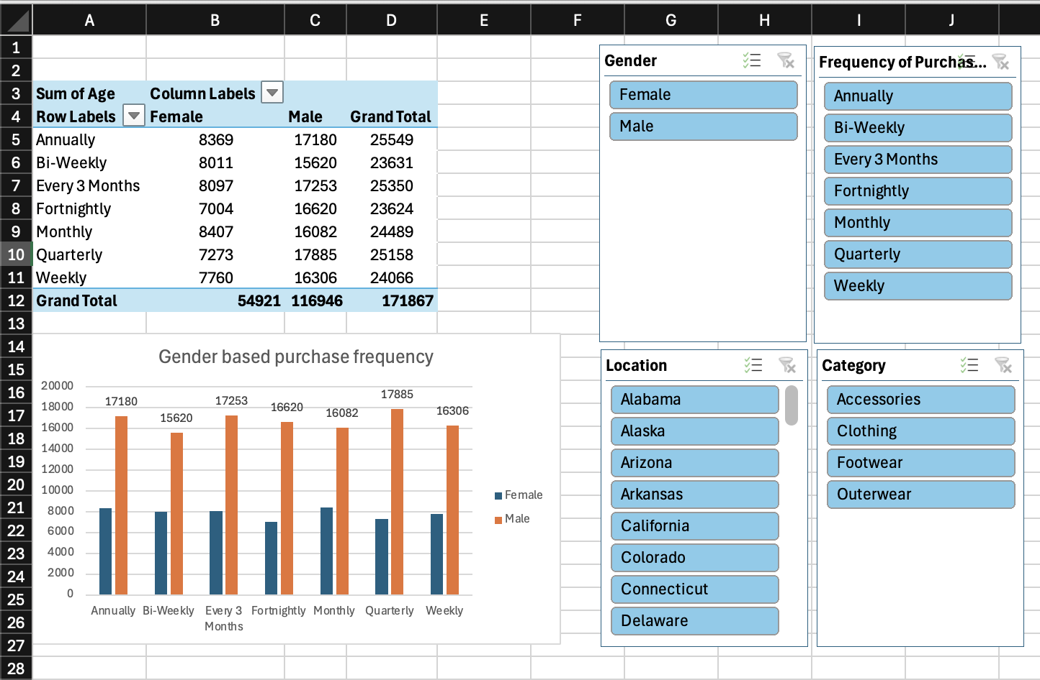

Day 3: Task 1

Please download the dataset ‘Day_3_Task_1_Bike_Sales_Pivot_Lab.xlsx’ and the lab instructions.

Do not worry if you do not complete the lab, just working with data and playing with the pivot table will be good experience.

Please paste your final pivot table below and complete the reflection questions:

Print screen 1 | 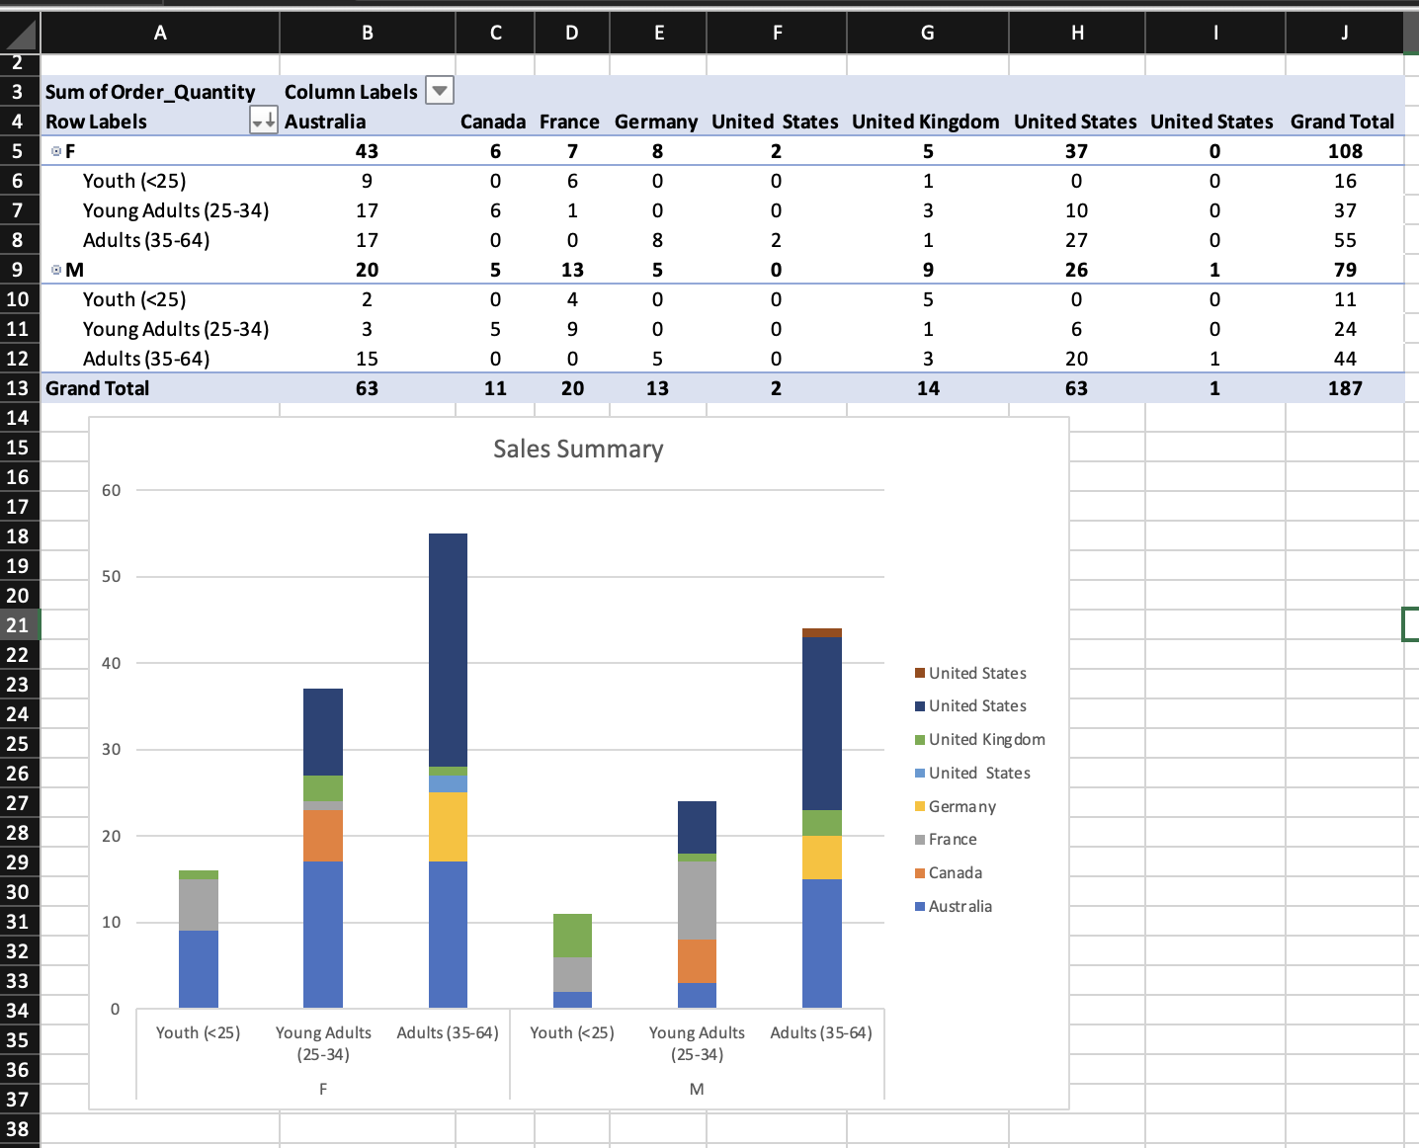
In which markets does Germany have customers? | Female and male adults (35-64)
What country has sales in all markets? | Australia and United Kingdom
What are the most profitable markets by country, age group, and gender? | Young adults (25-34) in Australia, Canada, France and United kingdom
Any other findings?

Day 3: Task 2

The dataset below tracks the sales performance of different products in various counties in England. Please paste the dataset into a blank Excel workbook. Your task is to:
- Create a Pivot Table to summarise the data by county and product.
- Use the SWITCH function to categorise products based on their sales volume.

Dataset:
County | Product | Sales Volume
Yorkshire | Laptops | 500
Yorkshire | Smartphones | 200
Cornwall | Laptops | 700
Cornwall | Printers | 400
Lancashire | Smartphones | 150
Lancashire | Laptops | 600
Essex | Printers | 800
Essex | Smartphones | 300
Durham | Laptops | 250
Durham | Printers | 300
Greater Manchester | Smartphones | 600
Greater Manchester | Laptops | 400

Step 1: Create a Pivot Table
- Select the dataset (columns A to C).
- Insert a Pivot Table to summarise the data by County in the rows and Products in the columns. Use Sales Volume as the value to be summarised.

Step 2: Use the SWITCH Function
In a new column next to your data, use the SWITCH function to categorise products based on Sales Volume as follows:
  - For sales greater than 600: "High"
  - For sales between 300 and 600: "Medium"
  - For sales less than 300: "Low"
SWITCH Function Example:
=SWITCH(TRUE, C2 > 600, "High", C2 >= 300, "Medium", "Low")
- Apply this formula to each row, and check if the products are categorised correctly.

Submission:
- A completed Pivot Table summarising sales by county and product.
- A new column in the dataset categorising products by sales volume using the SWITCH function.
  - Please paste your completed work below

Print screen 1 | 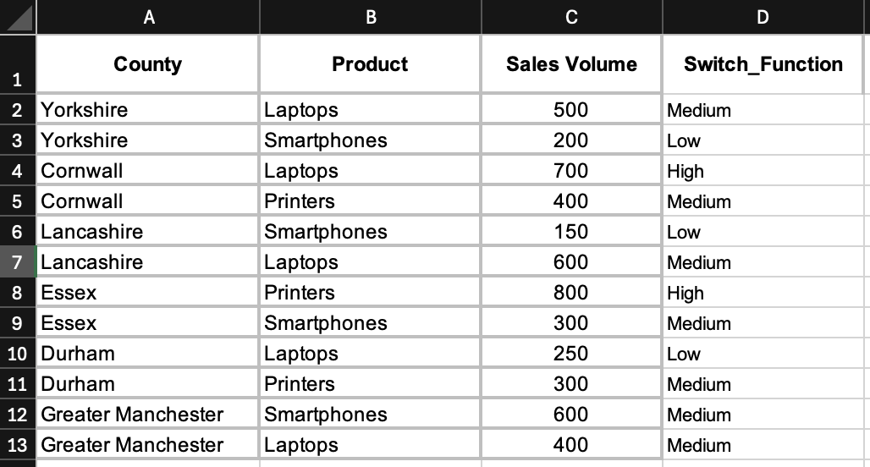  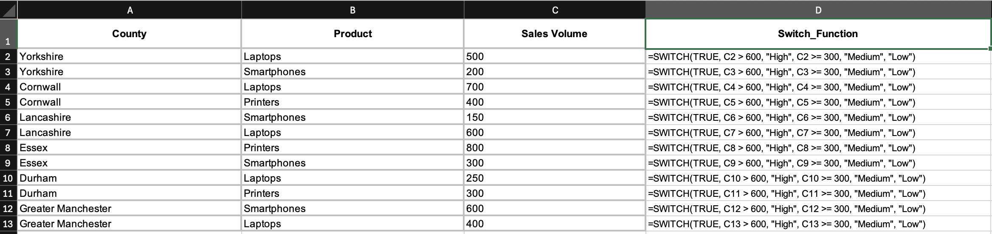

Day 3: Task 3

Please download the dataset ‘Day_3_Task_3_Bike_Sales_Visualisations_Lab.xlsx’ and the the lab instructions. Do not worry if you do not complete the lab, just working with data and playing with the charts will be good experience.

Please paste your results below:

Print screen 1 | 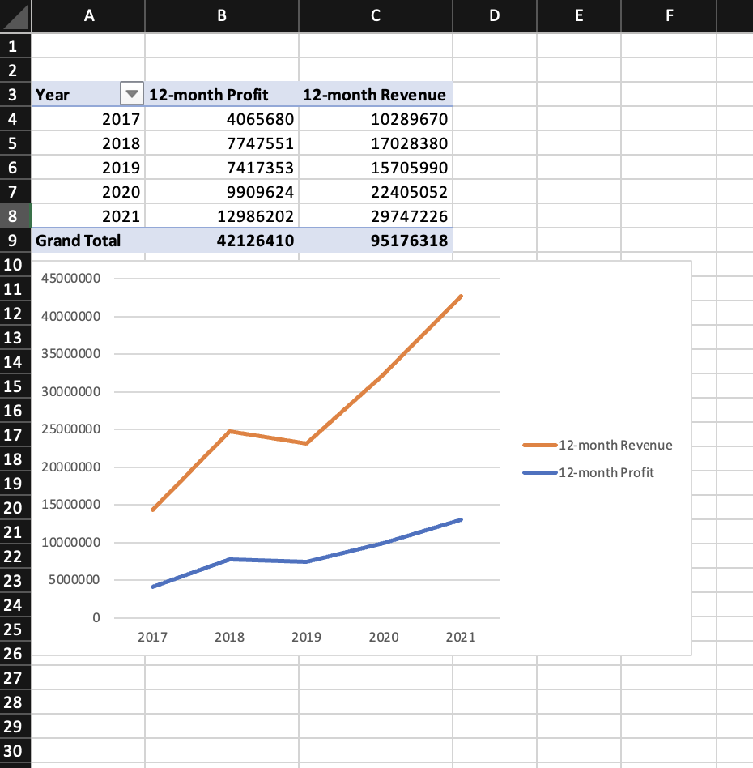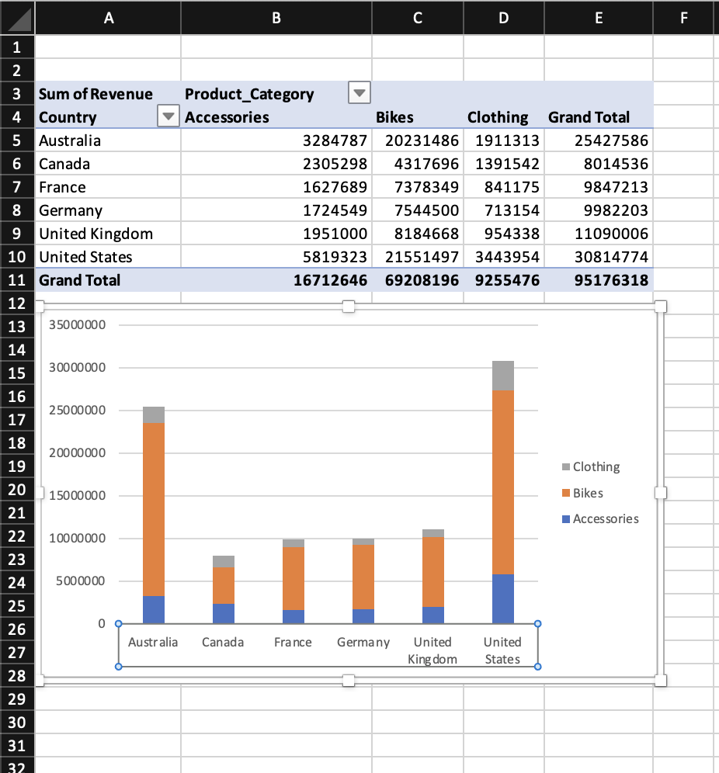  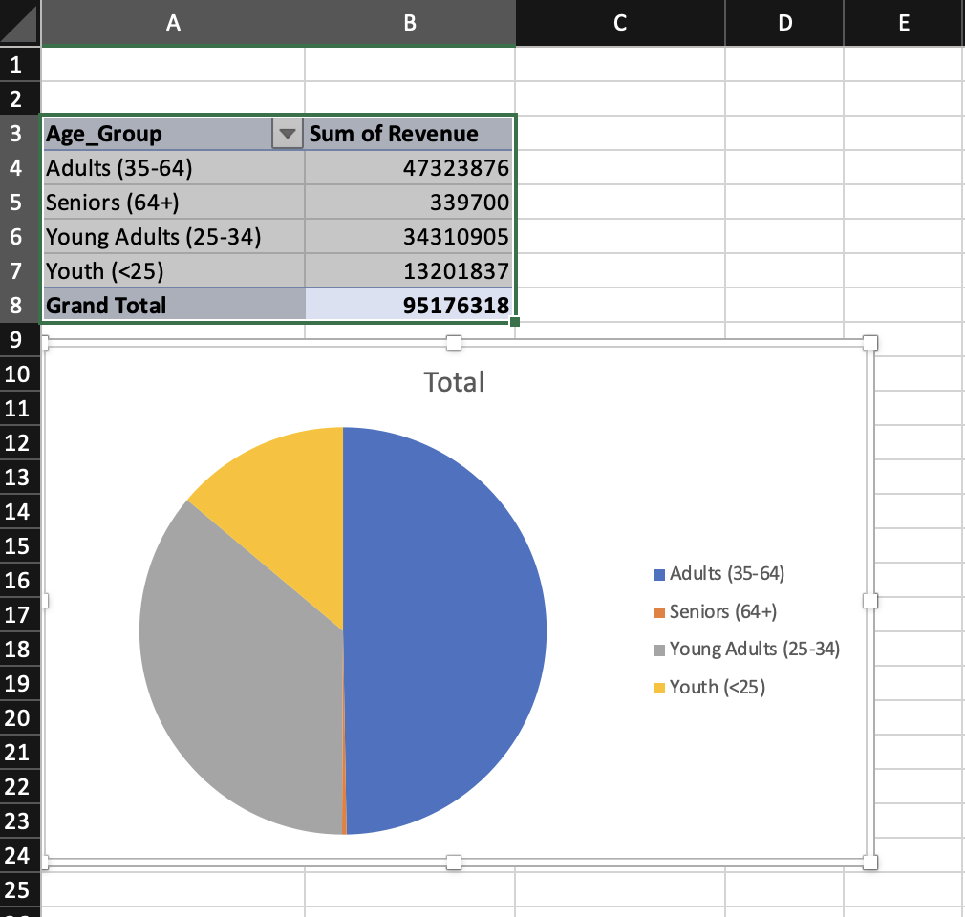

Day 4: Task 1

You have been asked to deliver your analysis findings to the board of directors, with your analysis you have identified that customers are leaving your company at the 12-month point, this is typically when they receive their renewal price.

Conduct research and complete the below questions:

How would you prepare for the delivery? | Define a clear key message and align it with the business priorities. Use clear visuals (charts) for clarity. Measure the financial impact and propose scenarios.
What tools would you use for the delivery? | I would use, Excel to create PivotTables and charts. PowerBI to create an interactive dashboard and PowerPoint
What is prospecting and why would you complete this before your delivery? | Prospecting is the process of identifying and researching potential customers who might be interested in what you’re offering. It’s useful to do this before delivery because it helps you understand exactly who your audience is, what matters to them, and how they might react to your analysis
Tell me best practices for public speaking and providing updates to senior leaders | When speaking to senior leaders, you should be clear, concise and focused, open with your key message and connect it directly to business priorities. Use simple, visual slides and tell a coherent story, avoiding jargon. Anticipate questions, have extra data just in case and practise thoroughly so you’re confident and composed under pressure.
What will you show the board in your delivery? | I would show the board a chart that clearly shows how many customers leave around the 12month point, how much money is lose when they don’t renew, and a few “what-if” scenarios for example, what happens if we lower the renewal price or add an incentive.
How will you articulate the changes that are needed? | I would explain the needed changes by telling a powerful story. First, I’d clearly describe the why change is necessary using data to show the risk of doing nothing. Then I’d present a vision for what the future looks like if we act, how things will improve and what outcomes we can realistically achieve
Provide a list of online resources and videos that will support your preparation for public speaking | https://www.youtube.com/watch?v=xSp78RwcAS4  https://www.youtube.com/watch?v=jizZKNnx9wA
Evaluate tools that provide visualisation.  Tell me what they are.  Tell me what you would choose when delivering your presentation and why | I’d choose Power BI to deliver my presentation because it allows me to build clean, interactive dashboards that make the data easy to understand and explore. It can connect to my data sources directly, so I know the numbers are accurate. I can also embed live Power BI visuals into PowerPoint, which means I can present compelling charts and still dive into details when asked.

Course Notes

It is recommended to take notes from the course, use the space below to do so, or use the revision guide shared with the class:

Additional Information

We have included a range of additional links to further resources and information that you may find useful, these can be found within your revision guide.

END OF WORKBOOK

Please check through your work thoroughly before submitting and update the table of contents if required.

Please send your completed work booklet to your trainer.

