

Data Technician

Name:
Course Date:
Table of contents
Day 1: Task 1 2
Day 1: Task 2 2
Day 2: Task 1 3
Day 2: Task 2 3
Day 3: Task 1 4
Day 3: Task 2 5
Day 4: Task 1 6
Day 4: Task 2 7
Course Notes 7
Additional Information 8

Day 1: Task 1

Please research the different versions of Tableau, compare and contrast them below and explain the limited functionality on ‘Tableau Public’.

Different Tableau versions | 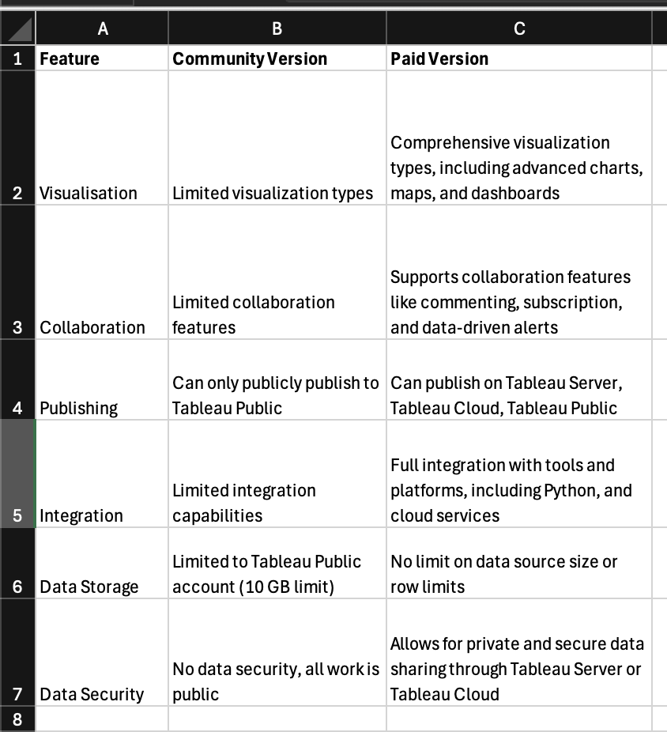

Day 1: Task 2

Using the EMSI_JobChange_UK dataset, create your own dashboard, I want to see a bar chart showing percentage change and a UK based map showing the key city locations impacted.

Paste your print screen here | 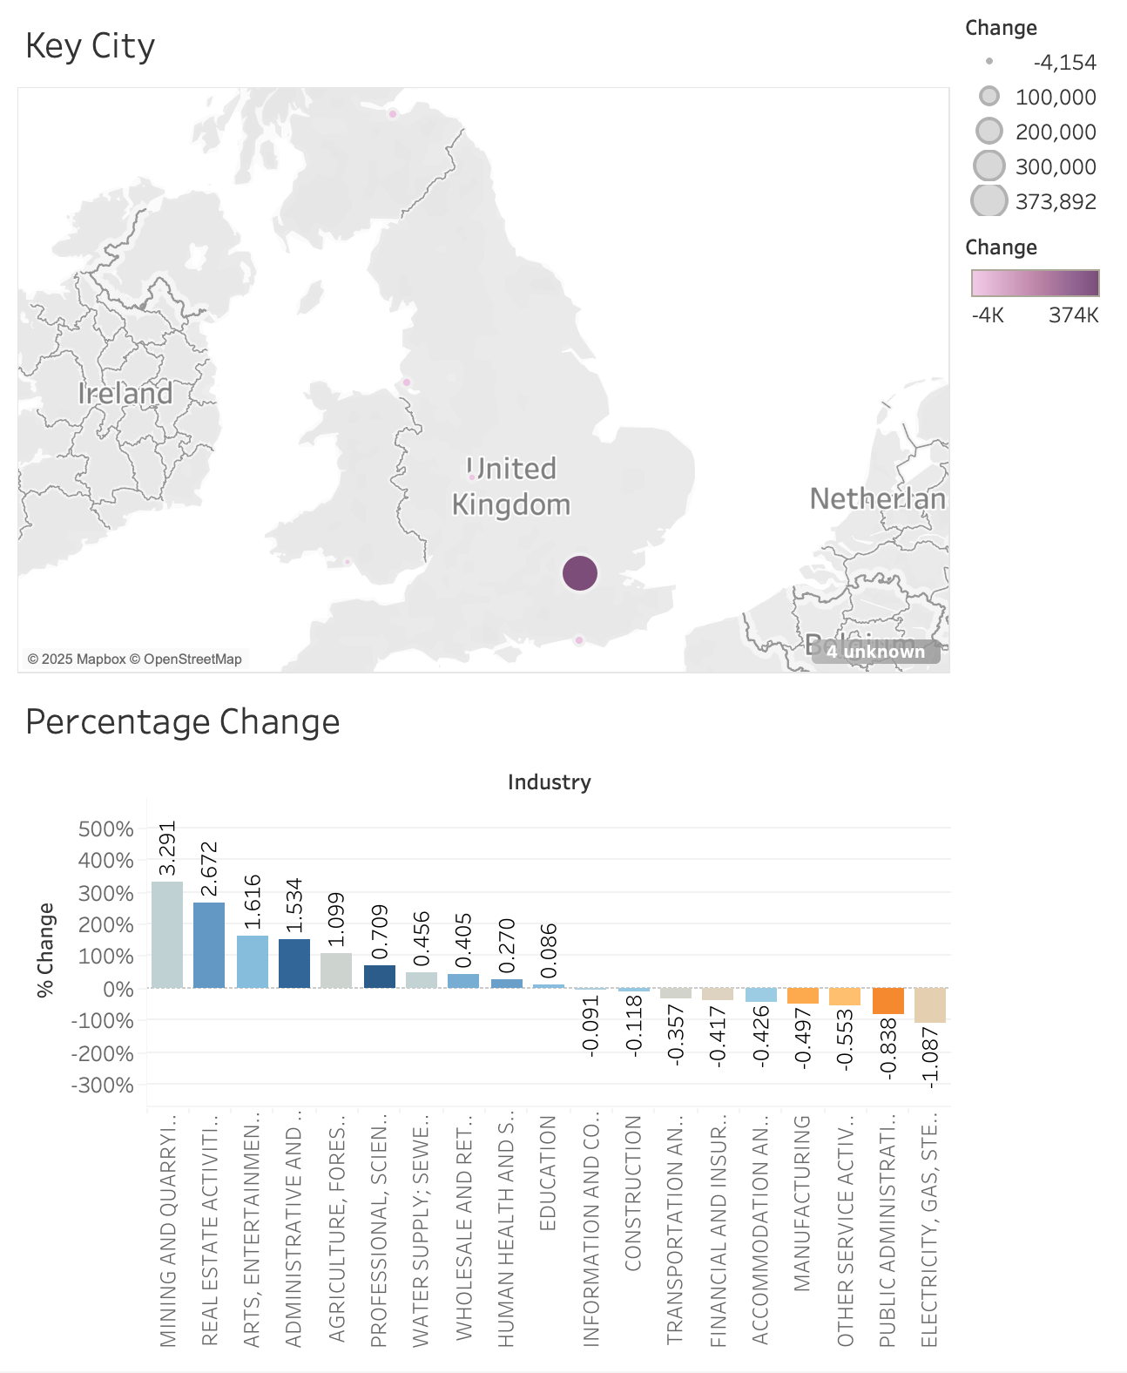

Day 2: Task 1

Using the Spotify data set, conduct an analysis to find trends and key information that could be used by an organisation for future projects.

There is no set scope for the analysis, simply to find trends and document them below:

Paste your print screens here | 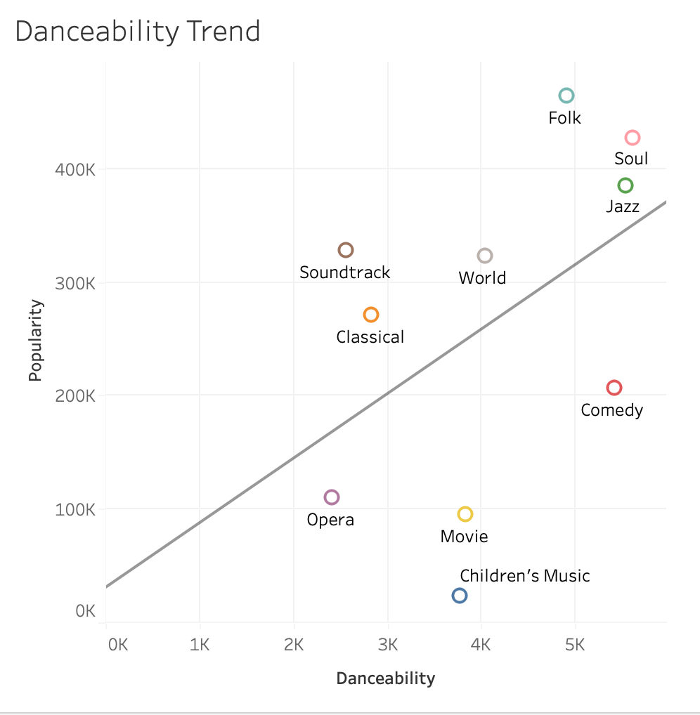  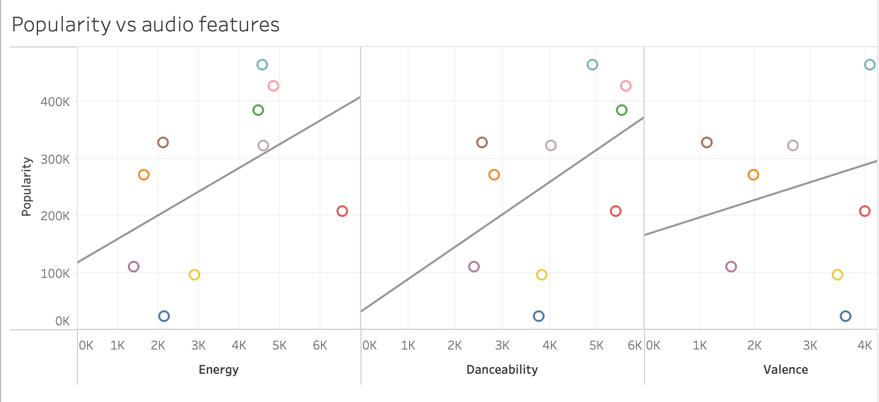  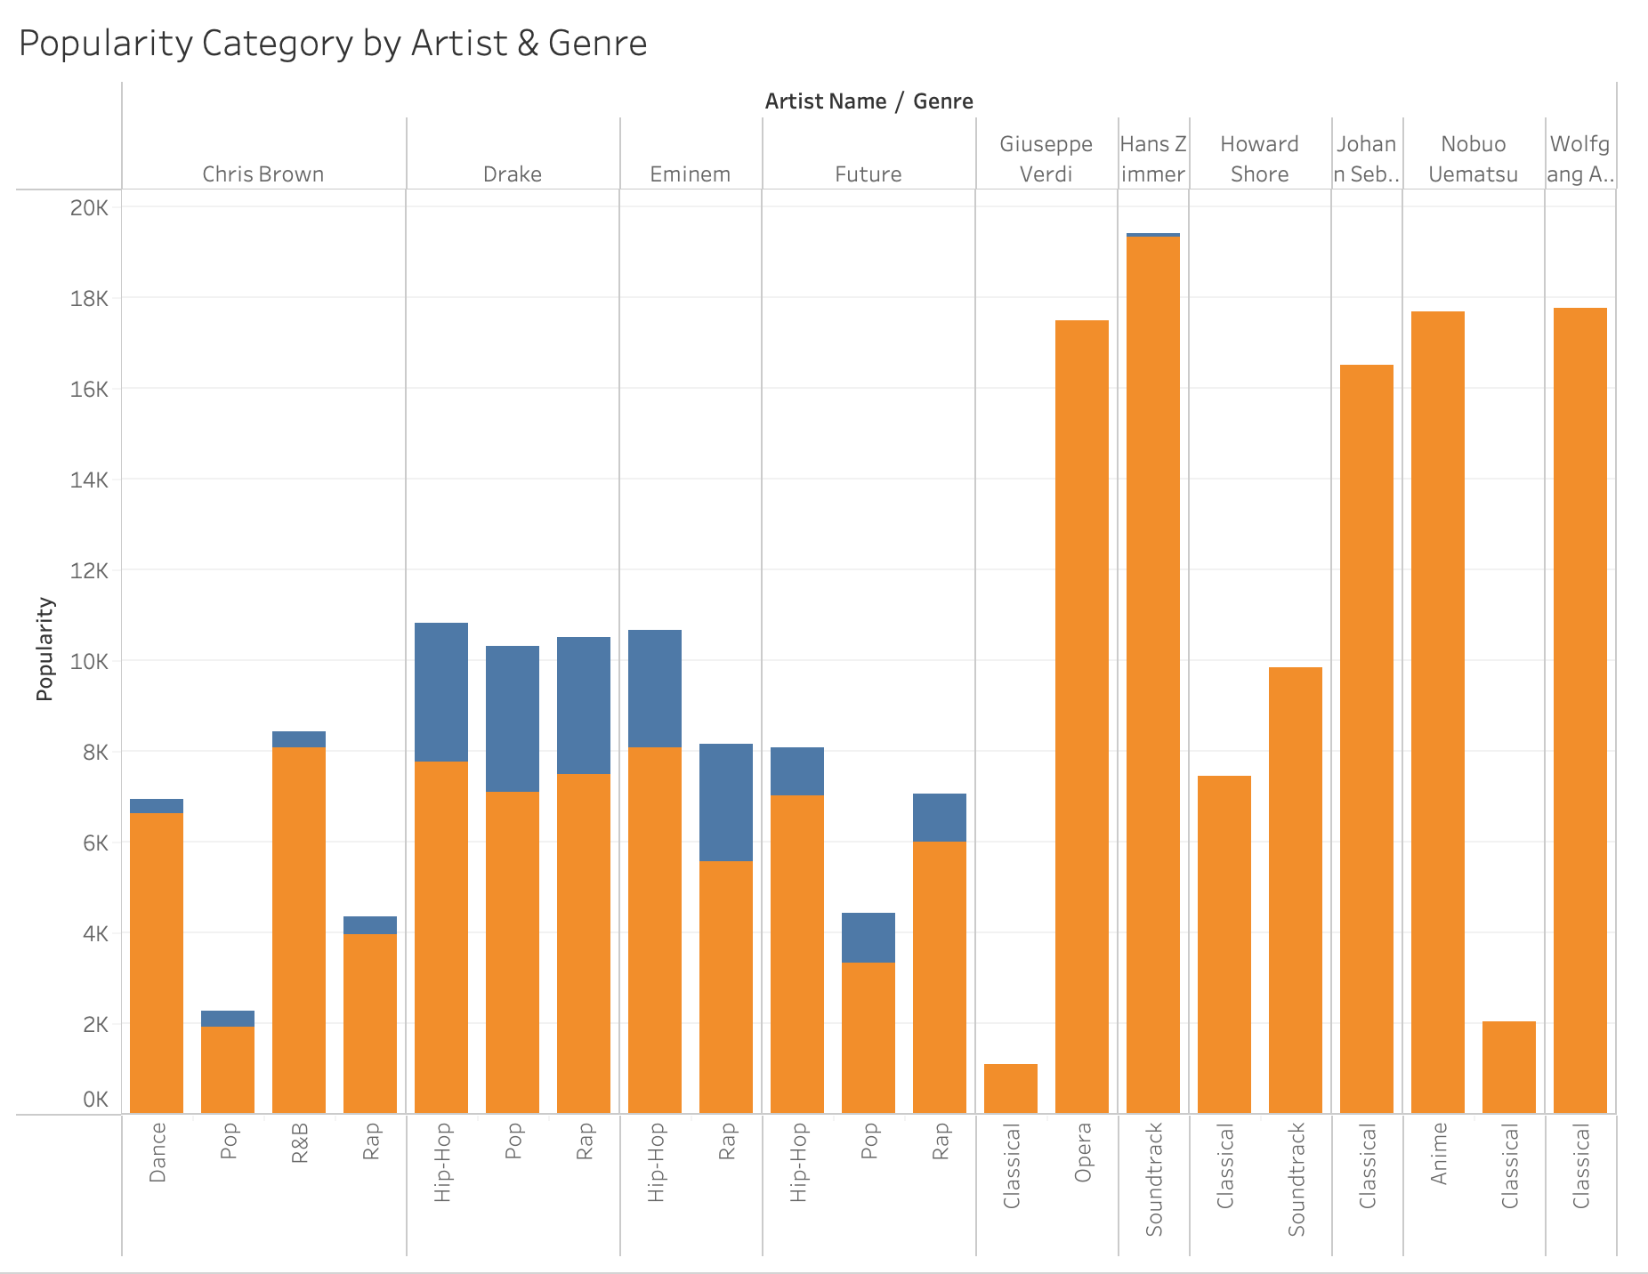  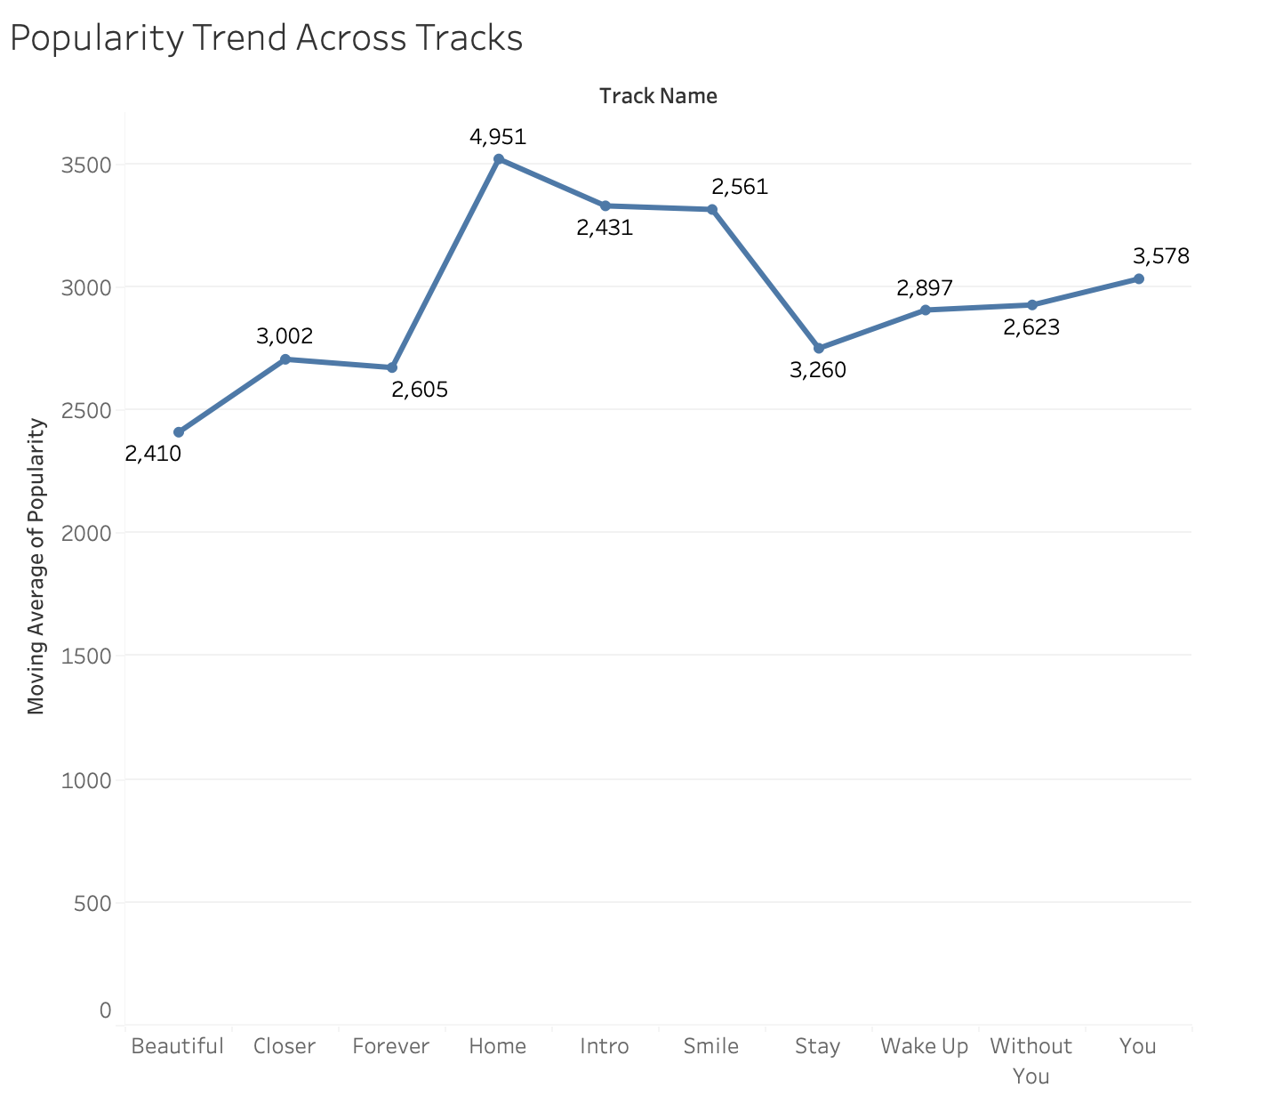  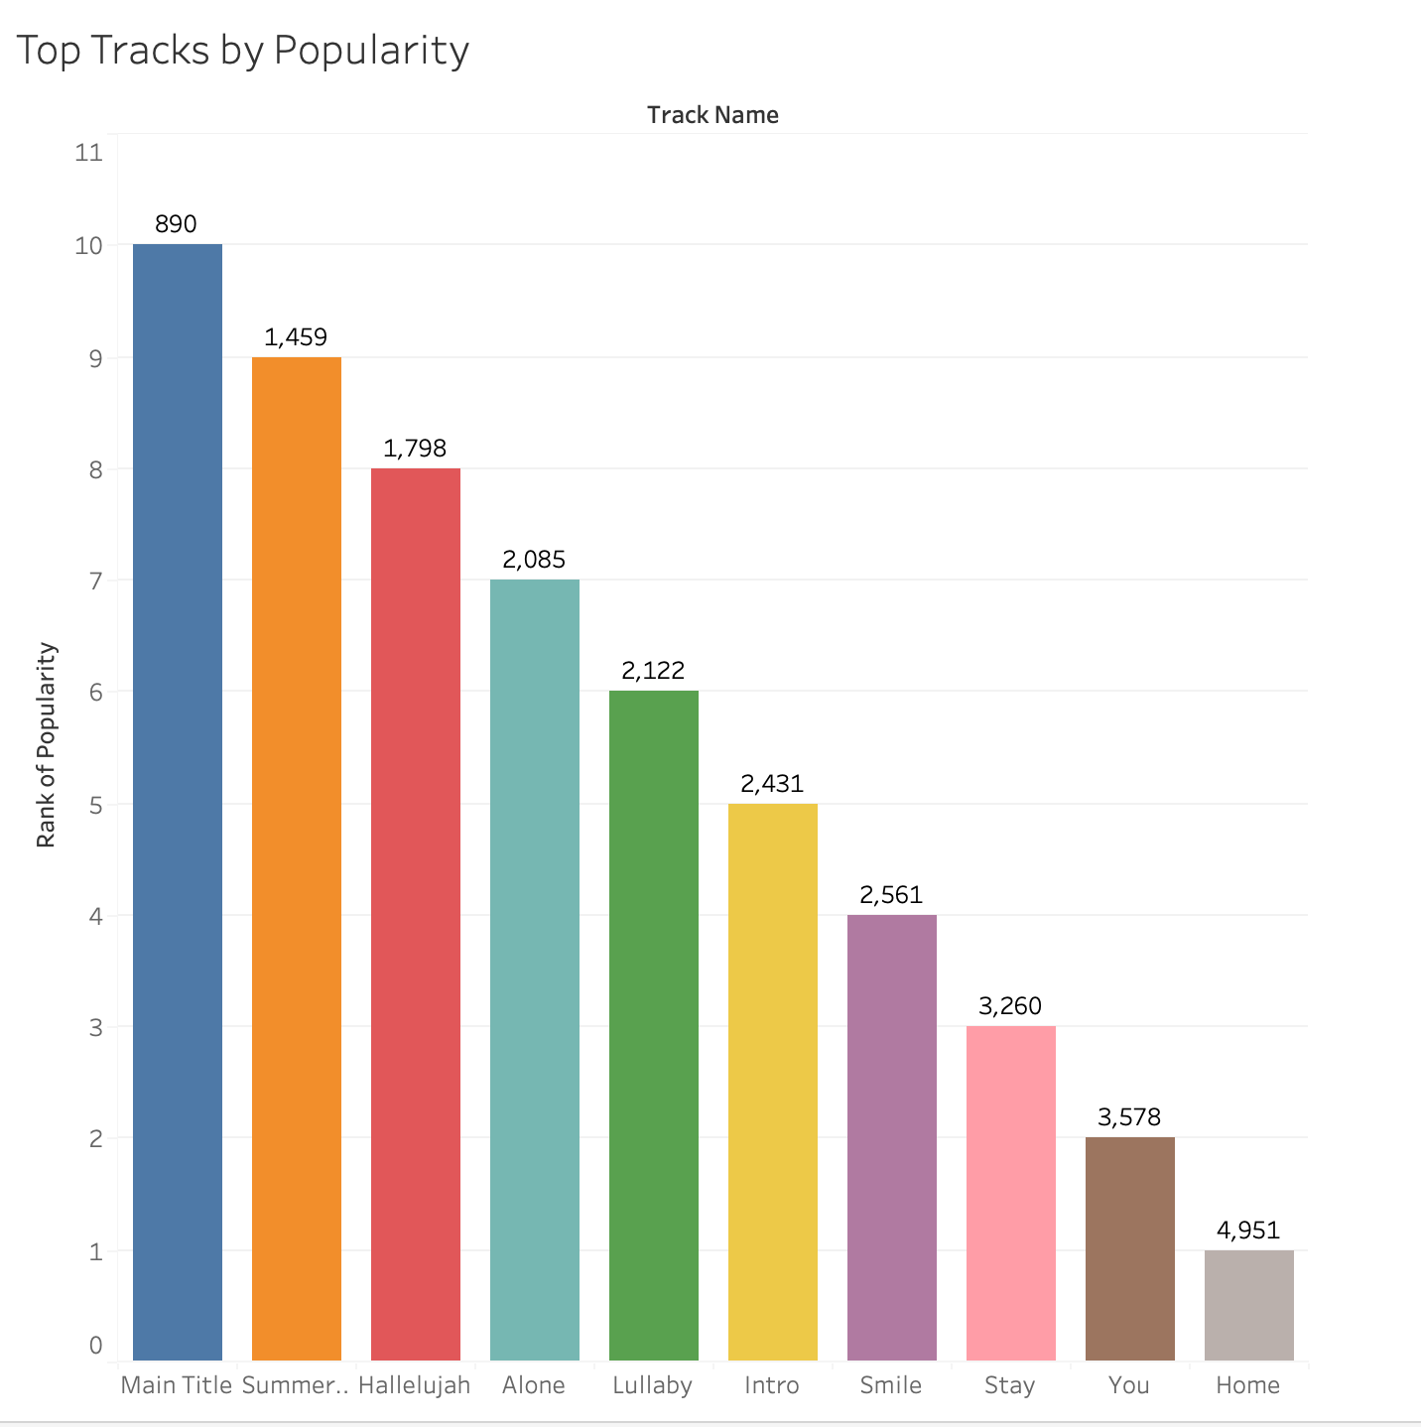

What did you find? | - The relationship between Danceability and Popularity. Overall, more danceable songs tend to be more popular. For example, genres like Jazz and Soul have both high danceability and high popularity, indicating that listeners are more attracted to songs that are more enjoyable to dance to.  - Compares popularity with key audio features such as energy, danceability, and valence. Overall, songs with higher energy and danceability tend to be more popular, while valence shows a weaker relationship. This suggests that upbeat, energetic tracks are more appealing to listeners  - Shows how different artists and genres fall into either High Popularity or Low Popularity categories. It highlights which genres tend to have more popular artists overall, and which ones have more artists in the lower popularity range  - Displays moving average  - Highlights the tracks with the highest popularity scores in the dataset, making it easy to identify which songs stand out as the most successful or widely listened to

Day 2: Task 2

Using the Health, conduct an analysis to find trends and key information that could be used by an organisation for future support.

There is no set scope for the analysis, simply to find trends and document them below.

- Data can be lifesaving and is being used more within the NHS, reflect on how this data could support decision making for the NHS.

Paste your print screens here | 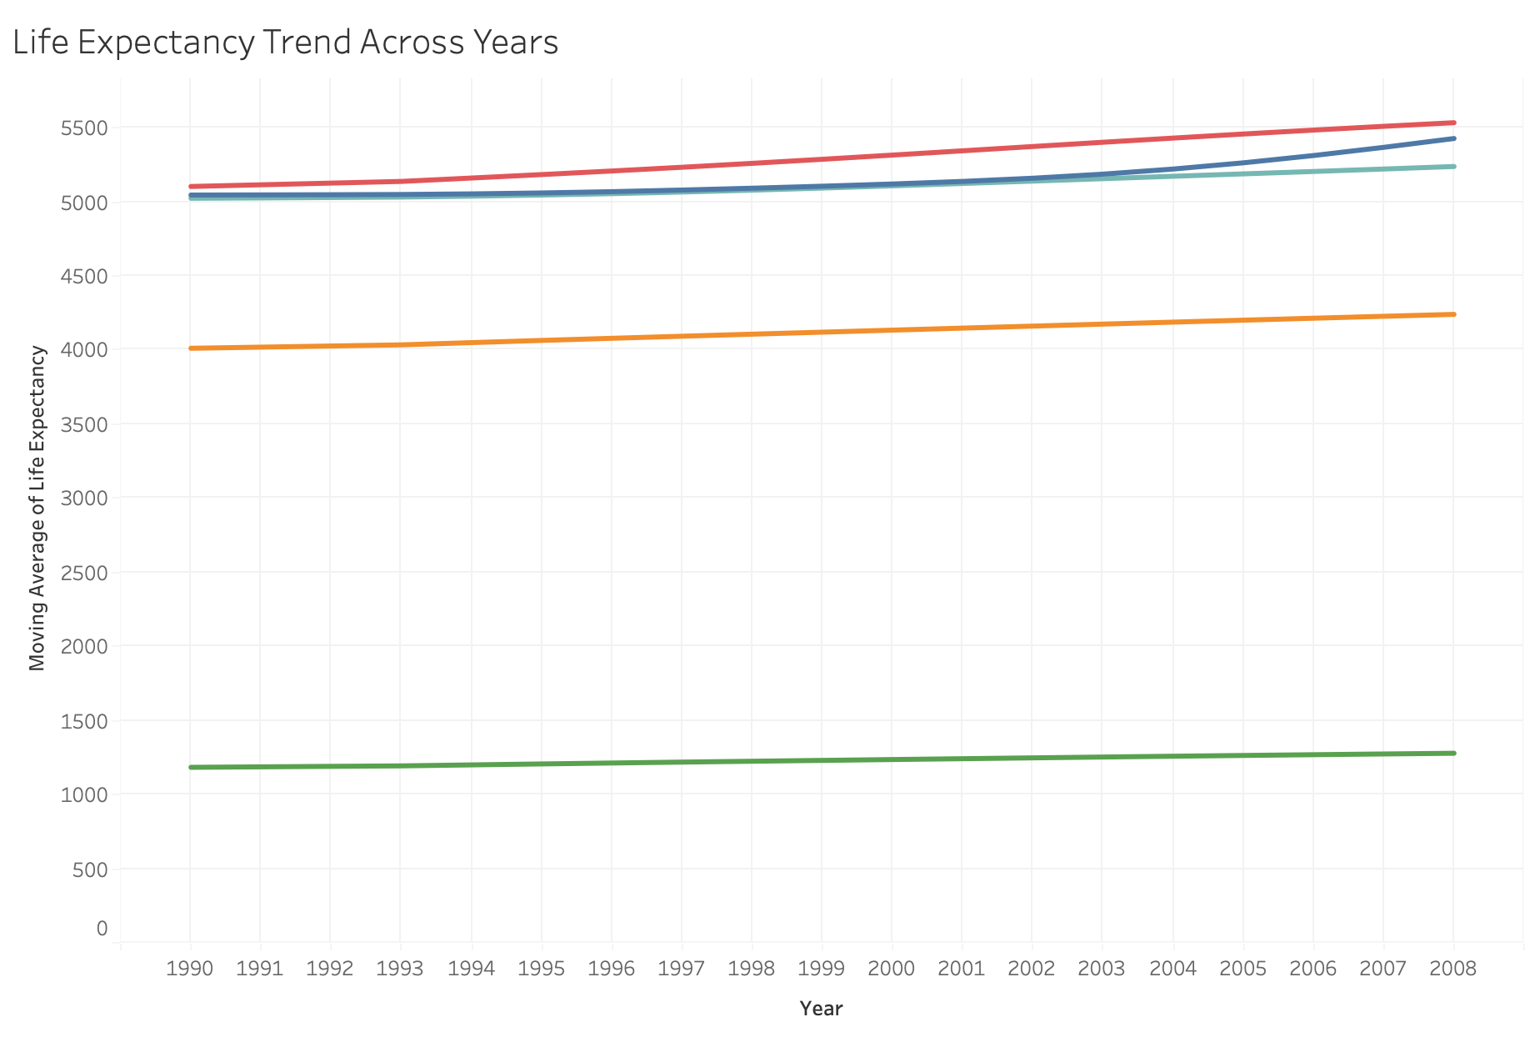  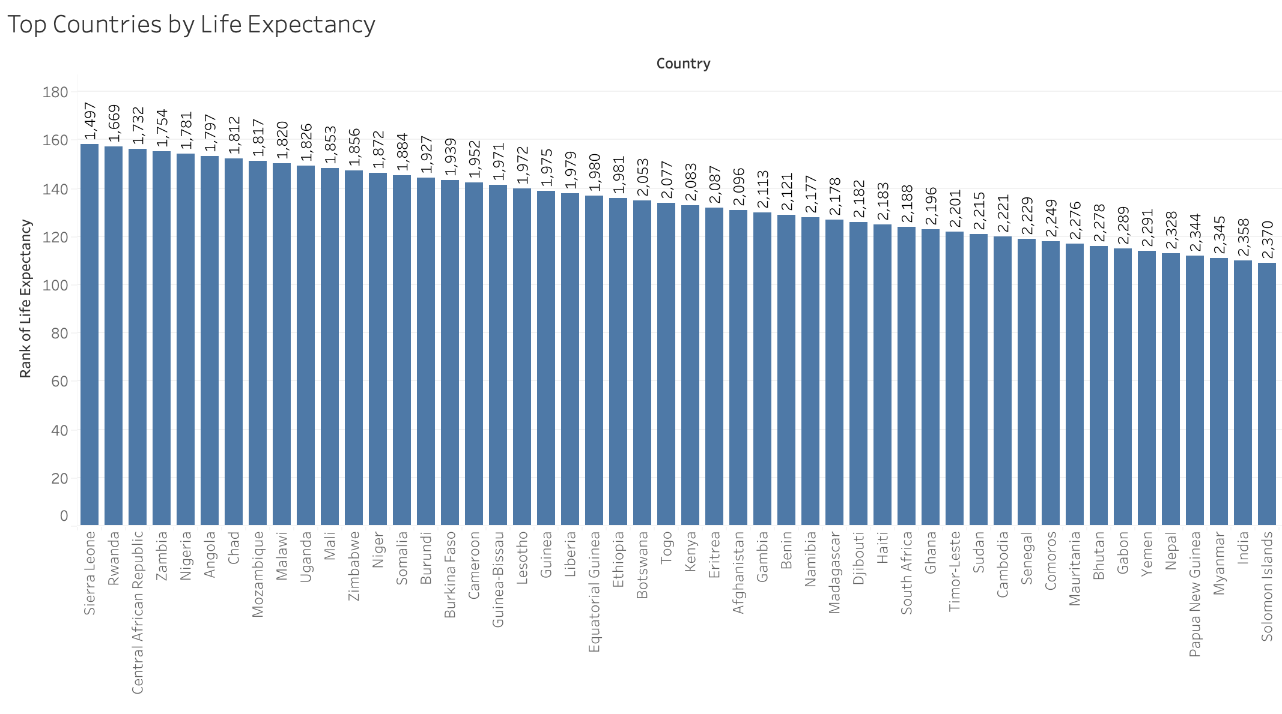  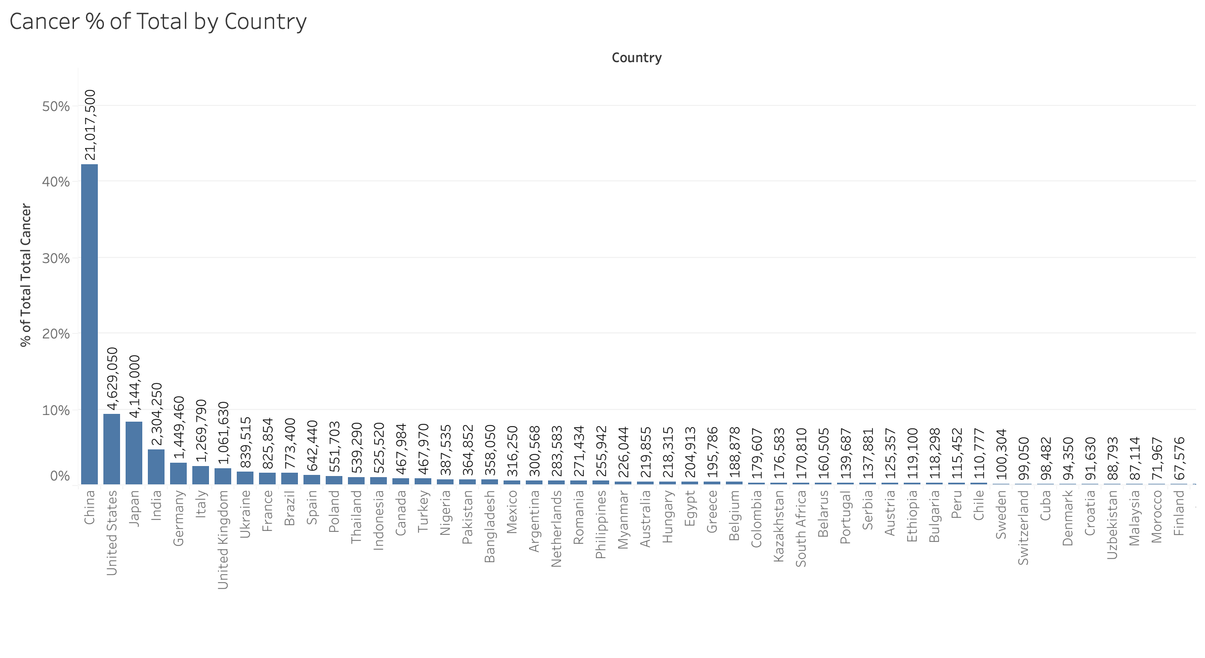  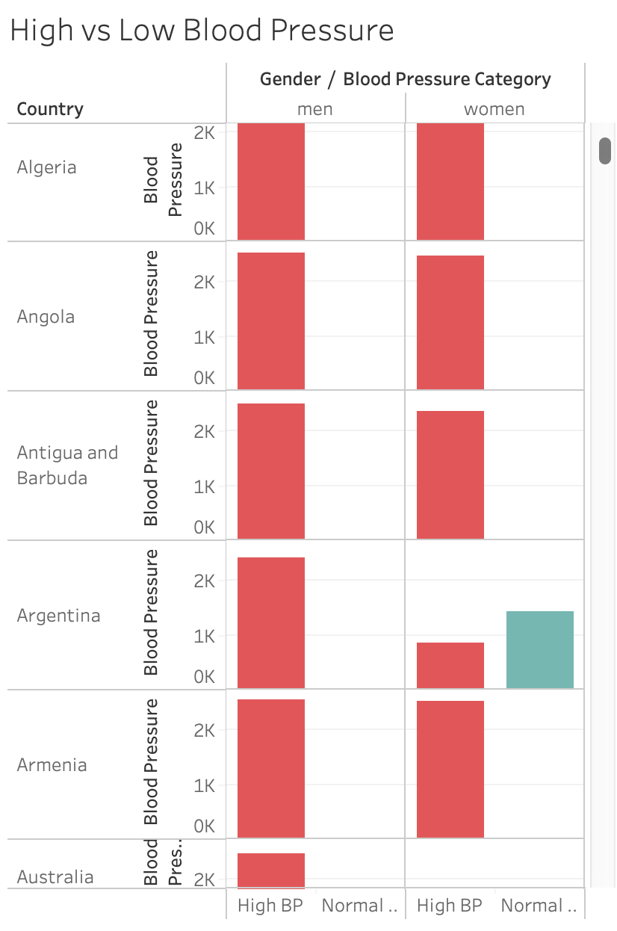  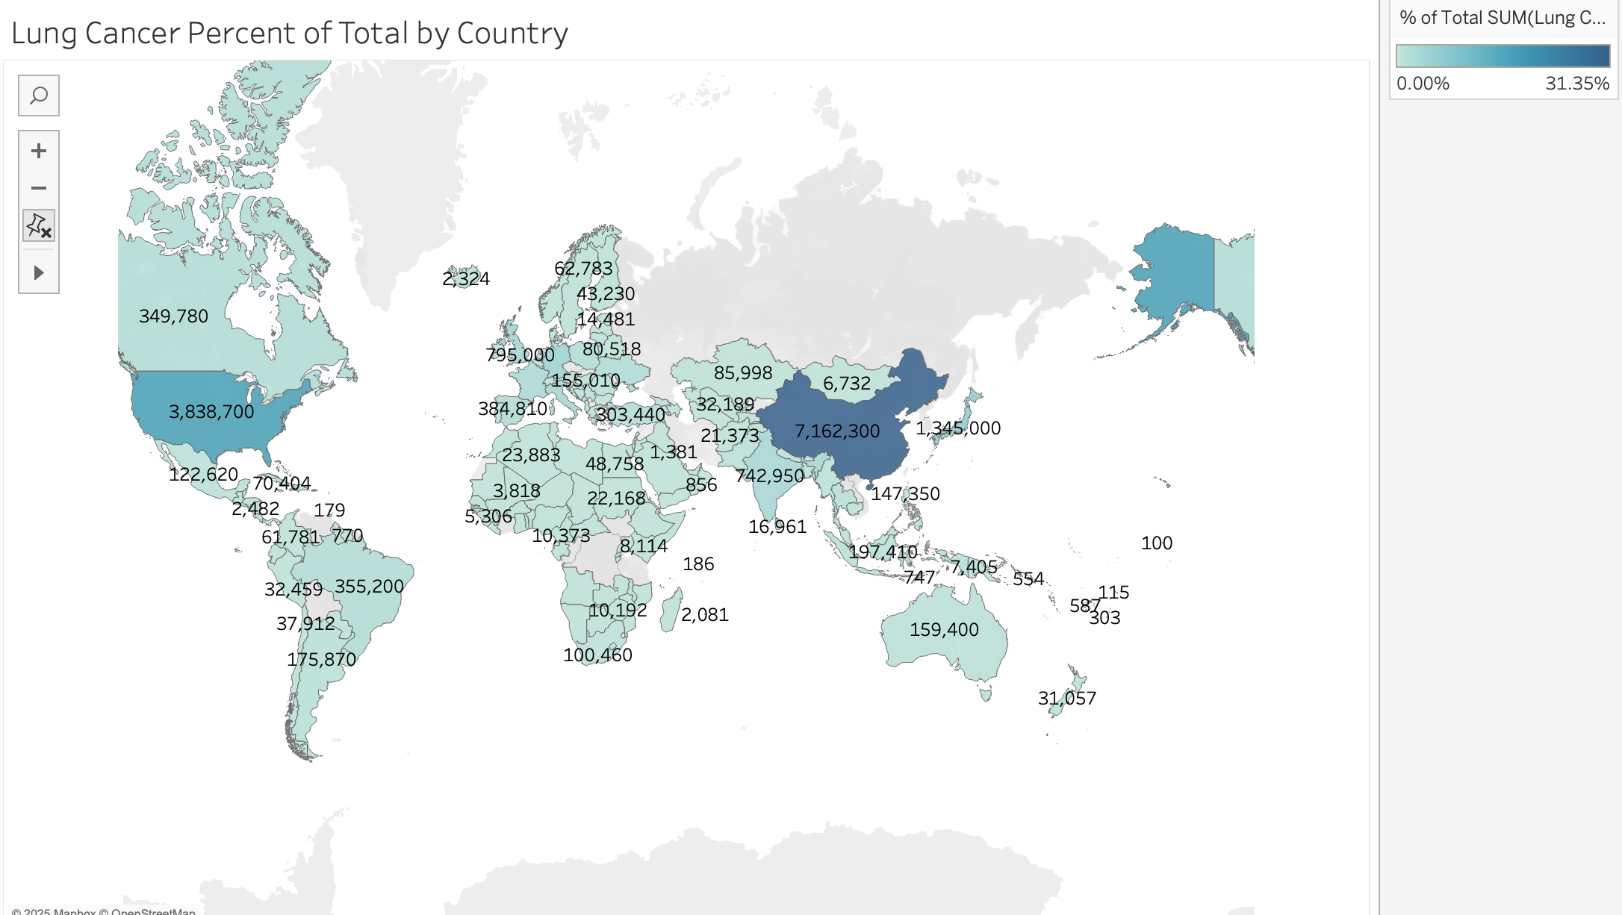
What did you find and any reflections on how the NHS could use this? | - This chart shows how life expectancy changes over time, allowing us to see long-term trends such as whether people are living longer or if life expectancy remains stable across the years  - Highlights the countries with the highest life expectancy, making it easy to compare which nations have the best overall health outcomes.  - shows the percentage each country contributes to the total number of cancer cases, helping identify which countries have higher or lower shares of the overall cancer %  - categorizes individuals by blood pressure Low, Normal, High and compares the distribution across genders and countries, highlighting differences in cardiovascular risk between males and females and between regions.  - This map shows the percentage of total lung cancer cases contributed by each country, using colour intensity to highlight nations with higher or lower shares of global lung cancer.

Day 3: Task 1

Please complete Lab 1 ‘Get Data in Power Bi Desktop’. Once complete, paste a print screen below and in the collaboration board.

“Teaching is the best way to learn, so please listen out for support requests from the class and we’ll work through the challenges together”

Paste your completed lab here | 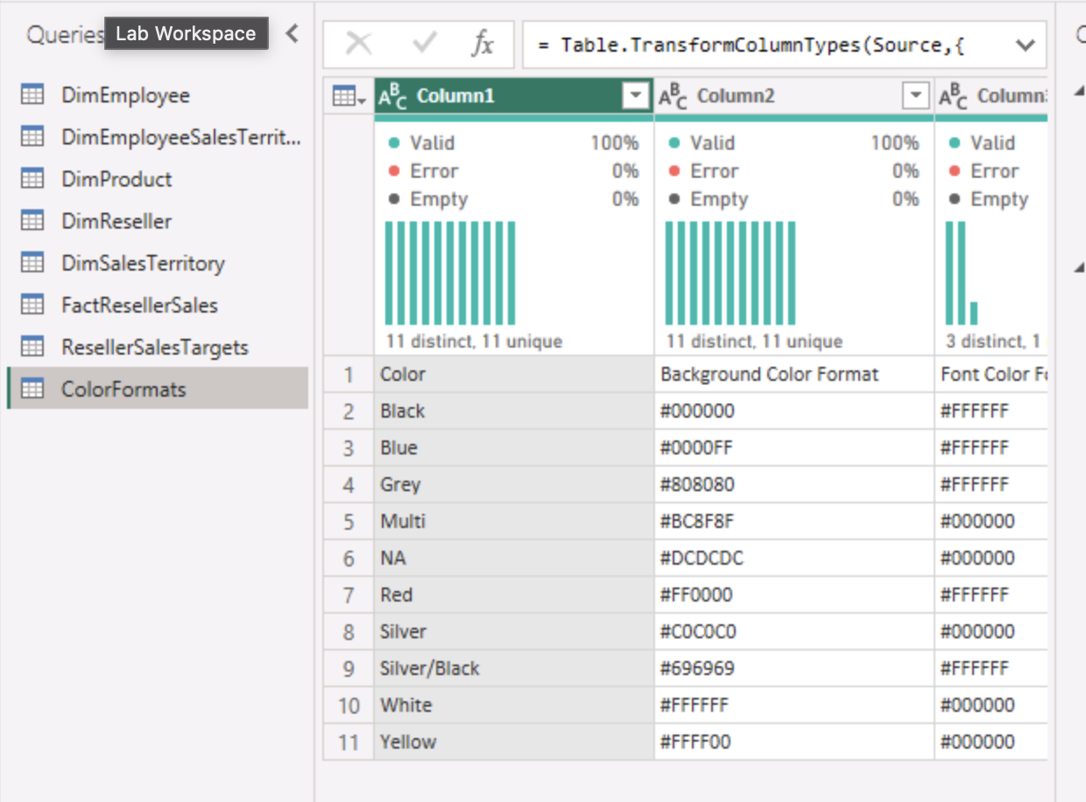

Day 3: Task 2

Please complete Lab 2 ‘Load Transformed Data in Power BI Desktop’. Once complete, paste a print screen below and in the collaboration board.

“Teaching is the best way to learn, so please listen out for support requests from the class and we’ll work through the challenges together”

Paste your completed lab here | 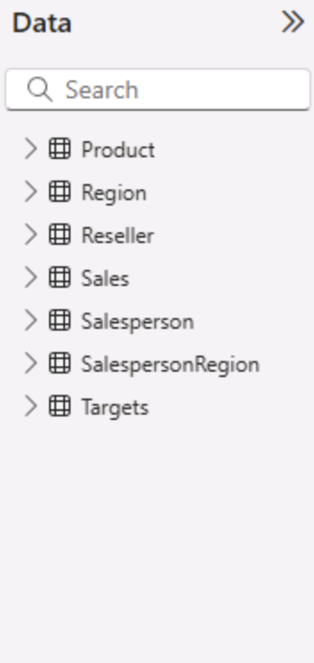

Day 4: Task 1

Please complete Lab 8 ‘Design a Report in Power BI Desktop’. Once complete, paste a print screen below and in the collaboration board.

“Teaching is the best way to learn, so please listen out for support requests from the class and we’ll work through the challenges together”

Paste your completed lab here | 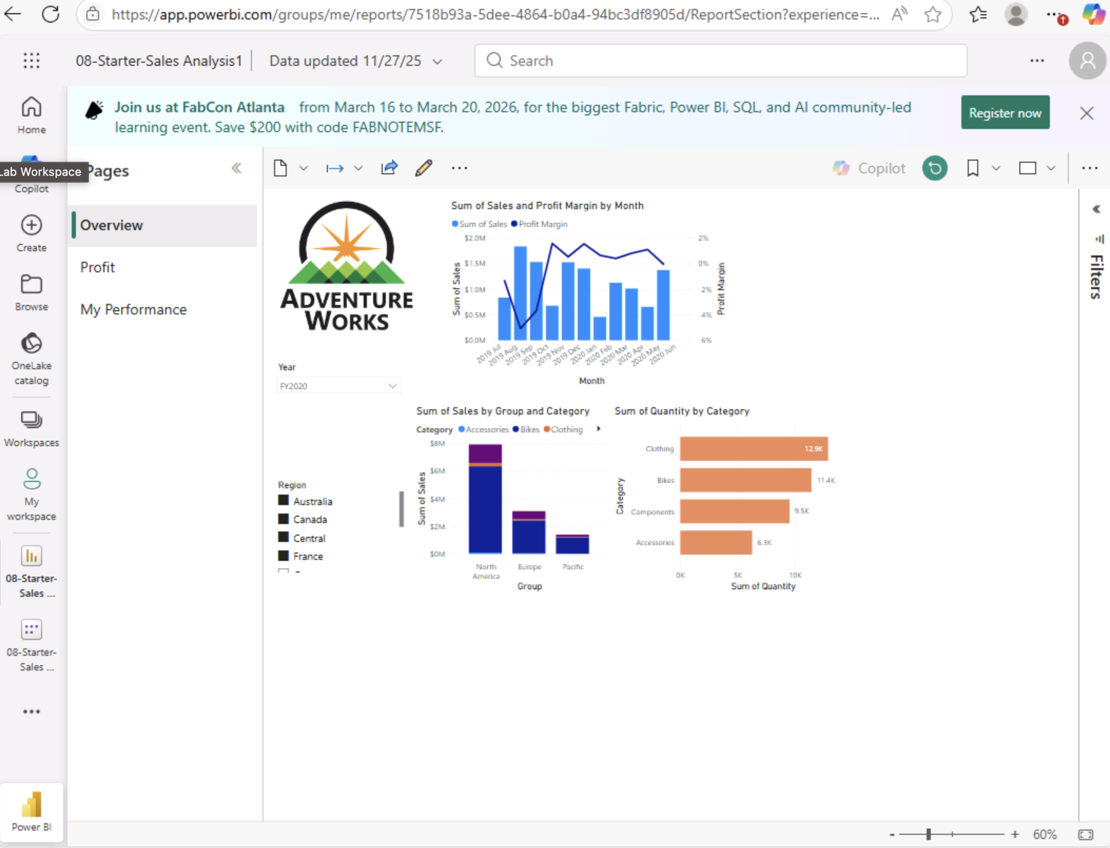

Day 4: Task 2

Please complete Lab 12 ‘Create a Power BI Dashboard’. Once complete, paste a print screen below and in the collaboration board.

“Teaching is the best way to learn, so please listen out for support requests from the class and we’ll work through the challenges together”

Paste your completed lab here

Course Notes

It is recommended to take notes from the course, use the space below to do so, or use the revision guide shared with the class.

We have included a range of additional links to further resources and information that you may find useful, these can be found within your revision guide.

END OF WORKBOOK

Please check through your work thoroughly before submitting and update the table of contents if required.

Please send your completed work booklet to your trainer.

Information

