

Data Technician

Name:
Course Date:
Table of contents
Day 1: Task 1 3
Day 1: Task 2 3
Day 3: Task 1 4
Day 4: Task 1: Written 6
Day 4: Task 2: SQL Practical 9
Course Notes 19
Additional Information 19

Day 1: Task 1

Please research and complete the below questions relating to key concepts of databases.

What is a primary key? | A primary key is a field in a table that uniquely identifies each record. It must contain a value for every entry, and no two records should have the same one.
How does this differ from a secondary key? | The difference between a primary key and a secondary key is that a primary key uniquely identifies each record in a table, while a secondary key is another field that can be used to search for or organise records but does not uniquely identify them.
How are primary and foreign keys related? | Primary and foreign keys are related because a foreign key in one table refers to the primary key in another table, creating a link between the two tables
Provide a real-world example of a one-to-one relationship | A real world example of a one-to-one relationship is a person and their passport, each person has one passport and each passport belongs to only one person.
Provide a real-world example of a one-to-many relationship | A real world example of a one-to-many relationship is a parent and their children, one parent can have many children, but each child has one set of parents (mum or dad).
Provide a real-world example of a many-to-many relationship | A real world example of a many-to-many relationship is actors and movies, each actor can appear in multiple movies, and each movie can feature multiple actors.

What is the difference between a relational and non-relational database? | Relational databases store data in organised tables with set structures, while non-relational databases store data in flexible formats like documents or graphs, and are often used for large, unstructured data.
What type of data would benefit off the non-relational model?  Why? | Data that would benefit from a non-relational model is unstructured, such as social media posts and product reviews. This is because non-relational databases can store and manage diverse data without a fixed structure, making them flexible and able to handle large, constantly changing datasets

Day 3: Task 1

Please research the below ‘JOIN’ types, explain what they are and provide an example of the types of data it would be used on.

Self-join | A self-join is when a table is joined with itself, t allows you to combine rows from the same table based on a related condition.  For example in a products table, you could use a self-join to find products in the same category.
Right join | The right join returns all rows from the right table and the matching rows from the left table. If there’s no match, the result will show NULL for the left table's columns.  For example if a table is called flavours with chocolate, vanilla etc and another table is called prices with chocolate-£2, strawberry- £3 and you do a right join on the flavour name, the result will show chocolate-£2 and strawberry–£3, with null for the flavour in the second row because strawberry isn’t in the flavours table.
Full join | A full join shows all rows from both tables. If there is no match, the missing side is empty.  For example a table of students (tom, anna) and a table of clubs (chess, drama). a full join will show all students and all clubs, even if some students don’t belong to any club or some clubs have no members.
Inner join | An inner join shows only rows that match in both tables.  For example, if a table of students Mike, Alice and a table of clubs (chess, Alice) an inner join will show only Alice, because she appears in both tables.
Cross join | A cross join pairs every row from one table with every row from another table.  For example a table of ice cream flavours chocolate, vanilla and a table of cones waffle, cup. A cross join will pair every flavour with every cone, showing all possible flavour-cone combinations.
Left join | A left join shows all rows from the left table and matching rows from the right table.  For example a table of students Alice, Mike, Tom) and a table of clubs (Alice–chess, Tom–drama). A left join will show all students with their club if they belong to one and null for mike because he isn’t in a club.

Day 4: Task 1: Written

In your groups, discuss and complete the below activity. You can either nominate one writer or split the elements between you. Everyone however must have the completed work below:

Imagine you have been hired by a small retail business that wants to streamline its operations by creating a new database system. This database will be used to manage inventory, sales, and customer information. The business is a small corner shop that sells a range of groceries and domestic products. It might help to picture your local convenience store and think of what they sell. They also have a loyalty program, which you will need to consider when deciding what tables to create.

Write a 500-word essay explaining the steps you would take to set up and create this database. Your essay should cover the following points:
- Understanding the Business Requirements:
  - What kind of data will the database need to store?
  - Who will be the users of the database, and what will they need to accomplish?
- Designing the Database Schema:
  - How would you structure the database tables to efficiently store inventory, sales, and customer information?
  - What relationships between tables are necessary (e.g., how sales relate to inventory and customers)?
- Implementing the Database:
  - What SQL commands would you use to create the database and its tables?
  - Provide examples of SQL statements for creating tables and defining relationships between them.
- Populating the Database:
  - How would you input initial data into the database? Give examples of SQL INSERT statements.
- Maintaining the Database:
  - What measures would you take to ensure the database remains accurate and up to date?
  - How would you handle backups and data security?

Your essay should include specific examples of SQL commands and explain why each step is necessary for creating a functional and efficient database for the retail business.

Please write your 500-word essay here | The database will need to store data like inventory details, including product names, categories, suppliers, stock levels, and prices to track availability and manage restocking. It will also store supplier information, such as contact details, to support purchasing. Sales data, including items sold, quantities, prices, and totals, is needed to track daily operations and generate reports. Finally, customer information for the loyalty program, such as names, contact details, loyalty points, and join dates, must be stored.  The primary users will be store employees and managers. Employees will use the database to process sales, update inventory, and manage loyalty points. Managers will track sales, monitor stock, and manage suppliers. Overall, the database supports daily operations.  The database would use separate tables for each part of the business. Inventory stores product details, Suppliers holds contact info, Customers tracks details and loyalty points, and Sales is split into Sales_Transactions and Sales_Items. This structure keeps data organised, avoids duplication, and simplifies updates.  The tables need relationships to connect different areas of the business. Inventory links to Suppliers through Supplier_ID, and Sales_Transactions link to the Customer table through the loyalty card number. Sales_Items connects each sale to specific products in Inventory and to the transaction it belongs to. These relationships ensure stock updates correctly, sales are recorded accurately, and loyalty points are applied to the right customer.  To set up the database, I would use SQL commands. I would use CREATE DATABASE to make the new database, and CREATE TABLE to build each table inside it. I would also use FOREIGN KEY links so the tables can connect to each other, for example linking sales records to customers or products to their suppliers.  This creates a table to store all customer details. The PRIMARY KEY ensures each customer has a unique ID, which is essential for tracking loyalty points and linking to sales.  CREATE TABLE Customer (  Loyalty_Card_Number INT PRIMARY KEY,  First_Name TEXT,  Last_Name TEXT,  Email TEXT,  Contact_Number TEXT,  DOB DATE,  Date_of_join DATE,  Current_Loyalty_Points INT  );  This table records items sold in each transaction. FOREIGN KEYs link sales to customers and products, ensuring data is accurate and relationships are maintained.  CREATE TABLE Sales_Items (  Sales_Item_ID INT PRIMARY KEY,  Sales_ID INT,  Product_ID INT,  Quantity INT,  Selling_Price REAL,  FOREIGN KEY (Sales_ID) REFERENCES Sales_Transactions(Sales_ID),  FOREIGN KEY (Product_ID) REFERENCES Inventory(Product_ID)  );  This adds initial customer data, allowing the business to immediately track purchases, loyalty points, and customer information.  INSERT INTO Customers (CustomerID, FirstName, LastName, Email, Phone, LoyaltyPoints)  VALUES (1, 'Alice', 'Smith', 'alice@email.com', '0123456789', 50);  This adds initial products to the inventory, enabling the store to manage stock levels and link sales to the correct items.  INSERT INTO Inventory (ProductID, ProductName, Category, Price, QuantityInStock)  VALUES (101, 'Milk', 'Dairy', 1.50, 50);  To keep the database accurate, I would regularly update inventory, sales, and customer records, and use validation rules to prevent errors. Automated updates, such as adding loyalty points after purchases, help maintain consistency.  For backups and security, I would schedule regular backups and store them safely, while using access controls and passwords to protect sensitive data. These steps ensure the database stays reliable and secure.

Day 4: Task 2: SQL Practical

In your groups, work together to answer the below questions. It may be of benefit if one of you shares your screen with the group and as a team answer / take screen shots from there.

Setting up the database:

- Download world_db(1)
- Follow each step to create your database

For each question I would like to see both the syntax used and the output.

- Count Cities in USA: Scenario: You've been tasked with conducting a demographic analysis of cities in the United States. Your first step is to determine the total number of cities within the country to provide a baseline for further analysis.

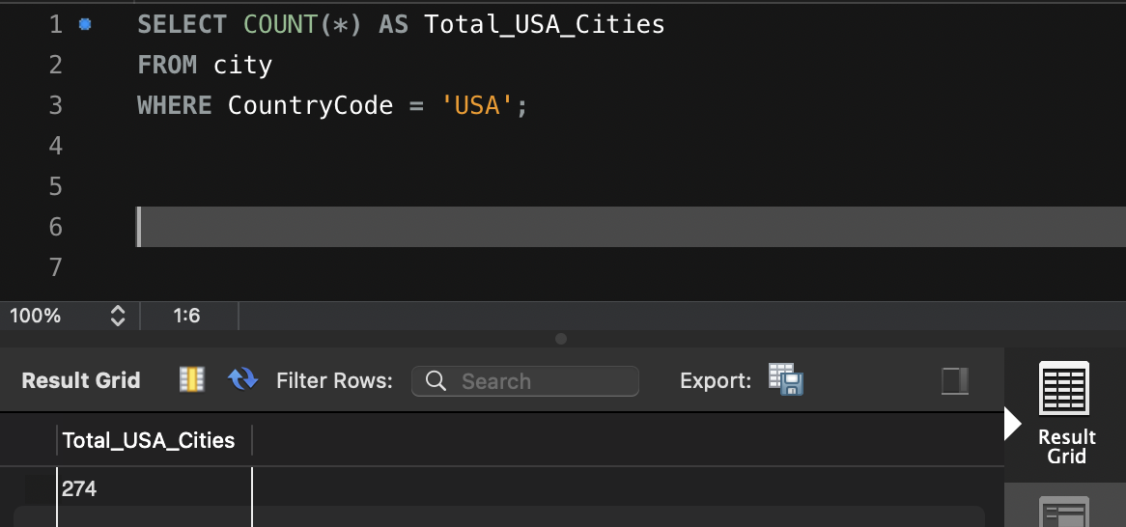

- Country with Highest Life Expectancy: Scenario: As part of a global health initiative, you've been assigned to identify the country with the highest life expectancy. This information will be crucial for prioritising healthcare resources and interventions.

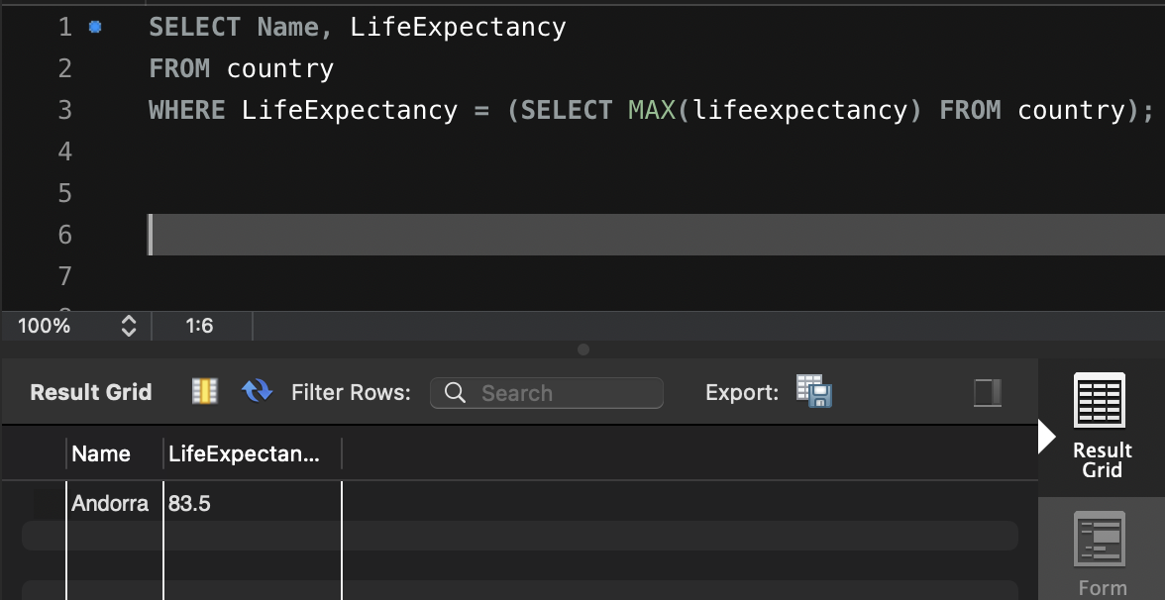

- "New Year Promotion: Featuring Cities with 'New : Scenario: In anticipation of the upcoming New Year, your travel agency is gearing up for a special promotion featuring cities with names including the word 'New'. You're tasked with swiftly compiling a list of all cities from around the world. This curated selection will be essential in creating promotional materials and enticing travellers with exciting destinations to kick off the New Year in style.

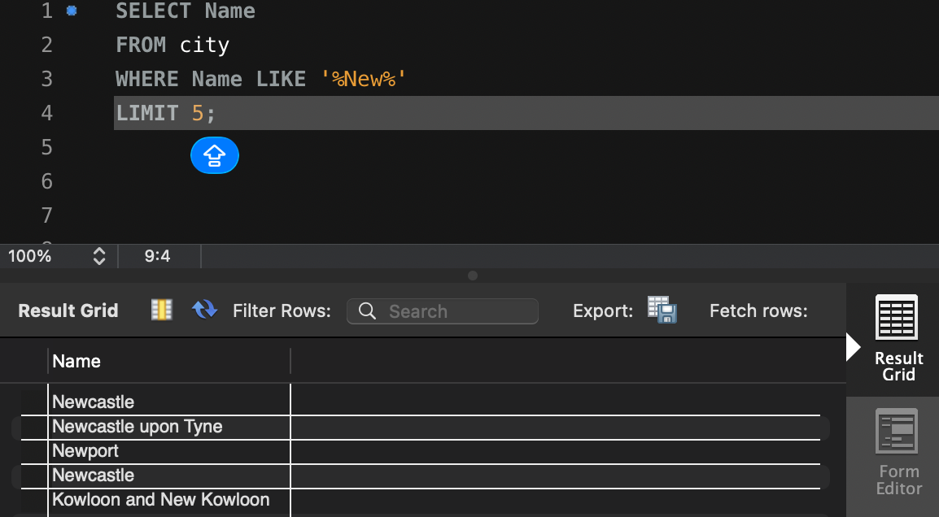

- Display Columns with Limit (First 10 Rows): Scenario: You're tasked with providing a brief overview of the most populous cities in the world. To keep the report concise, you're instructed to list only the first 10 cities by population from the database.

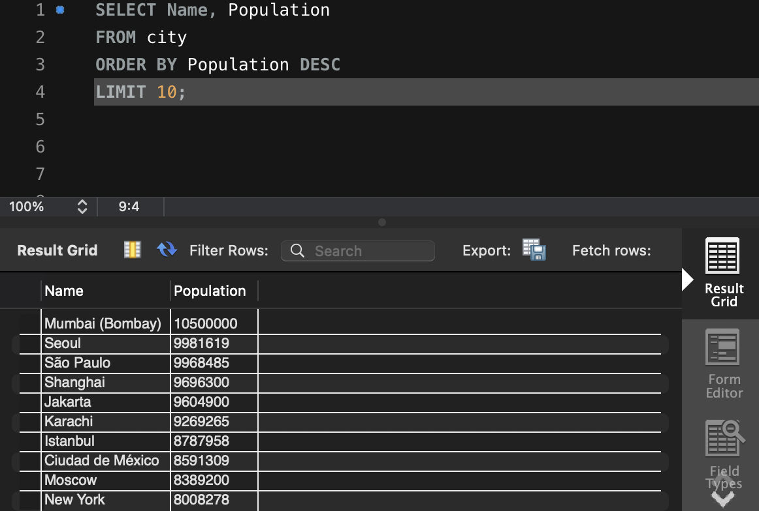

- Cities with Population Larger than 2,000,000: Scenario: A real estate developer is interested in cities with substantial population sizes for potential investment opportunities. You're tasked with identifying cities from the database with populations exceeding 2 million to focus their research efforts.

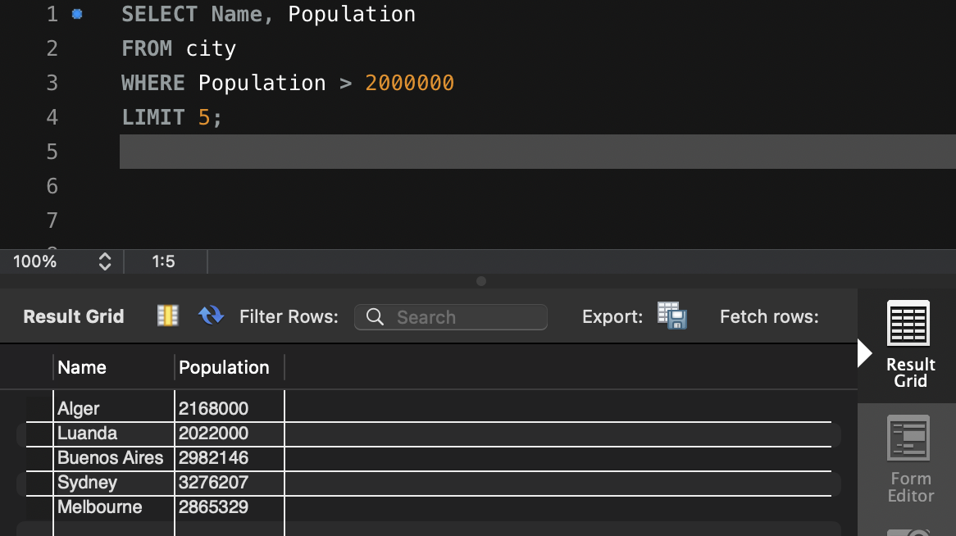

- Cities Beginning with 'Be' Prefix: Scenario: A travel blogger is planning a series of articles featuring cities with unique names. You're tasked with compiling a list of cities from the database that start with the prefix 'Be' to assist in the blogger's content creation process.

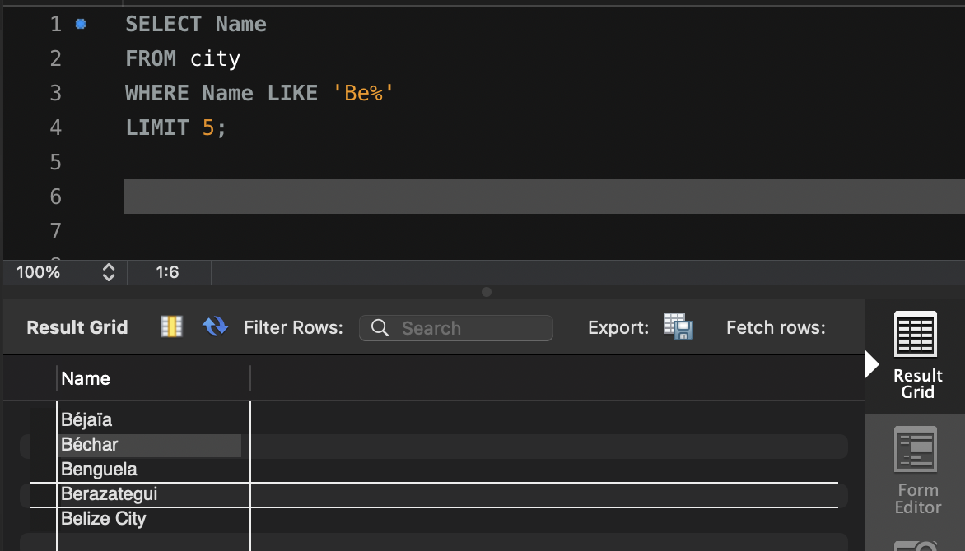

- Cities with Population Between 500,000-1,000,000: Scenario: An urban planning committee needs to identify mid-sized cities suitable for infrastructure development projects. You're tasked with identifying cities with populations ranging between 500,000 and 1 million to inform their decision-making process.

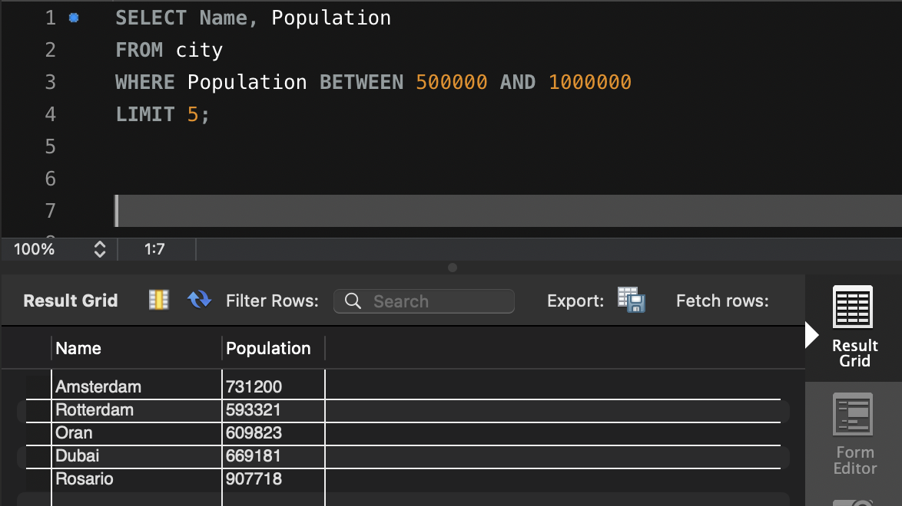

- Display Cities Sorted by Name in Ascending Order: Scenario: A geography teacher is preparing a lesson on alphabetical order using city names. You're tasked with providing a sorted list of cities from the database in ascending order by name to support the lesson plan.

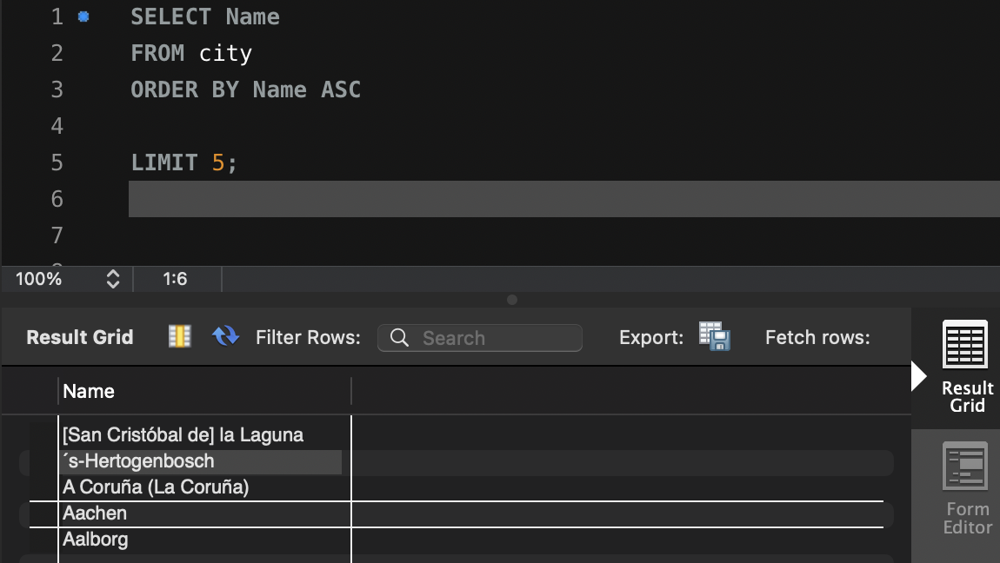

- Most Populated City: Scenario: A real estate investment firm is interested in cities with significant population densities for potential development projects. You're tasked with identifying the most populated city from the database to guide their investment decisions and strategic planning.

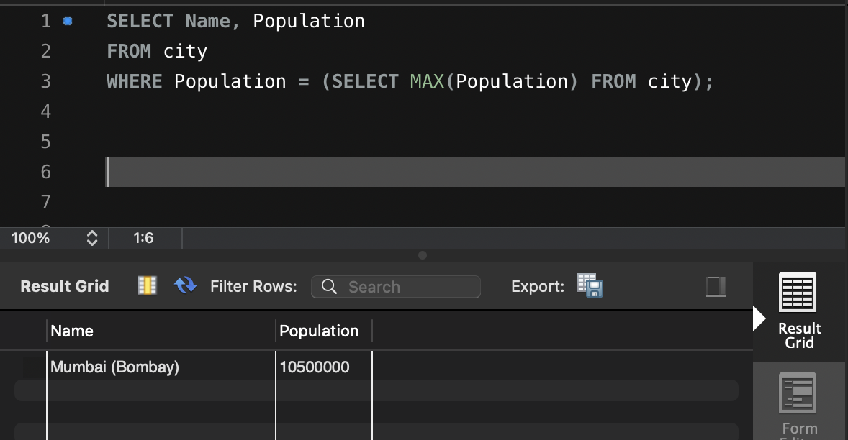

- City Name Frequency Analysis: Supporting Geography Education Scenario: In a geography class, students are learning about the distribution of city names around the world. The teacher, in preparation for a lesson on city name frequencies, wants to provide students with a list of unique city names sorted alphabetically, along with their respective counts of occurrences in the database. You're tasked with this sorted list to support the geography teacher.

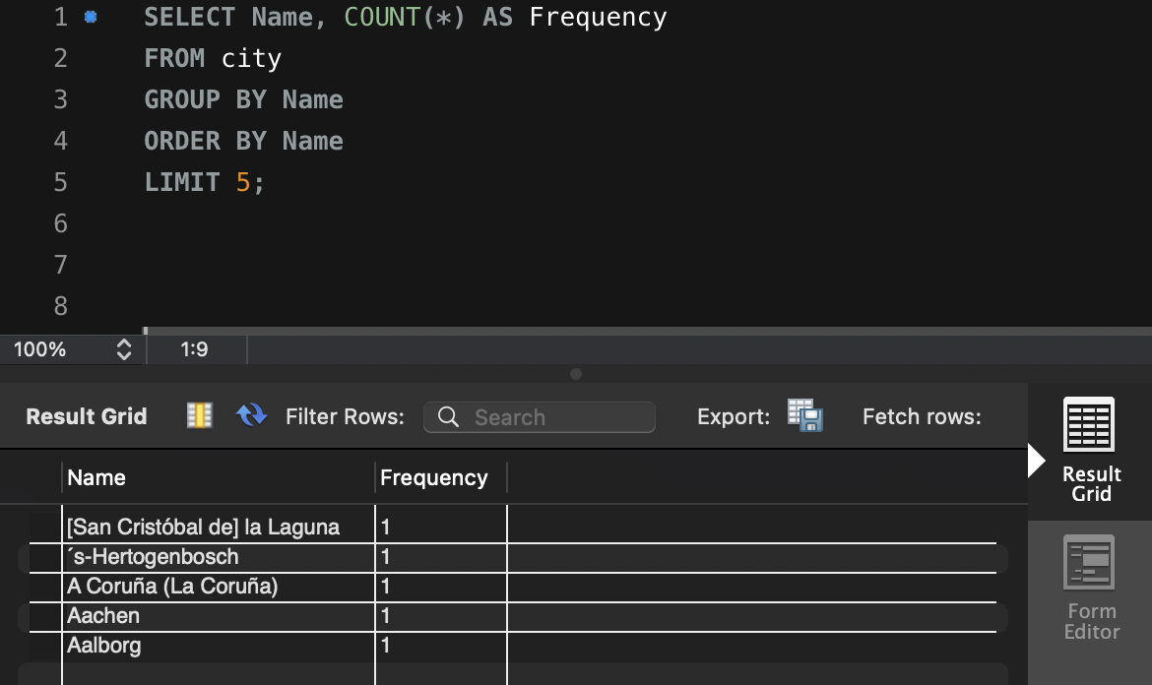

- City with the Lowest Population: Scenario: A census bureau is conducting an analysis of urban population distribution. You're tasked with identifying the city with the lowest population from the database to provide a comprehensive overview of demographic trends.

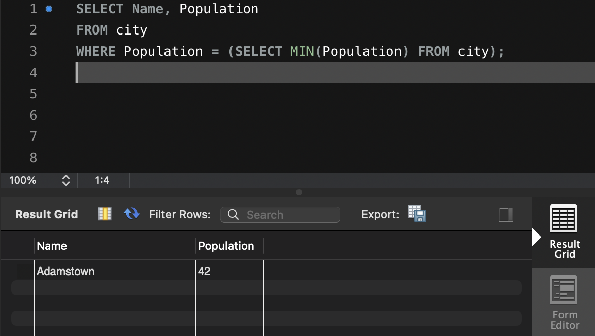

- Country with Largest Population: Scenario: A global economic research institute requires data on countries with the largest populations for a comprehensive analysis. You're tasked with identifying the country with the highest population from the database to provide valuable insights into demographic trends.

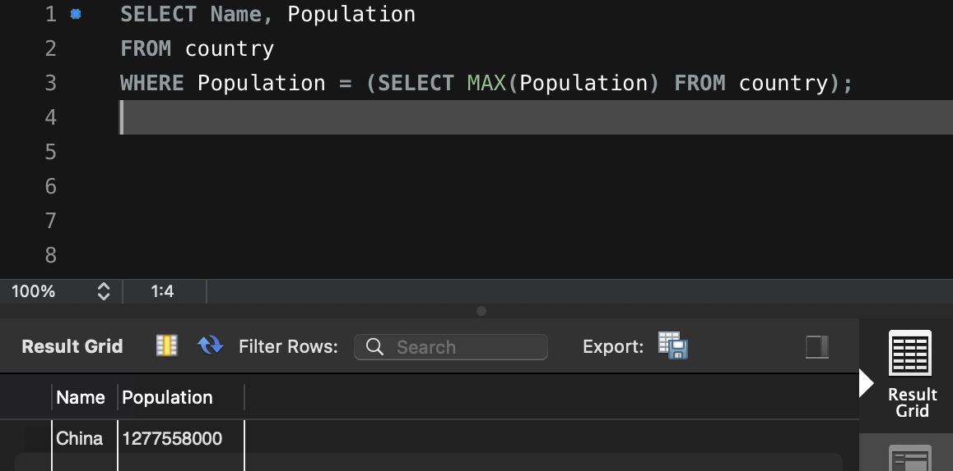

- Capital of Spain: Scenario: A travel agency is organising tours across Europe and needs accurate information on capital cities. You're tasked with identifying the capital of Spain from the database to ensure itinerary accuracy and provide travellers with essential destination information.

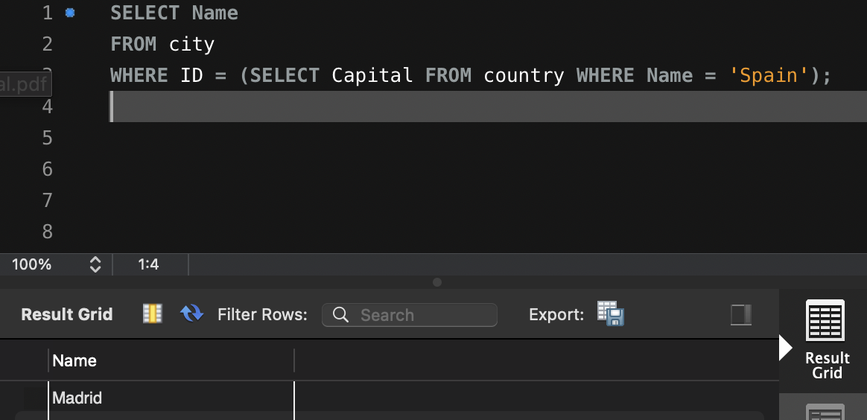

- Country with Shortest Life Expectancy: Scenario: A healthcare foundation is conducting research on global health indicators. You're tasked with identifying the country with the highest life expectancy from the database to inform their efforts in improving healthcare systems and policies.

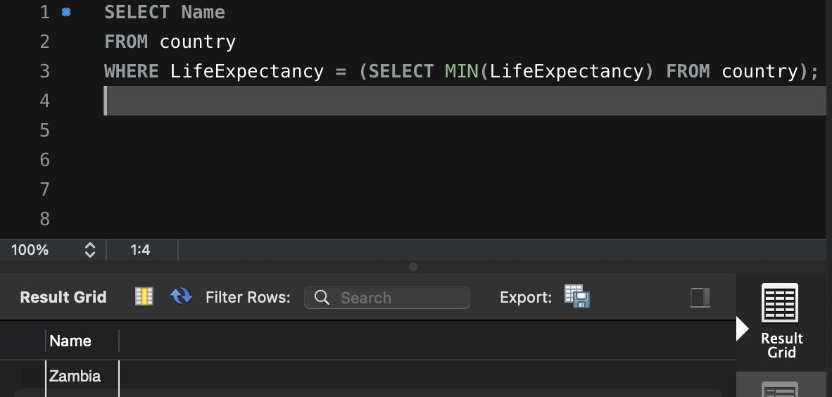

- Cities in Europe: Scenario: A European cultural exchange program is seeking to connect students with cities across the continent. You're tasked with compiling a list of cities located in Europe from the database to facilitate program planning and student engagement.
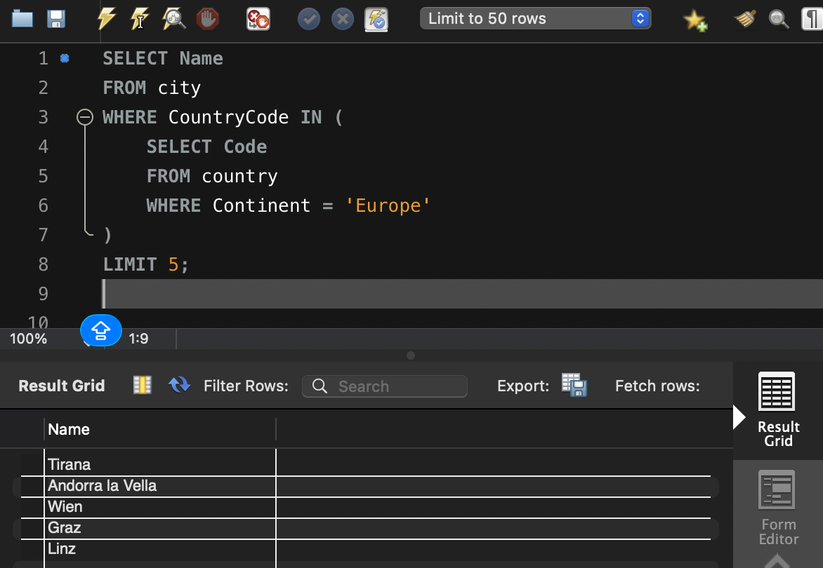

- Average Population by Country: Scenario: A demographic research team is conducting a comparative analysis of population distributions across countries. You're tasked with calculating the average population for each country from the database to provide valuable insights into global population trends.

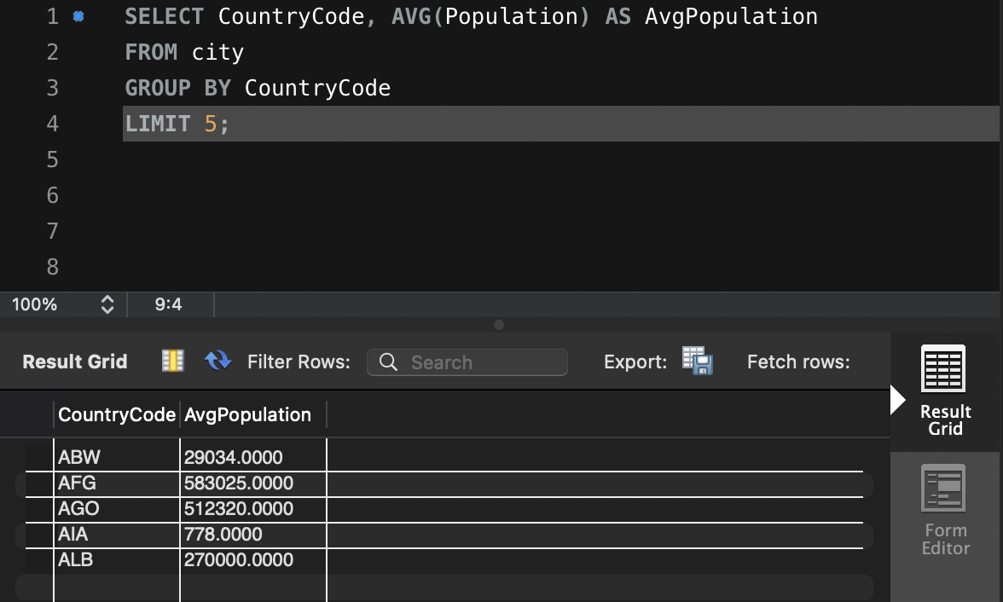

- Capital Cities Population Comparison: Scenario: A statistical analysis firm is examining population distributions between capital cities worldwide. You're tasked with comparing the populations of capital cities from different countries to identify trends and patterns in urban demographics.

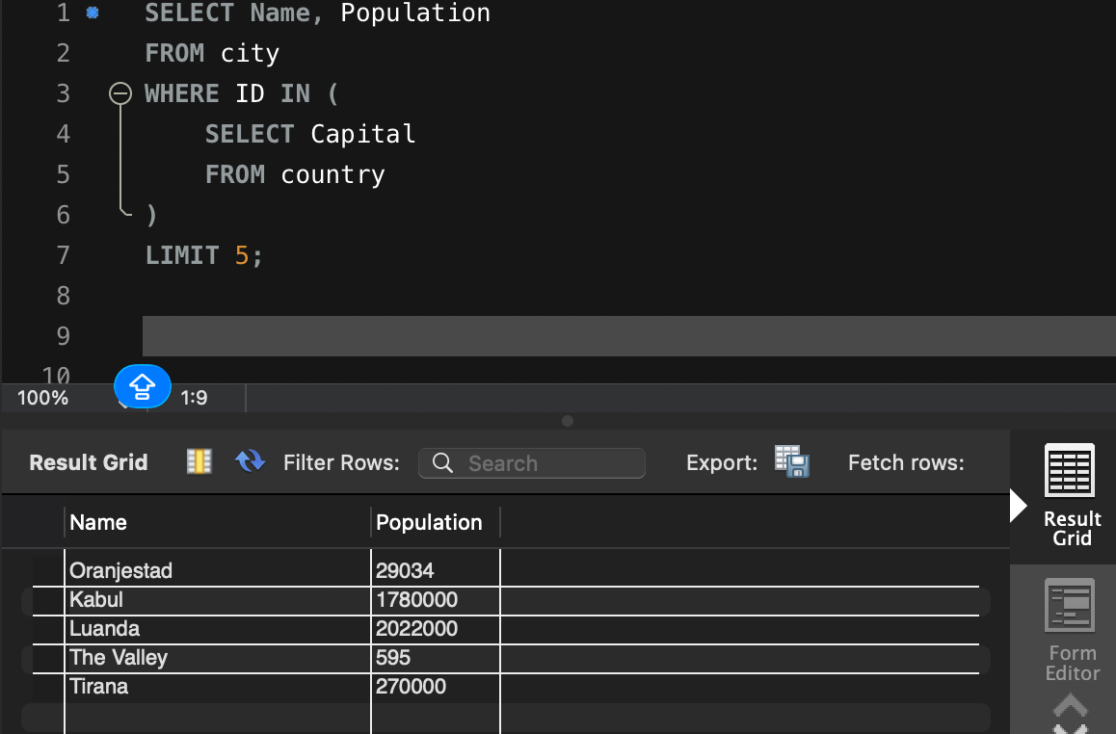

- Countries with Low Population Density: Scenario: An agricultural research institute is studying countries with low population densities for potential agricultural development projects. You're tasked with identifying countries with sparse populations from the database to support the institute's research efforts.

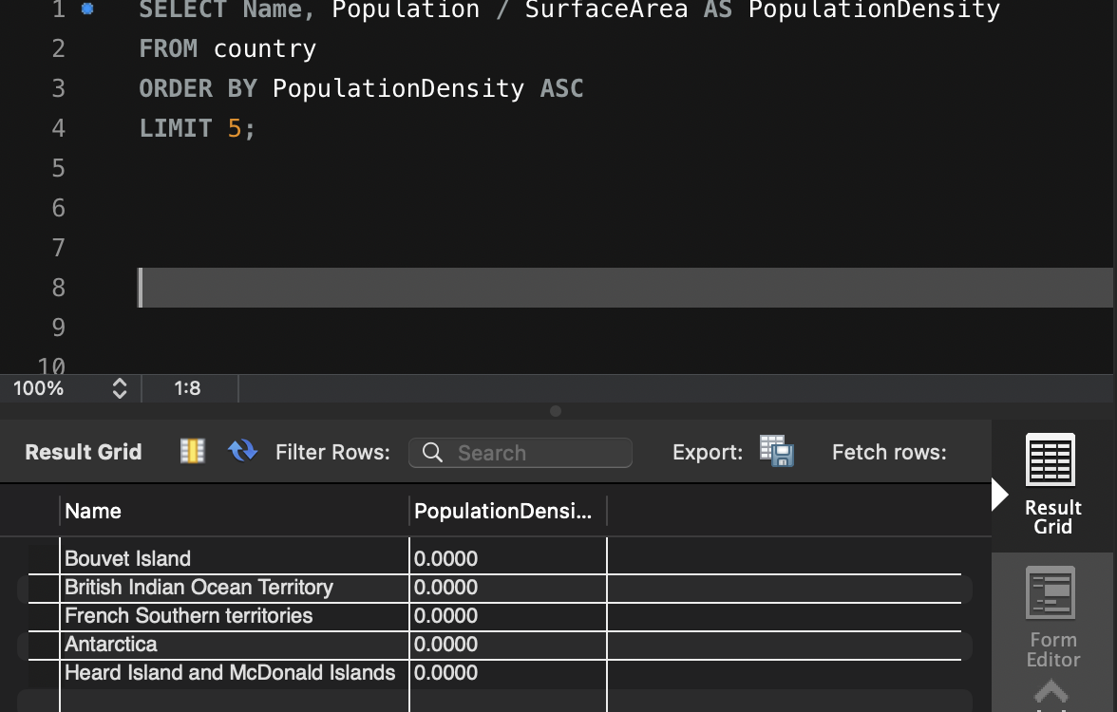

- Cities with High GDP per Capita: Scenario: An economic consulting firm is analysing cities with high GDP per capita for investment opportunities. You're tasked with identifying cities with above-average GDP per capita from the database to assist the firm in identifying potential investment destinations.

- Display Columns with Limit (Rows 31-40): Scenario: A market research firm requires detailed information on cities beyond the top rankings for a comprehensive analysis. You're tasked with providing data on cities ranked between 31st and 40th by population to ensure a thorough understanding of urban demographics.

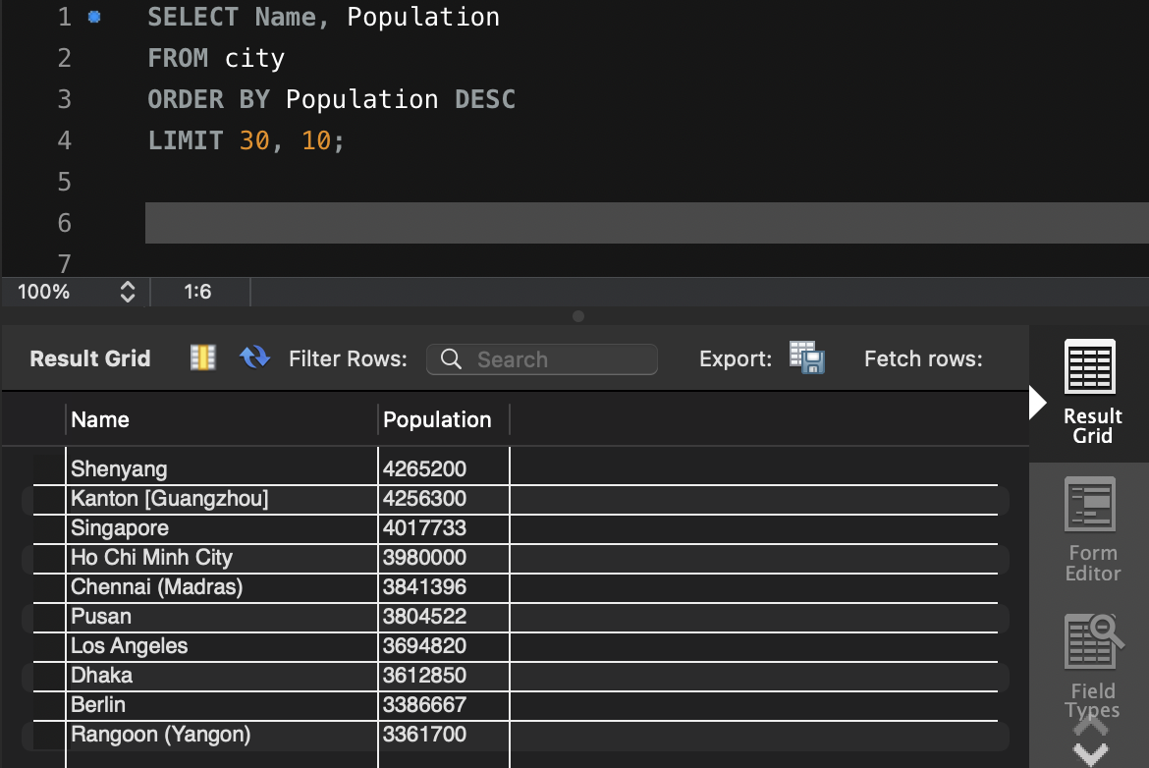

Course Notes

It is recommended to take notes from the course, use the space below to do so, or use the revision guide shared with the class:

Additional Information

We have included a range of additional links to further resources and information that you may find useful, these can be found within your revision guide.

END OF WORKBOOK

Please check through your work thoroughly before submitting and update the table of contents if required.

Please send your completed work booklet to your trainer.

