UNIT 4.5

SOFTWARE ENGINEERING
TUTOR NAME: MS. DR LORAINE

SUBMITTED BY FATIMA EJAZ BARRI

TABLE OF CONTENTS
SOFTWARE ENGINEERING | 03
THE SOFTWARE DEVELOPMENT OF LIFE CYCLE | 03
WATERFALL MODEL | 05
INCREMENTAL MODEL | 07
SPIRAL MODEL | 08
PROTOTYPING MODEL | 11
MODELING TOOLS | 13
ENTITY RELATIONSHIP DIAGRAM | 13
UNIFIED MODELING LANGUAGE | 20
DATA FLOW DIAGRAM | 27
LEVELS OF DFD | 30
TEAM STRUCTURE | 37

- What is software engineering?
Software engineering is known as the process of analysing user needs and designing, constructing and testing end-user applications, which satisfies these needs using software process models. In contrary to simple programming, software engineering is used for larger and more complex software systems such as critical systems for businesses and organizations.
A software engineer keeps always end-users in his mind and develops new applications.
- The Software development life cycle (SDLC)
Software development life cycle (SDLC) is a process used to develop software systems. The SDLC’s main goal is to develop quality software that meets and exceeds customer expectations.
The SDLC consists of the following steps to meet their main goal, develop a good software system.

- Phase1: Planning
The planning phase consists of determining the main goal of the project and the software system. This phase also consists of planning of how to reach said goals. The two primary activities involved in the planning phase are as follows:
- Identification of the system for development
- Feasibility assessment
- Phase2: Analysis
In the process of analysis, the business requirements needed for the completion of the project are analysed and the planning of the project is modified. The two primary activities involved in the analysis phase are as follows:
- Gathering business requirement
- Performing a detailed analysis
- Phase3: Design
In the design phase, we plan and confirm the desired features and look of the project. This phase includes business rules, pseudo code, screen layouts, and other necessary documentation. The two primary activities involved in the design phase are as follows:
- Design of IT infrastructure
- Designing the system model
To avoid any fail in the system or the final project, the technical bae of the software should be of high quality.

- Phase4: Development
In the development phase, all the information from the previous phases is kept in mind and the developing of the software system is done according to the plan. The two primary activities involved in the development phase are as follows:
- Development of IT infrastructure
- Development of database and code
In the design phase, only a rough estimation of the final project is made while in the development phase the rough plans are put to work and tweaked to perfection.

- Phase5: Testing
In the testing phase, all the parts to develop the final system are integrated. Testers then follow the software testing life cycle to test the system for any malfunctions so that they can avoid them in the final software. The two primary activities involved in the testing phase are as follows:
- Writing test cases
- Execution of test cases
Testing is a very important part of the whole cycle because it helps to build a high quality software. Once test cases are done, the tester compares the expected result to the actual result to see the errors in the system and devises plans to fix them. Writing test cases and executing them is a difficult task for organizations but it promises the execution of a great project if done properly.
- Phase6: Deployment
In this phase, the software is put out in the world for the client’s use. All the components of the system are put out for public use. This phase is also called the delivery phase.
- Phase7: maintenance
In the maintenance phase, important changes are made to fit the system in the client’s expectations, the organization works to improve the system and updates it. This is necessary to enable the software to stay relevant and helpful in the future. The three primary activities involved in the maintenance phase are as follows:
- Support the system users
- System maintenance
- System changes and adjustment

PLANNING
ANALYSIS
DESIGN
DEVELOPMENT
TEXTING
DEPLOYMENT
MAINTENANCE

- Waterfall model with diagram & all the phase
The Waterfall Model was the first Process Model to be introduced. It is very simple to understand and use. In a Waterfall model, there is no overlapping of phases and one step must be compete to move onto the rest. The Waterfall model is the earliest SDLC approach that was used for software development.
Maintenance
Requirements
System Design
Implementation
Integration And Testing
Deployment Of System

Sequential phases in the waterfall model:
- Requirements: This step involves the laying out of the function and requirements for the system. For this purpose, the specifications of the input and output and the final product is marked.
- System design: the requirement specifications from the first phase are studied in this studied in this phase and system design is prepared. System design helps in specifying hardware and system requirements and helps in defining overall system architecture. The software code to be written in the next stage is created now.
- Implementation: with inputs from system design, the system is first developed in small programs called units, which are integrated into the next phase. Each unit developed and tested for it is functionally which is referred to as unit testing.
- Integration and testing: all the units developed in the implementation phase are integrated into a system after testing of each unit. The software designed, needs to go through constant software testing to find out if there are any flaw or errors. Testing is done so that the client does not face any problem during the installation of the software.
- Deployment of system: once the functional and non-functional testing is done, the product is deployed in the customer environment or released into the market.
- Maintenance: this step occurs after installation, and involves making modifications to the system or an individual component to alter attributes or improves performance. These modifications arise due to change either requests initiated by the customer, or defects uncovered during live use of the system. The client is provided with regular maintenance and support for the developed software.
- Advantages of the waterfall model
the advantages of waterfall development is that it allows for departmentalization and control. A schedule can be set with declines for each stage of development and a product can proceed through the development process model phases one by one. The waterfall model progresses through easily understandable and explainable phases and thus it is easy to use.it is easy to manage due to the rigidity of the model each phase has specific deliverables and a review process.in this model phases are processed and completed one at a time and they do not overlap. Waterfall model works well for smaller projects where requirements are very well understood.
- Disadvantage of the waterfall model
it is difficult to estimate time and cost for each phase of the development process. Once an application is in the testing stage.it is very difficult to go back and change something that was not well thought out in the concept stage. Not a good model for complex and object oriented projects. Not suitable for the projects where requirements are at a moderate to high risk of changing.

Explain when to use the waterfall model.
One should use the waterfall model only when:
- Requirements are very clear and fixed.
- There are no ambiguous requirements.
- Ample resources with required expertise are available freely.
- The client has high confidence in the organization.
- The organization has experience of similar projects.
- The project is short.
- It is good to use this model when the technology is well understood.

- Incremental model
Incremental Model is a process of software development where requirements divided into multiple standalone modules of the software development cycle. In this model, each module goes through the requirements, design, implementation and testing phases. Every subsequent release of the module adds function to the previous release. The process continues until the complete system achieved.
For example:-

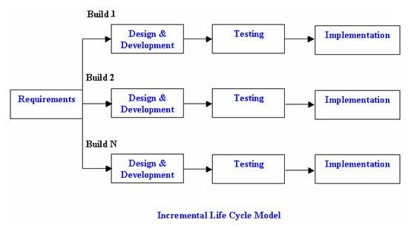
Diagram of Incremental model:

Advantages of Incremental model:
- Generates working software quickly and early during the software life cycle.
- This model is more flexible – less costly to change scope and requirements.
- It is easier to test and debug during a smaller iteration.
- In this model customer can respond to each built.
- Lowers initial delivery cost.
- Easier to manage risk because risky pieces are identified and handled during it had iteration.
Disadvantages of Incremental model:
- Needs good planning and design.
- Needs a clear and complete definition of the whole system before it can be broken down and built incrementally.
- Total cost is higher than waterfall.
When to use the Incremental model:
- This model can be used when the requirements of the complete system are clearly defined and understood.
- Major requirements must be defined; however, some details can evolve with time.
- There is a need to get a product to the market early.
- A new technology is being used
- Resources with needed skill set are not available
- There are some high-risk features and goals.

- Spiral model
Spiral Model is a combination of a waterfall model and iterative model. Each phase in spiral model begins with a design goal and ends with the client reviewing the progress. Barry Boehm first mentioned the spiral model in his 1986 paper. The development team in Spiral-SDLC model starts with a small set of requirement and goes through each development phase for those set of requirements. The software engineering team adds functionality for the additional requirement in every-increasing spirals until the application is ready for the production phase.

Diagram of Spiral model:

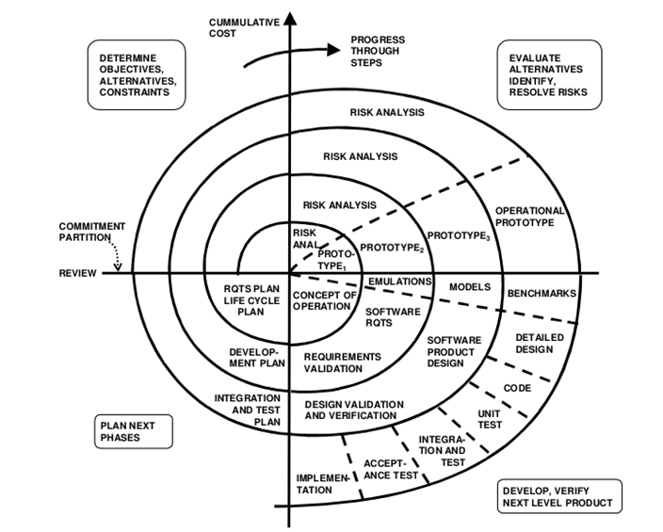

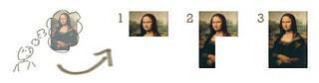
Spiral model phases
Planning: it includes estimating the cost, schedule and resources for the iteration. It also involves understanding the system requirements for continuous communication between the system analyst and the customer
Risk analysis: identification of potential risk is done while risk mitigation strategy is planned and finalized
Engineering: it includes testing, coding and deploying software at the customer site
Evaluation: evaluation of software by the customer. Also includes identifying and monitoring risks such as schedule slippage and cost overrun

Advantage of spiral model
- Additional functionality or changes can be done at a later stage
- Cost estimation becomes easy as the prototype building is done in small fragments
- Continuous or repeated development helps in risk management
- Development is fast and features are added in a systematic way
- There is always a space for customer feedback

Disadvantage of spiral model
- Risk of not meeting the schedule or budget
- It works best for large projects only also demands risk assessment expertise
- For its smooth operation spiral model protocol needs to be followed strictly
- Documentation is more as it has intermediate phases
- It is not advisable for smaller project, it might cost them a lot

When to use the spiral model
- When project is large
- When releases are required to be frequent
- When creation of a prototype is applicable
- When risk and costs evaluation is important
- For medium to high-risk projects
- When requirements are unclear and complex
- When changes may require at any time
- When long term project commitment is not feasible due to changes in economic priorities

Conclusion:
- Each spiral can be termed as a loop and each loop is a separate development process in a spiral model. The four activities (Planning, Risk analysis, engineering and evaluation) form the intermediary phases of a spiral model and is repeated again for each loop.
- This model is very good to use for larger projects where you can develop and deliver smaller prototypes and can enhance it to make the larger software. The implementation of this model requires experienced resources as risk analysis is an integral part of this model and risk analysis requires expertise and as a result, this model becomes costly.
- Prototyping
Prototype is a working model of software with some limited functionality. The prototype does not always hold the exact logic used in the actual software application and is an extra effort to be considered under effort estimation.
Prototyping is used to allow the users evaluate developer proposals and try them out before implementation. It also helps understand the requirements, which are user specific and may not have been considered by the developer during product design.
Types of prototyping
There are different types of software prototypes used in the industry. Following are the major software prototyping types used widely

Throwaway Prototyping
Throwaway prototyping is also called as rapid or close-ended prototyping. This type of prototyping uses very little efforts with minimum requirement analysis to build a prototype. Once the actual requirements are understood, the prototype is discarded and the actual system is developed with a much clear understanding of user requirements.

Evolutionary Prototyping
Evolutionary prototyping also called as breadboard prototyping is based on building actual functional prototypes with minimal functionality in the beginning. The prototype developed forms the heart of the future prototypes on top of which the entire system is built. By using evolutionary prototyping, the well-understood requirements are included in the prototype, the requirements are added as, and when they are understood.

Incremental Prototyping
Incremental prototyping refers to building multiple functional prototypes of the various sub-systems and then integrating all the available prototypes to form a complete system.

Extreme Prototyping
Extreme prototyping is used in the web development domain. It consists of three sequential phases. First, a basic prototype with all the existing pages is presented in the HTML format. Then the data processing is simulated using a prototype services layer. Finally, the services are implemented and integrated to the final prototype. This process is called Extreme Prototyping used to draw attention to the second phase of the process, where a fully functional UI is developed with very little regard to the actual services.

Advantages and disadvantages
Software prototyping is used in typical cases and the decision should be taken very carefully so that the efforts spent in building the prototype add considerable value to the final software developed. The model has its own advantages and disadvantages discussed as follows.
The advantages of the Prototyping Model are as follows:
- Increased user involvement in the product even before its implementation.
- Since a working model of the system is displayed, the users get a better understanding of the system being developed.
- Reduces time and cost as the defects can be detected much earlier.
- Quicker user feedback is available leading to better solutions.
- Missing functionality can be identified easily.
- Confusing or difficult functions can be identified.
The Disadvantages of the Prototyping Model are as follows:
- Risk of insufficient requirement analysis owing to too much dependency on the prototype.
- Users may get confused in the prototypes and actual systems.
- Practically, this methodology may increase the complexity of the system as scope of the system may expand beyond original plans.
- Developers may try to reuse the existing prototypes to build the actual system, even when it is not technically feasible.
- The effort invested in building prototypes may be too much if it is not monitored properly.
When to use the prototyping
- When the requirement of customer is unclear and certainly changing at that time prototype model are used.
- In this model generally evolved a customer interaction.

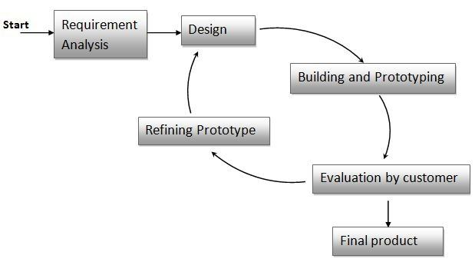
Here is the diagrammatic view of the prototype model.

Few points to be noted:
- Here, the developer and client interact to establish the requirements of the software.
- The essence of prototyping is a quickly designed and can undergo immediate evaluation.
- Here, the visible elements of the software, the input and the output are designed.
- The final product of the design through this model is a prototype.
- After the prototype is developed, the client evaluates the prototype and provides its recommendations and suggestion to the developer.
- Until the all, the user requirements are met, it continues in an iterative manner.
- Hence, this model accommodates problem of changing requirements.
- Modelling tools
Modelling tools are model-based testing tools that actually generates test inputs or test cases from stored information about a particular model (e.g. a state diagram) so are classified as test design tools.it helps to validate models of the system or software. For an example, a tool can check consistency of data objects in a database and can find inconsistencies and defects. These maybe difficult to pick up during testing because you may have tested with one data item and not realize that in another part of the database there is conflicting information related to that item. Modelling tools can also be used for checking state models or object models. Modelling tools are generally used by developers and can help in the design of the software.
- Entity relationship diagram
ER modelling is data modelling method used in software engineering to produce a conceptual data model of an information system. Diagrams created using this ER-modelling method are called ERDs.
There are four basic components of an ER diagram:
- Entities: definable objects or concepts about which data stored.
- Attributes: properties or characteristics of entities.
- Relationship: the relationship between the entities
- Cardinality: possible number of occurrence in one entity, which is associated with the number of occurrences in another.

Entity
An entity can be a real world object, either animate or inanimate, that can be merely identifiable.an entity is denoted as a rectangle in an ERD. For example, in a school database, students, teachers, classes and course offered can be treated as entities. All these entities have some attributes or properties that give them their identity.
Entity set
An entity set is a collection of related types of entities.an entity set may include entities with attribute sharing similar values. For example, a student set may contain all h students of a school; likewise, a teacher set may include all the teachers of a school from all faculties. Entity set need not be disjoint.
WORKS FOR
EMPLOYEE
DEPARTMENT

Attributes
Entities are denoted utilizing their properties, knows as attributes. All attributes have values. For example, a student entity may have name, class and age as attributes. There exists a domain or range of values that can be assigned to attributes. For example, a student’s name cannot be a numeric value. It has to be alphabetic. A student’s age cannot be negative etc.

NAME
ADDRESS

STUDENT

AGE
ID NO.

- Key
Key attribute: key is an attribute or collection of attributes that uniquely identifies an entity among the entity set. For example, the roll number of a student makes him identifiable among students.
ROLL NO

NAME
STUDENT
AGE

ADDRESS

There are mainly three types of keys:
Super key: a set of attributes that collectively identifies an entity in the entity set.
Candidate key: a minimal super key is known as a candidate key. An entity set may have more than one candidate key.
Primary key: a primary key is one of the candidate keys chosen by the database designer to uniquely identify the entity set.
There are four types of attributes:
- Composite attribute
- Single valued attribute
- Multi valued attribute
- Derived attribute
Composite attribute: an attribute that is a combination of other attributes is called a composite attribute. For example, in student entity, the student address is a composite attribute as an address is composed of other characteristics such as pin code, state, country.
PIN

STUDENT
ADDRESS
STATE

COUNTRY

Single-valued attribute: single-valued attribute contain a single value. For example, social security number.
Multi-valued attribute: if an attribute can have more than one value, it is known as a multi-valued attribute. The double ellipse depicts multi-valued attribute. For example, a person can have more than one phone number, email address, etc.

PHONE_NO

Derived attribute: derived attributes are the attribute that does not exist in the physical database but their values are derived from other attributes present in the database. For example, age can be derived from date_of_birth. In the ERD, the dashed ellipse depicts derived attributes.
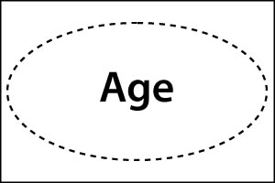

FIG-1.1:Drived attribute
The complete entity type student with its attributes can be represented as:
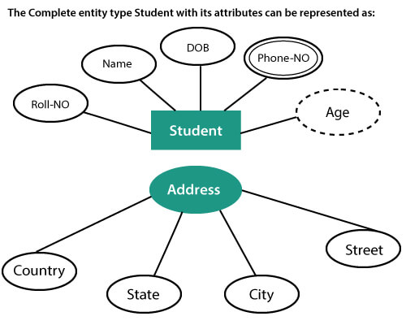

Relationships
The association among entities is known as relationship. Relationships are represented by the diamond shaped box. For example, an employee works at a department, a student enrols in a course. Here, works at and enrols are called relationships.

TEACHER
TEACHES
STUDENT

Relationship set
A set of relationship of a similar type is known as a relationship set. Like entities, a relationship too can have attributes. These attributes are called descriptive attributes.
The three most common relationships in ER models are:
- Unary
- Binary
- Ternary
Unary relationship: this is also called recursive relationships. It is a relationship between the instances of one entity type. For example, one person is married to only one person.
PERSON
MARRIED TO

Binary relationship: it is a relationship between the instances of two entity types. For examples, the teacher teaches the subject.
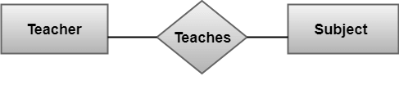

Ternary relationship: it is a relationship amongst instances of three entity types. The relationship, “may have” provide the association of three entities, i.e. Teacher, student and subject. All three entities are many to many participants. There may be one or many participants in a ternary relationship. In a general, “n” entities can be related by the same relationship and is known as n-ary relationship.

TEACHER

STUDENT
MAY HAVE
SUBJECT

(Many too many)
Cardinality
Cardinality describes the number of entities in one entity set, which can be associated with the number of entities of other sets via relationship set.
Types of cardinalities
One to one: one entity from entity set A can be contained with at most one entity of entity set B and vice versa. Let us assume that each student has only one student ID, and each student ID is assigned to only one person.so, the relationship will be one to one.
STUDENT
IS ASSIGNED
STUDENT-ID

One to many: when a single instance of an entity is associated with more than one instances of another entity then it is called one to many relationships. For example, a client can place many orders; a order cannot be placed by many customers.

CUSTOMER
PLACED
ORDER

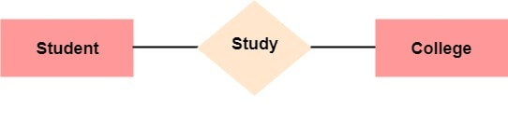
Many to one: more than one entity from entity set A can be associated with at most one entity of entity set B, however an entity from entity set B can be associated with more than one entity from entity set A. for example – many students can study in a single college, but a student cannot study in many colleges at the same time.

Many to many: one entity from A can be associated with more than one entity from B and vice-versa. From example, the student can be assigned to many project can be assigned to many students.
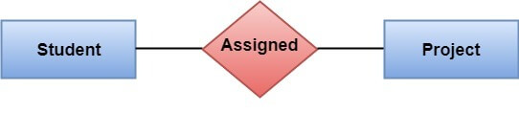

- Unified modeling language
Unified modeling language (UML) is a standardized, general-purpose and graphical modelling language for algorithms.
UML is a general-purpose modeling language in the field of software engineering, which is designed to provide a standard way to visualize the design of a system.it was created and developed by Grady Booch, Ivar Jacobson and James rum Baugh at rational software during 1994-95 with further development led by them through 1996.in 1997 it was adopted as a standard by the object management group (OMG), and has been managed by this organization ever since. In 2000, the unified modeling language was also accepted by the international organization for standardization (ISO) as an approved ISO standard. Since then it has been periodically revised to cover the latest revision of UML.
UML is divided into two types
- Structured modeling diagram
It depicts the static view of the model
- Behavioral modeling diagram
Behavior diagrams depict the varieties of interaction within a model as it “executes” over time

Structured modeling diagram
- Class diagram
- Object diagram
- Component diagram
- Package diagram
- Composite structure
- Deployment diagram
Behvorial modeling diagram
- Use case diagram
- Activity diagram
- Communication diagram
- Sequence diagram
- Timing diagram
- Interaction overview diagram
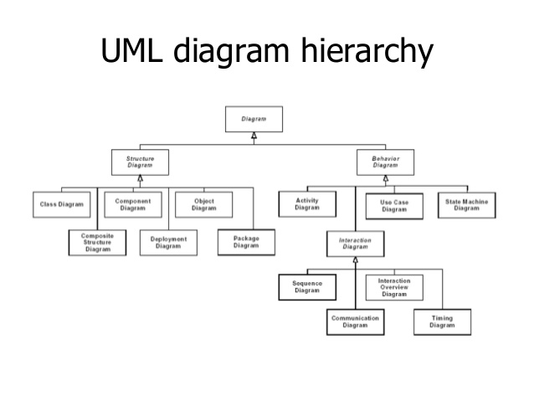
- UML Diagram

Class diagram
A class diagram is a diagram describing the structure of a system.
It consists the:
- Class name
- Attributes
- Operations
- Relationships among the classes.
CLASS NAME
ATTRIBUTES
OPERATIONS

Applications of UML
- UML is a very powerful modeling language. We can develop many diagrams using UML and provide users with ready-to-use, expressive modelling examples.
- UML can be applied in many areas like embedded systems, web applications, commercial applications, etc.
- Some UML tools generate program language code from UML
- UML can be used for modeling the whole system independent of platform language.
- UML gives us a standard way to write a systems view, covering conceptual things such as business processes and system functions, as well as things like classes written in a specifies programming language, database schemas, and reusable software components.
Advantages of UML
- You can model just about any type of application
- UML is effective for modeling large, complex software.
- It is simple to learn for most developers but provides systems.
- Advanced features for expert analysis, designers and architects.
- It can specify the system in an implementation-independent manner.
Disadvantages of UML
- It takes a lot of time to keep the diagram reasonable and synchronized with the actual code. UML diagrams do not run but require a lot of time. Therefore, they are good only if your organization size can manage them.
- You cannot represent every condition in the sequence diagram. It is impossible if you want to deliver. Therefore, the state diagram should convey basic facts, not all possible outcomes.
- Good UML software costs money and takes some time to master properly.
Sequence diagram
Sequence diagrams are interaction diagrams that detail how operations are carried out. They capture the interaction between objects in the context of a collaboration.
Purpose of sequence diagram
- Model high-level interaction between active objects in a system.
- Model the interaction between object instances within a collaboration that realizes a use case
- Model the interaction between objects within a collaboration that realizes an operation
Example of sequence diagram
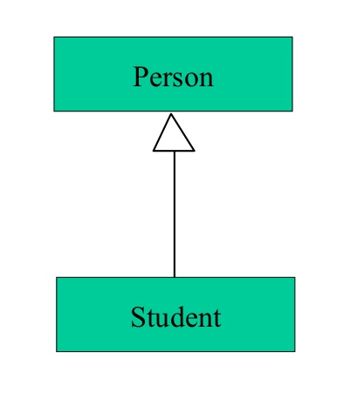

Relationships
There are mainly three kinds of relationships in UML:
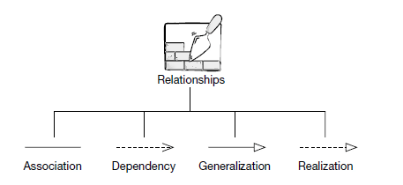
- Dependencies
- Generalizations
- Associations
- Realization
Dependency
A dependency indicates a semantic relationship between two or more elements. The dependency from Course Schedule to course exists because course is used in both the add and remove operations of course schedule.

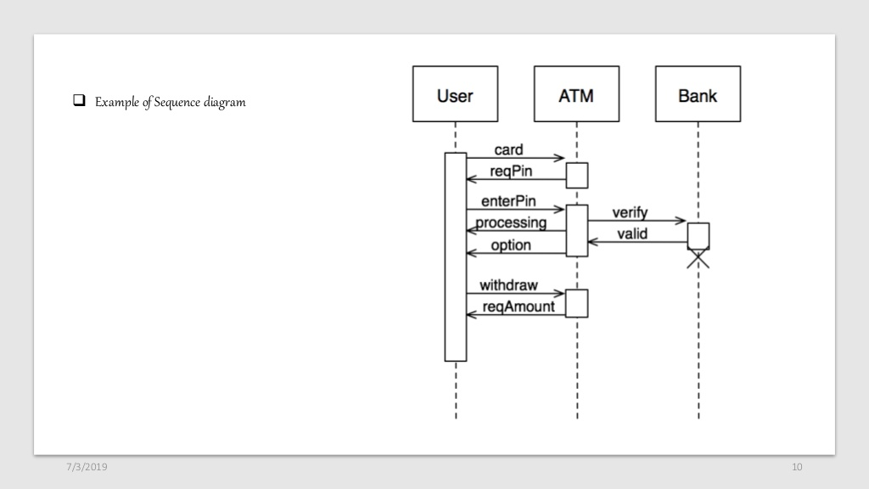

Generalization:
A generalization helps to connect a subclass to its superclass. A sub-class is inherited from its superclass. Generalization relationship cannot be used to model interface implementation. Class diagram allows inheriting from multiple super classes.
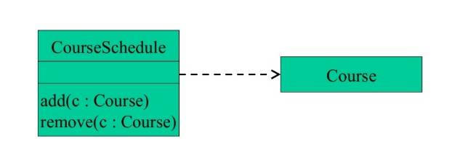

Association:
This kind of relationship represents static relationships between classes A and B. for example; an employee works for an organization.
Here are some rules for association:
- Association is mostly verb or a verb phrase or noun or noun phrase.
- It should be named to indicate the role played by the class attached at the end of the association path.
- Mandatory for reflexive associations
In these examples, the relationship between students and college is shown which studies.

STUDENT
STUDIES

COLLEGE

Multiplicity:
A multiplicity specifies whether the association is mandatory or not. It has some lower bound and upper bound. The college can have multiple students
STUDENT

STUDIES
COLLEGE
Aggregation
Aggregation is a special type of association that models a whole-part relationship between aggregate and its parts. For example, the class college is made up of one or more student.in aggregation; the contained classes are never very dependent on the lifecycle of the container. Here, the college class will remain even if the student is not available.
COLLEGE
STUDENT

Composition:
The composition is a special type of aggregation that denotes strong ownership between two classes when one class is part of another class.
For example, if college is composed of classes student. The college could contain many students, while each student belongs to only one college. Therefore, if college is not functioning all the students also removed.
COLLEGE
STUDENT

Realization relationship
The realization is a specialized abstraction relationship between two sets of classes, one represents a specification and the other represents an implementation of the client.
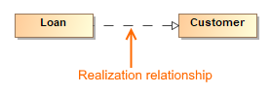

Interfaces
An interface is a named set of operations that specifies the Behavior of objects without showing their inner structure. It can be rendered in the model by a one or two compartment rectangle, with the stereotype <<interface>> above the interface name.
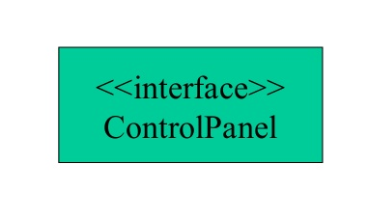

Enumeration
An enumeration is a user-defined data type that consists of a name and an ordered list of enumeration literals.
Packages
A package is a container-like element for organizing other elements into groups. A package can contain classes and other packages and diagrams. Packages can be used to provide controlled access between classes in different packages.
Data flow diagram
A data flow diagram is a graphical representation of the flow of data through the information system. DFD can be used to visualize data processing. DFD shows what kind of data will be input to the systems and what data is received as the input. In addition, it tells where the data will come from and go to and where it is stored in the process.
Example of data flow diagram
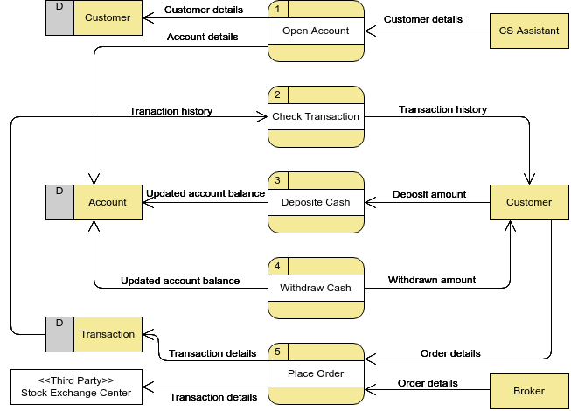
Symbols used in DFD
Data flow
The data flow is used to describe the movement of information from one part of the system to another part. Flows represent data in motion. Information flows through a pipeline. An arrow represents data flow.

Process

A circle or bubble represents a process that transforms incoming data to outgoing data. Process shows a part of the system that transform inputs to outputs.

External entity
a square defines a source or destination of system data. External entities represent any entity that supplies or receive information from system but is not a part of the system.

Data store
It represents the data store i.e. the file or database that is used to store the data.
Rules of data flow
- Data can flow form
- External entity to process
- Process to store and back
- Process to process
Data cannot flow from
- External entity to external entity
- External entity to store
- Store to external entity
- Store to store

Output
The output symbol is used when a hard copy is produced.
Example 1
This diagram represents a banking process, which maintains customer accounts.
In this example, customers can withdraw or deposit cash request information about their account or update their account details.
The five different symbols used in this example represent the full set symbols required to draw any business process diagram.
2 | Counter  Enquires  Deposits & withdrawals
CASH
Customer
D2 | ACCOUNT DETAILS
ACCOUNT
ACCOUNT
INFORMATION

LEVELS OF DFD
The data flow diagram may be used to perform a system or software at any level of abstraction. DFDs may be partitioned into levels that represent increasing information flow and functional detail. Levels in DFD are numbered 0, 1, 2 or beyond, these primarily three levels in the data flow diagram, which are 0-level DFD, 1-level DFD, and 2-level DFD.
0-LEVEL DFD
It is also known as the fundamental system model, or context diagram represents the entire software requirement as a single bubble input and output data denoted by incoming and outgoing arrows. Then the system is decomposed and described as a DFD with multiple bubbles. This process may be repeated at as many levels as necessary until the program is well understood.it is essential to preserve the number of inputs and outputs between levels, thus if bubble “A” has two inputs x1 and x2 and one output y, then the expanded DFD, that represents “A” should have exactly two external inputs and one external output in fig:

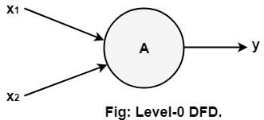
The level-0 DFD, conjointly referred to as context diagram of the result management system is shown in fig. because the bubbles are decomposed into less and fewer abstract bubbles, the corresponding knowledge flow may additionally be required to be decomposed.

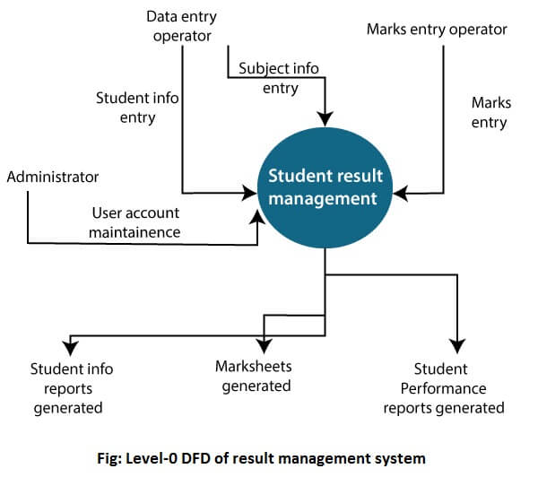

1-level DFD
In 1-level DFD, a context diagram is decomposed into multiple bubbles/processes.in this level, we prioritize only the main aims of the high-level process of 0-level DFD into subprocesses.
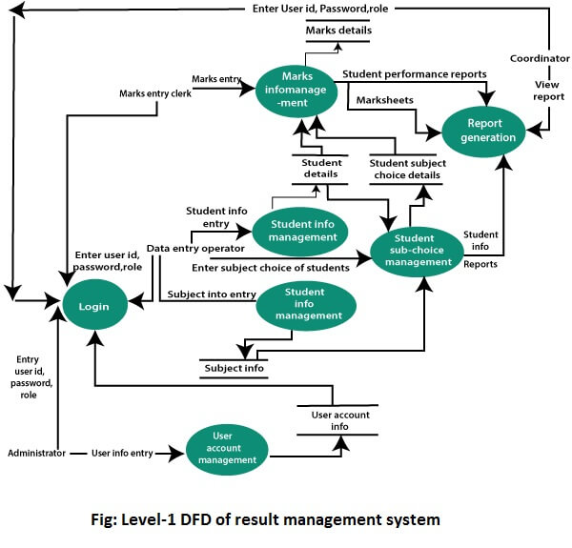
2-level DFD
2-level DFD goes one process deeper into parts of 1-level DFD. It can be used to project or record the specific necessary detail about the functioning of the systems.
- User account maintenance

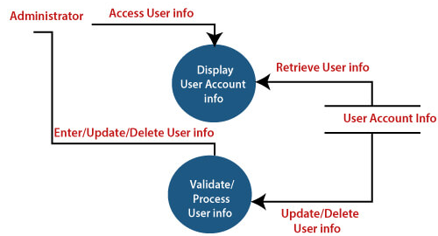

- Login
The level 2 DFD of this process is given below:
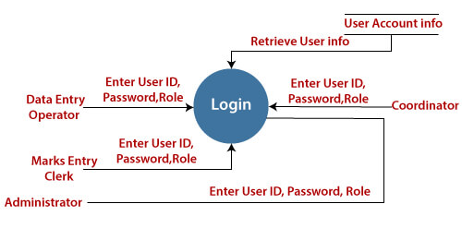
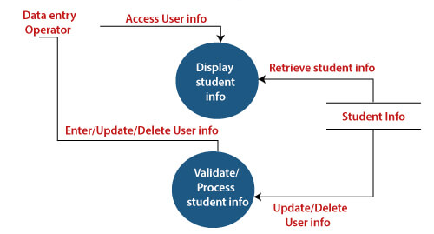
- Student information management

- Subject information management
The level 2 DFD of this process is given below:
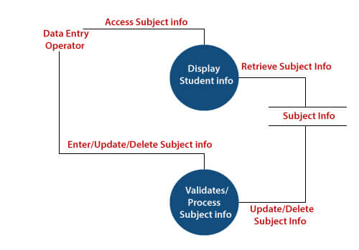
- Students subject choice management
The level 2 DFD of this process is given below:
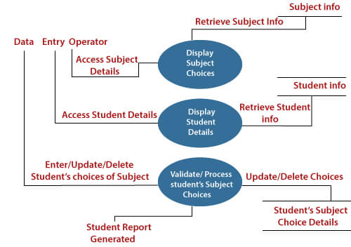

- Marks information management
The level 2 DFD of this process is given below:
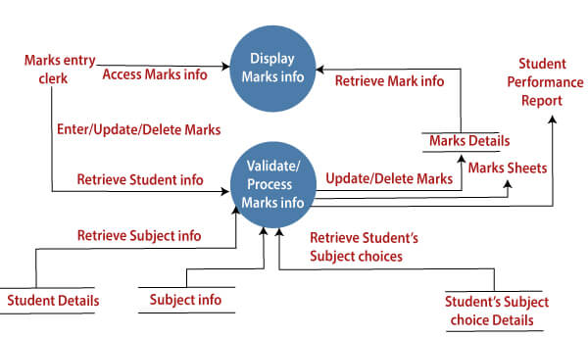
Types of Data flow diagram
Data flow diagrams are either logical or physical.
Logical data flow diagram: this type of DFD concentrates on the system process and flow of data in the system. For example in a banking software system, how data is moved between different entities.
Physical data flow diagram: this type of DFD shows how the data flow is actually implemented in the system. It is more specific and close to the implementation.
Benefits of logical data flow diagram
A physical data flow diagram shows how the system will be implemented, including the hardware, software, files, and people in the system. It is developed such that the processes described in the logical data flow diagrams are implemented correctly to achieve the goal of the business. Here is the benefits of the 2 type of DFDs:
- Clarifying which processes are manual and manual and which are automated: manual processes require detailed documentation and automated process require computer programs to be developed.
- Describing processes in mor detail than do logical DFDs: describes all steps for processing of data.
- Sequencing processes that have to be done in a particular order. Sequence of activities that lead to a meaningful result are described. For example, update must be performed before a producing a summary report.
- Identifying temporary data storage: temporary storage such as a sales transaction file for a customer receipt (report) in a grocery stroe, are described.
Benefits of physical data flow diagram
Clarifying which processes are manual and which are automated: manual processes require detailed documentation and automated process require computer programs to be developed.
- Describing processes in more detail than do logical DFDs: describes all steps for processing of data.
- Sequencing processes that have to be done in a particular order: sequence of activities that lead to a meaningful result are described. For example, update must be performed before a producing a summary report.
- Identifying temporary data storage: temporary storage such as a sales transaction file for a customer receipt (report) in a grocery store, are described.
- Specifying actual names of files and printouts: logical data flow diagrams describes actual filenames and reports, so that the programmers can relate those with the data dictionary during the developmental phase of the system.
- Adding controls to ensure the processes are done properly: these are conditions or validations of data that are to be met during input, update, delete and other processing of data.
Example of Physical and logical DFD
Physical DFD specifies actual flow of physical documentation, while logical DFD only focus on the information flow in business term.
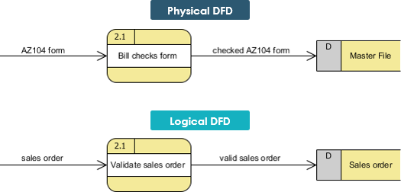

Components of data low diagram
There are four main components of data flow diagrams.
- External entities: it represent the source of data as input to the system.
- Data stores: it represent stores of data within the system.
- Processes: it represent activities in which data is manipulated by being stored, retrieved, or transferred in some way.
- Data flow: it represents the movement of data from one component to the other.
The team structure of software engineering
Team structure:
Team structure address the issue of organization of the individual project teams. The individual project teams can be organized in some possible ways.
There are mainly three formal team structures:
- Chief programmer team
- Democratic team
- The mixed team organizations
Although several other variations to these structures are possible. Problems of different complexities and sizes often require different team structures for chief solution.
- Chief programmer team:
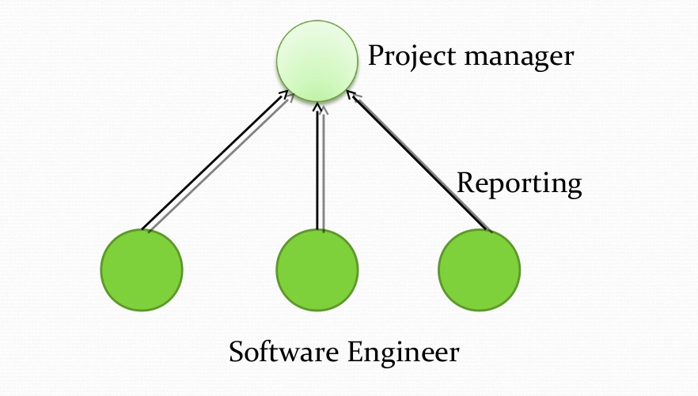

- The chief programmer provides an authority
- Leads to lower team morale
- Can inhibits original thinking
- Single point of failure
- It is more efficient than democratic team for well-understood problems (small and simple ones)
- Used when the completion of the project outweighs the team morale, personal development etc.
- Democratic team:
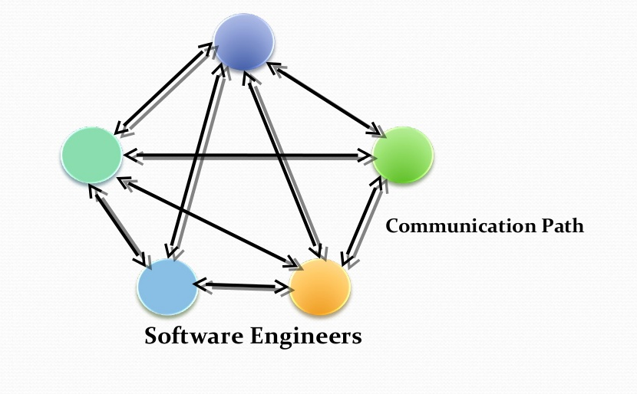

- Democratic organization leads to higher morale and job satisfaction.
- Encourages egoless programming
- A programmer is an artist (apply arts of programming)
- Cannot easily locate bugs and issues in their programs
- Programmer takes a lot of pride in their creations
- They should think of the product as an output of a group not an individual
- Wastes a lot of time arguing on trivial points (needs an authority)

- The mixed control team:

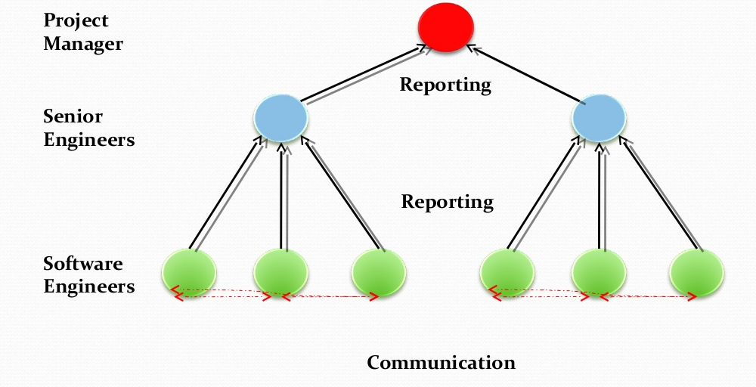

- Mixed ideas from the chief programmer and democratic team structures
- Hierarchical reporting
- Democratic setup
- Suitable for large teams
- Decompose the problem into simple task and assign them to groups
- Each group communities democratically
- Very popular and the most used structure

REFERENCES LIST
- https://www.toolsqa.com/software-testing/waterfall-model/
- https://www.careerride.com/pmp-when-to-use-waterfall-model.aspx
- http://tryqa.com/what-is-incremental-model-advantages-disadvantages-and-when-to-use-it/
- https://www.tutorialspoint.com/sdlc/sdlc_software_prototyping.htm
- https://www.guru99.com/what-is-spiral-model-when-to-use-advantages-disadvantages.html
- https://melsatar/2012/03/15/software-development-life-cycle-models-and-methodologies/
- http://tryqa.com/what-is-modelling-tools-in-software-testing/
- https://www.javatpoint.com/software-engineering-entity-relationship-diagrams
- https://www.defit.org/uml/
- https://en.wikipedia.org/wiki/Unified_Modeling_Language
- https://www.guru99.com/uml-relationships-with-example.html
- https://www.visual-paradigm.com/guide/data-flow-diagram/logical-vs-physical-data-flow-diagrams/
- https://spot.colorado.edu/~kozar/DFDtechnique.html
- https://www.visual-paradigm.com/tutorials/data-flow-diagram-dfd.jsp
- https://www.guru99.com/uml-class-diagram.html
- https://online.visual-paradigm.com/diagrams/examples/data-flow-diagram/securities-trading-platform/
- https://www.javatpoint.com/software-engineering-data-flow-diagrams

