# Task-1.1

**Different components of a computer system**

Computers are a combined Software and Hardware composition. They may be told to perform other tasks, logical as well as arithmetical. Programs make this collection of operations , making our time use and productivity of resources easier for us.

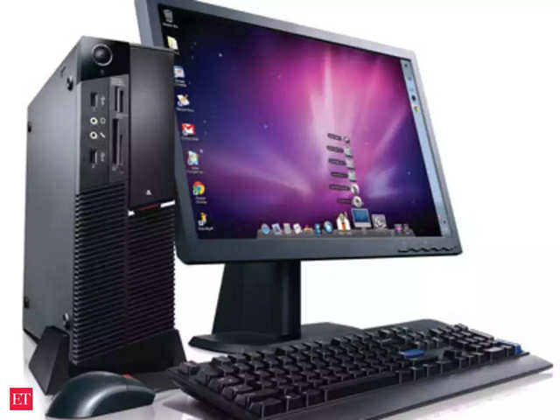

FIG-1.1: Computer

(The economic times, 2020)

A computer consists of multiple hardware and software components that work hand in hand, if one were to be removed from the equation, the other would be rendered useless

These components are:

# Hardware components

## Motherboard:

The hub that all the devices are connected to is known as the motherboard, it could be considered the brain of the computer. The motherboard is actually a big PCB with a chip connected to every part. For the computer to function, all the components have to be compatible with each other

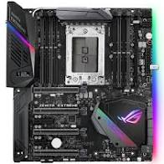

FIG 1.2- Motherboard

(Amazon.com, 2020)

## RAM: Random Access Memory:

The random access memory, also known as the RAM, is a form of storage that temporarily stores data that may be accessed frequently for ease of access therefore it’s referred to as the primary memory, that’s due to the fact that regardless of the size data is constantly being written and overwritten on it. RAM is capable of accessing data stored anywhere without the need of sequential access unlike other forms of storage

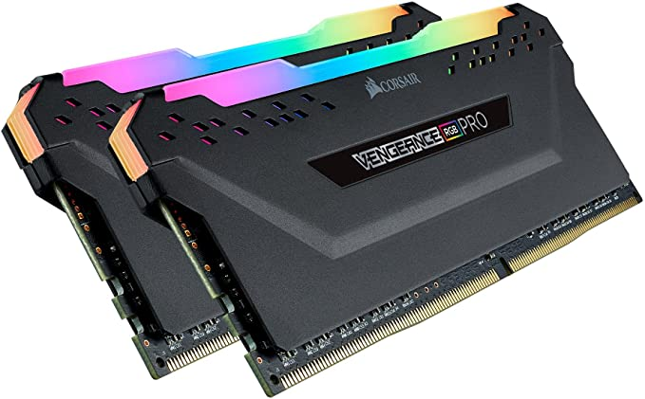

FIG-1.3: RAM

(Amazon.com, 2020)

## Processor:

The processor is a chip that is placed on the motherboard then coated in thermal paste or covered with thermal patches and a cooler is placed on top of it to avoid overheating. It’s one of the most essential components of the computer that carries out operations and processes them. A processor is mainly tasked with four things, they are:

* Translate
* Compile
* Rewrite
* Achieve

With the improvements and advancements in technology, multicore processors have come to existence, these are processors with more than one core, which helps improve the performance drastically

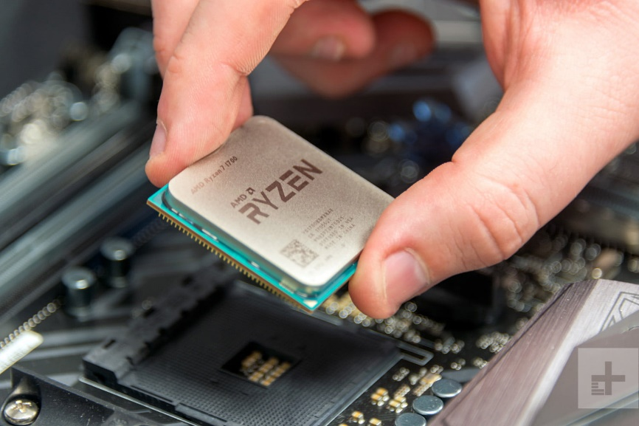

FIG-1.4: Processor

(Amazon.com,2020)

## Power supply:

The term power supply is pretty self-explanatory, the power supply is the component that provides power for all the components to run. It is important to know how much power the system is going to require before the system is built to ensure that the power supply will be sufficient

(Business, Center and Resources, 2020)

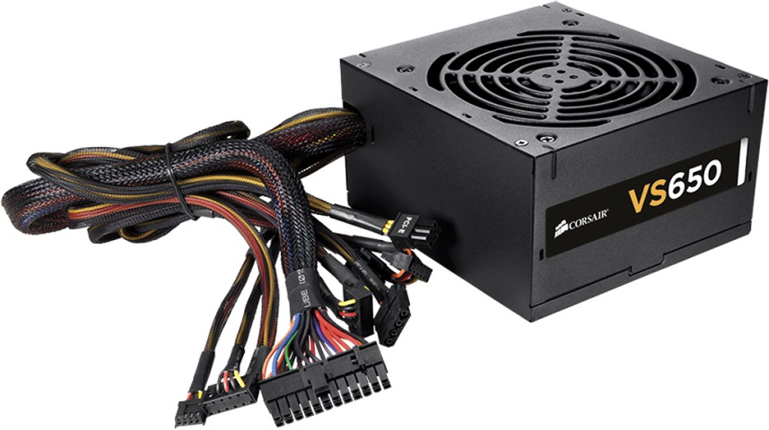

FIG-1.5: Power supply

(Amazon.com, 2020)

## Graphics card:

The graphics card also known as the graphics processing unit or integrated video interface. The graphics card produces the image on the monitor and renders images. Older computer systems would use the processor to render these images but with the increase in the requirements of games, a new component was required to do the job.

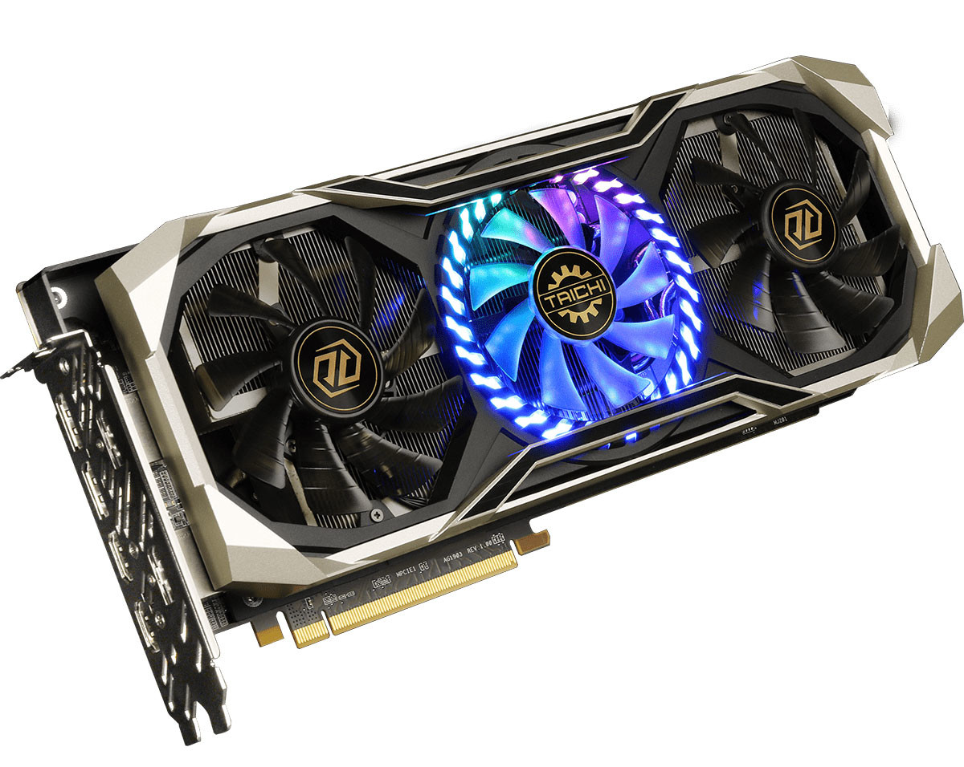

FIG-1.6: Graphics card

(Amazon.com, 2020)

## Network adapters:

These are cards that are inserted into the PCIE slot on the motherboard and provide a method for the system to connect to the internet.

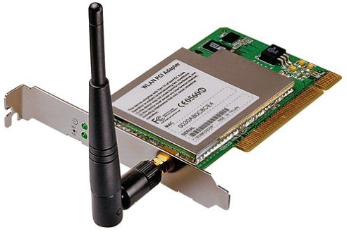

FIG-1.7: Network adapter

(Amazon.com, 2020)

# Software components

After the hardware has been established and put together, the next set of components are the software components.

## Operating system:

The operating system of the computer is basically the most essential software requirement for a computer for a computer to execute programs and run applications. The operating system performs the most basic of tasks such as collecting and inputting the commands from the peripherals, it keeps track of the drives, refers to the screen for the best output

## Drivers:

A driver is basically a software that forms the connection between the hardware and the software, each component has it’s own drivers that come with it. Some devices come with a disk that has the drivers on it, others have websites that provide the drivers

(Computer Devices | Information Literacy, 2020)

# Task-1.2:

# Networking**:**

The term “Networking” also referred to by many as computer networking, can be interpreted as a transaction where data is exchanged among multiple nodes through some sort of medium from within an information system. The networking process consists of factors such as construction, design, network infrastructure, maintenance, management, software and politics. A computer network can facilitate a connection between devices linked by a network such as a WAN (Wide area network) or a LAN (Large area network). Such a task is crucial for worldwide resource sharing, communicating and offering or using services among service providers, consumers and also businesses, networking also provides the means to make phone calls, send text message, stream videos and so much more.

(Anon, 2020)

### Types of networking:

Networking consists mainly of two types:

1. Wired networking: the first type of networking is wired networking, and as it’s name states, this type of networking makes use of wires to transfer data. The most common type of wired networking are copper-based Ethernet cables, these cables are both durable and cheap which prompts buyers to go for it. The cables in question are commonly used for tasks such as digital communication in homes or businesses. Optical fiber cables on the other hand are counterpart of the former, as they are considerably more expensive and fragile when compared. However, what they lack in durability they make up for in transfer speeds as they are much faster and are commonly used to transfer data over long distances
2. Wireless networking: a wireless network makes use of the radio waves to perform the transfer of data over the air, meaning there is no need for any wiring between the two devices using this network for the transfer of data. An example of such networks would be wireless LANs, there are also other uses of such networks such as satellites, cellular networks, Bluetooth etc. while it’s true that wireless networking lacks in speed and stability when it comes to the connection, it excels field such as flexibility, scalability and mobility

(Techopedia.com, 2020)

## Networking components:

For something to perform such functions and with such dexterity, it’s only natural that there would be multiple components involved in the process. When it comes to networking, the components fall into two categories:

1. Hardware components:

* Routers- a router is a device tasked with forwarding data packets among computers. A packet is a term used to refer to data sent through the internet. These packets transfer from one router to another within the network until it arrives at it’s desire destination 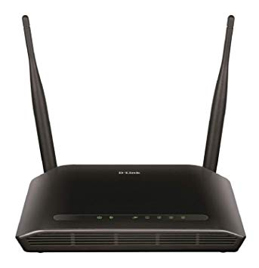

FIG-1.1: Router

(Amazon, 2020)

* Switches: switches, also known as network switches, switching hubs, bridging hubs or MAC bridges, are networking hardware devices that have the sole task of connecting devices within a computer network by making use of packet switching to perform the transfer of data back and forth between devices 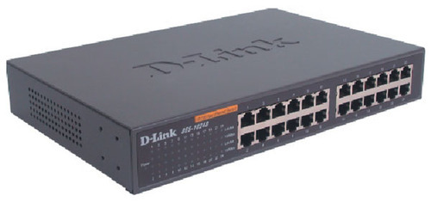

FIG-1.2: Networking switch

(Amazon, 2020)

* LAN cards: a LAN card is a device usually built into a computer, which connects the computer to a computer network. It’s through the use of this card that a connection can be made, these cards facilitate the use of Ethernet cables for wired networking and the use of WI FI for wireless networking 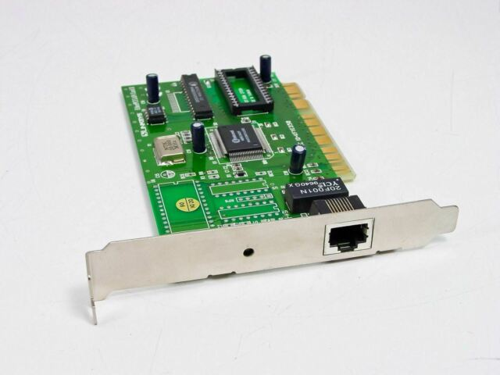

FIG-1.3: LAN card

(Amazon, 2020)

* Cables : Networking cables are the cables that facilitate the transfer of data in wired networking, these wires are a crucial component in the process. Networking cables are of many shapes and capabilities such as coaxial cables, twisted pair cables, optical fiber cables and so on

(Computer Devices | Information Literacy, 2020)

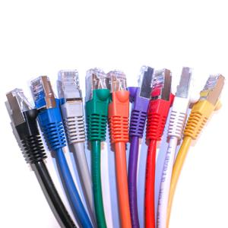

FIG-1.4: Networking cables

(FireFold, 2020)

1. Software components:

* Operating systems: Network operating systems (also known as NOSs) is a software that is used to manage the network resources. It pro ides a method to connect different devices to a network. A NOS manages is tasked with managing multiple inputs simultaneously while providing the necessary security within a network with multiple users. A NOS may also provide both certain directory services and a messaging system as well as the capability of multiprotocol routing

(University, 2020)

* Firewalls: a firewall is a security measure taken by computer engineers to prevent unauthorized access to data or data leaking. A firewall can be implemented in both hardware and software form or by implementing both to achieve an even more secure protection method. Firewalls are commonly used by companies to prevent unauthorized access and also to ensure that the data transferred through the network is clear of any viruses or malicious software or data. For data to pass through the firewall, it must meet the security criteria set by the firewall.

(University, 2020)

1. Topologies:  
   A topology is the orientation in which devices such as computer systems are linked and connected with each other. Topologies are the definitive physical and logical aspect when it comes to the network. There are multiple topologies with different orientations and properties, they are:
2. Bus topology: in this topology, all the workstations are connected to one another in a single alignment leading to each device being connected to one another.

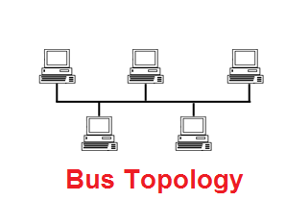

FIG-1.5: Bus topology

(Computerhope.com,2020)

1. Star topology: in this topology, all the devices are connected to a central hub. What makes this topology different from the bus topology is the fact that unlike the bus topology, the devices aren’t connected to each other 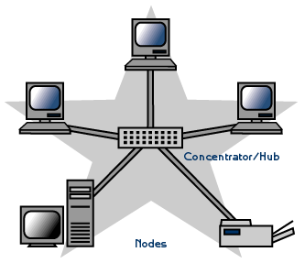

FIG-1.6: Star topology

(Computerhope.com,2020)

1. Ring topology: in this topology, all the computers are linked with one another directly without the involvement of a hub in between them, the information and data travels from one device to the next in the loop

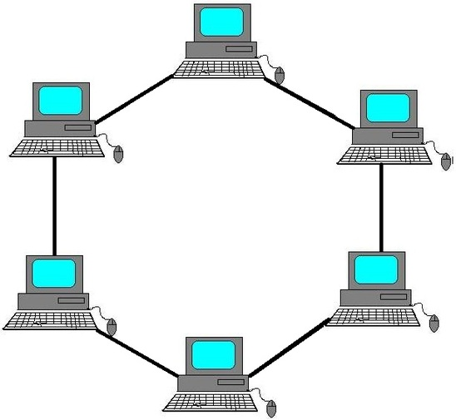

FIG=1.7: Ring topology

(Computerhope.com,2020)

1. Tree topology: this topology gets it’s name due to the way it’s orientation resembles the branches of a tree. This topology is mostly used for the organization of computers in the corporate network. This type of topology revolves around containing a single hub with all the devices being cone ted to it which helps with the data flow

# Task-1.3

For this task, the two systems selected for the comparison are:

1. HP AIO 20-C402NE
2. Acer Aspire C22-963

## Specifications:

## HP AIO 20-C402NE:

|  |  |
| --- | --- |
|  |  |
| Price | AED 1,999 |
| Family Type | All in One |
| Series | 15DW2003NE |

PROCESSOR

|  |  |
| --- | --- |
| Processor Type | Intel Core i3 |
| Processor Model Number | 1005G1 |
| Processor Core | 4 |
| Processor Memory Cache | 8 MB |
| Processor Clock Speed (GHz) | 1.2 GHz |
| Processor Max. Clock Speed (GHz) | 3.2 GHz |
| Processor Generation | 10th Gen |

MEMORY

|  |  |
| --- | --- |
| RAM | 4 GB |
| RAM frequency | 2300Mhz |
| HDD Storage Capacity | 1 TB |
| SSD Storage Capacity | 0 |
| Storage Type | HDD |

DISPLAY

|  |  |
| --- | --- |
| Screen Size | 15.6 inches |
| Resolution | 1920 x 1080 |
| Resolution Type | Full HD |
| Screen Refresh Rate | 0 |

GRAPHICS

|  |  |
| --- | --- |
| Graphic Processor | 0 |
| Graphic Processor Memory | 0 |

OPERATING SYSTEM

|  |  |
| --- | --- |
| Operating System | Windows 8 |

COLOR

|  |  |
| --- | --- |
| Color | Silver |

CONNECTIVITY

|  |  |
| --- | --- |
| USB 3.1 Ports | 1 |
| HDMI ports | 1 |
| USB-C Ports | 1 |
| Ethernet / LAN ports | 1 |
| Card reader | Yes |
| Bluetooth | 4.2 |
| Wi-Fi | 802.11 a/b/g/n/ac |

(Jumbo.ae, 2020)

## Acer Aspire C22-963:

|  |  |
| --- | --- |
| Price | AED 1,799 |
| Computer type | All in One |
| Series | Aspire C22 - 936 |
| Display size (inches) | 21.5 |
| Resolution (Pixels) | 1920 x 1080 |
| Screen Resolution | Full HD |
| Display type | Active Matrix TFT Colour LCD |
| Processor Type | Intel Core i3 |
| Processor Model Number | i3-1005G1 |
| Processor Cores | Dual-core (2 Core) |
| Processor Memory Cache | 4MB |
| Processor Clock Speed (GHz) | 3.4 |
| Processor Max. Clock Speed (GHz) | 4.0 |
| RAM (GB) | 8 |
| RAM frequency | 3000Mhz |
| HDD Storage | 1TB |
| Total Storage | 1TB |
| Graphics processor | UHD Graphics DDR4 SDRAM |
| Graphics memory | 4GB |
| HDMI ports | 1 |
| USB 3.1 Ports | 4 |
| USB 2.0 Ports | 0 |
| Ethernet / LAN ports | 1 |
| Wi-Fi | IEEE 802.11ac |
| Operating system | Windows 10 Home |
| Weight (Kg) | 3 |
| Manufacturer | 1 Year |

(Jumbo.ae, 2020)

Now that all the specifications have been mentioned, the next step is to write the requirements based on the task.

The mentioned task is one with relatively specific requirements, they are

1. Large ram with high frequency
2. An operating system of windows 8 or above
3. A capable processor with multiple cores and threads
4. A considerably small size as it should fit in a cubicle
5. Large storage to store all the data

After examining both options and evaluating the requirements, the conclusion arrived at was that the ideal device for the job is **Acer Aspire C22-963** due to the following reasons:

1. The device in question beat it’s peer in RAM capacity by 4GB
2. The device in question beat it’s peer in RAM frequency by 700 Mhz
3. The device in question beat it’s peer in processing speed by over 2Ghz
4. The device in question has a more advanced operating system

## Task-1.4: Peripheral devices:

By definition, a peripheral device is one that isn’t inherently part of the computer. A few examples are:

1. Mouse
2. Keyboard
3. Printer
4. Fax
5. Webcam
6. Drawing pad

There are mainly two types of peripheral devices, they are

1. External devices: these are peripherals that are on the outside of the computer and are connected to the computer via wire or wireless dongle, eg; headphones, mouse keyboard
2. Internal peripherals: these are the peripherals that are located on the inside of the device , eg: touch screen, built in webcam, built in speaker

Peripherals can be classified into three categories based on their information transfer direction, these categories are:

1. Output peripherals: these are devices that transfer data from the device to the user, eg: screen speaker, headphones
2. Input peripherals: these are devices that transfer data from the user to the device, eg: mouse, keyboard, microphone
3. Input/output: these are peripherals that transfer data both ways between the user and the computer, eg: touchscreen

## Peripheral devices to meet different purposes:

1. Mouse: the mouse is a peripheral used to control the cursor on the screen and navigate through the computer. It usually has three buttons

And a scroll. Mice come in different sizes and weight classes but serve the same purposes. The different types of mice are as follows:

1. Wired mouse: this is the basic mouse with a left click, a right click, a scroll and occasionally the scroll is clickable granting access to a third button



FIG-1.7: Wired Mouse

(Amazon.com,2020)

1. Wireless mouse: this mouse usually doesn’t differ that much in shape and functionality from the wired mouse, it does however function wirelessly with the assistance of a wireless dongle plugged into the computer or via Bluetooth. Theses mice usually require a battery or need to be charged to work 

FIG-1.8: Wireless mouse

(Amazon.com,2020)

1. Gaming mouse: these type of mice are high end peripherals with a button count ranging from 5 to 13 with them being programmable they usually have bright colors and adjustable lights. These mice are designed to be responsive and light for the most precise aim while gaming, they are also usually the most expensive. They may be wired or wireless



FIG-1.9: Gaming mouse

(Amazon.com, 2020)

1. Keyboard: the keyboard is the peripheral used to type and enter information to the computer. The following are the different types of keyboards:
2. Wired keyboard: this is the most basic type of keyboard with the letters, symbols, numbers, and number pad included. These keyboards use either a USB or analog wire to connect to the PC

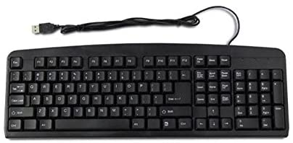

FIG-1.10: wired keyboard

(Amazon.com,2020)

1. Wireless keyboard: this keyboard is performs the same task and usually has the same specifications more or less but differs in it’s connectivity method as it is wireless and uses either Bluetooth or a wireless dongle to connect to the computer

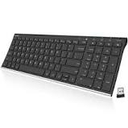

FIG-1.11: Wireless keyboard

(Amazon.com, 2020)

1. Gaming keyboard: these types of keyboard are more complex than the other keyboards as they have features such as low activation force for the buttons, mechanical switches that are more responsive than membrane, these vary in size, the smaller keyboards are referred to as a 60% keyboard while the middle one is referred to as 70% and their size is usually small to allow for more mouse room for gaming. These keyboard usually come with a backlit to help identify buttons in the dark. These keyboards connect via either usb cable, type c cable or Bluetooth

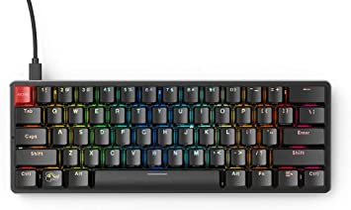

FIG-1.12: Gaming keyboard

(Amazon.com, 2020)

1. Monitor: monitors are the peripherals responsible for transferring visual data between the user and the computer. The different types of monitor are as follows:
2. CRT monitors( cathode ray tube): these monitors use CRT technology that is more popular in the production of television screen. These monitors use a stream of high-energy electrons thereby forming an image on a fluorescent screen. These monitors are usually bulky, big and heavy which is why they are no longer being produced and are rarely being used
3. LCD(liquid crystal display): LCD monitors use one of the most advanced form of technology. LCD monitors consist of a layer of monochrome pixels that are oriented between multiple transparent electrodes and two polarizing filters. Optical effect is made possible by polarizing the light in various

quantities and causing it to pass through the layer of liquid crystals.

(Anon.com, 2020)

# Task-2

## Operating system

The term “operating system” is used to describe a group of software tasked with managing all the hardware resources as well as providing the required services for the computer program. The operating system is a critical requirement for any computer to be able to function. Operating systems provide many services, here are a few:

1. File system manipulation
2. Error detection
3. Protection
4. Resource allocation
5. Program execution
6. I/O operations
7. Communication

When it comes to either multi-tasking environments or multi user resources like cpu cycles, main memory and storing files have to be assigned to each job or user. A few vital activities practiced by operating systems in regards to resource management are:

1. Resource management through schedulers
2. Employment of CPU scheduling algorithms to utilize the CPU more efficiently

There are 8 types of operating systems with each system having different properties along with it’s advantages and disadvantages, they are:

1. Simple batch system:

This is a type of system where the interaction between the computer and the user is non-existent. To communicate with the computer, the user has to submit a job in the form of a card or a tape to a computer operator, who then proceeds to input a batch of jobs on an input device. Hence the name simple batch system. The jobs get categorized based on their requirements and languages. The execution of the jobs then takes place under the supervision of a program known as “The monitor” , this program remains in the main memory at all times and and is always available for execution

Pros:

1. The interaction between the computer and the user is non-existent
2. Absence of a mechanism that prioritizes the processes
3. Multiprogramming batch system:

This type of operating system is based on the concept of keeping the CPU and the OS busy at all times. This is done through executing the job until it requires an input/output interaction. Once the execution gets to that phase, the OS takes up another program and starts executing it. The number of jobs on the disk is always more than the number of jobs in the memory. In a situation where multiple jobs can be ran at the same time, the OS runs a process known as “CPU scheduling” to decide which job to run. If the system is Non-Multiprogramed, the CPU has moments when it sits idle, however if the system is multiprogrammed, the CPU never sits idle

## Multiprocessor system

This system is one that contains multiple processors that have one physical memory. This type of system excels in speed as well as computing power. In this type of system all the processes work within the same OS. The transparency of how the processors work together and their multiplicity are a factor of this OS.

Pros:

1. Performance is enhanced
2. The fact that multiple tasks are being executed simultaneously by different processors result in the increase if the output without increasing the execution speed of any task
3. When possible, the task gets divided into multiple subtasks that are then executed in a parallel orientation in different processors resulting in a faster execution of a single task

## Desktop system

The older models of PCs and CPUs were found lacking when it came to shielding operating systems from user programs, which lead to the PC operating systems being neither multitasking nor multiuser. However over time, the focus of these devices has shifted from trying to maximize the utilization of the peripheral and the CPU to improve the responsiveness and the user convenience. These systems are referred to as desktop systems, this includes the PCs running Apple Macintosh and Microsoft Windows

## Distributed operating system

With the abundance in microprocessors that are both powerful and inexpensive and the advancements in the field of communication technology, the development of distributed operating system was inevitable. These systems consist of multiple computers that are linked through communication network.

There are two types of distributed operating systems

1. Peer-to-peer systems: this system use computer systems that don’t have a clock or memory in common, rather each processor is allocated it’s own local memory. Communication lines such as telephone lines and high-speed busses are used for communication by the processors. These systems may be labelled as loosely coupled systems.
2. Client-server systems: in modern age, centralized systems play the role of server systems to meet the needs generated by client systems. Server systems can either be compute server systems tasked with providing an interface where clients are capable of forwarding requests for an action to be performed which in response to, they execute the action and have the results sent back to the client or file server systems that provide an interface for files where the clients are free to update, create delete and read files.

Pros:

1. Resource-intensive tasks are easier to execute due to the ability of one site to utilize other sites’ resources
2. High speed processing
3. The load on the host machine is considerably lessened

## Clustered systems

Cluster systems and parallel systems share a trait and that is the ability to gather a group of CPUs to accomplish computational work, they differ however in the number of individual systems as clustered systems are usually consistent of two or more individual systems coupled together. The term “Clustered system’ refers to have a common storage and have a LAN networking link between them. Usually when clustering is performed, it means that there needs to be high availability provided. A layer of cluster software runs on is based and runs on nodes known as cluster nodes. The nodes monitor each other and if the machine tasked with monitoring fails, it can take ownership of it’s storage then restart the application that were previously running and failed on it. Even if the machine stays down, the clients and users only experience a brief interruption of service..

There are three types of clustering:

1. Symmetric clustering: this type of clustering would have multiple hosts running applications while being able to monitor each other simultaneously. This type of clustering is very efficient as it uses the available hardware more efficiently
2. Asymmetrical clustering: this type of clustering would have one machine run the application while the other is in a state referred to as “ Hot standby mode” where it monitors the server and if the server was to fail, the hot standby machine steps in and acts as an active server
3. Parallel clustering: this type allows for simultaneous access of the same data on the shared storage by multiple hosts. Due to the lack of the support for this method of simultaneous data access by multiple hosts by most operating systems, only special software versions and special application releases are able to accomplish this method of clustering.

## Real-time operating system

This type of operating system is generally used in real-time applications that tend to process data directly as it receives it with no buffer delays. The processing time requirements are so short that they are measure in tenths of seconds and sometimes even shorter. This system has a well-defined time constraint and if the processing isn’t done within the constraints, the system will fail. These systems are usually either time-sharing or event driven. The event driven system will switch between tasks solely based on their priority whereas time driven prioritizes tasks based on clock interrupts. Real-time operating systems typically have three states:

1. Running where the system executes the program on the CPU
2. Ready where the system is ready to execute the program
3. Blocked where the system is waiting for an event

## Handled system

These types of systems usually have a limited size of storage and a rather small amount of memory (512KB to 8MB) along with relatively small processors and small display screens. Due to the small memory storage, the applications and the operating system have to manage the memory more efficiently, for example when it’s not being used, the allocated memory is retuned to the memory manager. Since the devices that run on handled systems don’t use virtual memory, program developers must are forced to work within a confined memory space. The small size of these devices means a small battery which in turn leads to the use of processors that run at a fraction of the pc processors’ speed. The devices that run on these systems are phones, tablets, personal digital assistants etc.

(Techopedia.com, 2020)

# Task-2.2

## Different types of software:

A group of electronic program commands or a form of data read by a computer processor to help it in performing a task or an operation is known as a software. Based on what it’s designed for and it’s tasks, software can be categorized into three main types, they are:

1. System software: the programs designed to monitor and manage computer are known as system software, a good example would be an operating system, a disk operating system and utilities for file management. the following are the characteristics of a good system software

* Functionality: when it comes to system software, functionality is the magnitude of the performance in comparison to the intended purpose of the software. The functionality required functions are:
* 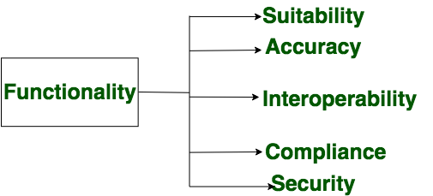

FIG-2.1: Functionality (geeksofgreek.org, 2020)

* Efficiency: the term efficiency here refers to the capability of the software to manage and make the most of the resources in a manner that would be considered efficient. The efficiency required functions are:



FIG-2.2: Efficiency (Geeksofgreek.org, 2020)

* : Reliability: the term reliability refers to the software’s ability to maintain the quality and performance when met with difficult conditions or time constraints. The required reliability functions are:



FIG-2.3: Reliability (Geeksofgreek.org, 2020)

* Usability: the term usability here refers to the effort that has to be put in by the user in order to learn how to use the software and how easy it is for the said user to master it. The required usability functions are:



FIG-2.4: Usability (Geeksofgreek.org, 2020)

* Maintainability: the term maintainability refers to the extent of the effort that has to be put in for desired modifications and alterations to be made in the software system to help improve the equality of performance or in some cases correct errors that may occur. The required maintainability functions are:



FIG-2.5: Maintainability (Geeksofgreek.org, 2020)

* Portability: the term portability refers to the software’s ability to moved from a certain environment to a different one while keeping the changes to a minimum if not none. The required portability functions are:



FIG-2.6: Portability (Geeksofgreek.org, 2020)

1. Application Software: application software also known as applications, are commonly referred to as productivity programs and may even be referred to as “end-user programs”, and the reasoning for that is because they grant the user the ability to complete tasks. An example of the tasks that could be achieved using these software are creating databases, spreadsheets, documents, designing graphics, etc. Applications software are usually designed with the goal of doing a certain task in mind, the task may be as simple as running calculations or word processing. Applications software are classified into three categories:

* User rights and property: this category is further classified into two sub-categories:

1. Closed source: this category may be defined as the proprietary software that is distributed under an agreement of licensing only to the users that have the authorization to modify, copy and republishing restrictions. In other words, closed source applications are not to be shared with the general public
2. Open source: this category covers the applications that are released to the general public and commonly includes a license granting the user the ability to modify and alter the software based on their needs and requirements.

* Programming language: this category is one that’s dependent on the language used in the programming of the software, this category classifies software as JavaScript, HTML, CSS and so on. Developers are capable of writing source codes in any one of the previously mentioned languages, however they can’t the hardware the application is installed on
* Output and purpose: this category has two sub-categories, they are:

1. Horizontal applications: these applications are more popular and widespread, and are mostly used by the general public like databases and word processors
2. Vertical: Also known as Custom based software, these are applications that are designed with a specific type of department or industry in mind. A good example would be the software suite which are a bunch of software applications having a related functionality such as a railway reservation software. These type of software provide certain features and aspects that the off-the-shelf applications can’t. These types of software tend to have a more expensive cost of production and tend to use up more resources than the off-the-shelf software as well as needing the designing programmer to completely understand what the company or industry requires from the software.

(Techopedia.com, 2020)

# Task-2.3

## Web applications

A web applications is one that uses a combinations of scripts known as “Server-Side Scripts” to manage the client’s information retrieval and storage as well as scripts known as “Client-Side Scripts” that are used for the purpose of information presentation to the users. These scripts grant users the ability to communicate and interact with the company through the use of online forums, shopping carts, content management systems and so on. These application also allow for the sharing of information, project collaboration and also grant access to common documents with no regard for the device being used or the location.

Usually, web applications are coded in languages that support browsers such as HTML and JavaScript mainly due to the fact that these languages depend on the browser when it comes to rendering programs executable. Applications may be dynamic in the sense that for it to function, server-side processing is required, while others may be static with no dependence on processing at the server. Web applications usually need a web server to help it manage requests from a client, it may even require a server known as an application server dedicated to performing the required tasks and sometimes, it ay require the assistance of a database for data storage. The technology of application servers vary from ASP.NET, ColdFusion, PHP, JSP, ASP and so on.

The flow of a web application typically looks like this:

1. The user starts the cycle by triggering a request to the web server which can be done through the application’s user interface or through a web browser
2. The request is then forwarded to respective web application server
3. The task is then performed by the web application server
4. The result is then sent to the web server with the processed data or the requested information
5. The processed data or information is then sent to the user and is visible n the users display.

Pros:

1. The capability of these applications to run on multiple devices without any regard for the OS, the only factor is the compatibility of the browser.
2. Since they aren’t stored on hard drives, they aren’t restricted by the storage capacity
3. Reduction in the chances of subscription based web application piracy
4. Because there is less maintenance and support required by the business as well as low requirements for the user’s computer, it reduces the cost of production and use

(Techopedia.com, 2020)

# Task-2.4

## Mobile application

The term mobile application is a term that is used to describe an application software that has been designed to run on a mobile device, meaning a tablet, a mobile phone, etc. generally the mobile application serves the same purpose and for the most part offers the same services as the applications designed for the computers. These applications are usually small, individual software units that have limited functions. The web applications were originally popularized by Apple as they implemented them flawlessly on their IPhone, IPad and IPod. Mobile applications are usually more simpler versions of the PC version of the applications as they are limited by the hardware constraints set by the device

Mobile applications are divided into two categories:

1. Native applications: these are the applications that are crafted and designed with a specific OS in mind whether it be IOS or Android. These applications are usually better tuned and run smoothly when compared to mobile web applications
2. Mobile web applications: these are the web applications that run on a mobile device, they are usually used in CSS or HTML5. These applications usually require less memory when compared to mobile applications as they run through a browser, the user gets rerouted on through a specific web page with all the information being saved on a database based on the server, they require a stable network connection to run though

Currently, there are three types of mobile applications being designed and programmed:

1. Gaming applications: these are the mobile equivalent of computer games, they usually have considerably lower graphics that can be adjusted based on the hardware resources the mobile device provides
2. Productivity applications: these applications are centered around the goal of improving efficiency in business by making tasks such as tracking progress, sending Emails, booking hotels and so on easier.
3. Lifestyle and entertainment: these category includes applications such as social media applications, dating applications, sharing media and so on, that encompass certain aspects of personal lifestyle