CREATE database Clinic;  
  
create table patient(  
 id int primary key,  
 full_name varchar(20) not null ,  
 date_of_birth date not null ,  
 gender char(1) check ( gender='m'or gender='f'),  
 phone varchar(15) unique not null ,  
 email varchar(50) unique not null  
  
);  
  
  
create table doctor (  
 id int primary key,  
 full_name varchar(20) not null ,  
 specialization varchar(100) not null,  
 phone varchar(15)not null unique,  
 email varchar(50) not null unique  
  
);  
  
create table appointment (  
 id int primary key ,  
 patient_id int,  
 foreign key (patient_id)references patient(id),  
 doctor_id int ,  
 foreign key (doctor_id)references doctor(id),  
 appointment_date date not null ,  
 appointment_time time not null ,  
 status varchar(11) check ( status='Scheduled'or status='Completed'or status='Canceled')  
  
);  
  
create table medical_presciption (  
 id int primary key ,  
 patient_id int,  
 foreign key (patient_id)references patient(id),  
 doctor_id int ,  
 foreign key (doctor_id)references doctor(id),  
 diagnosis varchar(200) not null,  
 medication varchar(20) check ( medication='tablets'or medication='capsules'or medication='liquids'or medication='creams'or medication='patches'),  
 dosage int not null ,  
 instructions varchar(200) not null  
  
);  
  
  
insert into patient values (1, 'Fatimah Alabdi', '1999-04-12', 'f', '05606089054', 'Fatimah@example.com');  
insert into patient values (2, 'Norah Sami', '1990-06-23', 'f', '0560608956', 'norah@example.com');  
insert into patient values (3, 'Abdullah Ali', '1978-11-05', 'm', '055069087', 'Abdullah@example.com');  
insert into patient values (4, 'Ibrahim Saif', '1982-02-14', 'm', '0560608905', 'Ibrahim@example.com');  
insert into patient values (5, 'Manal Mohammed', '1995-09-30', 'f', '0500609876', 'Manal@example.com');  
  
  
  
insert into doctor values (6, 'Dr. Ibrahim Ahmed', 'Anesthetist', '0560608905', 'ibra10@example.com');  
insert into doctor values(7, 'Dr. Sarah Sami', 'General Surgery', '056897654', 'Sarah@example.com');  
insert into doctor values(8, 'Dr. Abdullaziz Ali', 'Family Medicine', '050608903', 'Abdul_22@example.com');  
insert into doctor values(9, 'Dr. Mohammed Ali', 'Endocrinology', '050089764', 'moha_2@example.com');  
insert into doctor values(10, 'Dr. Fatimah Abdullah', 'Neurosurgery', '054098764', 'fatimah_20@example.com');  
  
  
insert into appointment values (01, 1, 6, '2024-08-10', '09:00:00', 'Scheduled');  
insert into appointment values (02, 2, 7, '2024-08-11', '10:00:00', 'Completed');  
insert into appointment values (03, 3, 8, '2024-08-12', '11:00:00', 'Canceled');  
insert into appointment values (04, 4, 9, '2024-08-13', '14:00:00', 'Scheduled');  
insert into appointment values (05, 5, 10, '2024-08-14', '15:00:00', 'Scheduled');  
  
insert into medical_presciption values (001, 1, 6, 'Hypertension', 'tablets', 2, 'Take one tablet twice daily');  
insert into medical_presciption values(002, 2, 7, 'Diabetes', 'capsules', 1, 'Take one capsule daily');  
insert into medical_presciption values(003, 3, 8, 'Asthma', 'liquids', 3, 'Take one spoon three times daily');  
insert into medical_presciption values(004, 4, 9, 'Eczema', 'creams', 1, 'Apply once daily');  
insert into medical_presciption values(005, 5, 10, 'Back Pain', 'patches', 1, 'Apply one patch every 12 hours');  
  
  
update patient set full_name ='Abeer Abdullah' where id=2;  
  
delete from appointment where doctor_id=10;  
delete from medical_presciption where doctor_id=10;  
delete from doctor where id=10;

1. Patient

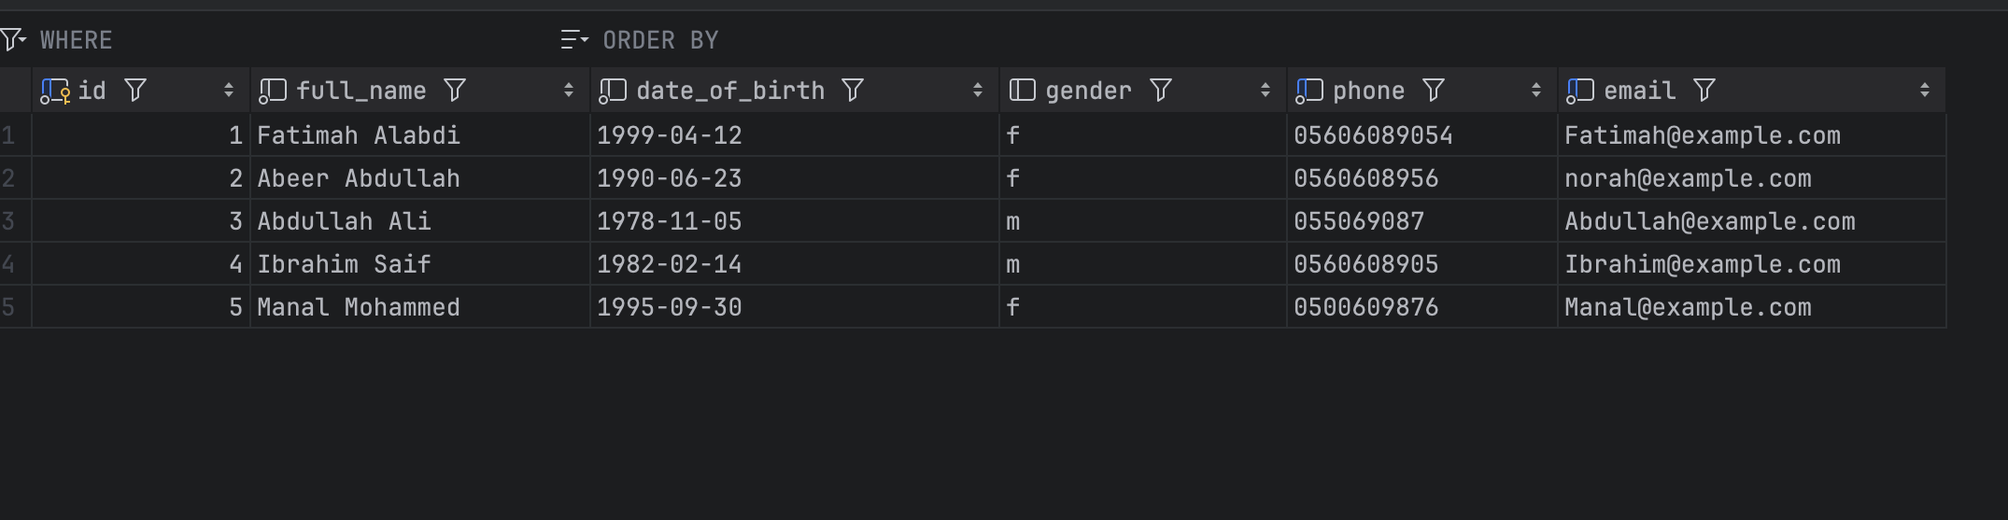

1. Doctor

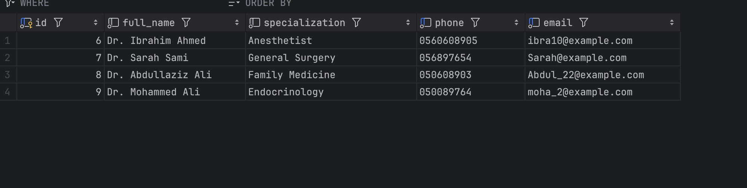

1. Appointment

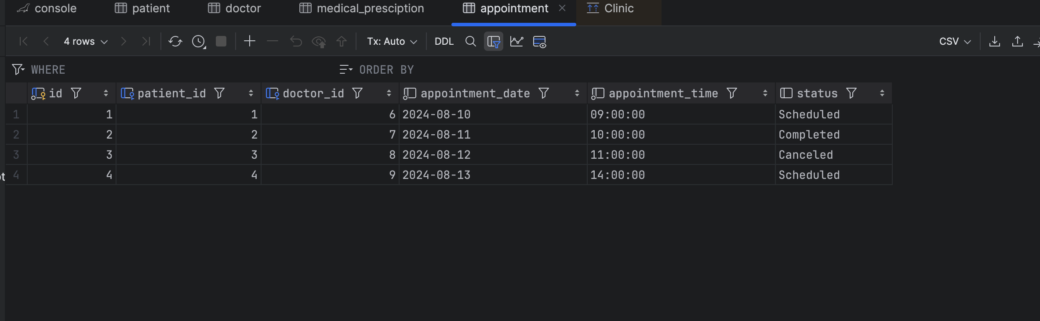

1. Medical_Presciption

