Smart Gym Monitoring System
Monthly Report — August 2026

Summary
During the month of August, overall gym activity remained steady with modest general attendance across the facility. The left strength zone was the busiest area of the gym, while the middle aisle was the quietest zone, seeing virtually no traffic and triggering three underused zone alerts. To address these patterns next month, management should consider repositioning some popular strength equipment toward quieter areas to spread member activity more evenly. Additionally, repurposing the underused middle aisle for functional stretching or mobility work would help maximize available floor space and relieve congestion in the main workout zones.

Occupancy Trend
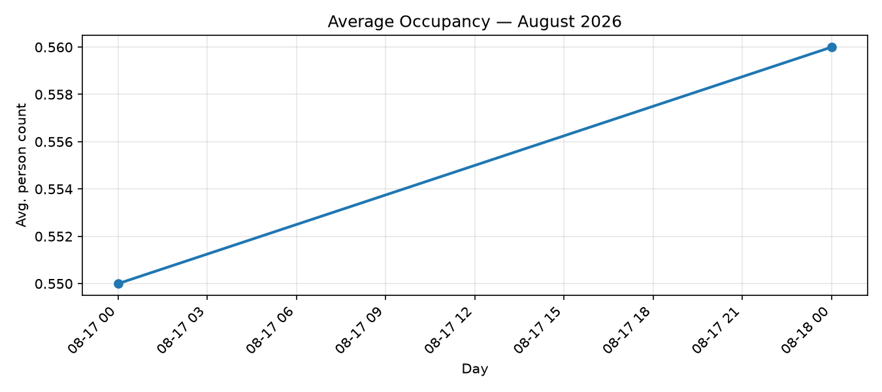

Automatically generated by the Smart Gym Monitoring System.

