## Multiplexing & De- Multiplexing

## Multiplexing is the generic term used to describe the operation of sending one or more analogue or digital signals over a common transmission line at different times or speeds and as such, the device we use to do just that is called a Multiplexing.

## 4×1 Multiplexer:

In the 4×1 multiplexer, there is a total of four inputs, i.e., A0, A1, A2, and A3, 2 selection lines, i.e., S0 and S1 and single output, i.e., Y. On the basis of the combination of inputs that are present at the selection lines S0 and S1, one of these 4 inputs are connected to the output. The block diagram and the truth table of the 4**×**1 multiplexer are given below.

### MultiplexerBlock Diagram:

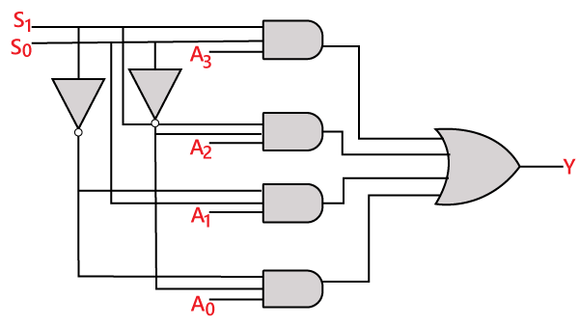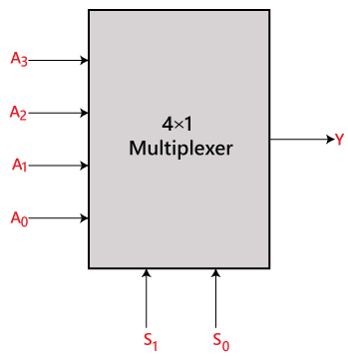

## 8 to 1 Multiplexer

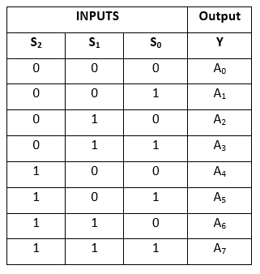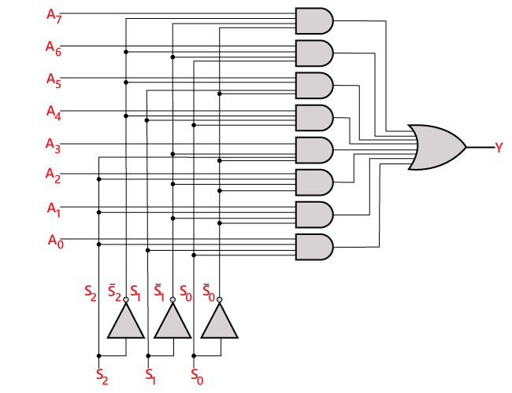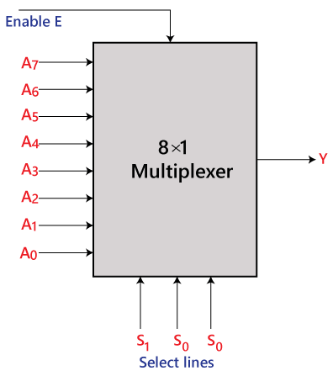In the 8 to 1 multiplexer, there are total eight inputs, i.e., A0, A1, A2, A3, A4, A5, A6, and A7, 3 selection lines, i.e., S0, S1and S2 and single output, i.e., Y. On the basis of the combination of inputs that are present at the selection lines S0, S1, and S2, one of these 8 inputs are connected to the output. The block diagram and the truth table of the 8**×**1 multiplexer are given below.

**De-Multiplexer**

**De-Multiplexer** is a combinational circuit that performs the reverse operation of Multiplexer. It has single input, ‘n’ selection lines and maximum of 2n outputs. The input will be connected to one of these outputs based on the values of selection lines.

Since there are ‘n’ selection lines, there will be 2n possible combinations of zeros and ones. So, each combination can select only one output. De-Multiplexer is also called as **De-Mux**.

**1x4 De-Multiplexer**

1x4 De-Multiplexer has one input I, two selection lines, s1 & s0 and four outputs Y3, Y2, Y1&Y0. The **block diagram** of 1x4 De-Multiplexer is shown in the following figure.

|  |  |  |  |  |  |
| --- | --- | --- | --- | --- | --- |
| **Selection Inputs** | | **Outputs** | | | |
| **S1** | **S0** | **Y3** | **Y2** | **Y1** | **Y0** |
| 0 | 0 | 0 | 0 | 0 | **I** |
| 0 | 1 | 0 | 0 | **I** | 0 |
| 1 | 0 | 0 | **I** | 0 | 0 |
| 1 | 1 | **I** | 0 | 0 | 0 |

The single input ‘I’ will be connected to one of the four outputs, Y3 to Y0 based on the values of selection lines s1 & s0. The **Truth table** of 1x4 De-Multiplexer is shown below.

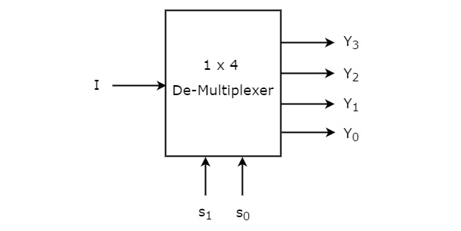

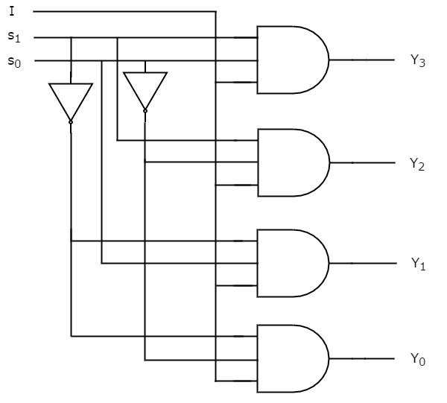

## 1×8 De-multiplexer

In 1 to 8 De-multiplexer, there are total of eight outputs, i.e., Y0, Y1, Y2, Y3, Y4, Y5, Y6, and Y7, 3 selection lines, i.e., S0, S1and S2 and single input, i.e., A. On the basis of the combination of inputs which are present at the selection lines S0, S1and S2, the input will be connected to one of these outputs. The block diagram and the truth table of the 1**×**8 de-multiplexer are given below.

### De-multiplexerBlock Diagram:

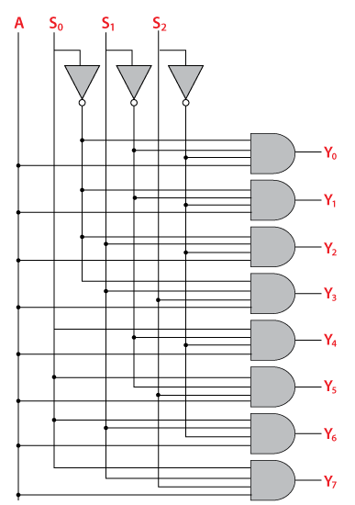**Circuit Diagram:**

### Truth Table:

### De-multiplexer

### 1×8 De-multiplexer using 1×4 and 1×2 de-multiplexer

