

Assignment 02

Database Systems



Fatima Qurban

i211195

SE-P

**ERD for Train Management System with Passenger Management and Employee Management**

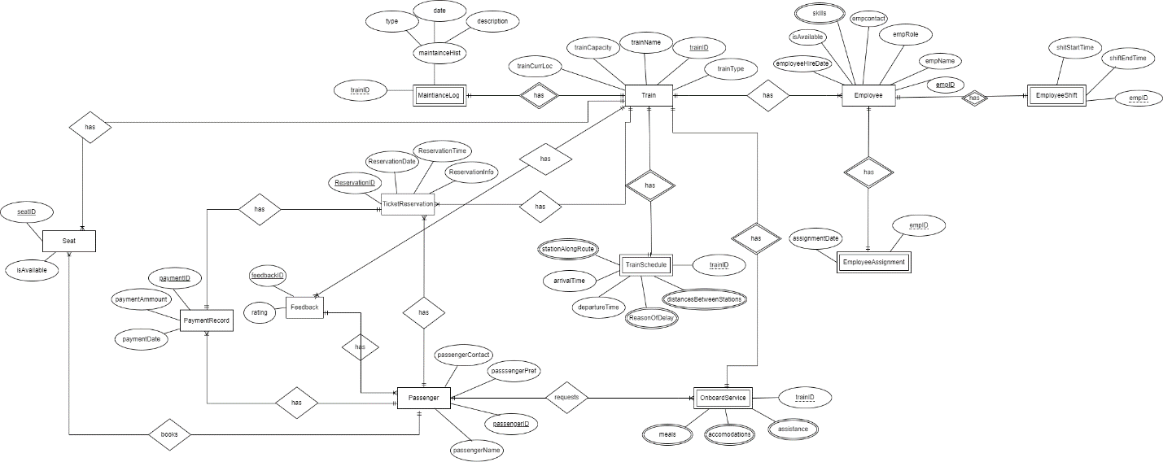

**Q#1:**

**Relational Schema:**

Train

|  |  |  |  |  |
| --- | --- | --- | --- | --- |
| trainID | trainCapacity | trainName | trainCurrLoc | trainType |

MaintanceLog

|  |  |  |  |
| --- | --- | --- | --- |
| trainID (FK) | Maintancetype | maintanceDate | MaintanceDescp |

TicketReservation

|  |  |  |  |  |  |
| --- | --- | --- | --- | --- | --- |
| ReservationID | ReservationDate | reservationTime | reservationInfo | tainID | paymentID (FK) |

PaymentRecord

|  |  |  |  |
| --- | --- | --- | --- |
| paymentID | paymetAmmount | paymentDate | PassengerID (FK) |

Seat

|  |  |  |  |
| --- | --- | --- | --- |
| SeatID | IsAvailable | trainID (FK) | passengerID (FK) |

Feedback

|  |  |  |
| --- | --- | --- |
| feedbackID | rating | trainID (FK) |

Passenger

|  |  |  |  |  |
| --- | --- | --- | --- | --- |
| passengerID | passengerName | passengerPref | passengerCOntract | feedbackID (FK) |

TrainScedule

|  |  |  |
| --- | --- | --- |
| trainArrivalTime | TrainDesperatureTime | trainID (FK)(PK) |

stationAlongRoutes

|  |  |
| --- | --- |
| trainID | routeStation |

reasonOfDelay

|  |  |
| --- | --- |
| trainID | delayReason |

RoutesBwDistance

|  |  |
| --- | --- |
| trainID | distanceBwRoutes |

OboardService

|  |  |
| --- | --- |
| TrainID (PK)(FK) | PassengerID |

mealService

|  |  |  |
| --- | --- | --- |
| trainID (PK)(FK) | passengerID (FK) | meals |

accomodationService

|  |  |  |
| --- | --- | --- |
| trainID (PK)(FK) | passengerID (FK) | Accommodation |

assistanceService

|  |  |  |
| --- | --- | --- |
| trainID (PK)(FK) | passengerID (FK) | assistance |

Employee

|  |  |  |  |  |  |
| --- | --- | --- | --- | --- | --- |
| empID | empName | empRole | empContact | isAvailable | empHireDate |

employeeShift

|  |  |  |
| --- | --- | --- |
| empID (FK) (PK) | shiftStartTime | shiftEndTime |

EmployeeAssignment

|  |  |
| --- | --- |
| empID (FK) (PK) | assignmentDate |

EmpSkill

|  |  |
| --- | --- |
| empID | empSkill |

**Q#2:**

**Flat Table:**

(TrainID,TrainCapacity,TrainName,trainCurrLoc, trainType, MaintanceType,maintanceDate, MaintanceDesc, reservationID, reservationDate, reservationTime, reservationInfo, paymentID, paymentammount, PaymentDate, passengerName, passengerPref, passengerContract, feedbackID, rating, seatID, seatAvailibility, trainArrTime, trainDeptTime, routeStation, delayReason, distbwRoutes, meals, accommodation, assistance, empID, empName, empRole, empContact, empAvailibilty, empHireDate, empShiftStartTime, empShiftEndTime, empAssignmentDate, empSkill)

**Entities and their functional dependencies:**

**Train Entity:**

* TrainID → TrainCapacity, TrainName, trainCurrLoc, trainType, MaintanceType, maintanceDate, MaintanceDesc, trainArrTime, trainDeptTime, routeStation, delayReason, distbwRoutes, meals, accommodation, assistance

**Reservation Entity:**

* reservationID → TrainID, reservationDate, reservationTime, reservationInfo, paymentID
* TrainID, reservationDate → reservationTime, reservationInfo, paymentID
* paymentID → paymentammount, PaymentDate

**Passenger Entity:**

* reservationID → passengerName, passengerPref, passengerContact
* feedbackID → rating

**Employee Entity:**

* empID → empName, empRole, empContact, empAvailibilty, empHireDate, empShiftStartTime, empShiftEndTime, empAssignmentDate, empSkill
* empRole → empID

**Relationships and their functional dependencies:**

* **Train-Reservation Relationship:**
  + TrainID → reservationID, reservationDate, reservationTime, reservationInfo, paymentID
  + reservationID → TrainID, reservationDate, reservationTime, reservationInfo, paymentID
* **Passenger-Reservation Relationship:**
  + reservationID → passengerName, passengerPref, passengerContact
* **Payment-Reservation Relationship:**
  + paymentID → paymentammount, PaymentDate
* **Passenger-Feedback Relationship:**
  + feedbackID → rating
* **Employee-Assignment Relationship:**
  + empID → empName, empRole, empContact, empAvailibilty, empHireDate, empShiftStartTime, empShiftEndTime, empAssignmentDate, empSkill
  + empRole → empID

**1st Normal Form:**

FlatTable (TrainID, TrainCapacity, TrainName, trainCurrLoc, trainType, MaintanceType, maintanceDate, MaintanceDesc, reservationID, reservationDate, reservationTime, reservationInfo, paymentID, paymentammount, PaymentDate, passengerID, passengerName, passengerPref, passengerContract, feedbackID, rating, seatID, seatAvailibility, trainArrTime, trainDeptTime, empID, empName, empRole, empContact, empAvailibilty, empHireDate, empShiftStartTime, empShiftEndTime, empAssignmentDate,)

stationAlongRoutes

|  |  |
| --- | --- |
| trainID | routeStation |

reasonOfDelay

|  |  |
| --- | --- |
| trainID | delayReason |

RoutesBwDistance

|  |  |
| --- | --- |
| trainID | distanceBwRoutes |

mealService

|  |  |  |
| --- | --- | --- |
| trainID (PK)(FK) | passengerID (FK) | meals |

accomodationService

|  |  |  |
| --- | --- | --- |
| trainID (PK)(FK) | passengerID (FK) | Accommodation |

assistanceService

|  |  |  |
| --- | --- | --- |
| trainID (PK)(FK) | passengerID (FK) | assistannce |

EmpSkill

|  |  |
| --- | --- |
| empID | empSkill |

**Description:**

In first normal form, all the table which has multivalued attributes are converted into separate tables.

**2nd Normal Form:**

Train

|  |  |  |  |  |  |  |  |
| --- | --- | --- | --- | --- | --- | --- | --- |
| trainID | trainCapacity | trainName | trainCurrLoc | trainType | mntnctype | mntncDate | mntncDescp |

TicketReservation

|  |  |  |  |  |  |
| --- | --- | --- | --- | --- | --- |
| ReservationID | ReservationDate | reservationTime | reservationInfo | tainID | paymentID (FK) |

PaymentRecord

|  |  |  |  |
| --- | --- | --- | --- |
| paymentID | paymetAmmount | paymentDate | PassengerID (FK) |

Seat

|  |  |  |  |
| --- | --- | --- | --- |
| SeatID | IsAvailable | trainID (FK) | passengerID (FK) |

Employee

|  |  |  |  |  |  |  |  |
| --- | --- | --- | --- | --- | --- | --- | --- |
| empID | empName | empRole | empContact | isAvailable | empHireDate | shiftStartTime | shiftEndTime |

Feedback

|  |  |  |
| --- | --- | --- |
| feedbackID | rating | trainID (FK) |

**Description:**

In 2nd NF, the flat table has primary composite keys so all the attributes connected the one part of composite keys are combined and the attributes with the other part of composite keys are separated.

**3rd Normal Form:**

Train

|  |  |  |  |  |
| --- | --- | --- | --- | --- |
| trainID | trainCapacity | trainName | trainCurrLoc | trainType |

MaintanceLog

|  |  |  |  |
| --- | --- | --- | --- |
| trainID (FK) | Maintancetype | maintanceDate | MaintanceDescp |

TicketReservation

|  |  |  |  |  |  |
| --- | --- | --- | --- | --- | --- |
| ReservationID | ReservationDate | reservationTime | reservationInfo | tainID | paymentID (FK) |

PaymentRecord

|  |  |  |  |
| --- | --- | --- | --- |
| paymentID | paymetAmmount | paymentDate | PassengerID (FK) |

Seat

|  |  |  |  |
| --- | --- | --- | --- |
| SeatID | IsAvailable | trainID (FK) | passengerID (FK) |

Feedback

|  |  |  |
| --- | --- | --- |
| feedbackID | rating | trainID (FK) |

Passenger

|  |  |  |  |  |
| --- | --- | --- | --- | --- |
| passengerID | passengerName | passengerPref | passengerCOntract | feedbackID (FK) |

TrainScedule

|  |  |  |
| --- | --- | --- |
| trainArrivalTime | TrainDesperatureTime | trainID (FK)(PK) |

stationAlongRoutes

|  |  |
| --- | --- |
| trainID | routeStation |

reasonOfDelay

|  |  |
| --- | --- |
| trainID | delayReason |

RoutesBwDistance

|  |  |
| --- | --- |
| trainID | distanceBwRoutes |

OboardService

|  |  |
| --- | --- |
| TrainID (PK)(FK) | PassengerID |

mealService

|  |  |  |
| --- | --- | --- |
| trainID (PK)(FK) | passengerID (FK) | meals |

accomodationService

|  |  |  |
| --- | --- | --- |
| trainID (PK)(FK) | passengerID (FK) | Accommodation |

assistanceService

|  |  |  |
| --- | --- | --- |
| trainID (PK)(FK) | passengerID (FK) | assistance |

Employee

|  |  |  |  |  |  |
| --- | --- | --- | --- | --- | --- |
| empID | empName | empRole | empContact | isAvailable | empHireDate |

employeeShift

|  |  |  |
| --- | --- | --- |
| empID (FK) (PK) | shiftStartTime | shiftEndTime |

EmployeeAssignment

|  |  |
| --- | --- |
| empID (FK) (PK) | assignmentDate |

EmpSkill

|  |  |
| --- | --- |
| empID | empSkill |

**Description:**

In 3rd NF, all the table has its own set of primary and foreign keys.