Computer Architecture Lab
(EL-2012)
LABORATORY REPORT

Fall 2026

(Lab#03)
Apply Behavioral-level Verilog to Design and
Simulate Combinational Modules

Student Name: Fatima Tariq Roll No: 24i-6557 Section: CE-A

Date performed: 4, August, 2026

MARKS AWARDED: ________ / 10

Signature and date of Instructor: _________________
Lab Instructors: Dr. Nasir Ali Shah, Engr. Fasih Ahmad

______________________________________________________________________________________________________________________________________________________

NATIONAL UNIVERSITY OF COMPUTER AND EMERGING SCIENCES, ISLAMABAD
Prepared by: | Fasih Ahmad |  | Version: 1.0
Verified by: | Dr. Nasir Ali Shah |  | Updated: Fall 2026

Task 1: Write Verilog code for a 4-bit adder/subtractor. The circuit should perform addition or
subtraction depending on the control signal. Simulate the results using a testbench.

Description:
In this task a 4-bit adder and subtractor was implemented in Modelsim using Verilog Language. Registers were used for taking 4 bit inputs and storing 4 bit results.
Code:
module task01(a,b,M,sum,carry);
input [3:0] a;
input [3:0] b;
input M;
output reg [3:0] sum;
output reg carry;
always@(*)
begin
if (M == 0)
{carry,sum}=a+b;
else
{carry,sum}=a-b;
end
endmodule
module testbench_addsub();
reg [3:0] a;
reg [3:0] b;
reg M;
wire [3:0] sum;
wire carry;
task01 uut(a,b,M,sum,carry);
initial
begin
a=4'b0001;
b=4'b1000;
M=1'b1;
#50;
a=4'b1001;
b=4'b1010;
M=1'b1;
#50;
a=4'b0000;
b=4'b1110;
M=1'b0;
#50;
a=4'b1011;
b=4'b0111;
M=1'b0;
#50;
end
endmodule

Output:
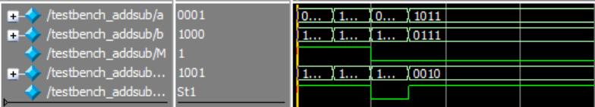

Task 2: Write Verilog code for 2x1 MUX having below mentioned operations. Simulate your
program through testbench.
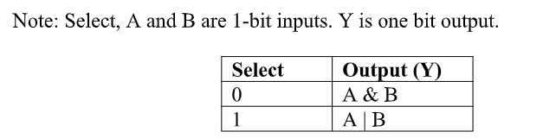
Description:
In this task a 2x1 mux was implemented in Model-sim where if select pin is 0 the AND operation was performed between the inputs and if select pin was set to 1 then OR operation was performed. Desired results were achieved.
Code:
module task02(a,b,s,y);
input a,b,s;
output reg y;
always @(*)
begin
if(s==0)
y=a&b;
else
y=a|b;
end
endmodule
module testbench2x1();
reg a;
reg b;
reg s;
wire y;
task02 uut(a,b,s,y);
initial begin
a=1'b0;
b=1'b0;
s=1'b0;
#50;
a=1'b0;
b=1'b0;
s=1'b1;
#50;
a=1'b0;
b=1'b1;
s=1'b0;
#50;
a=1'b0;
b=1'b1;
s=1'b1;
#50;
a=1'b1;
b=1'b0;
s=1'b0;
#50;
a=1'b1;
b=1'b0;
s=1'b1;
#50;
a=1'b1;
b=1'b1;
s=1'b0;
#50;
a=1'b1;
b=1'b1;
s=1'b1;
#50;
end
endmodule
Output:
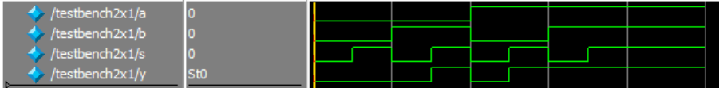

Task 3: Write Verilog code for a 2-bit comparator that compares two 2-bit binary numbers and
outputs the result as equality, greater than, or less than. Simulate the circuit with a testbench.

Description:
In this task a 2-bit comparator was implemented in Model-sim using Verilog language. And based on the inputs it compared whether the inputs were greater, lesser or equal to each other and produced desired results.

Code:
module task03(a,b,e,g,l);
input [1:0] a;
input [1:0] b;
output reg e;
output reg g;
output reg l;
always @(*)
begin
if(a==b)
begin
e=1'b1;
g=1'b0;
l=1'b0;
end
else if(a>b)
begin
e=1'b0;
g=1'b1;
l=1'b0;
end
else
begin
e=1'b0;
g=1'b0;
l=1'b1;
end
end
endmodule
module testbench_comp();
reg [1:0] a;
reg [1:0] b;
wire e;
wire g;
wire l;
task03 uut(a,b,e,g,l);
initial
begin
a=2'b00;
b=2'b00;
#50;
a=2'b00;
b=2'b01;
#50;
a=2'b00;
b=2'b10;
#50;
a=2'b00;
b=2'b11;
#50;
a=2'b01;
b=2'b00;
#50;
a=2'b01;
b=2'b01;
#50;
a=2'b01;
b=2'b10;
#50;
a=2'b01;
b=2'b11;
#50;
a=2'b10;
b=2'b00;
#50;
a=2'b10;
b=2'b01;
#50;
a=2'b10;
b=2'b10;
#50;
a=2'b10;
b=2'b11;
#50;
a=2'b11;
b=2'b00;
#50;
a=2'b11;
b=2'b01;
#50;
a=2'b11;
b=2'b10;
#50;
a=2'b11;
b=2'b11;
#50;
end
endmodule
Output:

