

Assessment Cover Sheet
Assessment Title
Project(Individual)
Assessment Type
Uncontrolled
Individual
Not must-pass
Due Date
8th January 2026
Course Code
IT9002
Course Title
Natural Language Processing

Internal Moderator’s
Dr.
Dr. Abdelhameed Fawzy
External Examiner’s

Instructions:
- This cover sheet must be completed (section in blue below) and attached to your assessment before submission in hard copy/soft copy.
- The time allowed for this assessment is XXX minutes/hours/days.
- This assessment carries XXX marks distributed to a total of XXX questions assessing CILO X and CILO X.
- The materials allowed for use in this assessment are XXX, XXX, and XXX.
- The use of generative AI tools is strictly prohibited.
- References consulted (if any) must be properly acknowledged and cited.
- The assessment has a total of XXX pages.

8th January 2025
Date Submitted

202508958
Learner ID
Fatema Husain Hasan
Learner Name

Sini Raj Pulari
IT9002
MSc in AI
Lecturer’s Name
Programme Code
Programme Title
By submitting this assessment for marking, I affirm that this assessment is my own work.
Learner Signature

Do not write beyond this line. For assessor use only.
Assessor’s Name
Marking Date
Marks Obtained

Comments:
Table of Contents
Task 1 - Problem Statement Formulation and Definition 5
1.1 Introduction 5
1.2 Motivation 5
1.3 Problem Statement 6
1.4 Project Definition 6
1.5 Objectives 6
1.6 Expected Outcomes 6
Task 2 - Selection of an Appropriate Data Set (Data Collection) 7
2.1 Dataset Overview 7
2.2 Dataset Source 7
2.3 Dataset Selection Justification 7
2.4 Dataset Structure and Shape 8
2.5 Description of Key Attributes 9
2.6 Label Identification and Transformation 9
2.7 Exploratory Data Analysis and Visualization 10
Task 3 – Text Preprocessing 11
3.1 Introduction to text Preprocessing 11
3.2 Lowercasing 11
3.3 Emoji Removal 12
3.4 Punctuation and Numbers Removal 12
3.5 Tokenization 13
3.6 Stopword Removal 13
3.7 Stemming 14
3.8 Lemmatization 14
3.9 Final Preprocessed Text 15
Task 4 – Text Representation 15
4.1 Introduction to Text Representation 15
4.2 Bag of Words (BoW) 15
4.3 N-grams Representation 18
4.4 Part-of-Speech (POS) Tagging 19
4.5 Named Entity Recognition (NER) 20
Task 5 - Text Classification / Prediction 20
5.1 Task 5 Introduction 20
5.2 Sentiment Label Creation 21
5.3 Train and Test Data Split 21
5.4 Feature Extraction Using TF-IDF 22
5.5 Model Selection and Justification 22
5.5.1 Multinomial Naive Bayes 22
5.5.2 Logistic Regression 23
5.6 Model Training and Prediction 23
Task 6 - Evaluation, Inferences, Recommendation and Reflection 24
6.1 Task 6 Introduction 24
6.2 Evaluation Metrics 24
6.3 Model Performance Evaluation 25
6.4 Model Comparison 25
6.7 Project Enhancements 27
6.8 Learning Reflection 28
References 29

Table of Figures
Figure 1 - Import Libraries 8
Figure 2 - Presenting first 5 rows in the dataset 8
Figure 3 - Presenting the dataset shape and columns 8
Figure 4 - Labelling the data into sentiment classes 9
Figure 5 - Labelling the data visualization 10
Figure 6 – Lowercasing 11
Figure 7 - Emoji Removal 12
Figure 8 - Punctuation and Numbers Removal 12
Figure 9 - Tokenization 13
Figure 10 - Stopword Removal 13
Figure 11 - Stemming 14
Figure 12 - Lemmatization 14
Figure 13 - Final Preprocessed Text 15
Figure 14 - Bag of Words 16
Figure 15 - Bag of Words Visualization 17
Figure 16 - Top 20 Words in BoW Visualization 17
Figure 17 - N-gram 18
Figure 18 - Top 20 words Bigrams 18
Figure 19 - POS Tagging 19
Figure 20 - Top 10 POS Visualization 19
Figure 21 - NER with example 20
Figure 22 - Sentiment Label Creation and testing 21
Figure 23 - Train and Test Data Split 21
Figure 24 - TF-IDF 22
Figure 25 - Multinomial Naive Bayes 23
Figure 26 - Logistic Regression 23
Figure 27 - Evaluation Metrics 24
Figure 28 - Confusion Matrix Naive Bayes 26
Figure 29 - Confusion Matrix Logistic Regression 27

Task 1 - Problem Statement Formulation and Definition

Introduction
The fast increase in e-commerce sites is making customers rely increasingly on online reviews as a means of sharing their minds and experiences with products and services. These ratings play an important role in the buying decisions of the consumers and provide companies with valuable data. The examination of customer reviews by a human, however, is a time-consuming and impracticable undertaking due to the colossal amount of the textual data generated by users. Natural language processing, or NLP, provides effective methods of automatic analysis and extraction of significant information of unstructured text data. NLP based text categorization methods can help businesses understand the urges of the clients, identify potential issues, and improve the decision-making process.

Motivation
The primary objective of this project is to explore the possible application of the NLP techniques that I have studied in this course in deriving helpful information about the actual business data. Online shopping websites such as Amazon are the recipients of thousands of evaluations every day which reflect consumer happiness, dissatisfaction, and neutral opinions. By understanding the sentiment of consumers on a large scale, the following things can be done by businesses:
- Monitor the level of customer satisfaction.
- Identify negative remarks in good time.
- Increase customer care and quality of products.
- Enhance the overall user experience.

Problem Statement
To design and implement an automatic Natural Language Processing based program that assesses Amazon customer reviews and separates them into three sentiment groups (positive, neutral and negative) based on the text of the reviews.

Project Definition
The objective of this project is to utilize natural language processing (NLP) strategies to pre-process customer review data, turn it into the relevant numerical form, and develop machine learning models, which can be used to categorize sentiment. The project consists of numerous stages, including model training, evaluation, text representation, and data preparation. The system anticipates sentiment categories of unseen reviews through supervised learning methods to determine patterns in labeled review data.

Objectives
The key objectives of the project are as follows:
- To apply NLP techniques to unprocessed review data of customers. In order to employ appropriate methods of feature extraction to quantify the textual information.
- Principles of using and comparing various text categorization models.
- To evaluate the performance of the model using traditional categorization measures.
- To extract useful data from sentiment analysis of customers.

Expected Outcomes
The expected outcomes of this project at the end of its implementation are as follows:
- A preprocessed and cleansed Amazon reviews dataset.
- Representations that are effective with machine learning models.
- Models of classification that can predict consumer mood using training.
- Performance of models in comparison.
- Business-relevant insights obtained through sentiment analysis.

Task 2 - Selection of an Appropriate Data Set (Data Collection)

2.1 Dataset Overview
This study was conducted using an Amazon customer reviews dataset, which is updated daily to perform text-based sentiment categorization. The data set is also perfectly suited to Natural Language Processing tasks using sentiment analysis as it contains real user-generated ratings collected on an e-commerce platform. The collection contains textual customer reviews and metadata, including ratings and timestamps. It becomes feasible to apply the supervised learning techniques to sentiment prediction.

2.2 Dataset Source
Dataset Name: Amazon Shopping Reviews (Daily Updated)
Source: Kaggle
Domain: E-commerce / Online Retail
The data was acquired in Kaggle due to the availability of well-documented, publicly available datasets frequently used in machine learning and academic studies (Kumar, 2025). Kaggle datasets are credible and commonly used in research on sentiment analysis using NLP.

2.3 Dataset Selection Justification
This dataset was chosen because of the following factors:
- It possesses a large number of verifiable customer reviews that reflect the opinion of real users.
- The text is not structured and, therefore, it is ideal to apply NLP preprocessing and feature extraction to it.
- The data represents a practical business scenario where automated sentiment analysis can be used to provide valuable information to support decision-making.

2.4 Dataset Structure and Shape
The structure of the dataset was examined to know the number of records and attributes on it after loading it.
Rows: Present testimonials of different clients.
Columns: Include review id, username, content, score, thumbs up count, review Created Version, at (timestamp) app Version.
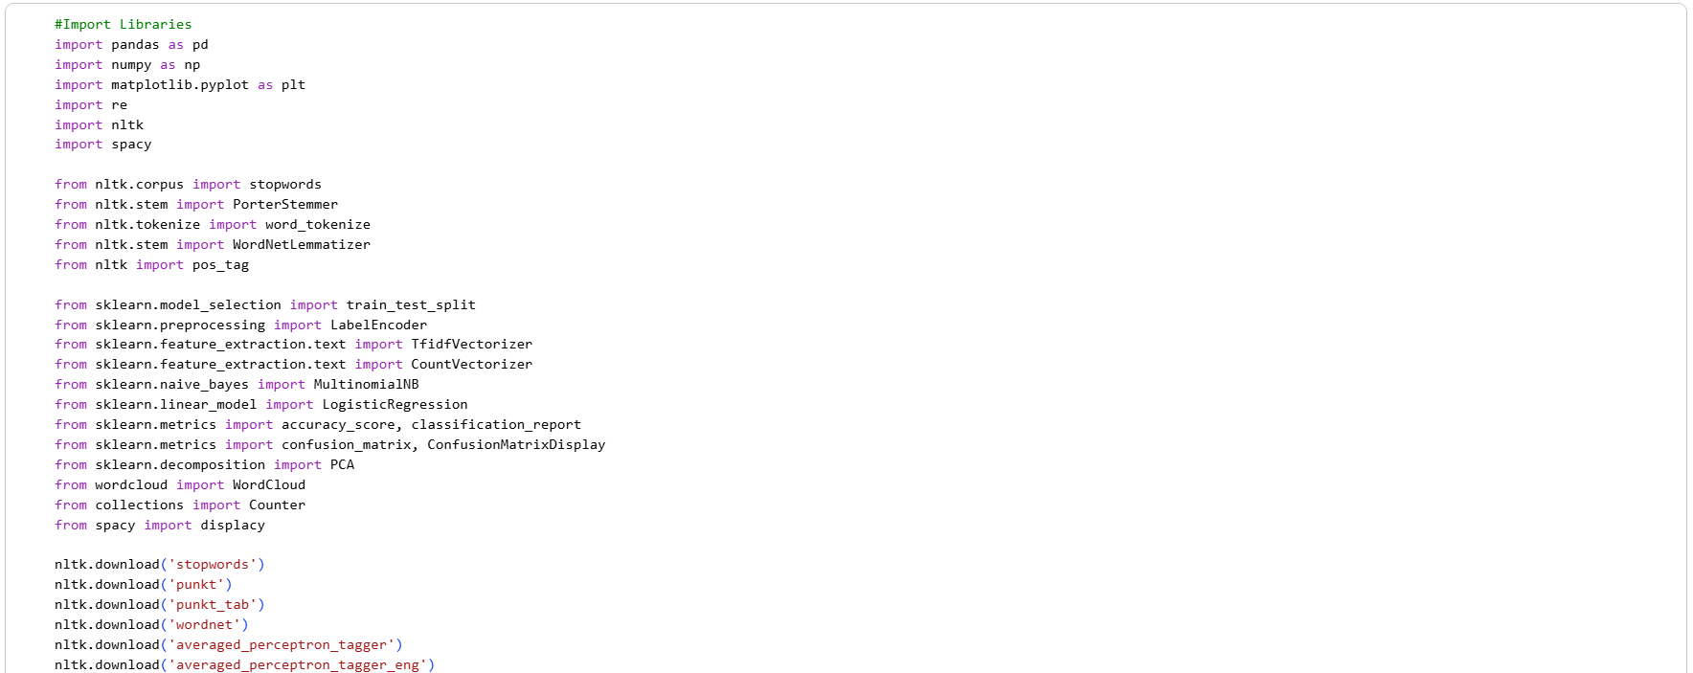
Figure 1 - Import Libraries
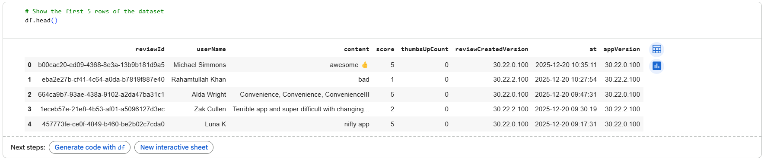
Figure 2 - Presenting first 5 rows in the dataset
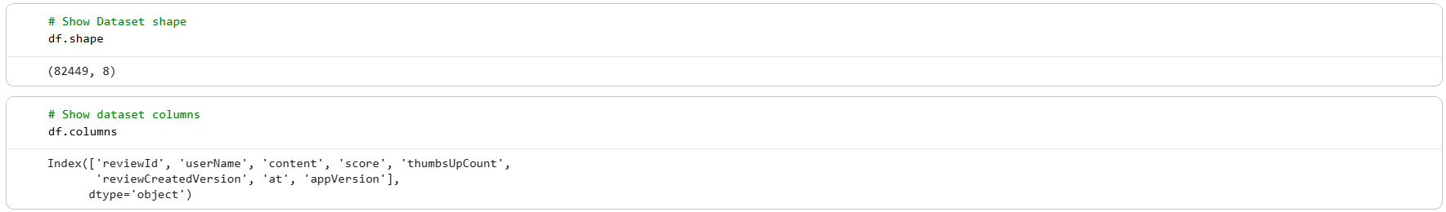
Figure 3 - Presenting the dataset shape and columns

2.5 Description of Key Attributes
The attributes that are most relevant to this project are as follows:
Content: Customer written textual reviews are included. This column forms the primary input of NLP processing.
Score: Refers to the rating of the customer number. Based on this column, sentiment labels are obtained.
Other columns (reviewId, Username and timestamp) do provide more metadata, though not directly assist in model training.

2.6 Label Identification and Transformation
The data set originally had numerical ratings that measured the level of low and high. These ratings were transformed into three sentiment categories to be used in sentiment classification by using the if condition as seen in figure 4 and classified as below:
- Negative: Poor ratings (1-2 Stars)
- Neutral: Medium ratings (3 Stars)
- Positive: Excellent ratings (4-5 Stars)
This transformation is in line with the conventional practices of sentiment analysis research and allows application of multi-class classification algorithms.
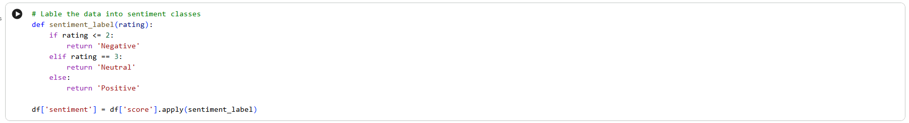
Figure 4 - Labelling the data into sentiment classes
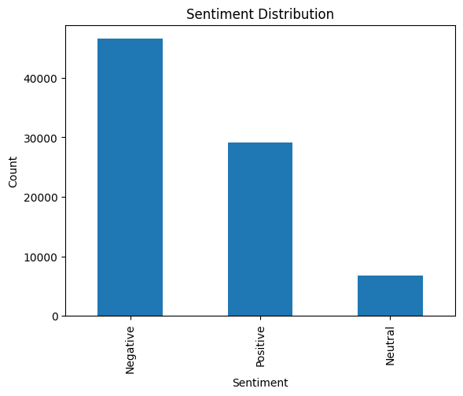
Figure 5 - Labelling the data visualization

2.7 Exploratory Data Analysis and Visualization
The exploratory analysis was conducted to get a better insight into the data: The distribution of labels of emotions was presented in the form of bar charts. Sample reviews were assessed to understand the length of the text, the language usage and the type of writing. Since it is typical of e-commerce websites where satisfied customers are better positioned to leave feedback, the graph indicated that the proportion of positive ratings was greater in the dataset compared to the rate of neutral and negative ratings.

Task 3 – Text Preprocessing

3.1 Introduction to text Preprocessing
Text preprocessing is a key step in natural language processing because text raw data often includes noise (Deepanshi, 2025) such as irregular cases, punctuation, emojis, stopwords and repeated words. Failure to deal with such noise can affect the performance of machine learning models. The text preprocessing produced by this project aims at transforming unstructured unprocessed customer review of Amazon into a format that is appropriate to use in sentiment classification and feature extraction.

3.2 Lowercasing
In this task lowercasing is applied to convert all the letters in the text to a lower case by using NLTK tokenizer as shown in the figure below (figure 6). This ensures that when words of identical meaning but different letter casing like “Bad” and “bad” are analyzed they are treated as the same. The use of lowercase helps to improve consistency across the dataset and reduce the size of vocabulary.
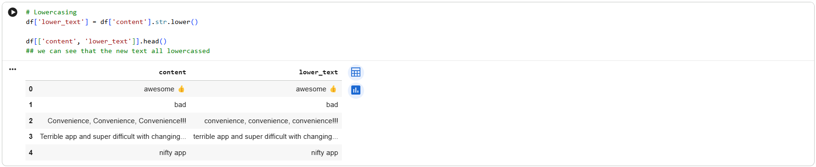
Figure 6 – Lowercasing

3.3 Emoji Removal
Customer reviews often include the use of emojis to express emotions. At times, emojis can convey emotion, though in this project, they were discarded to simplify textual analysis and get down to sentiment patterns by word as shown in the figure below along with the results (figure 7). Textual data can be made more understandable by emoji removal to traditional machine learning models and can be used to eliminate non-textual noise.
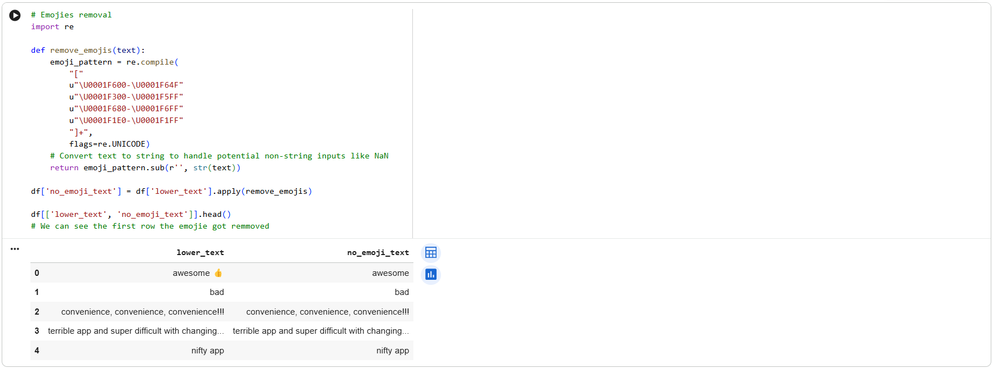
Figure 7 - Emoji Removal

3.4 Punctuation and Numbers Removal
Overall, punctuation and number characters do not give helpful data on emotion classification. To retain only the alphabetic characters, it became necessary to remove them. Besides the fact that the dataset must include clear textual data that can be tokenized and used to extract features, this step will reduce the amount of noise as shown in the figure below with the results before and after (figure 8).
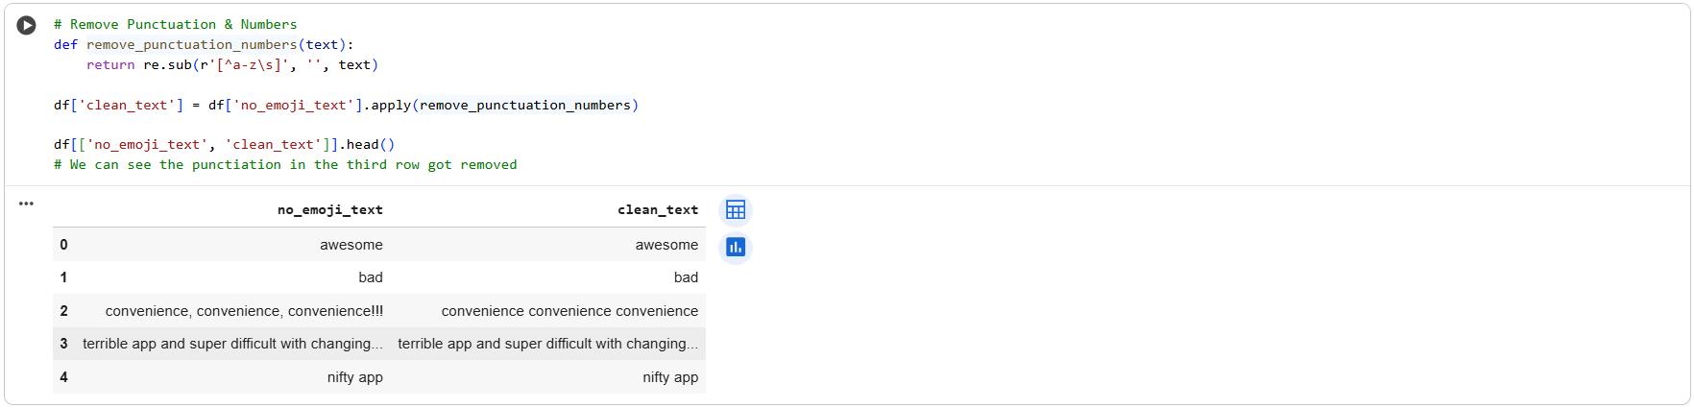
Figure 8 - Punctuation and Numbers Removal

3.5 Tokenization
In this task we used the tokenization process of breaking down text into separate words, or tokens. Rather than text being analyzed as a continuous string, the result allows the NLP pipeline to analyze text on the word level. In this project, the tokenization method was employed to divide the customer reviews into individual word tokens which form the foundation of other preprocessing tasks such as lemmatization, stemming and removal of stopwords as shown in the figure below (figure 9).
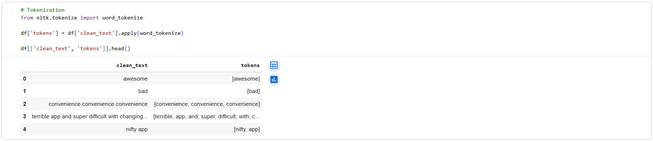
Figure 9 - Tokenization

3.6 Stopword Removal
Stopwords Words such as “is, the, and” and that are frequently used, but usually do not provide much information in terms of sentiment categorization tasks. In this task removing stopwords by using NLTK tool will help the models to focus on more informative words that can help predict the sentiment in addition to dimensionality reduction as shown in the figure below (figure 10).
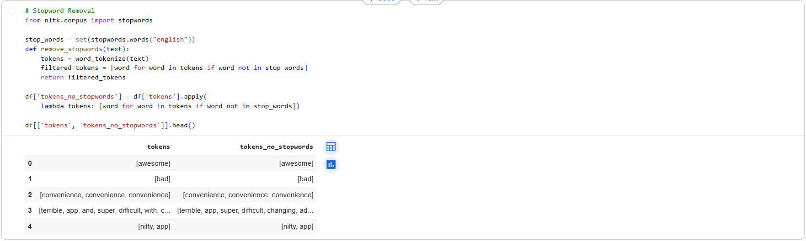
Figure 10 - Stopword Removal

3.7 Stemming
In this step stemming is used to remove suffixes from the simplest form of words however sometimes it might create words with no meaning as shown in the figure below (figure 11) . An example is that the words such as liked, liking and likes are simplified into like. In such a way, the size of vocabulary is reduced and similar words in the form are collocated.
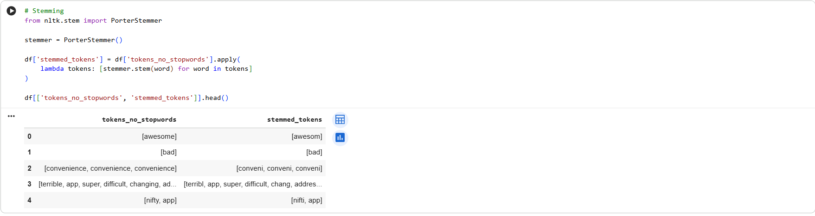
Figure 11 - Stemming

3.8 Lemmatization
Unlike stemming, Lemmatization gives meaning to meaningful words and increases interpretability. In this task we employed Lemmatization to get standard word forms without sacrificing the semantic meaning when stopwords were removed.
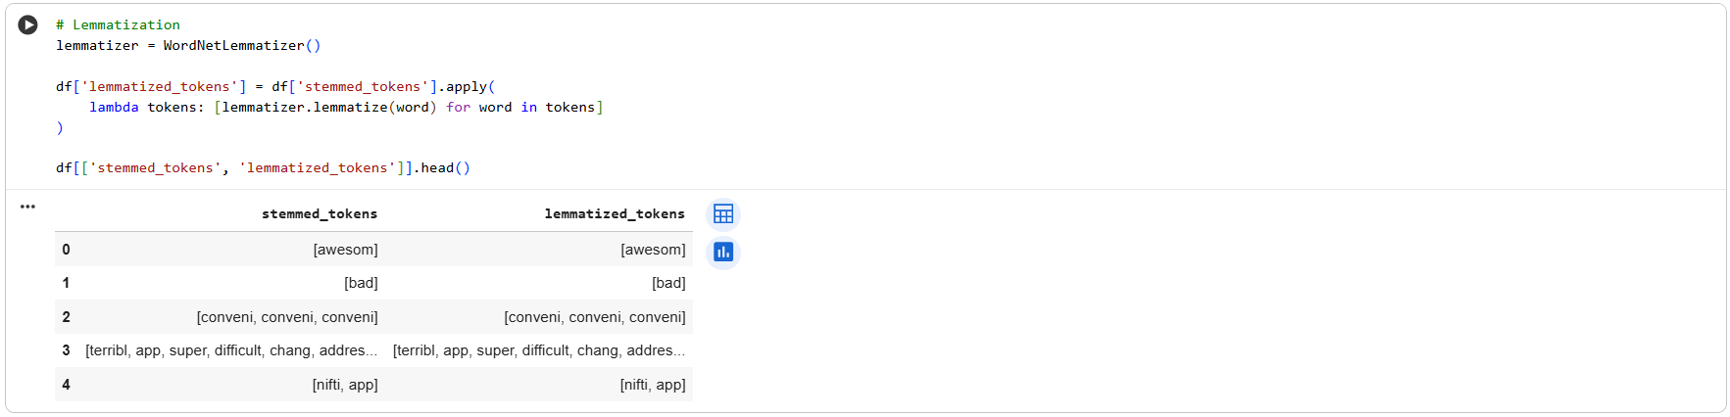
Figure 12 - Lemmatization

3.9 Final Preprocessed Text
After all preprocessing processes had been completed, the cleaned tokens were recreated into one text string in case of each review. This end result of preprocessed text is used as input in later tasks in text representation and classification models. The preprocessing pipeline highly enhances the effectiveness of the feature extraction and machine learning models, reduces noise, and enhances the quality of data.
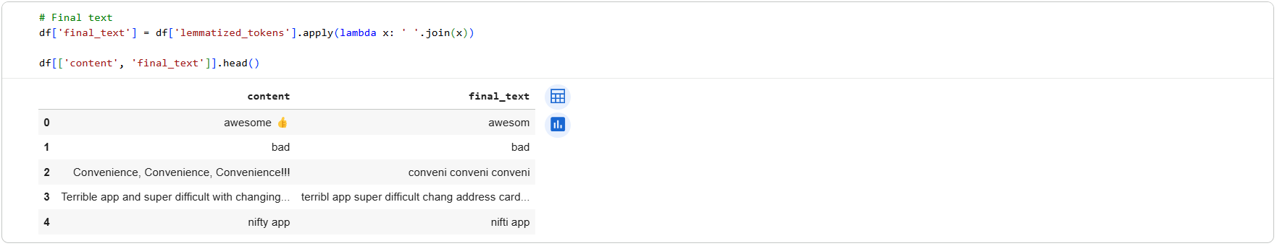
Figure 13 - Final Preprocessed Text
The figure above represents the text before and after the text preprocessing. We can see that emojis and punctuation got removed. In addition, lower casing and other preprocessing methods were applied successfully.

Task 4 – Text Representation

4.1 Introduction to Text Representation
The second step in the NLP pipeline is text representation involving representation of the text that has been preprocessed. Text representation strategies gather language patterns, word usage and context in a way that is suitable for model training. To ensure that the syntactic and semantic attributes of customer reviews were effectively captured, the following types of text representations were employed in the study.

4.2 Bag of Words (BoW)
The Bag of Words model does not pay attention to word order and grammar instead of text representation that is achieved through the computation of the frequency of each word in the sample. Each review is turned into a vector, and each dimension is a specific term and its frequency. As a simple and practical baseline form of sentiment categorization, Bag of Words does not consider the word sequence. In this undertaking, the BoW has applied to locate frequent expressions used by customers in their reviews and understand dominant issues related to consumer satisfaction and product experience. Some of the frequently referred qualities that were highlighted in a graphic of the most used terms included product quality, performance and usability.
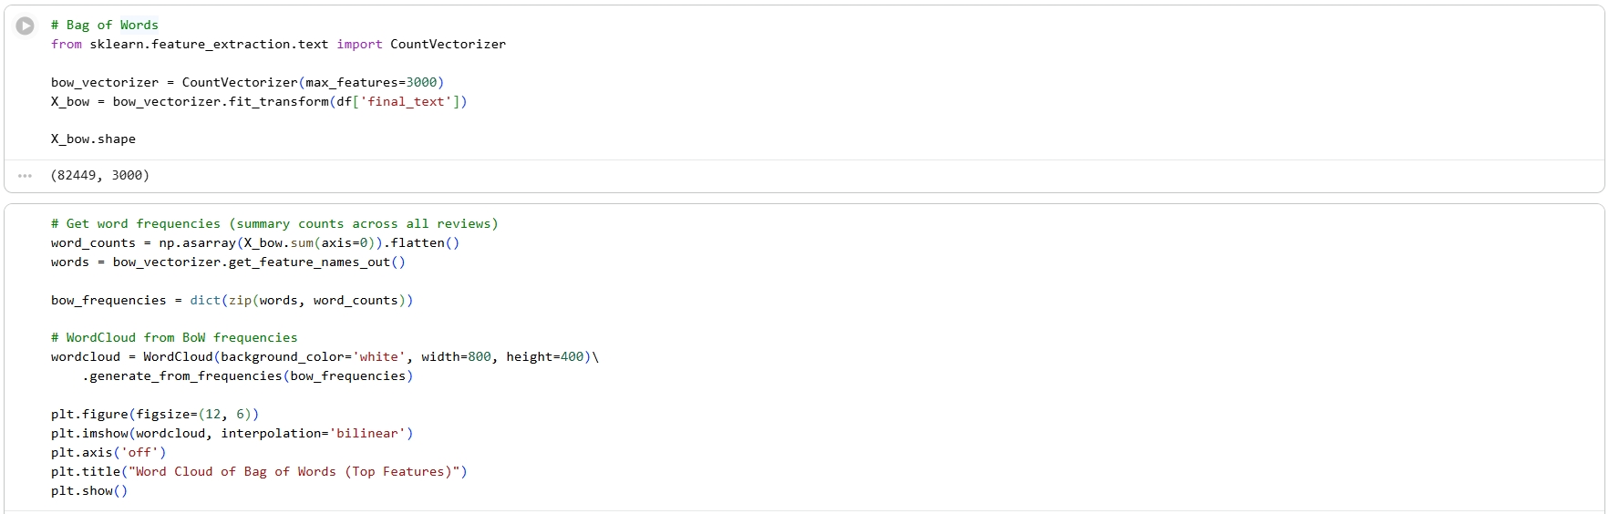
Figure 14 - Bag of Words

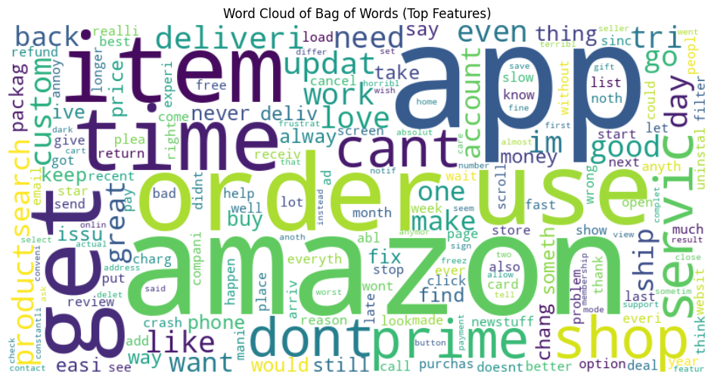
Figure 15 - Bag of Words Visualization
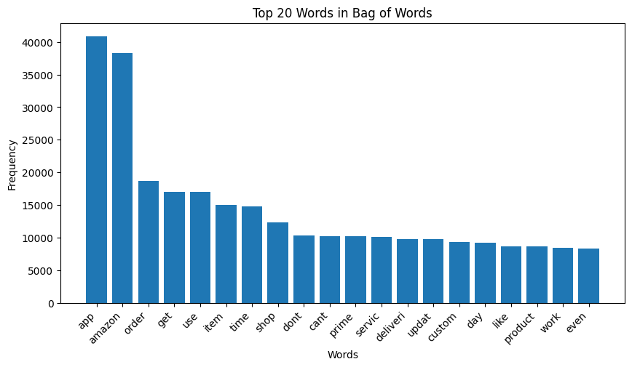
Figure 16 - Top 20 Words in BoW Visualization

4.3 N-grams Representation
Bag of Words is used to estimate how often words are used but it does not consider the relationship between words that follow each other. To overcome this limitation, n-gram representation was used. N-grams are sequences of n consecutive words. This research involved both unigrams and bigrams. This method can capture sentiment-bearing phrases such as not good, very bad, and high quality, which are often necessary in sentiment analysis. N-grams enhance the classification and ability of the model to extract contextual patterns.
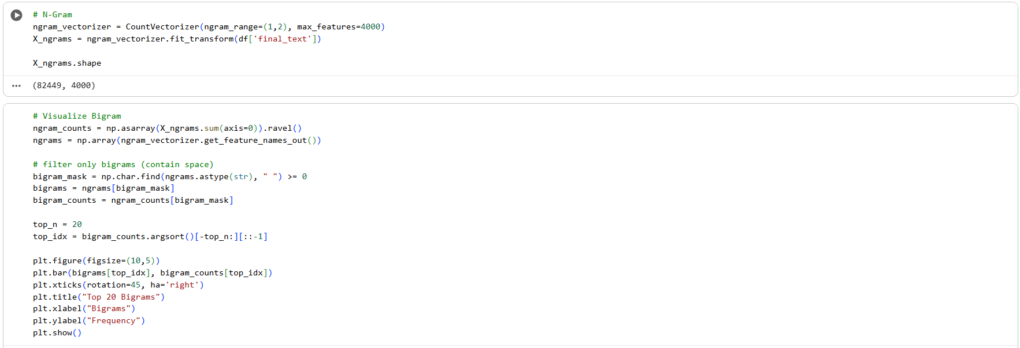
Figure 17 - N-gram
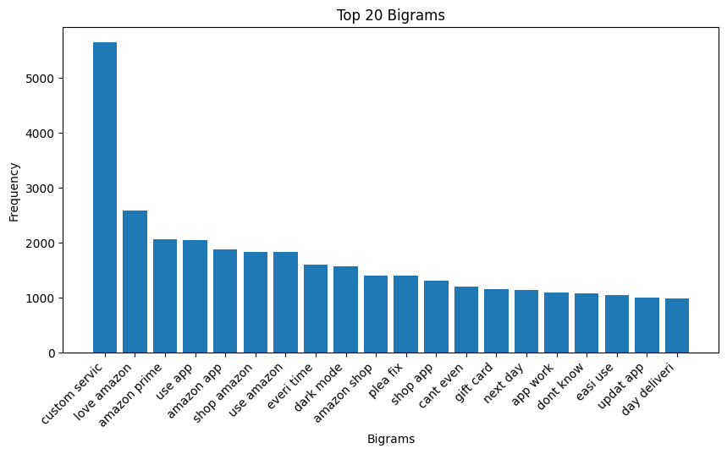
Figure 18 - Top 20 words Bigrams

4.4 Part-of-Speech (POS) Tagging
Part-of-speech tagging is used to assign each word in the text as grammatical label (e.g. nouns, verbs and adjectives). The POS tagging helps to identify word categories that are particularly important to sentiment analysis, as well as provides the information on the syntactic structure of sentences. Strong feeling is common in customer assessment in the use of adjectives and adverbs, e.g. excellent, terrible. The distribution of POS tags may be studied to determine the trends in consumer views and emotions. To demonstrate grammar structure and to determine commonly occurring parts of speech, POS tagging was performed to a subset of reviews.
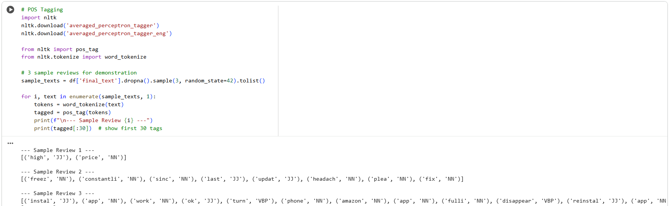
Figure 19 - POS Tagging
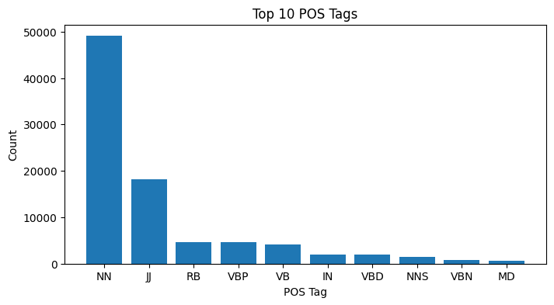
Figure 20 - Top 10 POS Visualization

4.5 Named Entity Recognition (NER)
Real world things that can be identified in text by Named Entity Recognition (NER) can include organizations, places and product names. NER can help to recognize companies, people, or locations that may frequently be mentioned in a review of e-commerce (Aya Data, 2024). NER was used to extract entities such as product brands and business names in the review text. The approach demonstrates that NLP may be applied to extract business-relevant information based on customer feedback along with sentiment classification.
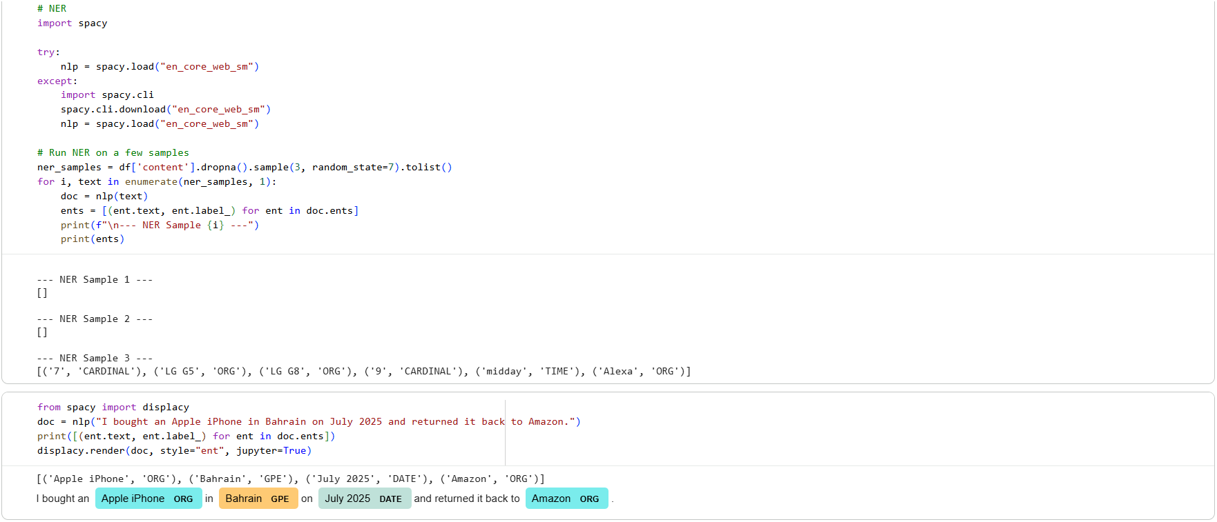
Figure 21 - NER with example

Task 5 - Text Classification / Prediction

5.1 Task 5 Introduction
The objective of the task is to create and evaluate machine learning systems which can automatically label customer reviews into sentiment categories based on their text. The sentiment labels were predicted with the use of supervised learning methods where the text had to be preprocessed and numerically represented.

5.2 Sentiment Label Creation
As mentioned in task 2 the original dataset incorporates the numerical ratings of customers and below are the labels selected for this sentiment analysis project.
- Negative: Poor ratings (1-2 Stars)
- Neutral: Medium ratings (3 Stars)
- Positive: Excellent ratings (4-5 Stars)
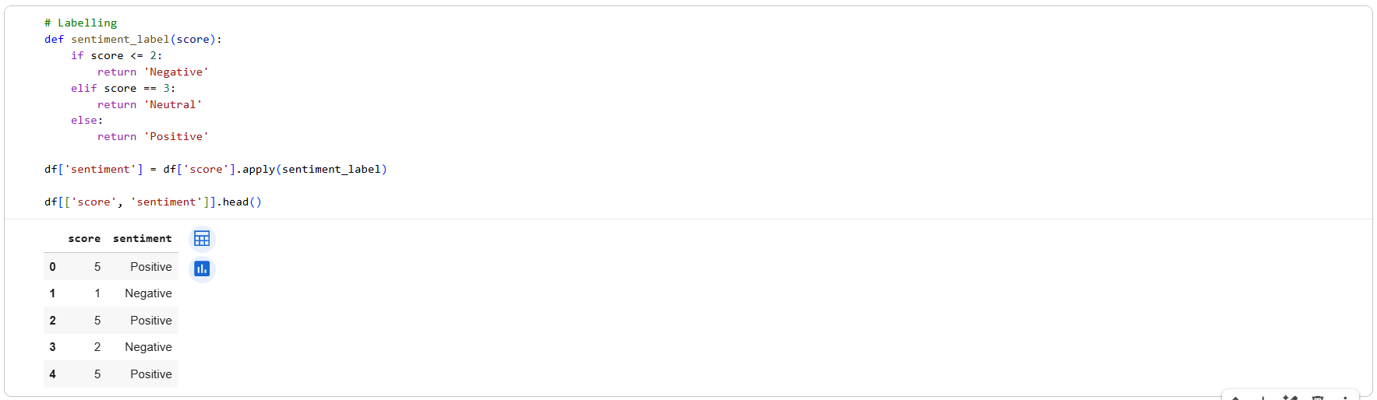
Figure 22 - Sentiment Label Creation and testing

5.3 Train and Test Data Split
The data has been divided into training and testing sets to determine the ability of the models to generalize. Using the test set as a measure of the model in unseen reviews, the training set was used to derive patterns of the data. This approach provides a reliable extrapolation of the performance of the models in real cases and prevents overfitting.
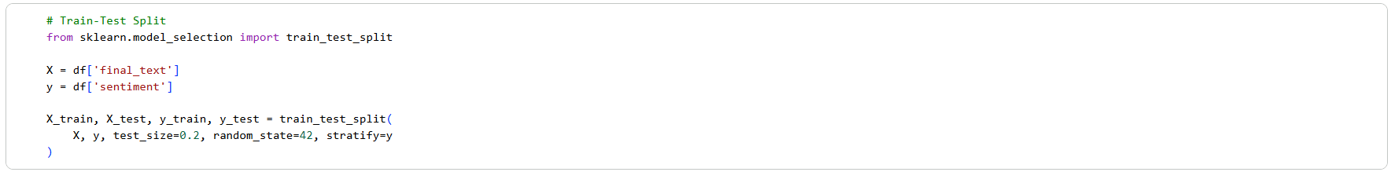
Figure 23 - Train and Test Data Split

5.4 Feature Extraction Using TF-IDF
The already processed text was converted into numeric feature vectors by using the Term Frequency-Inverse Document Frequency (TF-IDF). TF-IDF places more weight on words common to a specific text and less to the corpus.
TF-IDF was chosen due to:
- It deals with sparse text data of high dimensions.
- It reduces the impact of often used terms that are not very informative.
- It is effective with linear classifiers in situations that involve text classification.
- The resultant feature vectors were used as inputs in both classification models.
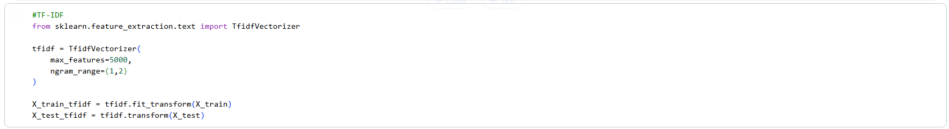
Figure 24 - TF-IDF

5.5 Model Selection and Justification
Two machine learning models were chosen to be used in sentiment classification.

5.5.1 Multinomial Naive Bayes
Multinomial Naive Bayes is a popular text categorization problem probabilistic classifier.
This model was chosen because of:
- It is good in calculation.
- It gives a firm basis on sentiment analysis.
- It is compatible with large pool of texts.
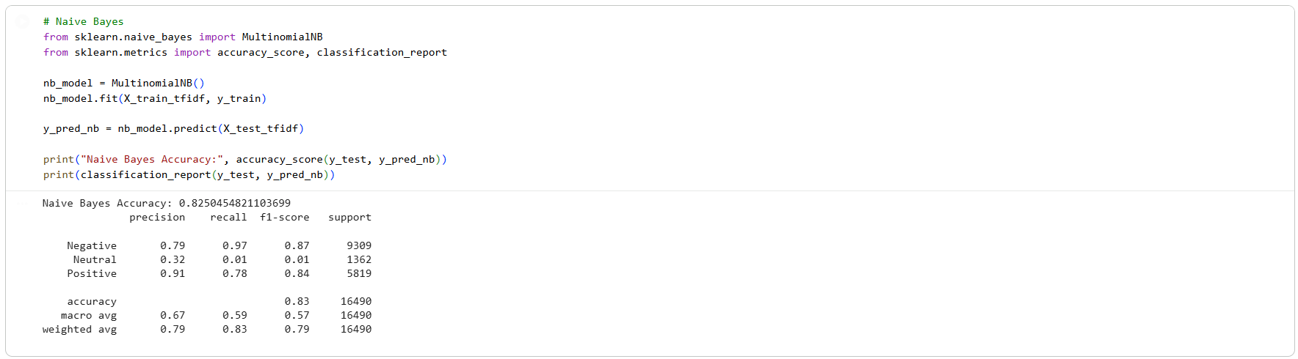
Figure 25 - Multinomial Naive Bayes

5.5.2 Logistic Regression
The logistic regression method of linear classification is rather effective in the high-dimensional feature space such as that produced by TF-IDF. It relies on a linear line of decisions to predict the possibility of membership to the class.
- The reason behind the choice of this model is that to:
- It can easily handle sparse text features.
- It is often more precise and recalls more than Naive Bayes.
- It provides consistent and understandable findings of sentiment categorization.
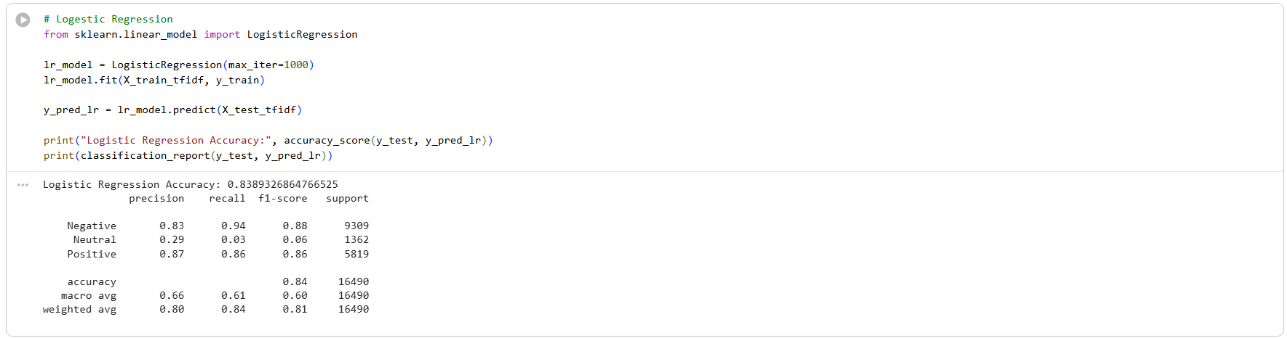
Figure 26 - Logistic Regression

5.6 Model Training and Prediction
Both models were trained using the feature representations of the training data in terms of TF-IDF. The test data were also predicted after training. Performance was then measured on the comparisons between the predicted sentiment labels and the actual labels.

Task 6 - Evaluation, Inferences, Recommendation and Reflection

6.1 Task 6 Introduction
The purpose of this task is to determine how effective sentiment categorization models were developed during the previous task. Evaluation measures are used to measure the effectiveness of the algorithms in forecasting the sentiment of the clients.

6.2 Evaluation Metrics
To measure the effectiveness of the categorization models, several evaluation metrics were used (Friedman, 2024):
- Accuracy: Measures the overall accuracy of the model.
- Precision: Indicates the percentage of sentiment labels that are predicted correctly.
- Recall: Determines the capability of the model to identify actual emotion classes.
- F1-score: Provides a reasonable evaluation of accuracy and memory.
- Confusion Matrix: This indicates the correct and incorrect prediction of each sentiment type.
Rather than relying on accuracy only, a range of indicators ensures that the model’s performance is adequately evaluated.
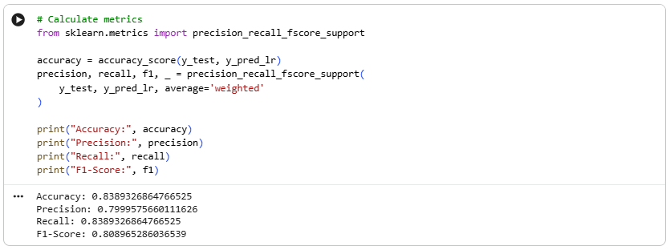
Figure 27 - Evaluation Metrics

6.3 Model Performance Evaluation
The above metrics were employed in evaluating the Multinomial Naive Bayes and Logistic Regression models using the test data. The confusion matrices displayed the performance of each model in the three sentiment classes (Negative, Neutral and Positive). The results indicated that although neutral reviews were comparatively more challenging to sort out accurately, both models can classify positive and negative reviews quite successfully. Logistic Regression generally performed well on balance in terms of accuracy, recall and F1-score as compared to Multinomial Naive Bayes, suggesting that it was overall more successful.

6.4 Model Comparison
Logistic Regression was more successful particularly in terms of F1-score. Multinomial Naive Bayes is a baseline model and was not very good at processing sentiment expressions that were overlapping. Neutral sentiment reviews were harder to classify because of language ambiguity. TF-IDF with linear classifiers were effective in analyzing sentiments of customer ratings. These findings indicate that the correct model to use is crucial in achieving precise sentiment categorization results.
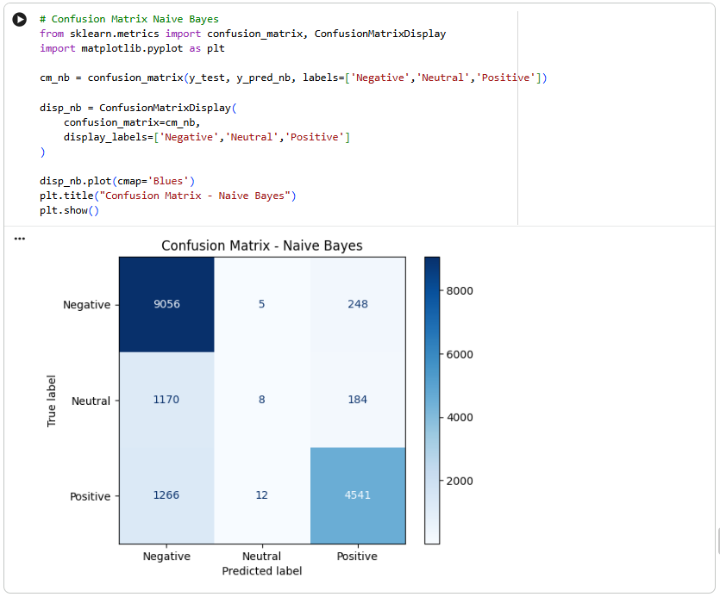
Figure 28 - Confusion Matrix Naive Bayes
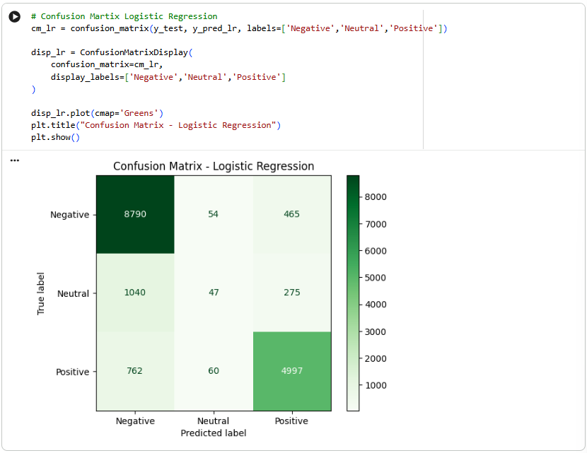
Figure 29 - Confusion Matrix Logistic Regression

6.7 Project Enhancements
Although the performance of the models is strong, additional studies could consider a series of improvements:
- Learning sequential relationships using deep learning such as LSTM.
- Transformer-based models like BERT are contextual understanding models.
- Resampling to solve the imbalance in classes.
- Installing sentiment lexicons and emojis instead of removing them.

6.8 Learning Reflection
The project provided me with the invaluable hands-on experience of natural language processing techniques on a real dataset. This project has allowed me to learn more about sentiment classification, feature extraction and text preprocessing. I also learned the impact of different types of classifiers and text representation on the performance of the model. Another benefit that the project brought me was the ability to critically evaluate models based on various indicators and interpret results in both technical and business perspectives. Overall, it is possible to state that this project enhanced my understanding of the principles of NLP and provided me with greater confidence in applying machine learning approaches to address real-world problems.

References
Aya Data. (2024, August 6). What is named entity recognition in NLP? AyaData.ai. https://www.ayadata.ai/what-is-named-entity-recognition-in-nlp/
Deepanshi. (2021, June 25). Text preprocessing in NLP with Python codes. Analytics Vidhya. https://www.analyticsvidhya.com/blog/2021/06/text-preprocessing-in-nlp-with-python-codes/
Friedman, Y. (2024, June 13). Understanding F1 score, accuracy, ROC-AUC, and PR-AUC metrics for models. Deepchecks. https://www.deepchecks.com/f1-score-accuracy-roc-auc-and-pr-auc-metrics-for-models
Kumar, A. (2025, December). Amazon Shopping Reviews [Daily Updated] [Dataset]. Kaggle. https://www.kaggle.com/datasets/ashishkumarak/amazon-shopping-reviews-daily-updated

