> #Rename variables

> colnames(RedWineData_Stat6509Project)=c("FixedAcidity", "VolatileAcidity", "CitricAcid", "ResidualSugar", "Chlorides", "FreeSulfurDioxide", "TotalSulfurDioxide", "Denisty", "pH", "Sulphates", "Alcohol", "Quality")

>

> #histogram for the distribution of quality ratings

> hist(RedWineData_Stat6509Project$Quality,main="Distribution of red wine quality ratings",xlim = c(2,10),

+ ,col = c("pink"))

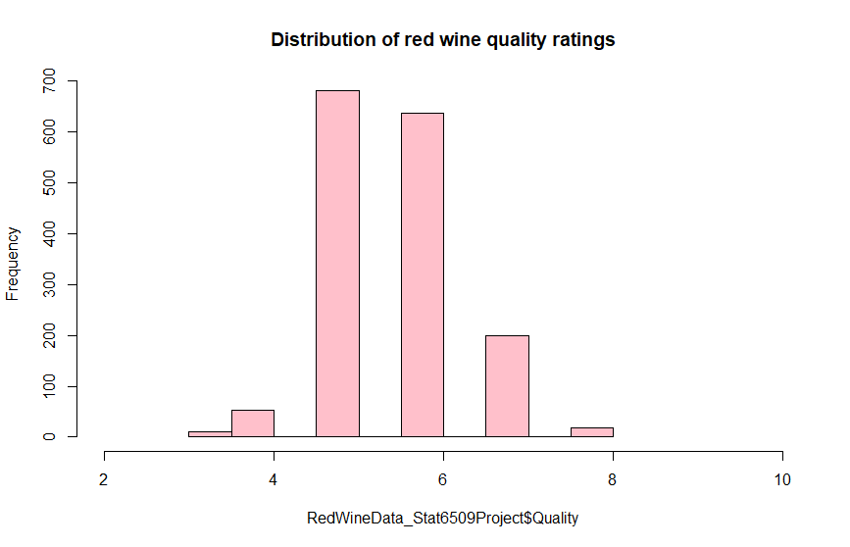

>

> #more informative scatterplot matrix

> install.packages("psych")

Error in install.packages : Updating loaded packages

> library(psych)

> pairs.panels(RedWineData_Stat6509Project[c("Quality","FixedAcidity", "VolatileAcidity", "CitricAcid", "ResidualSugar", "Chlorides", "FreeSulfurDioxide", "TotalSulfurDioxide", "Denisty", "pH", "Sulphates", "Alcohol")])

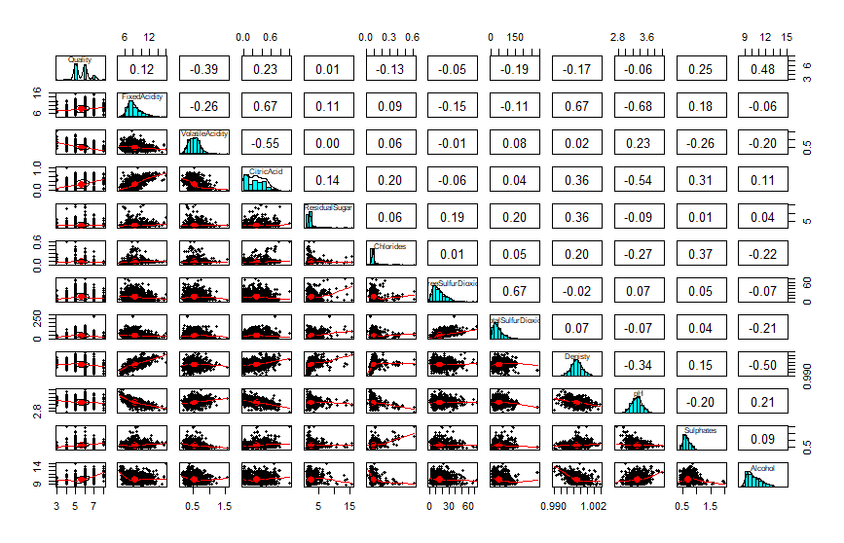

> install.packages("psych")

Warning in install.packages :

package ‘psych’ is in use and will not be installed

|  |
| --- |
| > # Run AIC to choose variables for model  > null=lm(Quality~1, data=RedWineData_Stat6509Project)  > summary(null)  Call:  lm(formula = Quality ~ 1, data = RedWineData_Stat6509Project)  Residuals:  Min 1Q Median 3Q Max  -2.636 -0.636 0.364 0.364 2.364  Coefficients:  Estimate Std. Error t value Pr(>|t|)  (Intercept) 5.6360 0.0202 279.1 <2e-16 ***  ---  Signif. codes: 0 ‘***’ 0.001 ‘**’ 0.01 ‘*’ 0.05 ‘.’ 0.1 ‘ ’ 1  Residual standard error: 0.8076 on 1598 degrees of freedom  >  > #Additive models  > full = lm(Quality~FixedAcidity+VolatileAcidity+CitricAcid+ResidualSugar+Chlorides+FreeSulfurDioxide+TotalSulfurDioxide+Denisty+pH+Sulphates+Alcohol, data=RedWineData_Stat6509Project)  > summary(full)  Call:  lm(formula = Quality ~ FixedAcidity + VolatileAcidity + CitricAcid +  ResidualSugar + Chlorides + FreeSulfurDioxide + TotalSulfurDioxide +  Denisty + pH + Sulphates + Alcohol, data = RedWineData_Stat6509Project)  Residuals:  Min 1Q Median 3Q Max  -2.68911 -0.36652 -0.04699 0.45202 2.02498  Coefficients:  Estimate Std. Error t value Pr(>|t|)  (Intercept) 2.197e+01 2.119e+01 1.036 0.3002  FixedAcidity 2.499e-02 2.595e-02 0.963 0.3357  VolatileAcidity -1.084e+00 1.211e-01 -8.948 < 2e-16 ***  CitricAcid -1.826e-01 1.472e-01 -1.240 0.2150  ResidualSugar 1.633e-02 1.500e-02 1.089 0.2765  Chlorides -1.874e+00 4.193e-01 -4.470 8.37e-06 ***  FreeSulfurDioxide 4.361e-03 2.171e-03 2.009 0.0447 *  TotalSulfurDioxide -3.265e-03 7.287e-04 -4.480 8.00e-06 ***  Denisty -1.788e+01 2.163e+01 -0.827 0.4086  pH -4.137e-01 1.916e-01 -2.159 0.0310 *  Sulphates 9.163e-01 1.143e-01 8.014 2.13e-15 ***  Alcohol 2.762e-01 2.648e-02 10.429 < 2e-16 ***  ---  Signif. codes: 0 ‘***’ 0.001 ‘**’ 0.01 ‘*’ 0.05 ‘.’ 0.1 ‘ ’ 1  Residual standard error: 0.648 on 1587 degrees of freedom  Multiple R-squared: 0.3606, Adjusted R-squared: 0.3561  F-statistic: 81.35 on 11 and 1587 DF, p-value: < 2.2e-16  > step(null, scope=list(lower=null, upper=full),  + direction="forward")  Start: AIC=-682.5  Quality ~ 1  Df Sum of Sq RSS AIC  + Alcohol 1 236.295 805.87 -1091.65  + VolatileAcidity 1 158.967 883.20 -945.14  + Sulphates 1 65.865 976.30 -784.89  + CitricAcid 1 53.405 988.76 -764.61  + TotalSulfurDioxide 1 35.707 1006.46 -736.24  + Denisty 1 31.887 1010.28 -730.19  + Chlorides 1 17.318 1024.85 -707.29  + FixedAcidity 1 16.038 1026.13 -705.29  + pH 1 3.473 1038.69 -685.84  + FreeSulfurDioxide 1 2.674 1039.49 -684.61  <none> 1042.17 -682.50  + ResidualSugar 1 0.197 1041.97 -680.80  Step: AIC=-1091.65  Quality ~ Alcohol  Df Sum of Sq RSS AIC  + VolatileAcidity 1 94.074 711.80 -1288.1  + Sulphates 1 44.977 760.89 -1181.5  + CitricAcid 1 31.953 773.92 -1154.3  + pH 1 26.362 779.51 -1142.8  + FixedAcidity 1 24.623 781.25 -1139.3  + TotalSulfurDioxide 1 8.270 797.60 -1106.2  + Denisty 1 5.203 800.67 -1100.0  <none> 805.87 -1091.7  + Chlorides 1 0.611 805.26 -1090.9  + FreeSulfurDioxide 1 0.325 805.55 -1090.3  + ResidualSugar 1 0.041 805.83 -1089.7  Step: AIC=-1288.14  Quality ~ Alcohol + VolatileAcidity  Df Sum of Sq RSS AIC  + Sulphates 1 19.6916 692.10 -1331.0  + TotalSulfurDioxide 1 6.3730 705.42 -1300.5  + pH 1 5.9515 705.84 -1299.6  + FixedAcidity 1 5.7061 706.09 -1299.0  + Denisty 1 1.9410 709.86 -1290.5  <none> 711.80 -1288.1  + FreeSulfurDioxide 1 0.6621 711.13 -1287.6  + Chlorides 1 0.3762 711.42 -1287.0  + CitricAcid 1 0.1936 711.60 -1286.6  + ResidualSugar 1 0.0101 711.79 -1286.2  Step: AIC=-1331  Quality ~ Alcohol + VolatileAcidity + Sulphates  Df Sum of Sq RSS AIC  + TotalSulfurDioxide 1 8.2176 683.89 -1348.1  + Chlorides 1 7.4925 684.61 -1346.4  + FixedAcidity 1 3.3282 688.78 -1336.7  + pH 1 3.0454 689.06 -1336.0  + FreeSulfurDioxide 1 1.1129 690.99 -1331.6  <none> 692.10 -1331.0  + CitricAcid 1 0.2522 691.85 -1329.6  + Denisty 1 0.2222 691.88 -1329.5  + ResidualSugar 1 0.0143 692.09 -1329.0  Step: AIC=-1348.1  Quality ~ Alcohol + VolatileAcidity + Sulphates + TotalSulfurDioxide  Df Sum of Sq RSS AIC  + Chlorides 1 8.0370 675.85 -1365.0  + pH 1 3.3094 680.58 -1353.8  + FixedAcidity 1 2.1037 681.78 -1351.0  + FreeSulfurDioxide 1 1.3557 682.53 -1349.3  <none> 683.89 -1348.1  + ResidualSugar 1 0.2634 683.62 -1346.7  + Denisty 1 0.1077 683.78 -1346.3  + CitricAcid 1 0.0730 683.81 -1346.3  Step: AIC=-1365  Quality ~ Alcohol + VolatileAcidity + Sulphates + TotalSulfurDioxide +  Chlorides  Df Sum of Sq RSS AIC  + pH 1 5.9189 669.93 -1377.1  + FixedAcidity 1 2.4065 673.44 -1368.7  + FreeSulfurDioxide 1 1.2403 674.61 -1365.9  <none> 675.85 -1365.0  + ResidualSugar 1 0.5531 675.30 -1364.3  + CitricAcid 1 0.1615 675.69 -1363.4  + Denisty 1 0.1526 675.70 -1363.4  Step: AIC=-1377.06  Quality ~ Alcohol + VolatileAcidity + Sulphates + TotalSulfurDioxide +  Chlorides + pH  Df Sum of Sq RSS AIC  + FreeSulfurDioxide 1 2.39413 667.54 -1380.8  <none> 669.93 -1377.1  + CitricAcid 1 0.80525 669.13 -1377.0  + ResidualSugar 1 0.28390 669.65 -1375.7  + Denisty 1 0.04468 669.89 -1375.2  + FixedAcidity 1 0.01040 669.92 -1375.1  Step: AIC=-1380.79  Quality ~ Alcohol + VolatileAcidity + Sulphates + TotalSulfurDioxide +  Chlorides + pH + FreeSulfurDioxide  Df Sum of Sq RSS AIC  <none> 667.54 -1380.8  + CitricAcid 1 0.47480 667.06 -1379.9  + ResidualSugar 1 0.16673 667.37 -1379.2  + Denisty 1 0.03079 667.51 -1378.9  + FixedAcidity 1 0.00663 667.53 -1378.8  Call:  lm(formula = Quality ~ Alcohol + VolatileAcidity + Sulphates +  TotalSulfurDioxide + Chlorides + pH + FreeSulfurDioxide,  data = RedWineData_Stat6509Project)  Coefficients:  (Intercept) Alcohol VolatileAcidity Sulphates TotalSulfurDioxide Chlorides  4.430099 0.289303 -1.012753 0.882665 -0.003482 -2.017814  pH FreeSulfurDioxide  -0.482661 0.005077  >  > model1=lm(formula = Quality ~ Alcohol + VolatileAcidity + Sulphates +  + TotalSulfurDioxide + Chlorides + pH + FreeSulfurDioxide,  + data = RedWineData_Stat6509Project)  > summary(model1)  Call:  lm(formula = Quality ~ Alcohol + VolatileAcidity + Sulphates +  TotalSulfurDioxide + Chlorides + pH + FreeSulfurDioxide,  data = RedWineData_Stat6509Project)  Residuals:  Min 1Q Median 3Q Max  -2.68918 -0.36757 -0.04653 0.46081 2.02954  Coefficients:  Estimate Std. Error t value Pr(>|t|)  (Intercept) 4.4300987 0.4029168 10.995 < 2e-16 ***  Alcohol 0.2893028 0.0167958 17.225 < 2e-16 ***  VolatileAcidity -1.0127527 0.1008429 -10.043 < 2e-16 ***  Sulphates 0.8826651 0.1099084 8.031 1.86e-15 ***  TotalSulfurDioxide -0.0034822 0.0006868 -5.070 4.43e-07 ***  Chlorides -2.0178138 0.3975417 -5.076 4.31e-07 ***  pH -0.4826614 0.1175581 -4.106 4.23e-05 ***  FreeSulfurDioxide 0.0050774 0.0021255 2.389 0.017 *  ---  Signif. codes: 0 ‘***’ 0.001 ‘**’ 0.01 ‘*’ 0.05 ‘.’ 0.1 ‘ ’ 1  Residual standard error: 0.6477 on 1591 degrees of freedom  Multiple R-squared: 0.3595, Adjusted R-squared: 0.3567  F-statistic: 127.6 on 7 and 1591 DF, p-value: < 2.2e-16  >  > #Diagnostics with Model 1  > par(mfrow=c(2,2))  > plot(model1, which=1:4) |
|  |
| |  | | --- | | > | |

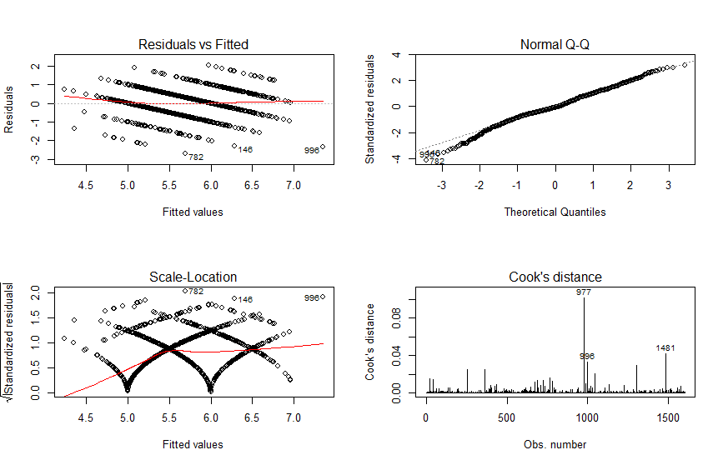

> #With Interactions

> full2 = lm(Quality~FixedAcidity*VolatileAcidity*CitricAcid*ResidualSugar*Chlorides*FreeSulfurDioxide*TotalSulfurDioxide*Denisty*pH*Sulphates*Alcohol, data=RedWineData_Stat6509Project)

summary(full2) (output gets cut off.. I attached what was left after R completed the Analysis)

|  |
| --- |
| FixedAcidity:VolatileAcidity -6.374e+05  FixedAcidity:CitricAcid -4.008e+05  VolatileAcidity:CitricAcid -4.951e+06  FixedAcidity:ResidualSugar -1.927e+05  VolatileAcidity:ResidualSugar -2.734e+06  CitricAcid:ResidualSugar 8.089e+05  FixedAcidity:Chlorides -8.230e+06  VolatileAcidity:Chlorides -5.258e+07  CitricAcid:Chlorides 1.679e+07  ResidualSugar:Chlorides 1.416e+06  FixedAcidity:FreeSulfurDioxide 1.044e+04  VolatileAcidity:FreeSulfurDioxide -8.777e+04  CitricAcid:FreeSulfurDioxide -4.886e+05  ResidualSugar:FreeSulfurDioxide -5.645e+04  Chlorides:FreeSulfurDioxide 3.932e+04  FixedAcidity:TotalSulfurDioxide -6.180e+03  VolatileAcidity:TotalSulfurDioxide -1.148e+04  CitricAcid:TotalSulfurDioxide 1.307e+05  ResidualSugar:TotalSulfurDioxide -1.327e+04  Chlorides:TotalSulfurDioxide -2.552e+05  FreeSulfurDioxide:TotalSulfurDioxide 1.766e+03  FixedAcidity:Denisty -5.504e+05  VolatileAcidity:Denisty -3.694e+06  CitricAcid:Denisty 1.737e+06  ResidualSugar:Denisty -9.540e+05  Chlorides:Denisty -4.767e+07  FreeSulfurDioxide:Denisty -9.185e+04  TotalSulfurDioxide:Denisty 1.380e+04  FixedAcidity:pH -3.087e+04  VolatileAcidity:pH 5.844e+05  CitricAcid:pH 1.488e+06  ResidualSugar:pH 3.169e+05  Chlorides:pH -5.924e+06  FreeSulfurDioxide:pH 3.481e+04  TotalSulfurDioxide:pH -1.456e+04  Denisty:pH 7.841e+04  FixedAcidity:Sulphates 1.485e+05  VolatileAcidity:Sulphates 7.242e+06  CitricAcid:Sulphates 1.003e+07  ResidualSugar:Sulphates -2.907e+05  Chlorides:Sulphates -1.030e+07  FreeSulfurDioxide:Sulphates -6.091e+04  TotalSulfurDioxide:Sulphates 1.150e+05  Denisty:Sulphates 2.125e+06  pH:Sulphates 1.337e+06  FixedAcidity:Alcohol -2.135e+04  VolatileAcidity:Alcohol -2.185e+05  CitricAcid:Alcohol -6.626e+04  ResidualSugar:Alcohol -7.481e+04  Chlorides:Alcohol -2.512e+05  FreeSulfurDioxide:Alcohol -6.949e+03  TotalSulfurDioxide:Alcohol 5.268e+03  Denisty:Alcohol -2.580e+05  pH:Alcohol -1.957e+04  Sulphates:Alcohol -2.521e+05  FixedAcidity:VolatileAcidity:CitricAcid 3.951e+05  FixedAcidity:VolatileAcidity:ResidualSugar 3.269e+05  FixedAcidity:CitricAcid:ResidualSugar 2.903e+05  VolatileAcidity:CitricAcid:ResidualSugar 1.400e+06  FixedAcidity:VolatileAcidity:Chlorides 9.218e+06  FixedAcidity:CitricAcid:Chlorides 5.826e+06  VolatileAcidity:CitricAcid:Chlorides 6.625e+07  FixedAcidity:ResidualSugar:Chlorides 1.271e+06  VolatileAcidity:ResidualSugar:Chlorides 1.710e+07  CitricAcid:ResidualSugar:Chlorides -2.209e+07  FixedAcidity:VolatileAcidity:FreeSulfurDioxide -5.848e+03  FixedAcidity:CitricAcid:FreeSulfurDioxide 4.216e+03  VolatileAcidity:CitricAcid:FreeSulfurDioxide 1.312e+05  FixedAcidity:ResidualSugar:FreeSulfurDioxide 7.069e+02  VolatileAcidity:ResidualSugar:FreeSulfurDioxide 7.713e+04  CitricAcid:ResidualSugar:FreeSulfurDioxide 1.355e+05  FixedAcidity:Chlorides:FreeSulfurDioxide -9.914e+04  VolatileAcidity:Chlorides:FreeSulfurDioxide -7.046e+05  CitricAcid:Chlorides:FreeSulfurDioxide 3.232e+06  ResidualSugar:Chlorides:FreeSulfurDioxide 2.617e+05  FixedAcidity:VolatileAcidity:TotalSulfurDioxide 4.350e+03  FixedAcidity:CitricAcid:TotalSulfurDioxide -4.909e+03  VolatileAcidity:CitricAcid:TotalSulfurDioxide -9.572e+04  FixedAcidity:ResidualSugar:TotalSulfurDioxide 2.007e+03  VolatileAcidity:ResidualSugar:TotalSulfurDioxide 2.467e+04  CitricAcid:ResidualSugar:TotalSulfurDioxide -2.572e+03  FixedAcidity:Chlorides:TotalSulfurDioxide 8.332e+04  VolatileAcidity:Chlorides:TotalSulfurDioxide 6.421e+05  CitricAcid:Chlorides:TotalSulfurDioxide -1.156e+06  ResidualSugar:Chlorides:TotalSulfurDioxide 6.868e+04  FixedAcidity:FreeSulfurDioxide:TotalSulfurDioxide -4.395e+01  VolatileAcidity:FreeSulfurDioxide:TotalSulfurDioxide -4.406e+02  CitricAcid:FreeSulfurDioxide:TotalSulfurDioxide 7.335e+02  ResidualSugar:FreeSulfurDioxide:TotalSulfurDioxide -2.096e+02  Chlorides:FreeSulfurDioxide:TotalSulfurDioxide -1.888e+03  FixedAcidity:VolatileAcidity:Denisty 6.579e+05  FixedAcidity:CitricAcid:Denisty 4.468e+05  VolatileAcidity:CitricAcid:Denisty 5.974e+06  FixedAcidity:ResidualSugar:Denisty 1.766e+05  VolatileAcidity:ResidualSugar:Denisty 2.593e+06  CitricAcid:ResidualSugar:Denisty -4.113e+05  FixedAcidity:Chlorides:Denisty 8.418e+06  VolatileAcidity:Chlorides:Denisty 5.376e+07  CitricAcid:Chlorides:Denisty -3.417e+06  ResidualSugar:Chlorides:Denisty -6.143e+05  FixedAcidity:FreeSulfurDioxide:Denisty -5.561e+03  VolatileAcidity:FreeSulfurDioxide:Denisty 1.394e+05  CitricAcid:FreeSulfurDioxide:Denisty 4.736e+05  ResidualSugar:FreeSulfurDioxide:Denisty 6.183e+04  Chlorides:FreeSulfurDioxide:Denisty 8.965e+04  FixedAcidity:TotalSulfurDioxide:Denisty 5.321e+03  VolatileAcidity:TotalSulfurDioxide:Denisty 1.560e+04  CitricAcid:TotalSulfurDioxide:Denisty -1.206e+05  ResidualSugar:TotalSulfurDioxide:Denisty 1.221e+04  Chlorides:TotalSulfurDioxide:Denisty 3.070e+05  FreeSulfurDioxide:TotalSulfurDioxide:Denisty -1.603e+03  FixedAcidity:VolatileAcidity:pH -1.058e+04  FixedAcidity:CitricAcid:pH 4.733e+04  VolatileAcidity:CitricAcid:pH -1.760e+05  FixedAcidity:ResidualSugar:pH 4.474e+03  VolatileAcidity:ResidualSugar:pH -8.518e+04  CitricAcid:ResidualSugar:pH -6.318e+05  FixedAcidity:Chlorides:pH 1.243e+06  VolatileAcidity:Chlorides:pH 1.740e+06  CitricAcid:Chlorides:pH -1.625e+07  ResidualSugar:Chlorides:pH -3.761e+06  FixedAcidity:FreeSulfurDioxide:pH -4.723e+03  VolatileAcidity:FreeSulfurDioxide:pH -1.106e+04  CitricAcid:FreeSulfurDioxide:pH 1.252e+05  ResidualSugar:FreeSulfurDioxide:pH -8.096e+02  Chlorides:FreeSulfurDioxide:pH -1.682e+05  FixedAcidity:TotalSulfurDioxide:pH 2.666e+03  VolatileAcidity:TotalSulfurDioxide:pH 1.317e+04  CitricAcid:TotalSulfurDioxide:pH -2.611e+04  ResidualSugar:TotalSulfurDioxide:pH 2.418e+03  Chlorides:TotalSulfurDioxide:pH 1.073e+05  FreeSulfurDioxide:TotalSulfurDioxide:pH -7.105e+02  FixedAcidity:Denisty:pH 2.683e+04  VolatileAcidity:Denisty:pH -6.006e+05  CitricAcid:Denisty:pH -1.280e+06  ResidualSugar:Denisty:pH -3.341e+05  Chlorides:Denisty:pH 6.304e+06  FreeSulfurDioxide:Denisty:pH -2.674e+04  TotalSulfurDioxide:Denisty:pH 1.423e+04  FixedAcidity:VolatileAcidity:Sulphates -2.346e+05  FixedAcidity:CitricAcid:Sulphates -2.187e+05  VolatileAcidity:CitricAcid:Sulphates 4.769e+05  FixedAcidity:ResidualSugar:Sulphates 6.873e+04  VolatileAcidity:ResidualSugar:Sulphates 9.947e+05  CitricAcid:ResidualSugar:Sulphates -7.699e+05  FixedAcidity:Chlorides:Sulphates 2.253e+06  VolatileAcidity:Chlorides:Sulphates -5.216e+07  CitricAcid:Chlorides:Sulphates -3.476e+07  ResidualSugar:Chlorides:Sulphates -2.217e+06  FixedAcidity:FreeSulfurDioxide:Sulphates 8.660e+02  VolatileAcidity:FreeSulfurDioxide:Sulphates 1.732e+05  CitricAcid:FreeSulfurDioxide:Sulphates 4.624e+04  ResidualSugar:FreeSulfurDioxide:Sulphates 2.180e+04  Chlorides:FreeSulfurDioxide:Sulphates 4.834e+05  FixedAcidity:TotalSulfurDioxide:Sulphates -7.167e+03  VolatileAcidity:TotalSulfurDioxide:Sulphates -1.425e+05  CitricAcid:TotalSulfurDioxide:Sulphates -1.004e+05  ResidualSugar:TotalSulfurDioxide:Sulphates 7.721e+03  Chlorides:TotalSulfurDioxide:Sulphates -4.152e+05  FreeSulfurDioxide:TotalSulfurDioxide:Sulphates -9.980e+02  FixedAcidity:Denisty:Sulphates -1.516e+05  VolatileAcidity:Denisty:Sulphates -7.482e+06  CitricAcid:Denisty:Sulphates -9.716e+06  ResidualSugar:Denisty:Sulphates 2.256e+05  Chlorides:Denisty:Sulphates 1.096e+07  FreeSulfurDioxide:Denisty:Sulphates 8.385e+04  TotalSulfurDioxide:Denisty:Sulphates -1.199e+05  FixedAcidity:pH:Sulphates -1.704e+05  VolatileAcidity:pH:Sulphates -2.164e+06  CitricAcid:pH:Sulphates -2.792e+06  ResidualSugar:pH:Sulphates -4.428e+05  Chlorides:pH:Sulphates 8.195e+06  FreeSulfurDioxide:pH:Sulphates -4.347e+04  TotalSulfurDioxide:pH:Sulphates -3.473e+03  Denisty:pH:Sulphates -1.358e+06  FixedAcidity:VolatileAcidity:Alcohol 2.239e+04  FixedAcidity:CitricAcid:Alcohol -1.148e+04  VolatileAcidity:CitricAcid:Alcohol 2.684e+05  FixedAcidity:ResidualSugar:Alcohol 3.917e+03  VolatileAcidity:ResidualSugar:Alcohol 8.494e+04  CitricAcid:ResidualSugar:Alcohol -5.781e+04  FixedAcidity:Chlorides:Alcohol 1.386e+05  VolatileAcidity:Chlorides:Alcohol 1.357e+06  CitricAcid:Chlorides:Alcohol -4.522e+05  ResidualSugar:Chlorides:Alcohol 2.418e+04  FixedAcidity:FreeSulfurDioxide:Alcohol -6.736e+02  VolatileAcidity:FreeSulfurDioxide:Alcohol -2.517e+03  CitricAcid:FreeSulfurDioxide:Alcohol 1.534e+03  Std. Error  (Intercept) 1.936e+06  FixedAcidity 1.697e+05  VolatileAcidity 2.631e+06  CitricAcid 2.595e+06  ResidualSugar 6.660e+05  Chlorides 1.957e+07  FreeSulfurDioxide 8.807e+04  TotalSulfurDioxide 3.376e+04  Denisty 1.987e+06  pH 4.766e+05  Sulphates 1.935e+06  Alcohol 9.333e+04  FixedAcidity:VolatileAcidity 2.492e+05  FixedAcidity:CitricAcid 2.116e+05  VolatileAcidity:CitricAcid 3.239e+06  FixedAcidity:ResidualSugar 5.422e+04  VolatileAcidity:ResidualSugar 8.504e+05  CitricAcid:ResidualSugar 8.364e+05  FixedAcidity:Chlorides 1.966e+06  VolatileAcidity:Chlorides 2.417e+07  CitricAcid:Chlorides 2.187e+07  ResidualSugar:Chlorides 6.456e+06  FixedAcidity:FreeSulfurDioxide 8.269e+03  VolatileAcidity:FreeSulfurDioxide 9.476e+04  CitricAcid:FreeSulfurDioxide 1.222e+05  ResidualSugar:FreeSulfurDioxide 3.098e+04  Chlorides:FreeSulfurDioxide 8.184e+05  FixedAcidity:TotalSulfurDioxide 3.037e+03  VolatileAcidity:TotalSulfurDioxide 4.149e+04  CitricAcid:TotalSulfurDioxide 4.592e+04  ResidualSugar:TotalSulfurDioxide 8.636e+03  Chlorides:TotalSulfurDioxide 2.801e+05  FreeSulfurDioxide:TotalSulfurDioxide 4.271e+02  FixedAcidity:Denisty 1.713e+05  VolatileAcidity:Denisty 2.664e+06  CitricAcid:Denisty 2.553e+06  ResidualSugar:Denisty 6.738e+05  Chlorides:Denisty 2.010e+07  FreeSulfurDioxide:Denisty 8.894e+04  TotalSulfurDioxide:Denisty 3.366e+04  FixedAcidity:pH 4.993e+04  VolatileAcidity:pH 6.380e+05  CitricAcid:pH 6.457e+05  ResidualSugar:pH 1.963e+05  Chlorides:pH 4.773e+06  FreeSulfurDioxide:pH 2.352e+04  TotalSulfurDioxide:pH 8.507e+03  Denisty:pH 4.875e+05  FixedAcidity:Sulphates 1.855e+05  VolatileAcidity:Sulphates 2.682e+06  CitricAcid:Sulphates 2.660e+06  ResidualSugar:Sulphates 5.887e+05  Chlorides:Sulphates 1.072e+07  FreeSulfurDioxide:Sulphates 7.795e+04  TotalSulfurDioxide:Sulphates 2.958e+04  Denisty:Sulphates 1.932e+06  pH:Sulphates 5.671e+05  FixedAcidity:Alcohol 8.829e+03  VolatileAcidity:Alcohol 9.374e+04  CitricAcid:Alcohol 1.504e+05  ResidualSugar:Alcohol 2.142e+04  Chlorides:Alcohol 8.424e+05  FreeSulfurDioxide:Alcohol 2.792e+03  TotalSulfurDioxide:Alcohol 9.223e+02  Denisty:Alcohol 9.318e+04  pH:Alcohol 1.708e+04  Sulphates:Alcohol 1.037e+05  FixedAcidity:VolatileAcidity:CitricAcid 2.442e+05  FixedAcidity:VolatileAcidity:ResidualSugar 6.210e+04  FixedAcidity:CitricAcid:ResidualSugar 5.316e+04  VolatileAcidity:CitricAcid:ResidualSugar 7.618e+05  FixedAcidity:VolatileAcidity:Chlorides 2.375e+06  FixedAcidity:CitricAcid:Chlorides 1.409e+06  VolatileAcidity:CitricAcid:Chlorides 2.264e+07  FixedAcidity:ResidualSugar:Chlorides 5.703e+05  VolatileAcidity:ResidualSugar:Chlorides 7.103e+06  CitricAcid:ResidualSugar:Chlorides 7.702e+06  FixedAcidity:VolatileAcidity:FreeSulfurDioxide 7.481e+03  FixedAcidity:CitricAcid:FreeSulfurDioxide 9.562e+03  VolatileAcidity:CitricAcid:FreeSulfurDioxide 1.535e+05  FixedAcidity:ResidualSugar:FreeSulfurDioxide 1.442e+03  VolatileAcidity:ResidualSugar:FreeSulfurDioxide 3.189e+04  CitricAcid:ResidualSugar:FreeSulfurDioxide 3.288e+04  FixedAcidity:Chlorides:FreeSulfurDioxide 7.070e+04  VolatileAcidity:Chlorides:FreeSulfurDioxide 8.283e+05  CitricAcid:Chlorides:FreeSulfurDioxide 7.908e+05  ResidualSugar:Chlorides:FreeSulfurDioxide 1.492e+05  FixedAcidity:VolatileAcidity:TotalSulfurDioxide 3.096e+03  FixedAcidity:CitricAcid:TotalSulfurDioxide 2.828e+03  VolatileAcidity:CitricAcid:TotalSulfurDioxide 4.058e+04  FixedAcidity:ResidualSugar:TotalSulfurDioxide 5.352e+02  VolatileAcidity:ResidualSugar:TotalSulfurDioxide 1.002e+04  CitricAcid:ResidualSugar:TotalSulfurDioxide 7.550e+03  FixedAcidity:Chlorides:TotalSulfurDioxide 2.283e+04  VolatileAcidity:Chlorides:TotalSulfurDioxide 3.453e+05  CitricAcid:Chlorides:TotalSulfurDioxide 3.978e+05  ResidualSugar:Chlorides:TotalSulfurDioxide 4.925e+04  FixedAcidity:FreeSulfurDioxide:TotalSulfurDioxide 4.535e+01  VolatileAcidity:FreeSulfurDioxide:TotalSulfurDioxide 4.289e+02  CitricAcid:FreeSulfurDioxide:TotalSulfurDioxide 7.357e+02  ResidualSugar:FreeSulfurDioxide:TotalSulfurDioxide 8.331e+01  Chlorides:FreeSulfurDioxide:TotalSulfurDioxide 4.076e+03  FixedAcidity:VolatileAcidity:Denisty 2.480e+05  FixedAcidity:CitricAcid:Denisty 2.098e+05  VolatileAcidity:CitricAcid:Denisty 3.283e+06  FixedAcidity:ResidualSugar:Denisty 5.349e+04  VolatileAcidity:ResidualSugar:Denisty 8.297e+05  CitricAcid:ResidualSugar:Denisty 7.996e+05  FixedAcidity:Chlorides:Denisty 1.975e+06  VolatileAcidity:Chlorides:Denisty 2.473e+07  CitricAcid:Chlorides:Denisty 2.111e+07  ResidualSugar:Chlorides:Denisty 6.537e+06  FixedAcidity:FreeSulfurDioxide:Denisty 8.531e+03  VolatileAcidity:FreeSulfurDioxide:Denisty 9.480e+04  CitricAcid:FreeSulfurDioxide:Denisty 1.187e+05  ResidualSugar:FreeSulfurDioxide:Denisty 3.066e+04  Chlorides:FreeSulfurDioxide:Denisty 8.284e+05  FixedAcidity:TotalSulfurDioxide:Denisty 2.979e+03  VolatileAcidity:TotalSulfurDioxide:Denisty 4.114e+04  CitricAcid:TotalSulfurDioxide:Denisty 4.713e+04  ResidualSugar:TotalSulfurDioxide:Denisty 8.100e+03  Chlorides:TotalSulfurDioxide:Denisty 2.801e+05  FreeSulfurDioxide:TotalSulfurDioxide:Denisty 4.337e+02  FixedAcidity:VolatileAcidity:pH 6.471e+04  FixedAcidity:CitricAcid:pH 5.204e+04  VolatileAcidity:CitricAcid:pH 7.864e+05  FixedAcidity:ResidualSugar:pH 1.459e+04  VolatileAcidity:ResidualSugar:pH 2.297e+05  CitricAcid:ResidualSugar:pH 2.063e+05  FixedAcidity:Chlorides:pH 5.104e+05  VolatileAcidity:Chlorides:pH 6.107e+06  CitricAcid:Chlorides:pH 6.153e+06  ResidualSugar:Chlorides:pH 1.788e+06  FixedAcidity:FreeSulfurDioxide:pH 2.088e+03  VolatileAcidity:FreeSulfurDioxide:pH 2.536e+04  CitricAcid:FreeSulfurDioxide:pH 3.542e+04  ResidualSugar:FreeSulfurDioxide:pH 7.226e+03  Chlorides:FreeSulfurDioxide:pH 2.307e+05  FixedAcidity:TotalSulfurDioxide:pH 7.882e+02  VolatileAcidity:TotalSulfurDioxide:pH 9.791e+03  CitricAcid:TotalSulfurDioxide:pH 9.796e+03  ResidualSugar:TotalSulfurDioxide:pH 1.774e+03  Chlorides:TotalSulfurDioxide:pH 7.171e+04  FreeSulfurDioxide:TotalSulfurDioxide:pH 1.055e+02  FixedAcidity:Denisty:pH 5.048e+04  VolatileAcidity:Denisty:pH 6.429e+05  CitricAcid:Denisty:pH 6.232e+05  ResidualSugar:Denisty:pH 1.966e+05  Chlorides:Denisty:pH 4.871e+06  FreeSulfurDioxide:Denisty:pH 2.365e+04  TotalSulfurDioxide:Denisty:pH 8.448e+03  FixedAcidity:VolatileAcidity:Sulphates 2.389e+05  FixedAcidity:CitricAcid:Sulphates 1.946e+05  VolatileAcidity:CitricAcid:Sulphates 3.560e+06  FixedAcidity:ResidualSugar:Sulphates 5.104e+04  VolatileAcidity:ResidualSugar:Sulphates 8.661e+05  CitricAcid:ResidualSugar:Sulphates 7.308e+05  FixedAcidity:Chlorides:Sulphates 1.082e+06  VolatileAcidity:Chlorides:Sulphates 1.042e+07  CitricAcid:Chlorides:Sulphates 1.109e+07  ResidualSugar:Chlorides:Sulphates 1.695e+06  FixedAcidity:FreeSulfurDioxide:Sulphates 6.329e+03  VolatileAcidity:FreeSulfurDioxide:Sulphates 9.778e+04  CitricAcid:FreeSulfurDioxide:Sulphates 1.075e+05  ResidualSugar:FreeSulfurDioxide:Sulphates 2.075e+04  Chlorides:FreeSulfurDioxide:Sulphates 2.406e+05  FixedAcidity:TotalSulfurDioxide:Sulphates 1.518e+03  VolatileAcidity:TotalSulfurDioxide:Sulphates 4.202e+04  CitricAcid:TotalSulfurDioxide:Sulphates 4.121e+04  ResidualSugar:TotalSulfurDioxide:Sulphates 4.349e+03  Chlorides:TotalSulfurDioxide:Sulphates 9.401e+04  FreeSulfurDioxide:TotalSulfurDioxide:Sulphates 4.454e+02  FixedAcidity:Denisty:Sulphates 1.813e+05  VolatileAcidity:Denisty:Sulphates 2.656e+06  CitricAcid:Denisty:Sulphates 2.623e+06  ResidualSugar:Denisty:Sulphates 5.617e+05  Chlorides:Denisty:Sulphates 1.052e+07  FreeSulfurDioxide:Denisty:Sulphates 7.659e+04  TotalSulfurDioxide:Denisty:Sulphates 2.927e+04  FixedAcidity:pH:Sulphates 5.231e+04  VolatileAcidity:pH:Sulphates 7.448e+05  CitricAcid:pH:Sulphates 7.488e+05  ResidualSugar:pH:Sulphates 1.875e+05  Chlorides:pH:Sulphates 1.311e+06  FreeSulfurDioxide:pH:Sulphates 2.040e+04  TotalSulfurDioxide:pH:Sulphates 6.825e+03  Denisty:pH:Sulphates 5.705e+05  FixedAcidity:VolatileAcidity:Alcohol 7.707e+03  FixedAcidity:CitricAcid:Alcohol 1.156e+04  VolatileAcidity:CitricAcid:Alcohol 1.877e+05  FixedAcidity:ResidualSugar:Alcohol 2.505e+03  VolatileAcidity:ResidualSugar:Alcohol 2.072e+04  CitricAcid:ResidualSugar:Alcohol 2.569e+04  FixedAcidity:Chlorides:Alcohol 7.193e+04  VolatileAcidity:Chlorides:Alcohol 7.480e+05  CitricAcid:Chlorides:Alcohol 6.909e+05  ResidualSugar:Chlorides:Alcohol 1.868e+05  FixedAcidity:FreeSulfurDioxide:Alcohol 3.179e+02  VolatileAcidity:FreeSulfurDioxide:Alcohol 3.585e+03  CitricAcid:FreeSulfurDioxide:Alcohol 5.101e+03  t value  (Intercept) -1.793  FixedAcidity 3.232  VolatileAcidity 1.366  CitricAcid -1.016  ResidualSugar 1.447  Chlorides 2.309  FreeSulfurDioxide 0.653  TotalSulfurDioxide -0.330  Denisty 1.832  pH -0.204  Sulphates -1.125  Alcohol 2.503  FixedAcidity:VolatileAcidity -2.557  FixedAcidity:CitricAcid -1.894  VolatileAcidity:CitricAcid -1.529  FixedAcidity:ResidualSugar -3.554  VolatileAcidity:ResidualSugar -3.215  CitricAcid:ResidualSugar 0.967  FixedAcidity:Chlorides -4.185  VolatileAcidity:Chlorides -2.175  CitricAcid:Chlorides 0.767  ResidualSugar:Chlorides 0.219  FixedAcidity:FreeSulfurDioxide 1.263  VolatileAcidity:FreeSulfurDioxide -0.926  CitricAcid:FreeSulfurDioxide -3.999  ResidualSugar:FreeSulfurDioxide -1.822  Chlorides:FreeSulfurDioxide 0.048  FixedAcidity:TotalSulfurDioxide -2.035  VolatileAcidity:TotalSulfurDioxide -0.277  CitricAcid:TotalSulfurDioxide 2.846  ResidualSugar:TotalSulfurDioxide -1.537  Chlorides:TotalSulfurDioxide -0.911  FreeSulfurDioxide:TotalSulfurDioxide 4.135  FixedAcidity:Denisty -3.213  VolatileAcidity:Denisty -1.387  CitricAcid:Denisty 0.680  ResidualSugar:Denisty -1.416  Chlorides:Denisty -2.372  FreeSulfurDioxide:Denisty -1.033  TotalSulfurDioxide:Denisty 0.410  FixedAcidity:pH -0.618  VolatileAcidity:pH 0.916  CitricAcid:pH 2.304  ResidualSugar:pH 1.614  Chlorides:pH -1.241  FreeSulfurDioxide:pH 1.480  TotalSulfurDioxide:pH -1.711  Denisty:pH 0.161  FixedAcidity:Sulphates 0.801  VolatileAcidity:Sulphates 2.701  CitricAcid:Sulphates 3.772  ResidualSugar:Sulphates -0.494  Chlorides:Sulphates -0.961  FreeSulfurDioxide:Sulphates -0.781  TotalSulfurDioxide:Sulphates 3.888  Denisty:Sulphates 1.100  pH:Sulphates 2.357  FixedAcidity:Alcohol -2.419  VolatileAcidity:Alcohol -2.331  CitricAcid:Alcohol -0.441  ResidualSugar:Alcohol -3.492  Chlorides:Alcohol -0.298  FreeSulfurDioxide:Alcohol -2.489  TotalSulfurDioxide:Alcohol 5.712  Denisty:Alcohol -2.769  pH:Alcohol -1.146  Sulphates:Alcohol -2.430  FixedAcidity:VolatileAcidity:CitricAcid 1.618  FixedAcidity:VolatileAcidity:ResidualSugar 5.263  FixedAcidity:CitricAcid:ResidualSugar 5.460  VolatileAcidity:CitricAcid:ResidualSugar 1.838  FixedAcidity:VolatileAcidity:Chlorides 3.882  FixedAcidity:CitricAcid:Chlorides 4.134  VolatileAcidity:CitricAcid:Chlorides 2.927  FixedAcidity:ResidualSugar:Chlorides 2.229  VolatileAcidity:ResidualSugar:Chlorides 2.407  CitricAcid:ResidualSugar:Chlorides -2.868  FixedAcidity:VolatileAcidity:FreeSulfurDioxide -0.782  FixedAcidity:CitricAcid:FreeSulfurDioxide 0.441  VolatileAcidity:CitricAcid:FreeSulfurDioxide 0.855  FixedAcidity:ResidualSugar:FreeSulfurDioxide 0.490  VolatileAcidity:ResidualSugar:FreeSulfurDioxide 2.419  CitricAcid:ResidualSugar:FreeSulfurDioxide 4.120  FixedAcidity:Chlorides:FreeSulfurDioxide -1.402  VolatileAcidity:Chlorides:FreeSulfurDioxide -0.851  CitricAcid:Chlorides:FreeSulfurDioxide 4.086  ResidualSugar:Chlorides:FreeSulfurDioxide 1.754  FixedAcidity:VolatileAcidity:TotalSulfurDioxide 1.405  FixedAcidity:CitricAcid:TotalSulfurDioxide -1.735  VolatileAcidity:CitricAcid:TotalSulfurDioxide -2.359  FixedAcidity:ResidualSugar:TotalSulfurDioxide 3.751  VolatileAcidity:ResidualSugar:TotalSulfurDioxide 2.463  CitricAcid:ResidualSugar:TotalSulfurDioxide -0.341  FixedAcidity:Chlorides:TotalSulfurDioxide 3.649  VolatileAcidity:Chlorides:TotalSulfurDioxide 1.860  CitricAcid:Chlorides:TotalSulfurDioxide -2.905  ResidualSugar:Chlorides:TotalSulfurDioxide 1.395  FixedAcidity:FreeSulfurDioxide:TotalSulfurDioxide -0.969  VolatileAcidity:FreeSulfurDioxide:TotalSulfurDioxide -1.027  CitricAcid:FreeSulfurDioxide:TotalSulfurDioxide 0.997  ResidualSugar:FreeSulfurDioxide:TotalSulfurDioxide -2.517  Chlorides:FreeSulfurDioxide:TotalSulfurDioxide -0.463  FixedAcidity:VolatileAcidity:Denisty 2.652  FixedAcidity:CitricAcid:Denisty 2.129  VolatileAcidity:CitricAcid:Denisty 1.820  FixedAcidity:ResidualSugar:Denisty 3.301  VolatileAcidity:ResidualSugar:Denisty 3.126  CitricAcid:ResidualSugar:Denisty -0.514  FixedAcidity:Chlorides:Denisty 4.262  VolatileAcidity:Chlorides:Denisty 2.174  CitricAcid:Chlorides:Denisty -0.162  ResidualSugar:Chlorides:Denisty -0.094  FixedAcidity:FreeSulfurDioxide:Denisty -0.652  VolatileAcidity:FreeSulfurDioxide:Denisty 1.471  CitricAcid:FreeSulfurDioxide:Denisty 3.988  ResidualSugar:FreeSulfurDioxide:Denisty 2.016  Chlorides:FreeSulfurDioxide:Denisty 0.108  FixedAcidity:TotalSulfurDioxide:Denisty 1.786  VolatileAcidity:TotalSulfurDioxide:Denisty 0.379  CitricAcid:TotalSulfurDioxide:Denisty -2.559  ResidualSugar:TotalSulfurDioxide:Denisty 1.507  Chlorides:TotalSulfurDioxide:Denisty 1.096  FreeSulfurDioxide:TotalSulfurDioxide:Denisty -3.696  FixedAcidity:VolatileAcidity:pH -0.163  FixedAcidity:CitricAcid:pH 0.910  VolatileAcidity:CitricAcid:pH -0.224  FixedAcidity:ResidualSugar:pH 0.307  VolatileAcidity:ResidualSugar:pH -0.371  CitricAcid:ResidualSugar:pH -3.063  FixedAcidity:Chlorides:pH 2.435  VolatileAcidity:Chlorides:pH 0.285  CitricAcid:Chlorides:pH -2.641  ResidualSugar:Chlorides:pH -2.103  FixedAcidity:FreeSulfurDioxide:pH -2.262  VolatileAcidity:FreeSulfurDioxide:pH -0.436  CitricAcid:FreeSulfurDioxide:pH 3.534  ResidualSugar:FreeSulfurDioxide:pH -0.112  Chlorides:FreeSulfurDioxide:pH -0.729  FixedAcidity:TotalSulfurDioxide:pH 3.382  VolatileAcidity:TotalSulfurDioxide:pH 1.345  CitricAcid:TotalSulfurDioxide:pH -2.665  ResidualSugar:TotalSulfurDioxide:pH 1.363  Chlorides:TotalSulfurDioxide:pH 1.496  FreeSulfurDioxide:TotalSulfurDioxide:pH -6.738  FixedAcidity:Denisty:pH 0.531  VolatileAcidity:Denisty:pH -0.934  CitricAcid:Denisty:pH -2.054  ResidualSugar:Denisty:pH -1.699  Chlorides:Denisty:pH 1.294  FreeSulfurDioxide:Denisty:pH -1.131  TotalSulfurDioxide:Denisty:pH 1.685  FixedAcidity:VolatileAcidity:Sulphates -0.982  FixedAcidity:CitricAcid:Sulphates -1.124  VolatileAcidity:CitricAcid:Sulphates 0.134  FixedAcidity:ResidualSugar:Sulphates 1.347  VolatileAcidity:ResidualSugar:Sulphates 1.148  CitricAcid:ResidualSugar:Sulphates -1.054  FixedAcidity:Chlorides:Sulphates 2.081  VolatileAcidity:Chlorides:Sulphates -5.005  CitricAcid:Chlorides:Sulphates -3.134  ResidualSugar:Chlorides:Sulphates -1.308  FixedAcidity:FreeSulfurDioxide:Sulphates 0.137  VolatileAcidity:FreeSulfurDioxide:Sulphates 1.772  CitricAcid:FreeSulfurDioxide:Sulphates 0.430  ResidualSugar:FreeSulfurDioxide:Sulphates 1.051  Chlorides:FreeSulfurDioxide:Sulphates 2.009  FixedAcidity:TotalSulfurDioxide:Sulphates -4.722  VolatileAcidity:TotalSulfurDioxide:Sulphates -3.392  CitricAcid:TotalSulfurDioxide:Sulphates -2.436  ResidualSugar:TotalSulfurDioxide:Sulphates 1.775  Chlorides:TotalSulfurDioxide:Sulphates -4.416  FreeSulfurDioxide:TotalSulfurDioxide:Sulphates -2.241  FixedAcidity:Denisty:Sulphates -0.836  VolatileAcidity:Denisty:Sulphates -2.817  CitricAcid:Denisty:Sulphates -3.704  ResidualSugar:Denisty:Sulphates 0.402  Chlorides:Denisty:Sulphates 1.042  FreeSulfurDioxide:Denisty:Sulphates 1.095  TotalSulfurDioxide:Denisty:Sulphates -4.095  FixedAcidity:pH:Sulphates -3.258  VolatileAcidity:pH:Sulphates -2.906  CitricAcid:pH:Sulphates -3.729  ResidualSugar:pH:Sulphates -2.361  Chlorides:pH:Sulphates 6.253  FreeSulfurDioxide:pH:Sulphates -2.131  TotalSulfurDioxide:pH:Sulphates -0.509  Denisty:pH:Sulphates -2.381  FixedAcidity:VolatileAcidity:Alcohol 2.905  FixedAcidity:CitricAcid:Alcohol -0.993  VolatileAcidity:CitricAcid:Alcohol 1.430  FixedAcidity:ResidualSugar:Alcohol 1.564  VolatileAcidity:ResidualSugar:Alcohol 4.099  CitricAcid:ResidualSugar:Alcohol -2.250  FixedAcidity:Chlorides:Alcohol 1.927  VolatileAcidity:Chlorides:Alcohol 1.814  CitricAcid:Chlorides:Alcohol -0.654  ResidualSugar:Chlorides:Alcohol 0.129  FixedAcidity:FreeSulfurDioxide:Alcohol -2.119  VolatileAcidity:FreeSulfurDioxide:Alcohol -0.702  CitricAcid:FreeSulfurDioxide:Alcohol 0.301  Pr(>|t|)  (Intercept) 0.073930  FixedAcidity 0.001363  VolatileAcidity 0.172819  CitricAcid 0.310629  ResidualSugar 0.148893  Chlorides 0.021618  FreeSulfurDioxide 0.514530  TotalSulfurDioxide 0.741996  Denisty 0.067978  pH 0.838553  Sulphates 0.261673  Alcohol 0.012856  FixedAcidity:VolatileAcidity 0.011034  FixedAcidity:CitricAcid 0.059166  VolatileAcidity:CitricAcid 0.127379  FixedAcidity:ResidualSugar 0.000440  VolatileAcidity:ResidualSugar 0.001447  CitricAcid:ResidualSugar 0.334282  FixedAcidity:Chlorides 3.74e-05  VolatileAcidity:Chlorides 0.030389  CitricAcid:Chlorides 0.443386  ResidualSugar:Chlorides 0.826592  FixedAcidity:FreeSulfurDioxide 0.207718  VolatileAcidity:FreeSulfurDioxide 0.355065  CitricAcid:FreeSulfurDioxide 8.00e-05  ResidualSugar:FreeSulfurDioxide 0.069421  Chlorides:FreeSulfurDioxide 0.961715  FixedAcidity:TotalSulfurDioxide 0.042698  VolatileAcidity:TotalSulfurDioxide 0.782156  CitricAcid:TotalSulfurDioxide 0.004728  ResidualSugar:TotalSulfurDioxide 0.125378  Chlorides:TotalSulfurDioxide 0.362851  FreeSulfurDioxide:TotalSulfurDioxide 4.59e-05  FixedAcidity:Denisty 0.001457  VolatileAcidity:Denisty 0.166509  CitricAcid:Denisty 0.496888  ResidualSugar:Denisty 0.157855  Chlorides:Denisty 0.018307  FreeSulfurDioxide:Denisty 0.302549  TotalSulfurDioxide:Denisty 0.682204  FixedAcidity:pH 0.536892  VolatileAcidity:pH 0.360343  CitricAcid:pH 0.021902  ResidualSugar:pH 0.107602  Chlorides:pH 0.215551  FreeSulfurDioxide:pH 0.139943  TotalSulfurDioxide:pH 0.088036  Denisty:pH 0.872344  FixedAcidity:Sulphates 0.423936  VolatileAcidity:Sulphates 0.007311  CitricAcid:Sulphates 0.000195  ResidualSugar:Sulphates 0.621757  Chlorides:Sulphates 0.337537  FreeSulfurDioxide:Sulphates 0.435188  TotalSulfurDioxide:Sulphates 0.000124  Denisty:Sulphates 0.272115  pH:Sulphates 0.019080  FixedAcidity:Alcohol 0.016170  VolatileAcidity:Alcohol 0.020425  CitricAcid:Alcohol 0.659733  ResidualSugar:Alcohol 0.000551  Chlorides:Alcohol 0.765773  FreeSulfurDioxide:Alcohol 0.013343  TotalSulfurDioxide:Alcohol 2.66e-08  Denisty:Alcohol 0.005978  pH:Alcohol 0.252753  Sulphates:Alcohol 0.015663  FixedAcidity:VolatileAcidity:CitricAcid 0.106741  FixedAcidity:VolatileAcidity:ResidualSugar 2.69e-07  FixedAcidity:CitricAcid:ResidualSugar 9.92e-08  VolatileAcidity:CitricAcid:ResidualSugar 0.067072  FixedAcidity:VolatileAcidity:Chlorides 0.000127  FixedAcidity:CitricAcid:Chlorides 4.62e-05  VolatileAcidity:CitricAcid:Chlorides 0.003687  FixedAcidity:ResidualSugar:Chlorides 0.026516  VolatileAcidity:ResidualSugar:Chlorides 0.016677  CitricAcid:ResidualSugar:Chlorides 0.004418  FixedAcidity:VolatileAcidity:FreeSulfurDioxide 0.434936  FixedAcidity:CitricAcid:FreeSulfurDioxide 0.659606  VolatileAcidity:CitricAcid:FreeSulfurDioxide 0.393367  FixedAcidity:ResidualSugar:FreeSulfurDioxide 0.624246  VolatileAcidity:ResidualSugar:FreeSulfurDioxide 0.016173  CitricAcid:ResidualSugar:FreeSulfurDioxide 4.88e-05  FixedAcidity:Chlorides:FreeSulfurDioxide 0.161869  VolatileAcidity:Chlorides:FreeSulfurDioxide 0.395650  CitricAcid:Chlorides:FreeSulfurDioxide 5.61e-05  ResidualSugar:Chlorides:FreeSulfurDioxide 0.080359  FixedAcidity:VolatileAcidity:TotalSulfurDioxide 0.161030  FixedAcidity:CitricAcid:TotalSulfurDioxide 0.083675  VolatileAcidity:CitricAcid:TotalSulfurDioxide 0.018967  FixedAcidity:ResidualSugar:TotalSulfurDioxide 0.000211  VolatileAcidity:ResidualSugar:TotalSulfurDioxide 0.014323  CitricAcid:ResidualSugar:TotalSulfurDioxide 0.733537  FixedAcidity:Chlorides:TotalSulfurDioxide 0.000310  VolatileAcidity:Chlorides:TotalSulfurDioxide 0.063873  CitricAcid:Chlorides:TotalSulfurDioxide 0.003937  ResidualSugar:Chlorides:TotalSulfurDioxide 0.164179  FixedAcidity:FreeSulfurDioxide:TotalSulfurDioxide 0.333260  VolatileAcidity:FreeSulfurDioxide:TotalSulfurDioxide 0.305073  CitricAcid:FreeSulfurDioxide:TotalSulfurDioxide 0.319556  ResidualSugar:FreeSulfurDioxide:TotalSulfurDioxide 0.012367  Chlorides:FreeSulfurDioxide:TotalSulfurDioxide 0.643581  FixedAcidity:VolatileAcidity:Denisty 0.008417  FixedAcidity:CitricAcid:Denisty 0.034035  VolatileAcidity:CitricAcid:Denisty 0.069799  FixedAcidity:ResidualSugar:Denisty 0.001078  VolatileAcidity:ResidualSugar:Denisty 0.001946  CitricAcid:ResidualSugar:Denisty 0.607330  FixedAcidity:Chlorides:Denisty 2.71e-05  VolatileAcidity:Chlorides:Denisty 0.030472  CitricAcid:Chlorides:Denisty 0.871479  ResidualSugar:Chlorides:Denisty 0.925191  FixedAcidity:FreeSulfurDioxide:Denisty 0.514960  VolatileAcidity:FreeSulfurDioxide:Denisty 0.142372  CitricAcid:FreeSulfurDioxide:Denisty 8.35e-05  ResidualSugar:FreeSulfurDioxide:Denisty 0.044664  Chlorides:FreeSulfurDioxide:Denisty 0.913891  FixedAcidity:TotalSulfurDioxide:Denisty 0.075084  VolatileAcidity:TotalSulfurDioxide:Denisty 0.704860  CitricAcid:TotalSulfurDioxide:Denisty 0.010990  ResidualSugar:TotalSulfurDioxide:Denisty 0.132785  Chlorides:TotalSulfurDioxide:Denisty 0.273856  FreeSulfurDioxide:TotalSulfurDioxide:Denisty 0.000260  FixedAcidity:VolatileAcidity:pH 0.870251  FixedAcidity:CitricAcid:pH 0.363785  VolatileAcidity:CitricAcid:pH 0.823022  FixedAcidity:ResidualSugar:pH 0.759290  VolatileAcidity:ResidualSugar:pH 0.710969  CitricAcid:ResidualSugar:pH 0.002389  FixedAcidity:Chlorides:pH 0.015457  VolatileAcidity:Chlorides:pH 0.775961  CitricAcid:Chlorides:pH 0.008694  ResidualSugar:Chlorides:pH 0.036268  FixedAcidity:FreeSulfurDioxide:pH 0.024399  VolatileAcidity:FreeSulfurDioxide:pH 0.662957  CitricAcid:FreeSulfurDioxide:pH 0.000473  ResidualSugar:FreeSulfurDioxide:pH 0.910864  Chlorides:FreeSulfurDioxide:pH 0.466437  FixedAcidity:TotalSulfurDioxide:pH 0.000814  VolatileAcidity:TotalSulfurDioxide:pH 0.179699  CitricAcid:TotalSulfurDioxide:pH 0.008106  ResidualSugar:TotalSulfurDioxide:pH 0.173938  Chlorides:TotalSulfurDioxide:pH 0.135764  FreeSulfurDioxide:TotalSulfurDioxide:pH 8.10e-11  FixedAcidity:Denisty:pH 0.595462  VolatileAcidity:Denisty:pH 0.350937  CitricAcid:Denisty:pH 0.040880  ResidualSugar:Denisty:pH 0.090299  Chlorides:Denisty:pH 0.196536  FreeSulfurDioxide:Denisty:pH 0.259007  TotalSulfurDioxide:Denisty:pH 0.093108  FixedAcidity:VolatileAcidity:Sulphates 0.326865  FixedAcidity:CitricAcid:Sulphates 0.261942  VolatileAcidity:CitricAcid:Sulphates 0.893511  FixedAcidity:ResidualSugar:Sulphates 0.179141  VolatileAcidity:ResidualSugar:Sulphates 0.251669  CitricAcid:ResidualSugar:Sulphates 0.292941  FixedAcidity:Chlorides:Sulphates 0.038246  VolatileAcidity:Chlorides:Sulphates 9.48e-07  CitricAcid:Chlorides:Sulphates 0.001894  ResidualSugar:Chlorides:Sulphates 0.191797  FixedAcidity:FreeSulfurDioxide:Sulphates 0.891252  VolatileAcidity:FreeSulfurDioxide:Sulphates 0.077480  CitricAcid:FreeSulfurDioxide:Sulphates 0.667535  ResidualSugar:FreeSulfurDioxide:Sulphates 0.294223  Chlorides:FreeSulfurDioxide:Sulphates 0.045427  FixedAcidity:TotalSulfurDioxide:Sulphates 3.58e-06  VolatileAcidity:TotalSulfurDioxide:Sulphates 0.000786  CitricAcid:TotalSulfurDioxide:Sulphates 0.015416  ResidualSugar:TotalSulfurDioxide:Sulphates 0.076851  Chlorides:TotalSulfurDioxide:Sulphates 1.40e-05  FreeSulfurDioxide:TotalSulfurDioxide:Sulphates 0.025767  FixedAcidity:Denisty:Sulphates 0.403576  VolatileAcidity:Denisty:Sulphates 0.005166  CitricAcid:Denisty:Sulphates 0.000252  ResidualSugar:Denisty:Sulphates 0.688207  Chlorides:Denisty:Sulphates 0.298022  FreeSulfurDioxide:Denisty:Sulphates 0.274456  TotalSulfurDioxide:Denisty:Sulphates 5.42e-05  FixedAcidity:pH:Sulphates 0.001249  VolatileAcidity:pH:Sulphates 0.003932  CitricAcid:pH:Sulphates 0.000229  ResidualSugar:pH:Sulphates 0.018846  Chlorides:pH:Sulphates 1.37e-09  FreeSulfurDioxide:pH:Sulphates 0.033927  TotalSulfurDioxide:pH:Sulphates 0.611285  Denisty:pH:Sulphates 0.017871  FixedAcidity:VolatileAcidity:Alcohol 0.003937  FixedAcidity:CitricAcid:Alcohol 0.321545  VolatileAcidity:CitricAcid:Alcohol 0.153778  FixedAcidity:ResidualSugar:Alcohol 0.118905  VolatileAcidity:ResidualSugar:Alcohol 5.33e-05  CitricAcid:ResidualSugar:Alcohol 0.025165  FixedAcidity:Chlorides:Alcohol 0.054901  VolatileAcidity:Chlorides:Alcohol 0.070654  CitricAcid:Chlorides:Alcohol 0.513288  ResidualSugar:Chlorides:Alcohol 0.897123  FixedAcidity:FreeSulfurDioxide:Alcohol 0.034878  VolatileAcidity:FreeSulfurDioxide:Alcohol 0.483074  CitricAcid:FreeSulfurDioxide:Alcohol 0.763871    (Intercept) .  FixedAcidity **  VolatileAcidity  CitricAcid  ResidualSugar  Chlorides *  FreeSulfurDioxide  TotalSulfurDioxide  Denisty .  pH  Sulphates  Alcohol *  FixedAcidity:VolatileAcidity *  FixedAcidity:CitricAcid .  VolatileAcidity:CitricAcid  FixedAcidity:ResidualSugar ***  VolatileAcidity:ResidualSugar **  CitricAcid:ResidualSugar  FixedAcidity:Chlorides ***  VolatileAcidity:Chlorides *  CitricAcid:Chlorides  ResidualSugar:Chlorides  FixedAcidity:FreeSulfurDioxide  VolatileAcidity:FreeSulfurDioxide  CitricAcid:FreeSulfurDioxide ***  ResidualSugar:FreeSulfurDioxide .  Chlorides:FreeSulfurDioxide  FixedAcidity:TotalSulfurDioxide *  VolatileAcidity:TotalSulfurDioxide  CitricAcid:TotalSulfurDioxide **  ResidualSugar:TotalSulfurDioxide  Chlorides:TotalSulfurDioxide  FreeSulfurDioxide:TotalSulfurDioxide ***  FixedAcidity:Denisty **  VolatileAcidity:Denisty  CitricAcid:Denisty  ResidualSugar:Denisty  Chlorides:Denisty *  FreeSulfurDioxide:Denisty  TotalSulfurDioxide:Denisty  FixedAcidity:pH  VolatileAcidity:pH  CitricAcid:pH *  ResidualSugar:pH  Chlorides:pH  FreeSulfurDioxide:pH  TotalSulfurDioxide:pH .  Denisty:pH  FixedAcidity:Sulphates  VolatileAcidity:Sulphates **  CitricAcid:Sulphates ***  ResidualSugar:Sulphates  Chlorides:Sulphates  FreeSulfurDioxide:Sulphates  TotalSulfurDioxide:Sulphates ***  Denisty:Sulphates  pH:Sulphates *  FixedAcidity:Alcohol *  VolatileAcidity:Alcohol *  CitricAcid:Alcohol  ResidualSugar:Alcohol ***  Chlorides:Alcohol  FreeSulfurDioxide:Alcohol *  TotalSulfurDioxide:Alcohol ***  Denisty:Alcohol **  pH:Alcohol  Sulphates:Alcohol *  FixedAcidity:VolatileAcidity:CitricAcid  FixedAcidity:VolatileAcidity:ResidualSugar ***  FixedAcidity:CitricAcid:ResidualSugar ***  VolatileAcidity:CitricAcid:ResidualSugar .  FixedAcidity:VolatileAcidity:Chlorides ***  FixedAcidity:CitricAcid:Chlorides ***  VolatileAcidity:CitricAcid:Chlorides **  FixedAcidity:ResidualSugar:Chlorides *  VolatileAcidity:ResidualSugar:Chlorides *  CitricAcid:ResidualSugar:Chlorides **  FixedAcidity:VolatileAcidity:FreeSulfurDioxide  FixedAcidity:CitricAcid:FreeSulfurDioxide  VolatileAcidity:CitricAcid:FreeSulfurDioxide  FixedAcidity:ResidualSugar:FreeSulfurDioxide  VolatileAcidity:ResidualSugar:FreeSulfurDioxide *  CitricAcid:ResidualSugar:FreeSulfurDioxide ***  FixedAcidity:Chlorides:FreeSulfurDioxide  VolatileAcidity:Chlorides:FreeSulfurDioxide  CitricAcid:Chlorides:FreeSulfurDioxide ***  ResidualSugar:Chlorides:FreeSulfurDioxide .  FixedAcidity:VolatileAcidity:TotalSulfurDioxide  FixedAcidity:CitricAcid:TotalSulfurDioxide .  VolatileAcidity:CitricAcid:TotalSulfurDioxide *  FixedAcidity:ResidualSugar:TotalSulfurDioxide ***  VolatileAcidity:ResidualSugar:TotalSulfurDioxide *  CitricAcid:ResidualSugar:TotalSulfurDioxide  FixedAcidity:Chlorides:TotalSulfurDioxide ***  VolatileAcidity:Chlorides:TotalSulfurDioxide .  CitricAcid:Chlorides:TotalSulfurDioxide **  ResidualSugar:Chlorides:TotalSulfurDioxide  FixedAcidity:FreeSulfurDioxide:TotalSulfurDioxide  VolatileAcidity:FreeSulfurDioxide:TotalSulfurDioxide  CitricAcid:FreeSulfurDioxide:TotalSulfurDioxide  ResidualSugar:FreeSulfurDioxide:TotalSulfurDioxide *  Chlorides:FreeSulfurDioxide:TotalSulfurDioxide  FixedAcidity:VolatileAcidity:Denisty **  FixedAcidity:CitricAcid:Denisty *  VolatileAcidity:CitricAcid:Denisty .  FixedAcidity:ResidualSugar:Denisty **  VolatileAcidity:ResidualSugar:Denisty **  CitricAcid:ResidualSugar:Denisty  FixedAcidity:Chlorides:Denisty ***  VolatileAcidity:Chlorides:Denisty *  CitricAcid:Chlorides:Denisty  ResidualSugar:Chlorides:Denisty  FixedAcidity:FreeSulfurDioxide:Denisty  VolatileAcidity:FreeSulfurDioxide:Denisty  CitricAcid:FreeSulfurDioxide:Denisty ***  ResidualSugar:FreeSulfurDioxide:Denisty *  Chlorides:FreeSulfurDioxide:Denisty  FixedAcidity:TotalSulfurDioxide:Denisty .  VolatileAcidity:TotalSulfurDioxide:Denisty  CitricAcid:TotalSulfurDioxide:Denisty *  ResidualSugar:TotalSulfurDioxide:Denisty  Chlorides:TotalSulfurDioxide:Denisty  FreeSulfurDioxide:TotalSulfurDioxide:Denisty ***  FixedAcidity:VolatileAcidity:pH  FixedAcidity:CitricAcid:pH  VolatileAcidity:CitricAcid:pH  FixedAcidity:ResidualSugar:pH  VolatileAcidity:ResidualSugar:pH  CitricAcid:ResidualSugar:pH **  FixedAcidity:Chlorides:pH *  VolatileAcidity:Chlorides:pH  CitricAcid:Chlorides:pH **  ResidualSugar:Chlorides:pH *  FixedAcidity:FreeSulfurDioxide:pH *  VolatileAcidity:FreeSulfurDioxide:pH  CitricAcid:FreeSulfurDioxide:pH ***  ResidualSugar:FreeSulfurDioxide:pH  Chlorides:FreeSulfurDioxide:pH  FixedAcidity:TotalSulfurDioxide:pH ***  VolatileAcidity:TotalSulfurDioxide:pH  CitricAcid:TotalSulfurDioxide:pH **  ResidualSugar:TotalSulfurDioxide:pH  Chlorides:TotalSulfurDioxide:pH  FreeSulfurDioxide:TotalSulfurDioxide:pH ***  FixedAcidity:Denisty:pH  VolatileAcidity:Denisty:pH  CitricAcid:Denisty:pH *  ResidualSugar:Denisty:pH .  Chlorides:Denisty:pH  FreeSulfurDioxide:Denisty:pH  TotalSulfurDioxide:Denisty:pH .  FixedAcidity:VolatileAcidity:Sulphates  FixedAcidity:CitricAcid:Sulphates  VolatileAcidity:CitricAcid:Sulphates  FixedAcidity:ResidualSugar:Sulphates  VolatileAcidity:ResidualSugar:Sulphates  CitricAcid:ResidualSugar:Sulphates  FixedAcidity:Chlorides:Sulphates *  VolatileAcidity:Chlorides:Sulphates ***  CitricAcid:Chlorides:Sulphates **  ResidualSugar:Chlorides:Sulphates  FixedAcidity:FreeSulfurDioxide:Sulphates  VolatileAcidity:FreeSulfurDioxide:Sulphates .  CitricAcid:FreeSulfurDioxide:Sulphates  ResidualSugar:FreeSulfurDioxide:Sulphates  Chlorides:FreeSulfurDioxide:Sulphates *  FixedAcidity:TotalSulfurDioxide:Sulphates ***  VolatileAcidity:TotalSulfurDioxide:Sulphates ***  CitricAcid:TotalSulfurDioxide:Sulphates *  ResidualSugar:TotalSulfurDioxide:Sulphates .  Chlorides:TotalSulfurDioxide:Sulphates ***  FreeSulfurDioxide:TotalSulfurDioxide:Sulphates *  FixedAcidity:Denisty:Sulphates  VolatileAcidity:Denisty:Sulphates **  CitricAcid:Denisty:Sulphates ***  ResidualSugar:Denisty:Sulphates  Chlorides:Denisty:Sulphates  FreeSulfurDioxide:Denisty:Sulphates  TotalSulfurDioxide:Denisty:Sulphates ***  FixedAcidity:pH:Sulphates **  VolatileAcidity:pH:Sulphates **  CitricAcid:pH:Sulphates ***  ResidualSugar:pH:Sulphates *  Chlorides:pH:Sulphates ***  FreeSulfurDioxide:pH:Sulphates *  TotalSulfurDioxide:pH:Sulphates  Denisty:pH:Sulphates *  FixedAcidity:VolatileAcidity:Alcohol **  FixedAcidity:CitricAcid:Alcohol  VolatileAcidity:CitricAcid:Alcohol  FixedAcidity:ResidualSugar:Alcohol  VolatileAcidity:ResidualSugar:Alcohol ***  CitricAcid:ResidualSugar:Alcohol *  FixedAcidity:Chlorides:Alcohol .  VolatileAcidity:Chlorides:Alcohol .  CitricAcid:Chlorides:Alcohol  ResidualSugar:Chlorides:Alcohol  FixedAcidity:FreeSulfurDioxide:Alcohol *  VolatileAcidity:FreeSulfurDioxide:Alcohol  CitricAcid:FreeSulfurDioxide:Alcohol  [ reached getOption("max.print") -- omitted 1848 rows ]  ---  Signif. codes: 0 ‘***’ 0.001 ‘**’ 0.01 ‘*’ 0.05 ‘.’ 0.1 ‘ ’ 1  Residual standard error: 0.2519 on 303 degrees of freedom  Multiple R-squared: 0.9816, Adjusted R-squared: 0.9027  F-statistic: 12.45 on 1295 and 303 DF, p-value: < 2.2e-16 |
|  |
| |  | | --- | | > | |
| > step(null, scope=list(lower=null, upper=full2),  + direction="forward")  Start: AIC=-682.5  Quality ~ 1  Df Sum of Sq RSS AIC  + Alcohol 1 236.295 805.87 -1091.65  + VolatileAcidity 1 158.967 883.20 -945.14  + Sulphates 1 65.865 976.30 -784.89  + CitricAcid 1 53.405 988.76 -764.61  + TotalSulfurDioxide 1 35.707 1006.46 -736.24  + Denisty 1 31.887 1010.28 -730.19  + Chlorides 1 17.318 1024.85 -707.29  + FixedAcidity 1 16.038 1026.13 -705.29  + pH 1 3.473 1038.69 -685.84  + FreeSulfurDioxide 1 2.674 1039.49 -684.61  <none> 1042.17 -682.50  + ResidualSugar 1 0.197 1041.97 -680.80  Step: AIC=-1091.65  Quality ~ Alcohol  Df Sum of Sq RSS AIC  + VolatileAcidity 1 94.074 711.80 -1288.1  + Sulphates 1 44.977 760.89 -1181.5  + CitricAcid 1 31.953 773.92 -1154.3  + pH 1 26.362 779.51 -1142.8  + FixedAcidity 1 24.623 781.25 -1139.3  + TotalSulfurDioxide 1 8.270 797.60 -1106.2  + Denisty 1 5.203 800.67 -1100.0  <none> 805.87 -1091.7  + Chlorides 1 0.611 805.26 -1090.9  + FreeSulfurDioxide 1 0.325 805.55 -1090.3  + ResidualSugar 1 0.041 805.83 -1089.7  Step: AIC=-1288.14  Quality ~ Alcohol + VolatileAcidity  Df Sum of Sq RSS AIC  + Sulphates 1 19.6916 692.10 -1331.0  + TotalSulfurDioxide 1 6.3730 705.42 -1300.5  + pH 1 5.9515 705.84 -1299.6  + FixedAcidity 1 5.7061 706.09 -1299.0  + Denisty 1 1.9410 709.86 -1290.5  <none> 711.80 -1288.1  + FreeSulfurDioxide 1 0.6621 711.13 -1287.6  + VolatileAcidity:Alcohol 1 0.4568 711.34 -1287.2  + Chlorides 1 0.3762 711.42 -1287.0  + CitricAcid 1 0.1936 711.60 -1286.6  + ResidualSugar 1 0.0101 711.79 -1286.2  Step: AIC=-1331  Quality ~ Alcohol + VolatileAcidity + Sulphates  Df Sum of Sq RSS AIC  + Sulphates:Alcohol 1 13.3466 678.76 -1360.1  + TotalSulfurDioxide 1 8.2176 683.89 -1348.1  + Chlorides 1 7.4925 684.61 -1346.4  + FixedAcidity 1 3.3282 688.78 -1336.7  + pH 1 3.0454 689.06 -1336.0  + FreeSulfurDioxide 1 1.1129 690.99 -1331.6  <none> 692.10 -1331.0  + VolatileAcidity:Alcohol 1 0.6578 691.45 -1330.5  + VolatileAcidity:Sulphates 1 0.2921 691.81 -1329.7  + CitricAcid 1 0.2522 691.85 -1329.6  + Denisty 1 0.2222 691.88 -1329.5  + ResidualSugar 1 0.0143 692.09 -1329.0  Step: AIC=-1360.13  Quality ~ Alcohol + VolatileAcidity + Sulphates + Alcohol:Sulphates  Df Sum of Sq RSS AIC  + TotalSulfurDioxide 1 9.0169 669.74 -1379.5  + pH 1 3.5584 675.20 -1366.5  + Chlorides 1 3.0289 675.73 -1365.3  + FixedAcidity 1 2.4299 676.33 -1363.9  + FreeSulfurDioxide 1 1.5762 677.18 -1361.8  <none> 678.76 -1360.1  + CitricAcid 1 0.2538 678.50 -1358.7  + VolatileAcidity:Alcohol 1 0.0335 678.72 -1358.2  + ResidualSugar 1 0.0126 678.75 -1358.2  + VolatileAcidity:Sulphates 1 0.0070 678.75 -1358.2  + Denisty 1 0.0045 678.75 -1358.1  Step: AIC=-1379.52  Quality ~ Alcohol + VolatileAcidity + Sulphates + TotalSulfurDioxide +  Alcohol:Sulphates  Df Sum of Sq RSS AIC  + TotalSulfurDioxide:Sulphates 1 12.7774 656.96 -1408.3  + VolatileAcidity:TotalSulfurDioxide 1 6.2841 663.46 -1392.6  + pH 1 3.8745 665.87 -1386.8  + Chlorides 1 3.2846 666.46 -1385.4  + FixedAcidity 1 1.3334 668.41 -1380.7  + FreeSulfurDioxide 1 1.0286 668.71 -1380.0  <none> 669.74 -1379.5  + ResidualSugar 1 0.3045 669.44 -1378.2  + VolatileAcidity:Sulphates 1 0.1890 669.55 -1378.0  + VolatileAcidity:Alcohol 1 0.1688 669.57 -1377.9  + CitricAcid 1 0.0679 669.67 -1377.7  + TotalSulfurDioxide:Alcohol 1 0.0431 669.70 -1377.6  + Denisty 1 0.0094 669.73 -1377.5  Step: AIC=-1408.32  Quality ~ Alcohol + VolatileAcidity + Sulphates + TotalSulfurDioxide +  Alcohol:Sulphates + Sulphates:TotalSulfurDioxide  Df Sum of Sq RSS AIC  + Chlorides 1 5.2303 651.73 -1419.1  + VolatileAcidity:TotalSulfurDioxide 1 4.4312 652.53 -1417.1  + pH 1 4.2543 652.71 -1416.7  + FreeSulfurDioxide 1 0.9459 656.02 -1408.6  + FixedAcidity 1 0.8776 656.09 -1408.5  <none> 656.96 -1408.3  + CitricAcid 1 0.3841 656.58 -1407.2  + VolatileAcidity:Sulphates 1 0.2888 656.67 -1407.0  + ResidualSugar 1 0.2047 656.76 -1406.8  + VolatileAcidity:Alcohol 1 0.1399 656.82 -1406.7  + Denisty 1 0.0545 656.91 -1406.5  + TotalSulfurDioxide:Alcohol 1 0.0004 656.96 -1406.3  Step: AIC=-1419.1  Quality ~ Alcohol + VolatileAcidity + Sulphates + TotalSulfurDioxide +  Chlorides + Alcohol:Sulphates + Sulphates:TotalSulfurDioxide  Df Sum of Sq RSS AIC  + pH 1 6.6385 645.09 -1433.5  + VolatileAcidity:TotalSulfurDioxide 1 4.6982 647.04 -1428.7  + Chlorides:Sulphates 1 1.5476 650.19 -1420.9  + FixedAcidity 1 1.1283 650.61 -1419.9  + FreeSulfurDioxide 1 0.9107 650.82 -1419.3  <none> 651.73 -1419.1  + VolatileAcidity:Sulphates 1 0.4995 651.23 -1418.3  + ResidualSugar 1 0.4007 651.33 -1418.1  + VolatileAcidity:Alcohol 1 0.3840 651.35 -1418.0  + VolatileAcidity:Chlorides 1 0.3299 651.40 -1417.9  + Chlorides:Alcohol 1 0.0937 651.64 -1417.3  + TotalSulfurDioxide:Alcohol 1 0.0229 651.71 -1417.2  + Denisty 1 0.0124 651.72 -1417.1  + CitricAcid 1 0.0078 651.73 -1417.1  + Chlorides:TotalSulfurDioxide 1 0.0035 651.73 -1417.1  Step: AIC=-1433.47  Quality ~ Alcohol + VolatileAcidity + Sulphates + TotalSulfurDioxide +  Chlorides + pH + Alcohol:Sulphates + Sulphates:TotalSulfurDioxide  Df Sum of Sq RSS AIC  + VolatileAcidity:TotalSulfurDioxide 1 3.7897 641.31 -1440.9  + CitricAcid 1 2.4365 642.66 -1437.5  + FreeSulfurDioxide 1 1.9926 643.10 -1436.4  + pH:Sulphates 1 1.6503 643.44 -1435.6  + Chlorides:Sulphates 1 1.6315 643.46 -1435.5  + Chlorides:pH 1 1.1174 643.98 -1434.2  + FixedAcidity 1 0.8398 644.26 -1433.5  <none> 645.09 -1433.5  + Denisty 1 0.5921 644.50 -1432.9  + VolatileAcidity:Sulphates 1 0.5268 644.57 -1432.8  + Chlorides:Alcohol 1 0.2556 644.84 -1432.1  + ResidualSugar 1 0.1657 644.93 -1431.9  + VolatileAcidity:Chlorides 1 0.1494 644.95 -1431.8  + VolatileAcidity:pH 1 0.0892 645.01 -1431.7  + VolatileAcidity:Alcohol 1 0.0547 645.04 -1431.6  + Chlorides:TotalSulfurDioxide 1 0.0510 645.04 -1431.6  + pH:Alcohol 1 0.0214 645.07 -1431.5  + TotalSulfurDioxide:pH 1 0.0054 645.09 -1431.5  + TotalSulfurDioxide:Alcohol 1 0.0004 645.09 -1431.5  Step: AIC=-1440.89  Quality ~ Alcohol + VolatileAcidity + Sulphates + TotalSulfurDioxide +  Chlorides + pH + Alcohol:Sulphates + Sulphates:TotalSulfurDioxide +  VolatileAcidity:TotalSulfurDioxide  Df Sum of Sq RSS AIC  + CitricAcid 1 3.1947 638.11 -1446.9  + FreeSulfurDioxide 1 2.4813 638.82 -1445.1  + pH:Sulphates 1 1.6494 639.66 -1443.0  + Chlorides:Sulphates 1 1.5283 639.78 -1442.7  + Chlorides:pH 1 1.2621 640.04 -1442.0  + FixedAcidity 1 1.1706 640.13 -1441.8  <none> 641.31 -1440.9  + Denisty 1 0.7907 640.51 -1440.9  + TotalSulfurDioxide:Alcohol 1 0.6450 640.66 -1440.5  + Chlorides:TotalSulfurDioxide 1 0.5171 640.79 -1440.2  + VolatileAcidity:Sulphates 1 0.3780 640.93 -1439.8  + TotalSulfurDioxide:pH 1 0.2877 641.02 -1439.6  + Chlorides:Alcohol 1 0.2849 641.02 -1439.6  + ResidualSugar 1 0.2757 641.03 -1439.6  + VolatileAcidity:Chlorides 1 0.2219 641.08 -1439.5  + pH:Alcohol 1 0.1146 641.19 -1439.2  + VolatileAcidity:Alcohol 1 0.0019 641.30 -1438.9  + VolatileAcidity:pH 1 0.0001 641.31 -1438.9  Step: AIC=-1446.88  Quality ~ Alcohol + VolatileAcidity + Sulphates + TotalSulfurDioxide +  Chlorides + pH + CitricAcid + Alcohol:Sulphates + Sulphates:TotalSulfurDioxide +  VolatileAcidity:TotalSulfurDioxide  Df Sum of Sq RSS AIC  + FreeSulfurDioxide 1 1.80889 636.30 -1449.4  + pH:Sulphates 1 1.63822 636.47 -1449.0  + Chlorides:Sulphates 1 1.59890 636.51 -1448.9  + CitricAcid:Sulphates 1 1.59412 636.52 -1448.9  + Chlorides:pH 1 1.32499 636.79 -1448.2  <none> 638.11 -1446.9  + CitricAcid:Chlorides 1 0.78105 637.33 -1446.8  + CitricAcid:TotalSulfurDioxide 1 0.73523 637.38 -1446.7  + Chlorides:TotalSulfurDioxide 1 0.58241 637.53 -1446.3  + ResidualSugar 1 0.57829 637.53 -1446.3  + TotalSulfurDioxide:Alcohol 1 0.53497 637.58 -1446.2  + pH:Alcohol 1 0.24283 637.87 -1445.5  + VolatileAcidity:Sulphates 1 0.20964 637.90 -1445.4  + VolatileAcidity:Chlorides 1 0.17459 637.94 -1445.3  + Chlorides:Alcohol 1 0.14576 637.96 -1445.2  + TotalSulfurDioxide:pH 1 0.12133 637.99 -1445.2  + CitricAcid:pH 1 0.09349 638.02 -1445.1  + VolatileAcidity:CitricAcid 1 0.05801 638.05 -1445.0  + VolatileAcidity:pH 1 0.04332 638.07 -1445.0  + CitricAcid:Alcohol 1 0.03117 638.08 -1445.0  + VolatileAcidity:Alcohol 1 0.02630 638.08 -1444.9  + FixedAcidity 1 0.01864 638.09 -1444.9  + Denisty 1 0.00589 638.10 -1444.9  Step: AIC=-1449.42  Quality ~ Alcohol + VolatileAcidity + Sulphates + TotalSulfurDioxide +  Chlorides + pH + CitricAcid + FreeSulfurDioxide + Alcohol:Sulphates +  Sulphates:TotalSulfurDioxide + VolatileAcidity:TotalSulfurDioxide  Df Sum of Sq RSS AIC  + CitricAcid:Sulphates 1 1.90413 634.40 -1452.2  + Chlorides:Sulphates 1 1.66266 634.64 -1451.6  + pH:Sulphates 1 1.45611 634.85 -1451.1  + Chlorides:pH 1 1.40518 634.90 -1451.0  + Chlorides:FreeSulfurDioxide 1 1.37779 634.92 -1450.9  + Chlorides:TotalSulfurDioxide 1 1.01399 635.29 -1450.0  + CitricAcid:TotalSulfurDioxide 1 0.94270 635.36 -1449.8  + CitricAcid:Chlorides 1 0.88569 635.42 -1449.6  + FreeSulfurDioxide:Alcohol 1 0.81108 635.49 -1449.5  <none> 636.30 -1449.4  + TotalSulfurDioxide:Alcohol 1 0.65353 635.65 -1449.1  + FreeSulfurDioxide:Sulphates 1 0.59197 635.71 -1448.9  + ResidualSugar 1 0.40324 635.90 -1448.4  + VolatileAcidity:FreeSulfurDioxide 1 0.37338 635.93 -1448.3  + CitricAcid:FreeSulfurDioxide 1 0.32753 635.97 -1448.2  + VolatileAcidity:Sulphates 1 0.26855 636.03 -1448.1  + TotalSulfurDioxide:pH 1 0.25644 636.05 -1448.1  + pH:Alcohol 1 0.19334 636.11 -1447.9  + VolatileAcidity:Chlorides 1 0.17273 636.13 -1447.8  + Chlorides:Alcohol 1 0.14382 636.16 -1447.8  + CitricAcid:pH 1 0.09055 636.21 -1447.6  + VolatileAcidity:CitricAcid 1 0.07869 636.22 -1447.6  + FixedAcidity 1 0.05613 636.25 -1447.6  + CitricAcid:Alcohol 1 0.05534 636.25 -1447.6  + FreeSulfurDioxide:pH 1 0.04894 636.25 -1447.5  + VolatileAcidity:pH 1 0.04751 636.25 -1447.5  + Denisty 1 0.01841 636.28 -1447.5  + VolatileAcidity:Alcohol 1 0.00726 636.29 -1447.4  + FreeSulfurDioxide:TotalSulfurDioxide 1 0.00052 636.30 -1447.4  Step: AIC=-1452.21  Quality ~ Alcohol + VolatileAcidity + Sulphates + TotalSulfurDioxide +  Chlorides + pH + CitricAcid + FreeSulfurDioxide + Alcohol:Sulphates +  Sulphates:TotalSulfurDioxide + VolatileAcidity:TotalSulfurDioxide +  Sulphates:CitricAcid  Df Sum of Sq RSS AIC  + CitricAcid:TotalSulfurDioxide 1 1.07213 633.33 -1452.9  <none> 634.40 -1452.2  + FreeSulfurDioxide:Alcohol 1 0.73904 633.66 -1452.1  + Chlorides:FreeSulfurDioxide 1 0.69555 633.70 -1452.0  + CitricAcid:FreeSulfurDioxide 1 0.66192 633.74 -1451.9  + TotalSulfurDioxide:Alcohol 1 0.57327 633.82 -1451.7  + Chlorides:TotalSulfurDioxide 1 0.55957 633.84 -1451.6  + VolatileAcidity:FreeSulfurDioxide 1 0.40654 633.99 -1451.2  + CitricAcid:pH 1 0.37693 634.02 -1451.2  + Chlorides:Sulphates 1 0.36809 634.03 -1451.1  + Chlorides:pH 1 0.36386 634.03 -1451.1  + ResidualSugar 1 0.36322 634.03 -1451.1  + Chlorides:Alcohol 1 0.31362 634.08 -1451.0  + pH:Sulphates 1 0.29189 634.11 -1450.9  + FreeSulfurDioxide:Sulphates 1 0.28677 634.11 -1450.9  + TotalSulfurDioxide:pH 1 0.19426 634.20 -1450.7  + pH:Alcohol 1 0.16180 634.24 -1450.6  + VolatileAcidity:pH 1 0.11253 634.28 -1450.5  + VolatileAcidity:Chlorides 1 0.09768 634.30 -1450.5  + FixedAcidity 1 0.09312 634.30 -1450.4  + Denisty 1 0.06739 634.33 -1450.4  + CitricAcid:Alcohol 1 0.05871 634.34 -1450.4  + CitricAcid:Chlorides 1 0.04101 634.36 -1450.3  + VolatileAcidity:Alcohol 1 0.01669 634.38 -1450.2  + VolatileAcidity:CitricAcid 1 0.00754 634.39 -1450.2  + FreeSulfurDioxide:pH 1 0.00661 634.39 -1450.2  + VolatileAcidity:Sulphates 1 0.00168 634.40 -1450.2  + FreeSulfurDioxide:TotalSulfurDioxide 1 0.00146 634.40 -1450.2  Step: AIC=-1452.91  Quality ~ Alcohol + VolatileAcidity + Sulphates + TotalSulfurDioxide +  Chlorides + pH + CitricAcid + FreeSulfurDioxide + Alcohol:Sulphates +  Sulphates:TotalSulfurDioxide + VolatileAcidity:TotalSulfurDioxide +  Sulphates:CitricAcid + TotalSulfurDioxide:CitricAcid  Df Sum of Sq RSS AIC  + Chlorides:FreeSulfurDioxide 1 0.91133 632.41 -1453.2  <none> 633.33 -1452.9  + Chlorides:TotalSulfurDioxide 1 0.75711 632.57 -1452.8  + CitricAcid:TotalSulfurDioxide:Sulphates 1 0.74468 632.58 -1452.8  + FreeSulfurDioxide:Alcohol 1 0.59100 632.73 -1452.4  + FreeSulfurDioxide:Sulphates 1 0.49609 632.83 -1452.2  + Chlorides:Sulphates 1 0.44426 632.88 -1452.0  + VolatileAcidity:FreeSulfurDioxide 1 0.42123 632.90 -1452.0  + Chlorides:pH 1 0.40139 632.92 -1451.9  + CitricAcid:pH 1 0.38607 632.94 -1451.9  + TotalSulfurDioxide:Alcohol 1 0.38459 632.94 -1451.9  + ResidualSugar 1 0.33519 632.99 -1451.8  + Chlorides:Alcohol 1 0.26859 633.06 -1451.6  + pH:Sulphates 1 0.18644 633.14 -1451.4  + FreeSulfurDioxide:pH 1 0.16813 633.16 -1451.3  + VolatileAcidity:pH 1 0.16665 633.16 -1451.3  + pH:Alcohol 1 0.12007 633.21 -1451.2  + VolatileAcidity:Chlorides 1 0.07804 633.25 -1451.1  + CitricAcid:Alcohol 1 0.07235 633.25 -1451.1  + CitricAcid:Chlorides 1 0.05798 633.27 -1451.1  + VolatileAcidity:Alcohol 1 0.05696 633.27 -1451.1  + CitricAcid:FreeSulfurDioxide 1 0.04482 633.28 -1451.0  + FreeSulfurDioxide:TotalSulfurDioxide 1 0.03836 633.29 -1451.0  + FixedAcidity 1 0.03108 633.29 -1451.0  + Denisty 1 0.02506 633.30 -1451.0  + TotalSulfurDioxide:pH 1 0.00726 633.32 -1450.9  + VolatileAcidity:Sulphates 1 0.00483 633.32 -1450.9  + VolatileAcidity:CitricAcid 1 0.00066 633.32 -1450.9  Step: AIC=-1453.22  Quality ~ Alcohol + VolatileAcidity + Sulphates + TotalSulfurDioxide +  Chlorides + pH + CitricAcid + FreeSulfurDioxide + Alcohol:Sulphates +  Sulphates:TotalSulfurDioxide + VolatileAcidity:TotalSulfurDioxide +  Sulphates:CitricAcid + TotalSulfurDioxide:CitricAcid + Chlorides:FreeSulfurDioxide  Df Sum of Sq RSS AIC  <none> 632.41 -1453.2  + ResidualSugar 1 0.75427 631.66 -1453.1  + CitricAcid:pH 1 0.48915 631.92 -1452.5  + CitricAcid:TotalSulfurDioxide:Sulphates 1 0.44478 631.97 -1452.3  + Chlorides:Alcohol 1 0.41712 632.00 -1452.3  + FreeSulfurDioxide:Sulphates 1 0.27169 632.14 -1451.9  + VolatileAcidity:FreeSulfurDioxide 1 0.26819 632.15 -1451.9  + Chlorides:Sulphates 1 0.25224 632.16 -1451.8  + TotalSulfurDioxide:Alcohol 1 0.22758 632.19 -1451.8  + Chlorides:pH 1 0.22104 632.19 -1451.8  + FreeSulfurDioxide:Alcohol 1 0.21744 632.20 -1451.8  + pH:Sulphates 1 0.17856 632.24 -1451.7  + VolatileAcidity:pH 1 0.14024 632.27 -1451.6  + CitricAcid:FreeSulfurDioxide 1 0.13791 632.28 -1451.6  + VolatileAcidity:Chlorides 1 0.13386 632.28 -1451.5  + Chlorides:TotalSulfurDioxide 1 0.08836 632.33 -1451.4  + pH:Alcohol 1 0.08203 632.33 -1451.4  + CitricAcid:Alcohol 1 0.06154 632.35 -1451.4  + VolatileAcidity:Alcohol 1 0.04878 632.37 -1451.3  + CitricAcid:Chlorides 1 0.03544 632.38 -1451.3  + FreeSulfurDioxide:pH 1 0.02941 632.38 -1451.3  + FixedAcidity 1 0.01788 632.40 -1451.3  + VolatileAcidity:Sulphates 1 0.00684 632.41 -1451.2  + VolatileAcidity:CitricAcid 1 0.00082 632.41 -1451.2  + TotalSulfurDioxide:pH 1 0.00051 632.41 -1451.2  + FreeSulfurDioxide:TotalSulfurDioxide 1 0.00034 632.41 -1451.2  + Denisty 1 0.00003 632.41 -1451.2  Call:  lm(formula = Quality ~ Alcohol + VolatileAcidity + Sulphates +  TotalSulfurDioxide + Chlorides + pH + CitricAcid + FreeSulfurDioxide +  Alcohol:Sulphates + Sulphates:TotalSulfurDioxide + VolatileAcidity:TotalSulfurDioxide +  Sulphates:CitricAcid + TotalSulfurDioxide:CitricAcid + Chlorides:FreeSulfurDioxide,  data = RedWineData_Stat6509Project)  Coefficients:  (Intercept) Alcohol VolatileAcidity  6.544110 0.095343 -1.559987  Sulphates TotalSulfurDioxide Chlorides  -0.998509 -0.002634 -0.570771  pH CitricAcid FreeSulfurDioxide  -0.666209 0.038574 0.010075  Alcohol:Sulphates Sulphates:TotalSulfurDioxide VolatileAcidity:TotalSulfurDioxide  0.303675 -0.014075 0.012022  Sulphates:CitricAcid TotalSulfurDioxide:CitricAcid Chlorides:FreeSulfurDioxide  -0.880601 0.005423 -0.051464  > model2=lm(formula = Quality ~ Alcohol + VolatileAcidity + Sulphates +  + TotalSulfurDioxide + Chlorides + pH + CitricAcid + FreeSulfurDioxide +  + Alcohol:Sulphates + Sulphates:TotalSulfurDioxide + VolatileAcidity:TotalSulfurDioxide +  + Sulphates:CitricAcid + TotalSulfurDioxide:CitricAcid + Chlorides:FreeSulfurDioxide,  + data = RedWineData_Stat6509Project)  > summary(model2)  Call:  lm(formula = Quality ~ Alcohol + VolatileAcidity + Sulphates +  TotalSulfurDioxide + Chlorides + pH + CitricAcid + FreeSulfurDioxide +  Alcohol:Sulphates + Sulphates:TotalSulfurDioxide + VolatileAcidity:TotalSulfurDioxide +  Sulphates:CitricAcid + TotalSulfurDioxide:CitricAcid + Chlorides:FreeSulfurDioxide,  data = RedWineData_Stat6509Project)  Residuals:  Min 1Q Median 3Q Max  -2.63657 -0.36712 -0.07204 0.42939 1.98705  Coefficients:  Estimate Std. Error t value Pr(>|t|)  (Intercept) 6.544110 0.885344 7.392 2.34e-13 ***  Alcohol 0.095343 0.072857 1.309 0.19085  VolatileAcidity -1.559987 0.186965 -8.344 < 2e-16 ***  Sulphates -0.998509 1.160279 -0.861 0.38960  TotalSulfurDioxide -0.002634 0.002981 -0.884 0.37699  Chlorides -0.570771 0.653449 -0.873 0.38254  pH -0.666209 0.131056 -5.083 4.15e-07 ***  CitricAcid 0.038574 0.373515 0.103 0.91776  FreeSulfurDioxide 0.010075 0.003884 2.594 0.00957 **  Alcohol:Sulphates 0.303675 0.107360 2.829 0.00473 **  Sulphates:TotalSulfurDioxide -0.014075 0.002404 -5.856 5.75e-09 ***  VolatileAcidity:TotalSulfurDioxide 0.012022 0.003038 3.958 7.90e-05 ***  Sulphates:CitricAcid -0.880601 0.495961 -1.776 0.07600 .  TotalSulfurDioxide:CitricAcid 0.005423 0.003019 1.796 0.07268 .  Chlorides:FreeSulfurDioxide -0.051464 0.034064 -1.511 0.13103  ---  Signif. codes: 0 ‘***’ 0.001 ‘**’ 0.01 ‘*’ 0.05 ‘.’ 0.1 ‘ ’ 1  Residual standard error: 0.6319 on 1584 degrees of freedom  Multiple R-squared: 0.3932, Adjusted R-squared: 0.3878  F-statistic: 73.31 on 14 and 1584 DF, p-value: < 2.2e-16 |
|  |
| |  | | --- | |  | |

> #Diagnostics with Model 2

> par(mfrow=c(2,2))

> plot(model2, which=1:4)

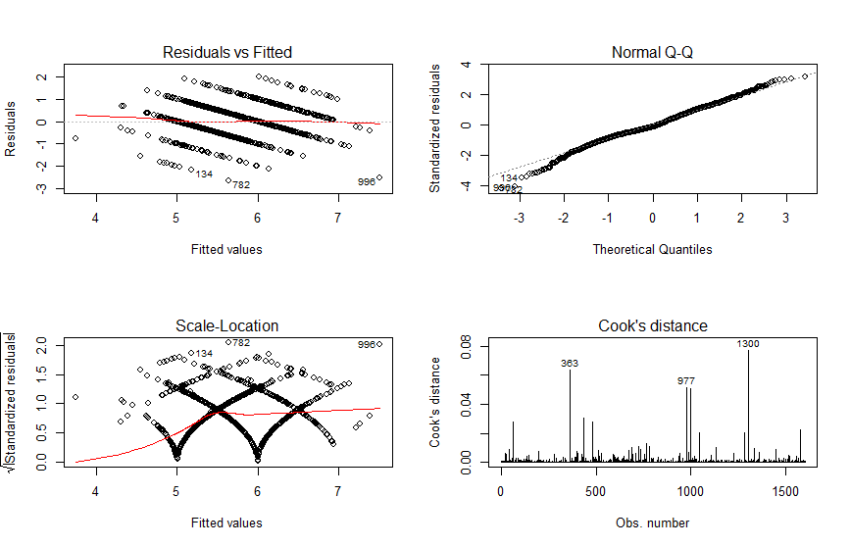

>

> #Check if interaction needed

> anova(model1,model2)

Analysis of Variance Table

Model 1: Quality ~ Alcohol + VolatileAcidity + Sulphates + TotalSulfurDioxide +

Chlorides + pH + FreeSulfurDioxide

Model 2: Quality ~ Alcohol + VolatileAcidity + Sulphates + TotalSulfurDioxide +

Chlorides + pH + CitricAcid + FreeSulfurDioxide + Alcohol:Sulphates +

Sulphates:TotalSulfurDioxide + VolatileAcidity:TotalSulfurDioxide +

Sulphates:CitricAcid + TotalSulfurDioxide:CitricAcid + Chlorides:FreeSulfurDioxide

Res.Df RSS Df Sum of Sq F Pr(>F)

1 1591 667.54

2 1584 632.41 7 35.123 12.568 9.201e-16 ***

---

Signif. codes: 0 ‘***’ 0.001 ‘**’ 0.01 ‘*’ 0.05 ‘.’ 0.1 ‘ ’ 1

|  |
| --- |
| > #model 3 interaction removing insignificant variables  > model3=lm(formula = Quality ~ Alcohol + VolatileAcidity + Sulphates +  + TotalSulfurDioxide + Chlorides + pH + CitricAcid + FreeSulfurDioxide +  + Alcohol:Sulphates + Sulphates:TotalSulfurDioxide + VolatileAcidity:TotalSulfurDioxide,  + data = RedWineData_Stat6509Project)  > summary(model3)  Call:  lm(formula = Quality ~ Alcohol + VolatileAcidity + Sulphates +  TotalSulfurDioxide + Chlorides + pH + CitricAcid + FreeSulfurDioxide +  Alcohol:Sulphates + Sulphates:TotalSulfurDioxide + VolatileAcidity:TotalSulfurDioxide,  data = RedWineData_Stat6509Project)  Residuals:  Min 1Q Median 3Q Max  -2.66692 -0.35953 -0.08165 0.43033 1.94969  Coefficients:  Estimate Std. Error t value Pr(>|t|)  (Intercept) 6.536422 0.858617 7.613 4.58e-14 ***  Alcohol 0.097115 0.072534 1.339 0.180795  VolatileAcidity -1.434032 0.167797 -8.546 < 2e-16 ***  Sulphates -1.230631 1.140839 -1.079 0.280882  TotalSulfurDioxide 0.001173 0.002309 0.508 0.611473  Chlorides -1.659530 0.415423 -3.995 6.77e-05 ***  pH -0.631623 0.130817 -4.828 1.51e-06 ***  CitricAcid -0.302903 0.120767 -2.508 0.012235 *  FreeSulfurDioxide 0.004473 0.002106 2.124 0.033821 *  Alcohol:Sulphates 0.300281 0.106709 2.814 0.004953 **  Sulphates:TotalSulfurDioxide -0.014446 0.002387 -6.053 1.77e-09 ***  VolatileAcidity:TotalSulfurDioxide 0.009112 0.002602 3.502 0.000475 ***  ---  Signif. codes: 0 ‘***’ 0.001 ‘**’ 0.01 ‘*’ 0.05 ‘.’ 0.1 ‘ ’ 1  Residual standard error: 0.6332 on 1587 degrees of freedom  Multiple R-squared: 0.3894, Adjusted R-squared: 0.3852  F-statistic: 92.02 on 11 and 1587 DF, p-value: < 2.2e-16  >  > #Compare models  > anova(model1,model3)  Analysis of Variance Table  Model 1: Quality ~ Alcohol + VolatileAcidity + Sulphates + TotalSulfurDioxide +  Chlorides + pH + FreeSulfurDioxide  Model 2: Quality ~ Alcohol + VolatileAcidity + Sulphates + TotalSulfurDioxide +  Chlorides + pH + CitricAcid + FreeSulfurDioxide + Alcohol:Sulphates +  Sulphates:TotalSulfurDioxide + VolatileAcidity:TotalSulfurDioxide  Res.Df RSS Df Sum of Sq F Pr(>F)  1 1591 667.54  2 1587 636.30 4 31.235 19.476 1.166e-15 ***  ---  Signif. codes: 0 ‘***’ 0.001 ‘**’ 0.01 ‘*’ 0.05 ‘.’ 0.1 ‘ ’ 1  >  > #Choose model 3 over model 1  > #Diagnostics for model 3  > par(mfrow=c(2,2))  > plot(model3, which=1:4) |
|  |
| |  | | --- | | > | |

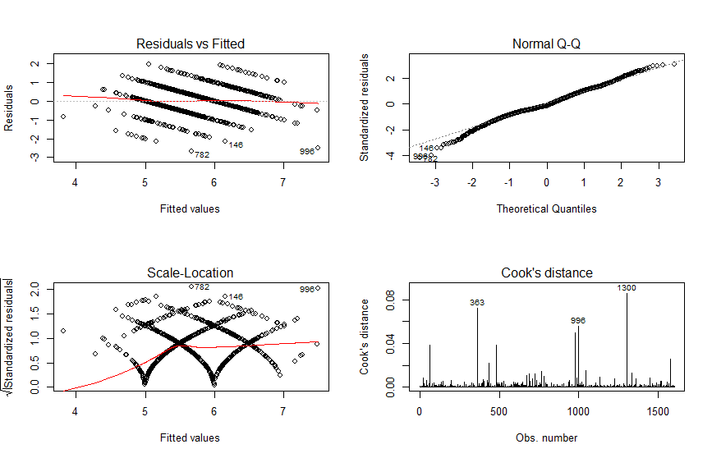

> #Improve the model 3

> #Check outliers

> install.packages("car")

Error in install.packages : Updating loaded packages

> library(car)

> par(mfrow=c(1,1))

> qqPlot(model3, id.n=2)

[1] 782 996

> install.packages("car")

Warning in install.packages :

package ‘car’ is in use and will not be installed

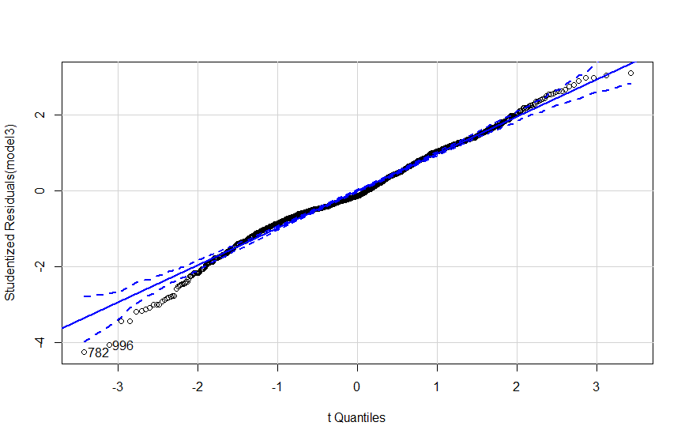

> outlierTest(model3)

rstudent unadjusted p-value Bonferonni p

782 -4.248855 2.2736e-05 0.036355

>

> #Outliers with high leverage

> influencePlot(model3)

StudRes Hat CookD

63 1.554025 0.161822898 0.03881970

363 2.420248 0.129497561 0.07239404

484 1.554025 0.161822898 0.03881970

782 -4.248855 0.006811091 0.01020718

996 -4.058917 0.039704268 0.05621562

1300 2.502371 0.141475486 0.08570637

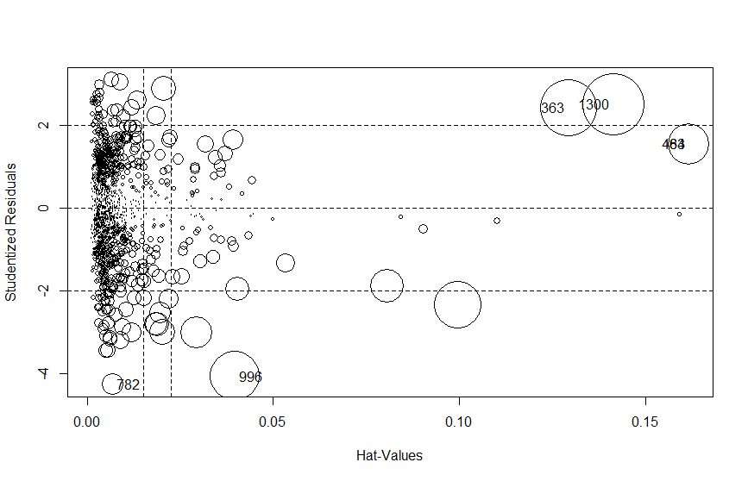

> #removing highest leverage outliers FINAL MODEL

> newdata1 <- RedWineData_Stat6509Project[c(-363,-1300),]

> model3c = lm(formula = Quality ~ Alcohol + VolatileAcidity + Sulphates +

+ TotalSulfurDioxide + Chlorides + pH + CitricAcid + FreeSulfurDioxide +

+ Alcohol:Sulphates + Sulphates:TotalSulfurDioxide + VolatileAcidity:TotalSulfurDioxide,

+ data = newdata1)

> summary(model3c)

Call:

lm(formula = Quality ~ Alcohol + VolatileAcidity + Sulphates +

TotalSulfurDioxide + Chlorides + pH + CitricAcid + FreeSulfurDioxide +

Alcohol:Sulphates + Sulphates:TotalSulfurDioxide + VolatileAcidity:TotalSulfurDioxide,

data = newdata1)

Residuals:

Min 1Q Median 3Q Max

-2.6898 -0.3628 -0.0702 0.4378 1.9690

Coefficients:

Estimate Std. Error t value Pr(>|t|)

(Intercept) 7.006875 0.864190 8.108 1.02e-15 ***

Alcohol 0.055069 0.073094 0.753 0.451318

VolatileAcidity -1.609609 0.173415 -9.282 < 2e-16 ***

Sulphates -1.870039 1.148791 -1.628 0.103759

TotalSulfurDioxide -0.003332 0.002588 -1.288 0.198095

Chlorides -1.574426 0.414411 -3.799 0.000151 ***

pH -0.588845 0.130793 -4.502 7.22e-06 ***

CitricAcid -0.309919 0.120311 -2.576 0.010085 *

FreeSulfurDioxide 0.005919 0.002132 2.776 0.005561 **

Alcohol:Sulphates 0.351012 0.107129 3.277 0.001074 **

Sulphates:TotalSulfurDioxide -0.012213 0.002449 -4.987 6.81e-07 ***

VolatileAcidity:TotalSulfurDioxide 0.013129 0.002799 4.690 2.97e-06 ***

---

Signif. codes: 0 ‘***’ 0.001 ‘**’ 0.01 ‘*’ 0.05 ‘.’ 0.1 ‘ ’ 1

Residual standard error: 0.6307 on 1585 degrees of freedom

Multiple R-squared: 0.3928, Adjusted R-squared: 0.3886

F-statistic: 93.21 on 11 and 1585 DF, p-value: < 2.2e-16

>

> #Check outlier distribution with the final model

> influencePlot(model3c)

StudRes Hat CookD

63 1.371723 0.163914307 0.03072391

483 1.371723 0.163914307 0.03072391

781 -4.302931 0.006902401 0.01060676

976 -2.355718 0.099531187 0.05096959

995 -4.005815 0.040019036 0.05522059

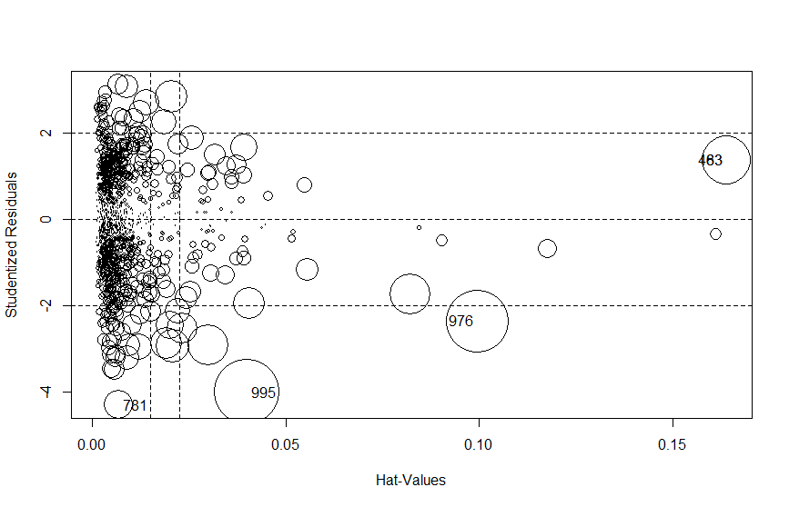

>

> #Diagnostics for model 3

> par(mfrow=c(2,2))

> plot(model3c, which=1:4)

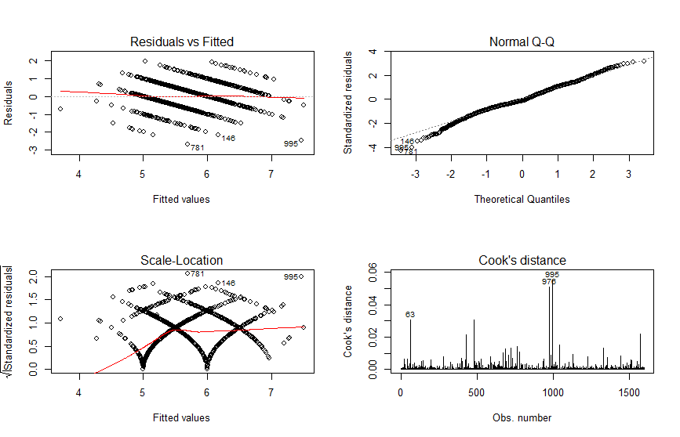

>

> #Diagnostics Model 3c

> par(mfrow=c(2,2))

> plot(model3c, which=1:4)

> shapiro.test(model3c$residuals)



Shapiro-Wilk normality test

data: model3c$residuals

W = 0.99039, p-value = 9.466e-09

> ncvTest(model3c)

Non-constant Variance Score Test

Variance formula: ~ fitted.values

Chisquare = 14.99261 Df = 1 p = 0.000107933