STAT651_Project

Mulati_Patiguli

12/12/2018

## 1.Rental vacancy rate state bin

library(mdsr)  
library(tidyr)  
library(tidyverse)  
library(readr)  
library(statebins)  
setwd("~/Desktop/data visualization /project")  
Rental_Vacancy <- read_csv("GeoFRED_Rental_Vacancy_Rate_by_State_Percent.csv")  
Rental_Vacancy%>%arrange(desc(percent))

## # A tibble: 51 x 4  
## `Series ID` state `Region Code` percent  
## <chr> <chr> <chr> <dbl>  
## 1 NDRVAC North Dakota 38 16.7  
## 2 WYRVAC Wyoming 56 14.7  
## 3 ALRVAC Alabama 01 14   
## 4 MSRVAC Mississippi 28 11.8  
## 5 ARRVAC Arkansas 05 11.6  
## 6 KSRVAC Kansas 20 11.5  
## 7 LARVAC Louisiana 22 10.7  
## 8 NMRVAC New Mexico 35 10.5  
## 9 INRVAC Indiana 18 10.4  
## 10 SCRVAC South Carolina 45 10.4  
## # ... with 41 more rows

##look at the structure of the data  
str(Rental_Vacancy)

## Classes 'tbl_df', 'tbl' and 'data.frame': 51 obs. of 4 variables:  
## $ Series ID : chr "ALRVAC" "AKRVAC" "AZRVAC" "ARRVAC" ...  
## $ state : chr "Alabama" "Alaska" "Arizona" "Arkansas" ...  
## $ Region Code: chr "01" "02" "04" "05" ...  
## $ percent : num 14 7.4 7.5 11.6 4.3 5.5 6.8 6.4 7.1 8.5 ...  
## - attr(*, "spec")=  
## .. cols(  
## .. `Series ID` = col_character(),  
## .. state = col_character(),  
## .. `Region Code` = col_character(),  
## .. percent = col_double()  
## .. )

##### From the rental vacancy rate state bin map ,darker-colored states have a higher rental vacancy rates and lighter-colored states have a lower rates. The states that are ND,WY,AL have the higher vacancy rate among all other states .Most of the low vacancy rates ,that we can see from below state bin map ,are located mostly in west coast and east cost areas . It might be because of some population and immigration ,more job oppurtunities,more high-tech companies are almost located in these area and this trend makes rental vacancy rate lower than other states .

library(statebins)  
statebins(state_data = Rental_Vacancy,   
 state_col = "state", value_col = "percent",  
 text_color = "black", breaks = 4,  
 labels = c("3-6", "6-9", "9-12", "12-15"),  
 brewer_pal="Blues", font_size = 3, legend_title="2017 Rental Vacancy Rate by State",legend_position="bottom")

## Warning: `show_guide` has been deprecated. Please use `show.legend`  
## instead.

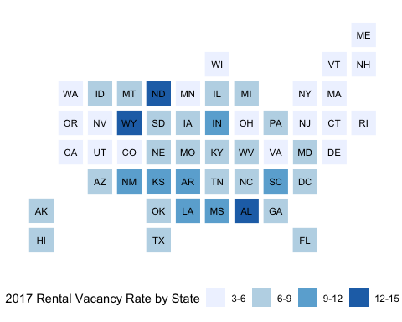 ##2.Death rate state bin

library(readr)  
library(statebins)  
library(tidyr)  
library(tidyverse)  
setwd("~/Desktop/data visualization /project")  
death <- read_csv("GeoFRED_deaths_Rate_by_State_Percent.csv")  
death%>%arrange(death_rate)

## # A tibble: 52 x 5  
## state births fertility_rate deaths death_rate  
## <chr> <dbl> <dbl> <dbl> <dbl>  
## 1 Alaska 11187 75.9 3849 533.  
## 2 Utah 51465 83.1 15266 542.  
## 3 Colorado 65187 62 32563 636.  
## 4 California 503755 63.3 239942 637.  
## 5 Texas 382727 69.9 168640 657.  
## 6 Hawaii 18980 71.6 9923 722.  
## 7 Georgia 130280 62.4 71248 726.  
## 8 Washington 87463 63.5 49691 728.  
## 9 District of Columbia 9399 55.3 4589 743.  
## 10 Minnesota 68772 65.7 39820 745   
## # ... with 42 more rows

##### From the death rate state bin map ,darker-colored states have a higher death rates and lighter-colored states have a lower rates. The WV state has the highest death rate among all other states and the states that have higher death rates are almost located in the middle states of the US. If we compare this trend to east and west coast areas , we can easily find out that the death rate are much lower than middle states except ME.

library(statebins)  
statebins_continuous(state_data = death,  
 state_col = "state",  
 text_color = "black", value_col = "death_rate",  
 brewer_pal="OrRd", font_size = 3,  
 legend_title="Mortality Rate (2010)",  
 legend_position="bottom"  
 )

## Warning: `show_guide` has been deprecated. Please use `show.legend`  
## instead.

