Algorithms

Homework 1

**Pseudocode**

Start

Input temp=15;

If (temp<15)

Print(“hava soyuqdur”)

Else

Print(“hava istidir”)

End ;

**Flowchart**

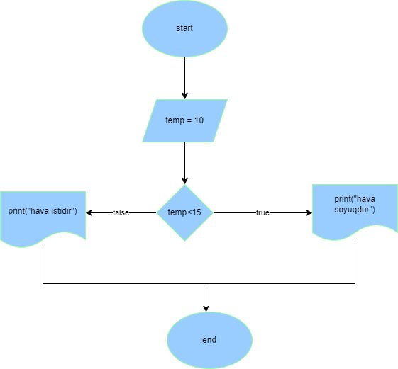

Homework 2.1

**Pseudocode**

Start

Input x;

If (x%3==0 and x%7==0)

Print(“x ededi 3 ve 7-e tam bolunur”)

Else

Print (“x ededi 3 ve 7-e tam bolunmur”)

End;

**Flowchart**

