1. Management of data (Group : Max 2 students)

* Store data into hive data warehouse (WQD7007 Big Data Management)

**-create a directory in the Hadoop(HDFS)**

hadoop fs -mkdir -p /user/Cheras_HomeTrovit



**-Copy or put the csv file to the Hadoop directory**

hadoop fs -copyFromLocal C://data//Cheras_HomeTrovit_raw.csv /user/Cheras_HomeTrovit



**or**

hadoop fs -put -f C://data//Cheras_HomeTrovit_raw.csv /user/Cheras_HomeTrovit



**-Check whether the file is available in Hdfs or not using below command:**

hadoop fs -ls /user/Cheras_HomeTrovit

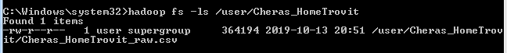

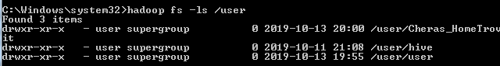

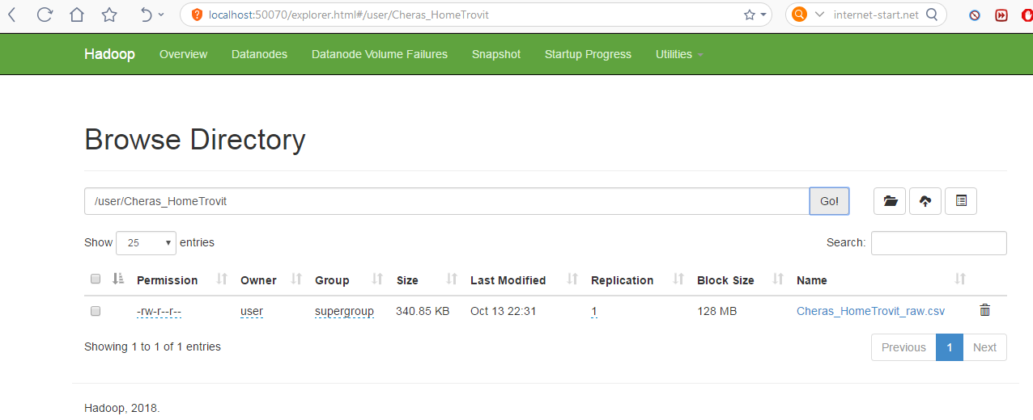

**-create an external table**

CREATE EXTERNAL TABLE IF NOT EXISTS HomeTrovit(Property_ID INT,Title STRING,Address STRING,Property_Details STRING,Url STRING,Image STRING,Source_Info STRING,Source_Days STRING, Price STRING,no_of_bedroom STRING,property_size STRING)

COMMENT 'Home Trovit Property'

ROW FORMAT DELIMITED

FIELDS TERMINATED BY ','

STORED AS TEXTFILE;

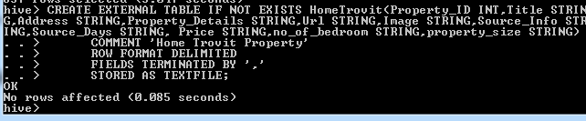

**-load the csv in hdfs to the table**

LOAD DATA INPATH '/user/Cheras_HomeTrovit/Cheras_HomeTrovit_raw.csv' OVERWRITE INTO TABLE HomeTrovit;



**Check the value of the table**

