1. **Step** 1: Verifying JAVA **Installation**. ...

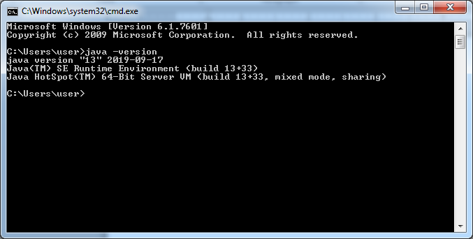

1. **Step** 2: Verifying **Hadoop Installation**. ...

**Configure core-site.xml**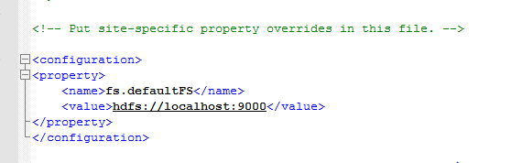

**Configure hdfs-site.xml**

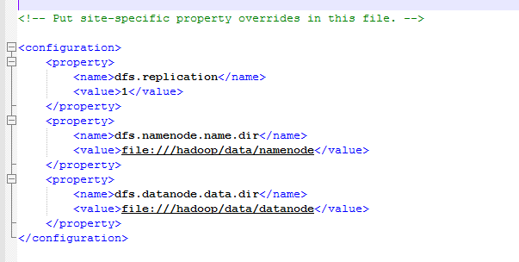

**Configure yarn-site.xml**

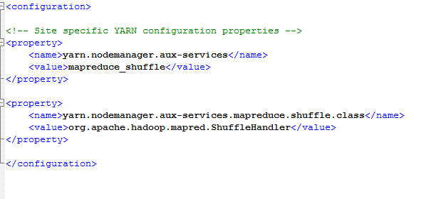

**Configure mapred-site.xml**

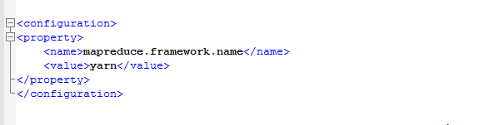

**Configure user variable and system variable “PATH” in environment variable**

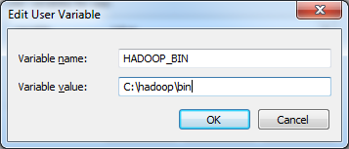

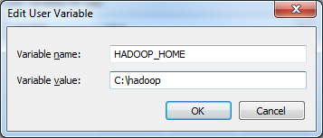

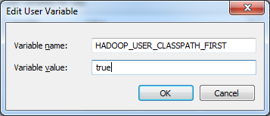

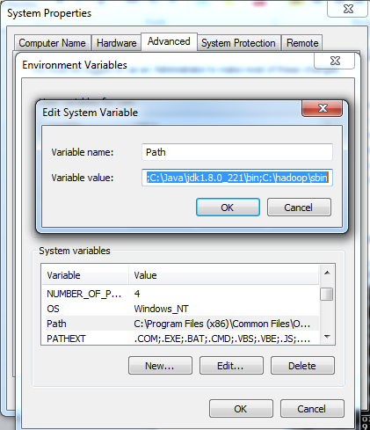

**Run hdfs namenode –format**

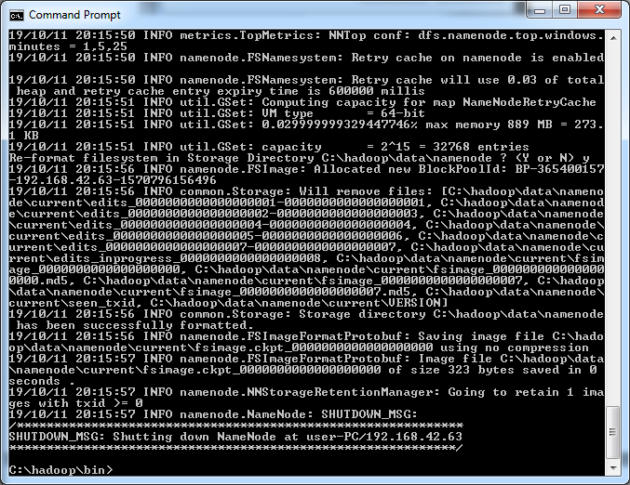

**Launch Hadoop by run**

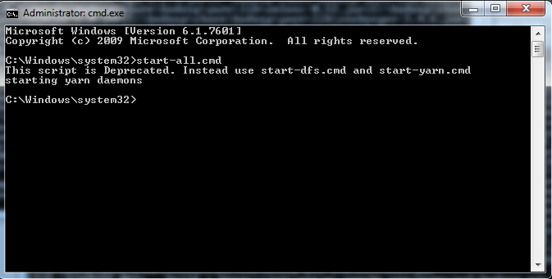

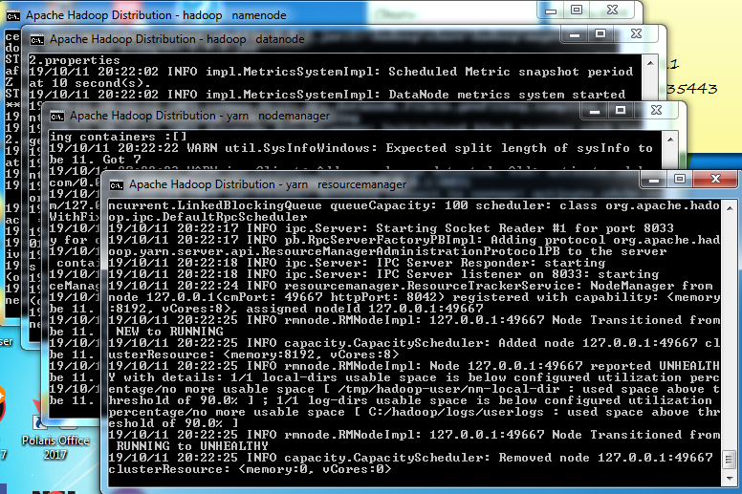

Check all the below localhost port to check if all up.

**http://localhost:8088/cluster**

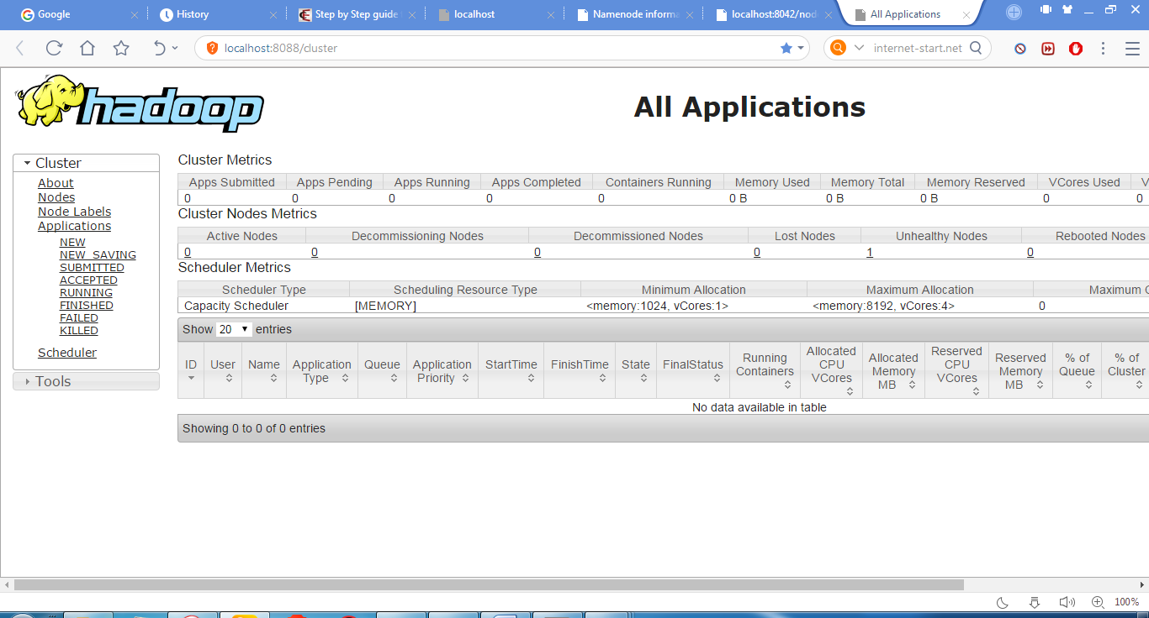

**http://localhost:8042/node**

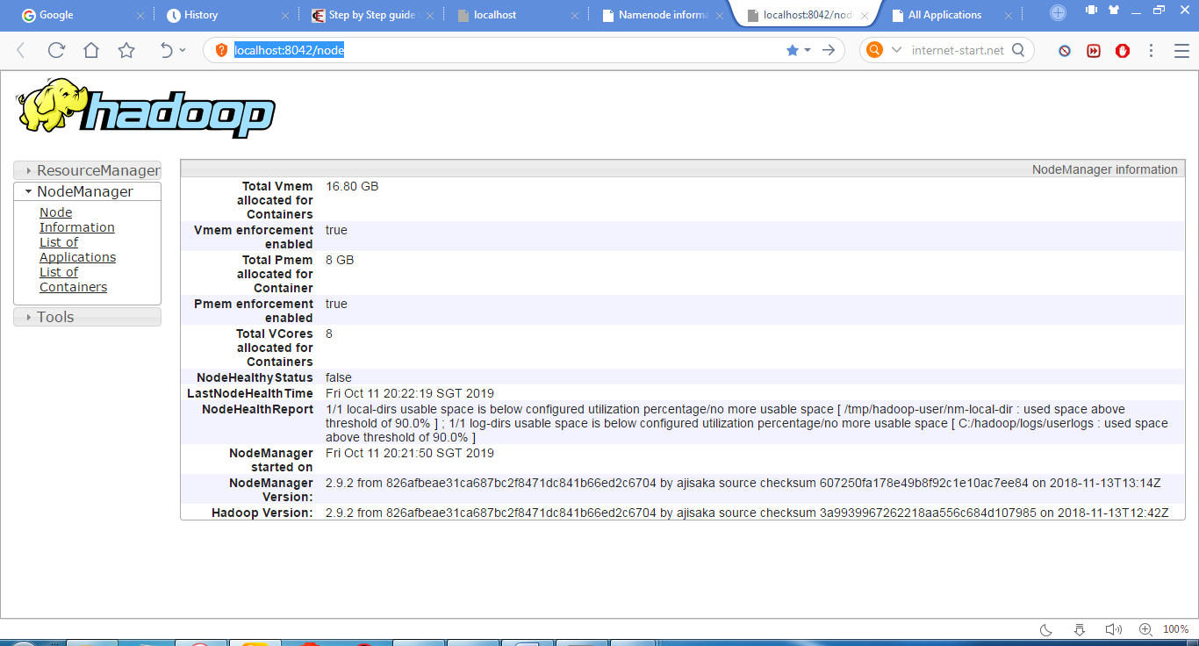

**http://localhost:50070/dfshealth.html#tab-overview**

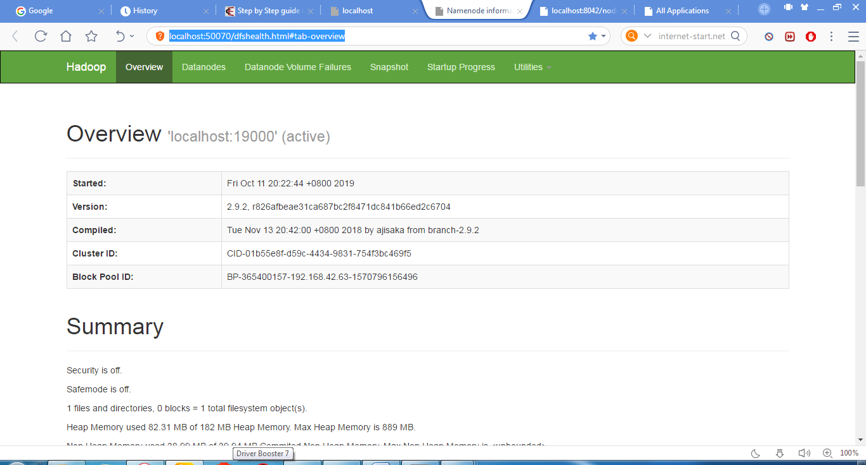

**http://localhost:50075/datanode.html**

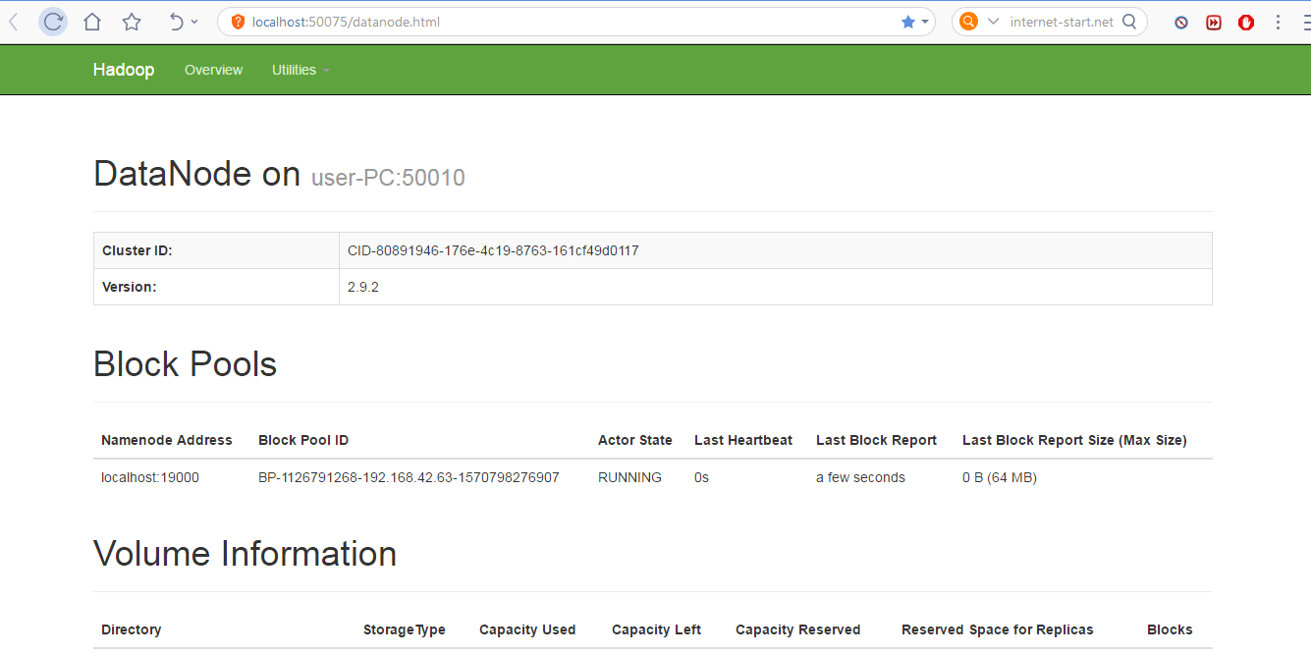

1. **Step** 4: **Installing Hive**. ...

**Extracted the hive zip file and move to C://**

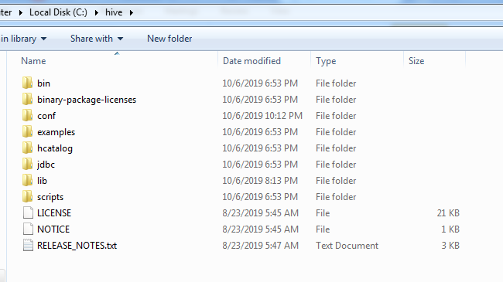

1. **Step** 5: Configuring **Hive**.

**Configure user variable and system variable “PATH” in environment variable**

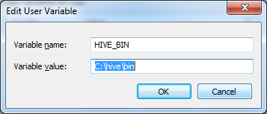

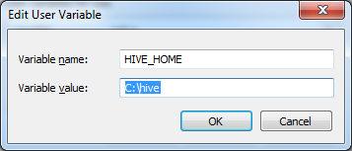

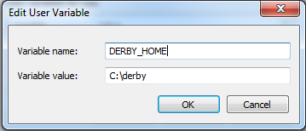



1. **Step** 6: Downloading and **Installing** Apache Derby. ...

**Extracted the derby zip file and move to C://**

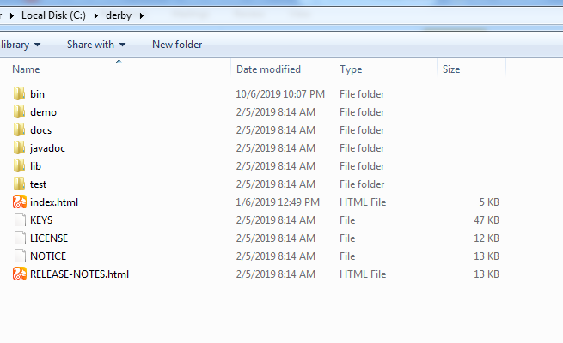



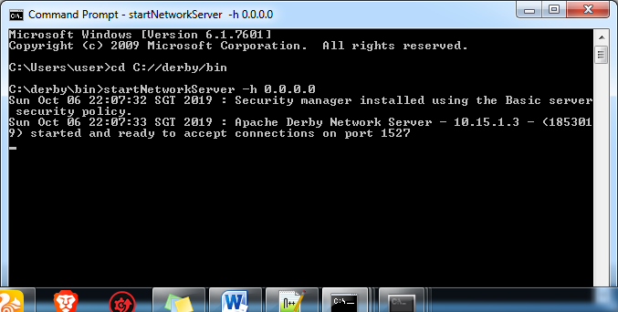

1. **Step** 7: Configuring Metastore of **Hive**. ...

**Configure hive-site.xml**

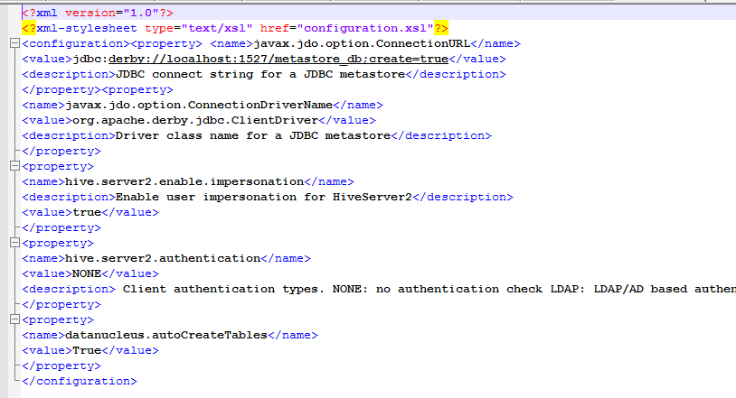

1. **Step** 8: Verifying **Hive Installation**.

**Start derby**

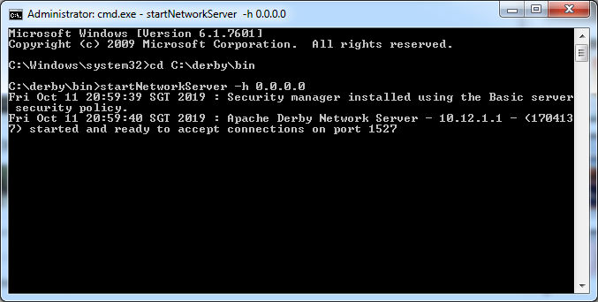

**Next run the below command**

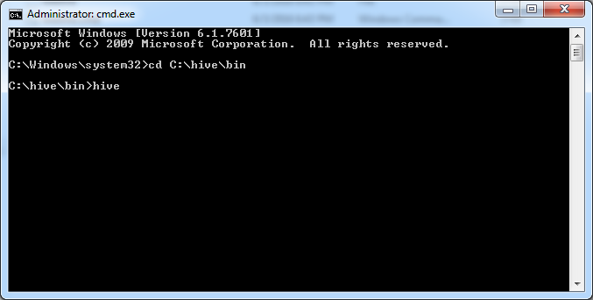

**Create Table in Hive**

