FrontDesk AI Detailed System Design
CIS 457 Senior Design | Team submission | Revised October 28, 2026
Fatkhaziz Mukhamedov, Amar Al Balkhi, Mohammad Abdullah, Baraa Khaled
Mentor: Dr. Liu

1 Scope and architectural decisions
This design specifies how to implement the October 22 requirements and initial design. The fall release is one dealership flow: owner sign-in, guided vehicle intake, photos, AI draft, approval, publication, bounded customer questions, and an inquiry inbox. Spring adds staff management, sandbox subscriptions, fixed-slot appointments, and one free-event template. Features and test results described here are planned, not completed.
We use a three-tier client-server architecture with a modular monolith. React supplies the presentation layer; one FastAPI service contains the application modules; managed PostgreSQL and private object storage hold data. Grok is a hosted API dependency. Modules are code boundaries, not separate microservices.
Chosen technology | Reason and alternative considered | Pilot cost
TypeScript / React | Reusable responsive forms and previews. Native mobile apps would add a second delivery platform. | No paid framework service.
Python / FastAPI / Uvicorn | Schemas and API docs in one process. Node/Express is viable; Python keeps validation and AI logic together. | Included in app compute.
Pydantic / HTTPX / PyJWT / Pillow | Validate structures and tokens, bound provider calls, and sanitize photos. Handwritten validation adds maintenance. | No paid library service.
PostgreSQL / SQLAlchemy / Alembic | Transactions and tenant FKs support approval/capacity integrity. A document database would need more application checks. | Included in Supabase.
Supabase Auth / Storage / Cron | Managed identities, private files, and retention SQL. Self-hosting these adds operations work. [3, 4, 8] | $0 Free; Pro from $25/month. [11]
Grok 4.7 API / ai_gateway | Structured draft and intent requests; configurable model ID. Local inference adds hardware and deployment work. [1, 2] | $2 input / $6 output per 1M tokens; $25 allowance. [1]
Docker / Render / Git / pytest | One repeatable build with workflow tests. Separate frontend hosting and workers add services to coordinate. [7] | Render 0.5 CPU / 512 MB: $7/month. [10]
Stripe hosted sandbox | Test subscriptions with provider-owned card entry. Custom payment forms increase implementation scope. [6] | Test mode; no real payments. [12]

The Grok API provides bounded server requests with our own approval and authorization checks; Grok Bot is outside this implementation. Pin working versions after the first integration prototype. Phone calls, social posting, ads, QR tickets, and extra industry templates remain optional.

2 Deployment and component responsibilities
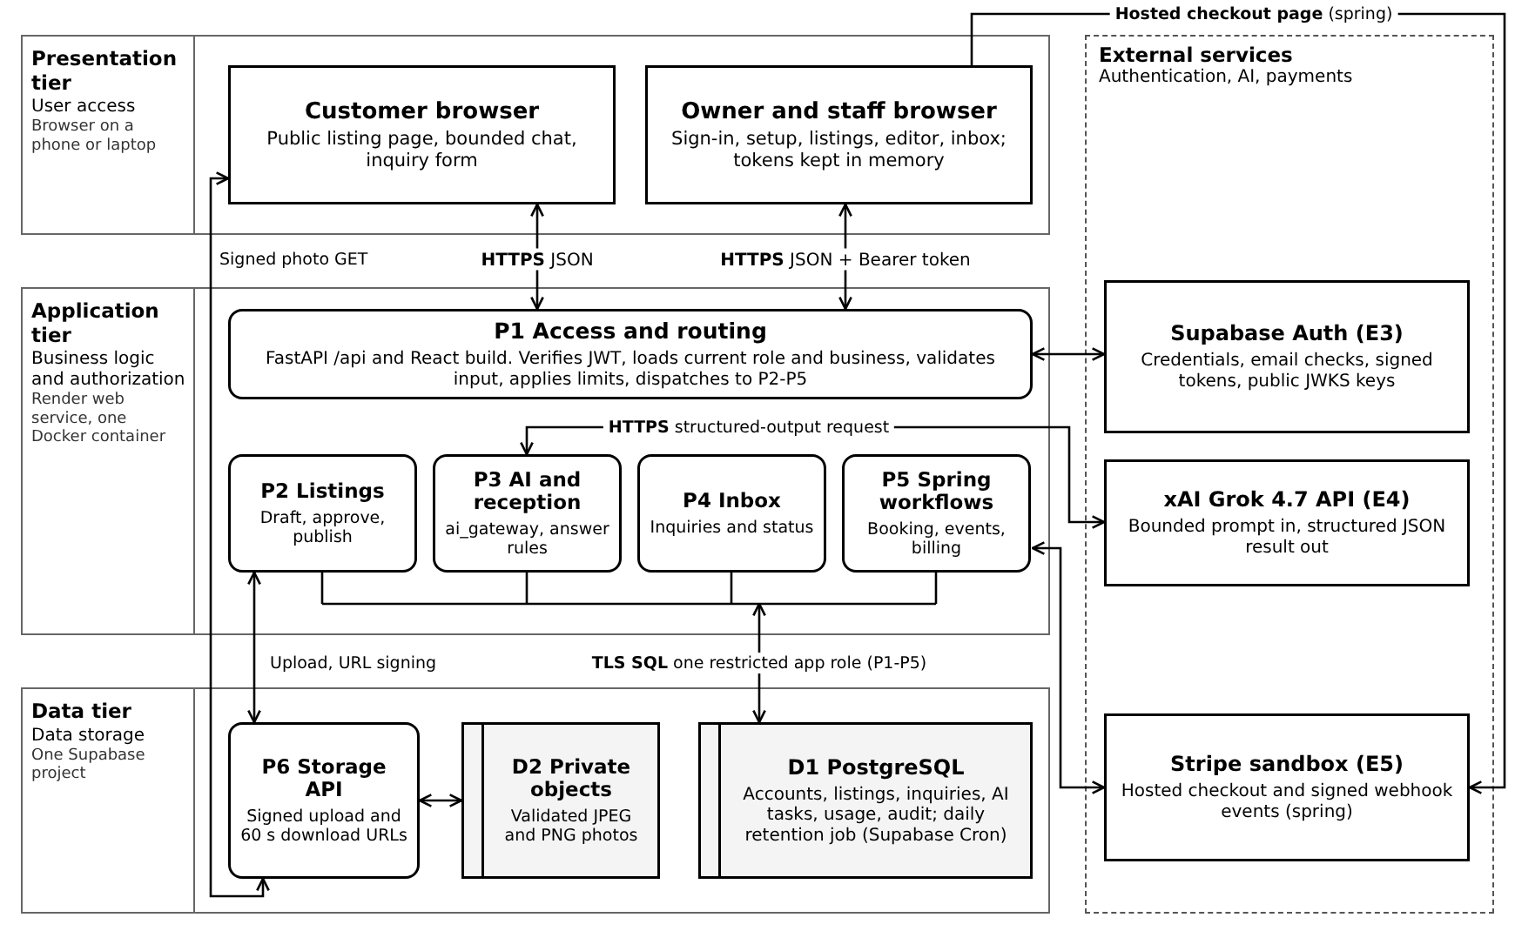
Figure 1. Three-tier deployment: the browser (presentation), one Render service holding P1-P5 (application), and one Supabase project (data), with authentication, AI, and payments as external services. The browser fetches approved images using short-lived storage URLs.
Location | Components and responsibility
Browser on phone or laptop | React forms, preview, chat, and inbox. Access and refresh tokens remain in memory in the prototype; reloading requires sign-in again. Business records remain saved.
Render Linux web service | Serves the React build and /api routes. P1 checks access; P2 controls listings; P3 handles AI; P4 manages inquiries; P5 handles spring workflows. HTTPX calls are asynchronous.
Supabase cloud | Auth verifies credentials and issues tokens. D1 stores application records; P6 Storage API serves D2 private objects. Managed data is logically part of FrontDesk, on separate infrastructure.
xAI and Stripe infrastructure | xAI performs inference; Stripe hosts test checkout and emits billing events. Neither service can directly approve a listing or query our application database.

P1 proxies authentication operations to Supabase without storing passwords or creating custom tokens. Protected routes use Bearer access tokens; P1 verifies signature, allowed algorithm, issuer, audience, and expiry against the project verification keys, then reads the current role from D1. Use stateless Auth requests, not a global mutable user session. [3]
Development runs on team laptops. The pilot uses one Render service and one Supabase project in suitable US locations. An optional later worker uses the same repository and a PostgreSQL queue; it is not needed for synchronous drafts or initial questions. No local model or GPU is required.

3 Level 0 context diagram
The system boundary includes our UI, API, application database, and managed file delivery. Authentication, AI inference, and payment processing remain external services. Infrastructure administration and deployment are outside the functional context.
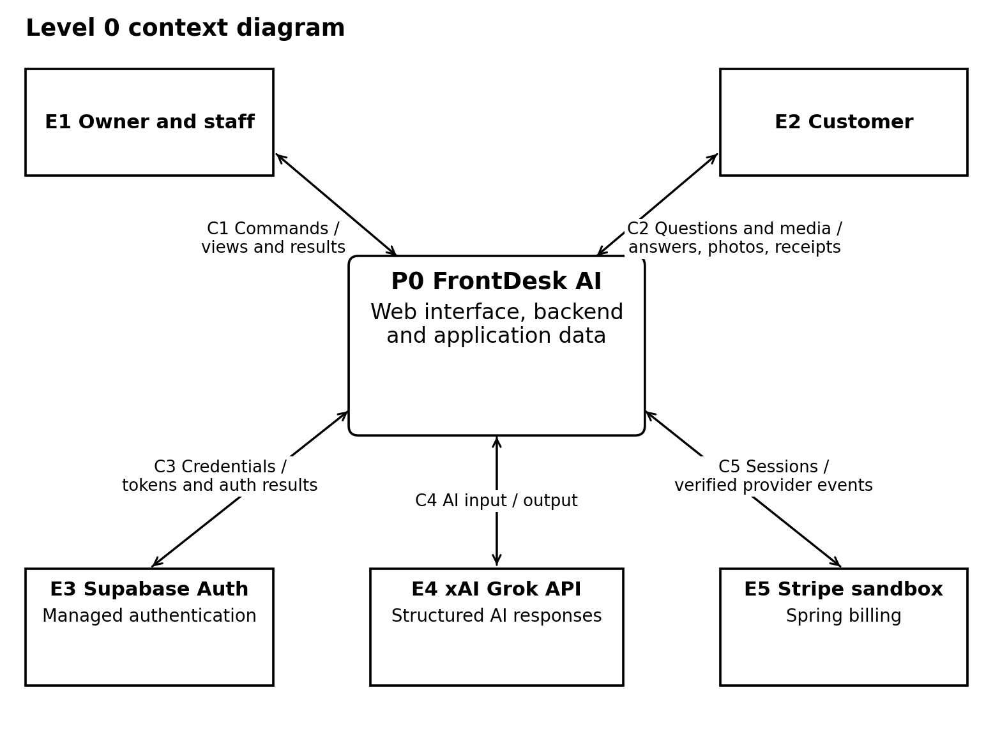
Figure 2. One system process and all functional external entities. Each paired arrow denotes the named request and return data, not a control sequence.
Flow | External entity | Data entering and leaving FrontDesk
C1 | E1 Owner and staff | Credentials, business facts, uploads, approvals, inbox actions, and spring commands; dashboard data, errors, and action results return.
C2 | E2 Customer | Public-page, question, inquiry, and signed-media requests; published facts, photo bytes, answers, and saved-request receipts return. Spring includes bookings and registrations.
C3 | E3 Supabase Auth | Authentication and recovery requests, refresh tokens, and verification-key requests; auth results, signed tokens, and public keys return.
C4 | E4 xAI API | Bounded draft or intent request with minimum context; structured result and provider usage return. No owner credential or inquiry contact field is sent.
C5 | E5 Stripe sandbox | Server-created checkout sessions and provider-state queries; session URLs, signed events, and verified subscription state return. Card entry stays on Stripe.

4 Level 1 data flow diagram
This Level 1 DFD preserves C1-C5 from the context diagram. Each component appears once; E2 also reads approved photos directly from P6, drawn along the right edge. P1-P5 run in FastAPI; P6 is managed file delivery.
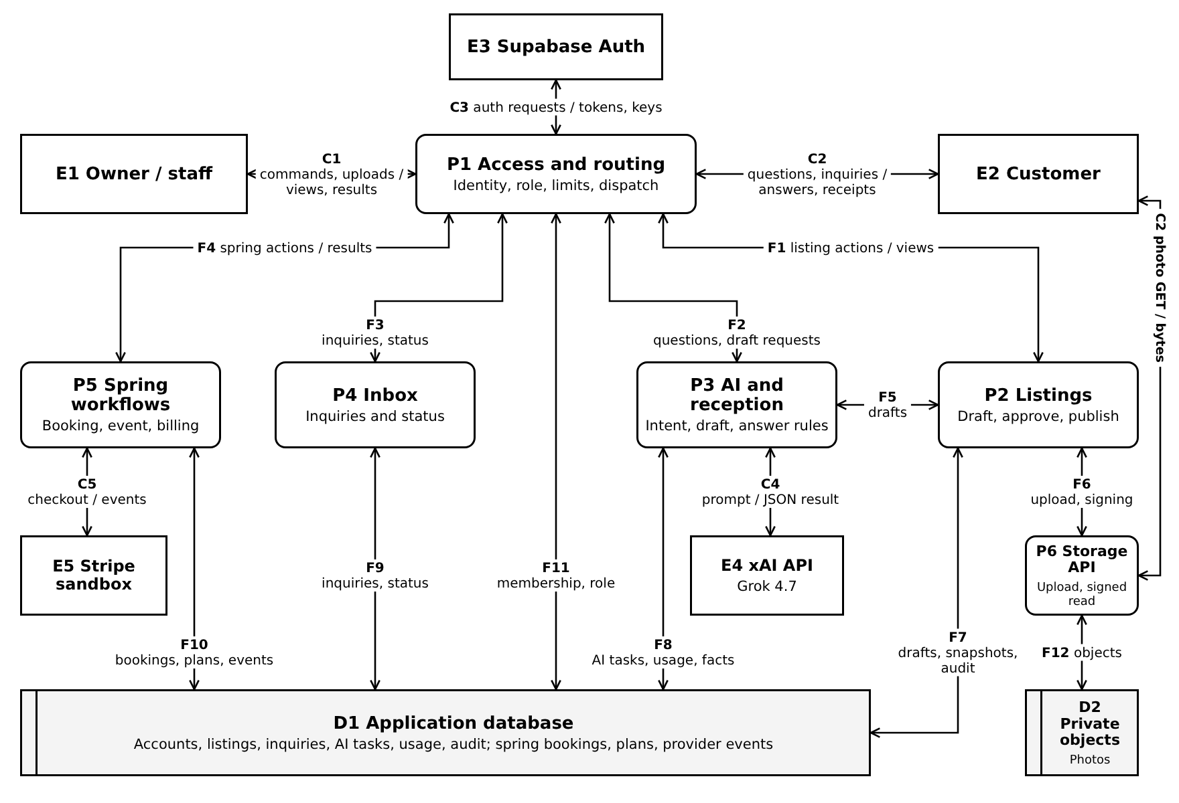
Figure 3. Level 1 DFD. Each component appears once and no lines cross. Each arrow shows its flow ID and main data; Section 5 gives the full payloads.
D1 holds the tables in Sections 6-8, including audit and usage data. D2 holds validated photo objects. Public data access always goes through a process: P2 authorizes media URLs; P6 validates the signed request and reads the private object. Internal flow definitions follow in Section 5.

5 Internal flows and Level 2 decomposition
Flow | Processes or stores | Payload and return data
F1 / F3 / F4 | P1 with P2 / P4 / P5 | Authorized listing, inbox, or spring commands and resulting views or confirmations.
F2 / F5 | P1 or P2 with P3 | Public question or owner draft request; validated intent, draft, answer, or fallback.
F6 / F12 | P2 with P6; P6 with D2 | Validated upload, stored-object result, or signing request; object writes and authorized reads.
F7 / F11 | P2 or P1 with D1 | Listing drafts, approval snapshots, and audit; business membership, role, and settings data.
F8 / F9 | P3 or P4 with D1 | AI task and usage reservations; current published fields; saved inquiries and status updates.
F10 | P5 with D1 | Booking, registration, plan, subscription, provider-event, and audit records.

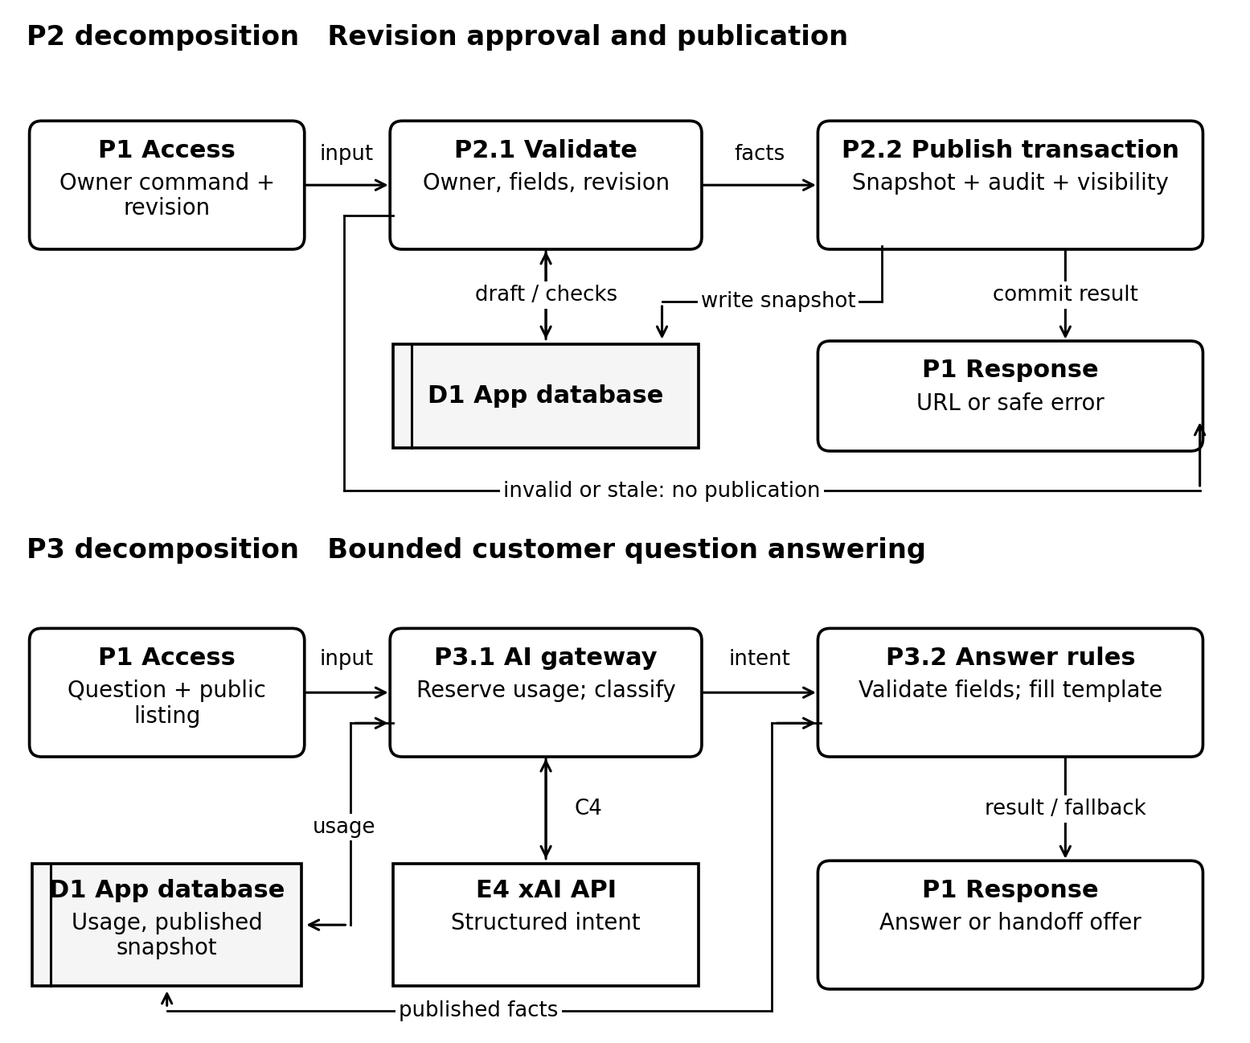
Figure 4. Level 2 views of P2 and P3. Rejected input returns a safe error or handoff offer; it does not bypass the database checks.
P3 performs its network call after committing a short usage reservation transaction. It never keeps a database row lock while awaiting xAI. P2.2 rechecks the revision under a row lock before committing publication.

6 Entity relationship model
The initial nine-table model is refined with USAGE_BUCKET so usage limits remain safe under concurrent requests. This is supporting storage for an existing requirement, not an extra product feature. PLAN and SUBSCRIPTION are delivered in the spring billing phase.
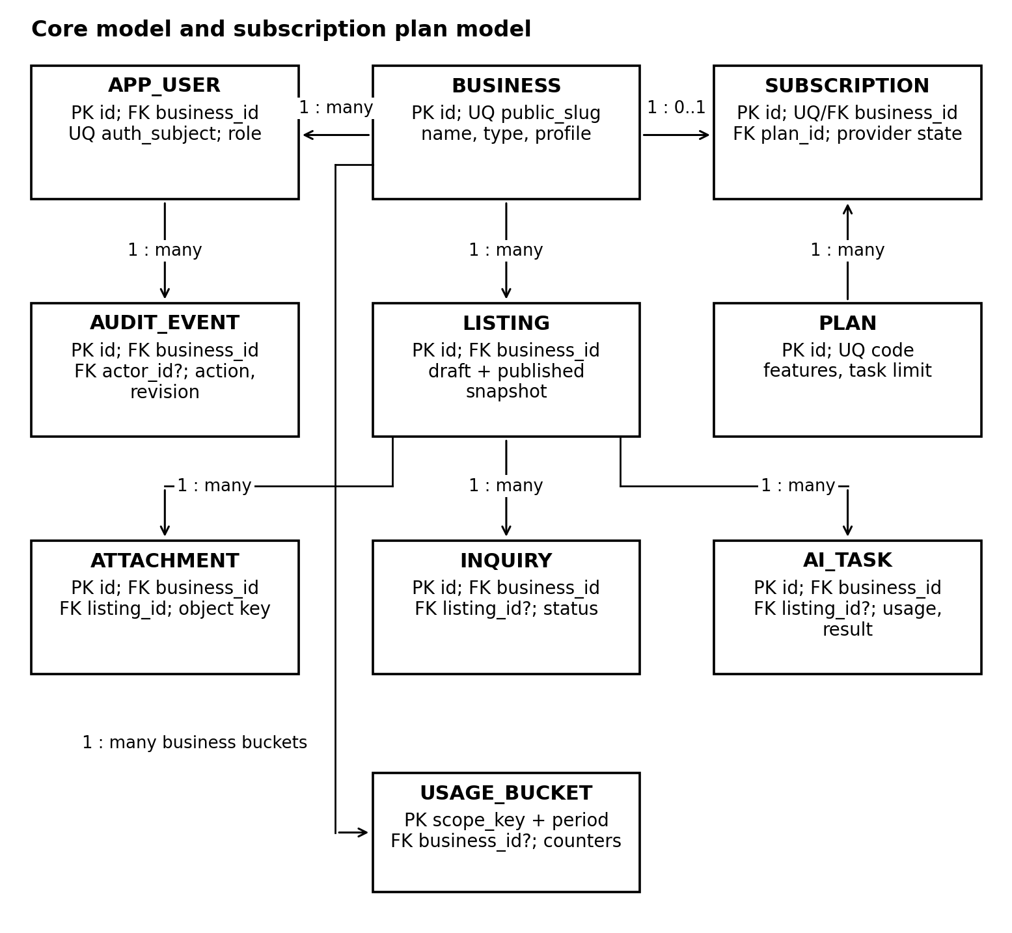
Figure 5. Core ERD. PK is primary key, FK is foreign key, UQ is unique, and ? means nullable. Arrows run from a parent to its related records.
Every tenant-owned child also has business_id; repeated BUSINESS edges are omitted to avoid crossed lines. Composite foreign keys enforce matching business ownership. An inquiry or AI task may have no listing. An audit actor may be null for a system action. A project-wide usage bucket has no business; other buckets reference one business.
D1 contains all relational tables shown here and in Figure 6. D2 stores file bytes; ATTACHMENT contains their metadata and storage key. Supabase identities are mapped through APP_USER.auth_subject; passwords are not copied into D1.

7 Core schema and integrity rules
Use UUID keys, UTC timestamptz values, and SQL migrations. Provider identifiers stay text. Vehicle facts require make, model, year, nonnegative integer price in USD cents and mileage in miles, and an availability enum. Public contact comes from the business profile. Pydantic validates these fields before JSONB storage.
Table | Principal fields and constraints
BUSINESS | id PK; public_slug UNIQUE; name; business_type; profile JSONB; time_zone; created_at. Public slug lookup does not authorize private reads.
APP_USER | id PK; business_id FK; auth_subject UUID UNIQUE; role in {owner, staff}; active bool. One business per identity. Only an owner endpoint may grant or revoke staff access.
LISTING | id PK; business_id FK; template_code; facts JSONB; draft_content; revision int; approved_revision?; approved_by? FK; published_snapshot JSONB?; published_revision?; is_published bool; updated_at.
ATTACHMENT | id PK; business_id and listing_id composite FK; object_key UNIQUE; state {processing, ready}; sha256; byte_size; mime_type; width; height. Object keys are immutable UUID-based paths.
INQUIRY | id PK; business_id FK; optional listing composite FK; customer_contact; message; reason; status {open, pending, resolved}; request_key; created_at. UNIQUE(business_id, request_key).
AI_TASK | id PK; business_id FK; optional listing composite FK; request_key; input_hash; kind; model; state; input_revision?; result JSONB?; input_tokens; output_tokens; reserved_cost; actual_cost?; created_at. UNIQUE(business_id, request_key).
USAGE_BUCKET | PK(scope_key, period_start); business_id? FK; request_limit; cost_limit; used_requests; spent_cost; reserved_cost. scope_key is project or business UUID; costs use integer micro-USD with nonnegative checks.
AUDIT_EVENT | id PK; business_id FK; actor_id? composite FK; action; entity_id; revision?; request_id; occurred_at. Application role may append and read relevant events, not update or delete them.
PLAN | id PK; code UNIQUE; feature_flags JSONB; monthly_task_limit; provider_price_id UNIQUE. No card information.
SUBSCRIPTION | id PK; business_id FK UNIQUE; plan_id FK; provider_customer_id UNIQUE; provider_subscription_id UNIQUE?; provider_status; period_end?; cancel_at_period_end; verified_at. Provider IDs must match server-created mappings.

Publication and relational checks
Make (id, business_id) unique on referenced tenant parents and use composite child foreign keys. Require revision > 0; published visibility requires a non-null snapshot and published revision. Each selected photo ID must belong to the listing and be ready. The snapshot stores facts, description, resolved contact, and selected photo IDs, so later draft edits cannot alter published content.
Index APP_USER(auth_subject), LISTING(business_id, updated_at), public business slug, INQUIRY(business_id, status, created_at), AI_TASK(business_id, created_at), and audit tenant/time. Preserve referenced photos until no current draft or published snapshot uses them. A privileged daily SQL retention job clears inquiries and AI result content after 30 days and usage/audit metadata after 90 days. [8]

8 Spring data model and transactional workflows
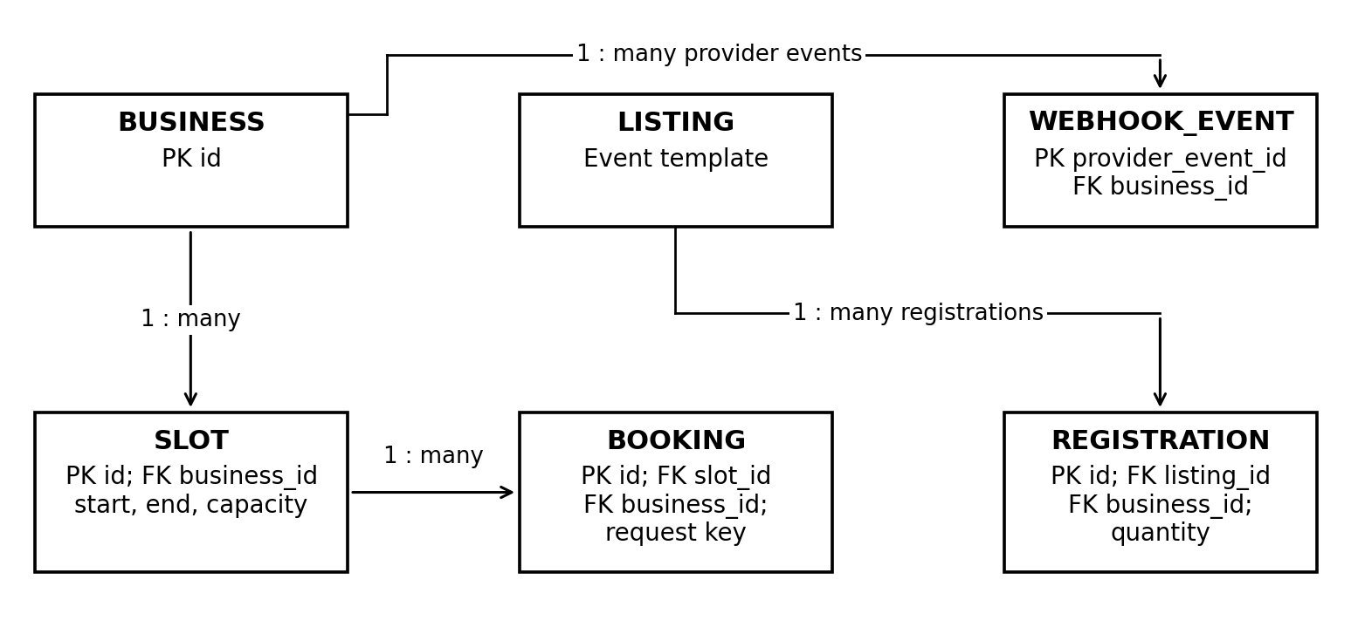
Figure 6. Spring extensions. BOOKING and REGISTRATION also reference BUSINESS through matching composite foreign keys; those repeated edges are omitted.
Table | Fields and checks
SLOT | id PK; business_id FK; starts_at; ends_at; capacity; enabled. CHECK end > start and capacity > 0. One scheduling resource per business in this release.
BOOKING | id PK; business_id and slot_id composite FK; customer_contact; status {confirmed, cancelled}; request_key; input_hash; cancel_token_hash; created_at. UNIQUE(business_id, request_key).
REGISTRATION | id PK; business_id and event listing composite FK; customer_contact; quantity > 0; status {confirmed, cancelled}; request_key; input_hash; cancel_token_hash; created_at. Same request-key uniqueness.
WEBHOOK_EVENT | provider_event_id text PK; business_id FK; event_type; payload_hash; processed_at. Store only processed provider event metadata; failed processing returns a retryable error.

Capacity and retries
Slot creation locks BUSINESS and rejects overlap. Booking and slot changes lock SLOT; registration and event publication lock LISTING. Check capacity against confirmed quantities; event capacity comes from the published snapshot, never a draft. Reject reductions below reservations and time changes with active reservations. Confirm after commit. Cancellation verifies a private token or staff role and releases capacity once. Reused request keys with different input hashes return 409. [5]

Subscription state
Verify the signed event and known provider mapping. A pinned session-mode SQL connection acquires a per-business advisory lock; do not use transaction pooling for this lock. Fetch current Stripe state with a short timeout, then commit event ID, subscription, and audit together. Duplicates do not reapply. Release in finally; busy or failed handling returns a retryable error. Serialization prevents older fetched state from being applied last. [5, 6]
Active or trialing plans allow configured features. Effective cancellation or unpaid status blocks new paid AI/scheduling actions. Read access, unpublishing, and reservation cancellation remain available; public listings remain until unpublished.

9 API contracts and state handling
Route group | Contract and authorization
POST /api/auth/{action} | signup, signin, refresh, and recovery proxy Supabase Auth. Generic recovery responses and login throttling reduce enumeration. Credentials are never logged.
POST /api/business; PATCH /api/business | Verified identity creates its first business atomically with APP_USER and audit. Owner may update its profile. GET /api/me returns current membership and role.
/api/listings and /{id}/photos | Owner or staff list, create, and edit drafts and upload photos. PATCH includes expected_revision; mismatch returns 409. Ready uploads increment draft revision and clear its approval.
POST /api/listings/{id}/publish | Owner only; body contains expected_revision and confirm_approval=true. One transaction checks facts and revision, records approval, copies snapshot, and audits. Repeating the same revision returns the same public URL.
POST /api/listings/{id}/draft; /unpublish | Draft requests accept a request key and expected revision; model output is saved only if the draft still matches. Unpublish requires owner access and stops public reads and new image URLs.
/api/public/{slug}/listings/{id} | GET returns only published fields and 60-second image URLs. POST /questions accepts question and request key; POST /inquiries accepts voluntary contact and message. Both bind business from the public route.
GET /api/inquiries; PATCH /{id} | Owner/staff can view tenant-scoped inquiries and change status. No public endpoint returns inbox records or other customer contact details.
Spring routes | /api/staff is owner-only. /api/slots, /public/.../bookings and /registrations validate plan and capacity. /api/billing/session is owner-only; /api/webhooks/stripe verifies the raw signed body, not a user token.

AI request and response boundary
A question is at most 1,000 characters. Grok receives the question and allowed field definitions; it returns intent=facts with fields from {make, model, year, price, mileage, availability, contact}, or intent=handoff with no fields. The spring event template uses {title, date, location, capacity, contact}. Reject unknown keys, invalid enums, and inconsistent structures. FastAPI reads the latest published snapshot after classification and formats values itself. The model supplies no record ID, SQL, price, or permission decision. [2]
Draft input is bounded owner-provided text and existing facts. Output contains proposed facts, missing fields, and draft text; owners confirm changes. An AI task input hash includes route/kind, listing, revision, and payload; a mismatched retry returns 409. A late draft is marked stale instead of overwriting a newer edit.

States and failure responses
LISTING keeps separate draft revision/approval and public visibility. AI_TASK transitions reserved > running > succeeded, failed, stale, or unknown. A timeout with uncertain provider execution remains reserved until reconciliation. INQUIRY is open > pending > resolved. Return 401 for invalid identity, 403 for a forbidden role, 404 for an inaccessible record, 409 for a stale version or full capacity, 422 for invalid input, and 429 for a usage limit. Provider failure returns a safe retry/handoff response with a request ID.

10 Wireframes for the core workflow
These are implementation wireframes with illustrative data, not completed screens. They use shared navigation and visible status messages. The owner editor and preview occupy one screen to keep the approval flow short.
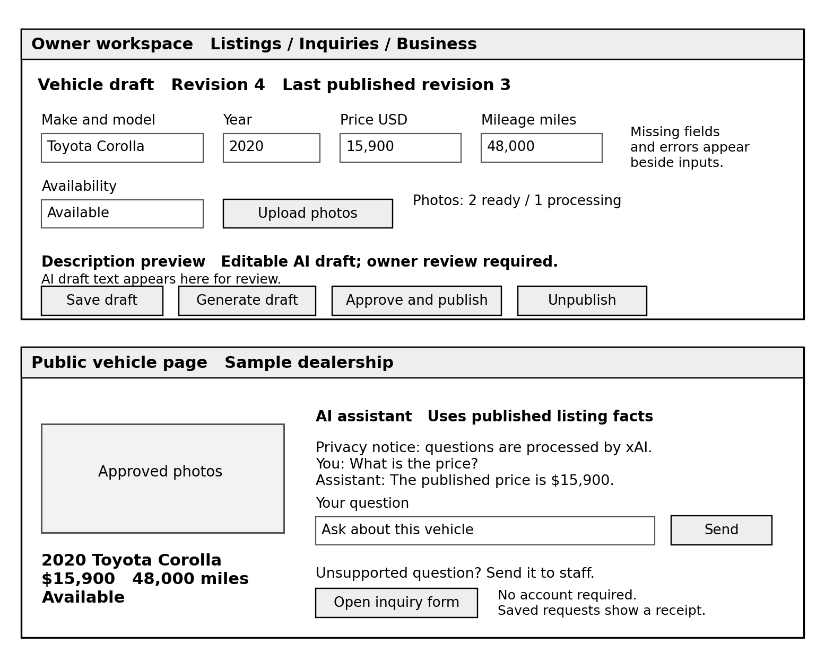
Figure 7. Owner listing editor and public listing with bounded chat and inquiry entry.
Interaction | Required feedback
Generate or save | Show progress within one second. Display missing fields beside inputs. A failed draft keeps the last saved content available.
Approve and publish | Show the exact revision and facts being approved; require explicit confirmation. On a stale version, refresh the preview and request review again.
Customer question | Identify the AI and show privacy information. Offer handoff for unsupported requests. Do not show a submitted state until the inquiry is saved.

On a phone, fields and preview stack vertically; actions remain labelled. Keyboard focus moves to the first validation error or confirmation message. Inputs have programmatic labels and errors do not rely on color.

11 Screen navigation and mobile layout
Owners move from the dashboard to an editor, then explicitly approve publication. Customers open the public link directly without signing in. Unsupported questions lead to a voluntary inquiry form; staff handle saved requests in the inbox.
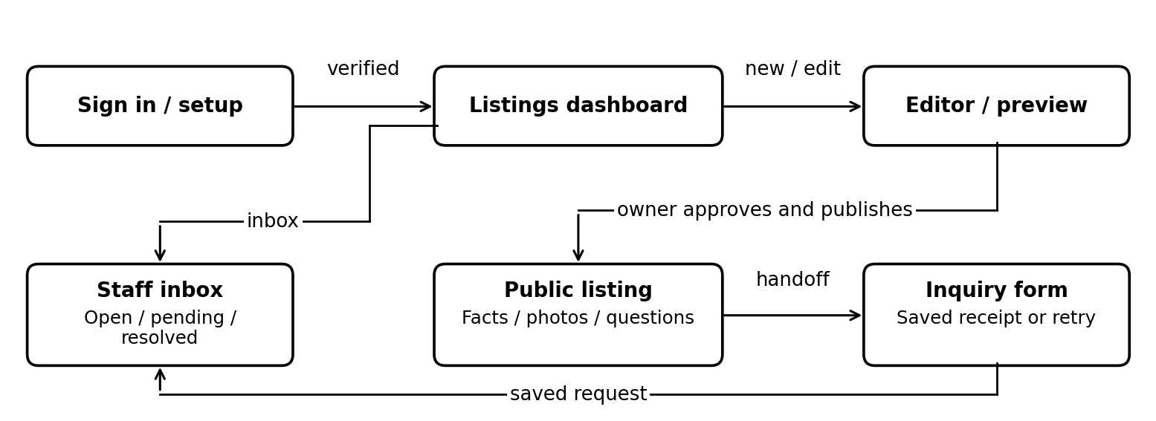
Figure 8. Main screen flow. Only an owner can publish; a handoff is saved only after the customer submits the form.
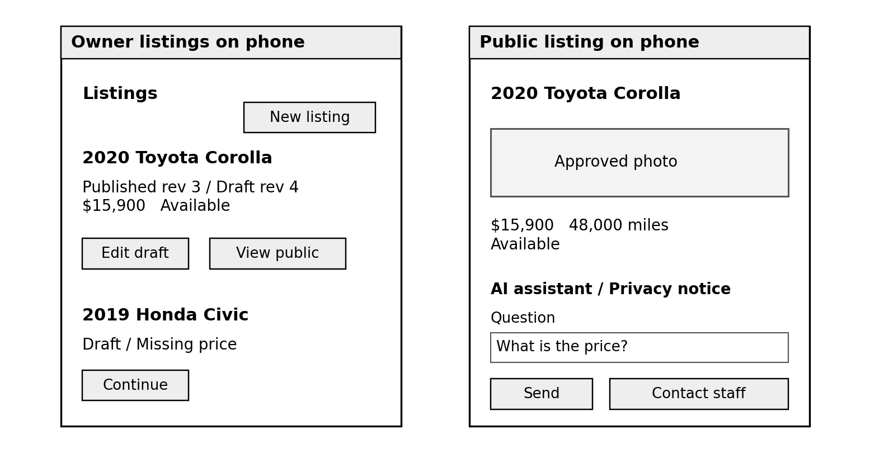
Figure 9. Phone layouts for the listings dashboard and public vehicle page. Data is illustrative.
Use one responsive React interface. Listing cards show public and draft state separately; controls stack on narrow screens. Text wraps at a 320 CSS-pixel viewport, with labelled touch controls, visible focus, and no required horizontal scrolling.

12 Account inbox and spring UI flows
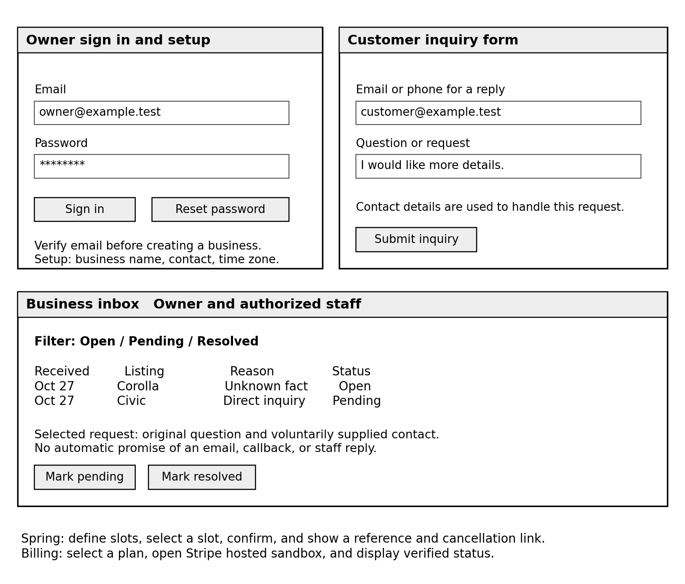
Figure 10. Sign-in/setup, voluntary inquiry form, staff inbox, and spring workflow paths.
Screen or flow | States and restrictions
Sign in and setup | Sign in, verification required, recovery sent, and business setup. Keep tokens in memory and never display raw provider errors or tokens.
Inquiry and inbox | Required contact and message fields; submitted, pending save, or retry states. Staff see the business inbox but no publish or billing controls.
Spring booking and billing | Show slot times with the business time zone and confirmation only after commit. Billing shows pending until verified provider state is stored. Stripe hosts card entry.

Hiding controls improves usability; backend checks enforce access. A copied owner URL still fails for staff. An owner with an inactive subscription can still read records, unpublish a listing, and cancel an existing reservation.

13 Spring booking and billing wireframes
These spring screens reuse the existing layout, field components, and status messages. Plan names, prices, and usage values are placeholders until the team configures the sandbox plans.
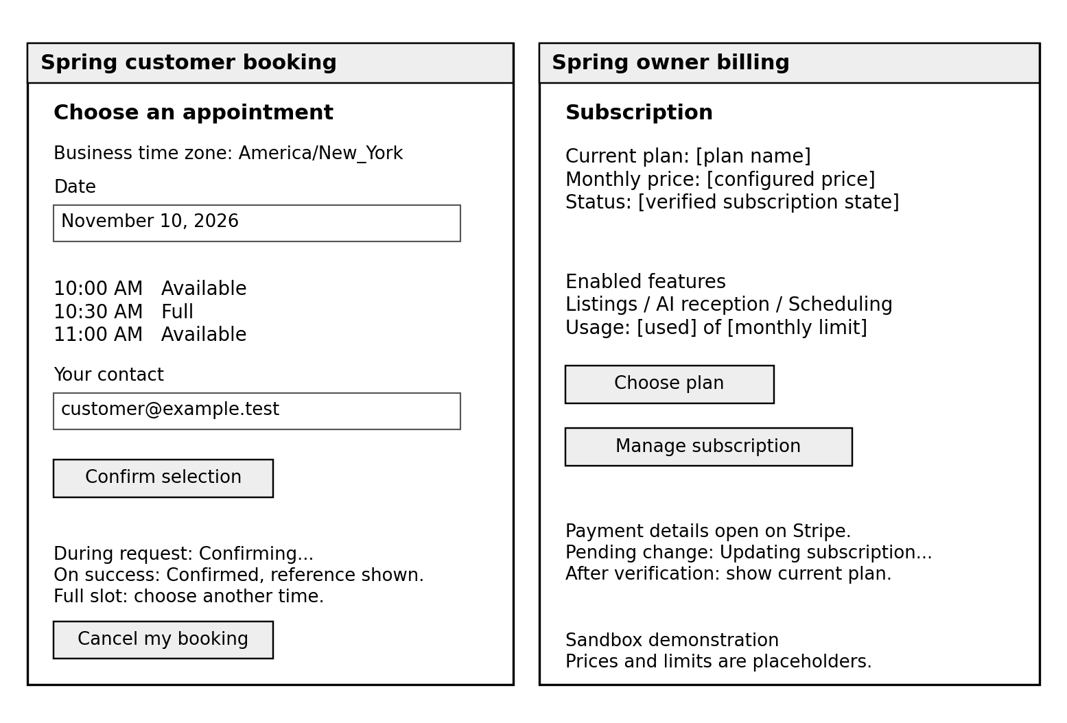
Figure 11. Appointment selection and owner subscription management. Event registration reuses the customer form with event facts and a quantity field.
Flow | Required behavior
Appointment or event | Select only an available slot or event. Collect voluntary contact details. Display confirming, confirmed, full, or retry states. Event quantity cannot exceed remaining capacity.
Cancellation | A customer uses the private cancellation link or authorized staff acts through the inbox. Show cancellation success only after the status change is saved; repeating it does not release capacity twice.
Business subscription | Open Stripe hosted sandbox for payment or management. A browser return shows pending while provider state is verified. Display the stored plan/status and explain which new actions are restricted.

No QR pass, paid event ticket, calendar account, or phone number is needed for these flows. Existing reservations remain visible and cancellable when a business subscription stops allowing new bookings.

14 Threat model and trust boundaries
The threat model uses the DFD IDs and data paths. Treat customer text, uploads, client record IDs, AI output, and incoming provider events as untrusted until validated. The diagram shows deployment trust changes; it does not imply that all Supabase services share an application credential.
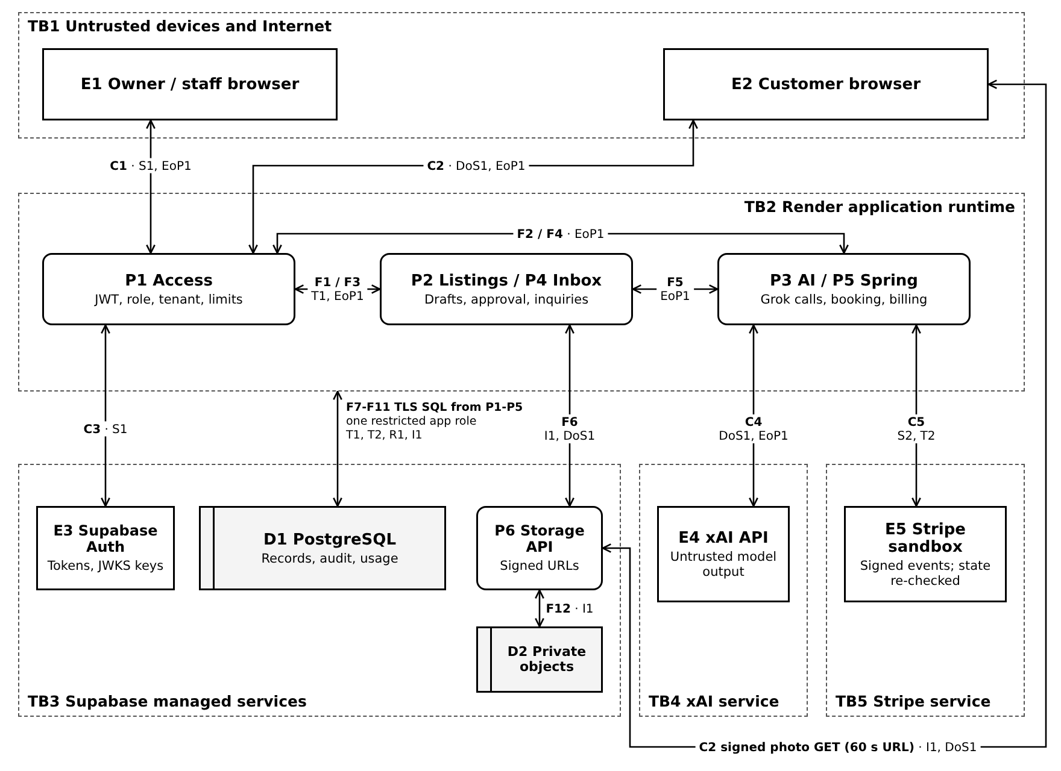
Figure 12. Trust boundaries and DFD paths. Each crossing flow lists its ID and the STRIDE threats from Section 15. P1-P5 share one runtime; F1-F5 remain internal. C2 signed-media requests reach P6, which checks the signature before reading D2.
Boundary | Risk requiring a control
TB1 to TB2 | Untrusted Internet requests cross into the API: authenticate protected routes, validate all inputs, scope tenant access, and apply limits.
TB2 to TB3 | Application credentials reach managed data: use separate database/storage privileges, TLS, authorized signing, and auditable writes.
TB2 to TB4 or TB5 | External results return to the app: validate AI schemas, verify Stripe signatures and state, and bound time and cost.

15 STRIDE threats impacts and mitigations
STRIDE groups threats as Spoofing, Tampering, Repudiation, Information disclosure, Denial of service, and Elevation of privilege. [9] Impact abbreviations are C confidentiality, I integrity, and A availability. Priorities below are design judgments for this pilot, not measured incident probabilities.
Threat and affected components | Nature and possible impact | Specific controls and verification
S1 Spoofing  P1, E3; C1/C3 | A forged, expired, or stolen owner token impersonates an account and exposes or changes its business records. Impact C/I; high priority. | Verify JWT signature, allowed algorithm, issuer, audience, expiry, verified email, and current APP_USER status. Keep browser tokens in memory; throttle login. Test altered, expired, wrong-project, and revoked-membership requests.
S2 Spoofing  P5, E5; C5 | A fake billing event or another business's provider ID grants unpaid features or changes the wrong subscription. Impact I/A; high. | Verify signature on raw webhook bytes, reject stale signatures, use server-created provider mappings, and retrieve current state. Test forged events and mismatched customer IDs.
T1 Tampering  P2, D1; F1/F7 | A client changes facts or photo IDs after review, or races a newer draft with an old approval. Impact I; high. | Validate all fields; compare expected revision under a row lock; check selected photo ownership and readiness. Publish and audit atomically. Test stale requests, foreign photo IDs, and repeated publish.
T2 Tampering  P5, D1; F10 | Concurrent reservations exceed capacity, or replayed/out-of-order events corrupt booking or billing state. Impact I/A; high. | Use parent-row locks, unique request keys with input hashes, conditional cancellation, and serialized provider verification. Test ten requests for one place and duplicate or reversed billing events.
R1 Repudiation  P2/P4/P5, D1 | A user denies an approval or status change because records omit the actor and revision; an editable log hides evidence. Impact I and accountability; medium. | Append actor, business, action, revision, timestamp, and request ID with successful writes. Application role cannot alter audit events. Test required entries and denied UPDATE/DELETE. Administrative tampering remains a residual risk.
I1 Information disclosure  P1/P2/P4/P6, D1/D2 | Changed record IDs, a leaked image URL, logs, or excess AI context reveal another tenant's data or private drafts. Impact C; high. | Derive tenant from membership; use composite FKs and scoped reads. Public image URLs require approval and expire in 60 seconds. Exclude stored inquiry contacts and app secrets from AI/logs. Test cross-tenant reads and public draft-image signing.
DoS1 Denial of service  P1/P3/P6; C2/C4 | Bots flood questions or uploads, exhaust memory, or spend the project AI allowance, blocking legitimate users. Impact A; high. | Bound bodies, files, text, concurrency, provider time, and SQL-backed cost reservations. Throttle IP/session requests. Test rejected excess calls and upload limits. Allow manual editing and non-AI inquiries during an AI outage.
EoP1 Elevation of privilege  P1/P2/P3; F1/F2 | Staff submits an owner action or injected AI text asks for SQL, publishing, or a different business. Impact C/I/A; high. | Read role from D1 for every protected action. Pydantic allowlists model fields; AI gets no execution or database tool. Server owns all actions. Test staff publish/billing attempts and hostile instructions in owner and customer text.

Residual risks: stolen provider credentials or a compromised application host can exceed tenant-level controls; rotate keys and isolate the project. Signed photo URLs are bearer links until expiry. Platform outages and volumetric attacks can interrupt a small pilot. Unverified customer contacts can reserve capacity; staff cancellation and rate limits reduce abuse, while contact verification is future work.

16 Security principles and performance design
Principle | Enforcing control
Least privilege | Use a restricted SQL app role; no anonymous/authenticated browser grants on application tables. Migration and retention credentials are separate from the web runtime. Storage admin credentials stay server-side.
Complete mediation | Every protected route reloads current membership and checks the record's business. Public routes select only published snapshots. CORS is not authentication.
Secure defaults and fail safely | Drafts and buckets are private. Missing identity, permission, approval, or valid output prevents the action. A timeout never means published, paid, or confirmed.
Separation of duties | Staff prepare drafts and handle inquiries; owners approve publishing and manage billing. Grok proposes content or fields; Python alone validates and executes actions.
Defense in depth | HTTPS and TLS SQL, JWT checks, input schemas, ORM parameters, tenant filters, composite FKs, row locks, quotas, and audit controls protect different failure paths.
Minimize exposure | Disable body logging for credentials and questions; redact tokens and contact values. Use a restrictive Content Security Policy, React text rendering, no raw model HTML, and same-origin API access.
Accountability and recovery | Record successful writes and request IDs, alert on repeated denied requests and budget use, rotate exposed keys, and test an export/restore into an isolated database.

File and secret handling
Accept JPEG/PNG only, at most 5 MB per upload, 20 million pixels, and 10 photos per listing. Decode/re-encode in one semaphore-limited thread inside the web service, stripping metadata; then mark ready. Server-generated object keys never overwrite published files. The storage service key bypasses RLS, so P2 authorizes every operation first. It is separate from the SQL app role. [4]

Pilot performance and availability
Reuse a small SQL connection pool and an asynchronous HTTPX client. Keep SQL transactions short; the rare spring billing reconciliation uses a bounded advisory lock with provider timeouts. Cache public verification keys, not mutable listing facts. Public facts and private responses use no-store; fingerprinted React assets can be cached. No stale answer cache may survive a published price change.
Guardrails: 10 questions/minute per IP/session, 1,000 characters, two concurrent model calls, 30-second AI timeout, and token/cost ceilings. IP counters are bounded in-memory records for the one-process pilot; scaling requires shared rate counters. SQL budget reservations are shared: lock project then business buckets, create the task and reserve cost, commit, call xAI, and finalize measured usage. Unknown timeout outcomes retain their reservation for reconciliation. These are pilot settings, not commercial throughput guarantees.
Unknown AI tasks are not automatically retried. The team reconciles reserved cost against provider usage before releasing it. Spring retention clears reservation contacts, input hashes, and cancellation hashes 30 days after the slot or event ends; capacity counts and non-identifying audit data follow the 90-day metadata policy.

17 Standards frameworks and benchmarks
These four references guide implementation and verification. Each has a defined application and evidence plan; this design does not claim certification or complete conformance.

NIST Cybersecurity Framework
Name and URL NIST CSF 2.0 https://doi.org/10.6028/NIST.CSWP.29
Summary description A framework for organizing security risk outcomes across Govern, Identify, Protect, Detect, Respond, and Recover.
Relation to our project Business records, customer contact details, and managed providers create risks that the team must assign and track.
Application and exclusions Govern: assign an incident contact. Identify: inventory data and dependencies. Protect: enforce access and secret controls. Detect: review denials, failures, and budget use. Respond: disable affected features and rotate keys. Recover: test export/restore and deployment. Evidence is a risk register and response/restore records; an institutional security program is outside scope.

OWASP Application Security Verification Standard
Name and URL OWASP ASVS 5.0.0 https://owasp.org/projects/asvs
Summary description A standard of technical security requirements for developing and verifying web applications.
Relation to our project The dashboard, API, sessions, forms, and file uploads require consistent security checks.
Application and exclusions Map applicable Level 1 requirements to JWT validation, tenant and role checks, safe output, input/upload limits, TLS, secrets, and logging. Keep individual checks and results. Mark unused protocols and optional integrations not applicable with reasons; do not claim blanket compliance.

OWASP Top 10 for LLM Applications
Name and URL OWASP LLM Top 10 2025 https://genai.owasp.org/llm-top-10/
Summary description A risk catalogue covering issues such as prompt injection, sensitive disclosure, unsafe output handling, excessive agency, misinformation, and uncontrolled consumption.
Relation to our project Owner text, questions, and AI output are untrusted; generated content can be inaccurate or costly.
Application and exclusions Use enum/schema validation, minimum context, owner approval, server templates, timeouts, and cost reservations. Give the model no execution tools. Keep hostile-input and AI quality tests. Training and vector-store controls are not implemented because neither capability is used; reassess if added.

Web Content Accessibility Guidelines
Name and URL WCAG 2.2 https://www.w3.org/TR/WCAG22/
Summary description A W3C standard with testable criteria for accessible web content across devices.
Relation to our project Owners and customers must use forms, status messages, and public listings on phones and with assistive technology.
Application and exclusions Target applicable Level AA criteria: photo alternatives (1.1.1), 4.5:1 normal-text contrast (1.4.3), 320 CSS-pixel reflow (1.4.10), keyboard access (2.1.1), visible focus (2.4.7), labelled errors (3.3.1/3.3.2), and announced status (4.1.3). Verify with keyboard, screen-reader, and contrast checks. Audio/video criteria are not applicable to this text/photo release. Record unmet criteria before claiming conformance.

18 Implementation validation and constraints
Check | Pass condition and trace
End-to-end fall flow | Sign in, draft, approve, publish, answer, handoff, and republish a changed price on the hosted app. Data persists across reload and reauthentication. UC-01 to UC-06.
Access and image privacy | All 20 prepared cross-business/role attempts denied; wrong-project/expired tokens fail; draft image URLs cannot be issued. FR-ACC-05; S1, I1, EoP1.
Approval and concurrency | Old revisions cannot publish; ten repeated publish requests create one listing; ten final-place booking requests produce one confirmation. FR-LST-06/10, FR-SCH-02; T1/T2.
AI quality and failure | At least 18/20 drafts need no factual correction; 18/20 questions select the right field or handoff; every displayed fact matches its published source. Invalid output, timeout, and quota exhaustion return safe outcomes. NFR-AIQ-01; DoS1/EoP1.
Performance and usability | Ordinary API p95 <1 second across 200 requests and 10 concurrent users, excluding AI/uploads. Report AI latency separately; waiting UI within 1 second. Four of five trial users complete the prepared flow unaided. NFR-EFF-01/02, NFR-USE-01.
Billing and operations | Forged webhooks fail; duplicates and reordered events do not corrupt access; export/restore reproduces seeded records; daily retention removes expired test data. FR-BIL-02/03; S2/R1; NFR-REL-02/PRV-01.

Build order: first prove one authenticated API request, database write, and Grok call. Then complete intake/uploads, approval/publication, bounded Q&A, and inbox. Run the fall checks before optional work. In spring, add the transactional schema extensions, plan enforcement, and final verification. Pin working dependency versions and document setup from a clean checkout.
Constraints: four students, one initial application deployment, and a small pilot dataset. Plan $7/month for one small Render service, $0 Free or $25 Pro for Supabase, and a $25 AI allowance: approximately $32 or $57/month before overages, tax, domains, or email delivery. Free Supabase projects may pause after a week of inactivity. Verify limits before demos and measure memory before upgrading compute. [10, 11] No 24/7 service-level guarantee, production payment launch, local GPU, phone integration, or automatic social posting is promised. A worker is added only if measured workload or durable jobs justify it.

Technical sources
[1] xAI models https://docs.x.ai/developers/models
[2] Structured outputs https://docs.x.ai/developers/model-capabilities/text/structured-outputs
[3] Supabase JWTs https://supabase.com/docs/guides/auth/jwts
[4] Storage access https://supabase.com/docs/guides/storage/security/access-control
[5] PostgreSQL locks https://www.postgresql.org/docs/current/explicit-locking.html
[6] Stripe webhooks https://docs.stripe.com/webhooks
[7] Render Docker https://render.com/docs/docker
[8] SQL scheduling https://supabase.com/docs/guides/cron
[9] Microsoft STRIDE https://learn.microsoft.com/en-us/azure/security/develop/threat-modeling-tool-threats
[10] Render pricing https://render.com/pricing
[11] Supabase pricing https://supabase.com/pricing
[12] Stripe test environments https://docs.stripe.com/testing
Provider pricing checked October 28, 2026. Allowances are team spending limits, not fixed provider charges.
Project sources: FrontDesk AI Initial System Design and FrontDesk AI Requirements Use Cases and Constraints, both October 22, 2026. New schema fields and process details above refine those baselines without adding an industry or integration to committed scope.

