My Certificates

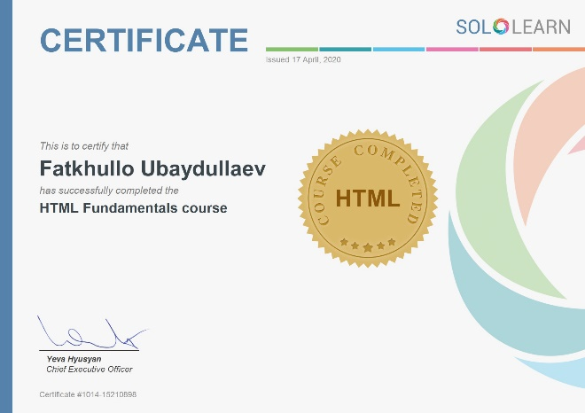

HTML Fundamentals

Issued: 17 April, 2020

Download: PDF | Image

PDF url: <https://www.sololearn.com/Certificate/1014-15210898/pdf/>

Image url: <https://www.sololearn.com/Certificate/1014-15210898/jpg/>

_____________________________________________________________________________________

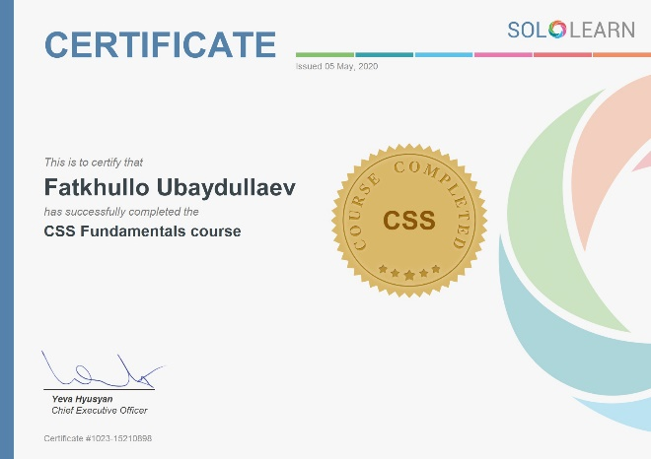

CSS Fundamentals

Issued: 05 May, 2020

Download: PDF | Image

PDF url: <https://www.sololearn.com/Certificate/1023-15210898/pdf/>

Image url: <https://www.sololearn.com/Certificate/1023-15210898/jpg/>

_____________________________________________________________________________________