Unit 3 – Covariance and Pearson Correlation
Machine Learning (ML_PCOM7E) | Unit 3 – Exercise 1 of 4 |

Aim
To compute covariance and Pearson's correlation coefficient from first principles, verify them against NumPy and SciPy, and observe how changing the data changes the result (notebook: covariance_pearson_correlation.ipynb).

Method
I simulated 100 height and weight values with a linear relationship plus noise. Covariance was calculated as the sum of cross-deviations divided by n − 1, and Pearson's r as covariance divided by the product of the standard deviations. I then varied the noise, added an outlier and tested a U-shaped relationship.

Results
- My manual covariance (60.04) and Pearson r (0.704) matched NumPy and SciPy exactly (p = 3.1 × 10⁻¹⁶).
- Increasing the noise standard deviation from 1 to 32 reduced r from 0.992 to 0.210, while covariance stayed roughly 59–66.
- One extreme point reduced r from 0.704 to 0.458.
- For perfectly U-shaped data, Pearson r was 0.005 and Spearman ρ −0.002 even though y depends completely on x.

Figures
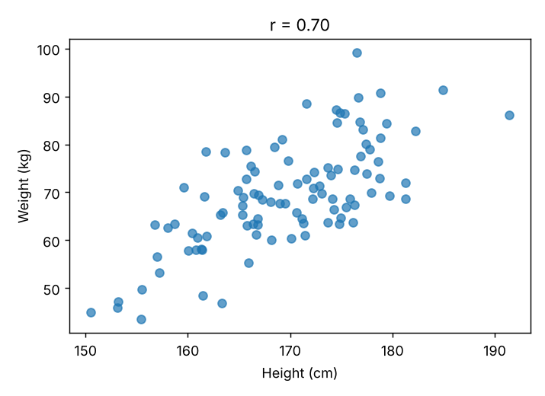
Figure 1:Simulated height and weight
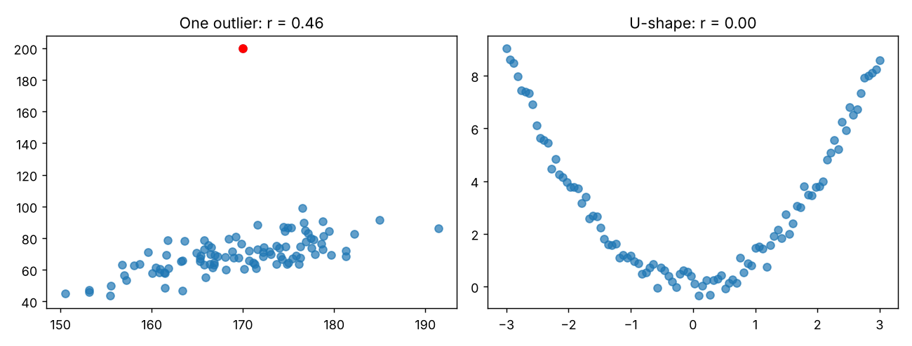
Figure 2: Effect of an outlier and of a non-linear relationship

Interpretation and reflection
Covariance has the units of both variables, so only the standardised r can be compared to other problems. The experiments demonstrated that the strength of linear association, not slope, is captured by r; and that r is sensitive to outliers and blind to non-linear dependence. The lesson to take from the practical is that the data should be plotted before quoting a coefficient. The statement "correlation is not causation" applies to correlation as well, as noted in the Unit 3 reading by Leetaru (2019). Limitations include the fact that the data are simulated rather than actual data, thus measurement error and confounding would be added if real data were used.

