Unit 3 – Simple Linear Regression
Machine Learning (ML_PCOM7E) | Unit 3 – Exercise 2 of 4 |

Aim
To fit a straight line by least squares, check it against scikit-learn, evaluate it and see how noise and outliers affect it (notebook: linear_regression.ipynb).

Method
I generated 120 points from y = 10 + 2.5x plus Gaussian noise (sd 6). I computed the closed-form slope and intercept, then fitted scikit-learn's LinearRegression on a 75/25 train–test split and evaluated with R², RMSE and a residual plot.

Results
- Closed-form estimates: intercept 9.99, slope 2.50 (true values 10 and 2.5).
- On the training split scikit-learn gave intercept 10.87 and slope 2.46. Test R² was 0.961 and RMSE 5.79.
- As noise rose from 2 to 25, R² fell from 0.995 to 0.634.
- Adding one high-leverage point (x = 80, y = 20) pulled the slope from 2.50 to 1.86.

Figures
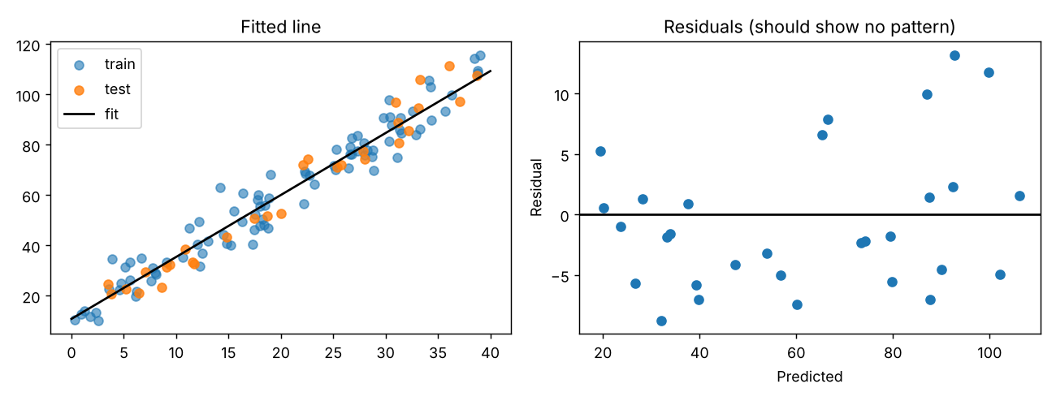
Figure 1: Fitted line and residuals

Interpretation and reflection
The model was very close to the actual relationship and the residuals were not curved. A Shapiro–Wilk test of the test residuals was p = 0.03 which was a hint of non-normality, but only about 30 points is weak evidence. R² decreased as a result of noise even though the model form is correct: R² = explained variance only, not correctness. The high-leverage example connects with Unit 2: Outliers should be explored prior to fitting. Again, the most obvious restriction is that the data are artificial and meet the regression conditions by design.

