Unit 3 – Multiple Linear Regression
Machine Learning (ML_PCOM7E) | Unit 3 – Exercise 3 of 4 |

Aim
To predict a continuous outcome from several predictors, interpret the coefficients, diagnose multicollinearity and compare feature subsets (notebook: multiple_linear_regression.ipynb).

Data and method
I used the scikit-learn Diabetes dataset (442 patients, ten baseline features, target = disease progression after a year). The data were split 75/25. I fitted ordinary least squares, reported R², adjusted R² and RMSE, calculated variance inflation factors (VIF) and compared several feature subsets.

Results
Feature set | Test R² | Adjusted R² | RMSE
All 10 features | 0.485 | 0.433 | 53.37
BMI only | 0.317 | 0.311 | 61.45
BMI + BP | 0.355 | 0.343 | 59.71
BMI + BP + s5 | 0.502 | 0.488 | 52.46
All except s1, s2 | 0.496 | 0.457 | 52.77

Figures
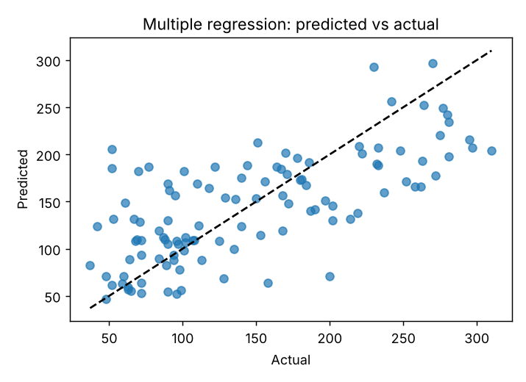
Figure 1: Predicted against actual progression

Interpretation and reflection
The complete model accounts for 49% of the variance in the unseen data. BMI and the s5 serum measure accounts for most of the signal, and a three-feature model out-performs the full model on test R² (0.502 vs 0.485) and adjusted R² (0.488 vs 0.433). The features s1 and s2 are strongly collinear (VIF 54 and 36) and can therefore not be read separately. They will almost never cost anything to drop. This lesson is that more predictors does not necessarily mean a better model and that coefficient interpretation should be preceded by a test for multicollinearity. A restriction is that train-test split is a single split; cross validation (unit 11) would be a more stable comparison.

