Unit 3 – Polynomial Regression
Machine Learning (ML_PCOM7E) | Unit 3 – Exercise 4 of 4 |

Aim
To model a non-linear relationship by adding polynomial terms and use the train–test gap to recognise under-fitting and over-fitting (notebook: polynomial_regression.ipynb).

Method
I generated 80 points from a cubic curve with noise, split them 70/30 and fitted polynomial degrees 1 to 10 using a scikit-learn pipeline (PolynomialFeatures then LinearRegression), recording train and test RMSE.

Results
- Degree 1 under-fits: train RMSE 3.30, test RMSE 3.23, test R² 0.702.
- Degree 3 (the true form) reaches test RMSE 1.26 and R² 0.955. Degrees 4–6 are marginally lower (1.22–1.23) but not meaningfully better.
- By degree 10 train RMSE is 1.07 but test RMSE has risen to 1.34: the model is fitting noise.

Figures
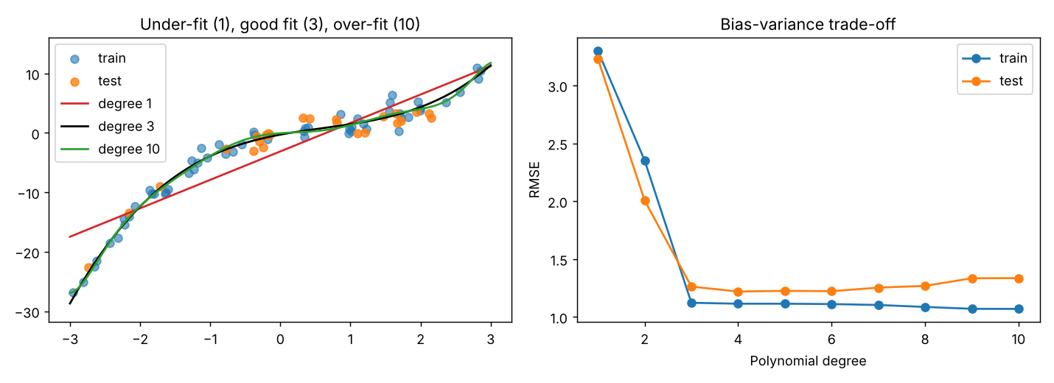
Figure 1: Fits of degree 1, 3 and 10, and the train/test error curve

Interpretation and reflection
Too little flexibility leads to systematic error, too much flexibility leads to chasing noise, the curve of train error is the "bias –variance trade off". I would take the cubic, the difference with degree 4 is not that great. In this run, the data were relatively low noise, and over-fitting was mild; reducing the number of points and/or adding more noise (N and NOISE at the top of the notebook) make it much more severe. One drawback is that the choice is made by one test split and cross validation would be more reliable.

