Unit 2 – Exploratory Data Analysis
Machine Learning (ML_PCOM7E) | Unit 2 |

Aim
To carry out the EDA steps taught in Unit 2 on a real dataset: understand it, check its quality, find anomalies, explore it visually and prepare it for machine learning. The code is in unit02_exploratory_data_analysis.ipynb.

Data and method
I used the Wine dataset bundled with scikit-learn (178 samples, 13 numeric chemical features, three cultivars) so the notebook runs offline in Jupyter or Colab. I checked types and summary statistics, counted missing values and duplicates, flagged outliers with the 1.5 × IQR rule, plotted histograms by cultivar and a correlation heat map, then standardised the features.

Results
- There were no missing values and no duplicate rows. Classes are reasonably balanced (59, 71 and 48 samples).
- The IQR rule flagged values in 17 of 178 rows, mostly in magnesium, alcalinity of ash and colour intensity. I kept them because they are plausible measurements rather than recording errors.
- Features are on very different scales, so StandardScaler was applied (mean 0, standard deviation 1 afterwards).
- The strongest feature pair is total phenols with flavanoids (r = 0.87), followed by flavanoids with the OD280/OD315 ratio (r = 0.79). Flavanoids (|r| = 0.85), OD280/OD315 (0.79) and proline (0.63) are the features most associated with the cultivar label.

Figures
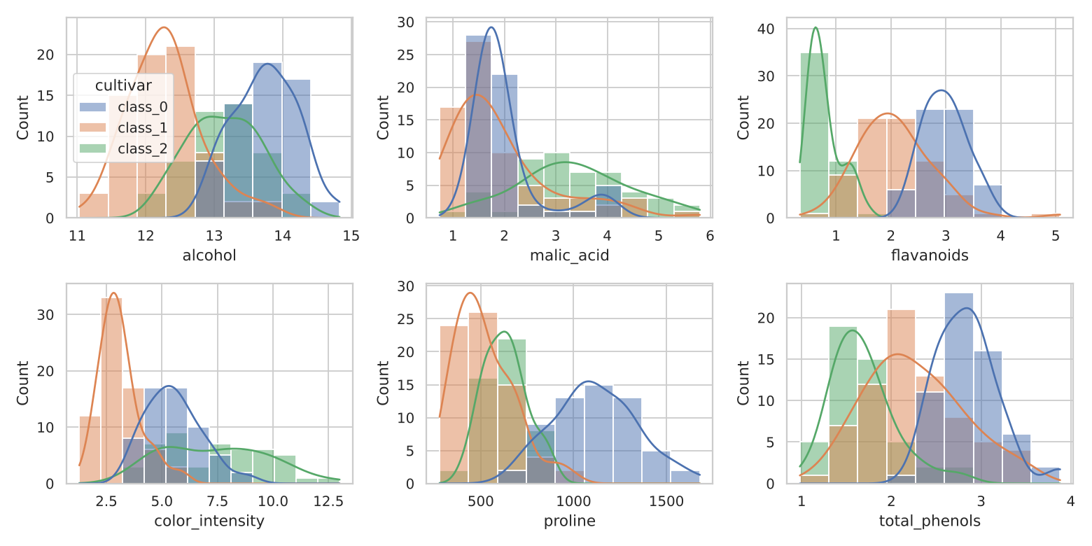
Figure 1: Feature distributions by cultivar
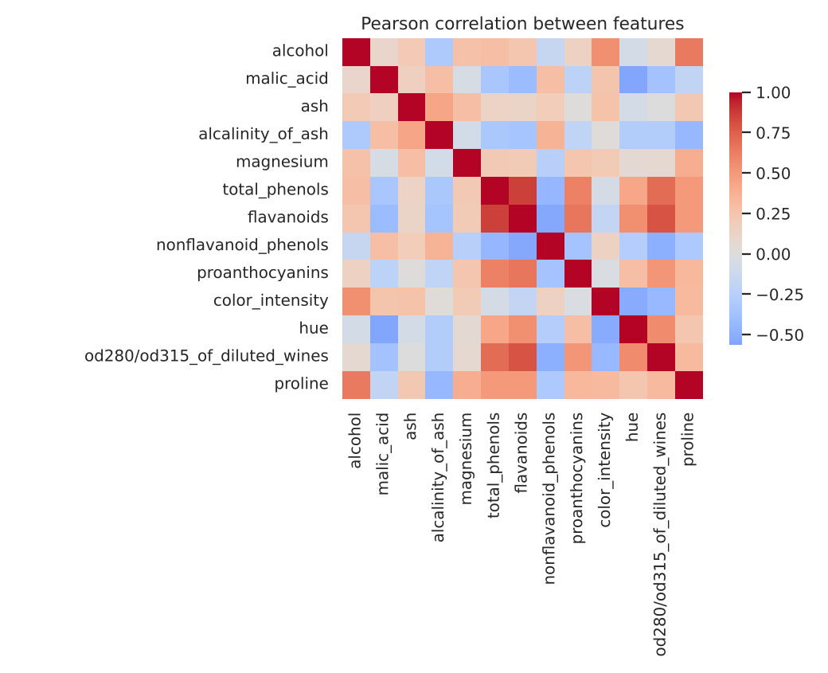
Figure 2: Pearson correlation between features

Interpretation and reflection
EDA altered what I would do next: The high correlation coefficient of the features related to phenol indicates that there is redundancy in the data from which a regression would be performed, and I should check for multicollinearity (as in Unit 3); moreover, the distance-based methods I would use (such as k-means in Unit 6) require scaling because of the scale differences. The choice of keeping the outliers was not a rule, but a judgement as to whether they represented genuine variation or not. But it is a limitation that the data is clean and small, and thus doesn't demonstrate the difficulty of dirty business data.

