Cairo University
Faculty of Computers and Artificial Intelligence

[Thesis Title — To Be Confirmed]
Benchmarking Fine-Tuned Encoders and Prompted Large Language Models for Software Requirements Classification
Methodology and Results
Prepared by
Fatma El-Zahraa
Supervised by
Prof. Khaled Tawfik Wassif
Dr. Lamia AbouZeid
2026

Methodology and Results

3.1 Overview
This chapter specifies the empirical design that answers the three research questions stated in Chapter 2, and reports its results. The study is a controlled benchmark: twelve model configurations — four fine-tuned encoder variants and eight prompted large language models — classify the same requirements under the same three tasks, the same frozen data splits, and one strict scoring protocol, so that every comparison in the results is paired on identical items. The pipeline is implemented as seven notebook stages; every stage writes a versioned artefact that the next stage consumes, and every number reported in this chapter is read from those artefacts. Section 3.2 describes the corpus, Section 3.3 the tasks, Section 3.4 the models, Section 3.5 the evaluation regimes, Section 3.6 the prompting protocol, Section 3.7 the metrics and statistical analysis, and Section 3.8 the cost model. Sections 3.9–3.12 then report the results for RQ1–RQ3 and summarise the threats to validity.

3.2 Corpus Construction
Two public corpora are merged into a single unified corpus. PROMISE_exp [17] contributes 969 labelled requirements drawn from 47 software projects (444 functional, 525 non-functional across eleven NFR sub-classes). SecReq [16] contributes 510 requirements from three industrial security specifications (Common Electronic Purse, Customer Premises Network, and the Global Platform specification), each labelled security or non-security. Requirement texts are normalised (whitespace collapse, encoding repair), and exact duplicate texts are removed: 67 duplicates are dropped, none of which appeared in both corpora. The unified corpus therefore holds 1,412 requirements — 968 from PROMISE_exp and 444 from SecReq — and Table 3.1 summarises its construction. Both corpus files, the split definitions, and a manifest recording the full drop accounting are stored as the pipeline's first artefact, together with the SHA-256 hash of each source file and the random seed (42). The split definitions are stored once and treated as immutable, because the grouped splits described in Section 3.5 depend on the version of the library that generated them.
Table 3.1. Corpus construction and deduplication (from the Stage-1 manifest).
Source | Raw rows | Provenance | Native labels | Final rows
PROMISE_exp | 969 | 47 projects | 444 FR / 525 NFR | 968
SecReq | 510 | 3 specifications | security / non-security | 444
Unified | 1479 − 67 dup. | 50 project groups | all tasks | 1412

3.3 Classification Tasks
Three task families are defined over the unified corpus. Binary FR/NFR uses the native PROMISE_exp labels. Binary security is labelled natively in SecReq and derived in PROMISE_exp from the security (SE) sub-class, giving the same task on two independently produced corpora — the property the cross-dataset arm of RQ2 exploits. NFR sub-type classification uses the eleven-class taxonomy of Cleland-Huang et al. [1] (availability, fault tolerance, legal, look-and-feel, maintainability, operational, performance, portability, scalability, security, usability); because several tail classes have single-digit support, two reduced variants are also evaluated: top-6 (the six most frequent sub-classes) and top-4 (security, usability, operational, performance). After de-duplication the sub-type task holds 353 (top-4), 433 (top-6) and 524 (all-11) items, and the taxonomy aligns with the ISO/IEC 25010 quality characteristics [23]. Macro-F1 is always computed over the full declared label set of the task variant, so a model is penalised for every class it never predicts.

3.4 Models
Table 3.2 lists the twelve configurations. The encoder tier fine-tunes bert-base-uncased (110 M parameters) [19] and roberta-base (125 M) [20] with a classification head (AdamW, learning rate 2×10⁻⁵, batch size 16, maximum sequence length 128, linear decay with no warmup; 3 epochs on the binary tasks and 10 on the sub-type tasks), each with inverse-frequency class weighting in the loss, plus an unweighted control on the security task's in-domain PROMISE_exp and cross-dataset families. The open tier runs six instruction-tuned models of 2.6–8.0 B parameters locally on a free-tier NVIDIA T4 GPU under 4-bit NF4 quantisation [21]. The hosted tier accesses Llama-3.3-70B through a free API tier, and the commercial tier accesses Gemini 3.1 Flash-Lite through its free tier. Additional hosted models were attempted and are retained in the raw store, but fell below the reportability gate of Section 3.7 (for example, Nemotron-3-Nano-30B, a ninth prompted model with 63 stored predictions — 21 per cell, below the 40-item minimum — which also parsed fewer than 50% of its FR/NFR responses) and are therefore excluded from all result tables.
Table 3.2. Model roster. Parameter counts are the published counts of the exact checkpoints; Gemini's is undisclosed and recorded as unknown rather than guessed.
Configuration | Checkpoint / endpoint | Params (B) | Access | Precision
BERT (weighted / unweighted) | bert-base-uncased | 0.11 | fine-tuned | full precision
RoBERTa (weighted / unweighted) | roberta-base | 0.125 | fine-tuned | full precision
Gemma-2-2B | google/gemma-2-2b-it | 2.61 | prompted, local | 4-bit NF4
SmolLM3-3B | HuggingFaceTB/SmolLM3-3B | 3.08 | prompted, local | 4-bit NF4
Qwen2.5-3B | Qwen/Qwen2.5-3B-Instruct | 3.09 | prompted, local | 4-bit NF4
Phi-4-mini | microsoft/Phi-4-mini-instruct | 3.84 | prompted, local | 4-bit NF4
Qwen2.5-7B | Qwen/Qwen2.5-7B-Instruct | 7.62 | prompted, local | 4-bit NF4
Llama-3.1-8B | meta-llama/Llama-3.1-8B-Instruct | 8.03 | prompted, local | 4-bit NF4
Llama-3.3-70B | llama-3.3-70b-versatile (hosted API) | 70.6 | prompted, hosted | provider-side
Gemini 3.1 Flash-Lite | gemini-3.1-flash-lite (API) | undisclosed | prompted, commercial | provider-side

3.5 Evaluation Regimes and Frozen Splits
Fourteen frozen split families implement three evaluation regimes. In-domain: stratified 5-fold cross-validation within a corpus (StratifiedKFold, seed 42). This is the in-distribution reference arm against which the transfer arms are measured, so projects are not held apart here; holding them apart is what the cross-project arm below does, and the difference between the two is the cross-project gap. Project grouping (StratifiedGroupKFold, seed 42) is applied to the cross-project families only. Cross-project: grouped folds that hold out entire unseen project groups, plus a leave-one-project-out arm over the 47 PROMISE_exp projects used for the per-project analysis. Cross-dataset: train on the security task of one corpus and test on the other (PROMISE_exp ↔ SecReq). All splits are generated once, stored as JSON keyed by stable requirement identifiers over source files that the Stage-1 manifest pins by SHA-256, and never regenerated: grouped-fold membership depends on the version of the scikit-learn library [22] that generated it, so the split file is treated as an immutable artefact and is consumed, not rebuilt, by every later stage. Prompted models are evaluated on stratified samples of the same test items — a 300-item core per binary cell and a 200-item core per sub-type cell (218 for the all-11 variant), allocated in proportion to the class prior with a floor of ten per class. The six local models complete those cores and additionally answer the full evaluation frames; the rate-limited hosted and commercial models complete as much of each core as their quotas allowed, which is why prompted cell sizes range from 59 to 960 items. Every encoder–LLM comparison in Section 3.10 is therefore paired on identical requirements, aligned by requirement identifier rather than by position.

3.6 Prompting Protocol
Each prompted model answers a fixed instruction template that names the task, defines the label vocabulary, and demands exactly one word in reply. Three phrasings — base, terse, and verbose — are compared in a two-model sub-study (Gemma-2-2B and Qwen2.5-7B), and few-shot conditions insert deterministic, class-balanced exemplars that are carved out of the corpus before the evaluation frames are formed, so no test item ever appears in a prompt: the binary tasks use k ∈ {2, 4, 8} exemplars in total (one, two and four per class), the sub-type tasks k ∈ {1, 2} per class (k = 1 already places eleven exemplars in an all-11 prompt). Decoding is greedy throughout (temperature 0, at most twelve new tokens), and the hosted and commercial models run zero-shot under the base phrasing only, under provider rate limits. Model outputs are parsed with a strict, word-boundary-aware rule: a leading label wins; otherwise exactly one label named anywhere in the reply wins; a reply naming both labels, or neither, is recorded as unparseable and scored as wrong. The parse rule is applied identically at harness time and in an idempotent repair stage that re-parses the stored raw outputs, so the archived predictions and the scored predictions can never diverge silently.

3.7 Metrics, Statistics, and the Reportability Gate
The primary metric is macro-averaged F1 over the task's declared label set, with weighted F1 and accuracy reported alongside. Uncertainty is quantified with a stratified bootstrap [24]: 2,000 resamples drawn within each true class (seed 42), so no resample loses a rare class, giving percentile 95% confidence intervals. Encoder–LLM comparisons use the exact two-sided McNemar test [25] on paired disagreements, and all 260 tests are corrected as one family with both the Holm [26] and Benjamini–Hochberg [27] procedures at α = 0.05; verdicts key on the BH-adjusted p-value. A result cell (model × task × dataset × regime) is reported only if every class has at least 5 test items, the cell has at least 40 items, and the model parsed at least 50% of its responses; of 87 cells, 6 fail this gate, leaving 81 reportable cells. In total the benchmark stores 76,115 predictions: 24,280 encoder predictions, 35,049 prompted binary predictions, and 16,786 prompted sub-type predictions.

3.8 Cost Model
Every prediction row records prompt and completion tokens, wall-clock latency, and — for encoders — training time. Local computation is priced as an imputed rental of the benchmark GPU (AWS g4dn.xlarge with one NVIDIA T4: $0.5260/hour on-demand, $0.3162 spot, rate verified 2026-08-06); API models are priced at provider list token prices. Encoder cost separates the one-off fine-tuning cost C₀ from the marginal per-item inference cost, giving a break-even volume N⁎ = C₀ / (c_alt − c_enc) against any prompted alternative. Because free-API latency is dominated by provider-side queueing, wall-clock projections use the per-request median latency, with the queue-inflated mean reported separately, and a batching sensitivity of ×1/×8/×32 (assumed speed-ups, not measured) is reported for the sequential-inference assumption.

3.9 Results: RQ1 — In-Domain Comparison
Table 3.3 reports in-domain macro-F1 for all twelve configurations across the six task × dataset cells (Fig. 3.1 and Fig. 3.2 visualise the binary and sub-type results with their bootstrap intervals). Fine-tuned encoders post the best score in five of the six columns: class-weighted BERT attains 0.9083 on FR/NFR and 0.9235 on PROMISE_exp security, and class-weighted RoBERTa attains 0.9356 / 0.8367 / 0.7240 on the top-4 / top-6 / all-11 sub-type variants. The one exception is SecReq security, where the quantised Qwen2.5-7B posts the best point estimate (0.8461 against class-weighted BERT's 0.8356) — a lead that never reaches significance (exact McNemar p = 0.696; BH-adjusted 0.774). The other prompted scores from the commercial and 70 B hosted tiers approach but do not overtake the encoders, and the small open models collapse on FR/NFR (0.55–0.73). Scale does not order the results — the 2.6 B Gemma-2-2B beats the hosted 70 B model on PROMISE_exp security (0.8999 against 0.8910) — and every reportable model clears the majority-class dummy baseline (macro-F1 0.035–0.466 across the six cells). Because cell sizes differ (n = 59–968), the top-4 ranking is also recomputed on the 59 items every model answered: the encoder margin there is +0.036 (0.9660 against Llama-3.3-70B's 0.9298), so the ordering is not an artefact of coverage. The paired tests of Section 3.10 make the in-domain verdict exact: encoders win 67 of 106 comparisons and lose none.
Table 3.3. In-domain macro-F1 (all reportable cells; — = below the reportability gate or not run). Cell sizes differ by model (n = 59–968 items); 95% bootstrap intervals are in Fig. 3.1 and Fig. 3.2, and the shared-item ranking is in Section 3.9.
model | tier | FR/NFR — PROMISE | Security — PROMISE | Security — SECREQ | NFR sub-types (top-4) — PROMISE | NFR sub-types (top-6) — PROMISE | NFR sub-types (all-11) — PROMISE
BERT (unweighted) | finetuned | — | 0.9069 | — | — | — | —
BERT (weighted) | finetuned | 0.9083 | 0.9235 | 0.8356 | 0.8780 | 0.8272 | 0.6572
RoBERTa (unweighted) | finetuned | — | 0.9035 | — | — | — | —
RoBERTa (weighted) | finetuned | 0.8956 | 0.9023 | 0.8237 | 0.9356 | 0.8367 | 0.7240
Gemini-3.1-Flash-Lite | commercial | 0.8665 | 0.8287 | 0.7128 | 0.9216 | — | —
Llama-3.3-70B (Groq) | open_hosted | 0.8516 | 0.8910 | 0.8140 | 0.9069 | 0.7819 | —
Gemma-2-2B | open_local | 0.6627 | 0.8999 | 0.8209 | 0.7596 | 0.6026 | 0.5272
Llama-3.1-8B | open_local | 0.6821 | 0.8724 | 0.8450 | 0.7004 | 0.7174 | 0.6287
Phi-4-mini | open_local | 0.7266 | 0.7985 | 0.6353 | 0.7268 | 0.7118 | 0.5987
Qwen2.5-3B | open_local | 0.5542 | 0.7067 | 0.7410 | 0.7315 | 0.6885 | 0.5426
Qwen2.5-7B | open_local | 0.6561 | 0.8840 | 0.8461 | 0.8762 | 0.8235 | 0.5760
SmolLM3-3B | open_local | 0.5622 | 0.8408 | 0.7172 | 0.7631 | 0.6929 | 0.4817

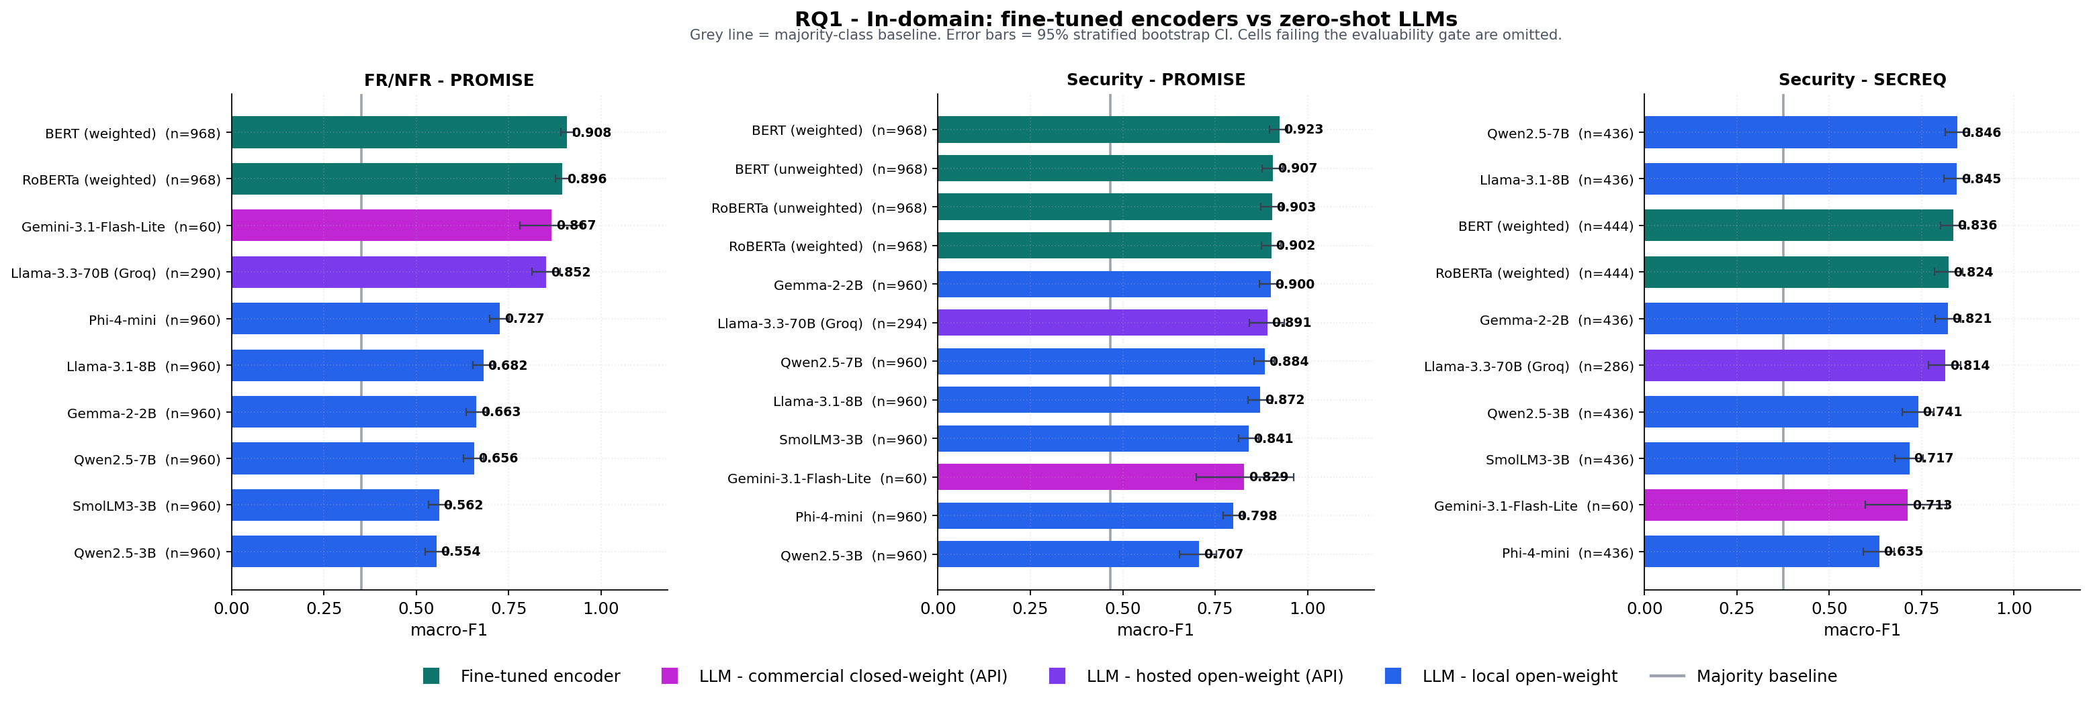
Figure 3.1. RQ1, binary tasks: in-domain macro-F1 with 95% stratified-bootstrap intervals.
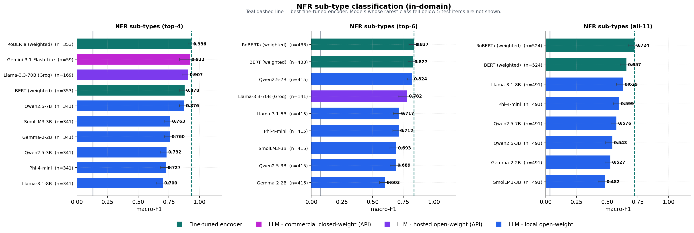
Figure 3.2. RQ1, NFR sub-types: macro-F1 across the all-11, top-6 and top-4 variants.

3.10 Results: RQ2 — The Generalisation Gap
Table 3.4 summarises the 260 exact McNemar tests by regime, and Table 3.5 lists every measured gap. In-domain the picture is one-sided: 67 encoder wins, 39 ties, no losses. Cross-project transfer within PROMISE_exp costs the encoders 2.7–10.1 macro-F1 points, and up to 24.7 points (29.6% relative) on the smaller SecReq corpus, but leaves them ahead or tied in 76 of 90 tests. Cross-dataset transfer on the security task reverses the ranking, and it is asymmetric: the same class-weighted BERT that scores 0.9235 on PROMISE_exp security falls to 0.5279 on the very same PROMISE_exp items once its training corpus is swapped for SecReq — a drop of 0.3956, or 42.8% of its in-domain score (RoBERTa: 22.7%) — while the reverse direction costs 17.4%. Per-class inspection is consistent with class-prior shift rather than unfamiliar vocabulary: the transferred encoder's security precision collapses from 0.847 to 0.210 while its recall falls far less (0.888 → 0.720), and it labels 44.2% of the PROMISE_exp items security against a true prevalence of 12.9% — close to the 39.9% prior of the corpus it was trained on. The reverse direction is less clean: the PROMISE_exp-trained encoder predicts security for 33.6% of SecReq items rather than the 12.9% a pure prior effect would imply, so content differences contribute there as well. A direct test, by correcting the transferred model's prior, is left to future work. The prompted models, which tune on nothing, move only with corpus difficulty (deltas of −0.034 to +0.163). Prompted models win 48 of the 64 cross-dataset tests. Fig. 3.3 sets every transferred encoder against the zero-shot field on the two cross-dataset security arms. Fig. 3.4 visualises every configuration's reference score against its transferred score.
Table 3.4. Exact McNemar verdicts by encoder evaluation regime (Holm- and BH-corrected as one 260-test family; verdicts key on BH at α = 0.05). The three rows are not the same test population: the 64 cross-dataset tests are the security task alone, whereas the 106 in-domain tests span all five task variants.
Regime | Tests | Encoder wins | n.s. | LLM wins
In-domain | 106 | 67 | 39 | 0
Cross-project | 90 | 38 | 38 | 14
Cross-dataset | 64 | 3 | 13 | 48
Total | 260 | 108 | 90 | 62

Table 3.5. Generalisation gaps: every configuration's reference macro-F1 against its transferred score (encoders: train-side gap; prompted models: corpus delta).
Model | Task | Evaluated on | Regime | Ref. F1 | Transf. F1 | Gap | Rel. drop %
RoBERTa (weighted) | fr_nfr | promise | cross_project | 0.8956 | 0.8525 | 0.0431 | 4.8
BERT (weighted) | fr_nfr | promise | cross_project | 0.9083 | 0.8432 | 0.0651 | 7.2
Gemini-3.1-Flash-Lite | security | promise vs secreq | n/a (zero-shot) | 0.8287 | 0.7128 | 0.1159 | 14.0
RoBERTa (weighted) | security | promise | cross_project | 0.9023 | 0.8756 | 0.0267 | 3.0
BERT (weighted) | security | promise | cross_project | 0.9235 | 0.8649 | 0.0586 | 6.3
RoBERTa (weighted) | security | secreq | cross_dataset | 0.8237 | 0.6958 | 0.1279 | 15.5
BERT (weighted) | security | secreq | cross_dataset | 0.8356 | 0.6898 | 0.1458 | 17.4
RoBERTa (weighted) | security | secreq | cross_project | 0.8237 | 0.6676 | 0.1561 | 19.0
RoBERTa (unweighted) | security | promise | cross_dataset | 0.9035 | 0.7066 | 0.1969 | 21.8
RoBERTa (weighted) | security | promise | cross_dataset | 0.9023 | 0.6975 | 0.2048 | 22.7
BERT (weighted) | security | secreq | cross_project | 0.8356 | 0.5883 | 0.2473 | 29.6
BERT (unweighted) | security | promise | cross_dataset | 0.9069 | 0.5341 | 0.3728 | 41.1
BERT (weighted) | security | promise | cross_dataset | 0.9235 | 0.5279 | 0.3956 | 42.8
Llama-3.3-70B (Groq) | security | promise vs secreq | n/a (zero-shot) | 0.8910 | 0.8140 | 0.0770 | 8.6
Qwen2.5-3B | security | promise vs secreq | n/a (zero-shot) | 0.7067 | 0.7410 | -0.0343 | -4.9
Llama-3.1-8B | security | promise vs secreq | n/a (zero-shot) | 0.8724 | 0.8450 | 0.0274 | 3.1
Qwen2.5-7B | security | promise vs secreq | n/a (zero-shot) | 0.8840 | 0.8461 | 0.0379 | 4.3
Gemma-2-2B | security | promise vs secreq | n/a (zero-shot) | 0.8999 | 0.8209 | 0.0790 | 8.8
SmolLM3-3B | security | promise vs secreq | n/a (zero-shot) | 0.8408 | 0.7172 | 0.1236 | 14.7
Phi-4-mini | security | promise vs secreq | n/a (zero-shot) | 0.7985 | 0.6353 | 0.1632 | 20.4
RoBERTa (weighted) | subtype_all | promise | cross_project | 0.7240 | 0.6884 | 0.0356 | 4.9
BERT (weighted) | subtype_all | promise | cross_project | 0.6572 | 0.5788 | 0.0784 | 11.9
BERT (weighted) | subtype_top4 | promise | cross_project | 0.8780 | 0.8001 | 0.0779 | 8.9
RoBERTa (weighted) | subtype_top4 | promise | cross_project | 0.9356 | 0.8347 | 0.1009 | 10.8
RoBERTa (weighted) | subtype_top6 | promise | cross_project | 0.8367 | 0.7528 | 0.0839 | 10.0
BERT (weighted) | subtype_top6 | promise | cross_project | 0.8272 | 0.7349 | 0.0923 | 11.2

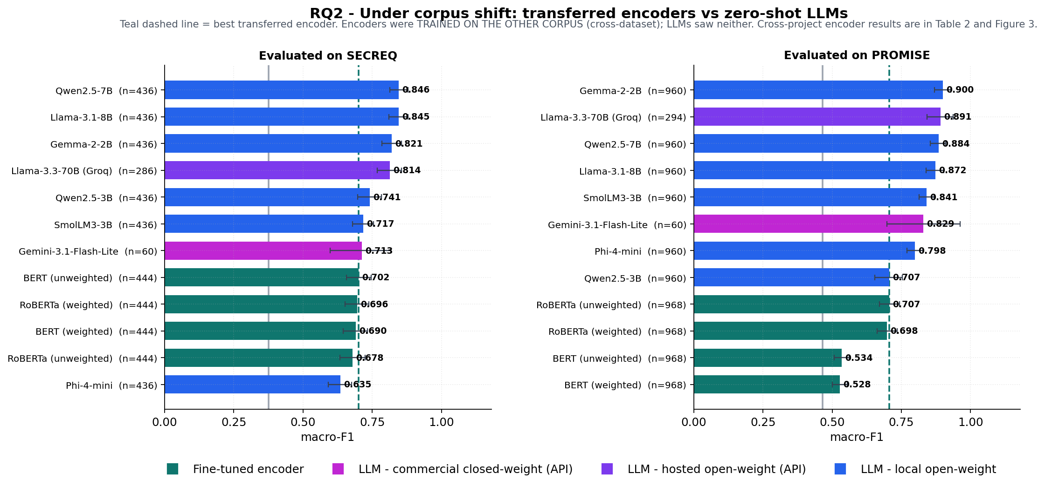
Figure 3.3. RQ2: transferred encoders against zero-shot LLMs on the two cross-dataset security arms; on both corpora the transferred encoders drop below the prompted field.
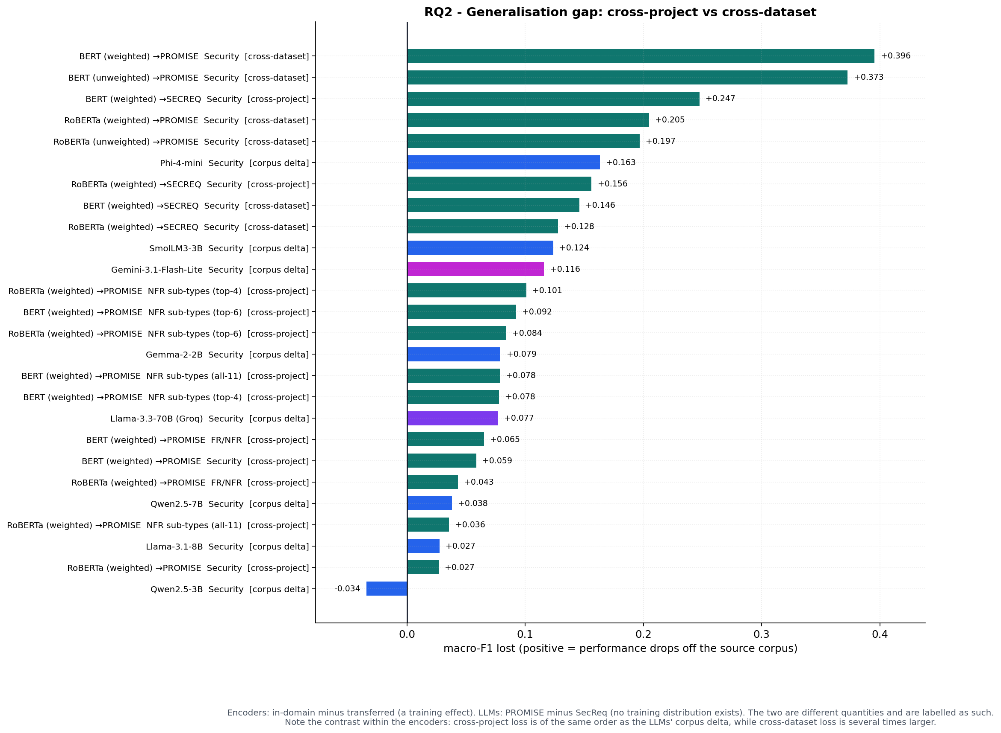
Figure 3.4. The generalisation gap per configuration and regime.

3.11 Results: Few-Shot Prompting and Prompt Sensitivity
Few-shot prompting mirrors the mechanism of Section 3.10. It is net-negative on the binary tasks (mean paired gain −0.007 over 54 tests — the over-prompting effect) but uniformly helpful on the sub-types (mean +0.062 over 36 tests; all 14 BH-significant sub-type effects are gains), where exemplars communicate an unfamiliar annotation vocabulary. Overall, across 90 paired comparisons the median gain is +0.024 macro-F1; 44 tests — corrected as a family separate from the 260 encoder–LLM tests — are BH-significant, splitting 26 improvements against 18 degradations (Fig. 3.5). Prompt phrasing (base / terse / verbose, Table 3.6) is usually a second-order effect — the median spread across the nine paired model × task cells is 0.0439 macro-F1 — but the extreme is 0.4846 (Gemma-2-2B on SecReq security), so phrasing sensitivity is a per-model property that must be reported, not averaged away. Fig. 3.6 completes the picture with per-class F1 on the in-domain all-11 sub-type task: it shows where each configuration's errors concentrate.
Table 3.6. Prompt-phrasing sensitivity on paired items.
Model | Task | Dataset | n paired | F1 base | F1 terse | F1 verbose | Spread
Gemma-2-2B | fr_nfr | promise | 300 | 0.6706 | 0.6654 | 0.6875 | 0.0221
Gemma-2-2B | security | promise | 300 | 0.8895 | 0.5558 | 0.9010 | 0.3452
Gemma-2-2B | security | secreq | 300 | 0.8271 | 0.3433 | 0.8279 | 0.4846
Qwen2.5-7B | fr_nfr | promise | 300 | 0.6747 | 0.6779 | 0.6697 | 0.0082
Qwen2.5-7B | security | promise | 300 | 0.8787 | 0.8193 | 0.8716 | 0.0594
Qwen2.5-7B | security | secreq | 300 | 0.8509 | 0.6290 | 0.8484 | 0.2219
Qwen2.5-7B | subtype_all | promise | 218 | 0.6060 | 0.5905 | 0.6264 | 0.0359
Qwen2.5-7B | subtype_top4 | promise | 200 | 0.8888 | 0.8679 | 0.8620 | 0.0268
Qwen2.5-7B | subtype_top6 | promise | 200 | 0.8130 | 0.8489 | 0.8050 | 0.0439

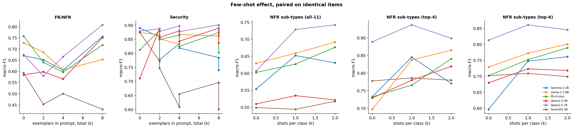
Figure 3.5. Few-shot gains by model and k; hatched bars are BH-significant.
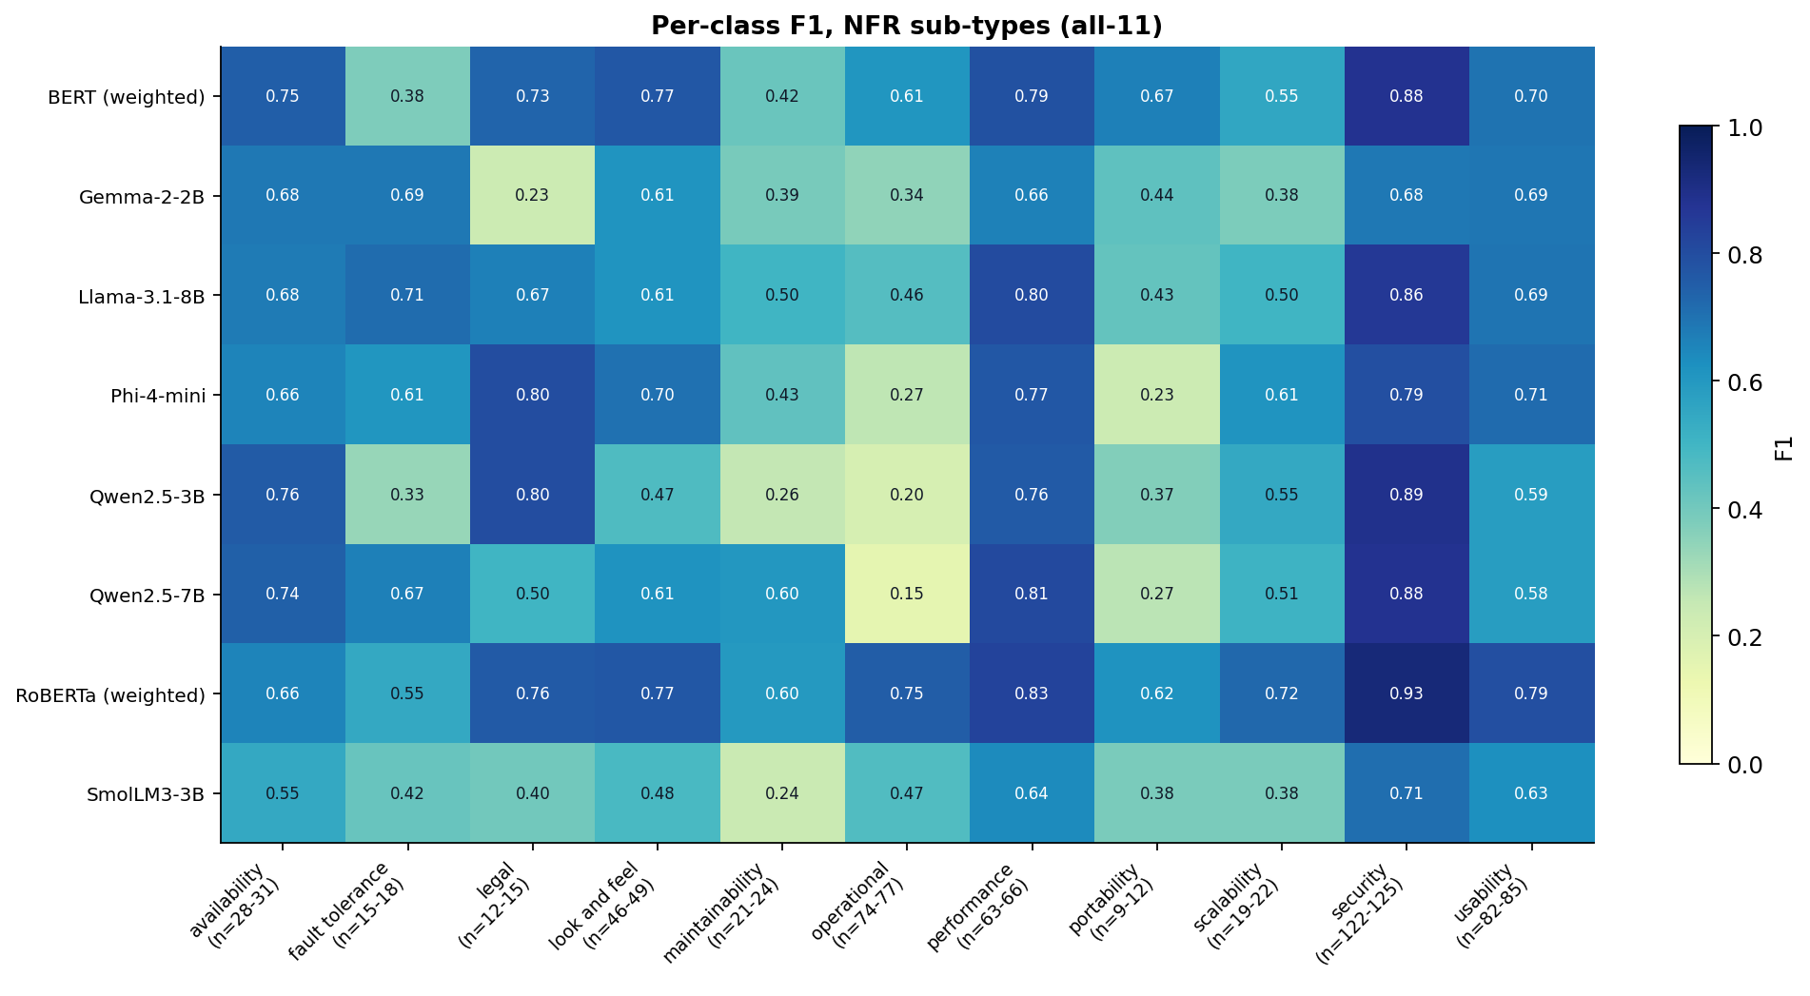
Figure 3.6. Per-class F1 on the in-domain all-11 sub-type task: where each model's errors concentrate, with class support under each column. The security-transfer per-class numbers are in Section 3.10.

3.12 Results: RQ3 — Cost and the Accuracy–Cost Frontier
Encoder inference costs ≈ $0.0024 per 1,000 classifications on the imputed T4 rental, 9 to 47 times cheaper than every prompted option ($0.0216–$0.1132 per 1,000 across all reportable prompted cells; $0.025–$0.070 on per-model medians), and the one-off fine-tuning cost is small (median $0.0093 for a single deployable model, ≈ 277 GPU-seconds across all folds of a family). All 276 encoder-versus-alternative break-even analyses are finite: N⁎ ranges from 46 to 552 classifications (median 215), and the encoder is the cheaper option in 276 of 276 pairs by 100,000 items. The Pareto frontier over reportable cells (Fig. 3.7) contains 10 cells: 9 encoder cells and one prompted entry — quantised Qwen2.5-7B on SecReq security (macro-F1 0.8461) — which is therefore the strongest freely available prompted fallback on that cell; no single prompted model leads on every task (Table 3.3). Fig. 3.8 shows the break-even curves, Fig. 3.9 the cost per correct classification, and Fig. 3.10 the latency profile: hosted-API medians are fast (0.095 s) but rate-limit queueing inflates the observed means, which is why all wall-clock projections in the cost tables use the median with the queue-inflated mean reported alongside.
Answering RQ3: fine-tune a small encoder whenever a few hundred labelled examples and non-trivial volume exist; prompt a mid-size quantised open model (Qwen2.5-7B here) when entering an unlabelled or shifting domain.
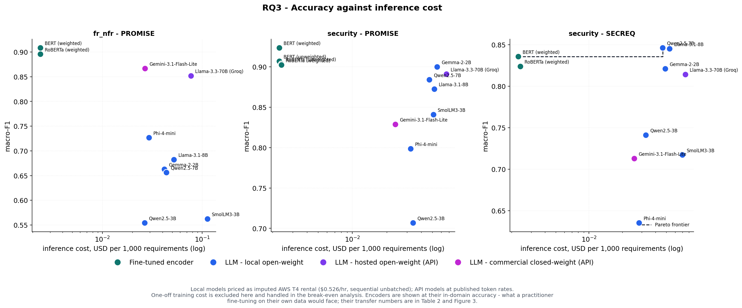
Figure 3.7. Accuracy against inference cost: the Pareto frontier over reportable cells. The frontier is computed within each task × dataset cell and pooled; the three binary cells are plotted.
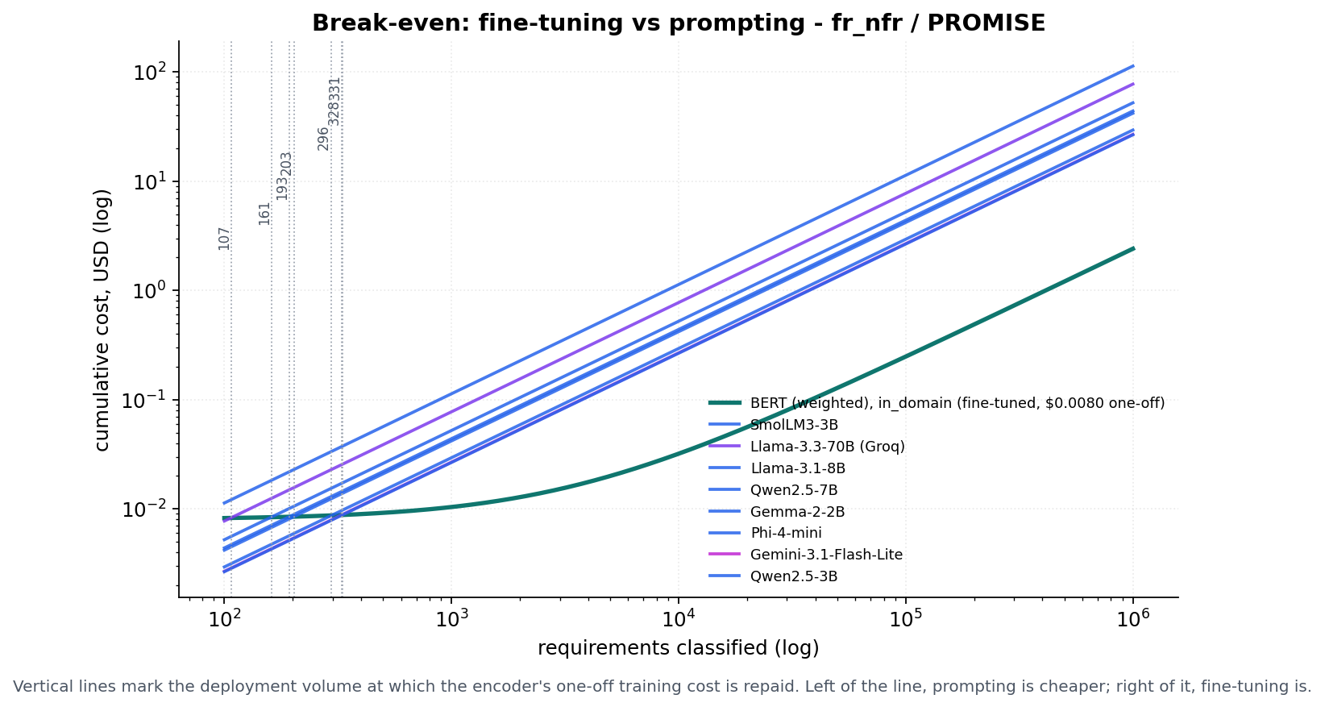
Figure 3.8. Break-even volume: cumulative cost of the encoder against each alternative. The panel plots the FR/NFR cell; the 46–552 range covers all 276 pairs.
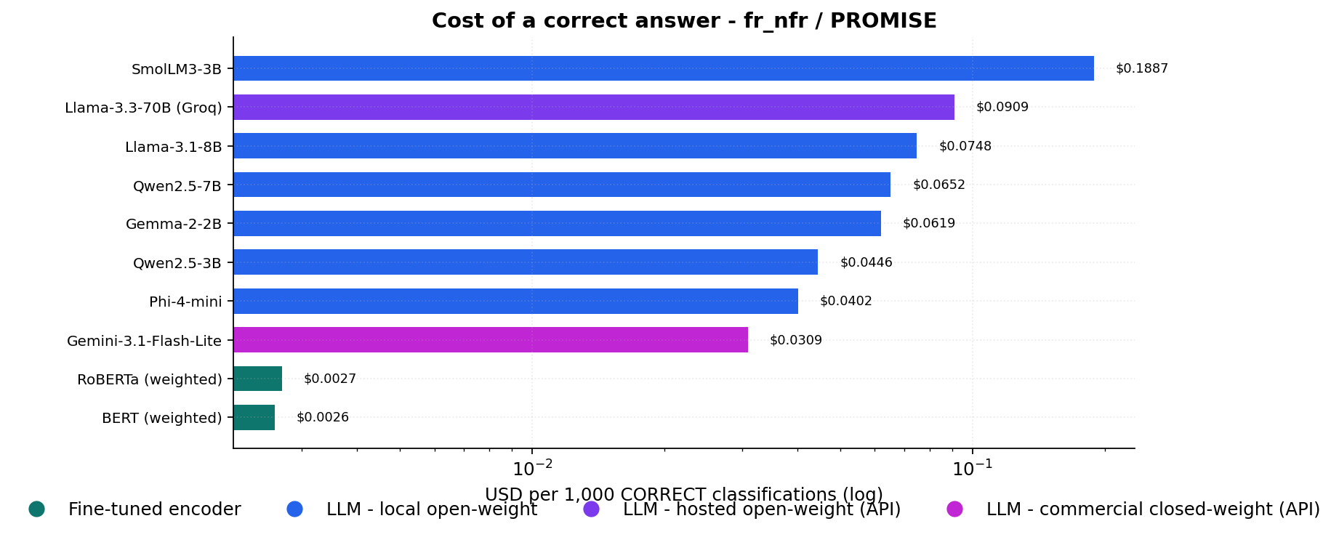
Figure 3.9. Cost per correct classification.
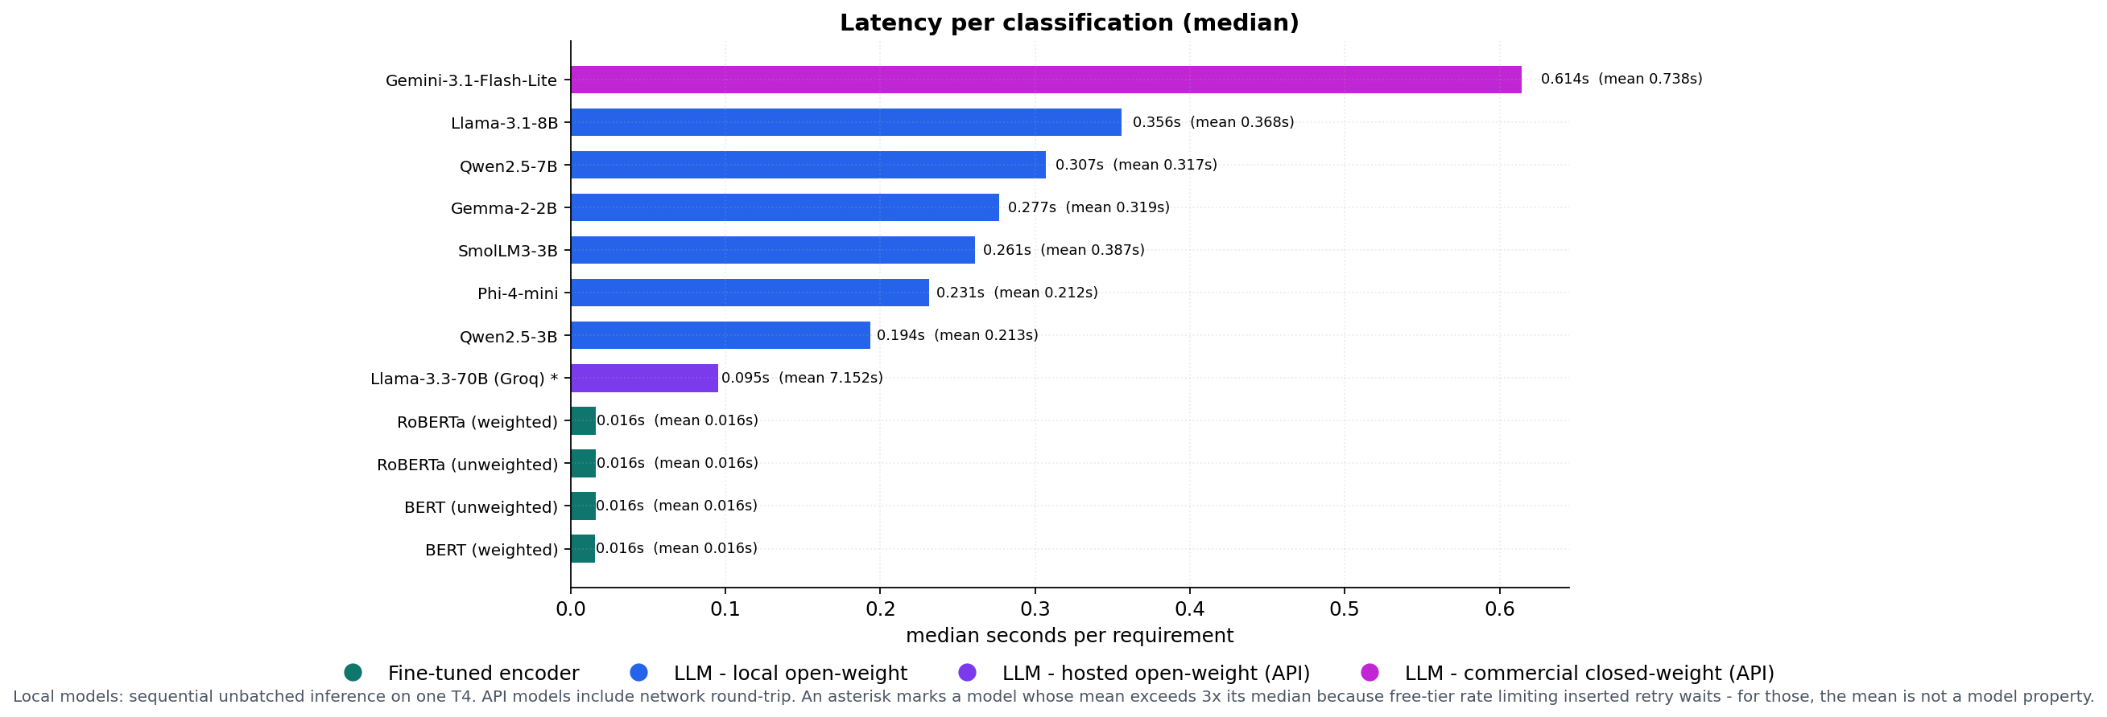
Figure 3.10. Latency profile per model: median against mean; queue-inflated means flagged.

3.13 Threats to Validity
Internal. The commercial arm ran at n ≈ 60 per cell, where 23 of its 26 paired comparisons are inconclusive, so “never significantly beaten” partly reflects limited power there. Free-tier quotas caused missing-not-at-random dropout for some hosted configurations and capped one commercial model's sub-type sample; the reportability gate excludes affected cells rather than imputing them. Local models ran under 4-bit quantisation, which may understate full-precision accuracy, and each configuration was trained with a single seed, so small encoder-to-encoder margins should not be over-read. A small number of source texts carried a legacy encoding artefact; they are reported in the Stage-1 manifest rather than silently rewritten. Construct. GPU costs are imputed from a rental rate, not billed; token prices are 2026-snapshot list prices (the ratios are more durable than the absolutes); the cost model prices computation only — the human annotation cost of the labelled data an encoder needs is excluded, which favours the encoder, and no classical (e.g. TF-IDF) baseline is priced; N⁎ is a pure cost crossover computed for every encoder–alternative pair regardless of the accuracy gap; strict scoring counts format non-compliance as error, which matches deployment but differs from lenient protocols. External. Both corpora are small, dated, and public, so pre-training contamination may inflate prompted in-domain scores — which would make the observed encoder advantage conservative; the two security label sets are also not defined identically — PROMISE_exp's is derived from the SE sub-type and is therefore non-functional by construction, while SecReq annotates any security-relevant sentence, functional ones included — so the cross-dataset arm carries definitional as well as distributional shift; results cover English requirements and one taxonomy; leave-project-out exists only for FR/NFR because SecReq has no comparable project structure, and the cross-dataset finding rests on one corpus pair. Conclusion. All paired tests are exact and multiplicity-corrected; the frozen splits depend on the version of the library that generated them, which is why they are stored once and never regenerated.

3.14 Summary
In-domain, fine-tuned encoders are never significantly beaten on any task; their advantage survives cross-project transfer but collapses across corpora, where prompted models — tuned on nothing — win 48 of 64 paired tests. Encoders are the cheapest option beyond a few hundred classifications on every measured pairing; a quantised 7 B open model is the best freely available prompted fallback on the transfer cell measured here. The next chapter interprets these findings against the literature of Chapter 2.

References
[1] J. Cleland-Huang, R. Settimi, X. Zou, and P. Solc, “Automated classification of non-functional requirements,” Requirements Engineering, vol. 12, no. 2, pp. 103–120, 2007.
[16] E. Knauss, S. Houmb, K. Schneider, S. Islam, and J. Jürjens, “Supporting requirements engineers in recognising security issues,” in Proc. REFSQ, 2011, pp. 4–18.
[17] M. Lima, V. Valle, E. Costa, F. Lira, and B. Gadelha, “Software engineering repositories: Expanding the PROMISE database,” in Proc. XXXIII Brazilian Symp. Software Engineering (SBES), Salvador, Brazil, 2019, pp. 427–436.
[19] J. Devlin, M.-W. Chang, K. Lee, and K. Toutanova, “BERT: Pre-training of deep bidirectional transformers for language understanding,” in Proc. NAACL-HLT, 2019, pp. 4171–4186.
[20] Y. Liu, M. Ott, N. Goyal, J. Du, M. Joshi, D. Chen, O. Levy, M. Lewis, L. Zettlemoyer, and V. Stoyanov, “RoBERTa: A robustly optimized BERT pretraining approach,” arXiv:1907.11692, 2019.
[21] T. Dettmers, A. Pagnoni, A. Holtzman, and L. Zettlemoyer, “QLoRA: Efficient finetuning of quantized LLMs,” in Advances in Neural Information Processing Systems, vol. 36, 2023, pp. 10088–10115.
[22] F. Pedregosa et al., “Scikit-learn: Machine learning in Python,” Journal of Machine Learning Research, vol. 12, pp. 2825–2830, 2011.
[23] ISO/IEC 25010:2011, Systems and Software Engineering — Systems and Software Quality Requirements and Evaluation (SQuaRE) — System and Software Quality Models. Geneva, Switzerland: International Organization for Standardization, 2011.
[24] B. Efron and R. J. Tibshirani, An Introduction to the Bootstrap. New York, NY, USA: Chapman & Hall/CRC, 1993.
[25] Q. McNemar, “Note on the sampling error of the difference between correlated proportions or percentages,” Psychometrika, vol. 12, no. 2, pp. 153–157, 1947.
[26] S. Holm, “A simple sequentially rejective multiple test procedure,” Scandinavian Journal of Statistics, vol. 6, no. 2, pp. 65–70, 1979.
[27] Y. Benjamini and Y. Hochberg, “Controlling the false discovery rate: A practical and powerful approach to multiple testing,” Journal of the Royal Statistical Society B, vol. 57, no. 1, pp. 289–300, 1995.

