PROJECT DOCUMENTATION
E-commerce Analytics Pipeline
BigQuery, dbt and Power BI: from raw data to business insight

Item | Detail
Dataset | Jaffle Shop (customers, orders, payments)
Warehouse | Google BigQuery, project dbt-bigquery-513807, dataset dbt_crash_course
Transformation | dbt with the dbt-bigquery adapter
Visualization | Power BI Desktop
Version | 1.0
Date | 5 November 2026

Contents
1. Executive Summary
2. Business Problem and Objectives
3. Solution Architecture
4. Environment and Setup
5. Data Sources
6. Data Transformation
7. Data Quality and Testing
8. Model Documentation
9. Power BI Dashboard
10. Business Metrics
11. Operations
12. Limitations and Future Improvements
13. References

1. Executive Summary
This project delivers an end-to-end analytics pipeline for an e-commerce business. Raw transactional data is loaded into Google BigQuery, cleaned and modeled with dbt into a layered structure (raw, staging, marts), validated with automated data tests, and exposed to business users through a Power BI dashboard.
The result is a single, trusted source of truth for orders, customers and payments, with consistent metric definitions, documented models and a repeatable build process.
Headline results (January to April 2018 data):
Metric | Value
Total Orders | 99
Total Customers | 100
Successful Payment Amount | 167K
Payment Success Rate | 0.94

2. Business Problem and Objectives

2.1 Problem statement
Operational tables are not suitable for direct reporting. Column names are inconsistent, business definitions such as a successful payment are not standardized, and there is no automated check that the data is correct. As a result, stakeholders cannot reliably answer basic questions about sales performance.

2.2 Business questions
- How many orders and customers does the business have, and what is the status of those orders?
- How much revenue comes from successful payments, and what share of payments succeed?
- Which customers generate the most revenue?
- Which payment methods do customers use most?
- How does revenue change over time?

2.3 Objectives
- Centralize raw data in a cloud data warehouse.
- Standardize and clean data in a dedicated staging layer.
- Publish business-ready dimension and fact tables.
- Guarantee data quality with automated tests.
- Document every model so the project is easy to maintain.
- Deliver a self-service dashboard for decision makers.

3. Solution Architecture

3.1 Data flow
Source tables (customers, orders, payments) flow into the BigQuery raw dataset, then into dbt staging views, then into dbt mart tables, and finally into the Power BI dashboard. Code is versioned in Git, and dbt provides transformation, testing and documentation across the warehouse layers.
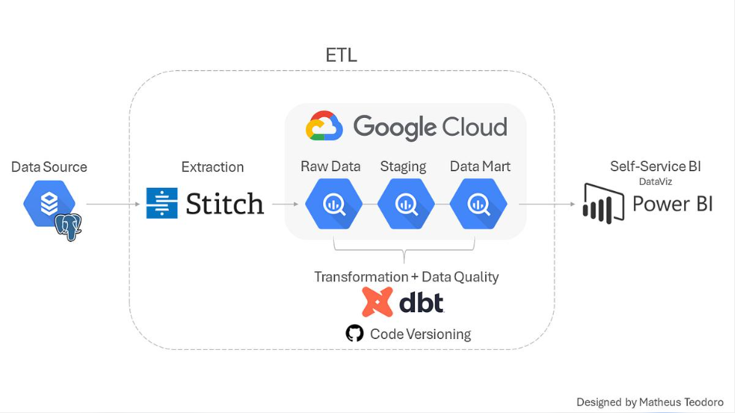
Figure 1: Reference pipeline architecture (adapted from Matheus Teodoro, Medium). This project loads data directly into BigQuery without a separate extraction tool.

3.2 Layers
Layer | Objects | Materialization | Purpose
Raw | customers, orders, payments | Tables | Untouched source data
Staging | stg_customers, stg_orders, stg_payments | Views | Rename columns, cast types, light cleaning
Marts | dim_customers, fact_orders, fact_payment | Tables | Business-ready dimensional model
BI | Power BI report | n/a | Visualization and self-service analysis

3.3 Technology stack
Component | Technology | Role
Data warehouse | Google BigQuery | Storage and compute
Transformation | dbt (dbt-bigquery) | Modeling, testing, documentation
Language | SQL | Cleaning, aggregation, modeling
Visualization | Power BI Desktop | Dashboard and reporting
Version control | Git / GitHub | Code versioning

4. Environment and Setup

4.1 Prerequisites
- Python and pip
- A Google Cloud project with BigQuery enabled
- A BigQuery service account key with Data Editor and Job User roles
- Power BI Desktop

4.2 Installation
pip install dbt-bigquery

4.3 Connection profile
Configure the service account in ~/.dbt/profiles.yml, then verify the connection:
dbt debug --profiles-dir "$HOME/.dbt"

4.4 Project structure
dbt_crash_course/
dbt_project.yml
README.md
analyses/
macros/
models/
mart/core/ dim_customers, fact_orders, fact_payment, schema.yml
raw/
stg/jaffle_shop/ stg_customers, stg_orders, stg_payments, schema.yml
seeds/
snapshots/
tests/

5. Data Sources
Table | Description | Key
customers | One record per customer | customer_id
orders | One record per order placed | order_id
payments | One record per payment attempt | payment_id

6. Data Transformation

6.1 Staging layer
Staging models map one-to-one to the source tables and are materialized as views. They apply consistent naming, correct data types (for example customer_id as INT64) and basic cleaning. No business logic is applied at this stage.
Model | Source | Responsibility
stg_customers | customers | Standardize customer fields
stg_orders | orders | Standardize order id, customer id, date and status
stg_payments | payments | Standardize payment method, status and amount

6.2 Mart layer
Mart models join and aggregate staging models into a dimensional structure and are materialized as tables for fast reads from Power BI.
Model | Type | Grain | Description
dim_customers | Dimension | One row per customer | Customer attributes plus order summary: first order date, most recent order date, number of orders
fact_orders | Fact | One row per order | Order id, customer id, order date, status and amount
fact_payment | Fact | One row per payment | Payment id, order id, payment method, status and amount

6.3 Relationships
- dim_customers.customer_id to fact_orders.customer_id (one to many)
- fact_orders.order_id to fact_payment.order_id (one to many)
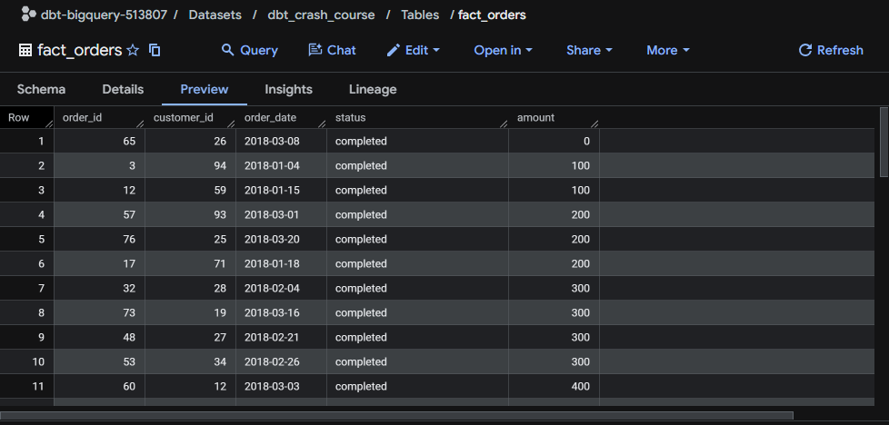
Figure 2: fact_orders table preview in BigQuery.

6.4 Data dictionary: fact_orders
Column | Type | Description
order_id | INT64 | Unique identifier of the order (primary key)
customer_id | INT64 | Customer who placed the order (foreign key to dim_customers)
order_date | DATE | Date the order was placed
status | STRING | placed, shipped, completed, return_pending or returned
amount | INT64 | Order amount derived from payments

7. Data Quality and Testing
Quality is enforced with dbt tests that run on every dbt build. A failing test stops the pipeline from silently publishing bad data.
Test | Applied to | Purpose
unique | customer_id, order_id, payment_id | No duplicate primary keys
not_null | Primary and foreign keys | No missing identifiers
relationships | fact_orders.customer_id, fact_payment.order_id | Every fact row has a valid parent record
accepted_values | status, payment_method | Only expected categories appear

Example configuration:
models:
- name: fact_orders
columns:
- name: order_id
tests: [unique, not_null]
- name: customer_id
tests:
- not_null
- relationships:
to: ref('dim_customers')
field: customer_id

8. Model Documentation
Every model and column carries a description in schema.yml. The documentation site, including the interactive lineage graph, is generated by dbt:
dbt docs generate
dbt docs serve --port 8080

The site is then available at http://localhost:8080.
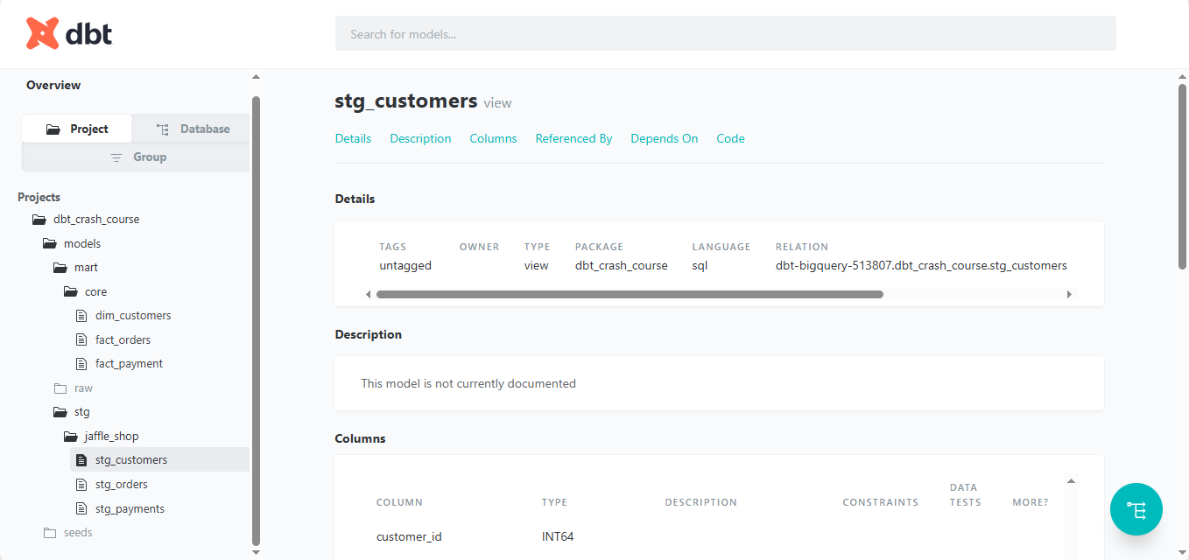
Figure 3: dbt documentation site showing the project tree and the stg_customers model.

9. Power BI Dashboard
The E-commerce Sales Overview report connects to the mart tables in BigQuery.
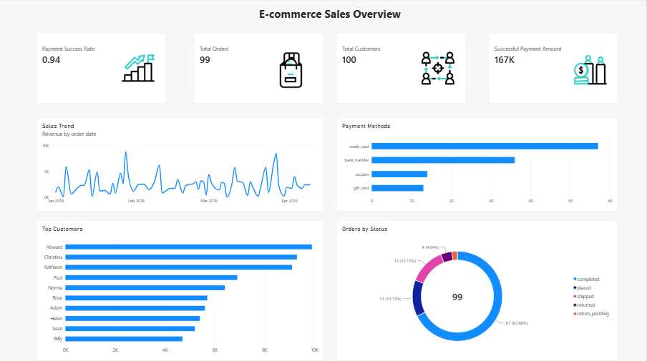
Figure 4: E-commerce Sales Overview dashboard.

9.1 Visuals
Visual | Content | Insight
KPI cards | Payment Success Rate, Total Orders, Total Customers, Successful Payment Amount | Headline business health
Sales Trend | Revenue by order date | Daily revenue is volatile, peaking near 10K
Payment Methods | Orders by credit card, bank transfer, coupon, gift card | Credit card is the most used method
Top Customers | Customers ranked by revenue | A small group of customers drives a large share of revenue
Orders by Status | Completed, placed, shipped, returned, return pending | 67 of 99 orders (about 68%) are completed

9.2 Connecting Power BI
- Open Power BI Desktop and choose Get Data, then Google BigQuery.
- Sign in and select project dbt-bigquery-513807 and dataset dbt_crash_course.
- Import dim_customers, fact_orders and fact_payment. Use mart tables only, not staging views.
- Confirm relationships on customer_id and order_id.
- Build the visuals and publish or share the report.

10. Business Metrics
Metric | Definition | Source
Total Orders | Count of distinct order_id | fact_orders
Total Customers | Count of distinct customer_id | dim_customers
Successful Payment Amount | Sum of amounts where payment status is successful | fact_payment
Payment Success Rate | Successful payments divided by total payments | fact_payment
Revenue Trend | Revenue aggregated by order_date | fact_orders

11. Operations

11.1 Common commands
Command | Purpose
dbt run | Build all models
dbt run --select stg | Build staging models only
dbt test | Run all data tests
dbt build | Run models and tests together
dbt run --full-refresh | Rebuild models from scratch
dbt docs generate | Generate documentation

11.2 Recommended workflow
- Create a feature branch in Git.
- Change or add models and update schema.yml.
- Run dbt build locally and confirm all tests pass.
- Open a pull request and merge to the main branch.
- Refresh the Power BI dataset.

12. Limitations and Future Improvements
- The dataset is small and covers January to April 2018, so trends are illustrative.
- BigQuery sandbox mode limits table expiry and some features.
- Add a scheduled run (dbt Cloud, GitHub Actions or Airflow) for automated refreshes.
- Add source freshness checks and CI that runs dbt build on every pull request.
- Add an incremental strategy for large fact tables.
- Extend the model with product and date dimensions.

13. References
- dbt documentation: https://docs.getdbt.com/
- BigQuery adapter setup: https://docs.getdbt.com/reference/warehouse-setups/bigquery-setup
- Power BI: https://powerbi.microsoft.com/
- Architecture diagram: Matheus Teodoro, Projeto Northwind: Pipeline de Dados, Medium

