Name: Fatma Osman Mahmoud
Lab 3: Multi-Tenancy with Namespaces and Internal Routing

Overview:
In this lab, we used a single Kubernetes cluster to deploy two separate environments: Development (dev) and Staging (staging). Each environment has a frontend and backend application, logically separated using namespaces. The backend runs a simple Python HTTP server, and the frontend uses Nginx to communicate with the backend using the backend service name.

Project Structure:
lab3-k8s/
- backend-app.py (Backend Python server with endpoints `/`, `/health`, `/info`)
- Dockerfile.backend (Dockerfile for backend image)
- index.html, nginx.conf, Dockerfile.frontend (Frontend application and Nginx config)
- dev-environment.yaml, staging-environment.yaml (Kubernetes manifests)
- README.md (This documentation)

Steps to Run the Lab:
1. Build Docker Images:
docker build -f Dockerfile.backend -t backend-app:latest .
docker build -f Dockerfile.frontend -t frontend-app:latest .

2. Load Images into Minikube:
minikube image load backend-app:latest
minikube image load frontend-app:latest

3. Create Namespaces:
kubectl create namespace dev
kubectl create namespace staging

4. Apply Kubernetes YAML Files:
kubectl apply -f dev-environment.yaml
kubectl apply -f staging-environment.yaml

5. Check Pods and Services:
Dev Namespace:
kubectl get pods,svc -n dev
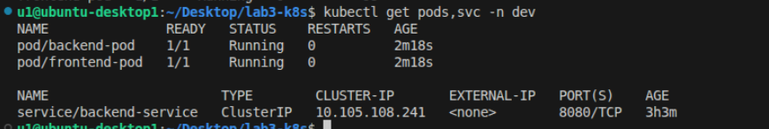
Staging Namespace:
kubectl get pods,svc -n staging
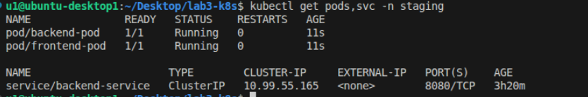
6. Port Forward to Access Frontend:
Dev Frontend:
kubectl port-forward pod/frontend-pod 8082:80 -n dev
Open browser at http://localhost:8082
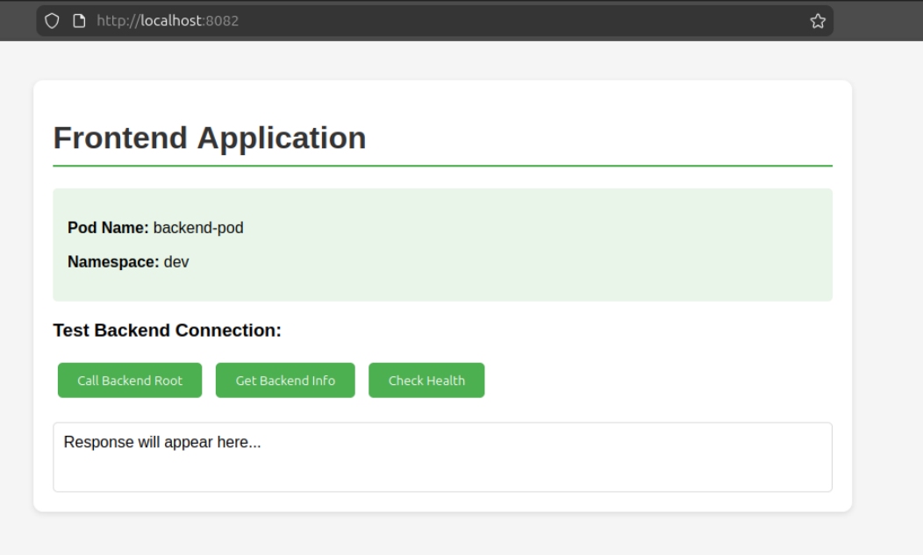
Staging Frontend:
kubectl port-forward pod/frontend-pod 8083:80 -n staging
Open browser at http://localhost:8083
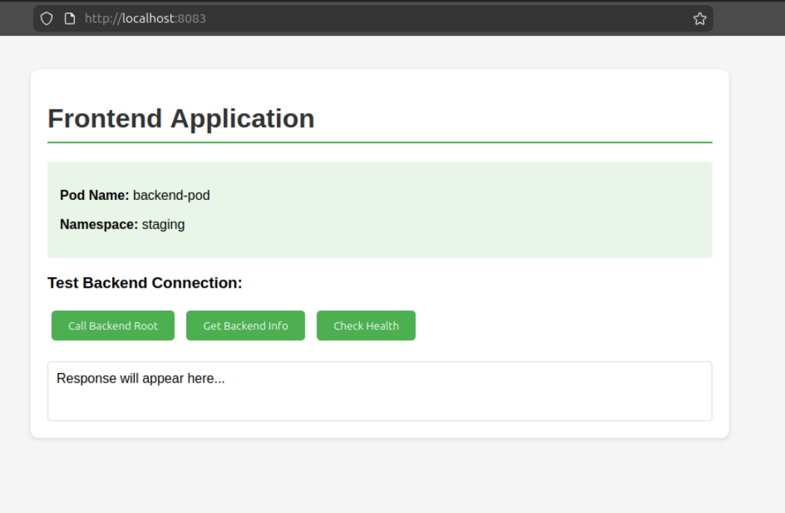
Notes:
- The backend exposes three endpoints: `/`, `/health`, `/info`.
- Frontend communicates with backend using the backend-service in the same namespace.
- Pod names and namespaces are displayed on the frontend for easy identification.
- imagePullPolicy: Never is used in YAML to ensure Kubernetes uses local images from Minikube.

