Project Planning & Management

1. Project Proposal

1.1 Project Overview
NutriVision is a mobile application that helps users manage their diet and make healthier food choices. Users can enter descriptions of their meals and receive estimated nutritional information, dietary advice, and healthier recipe alternatives. The application also allows users to calculate their BMI and daily calorie needs, track their daily water intake, monitor their weekly progress, and keep a record of their meals.
The application uses AI and prompt engineering to provide personalized food recommendations, healthier alternatives, and healthy recipes based on users' preferences and dietary restrictions. Firebase Authentication allows users to create accounts and sign in, while Firebase Cloud Firestore stores and syncs their meal records, water intake, and other related information.

1.2 Objectives

1.2.1 Functional Objectives
- Meal Management & Nutrition Analysis: Allow users to add, view, edit, and delete meals and receive estimated nutritional information through a suitable nutrition API.
- AI Recommendations & Healthy Recipe Generation: Use AI to provide personalized food recommendations, healthier alternatives, and healthy recipes based on users' needs and preferences.
- Weekly Progress Analytics: Display charts to help users track their meals, daily nutritional intake, and weekly progress.
- BMI & Calorie Calculator: Calculate users' BMI and estimate their daily calorie needs based on their age, weight, height, and activity level.
- Water Intake Tracking: Allow users to record their daily water intake and follow their progress toward their water intake goals.
- User Authentication: Allow users to register, sign in, and sign out using email and password or Google through Firebase Authentication.

1.2.2 Technical & Quality Objectives
- Mobile Application Development: Build a simple, responsive, and user-friendly mobile application using Flutter and Dart.
- API Integration: Use Dio and Interceptors to send requests to external nutrition APIs and handle responses and errors.
- Data Storage and Synchronization: Use Firebase Cloud Firestore to store and sync meal records, water intake, user information, dietary preferences, and progress data.
- AI Integration & Prompt Engineering: Use AI services and well-designed prompts to provide suitable food recommendations, healthier alternatives, and healthy recipes.
- Data Visualization: Use charting libraries to display weekly progress and nutritional information.
- Testing & Reliability: Use Unit and Widget tests to check calculations, API requests, data storage, tracking features, and the user interface.
- Security: Use Firebase Authentication and suitable Firestore security rules to protect user accounts and stored data.

1.3 Project Scope
The scope of NutriVision includes the following features and activities:
- App Development: Develop a Flutter mobile application for diet and nutrition management.
- User Interface: Design a simple and responsive interface using Flutter components such as GridView and Stack where appropriate. The design process will include user personas, wireframes, and user flows.
- User Authentication: Allow users to register, sign in, and sign out using email and password or Google through Firebase Authentication.
- Meal Management: Allow users to add, view, edit, and delete their meal records.
- Nutrition Analysis: Use an external nutrition API to provide estimated nutritional information for recorded meals.
- AI Integration & Prompt Engineering: Use AI services to generate personalized food recommendations, healthier alternatives, and healthy recipes.
- Dietary Preferences: Consider users' food preferences, allergies, and dietary restrictions when generating recommendations and recipes.
- Weekly Progress Analytics: Display meal history, daily nutritional intake, and weekly progress through charts based on recorded data.
- BMI & Calorie Calculator: Calculate BMI and estimate daily calorie needs using users' personal information and activity level.
- Water Intake Tracking: Allow users to record daily water intake and monitor their progress.
- API Integration: Use Dio and Interceptors to communicate with external nutrition APIs and handle errors.
- Data Storage: Use Firebase Cloud Firestore to store and sync meal records, water intake, user information, dietary preferences, and progress data.
- Testing: Use Unit and Widget tests to check calculations, API communication, data storage, and user interface behavior.

2. Project Plan

2.1 Timeline & Phases
The project will be completed in six phases from October to December 2026. Some phases will run at the same time to help the team finish the project within the deadline.
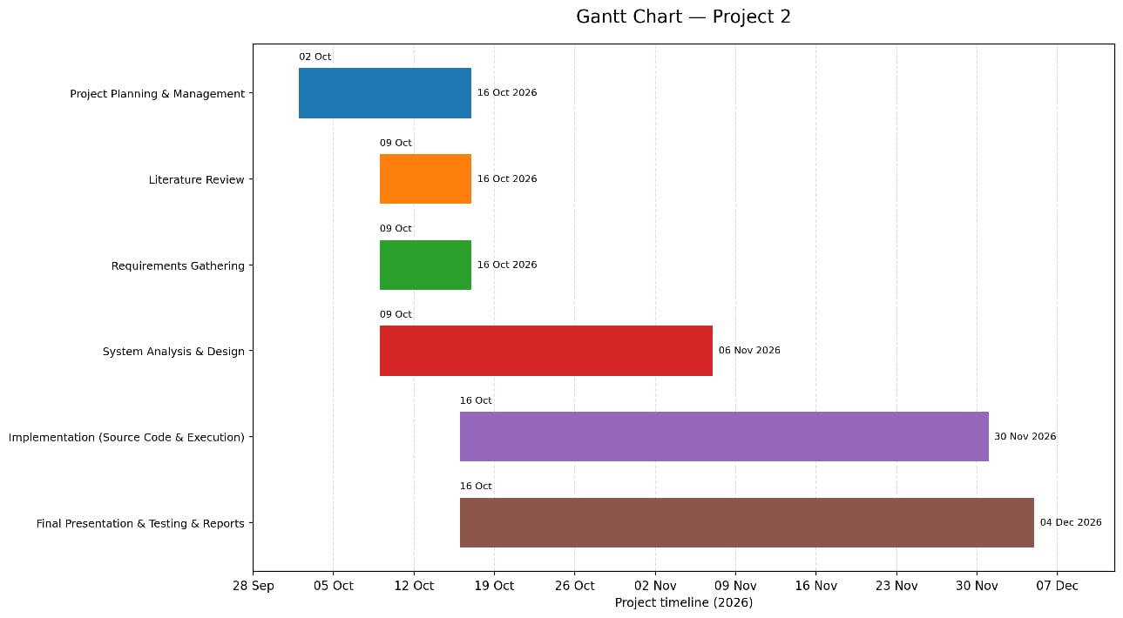

2.2 Key Milestones
- Milestone 1 – 16 October 2026: Complete project planning, literature review, and requirements gathering.
- Milestone 2 – 6 November 2026: Complete system analysis, software architecture, database design, and UI/UX design.
- Milestone 3 – 30 November 2026: Complete the main Flutter features, including authentication, meal management, nutrition analysis, BMI and calorie calculations, and water intake tracking.
- Milestone 4 – 30 November 2026: Complete AI recommendations, healthy recipe generation, weekly analytics, nutrition API integration, and Firebase integration.
- Milestone 5 – 4 December 2026: Complete final testing, documentation, the final presentation, and the project infographic.
Milestones 3 and 4 share the same deadline because the team will work on the main application features and service integrations in parallel.

2.3 Deliverables
- Project Documentation
The project proposal, project plan, task assignments, risk assessment, and KPIs.
- Literature Review
A review of related work, existing applications, and possible improvements.
- Requirements Documentation
Stakeholder analysis, user stories, use cases, and functional and non-functional requirements.
- System Analysis & Design
The problem statement, project objectives, software architecture, database design, ER diagram, DFD, sequence diagrams, activity diagrams, state diagrams, class diagrams, deployment diagram, component diagram, UI/UX designs, and technology stack.
- API & Integration Documentation
Documentation for the nutrition API, AI integration, Firebase Authentication, Cloud Firestore, BMI and calorie calculations, water tracking, and application deployment.
- Implementation
Flutter source code for authentication, meal management, nutrition analysis, AI recommendations, healthy recipes, weekly analytics, BMI and calorie calculations, and water intake tracking.
The implementation will also include a README file, clear code organization, reusable components, input validation, error handling, and appropriate security practices.
- Version Control
A GitHub repository with meaningful commit messages, a suitable branching strategy, and records of team contributions where applicable.
- Testing & Quality Assurance
A test plan, test cases, Unit and Widget tests, test results, and bug reports covering the main application features.
- Final Documentation
The user manual, technical documentation, database schema, and final project report.
- Final Presentation
A PowerPoint or PDF presentation, project infographic, and an optional video demonstration.

2.4 Resource Allocation
- Development: Flutter, Dart, Visual Studio Code, and Android Studio.
- Authentication: Firebase Authentication for email and Google sign-in.
- Database & Cloud Services: Firebase Cloud Firestore for data storage and synchronization.
- APIs & AI: An external nutrition API and an AI service for nutrition-related recommendations and recipe generation.
- Networking: Dio and Interceptors for API requests, responses, and error handling.
- Data Visualization: Flutter charting libraries for weekly progress charts.
- Testing: Unit and Widget testing tools, along with Postman for testing API requests.
- Version Control: Git and GitHub for source code management and team collaboration.
- UI/UX Design: Figma for wireframes and interface designs.
- Documentation & Presentation: Microsoft Word and PowerPoint.

3. Task Assignment & Roles

3.1 Team Roles
The five team members will divide the work based on their skills and the project's needs. Team members can help each other with shared tasks when needed.

Project Coordinator
Organize tasks, monitor progress, coordinate team communication, and follow the project timeline.

UI/UX Designer
Create user personas, wireframes, user flows, and application screen designs using Figma.

Flutter Developer
Develop the mobile interface and implement meal management, BMI and calorie calculators, and water intake tracking.

API, AI & Firebase Developer
Integrate the nutrition API and AI services, design prompts, and implement Firebase Authentication and Cloud Firestore.

Testing & Documentation Member
Prepare test cases, perform Unit and Widget testing, record bugs, and help prepare the final report and presentation.

4. Risk Assessment & Mitigation Plan

The following risks may affect the development of NutriVision. The team will use the planned solutions to reduce their impact.

Risk | Impact | Mitigation Plan
API Failure or Unavailability | The application may not retrieve nutritional information. | Handle API errors, display clear messages, and allow users to try again.
AI Service Failure | AI recommendations and healthy recipes may not be available. | Handle service errors and allow users to try again later.
Internet Connectivity Issues | Users may not be able to access external APIs or sync their data. | Handle network errors and inform users when an internet connection is required.
Firebase Service Issues | Meal records, water intake, or user data may not be saved or synced correctly. | Handle Firebase errors and test authentication, data storage, and synchronization.
Nutrition Data Accuracy Issues | Nutritional estimates may differ from the actual nutritional content of a meal. | Use a suitable nutrition API, validate input and returned data, and label nutritional values as estimates.
AI Recommendation Accuracy | AI-generated recommendations or recipes may not always be suitable for users. | Use clear prompts, check AI responses for basic validity, and explain that suggestions are for general information only.
BMI & Calorie Calculation Errors | Incorrect calculations may provide inaccurate results. | Use appropriate formulas and test different input values through Unit tests.
Water Intake Tracking Issues | Water records may not be saved or displayed correctly. | Validate user inputs and test calculations, data storage, and retrieval.
Weekly Analytics Errors | Charts may display incorrect or incomplete information. | Check recorded data before displaying charts and test calculations and charts.
Development Delays | Some features may not be completed on time. | Prioritize core features, divide tasks clearly, and monitor progress regularly.
Scope Creep | Additional features may increase the workload and delay the project. | Follow the agreed project scope and complete the planned features before adding optional improvements.
Technical Issues | Coding or integration problems may delay development. | Test features regularly, document problems, and fix them early.
UI Inconsistencies | The interface may look or behave differently across screen sizes. | Use responsive Flutter components and test the interface on supported screen sizes.
Authentication or Data Security Issues | User accounts or stored information may be accessed without permission. | Configure Firebase Authentication correctly, apply suitable Firestore security rules, use HTTPS, and protect secret API keys.

5. KPIs (Key Performance Indicators)
KPI | Target / Measurement
API Response Time | Nutrition API responses should be received within 3 seconds under normal network conditions.
API Success Rate | At least 95% of API requests should complete successfully during testing.
Data Synchronization | At least 95% of tested data synchronization operations should complete successfully.
Test Pass Rate | At least 90% of defined test cases should pass successfully.
Core Features Completion | 100% of planned core features should be implemented and tested.
Application Stability | Zero known critical crashes during final testing.
User Task Success Rate | At least 90% of defined core tasks should be completed successfully during testing.
Nutrition Data Processing | At least 95% of predefined test cases should correctly process and display the nutritional data returned by the nutrition API.
AI Recommendation Availability | At least 90% of tested AI requests should return valid, non-empty recommendations or healthy recipes.
Weekly Analytics Accuracy | At least 95% of predefined test cases should correctly reflect recorded meal and nutrition data.
BMI & Calorie Calculation | All predefined Unit test cases should match expected results within the specified rounding tolerance.
Water Intake Tracking | At least 95% of tested water intake records should be saved and retrieved successfully.

Note: Nutrition Data Processing measures how correctly the application processes and displays data returned by the nutrition API. It does not guarantee that the nutritional estimates exactly match the actual nutritional content of every meal.

