1. Problem Statement & Objectives

1.1 Problem Statement
Maintaining a healthy diet can be challenging because many people find it difficult to track their daily food intake, understand the nutritional value of their meals, and choose healthier alternatives. Calculating calories and nutrients manually can be time-consuming, while finding suitable healthy recipes based on personal dietary preferences may require considerable effort.
Therefore, there is a need for a user-friendly mobile application that simplifies nutrition tracking, provides accessible food information, and helps users make better dietary decisions.
MEALIO: AI-Driven Dietary Health Assistant addresses these challenges by providing a mobile solution that combines food nutrition data, AI-generated dietary recommendations, meal management, and health tracking features in one application.

1.2 Project Objectives
The main objectives of MEALIO are:
- Meal Nutrition Analysis: Allow users to search for foods and retrieve their available nutritional information, including calories, protein, carbohydrates, and fats, using the USDA FoodData Central API.
- Personalized Dietary Recommendations: Use AI prompt engineering to provide dietary suggestions and healthier food alternatives based on users' preferences and dietary restrictions.
- Healthy Recipe Generation: Help users discover healthy recipes suited to their dietary needs and preferences.
- Meal Management: Enable users to save, edit, and delete meal records while keeping their nutritional totals updated.
- BMI and Calorie Calculation: Provide tools to calculate Body Mass Index (BMI) and estimate daily calorie requirements based on user information.
- Water Intake Tracking: Allow users to record and monitor their daily water consumption.
- Weekly Progress Monitoring: Present nutrition and water intake data through charts to help users review their progress over time.
- Secure Data Management: Use Firebase Authentication and Cloud Firestore to support user authentication and store personal meal and health-tracking records.

1.3 Expected Outcome
The expected outcome is a user-friendly mobile application that simplifies daily nutrition tracking, helps users understand their eating habits, and supports healthier food choices through nutritional information, AI-powered recommendations, and progress monitoring.

1.4 Use Case Diagram & Descriptions

1.4.1 System Actors
1. User
- Role: The primary human actor who uses the application for tracking and managing dietary, health, and fitness goals.
2. Firebase Auth
- Role: An external authentication service handling user registration, login, and logout.
3. Firebase Firestore
- Role: A cloud database service used to store, retrieve, and manage application data (user profiles, calculators, trackers, logs, and analytics).
4. Nutrition API
- Role:Retrieves food information and available nutritional values from the USDA FoodData Central API to support food search and nutrition display.
5. AI Service
- Role: An external artificial intelligence service powering smart dietary recommendations, recipe generation, and healthy food alternatives.

1.4.2 Actor Interactions & Use Cases

1. User Interactions
The User interacts with all core functional modules of the system:
- User Authentication: Register, Login, and Logout.
- Manage User Data: Store, view, and edit user profile and personal data.
- BMI & Calorie Calculator: Calculate BMI and daily calorie needs.
- Water Intake Tracker: Track water intake, set water goals, and view water history.
- Weekly Progress Analytics: View weekly health and dietary progress.
- Meal Management & Nutrition Analysis: Add, view, edit, and delete meals.
- AI Recommendations / Healthy Recipes: Get AI-driven recommendations, generate healthy recipes, and find healthy alternatives.

2. Firebase Auth Interactions
- Connects with Register, Login, and Logout to manage user sessions and account creation.

3. Firebase Firestore Interactions
- Connects with data-driven use cases to persist and fetch information, including Store User Data, View User Data, Edit User Data, Calculate BMI, Calculate Daily Calorie Needs, Track Water Intake, Set Water Goal, View Water History, View Weekly Progress, Add Meal, View Meal, Edit Meal, Delete Meal, Get AI Recommendations, Generate Healthy Recipes, and Find Healthy Alternatives.

4. Nutrition API Interactions
- Interacts with the Analyze Nutrition use case (which is included via an <<include>> relationship when a user triggers Add Meal).

5. AI Service Interactions
- Connects with intelligence-driven features: Get AI Recommendations, Generate Healthy Recipes, and Find Healthy Alternatives.

2. Functional & Non-Functional Requirements

2.1Functional Requirements
Functional requirements describe the features and tasks that the MEALIO application must provide.

FR1 – User Authentication
The system shall allow users to register, sign in, and sign out using email and Google authentication.

FR2 – Meal Management
The system shall allow users to add, view, edit, and delete meal records.

FR3 – Nutrition Analysis
The system shall allow users to search for foods and retrieve available nutritional information, including calories, protein, carbohydrates, and fats, from the USDA FoodData Central API.

FR4 – AI Recommendations
The system shall provide personalized nutrition advice based on users’ needs and preferences using AI services.

FR5 – Healthy Recipe Generation
The system shall generate healthy recipes and suggest healthier food alternatives using AI and prompt engineering.

FR6 – Dietary Preferences and Restrictions
The system shall consider users’ dietary preferences, food allergies, and ingredients they need to avoid when generating recommendations and recipes.

FR7 – BMI Calculator
The system shall calculate users’ Body Mass Index (BMI) based on their height and weight.

FR8 – Daily Calorie Calculator
The system shall estimate users’ daily calorie needs based on their age, weight, height, and activity level.

FR9 – Water Intake Tracking
The system shall allow users to record their daily water intake and track their progress.

FR10 – Progress Analytics
The system shall display charts showing users’ daily and weekly nutritional intake and progress.

FR11 – Data Storage
The system shall store meal records, water intake, user information, and progress data using Firebase Cloud Firestore.

FR12 – Data Synchronization
The system shall synchronize users’ stored data across supported devices when an internet connection is available.

FR13 – Input Validation
The system shall validate user inputs before saving records or performing calculations to reduce errors.

FR14 – Allergy and Restriction Warnings
The system shall warn users when a meal or recipe may conflict with their recorded food allergies or dietary restrictions.

FR15 – Medical Disclaimer
The system shall display a disclaimer explaining that AI-generated nutrition advice is for general information and does not replace professional medical advice.

2.2 Non-Functional Requirements
Non-functional requirements describe the quality, performance, security, and reliability of the Mealio application.

NFR1 – Performance
- The application should respond smoothly to user actions.
- Nutrition information should load within 3 seconds, and AI-generated recipes should be returned within 8 seconds under normal network conditions.

NFR2 – Scalability
- The application should support future growth in users and stored data.
- Firestore queries should retrieve data efficiently using appropriate indexes.

NFR3 – Security
- The application shall use secure HTTPS connections when communicating with external services.
- Firestore security rules shall restrict access to each user's data.
- Secret API keys shall be stored securely outside the mobile application when required.

NFR4 – Privacy
- The application shall collect only the data needed to provide its features.
- Users shall be informed about how their personal and dietary data is used.
- The application shall limit the information sent to AI services to what is necessary.

NFR5 – Usability
- The application shall provide a simple and clear interface for users.
- Users should be able to record meals in a few simple steps.
- Text should be readable, and navigation should be clear and easy to understand.

NFR6 – Reliability
- The application should handle network and service errors without crashing or losing saved data.
- The application shall display clear error messages when requests fail.
- The application should provide retry options when appropriate.

NFR7 – Accuracy
- BMI and daily calorie calculations shall use correct formulas and units.
- Calculation functions shall be tested with different input values to verify their results.

NFR8 – Compatibility
- The application shall support the Android versions selected for development and testing.
- The interface should adapt to different supported screen sizes.

NFR9 – Maintainability
- The application code shall be organized into clear components to make updates and testing easier.
- The project shall use Git and GitHub for version control.
- Unit and widget tests shall be used to test important features.

NFR10 – Safety and Responsible AI
- The application shall display a disclaimer explaining that AI-generated nutrition advice is for general information and does not replace professional medical advice.
- The application shall warn users about possible conflicts between suggested meals or recipes and their recorded food allergies or dietary restrictions.
- The application shall not claim to diagnose medical conditions.

5. Assumptions and Constraints

5.1 Assumptions
- Users have a smartphone that supports the MEALIO application.
- Users can access the internet to retrieve nutrition information and use AI-powered features.
- External nutrition APIs and AI services are available and provide the required information.
- Users provide accurate information about their meals, age, weight, height, activity level, and dietary restrictions.
- Firebase Cloud Firestore is available for storing and synchronizing user data.
- Users understand that nutritional information and AI-generated recommendations are estimates and do not replace professional medical advice.

5.2 Constraints
- The project must be completed within the deadline specified in the project plan.
- The application will be developed using Flutter and Dart.
- Firebase Cloud Firestore will be used to store and synchronize user data.
- Third-party nutrition APIs and AI services may have usage limits and costs. Caching repeated nutrition lookups should be considered to reduce API calls.
- AI-estimated nutritional values may not be completely accurate, so users should be able to review and correct the values.
- An internet connection is required for AI features and external nutrition lookups. However, users should be able to record meals offline and synchronize them when the connection is restored.
- The accuracy of nutrition results depends on the available API data and the information entered by users.
- AI-generated recipes and recommendations may require validation and may not always be completely accurate.
- The project scope and implementation are limited by the team's available time, skills, and resources.
6. Software Architecture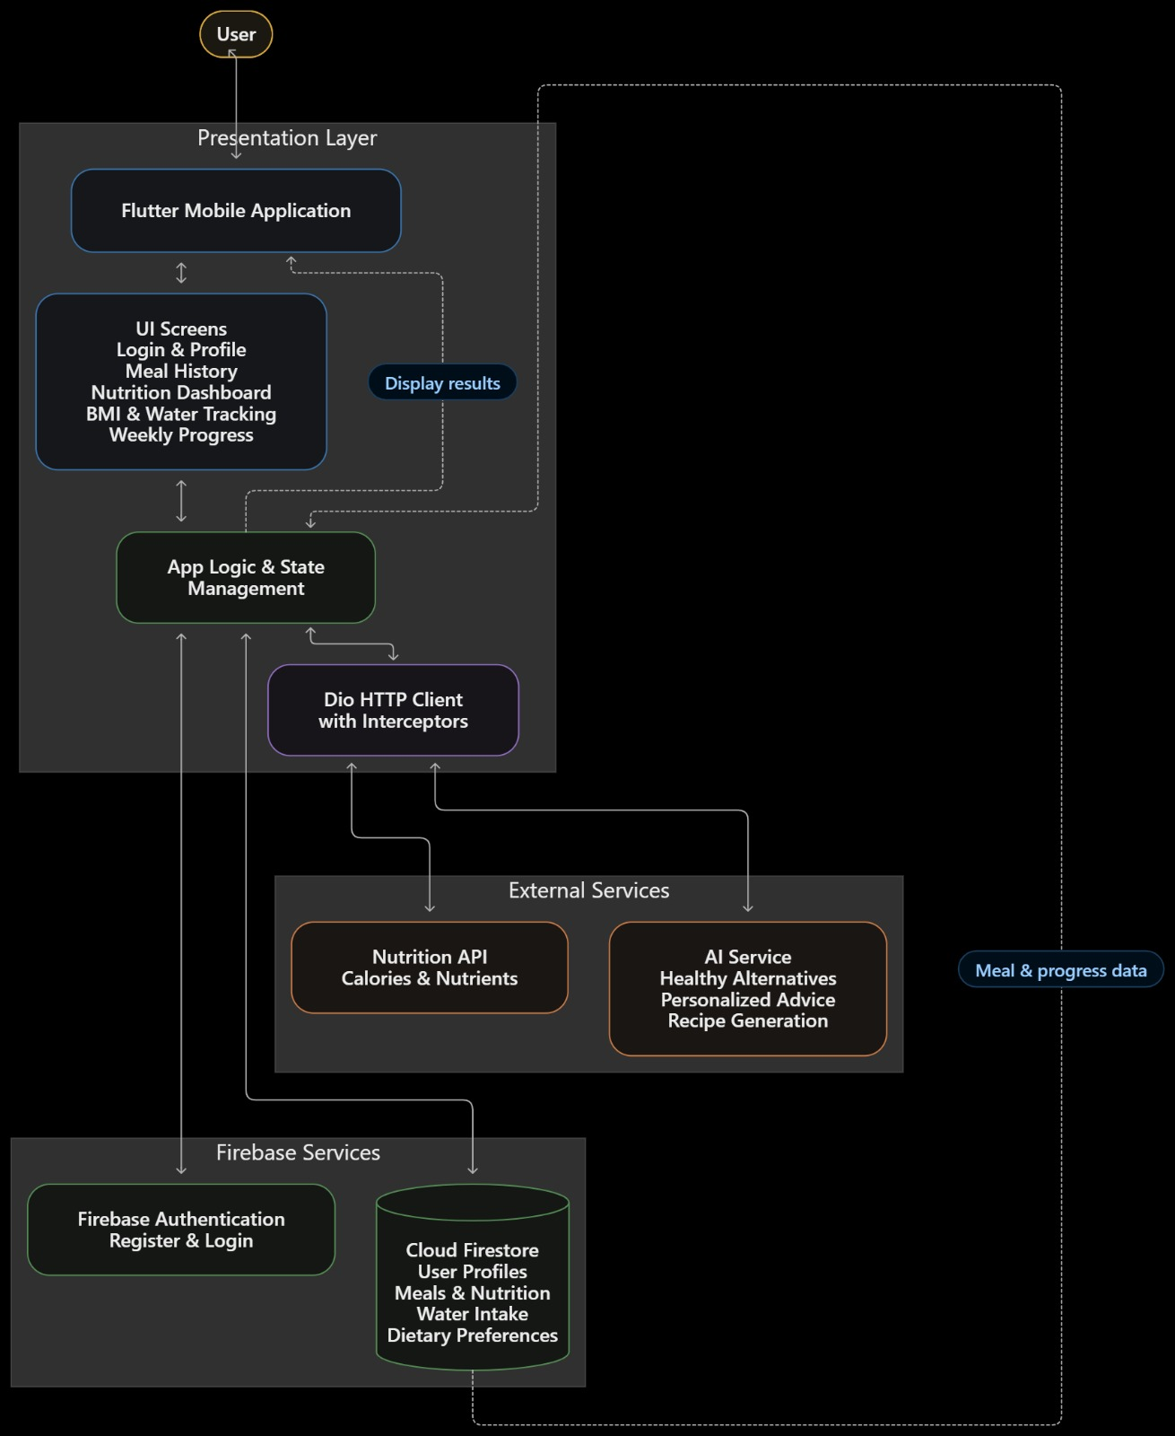

7. Database Design & Data Modeling

7.1 ER Diagram (Entity-Relationship Diagram)
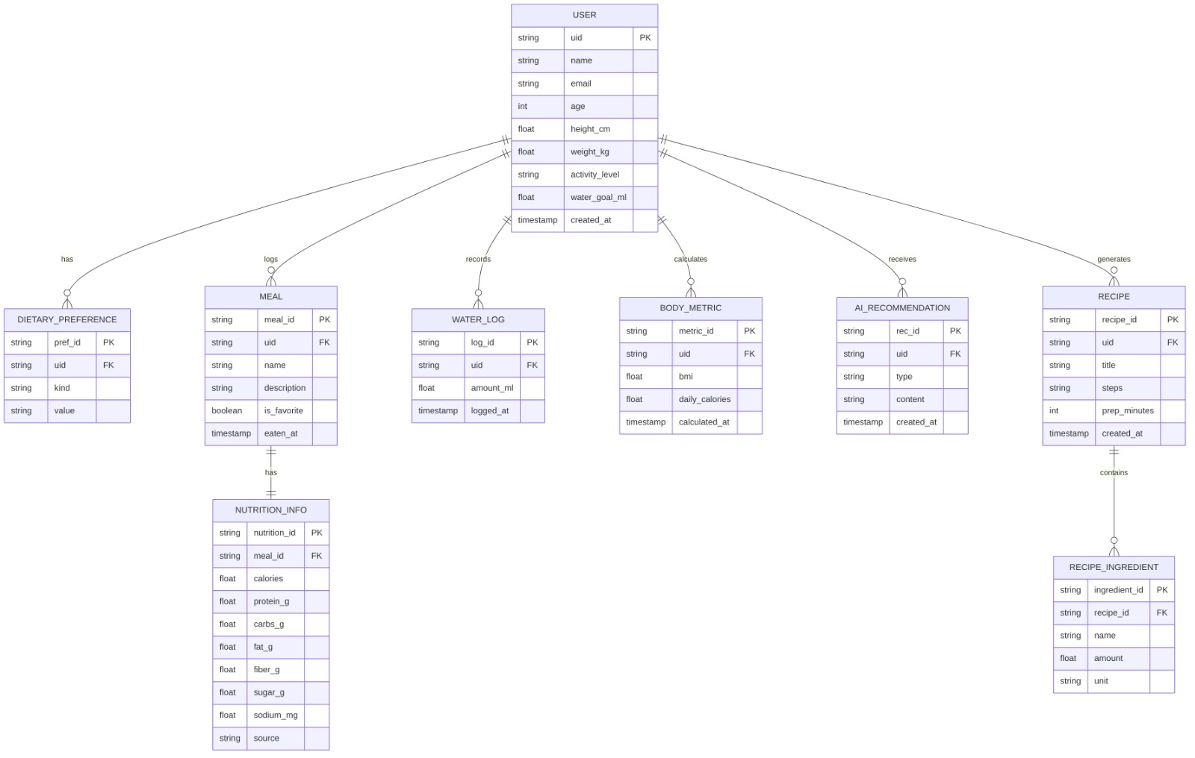

7.2 Logical & Physical Schema
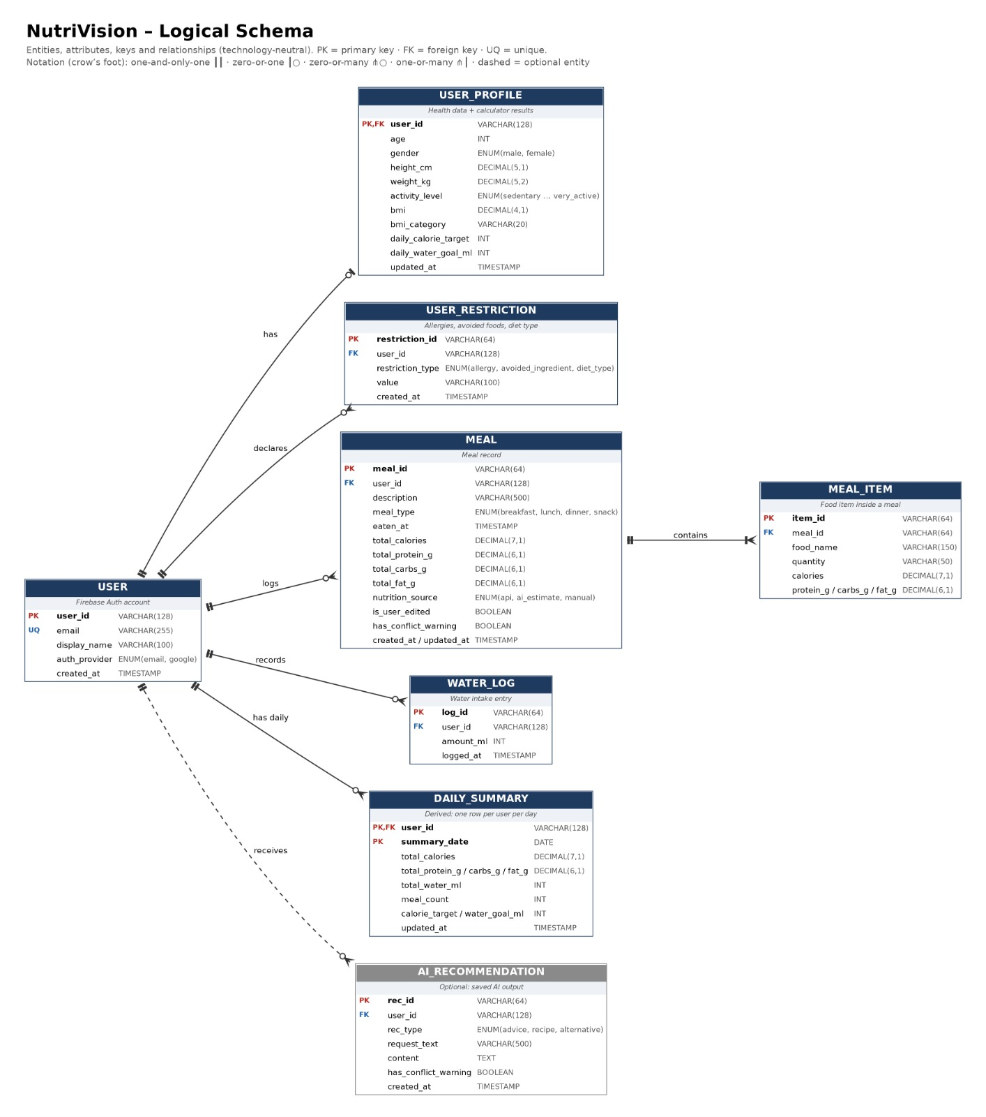
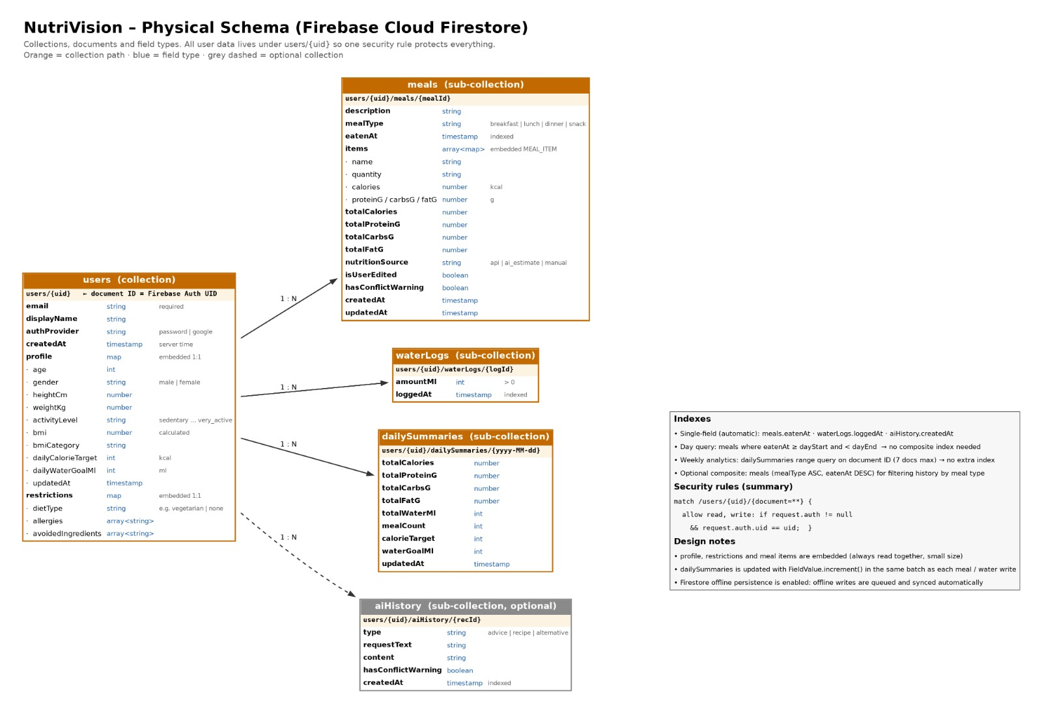

Data Flow & System Behavior

8.1 DFD (Data Flow Diagram)
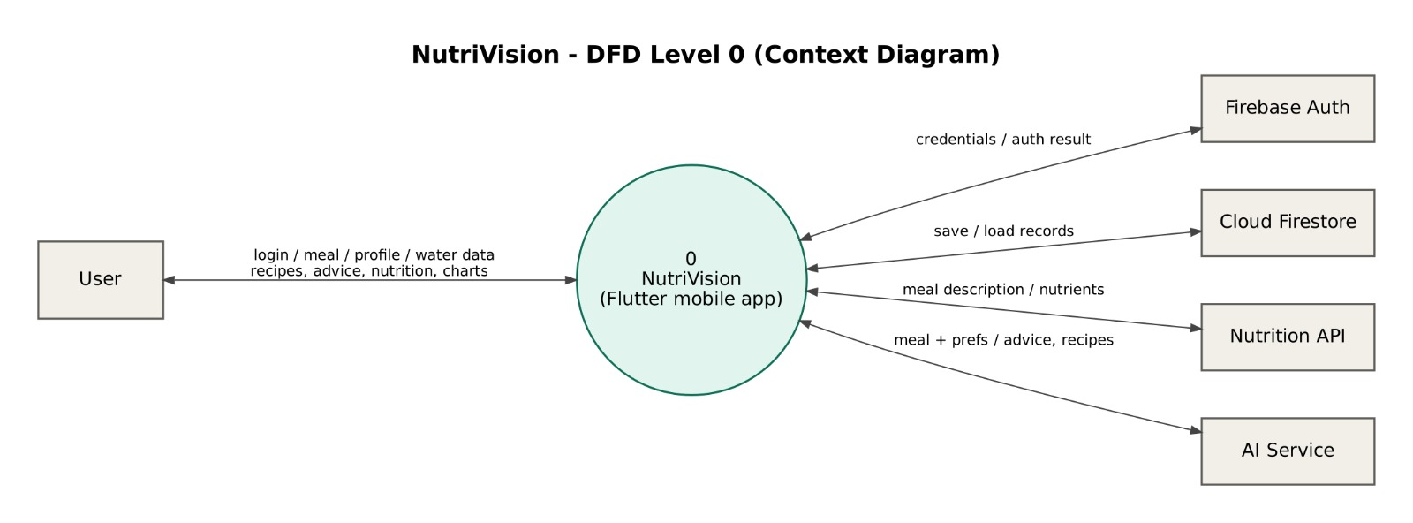
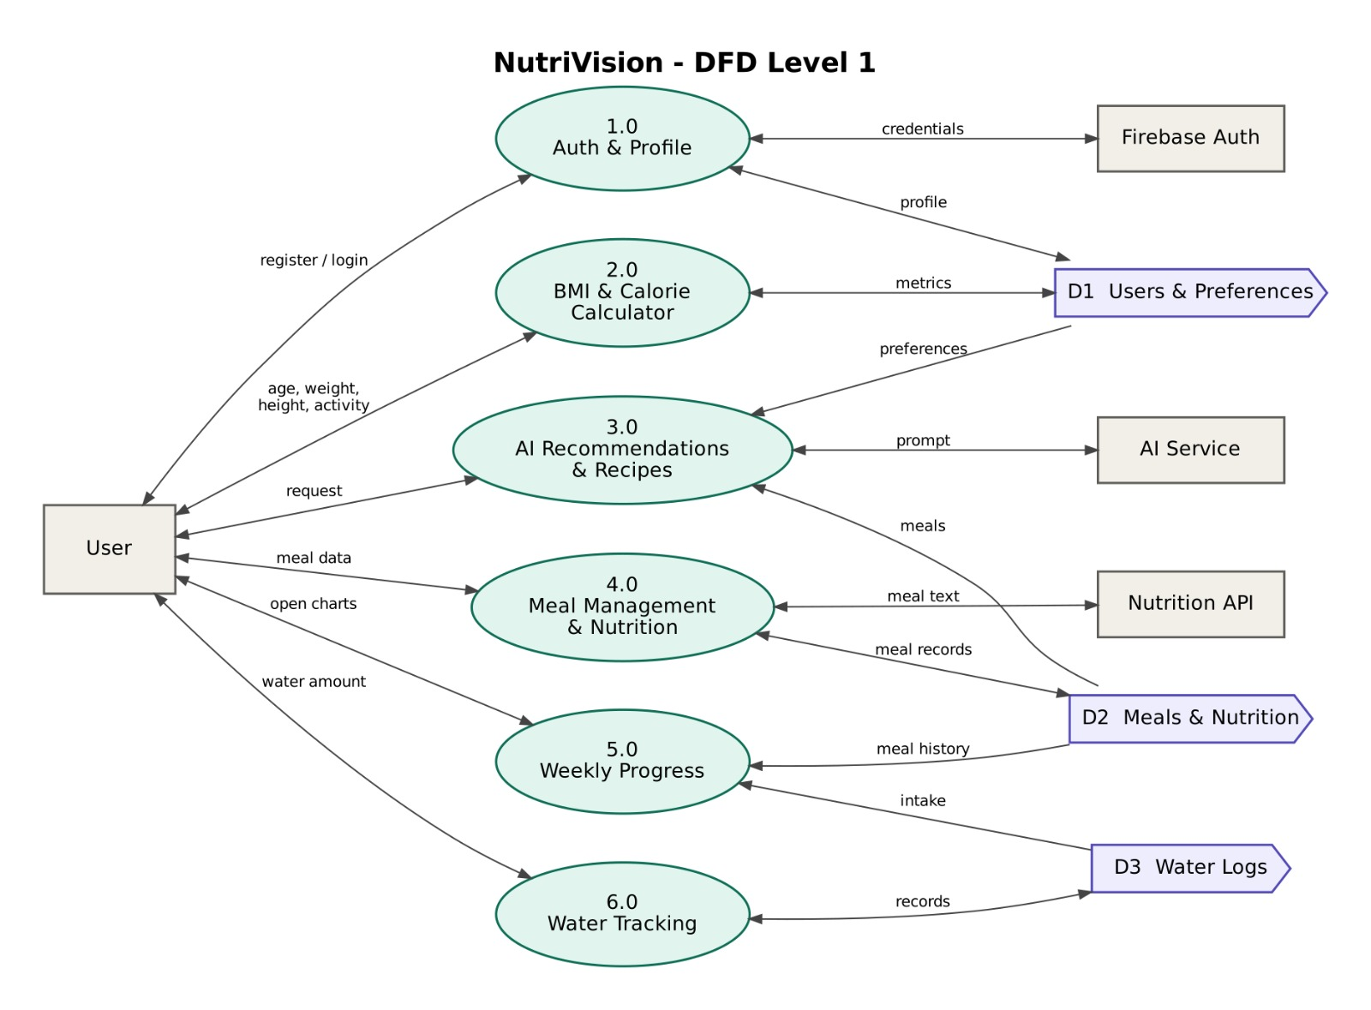

8.2 Sequence Diagrams
For AI Recommendations, Healthy Recipe Generation, Meal Managemen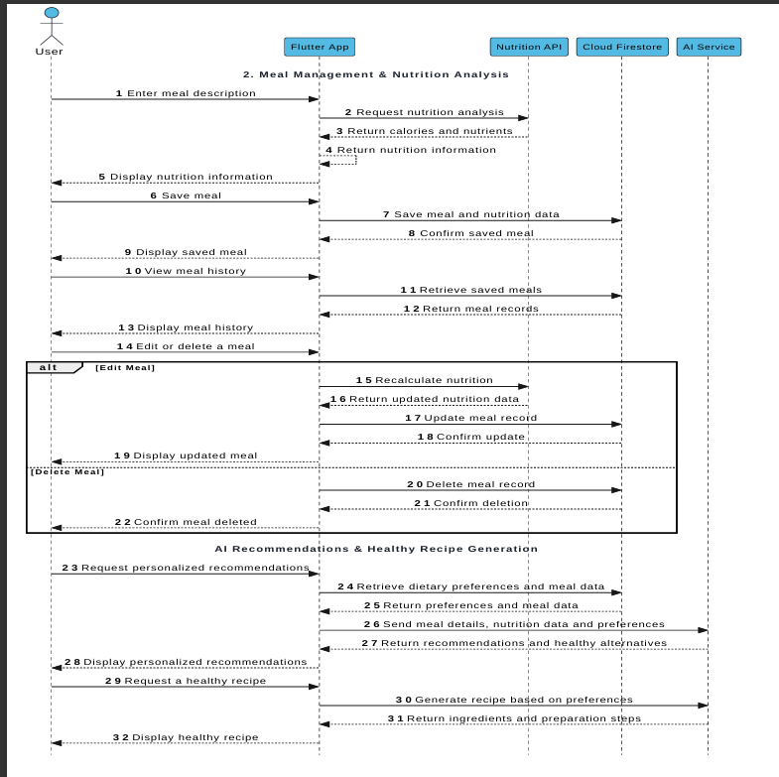

For BMI& Calories calculation ,Water intake tracking,Weekly progress analytics
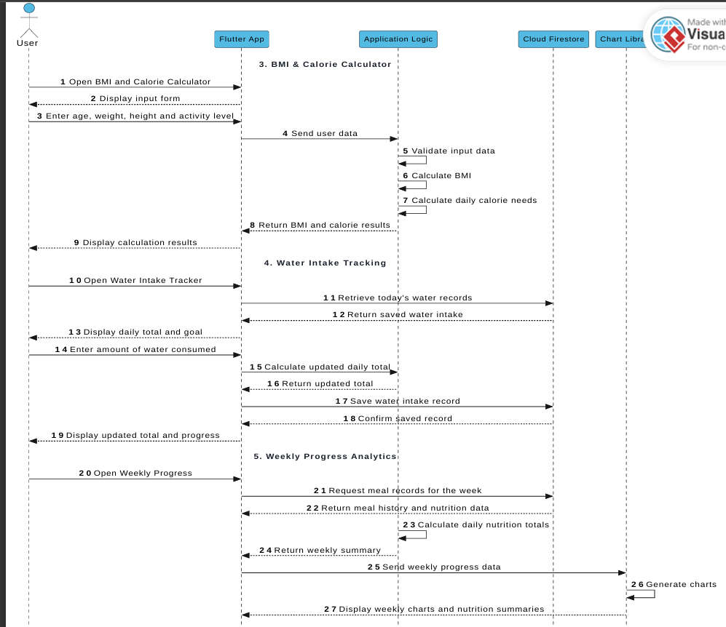

For login&register Authentication
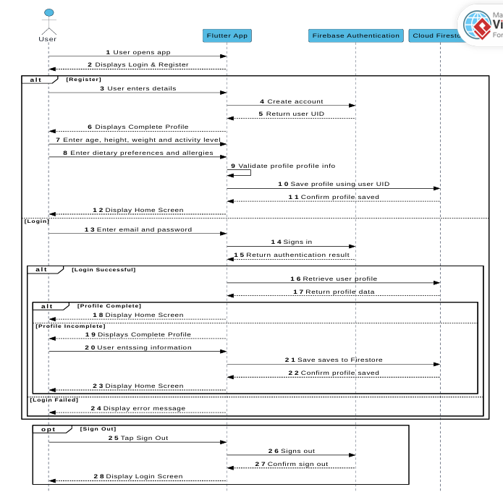

8.3 Activity Diagram
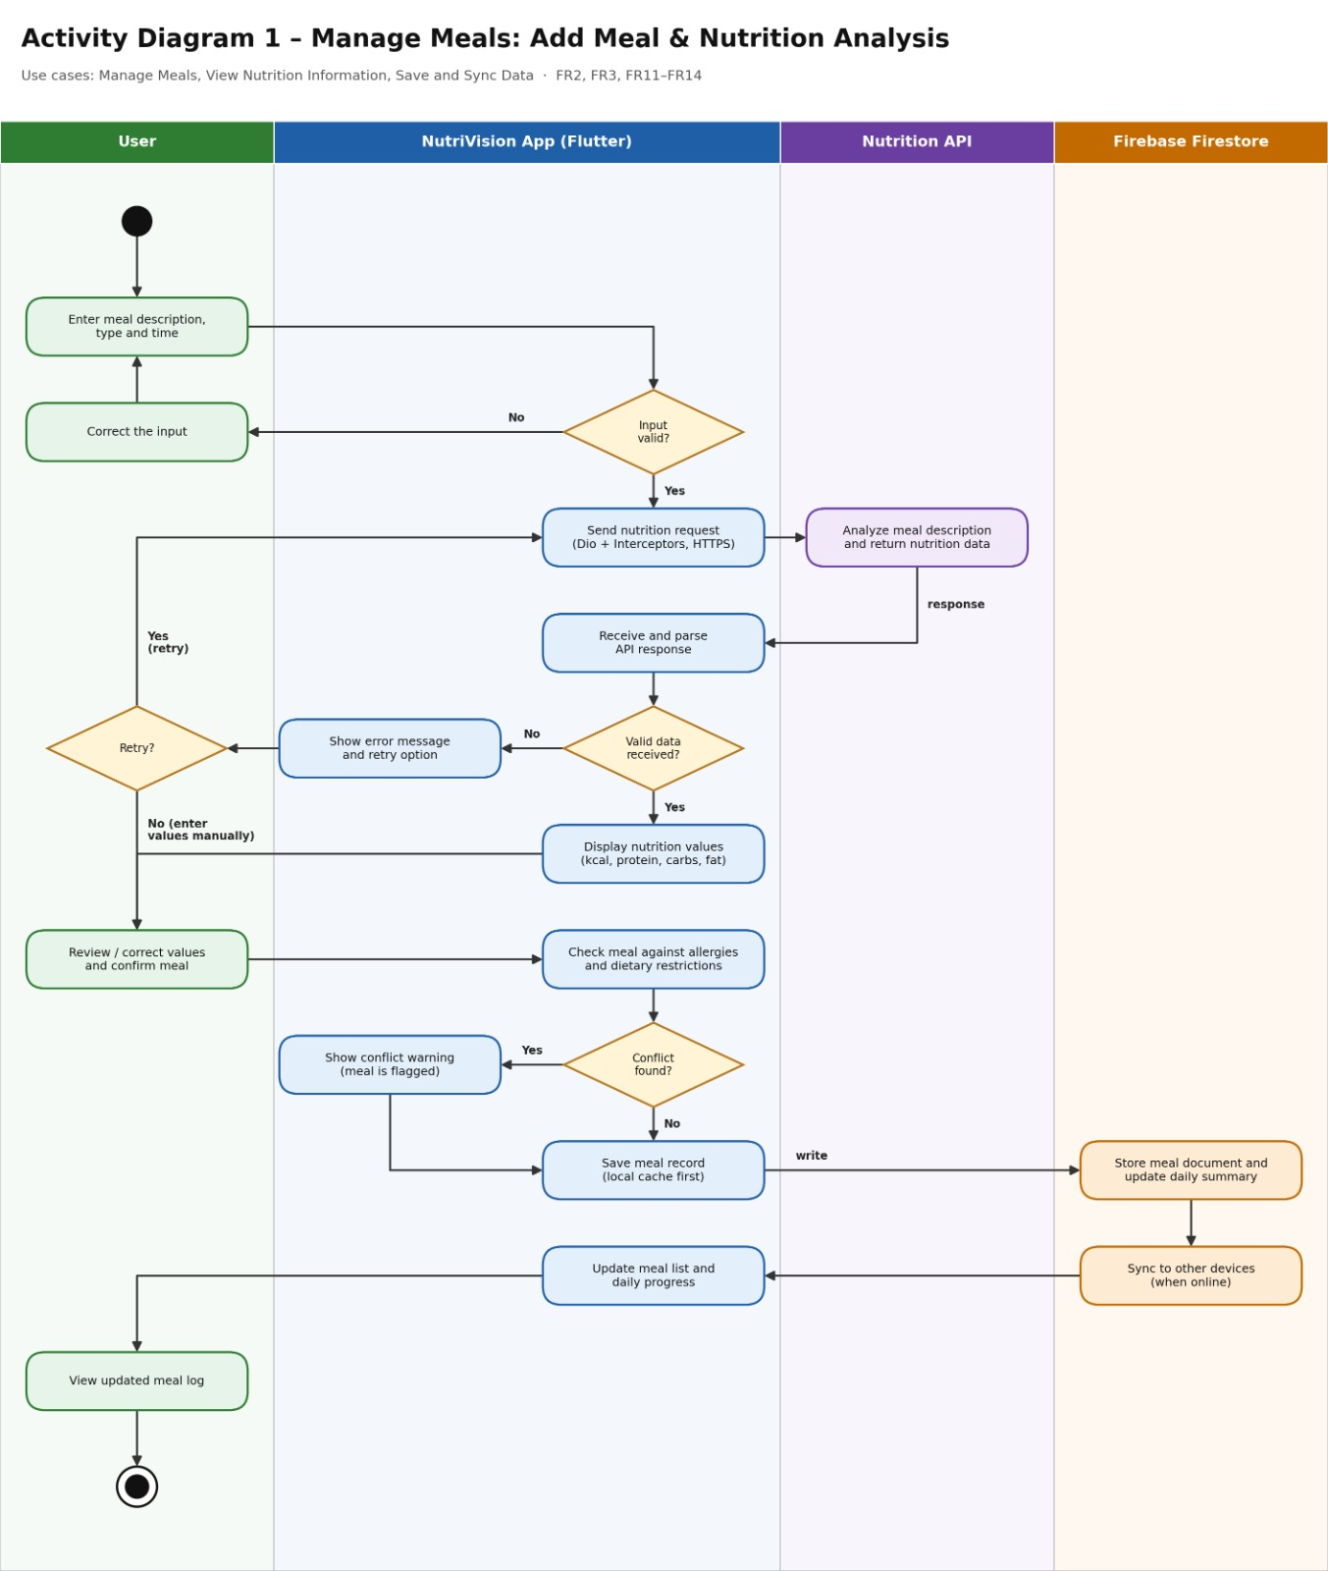
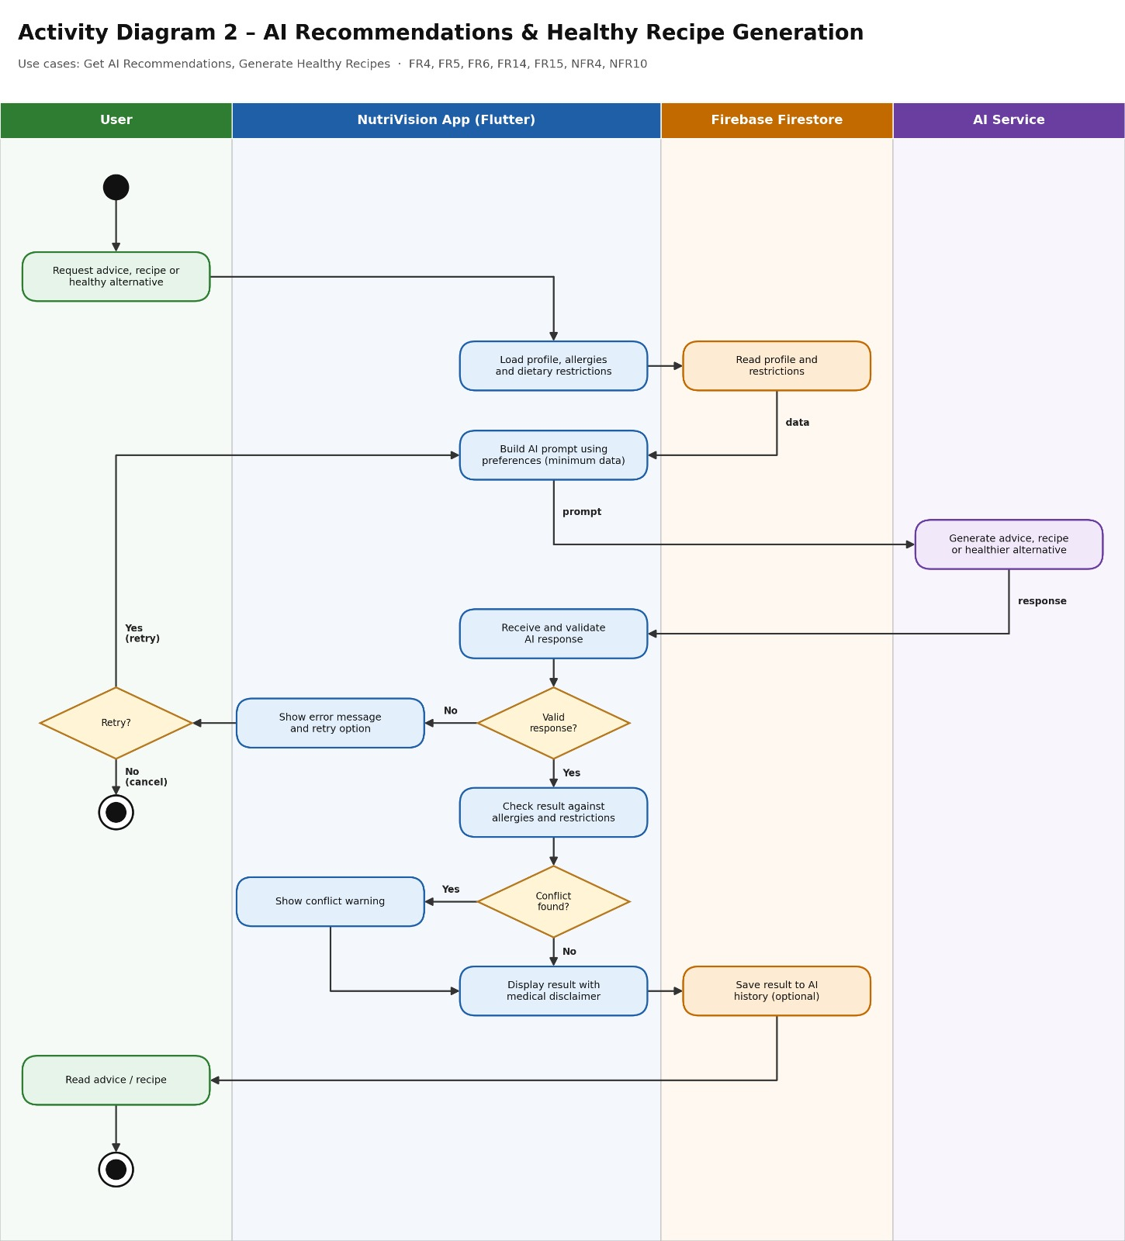
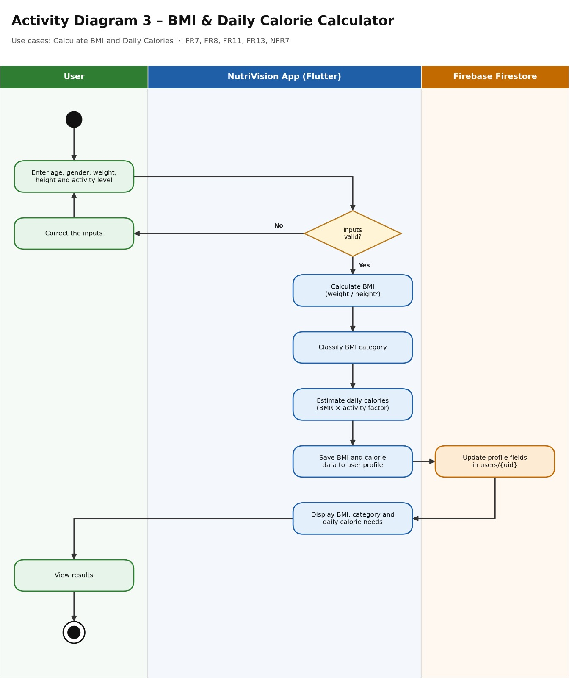
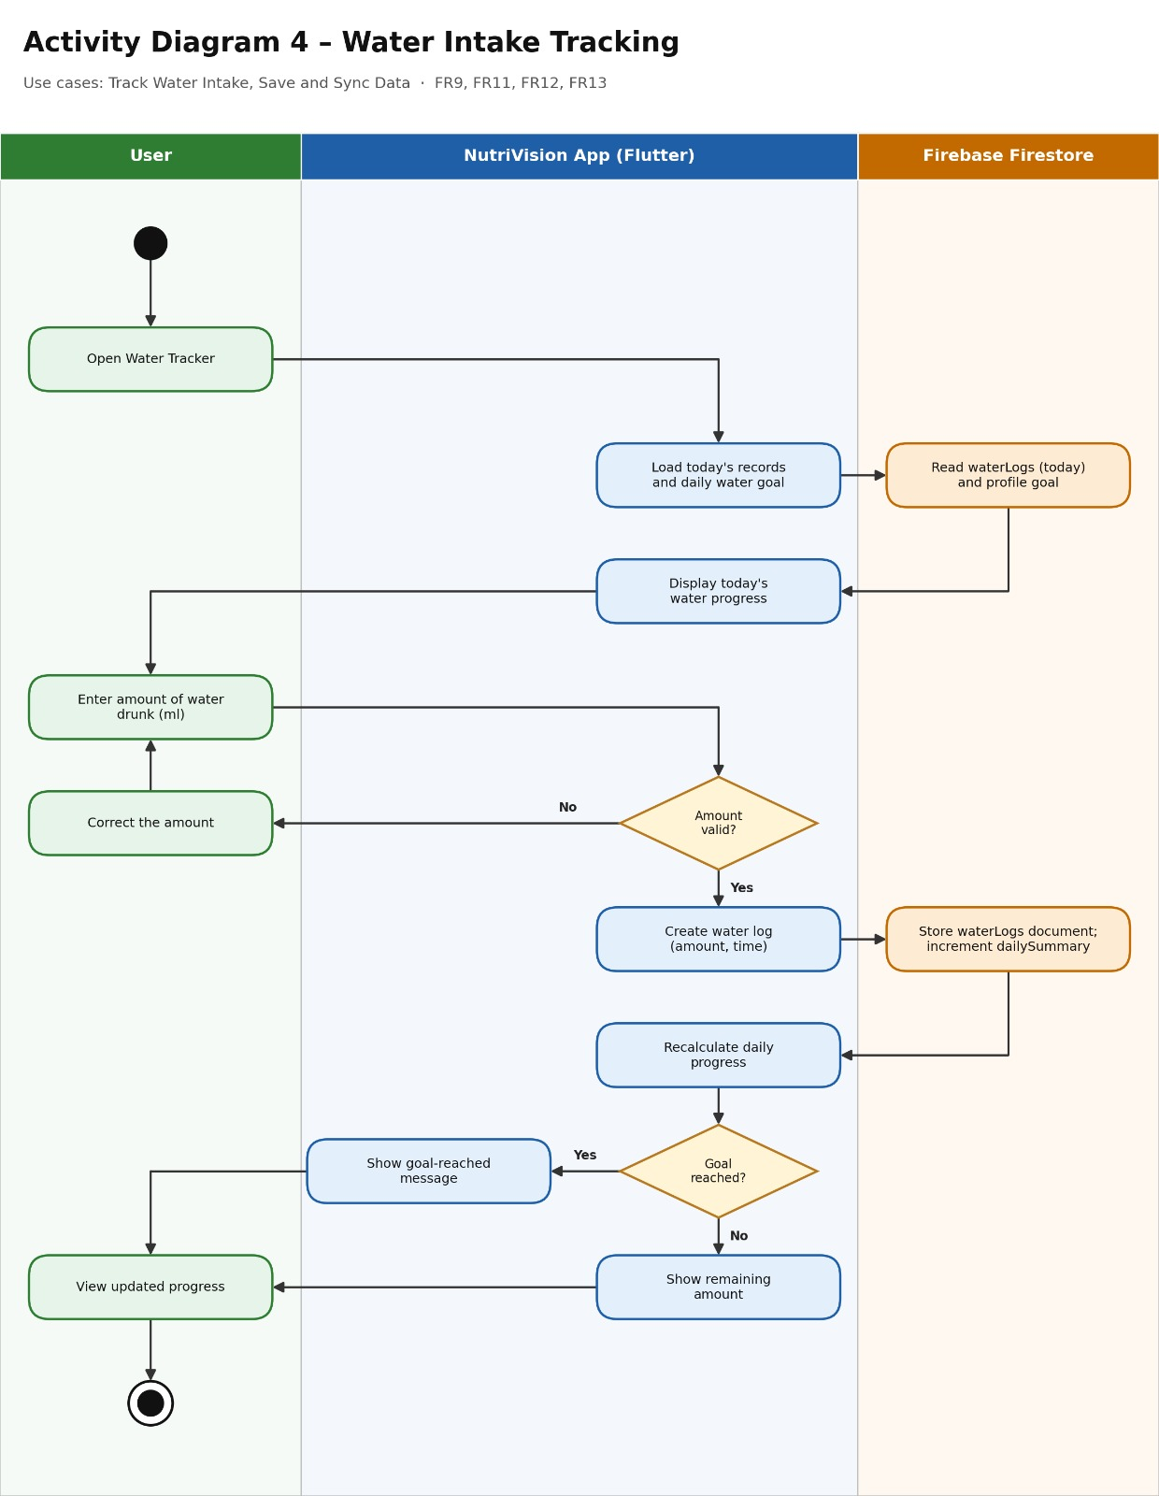
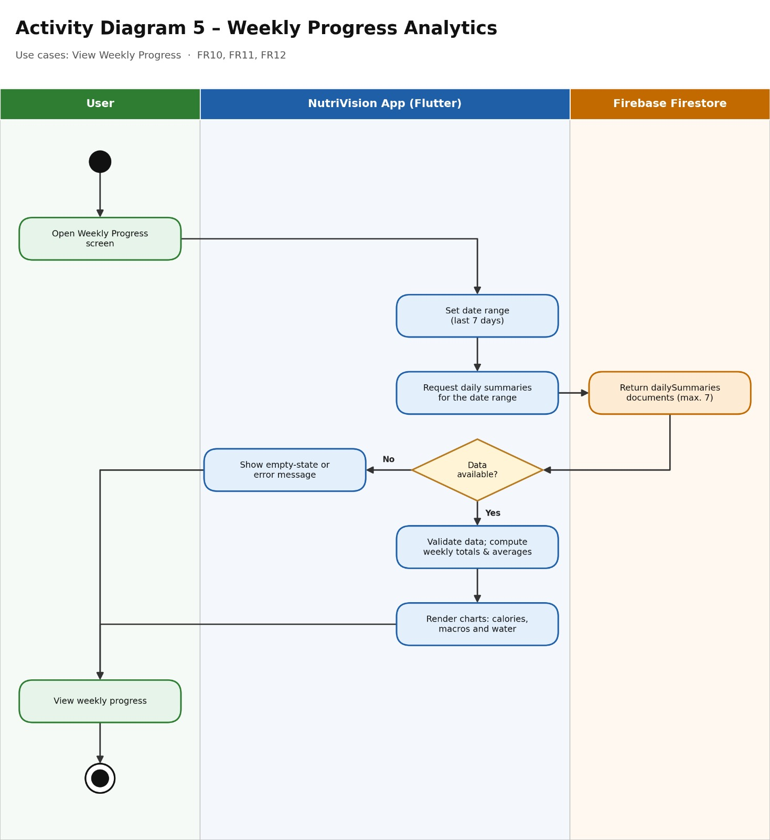

8.4 State Diagram

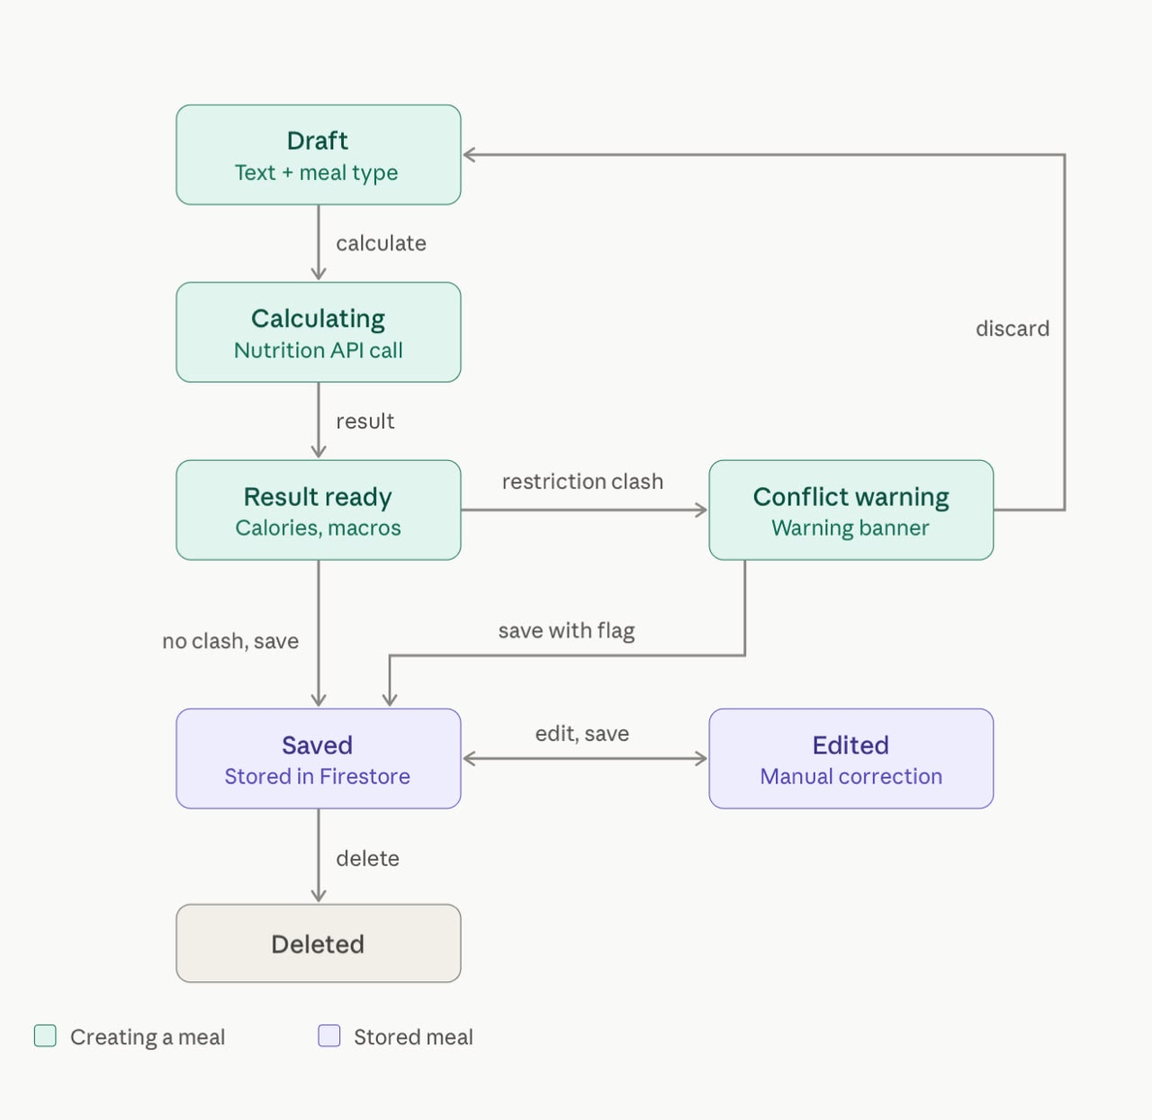

8.5 Class Diagram
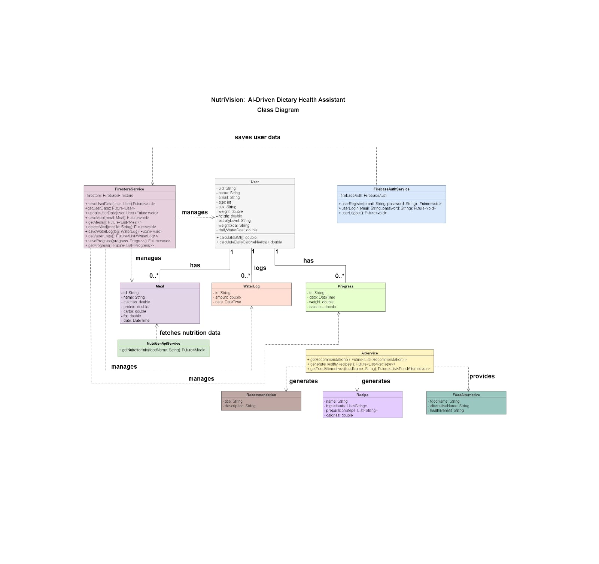

9. UI/UX Design & Prototyping

9.1 Wireframes & Mockups
Screens and visual representations of the user interface.
https://www.figma.com/design/mCEIj2GAtJC3Lln7wFVmRl/Untitled?node-id=0-1&t=qdYgDSMsL6IT3xkm-1

9.2 UI/UX Guidelines
This section defines the design principles, color scheme, typography, and accessibility considerations used across the 22 screens of the MEALIO mobile application, from onboarding and sign-up to meal logging, water tracking, weekly progress, and the AI assistant.

1. Design Principles
- Simplicity: Each screen has one purpose and one main green button, such as Add Meal, Save Meal, or Continue.
- Consistency: All screens use the same white rounded cards, pill-shaped option chips, and a centered title with a back arrow. Main screens share one bottom bar: Home, Recipes, My Meals, Progress, Profile.
- Visual Feedback: Circular progress rings show calories and water, colored bars show macros, and a weekly bar chart shows calorie trends.
- Minimal Effort: The user describes a meal in one sentence and the app calculates calories and macros. Water is logged with quick buttons (+150, +250, +500 ml).
- Safety and Clarity: A red warning card and a “Conflict” tag appear when a meal or an AI suggestion contains an allergen or an avoided ingredient.
- Encouraging Tone: Messages stay positive and short, for example “Keep going, 1,250 ml to your goal.”
- Guided Onboarding: Three intro screens lead into Health Profile, Dietary Restrictions, and a Results screen with BMI and daily targets.

2. Color Scheme
Role | Hex | Usage
Primary | ■ #2E7D4F | Buttons, active tabs, logo, progress rings.
Primary Light | ■ #5BAA6F | Leaf in the logo.
Background | ■ #F4F8F2 | Screen background.
Card / Input / Nav | ■ #FFFFFF | Cards, input fields, bottom navigation.
Border | ■ #DDE8DD | Card and navigation borders.
Input / Chip Border | ■ #C5D6C8 | Input and chip outlines.
Text Primary | ■ #1B2B21 | Titles and main text.
Text Muted | ■ #5B6B60 | Labels, hints, secondary lines.
Progress Track | ■ #E6EFE6 | Background of bars and rings.
Protein | ■ #5B6FD6 | Protein bars.
Carbs | ■ #E0A100 | Carbs bars.
Fat | ■ #E0583E | Fat bars.
Warning Background | ■ #FCE8E3 | Conflict warning cards and badges.
Warning Border | ■ #F0B8A8 | Border of warning cards.
Warning / Danger Text | ■ #8A2A12 | Warning text, Delete and Log Out buttons.

Macronutrient colors stay the same on Home, Nutrition Information, and Weekly Progress. Progress rings and bars use the primary green on a pale green track.

3. Typography
The interface uses the Inter typeface, with Arial as a fallback. Screens are designed at 390 × 844.
Element | Size (px) | Weight
Splash title | 34 | Bold 700
Onboarding / Login title | 26 | Bold 700
Screen title (My Meals, Profile) | 22 | Bold 700
Large numbers (BMI) | 44 | Bold 700
Card values (1,900 kcal) | 20 | Bold 700
Number inside rings | 24 | Bold 700
Top bar title | 18 | SemiBold 600
Section title (Recent Meals) | 17 | SemiBold 600
Card title and buttons | 16 | SemiBold 600
List item title | 15 | SemiBold 600
Input text and paragraphs | 15 | Regular 400
Chips | 14 (13 in My Meals) | Regular 400
Labels and secondary lines | 13 | Regular 400
Bottom navigation and Conflict badge | 12 | Regular 400 (active tab 700)

Shape and spacing
- Corner radius: buttons and inputs 12, cards 16, chips 18 (pill), Conflict badge 12, progress bars 4, chart bars 6.
- Heights: buttons and inputs 48 (small “+ Add” button 40), chips 36, badge 24, progress bar 8, bottom navigation 72.
- Progress rings: stroke 12 with round caps, diameter 104 (Water screen 140).
- Borders: 1 px, #DDE8DD on cards and #C5D6C8 on inputs and chips.
- Screen margins: 20 px left and right, with 16 px padding inside cards.
- Gaps: 12 px between list cards, 16 px between sections and between stacked buttons, 10 px between a label and its input, 8 px between chips.
- Main button: placed at the bottom of the screen, 36 px from the edge.

4. Accessibility Considerations
- Contrast: White text on the primary green (#2E7D4F) and muted text (#5B6B60) on the background both reach a contrast ratio of about 5:1, close to the WCAG AA level of 4.5:1. Main text (#1B2B21) has higher contrast.
- Touch targets: Buttons and inputs are 48 px high and span the screen width. Chips are 36 px high.
- Not relying on color alone: Macros always show a name and a value next to the colored bar, and warnings include text (“Conflict warning: contains peanuts”) as well as red color.
- Clear labels: Every input has a visible label above it and an example placeholder, such as “e.g. 165.”
- Readable navigation: The bottom bar uses text labels, and the active tab is shown in green and bold.
- Helpful messages: Warnings explain the problem, for example which ingredient conflicts with the user's profile.
- Scalable text: The layout should keep working when the user increases the system font size.

10. System Deployment & Integration

10.1 Technology Stack
- Frontend: Flutter and Dart are used to develop Mealio's cross-platform mobile application and build its user interface.
- Authentication: Firebase Authentication is used to manage user registration and login securely.
- Database:Cloud Firestore is used to store and retrieve user profiles and saved meal data.
- API Integration: The application uses the USDA FoodData Central API to retrieve food information and available nutritional values.
- HTTP Client: Dio is used to send HTTP requests to the API and handle responses.
- Backend Services: Firebase Authentication and Cloud Firestore provide authentication and data storage, while external APIs provide food-related information.

10.2 Deployment Diagram

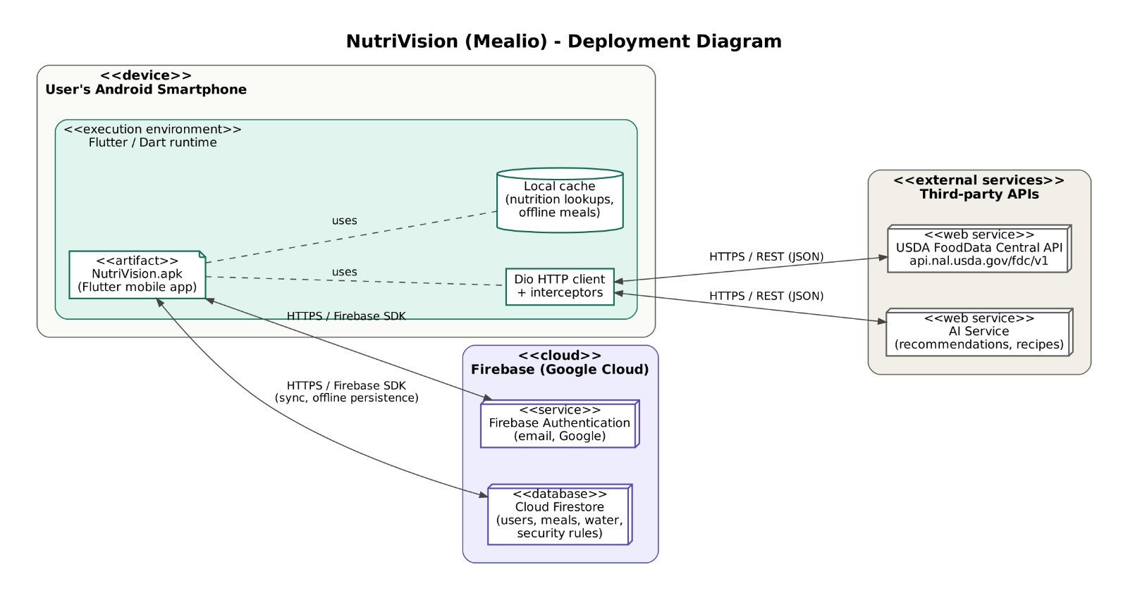

10.3 Component Diagram
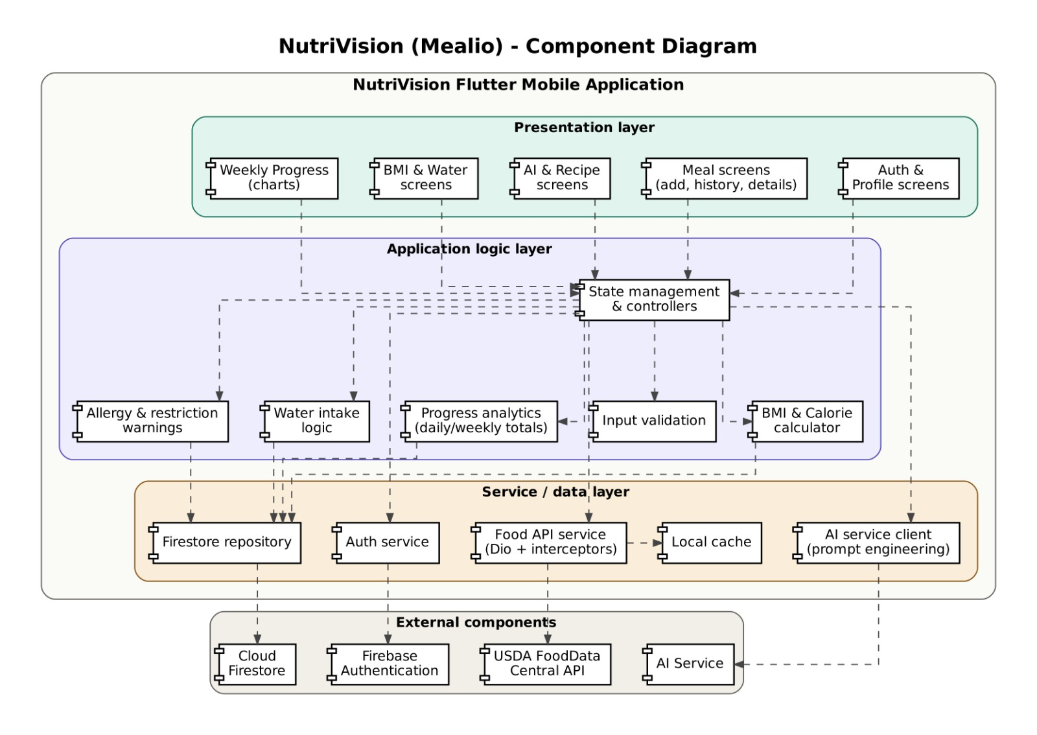

11. Additional Deliverables (if applicable)

11.1 API Documentation – MEALIO
MEALIO uses two external APIs to provide food information, retrieve nutritional values, and analyze meal descriptions. These APIs are integrated into the Flutter application using the Dio package to send HTTP requests and receive JSON responses.
The two APIs used in the system are:
- USDA FoodData Central API.
- Spoonacular API.

1. USDA FoodData Central API
Purpose:
The USDA FoodData Central API is the main source of food information and nutritional data in MEALIO. It allows users to search for different food items and retrieve their nutritional information, including calories, protein, carbohydrates, fats, fiber, sugar, sodium, and saturated fat.
Base URL:
https://api.nal.usda.gov/fdc/v1/
Authentication:
The API requires an API Key, which is passed as a request parameter named api_key.

Endpoint 1: Search Foods
HTTP Method: POST
Endpoint: /foods/search
Full URL:
https://api.nal.usda.gov/fdc/v1/foods/search
Description:
This endpoint allows MEALIO to search for food items by name and retrieve a list of matching food records with their available information.
Request Parameters:
- api_key: The USDA API key required for authentication.
- query: The name of the food item to search for.
- pageSize: The maximum number of search results to return.
- dataType: Specifies the food data categories to include in the search, such as Foundation, SR Legacy, Survey (FNDDS), and Branded.
Example Request Body:
{
"query": "chicken",
"pageSize": 50,
"dataType": [
"Foundation",
"SR Legacy",
"Survey (FNDDS)",
"Branded"
]
}

Endpoint 2: Get Food Details
HTTP Method: GET
Endpoint: /food/{fdcId}
Full URL:
https://api.nal.usda.gov/fdc/v1/food/{fdcId}
Description:
This endpoint retrieves detailed information about a specific food item using its unique FoodData Central ID (fdcId).
Request Parameters:
- fdcId: The unique identification number of the selected food item.
- api_key: The USDA API key required for authentication.
Response Data:
The response provides detailed food information, including:
- Food name.
- Food ID (fdcId).
- Calories.
- Protein.
- Carbohydrates.
- Total fat.
- Dietary fiber.
- Sugar.
- Sodium.
- Saturated fat.
- Available serving and portion information.
Usage in MEALIO:
The USDA FoodData Central API is used in the Meals section to search for food items and retrieve their nutritional information.
When a user searches for a food item, MEALIO retrieves matching food records from USDA. The application uses these results to identify the appropriate food record and obtain its nutritional values.
USDA also provides reference serving and portion information when available. This information can be used to determine or convert food quantities into grams for nutritional calculations.
The application calculates the total nutritional content according to the selected food record and the quantity used.
For example, if a food item contains 100 calories per 100 grams and the user consumes 150 grams, MEALIO calculates the total calories using the following formula:
Nutritional Value = (Value per 100g × Quantity in grams) / 100
This calculation is applied to the available nutritional values, including calories, protein, carbohydrates, and fats.

2. Spoonacular API
Purpose:
The Spoonacular API is used in MEALIO to analyze meal descriptions written by users in natural language. Its main responsibility is to identify the food ingredients mentioned in the user's description.
Base URL:
https://api.spoonacular.com
Authentication:
The API requires an API Key, which is passed as a query parameter named apiKey.

Endpoint: Parse Ingredients
HTTP Method: POST
Endpoint: /recipes/parseIngredients
Full URL:
https://api.spoonacular.com/recipes/parseIngredients
Description:
This endpoint analyzes a text containing food ingredients and converts it into structured ingredient information. It identifies ingredient names and provides information that helps the application process the meal ingredients separately.
Request Parameters:
- apiKey: The Spoonacular API key required for authentication.
- includeNutrition: Specifies whether nutritional information should be included in the response.
- ingredientList: The text containing the food ingredients to be analyzed.
- servings: The number of servings used for the ingredient analysis.
Example Request:
Query Parameters:
apiKey=YOUR_API_KEY
includeNutrition=true
Request Body:
ingredientList=100g chicken
1 cup rice
2 tomatoes

servings=1
Request Headers:
Accept: application/json
Content-Type: application/x-www-form-urlencoded
Response Data:
The API returns structured information about the identified ingredients, which may include:
- name: The ingredient name.
- amount: The ingredient quantity identified during the analysis.
- unit: The measurement unit.
- measures.metric: The equivalent quantity using metric measurements.
- nutrition.nutrients: Nutritional information that may be included in the response.
Usage in MEALIO:
The Spoonacular API is integrated into the application through the NutritionDescriptionApi service. When a user enters a meal description, the application sends the text to Spoonacular for analysis.
Spoonacular is responsible for analyzing the meal description and identifying the food ingredients mentioned by the user.
After extracting the ingredient names, the application searches for each ingredient using the USDA FoodData Central API. USDA is used to identify the appropriate food record and retrieve its nutritional information and relevant serving or quantity data.
The application then uses the selected USDA food records and the corresponding ingredient quantities to calculate the total nutritional values based on the actual amounts used in the meal.
Therefore, Spoonacular is responsible for ingredient identification from the meal description, while USDA is responsible for food record selection, nutritional data, and the quantity information used in the nutritional calculations.

3. Integration Between USDA and Spoonacular APIs
MEALIO integrates both APIs to provide a complete meal analysis process. Each API has a specific responsibility within the application.
USDA FoodData Central API:
Responsible for searching food items, identifying the appropriate food records, retrieving nutritional information, and providing available reference serving and portion data.
Spoonacular API:
Responsible for analyzing user-written meal descriptions and identifying the food ingredients mentioned in the text.
Integration Workflow:
- The user enters a meal description in the Describe Meal section.
- MEALIO sends the description to the Spoonacular API.
- Spoonacular analyzes the description and identifies the food ingredients.
- The application searches for each identified ingredient using the USDA FoodData Central API.
- USDA provides the matching food records and their available nutritional and serving information.
- The application uses the selected USDA food records and the corresponding quantities to calculate the total nutritional values.
- The final nutritional results are displayed to the user.
- The user can save the analyzed meal for future reference.
This integration allows MEALIO to combine natural language ingredient identification with reliable food database information to provide users with a convenient way to analyze meals and track their nutritional intake.

4. Error Handling
MEALIO handles API communication errors to ensure reliable application performance.
Common HTTP status codes include:
- 400 – Bad Request: The request contains invalid or missing parameters.
- 401 – Unauthorized: Authentication information is missing or invalid.
- 403 – Forbidden: Access to the requested resource is not permitted.
- 429 – Too Many Requests: The API request limit has been exceeded.
- 500 – Internal Server Error: An unexpected error occurred on the API server.
The application handles unsuccessful requests and network errors to prevent invalid API responses from affecting nutritional calculations.

5. API Security
To protect API credentials and maintain secure communication:
- API keys should not be exposed in public GitHub repositories.
- API requests should use the required authentication parameters.
- API responses should be validated before processing.
- Network errors and unsuccessful responses should be handled appropriately.
- Sensitive API credentials should be stored securely.

6. Official API Documentation
The following official documentation references provide additional technical information about the APIs used in MEALIO:
- USDA FoodData Central API Documentation: https://fdc.nal.usda.gov/api-guide.html
- Spoonacular API Documentation: https://spoonacular.com/food-api/docs

Conclusion
The USDA FoodData Central API and Spoonacular API are essential external services in MEALIO. Spoonacular analyzes meal descriptions and identifies food ingredients, while USDA is used to search for the appropriate food records and retrieve nutritional and available serving information. By integrating both APIs with Flutter-based nutritional calculations, MEALIO enables users to analyze meals, calculate nutritional values, and manage their daily food intake.

11.2 Testing & Validation
Testing and validation are important to ensure that the Mealio application functions correctly, processes nutritional information accurately, and provides a reliable user experience.

1. Unit Testing
Unit testing focuses on verifying individual functions and components of the application independently. The planned unit tests include:
- Food API Service: Verify food search requests, response processing, and extraction of nutritional values.
- Food Categories: Test food categorization and the translation of supported Arabic food names into English.
- BMI Calculator: Verify BMI calculations using different height and weight values.
- Daily Calorie Calculator: Validate daily calorie calculations using the required user information.
- Water Intake Tracking: Test water intake calculations and updates.
- Meal Management: Verify adding, editing, and deleting meal records where applicable.
- Data Validation: Test input validation and handling of missing or invalid values.

2. Integration Testing
Integration testing verifies that different components of the application work together correctly. The planned integration tests include:
- API Integration: Verify communication between the Flutter application and the USDA FoodData Central API.
- Firebase Authentication: Test the integration of user registration, login, and authentication.
- Cloud Firestore: Verify saving, retrieving, updating, and deleting user data where applicable.
- Meal Nutrition Analysis: Ensure that retrieved food information is processed and displayed correctly.
- Data Synchronization: Verify that saved meals, water intake records, and progress data are retrieved and displayed correctly.
- Error Handling: Test the application's response to network failures, unsuccessful API requests, and unavailable data.

3. User Acceptance Testing (UAT)
User acceptance testing evaluates whether the application meets user requirements and provides an easy-to-use experience. Test scenarios include:
- User Registration and Login: Verify that users can register, log in, and access the application.
- Food Search: Verify that users can search for foods and browse available food categories.
- Nutritional Information: Ensure that users can view available nutritional values for selected foods.
- Meal Management: Verify that users can record and manage their meals.
- BMI and Daily Calorie Calculation: Ensure that users can enter the required information and view the calculated results.
- Water Intake Tracking: Verify that users can record their water intake and view updated totals.
- Weekly Progress Monitoring: Ensure that users can view their available progress information and weekly charts.
- Usability: Evaluate the clarity of the interface, navigation, readability, and overall user experience.

4. Validation Criteria
The application will be evaluated according to the following criteria:
- All tested functions produce the expected results.
- Nutritional information is displayed according to the data returned by the API.
- User data is stored and retrieved correctly.
- Invalid inputs and failed requests are handled appropriately.
- The main application features work as expected.
- The interface is clear, consistent, and easy to navigate.
Testing results will be documented, and identified issues will be corrected and retested to improve the application's reliability and quality.

11.3 Deployment Strategy
The deployment strategy describes how the Mealio application will be prepared, deployed, and maintained to ensure reliable operation and support future updates.

1. Hosting Environment
The application relies on the following technologies:
- Flutter: Used to develop the application interface and run the application on supported devices.
- Firebase Authentication: Used to manage user registration, login, and authentication.
- Cloud Firestore: Used to store user information, meal records, and data related to the application's features.
- USDA FoodData Central API: Used to retrieve food information and nutritional values from the USDA database.
During development and testing, the application runs on a mobile device or emulator. A release version can then be prepared for installation and distribution according to the target platform.

2. Deployment Process
The deployment process includes the following steps:
- Review the application code and verify that the main features work correctly.
- Test the integration with Firebase services and the USDA FoodData Central API.
- Verify Firebase configuration and API key settings before preparing the final release.
- Generate a release build using Flutter tools.
- Test the release version on the target devices to ensure proper operation.
- Distribute the application to users or publish it through the appropriate application store, depending on the target platform requirements.

3. Security and Configuration
- Protect user data by applying appropriate Cloud Firestore security rules.
- Configure Firebase Authentication to verify user identities.
- Avoid embedding secret keys or sensitive credentials directly in the published application code.
- Review data and external service access permissions before deployment.

4. Maintenance and Updates
After deployment, the application can be maintained through the following activities:
- Fixing bugs identified during application use.
- Updating the application when new features are added or existing features are improved.
- Monitoring the availability of Firebase services and the external API.
- Testing modifications before releasing new updates.
- Improving application performance and user experience based on identified issues and feedback.

5. Scalability
The application can be enhanced in the future to support a larger number of users by improving data organization, optimizing Cloud Firestore queries, and reducing repeated API requests through caching when appropriate.
This deployment strategy provides an organized approach to preparing, deploying, and maintaining the application while allowing future improvements based on user needs.

