**OPERATING SYSTEM – COMP 3318 – FALL 2016**

**Homework #2**

**Due on October 10, 2016**

1. Assume multiple level queue system with a variable time quantum per queue, and that the incoming job needs 50 ms to run to completion. If the first queue has a time quantum of 5 ms and each queue thereafter has a time quantum that is twice as large as the previous one, how many times will the job be interrupted, and on which queue will it finish its execution? Explain how much time it spends in each queue?

Multilevel feedback queue  
Total time taken by the process to complete: 50 ms.

The process will execute in the first queue for 5 ms.  
Then it will move to the 2nd queue(since it didn't complete in 5 ms), and will execute there for 10 ms.  
Then it will move to the 3rd queue(since it didn't complete in 10 ms too), and will execute there for 20 ms.  
Then it will move to the 4th queue(since it didn't complete in 20 ms too), and will execute there for 15 ms before it is complete.

So, the job will be interrupted 3 times and it will finish the execution in the 4th queue.

1. Given the following information:

|  |  |  |
| --- | --- | --- |
| Job | Arrival Time | CPU Cycle |
| A | 0 | 15 |
| B | 2 | 2 |
| C | 3 | 14 |
| D | 6 | 10 |
| E | 9 | 1 |

Calculate the Start time, Finish time, turnaround time for each job, then calculate the average turnaround time using each of the following algorithms ( ignore time required for context switching)

1. FCFS
2. SJN
3. SRT
4. Round Robin (using time quantum of 5)

a)

Since FCFS schedules the jobs based on the order of arrival times, job A is processed first. By the time the job A is finished, All the remaining jobs B,C,D and E arrived into ready queue.

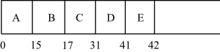

b)

Shortest job next (SJN) always schedules a job that have short CPU burst. Since at time 0, only A is available, A is processed first. When job A is finished, all the remaining jobs are available. But processed in the order E ->B-> D-> C.

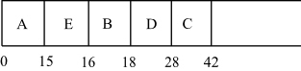

c)

Shortest remaining time (SRT) algorithm is the variant of SJN. SRT is a primitive scheduling algorithm. While SRT is processing a job, if another job with less CPU burst than the current running job is arrived, SRT preempts the current job and schedules the shortest job arrived.

Since at time 0 only A is available, A is scheduled first. But SRT interrupts the job A and schedules B when B is arrived into queue at time 2, because B has shortest burst time than the remaining burst time of A.

Therefore, B is arrived when job A is interrupted.

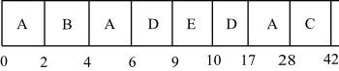

d)

Round Robin allows all the available jobs in ready queue to execute specified quantum time(time slice) one after one.

Since at time 0 A is only available, A is executed 5 cycles first. B is arrived at time 2 and C arrived at time 3. Thus, by the job A is interrupted, B and C are arrived.

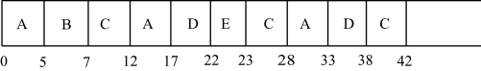  
  
average waiting time: (0+32+20+23+40)/5 = 23

average turnaround time: (10+39+42+49+61)/5 = 35.2

1. Given the following information for a real-time system using EDF :

|  |  |  |  |  |  |  |
| --- | --- | --- | --- | --- | --- | --- |
| JOB | A | B | C | D | E | F |
| Arrival Time | 0 | 0 | 1 | 1 | 3 | 6 |
| Execution-Time | 3 | 1 | 6 | 2 | 7 | 5 |
| Deadline | 6 | 1 | 44 | 2 | 16 | 15 |

Compute the time-before-deadline for each incoming job. Give the order in which the six jobs will finish, and identify any jobs that fail to meet their deadline. It may help to draw a timeline.