|  |
| --- |
| **UNIVERSITI MALAYSIA TERENGGANU**  **FACULTY OF OCEAN ENGINEERING TECHNOLOGY & INFORMATICS**  **CSM3114**  **FRAMEWORK-BASED MOBILE APPLICATION DEVELOPMENT**  **Project 2 Report**  **[Hotel Management Application]**  Prepared by:  S61438 NIK FATNIN ALANI BINTI NIK ABD RAHMAN  Prepared for:  Dr. Mohamad Nor Bin Hassan  [BACHELOR OF SCIENCE COMPUTER (MOBILE COMPUTING) WITH HONORS]  SEMESTER 2023/2024 |

Table of Contents

1.0 Executive Summary 3

2.0 Use Case 4

3.0 Widget Tree 5

4.0 Flutter Widget And Feature 6

5.0 User Interface with Explanation 7

6.0 Conclusion 10

7.0 References 11

8.0 Link For Github & Slide 11

# Executive Summary

The mobile applications are a part of business strategies in this competitive IT business environment. To make user stay connected with us in this modern era, it a must to provided an application that will reach user all over the places. For hotel business, I have created an application that call hotel management app to help user booking the room easier than before. This app offers a user-friendly interface.

Hotel Management application is a booking room hotel. The purpose of creating this app is to make user feel easy to choose room and stay in the hotel. User can easily sign up and log in, it will access to the main page. Through the app it provides user friendly interface. User can see the environment at the hotel from image slider that provided in main page. Below the image slider, it has a list of data room, including the picture of the room, room name, and price. User can slide the list of room and make the decision to choose room to stay.

This is one of the standout features of the hotel management app that user can pick their room based on their preferences and schedule. If user like one of the rooms it can be add by clicking the favourite icon. The price is also affordable for user, beside that each of the room provide with minimum basic amenities. For the higher price it provided mini fridge, coffee maker and large room that will make user comfortable.

The Hotel Management app offers consumers looking for lodging a smooth and pleasurable experience while also strategically responding to the demands of the contemporary business environment. This application has a wide selection of room choices, and customised features, is proof of our dedication to providing the best possible customer service in the cutthroat hospitality sector.

# 2.0 Use Case

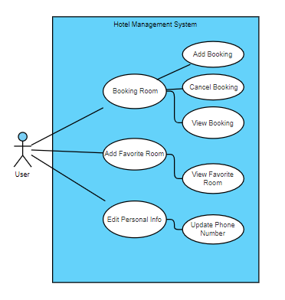

Figure 1 Use Case Hotel Management Application

Figure 1 is a Use Case for Hotel Management Application. User are provided with many features. The user can handle room booking either they want to cancel booking, add booking or view booking. By letting users choose their favourite rooms, the software goes above and beyond, making future choices more individualised and effective. Users can also update their personal information, with a particular emphasis on phone numbers, to ensure accurate communication. The hotel management app's integrated functionality guarantees a user-centric and efficient experience for managing reservations, preferences, and personal information.

# 3.0 Structure of Tree Widget

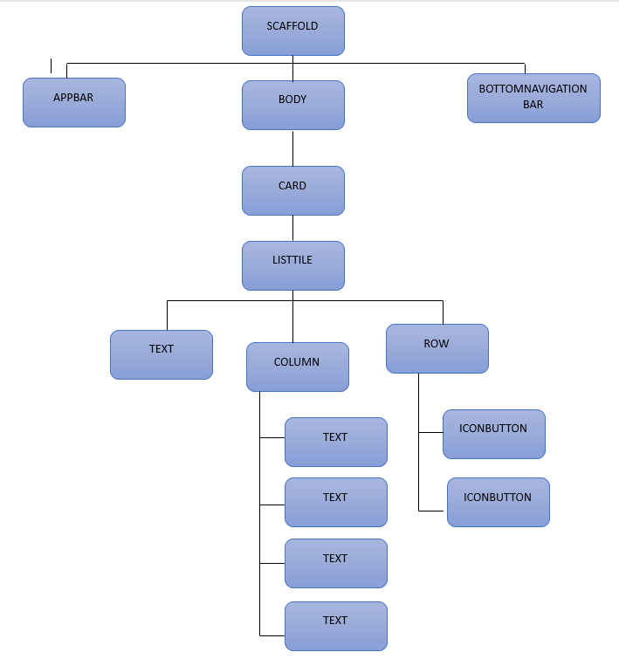

Figure Widget Tree for Booking Details

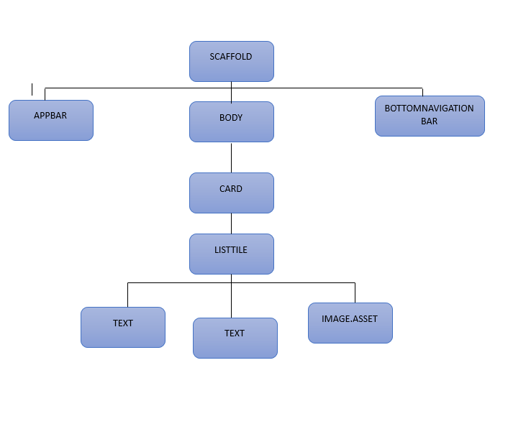

Figure Widget Tree for FavoriteList

# 4.0 Flutter Widget And Feature

Flutter is Google’s UI toolkit for crafting beautiful, natively compiled iOS and Android apps from a single code base (What is widgets in Flutter , 2022).Each element on application is a widget. For Hotel Management Application, the list of widgets that I use were:

1. **MaterialApp:**

* Configures the top-level MaterialApp.

1. **Scaffold**

* Provides a basic structure for a material design app.

1. **Stack:**

* Overlaps several children in a simple stack.

1. **Positioned:**

* Controls the position of a child within a Stack.

1. **Image:**

* Displays an image.

1. **ListView.builder:**

* Builds a scrollable list of widgets lazily.

1. **TextField:**

* Accepts input from the user.

1. **ElevatedButton:**

* A Material Design raised button.

1. **GestureDetector:**

* Detects gestures made by the user.

1. **AppBar:**

* A Material Design app bar.

1. **BottomNavigationBar:**

* A material widget that displays a horizontal row of tabs.

1. **AlertDialog:**

* A dialog that informs the user about a situation.

1. **DropdownButton:**

* A button that shows options to the user when clicked.

1. **TextButton:**

* A simple button without a border or background.

1. **ListView:**

* A scrollable list of widgets.

1. **Card:**

* A material design card. Displays information and actions about a single topic.

1. **ListTile:**

* A single fixed-height row that typically contains some text as well as a leading or trailing icon.

1. **IconButton:**

* A button that can display an icon.

1. **DateFormat:**

* A class for formatting and parsing dates.

# 5.0 User Interface with Explanation

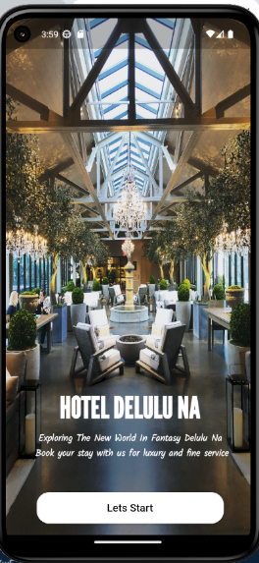

Figure User Interface for welcome page

Figure show that the welcome page for user. This is a simple page that only have text and button. When user click the lets start it will navigate to other page.

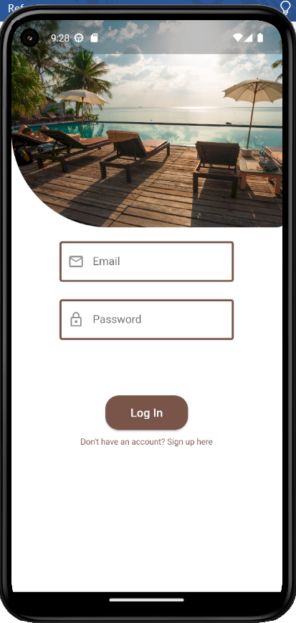 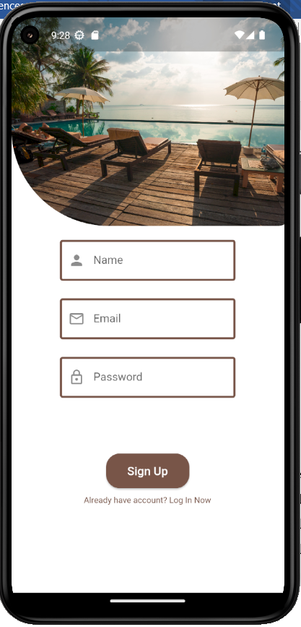

Figure Use Interface for Login and Signup

The figure show login and signup page. In the login page it has two text field and one button name Login. The text field required student to fill the form with their email and password. If user don’t have an account yet, user can simple took the text button then it will show signup button. The signup page is very easy as the user just try to fill up the name, email and password. I f finish just click signup button.

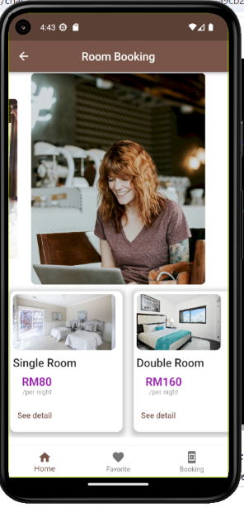

Figure User Interface for room booking

Figure 3 show User Interface for room booking. This is the first page that user will se if they success the login stage. The app provided user with image slider that can show image hotel environment at hotel. Below the image slider, it has a list of room that display image and text. Each of the room have image, price and text. User can click on see details to see the full information about this room.

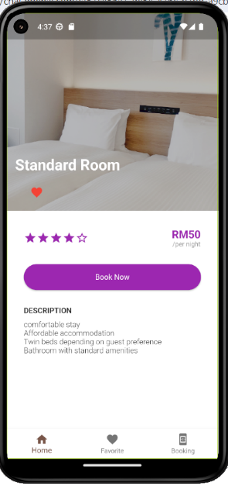

Figure User Interface details Booking

Figure 4 show the user interface for detail room. For this page, it has room image in above. It has name and favourite icon to add the room they want to list of favourite. The star is a rating that previous user gave based on our services. There is price in right side. If user attach with that room, they can add booking room by clicking the book now button.

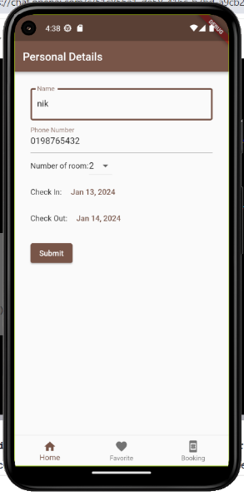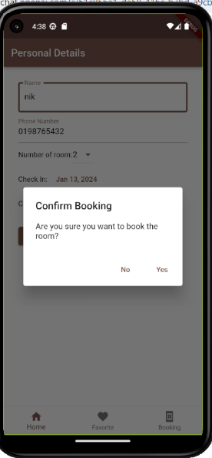

Figure User Interface for Personal Details

Figure 5 show the user interface for personal details. When user click the book now button it will direct it to personal detail. In this page, user need to fill up their personal information. And choose the date to check-in and check-out. If the user satisfied with the date, user can submit the data. Alert dialog will pop out and ask user for confirmation to continue booking or cancel it.

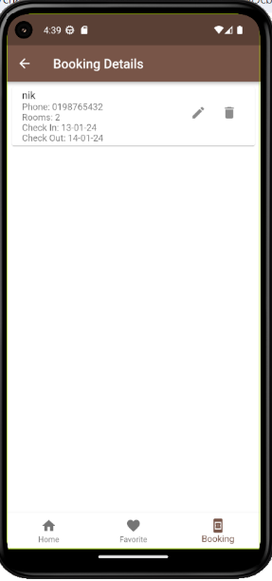

Figure User Interface For Booking Details

Figure 6 show the user interface for booking details. When user already click the confirmation, it will display the data that user fills in the previous page. The navigation below is to easier user to navigate to homepage, favourite and booking page.

# 6.0 Conclusion

In Conclusion, The Hotel management is a serious business that could pose a real headache to many. That's why Hotel management systems have been put in place to give hotel managers maximum control over their hotel. The benefits of using technology in hotels are plentiful especially in an era where customers have the highest expectations and all your competitors are leveraging technology as well (How Hotel Management works , n.d.). Through the seamless integration of personalised features, a wide variety of room options, and an intuitive design, the application not only streamlines the booking process but also improves the overall visitor experience. When combined with well-considered features, the rooms' reasonable prices demonstrate dedication to giving user value and comfort. We are committed to providing our visitors with an exceptional experience.

# 7.0 References

Appwriters (Director). (21 August, 2019). *Flutter UI - Hotel Booking App - Room Details page - Speed Code* [Motion Picture]. Retrieved from YouTube: https://www.youtube.com/watch?v=2G_PquLyiv0

*BottomNavigationBar class - material library - Dart API*. (n.d.). Retrieved from Flutter Documentation: https://api.flutter.dev/flutter/material/BottomNavigationBar-class.html

*Flutter Bottom Navigation Bar*. (n.d.). Retrieved from JavaTpoint: https://www.javatpoint.com/flutter-bottom-navigation-bar

*Flutter Carousel slider*. (15 February, 2021). Retrieved from GeeksforGeeks: https://www.geeksforgeeks.org/flutter-carousel-slider/

*How Hotel Management works* . (n.d.). Retrieved from Booking Ninjas: https://www.bookingninjas.com/blog/how-hotel-management-works

*What is widgets in Flutter* . (22 December, 2022). Retrieved from GeeksforGeeks: https://www.geeksforgeeks.org/what-is-widgets-in-flutter/

*What items do hotels usually provide for their guests in the rooms?* (n.d.). Retrieved from Quora: https://www.quora.com/What-items-do-hotels-usually-provide-for-their-guests-in-the-rooms

Chatgpt tools

# 8.0 Link For Github & Slide

**Link github :**

<https://github.com/FatninAlani/Framework_Project2.git>

**Link Slide :**

<https://www.canva.com/design/DAF5wAN-Np8/uB-MBIdFybg8O5xk8gDyRA/edit?utm_content=DAF5wAN-Np8&utm_campaign=designshare&utm_medium=link2&utm_source=sharebutton>