

**UNIVERSITI MALAYSIA TERENGGANU**

**FACULTY OF OCEAN ENGINEERING TECHNOLOGY & INFORMATICS**

**LAB REPORT 3**

**CSM3103**

|  |  |
| --- | --- |
| **Name:** | **NIK FATNIN ALANI BINTI NIK ABD RAHMAN** |
| **Matric Num:** | **S61438** |
| **Semester:** | **II 2022/2023** |
| **Lab:** | **MP1** |
| **Prepared for:** | Dr. Rabiei Bin Mamat |

**TASK1**

1. **Write a function to find the square of a given number**

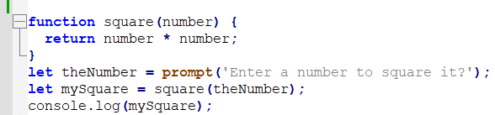

**OUTPUT:**

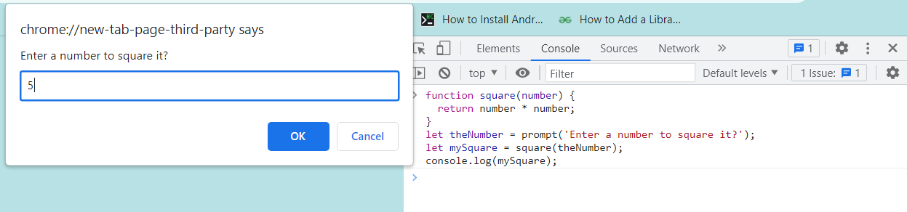

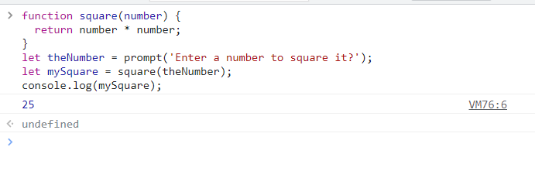

**2. Write a function to find sum of cubes of two numbers**

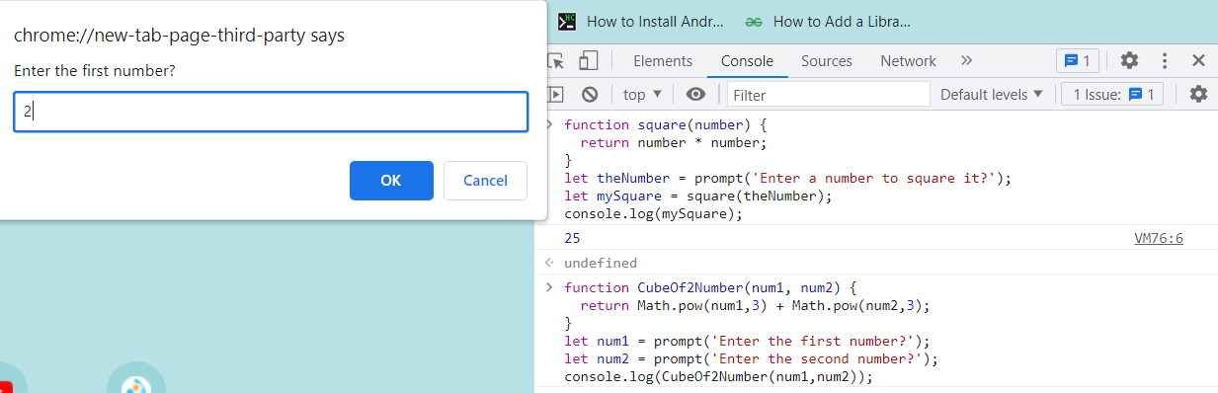

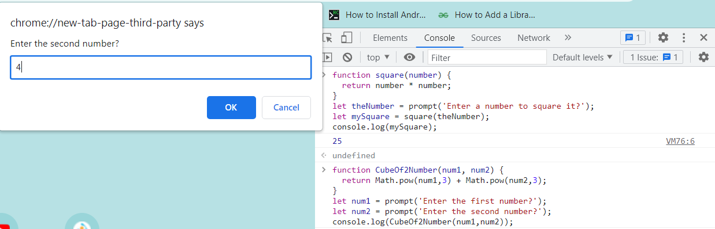

**OUTPUT:**

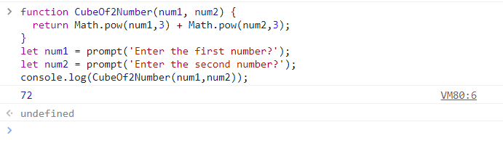

**3.** **Write a function to reverse a number**

**[ Hint n =12345 output : 54321 ]**

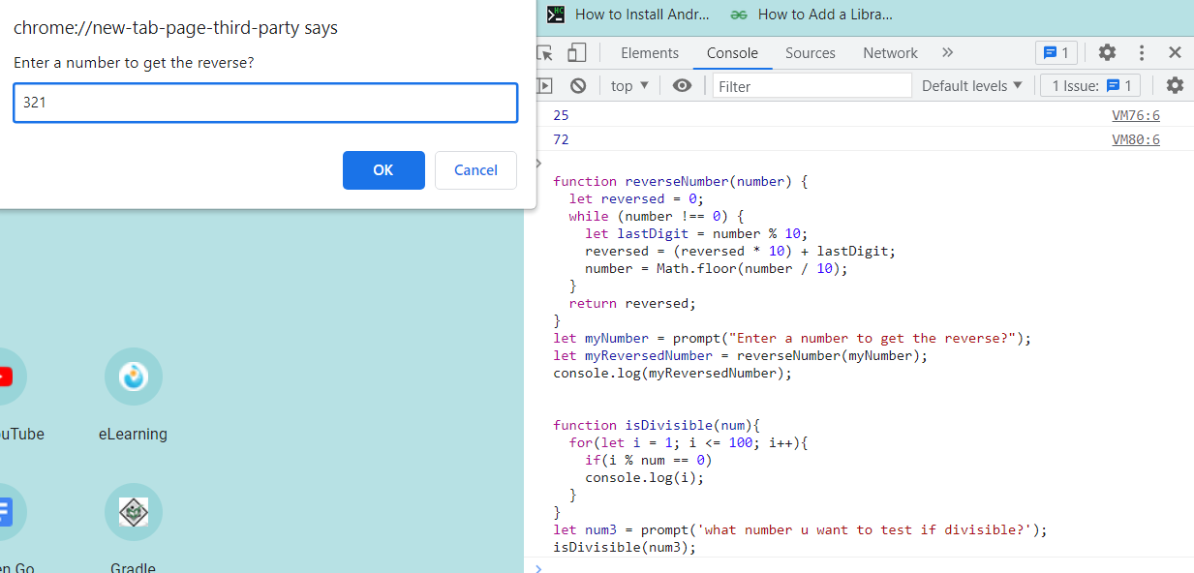

**OUTPUT:**

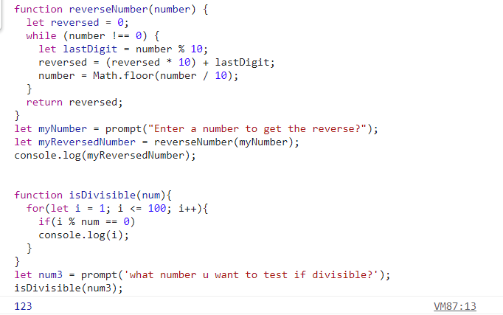

**4.** **Write a function to print all numbers between 1 and 100 which is divisible by**

**given number z**

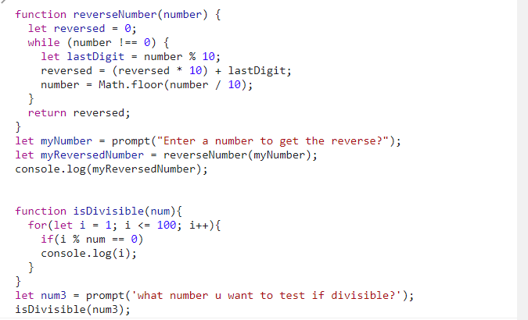

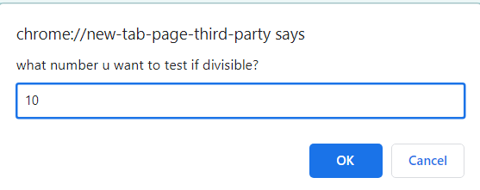

**OUTPUT:**

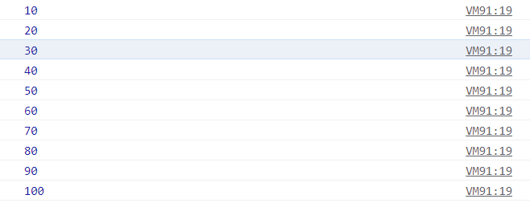

**TASK2**

**1.** **Write a JavaScript function to find sum of digits of a number**

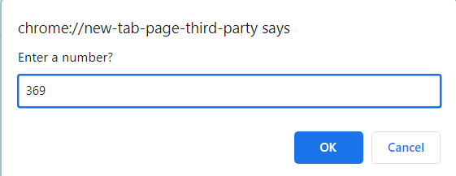

**OUTPUT:**

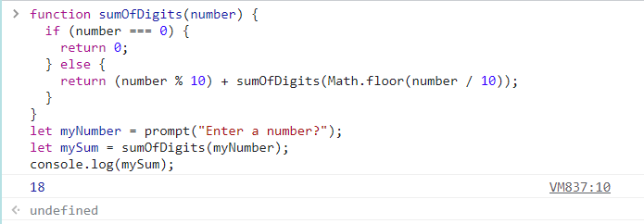

**2.** **Write a JavaScript program to compute x raise to the power y using recursion**

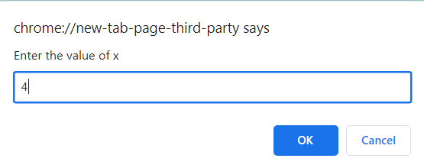

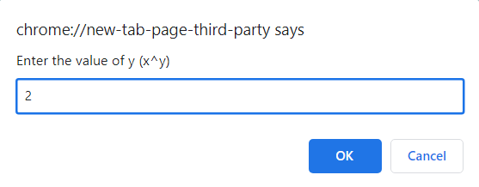

**OUTPUT:**

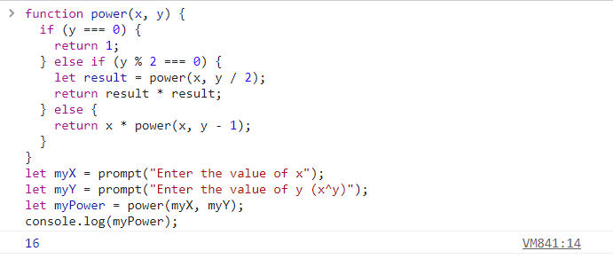

**TASK3**

**1. Write a JavaScript program to create object product**

**a) Add the property Product Name, Quantity and price.**

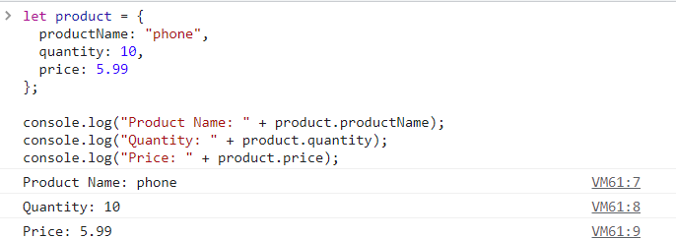

**b) Access all the properties and display them.**



**OUTPUT:**



**2. Write a JavaScript program to create object book**

**a)** **Add the property book name, author name**

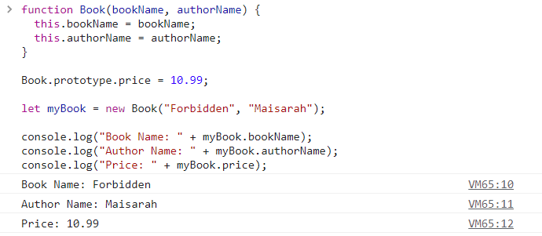

**b)** **Add the prototype property price .**



**c) Display all the properties.**



**output:**



**3. Write a JavaScript program to create Parent object employee (Property : Employee Name , Employee Id , Salary) and Child object Manager (Property : Manager Name , Branch). Inherit all the properties of employee and display all the properties.**

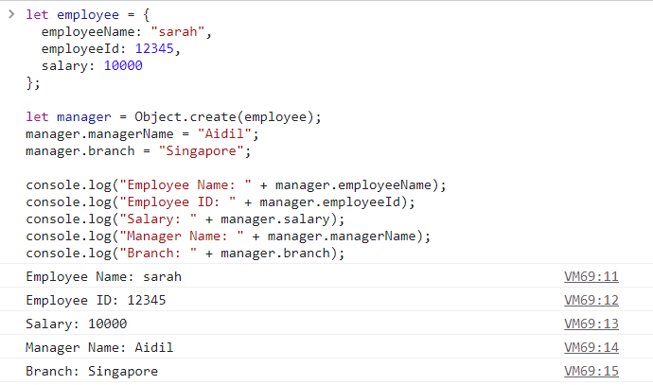

**TASK4**

1. **Create a HTML page with <p> paragraph. Change the paragraph color according to the following mouse events**

**a. Onclick, yellow background**

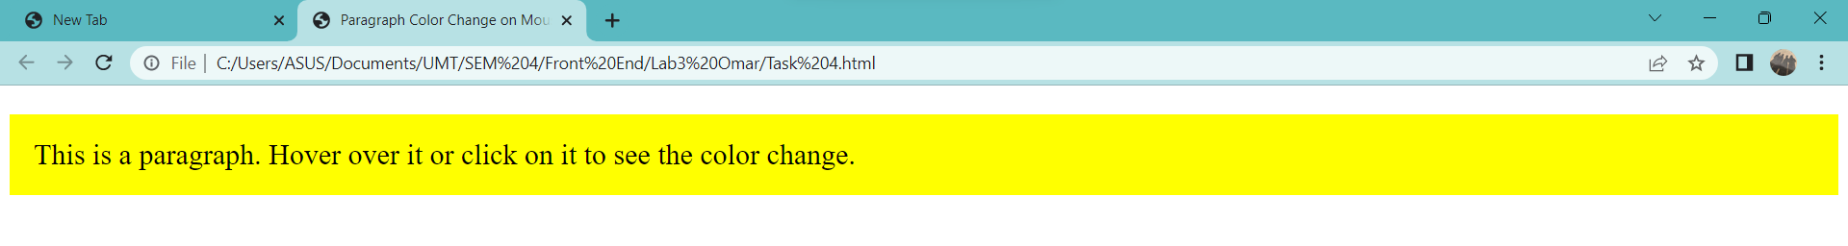

**b. ondblclick, blue background**

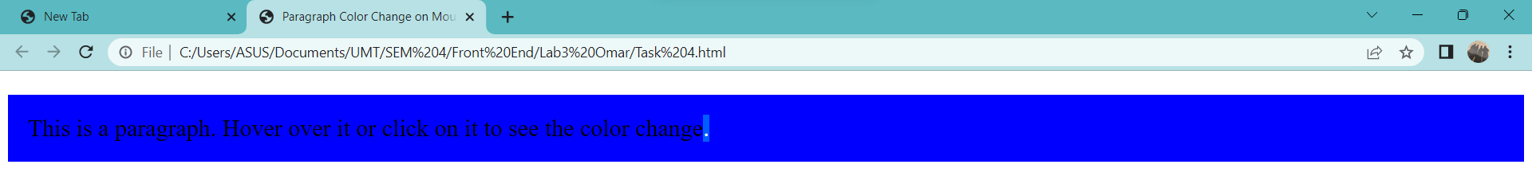

**c. onmouseover , red background**

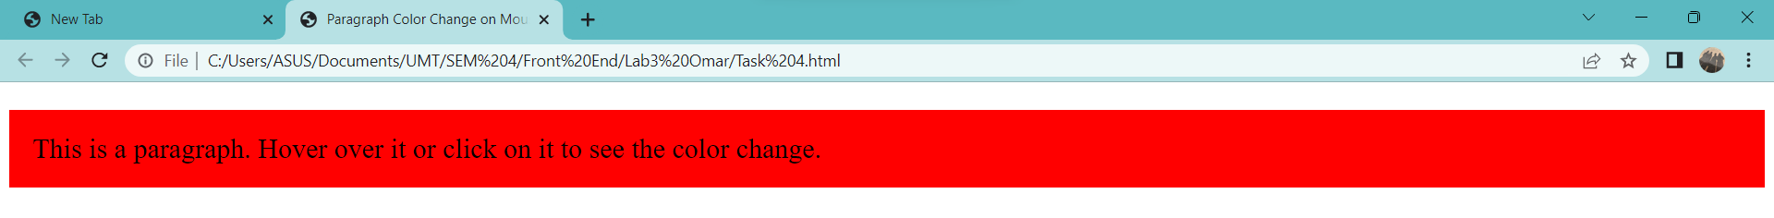

**d. onmouseout, green background**

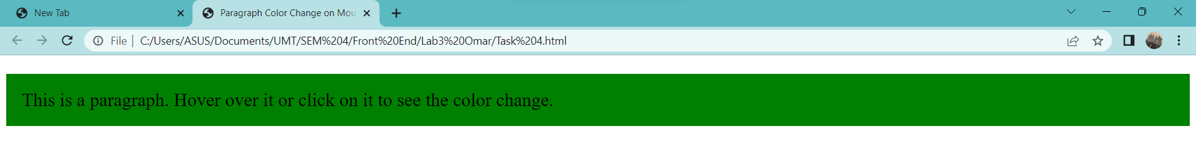

1. **Create a HTML page with textfield. Show some effects on the textfield when the following events occurred:**

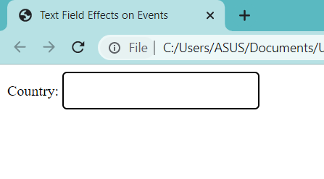

1. **Onchange**

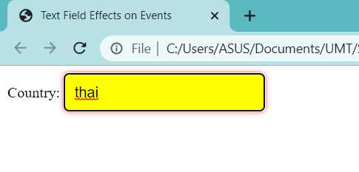

1. **Onfocus**

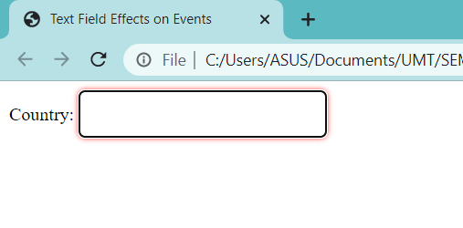

1. **onblur**

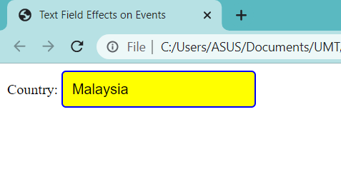

**TASK5**

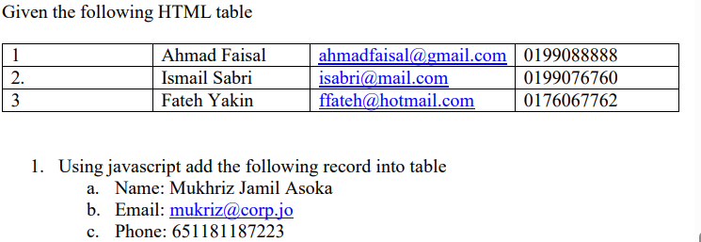

**CODING:**

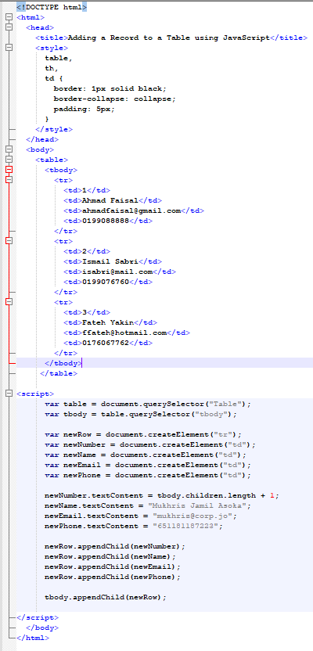

**OUTPUT:**

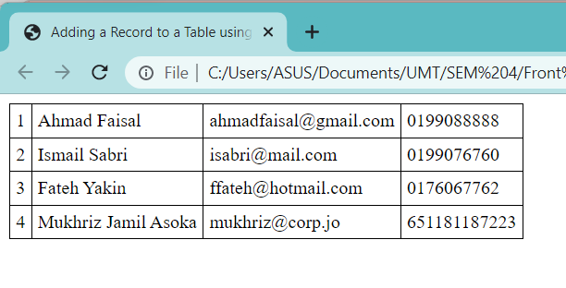

**2)** **Using javascript add the table header as follow: a. #, Name, Email, Phone #**

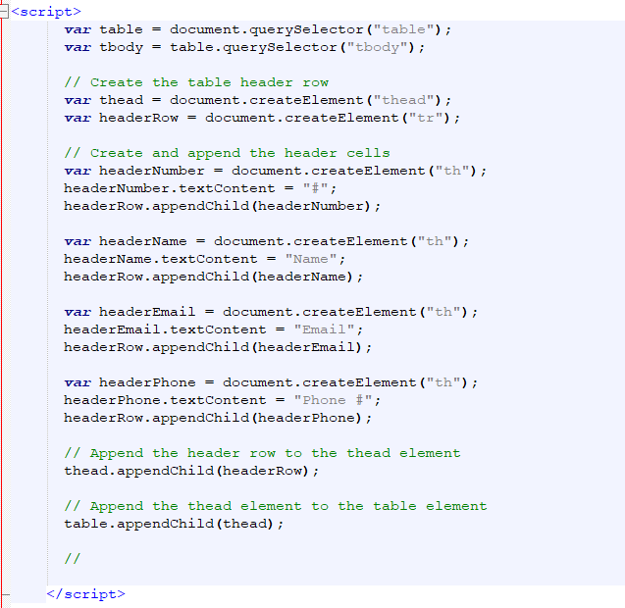

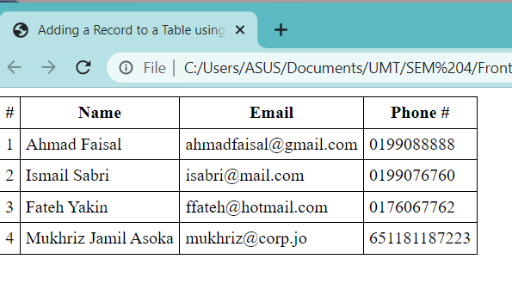

**3) Using javascript, delete any row from table when clicked on that row**

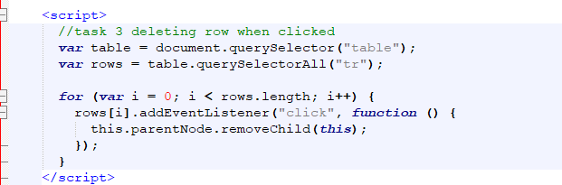

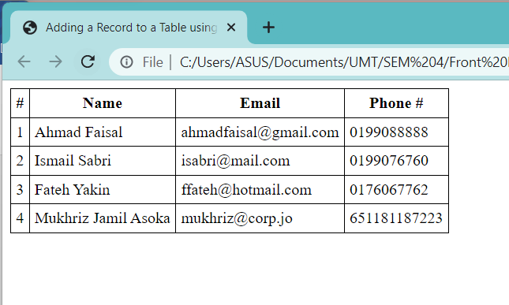

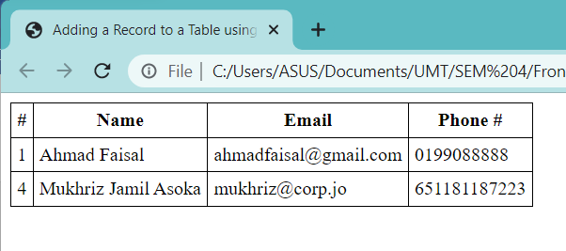

**TASK6**

Write a JavaScript program to move two small squares inside one big square in a random manner. User should be able to start and stop this animationusing button based events

**Math.floor(Math.random() * Math.floor(max)) will give you a random number that is less than max value**

**CSS**

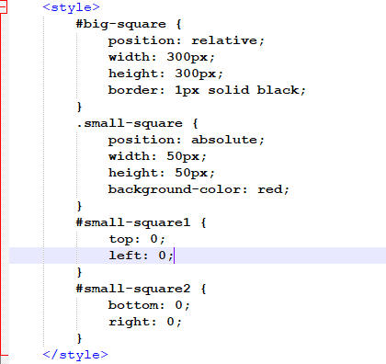

**HTML**

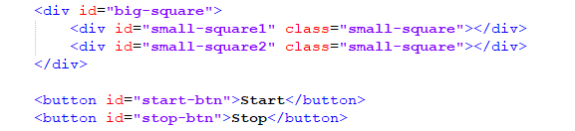

**JS**

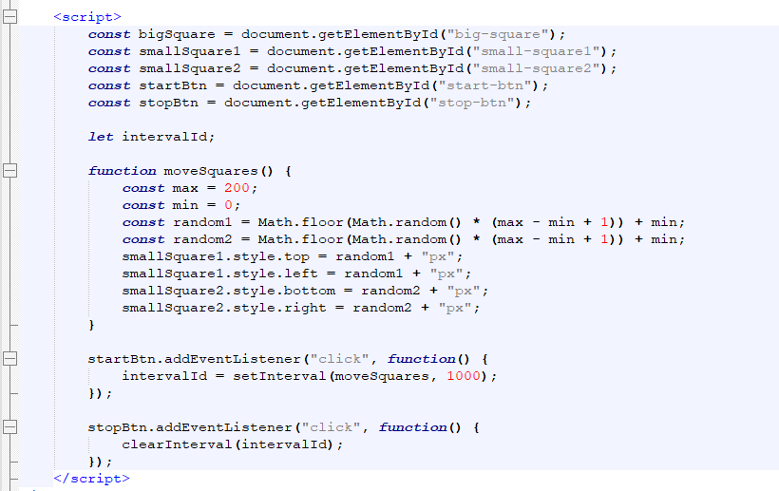

**OUTPUT :**

