**FPT UNIVERSITY**

Software development project Document

**PIMOND STORE**

|  |  |
| --- | --- |
| Subject code | SWP391 |
| Mentor | Mr. Trương Long |
| Group member | Nguyễn Tiến Phát - SE160374  Nguyễn Văn Dũng - SE160223  Châu Nhật Trường - SE161225  Trương Đinh Đăng Khoa - SE161228  Nguyễn Thanh Duy - SE160821 |

– Ho Chi Minh, February 2023 –

**Table of content**

Table of content 2

Project context 3

Project Information

Context

Problem facing

Proposed solution

Functional requirements

Non-Functional requirements

Project design 6

Actors and feature

Use case diagram

ERD conceptual

Database diagram

**I. Project context**

*1. Project information*

* Project name: PIMOND STORE
* Subject code: SWP391
* Software type: Web Application
* Project team:

|  |  |  |
| --- | --- | --- |
| **Full name** | **Email** | **Role** |
| Trương Long | longt5@fe.edu.vn | Mentor |

Table 1 – Mentor

|  |  |  |
| --- | --- | --- |
| **Full name** | **Email** | **Role** |
| Nguyễn Tiến Phát | phatntse160374@fpt.edu.vn | Leader |
| Nguyễn Văn Dũng | dungnvse160223@fpt.edu.vn | Member |
| Châu Nhật Trường | truongcnse161225@fpt.edu.vn | Member |
| Trương Đinh Đăng Khoa | khoattdse161228@fpt.edu.vn | Member |
| Nguyễn Thanh Duy | duyntse160821@fpt.edu.vn | Member |

Table 2 – Team members

*2. Context*

- Along with fashion products, the fashion accessories business is favored by many young people because of its creativity and cheap source of goods, moreover, this market is not very competitive.

- It is impossible not to mention the advantages of these small items in everyday wear, going out or partying. Fashion accessories contribute greatly to creating many unique creations for each outfit.

- Many people like fashion accessories because they enhance the outfit even the living space. But that doesn't mean they necessarily need to. Therefore, for this item to really appear in everyone's wardrobe, it must be accompanied by a unique and separate creativity.

- In the current market, there are not many fashion accessories businesses, so the competition is not great. If on the streets there are dense fashion stores, this number with fashion accessories is quite small, most of them are shop owners selling in parallel but the products are few and representative. Therefore, stores specializing in providing fashion accessories will have great growth potential.

*3. Problem facing*

- Compared to other items, the source of fashion accessories is quite limited, even at many wholesale markets selling many models of clothing but there is no source for this item. At many retail stores, the quantity and design are quite small, and the price is not cheap.

- Fashion accessories are chosen by many fashion lovers but are too narrow in terms of designs. And those who deal in this item are more about profit than quality.

- The demand for fashion accessories is growing, but now "supply does not meet demand". Scattered, there are many clothing and souvenir shops that sell accessories, but are not professional, the goods are not diverse, the designs are not up to date, and especially the brand problem: people only know each other's ears. Buy here and there. Most of the stores do not have a name and are not properly invested in marketing to be known by many people. Compared to fashion or many other items, this item is much weaker. This is also due to the reluctance of businesspeople to fear that this item cannot achieve the desired business performance.

*4. Proposed solution*

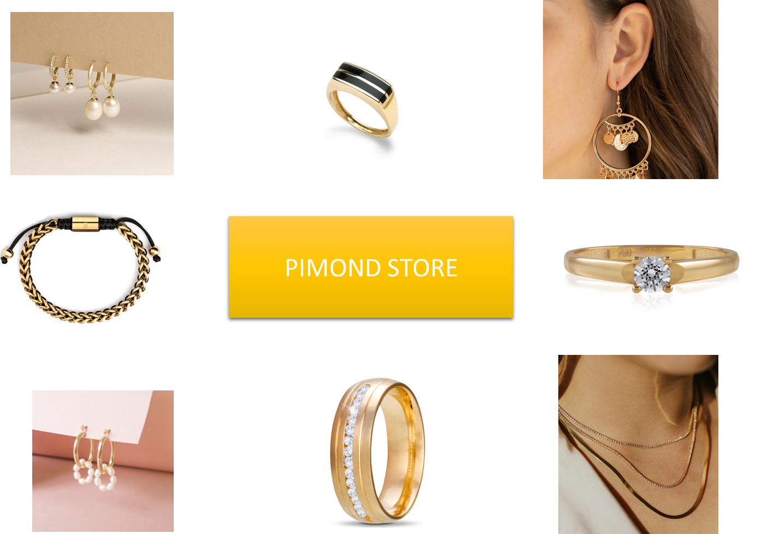

Picture 1 – PIMOND STORE model

*4. Functional requirements*

*5. Non-Functional requirements*

**II. Project design**

*1. Actors and feature*

- In general, our project will include the following:

**+ Login:**

- The login feature will not be activated and maintained in the top right corner of the screen, until the customer presses the payment button in the shopping cart will show the login section so that the customer is logged in or the customer does not need to log in, they just need them name, phone number and address are purchasing. The decorative layout can be like this, which can be different colors, icons, or positions to avoid coincidence with the original page:

* On the login page, there is 1 form including: box to fill in account login information & password, login with Google, login buttons, password forgot links and account registration buttons, these features are required must have.
* If the customer enters the correct information, go directly to the homepage with the login status, if the customer enters the wrong login information, catch the user error, and print out the error screen (e.g., missing required character length, wrong username, or password) and still maintain the login page.
* If the customer presses the account registration button, go to the account registration page. Here there must be a registration form including username, password, password confirmation, full name, email, phone number, all must catch system errors (because these errors the user does not know, for example, the password must include upper case, lower case, number, special character) and shows the user that for the correct user, there is a registration button. After the customer successfully registers, the line confirming the successful registration must be displayed and returned to the login page.
* If the customer presses the forgot password button, the customer's email or phone number must be displayed to confirm and reset the password, after confirming Done, you will go to the reset password page for the account, now in the box re-enter the password and catch user errors like the account registration feature clause.

**+ Show product:**

- In the product show category, there must be a list of product items based on each type (for example, dogs, cats, food, toys, ...) like below.

- When customers hover over each category, they will display information about each item related to that category , the name of each category and each name. The product should be a link to the search page.

- After clicking on the link will appear the filter section, search based on brand, status, price, product type, size, ... At the same time, below will appear related product types.

- The product information that appears must be presented in the same layout as below, including the item photo, product name, original price, price sold, added to the wish list, when hovering on the product will appear the add to cart button.

**+ Search product:**

- On the product search page, there must be an input bar to search for product information, after clicking on the input bar, it will show the keywords searched for to Customers can more easily search later, and at the bottom of the page there must be a Viewed Product section (searched or searched products view) so that customers can review purchased items.

**+ Add product to cart and wish list:**

- After pressing the add button to the wish list, it will automatically update to the list of items you have pressed, similar to cart, wish list will have actions such as viewing cart information, adding or removing items, and the information of these items will remain until When the account is deleted, this information will also be deleted.

- After clicking on the add to cart button, at the top of the screen in the right corner will update the status of the cart according to the number of items that customers The selected item, if the customer wants to view the cart information, must click on the cart icon and then go to the view cart page.

- On the cart view page, the information in the cart must be displayed, including: product order number, item name, quantity, unit price, promo code and to cash all items, where customers can add or remove items from the cart If the customer wishes, there is a button to switch to the checkout page and a button to continue purchase to return to the search page.

- Near the bottom page, 1 line appears a list of products that are best sellers or products that are on sale off so that customers can buy more products.

**+ Payment and purchase history:**

- First, the customer information must be filled in: If the customer already has an account and logs in, it will automatically update personal information based on previously registered customer information, then there is an address box for customers to enter the delivery address if the customer wants to replace change the delivery address.

- After the customer presses the confirmation will be transferred to the shipping page, on this page, there must be a section to confirm personal information to contact, including phone number, delivery address and shipping method options for customers to choose from.

- After the customer confirms the shipping information again, they will go to the payment method selection section including visa card, debit card , PayPal, via smart banking or payment upon receipt of goods, then show the bill for customers to check, when customers finish checking and click on the button If the payment is successful or unsuccessful, a message will appear on the SEACH page (i.e. return to the search page).

- The order history after payment will be recorded on the view profile page including, date and time of purchase, order ID , and bill details that were exported in advance when the customer presses the finish payment button.

*2. Use case diagram*

*3. ERD Conceptual*

Picture 3 – ERD Conceptual of database

*4. Database diagram*

Picture 4 – Database diagram