**SmartHome – User Documentation**

1. Access the website and login

To access the website, you have to use the following url:

web-app-t1-dev-cyaua4bqa8g2enhq.westeurope-01.azurewebsites.net

This will automatically redirect you to the login page, you will not be able to create an account as they are hardcoded in the database. They are two accounts, the username of the first one is : ‘johndoe’ and its password is ‘password123’. The other user is ‘janedoe’ and its password is ‘test’.

If you put an incorrect username or password, you shall not pass.

2. Dashboard

Once logged in, you will be greeted with a welcome message. You will also find a dashboard with the different rooms and devices already existing in your home.

For the user ‘johndoe’ these rooms are directly retrieved from an Arduino simulator which is simulating to be your house. In this simulator, johndoe has two rooms with two devices each time.

3. Add a room

But in the case of janedoe, she is not connected to the Arduino Simulator and has no rooms, if we want to add a room, we just have to click on the button in the top-left corner. Then a pop-up window opens, where you can choose a name and add the room.

4. Add a device

Great! Now that we have a room, we can add some devices inside by clicking the ‘Add device’ button. You must then choose a device type and give it a name. If your device type isn’t there you can just choose the ‘Other’ item.

As you can see the devices were added and each device type has an icon to help the user finding his device.

5. Toggle a device

When adding a device it’s by default switched off. You can change this by switching the toggle of the device. The goal of this is that it should then also switch on or off the device in the Arduino Simulator.

5. Delete a device

To delete a device, you only have to click on the red bin, as you can see the light device isn’t there anymore

5. Delete a room

As you can imagine if you can delete a device, you can also delete a room, therefore you just need to click on the ‘Delete room’ button which is becoming red on hover. This time you must confirm that you want to delete the room and then as you can see the dashboard becomes empty as there is no room anymore in janedoe’s house.



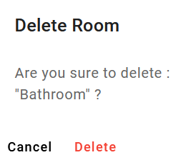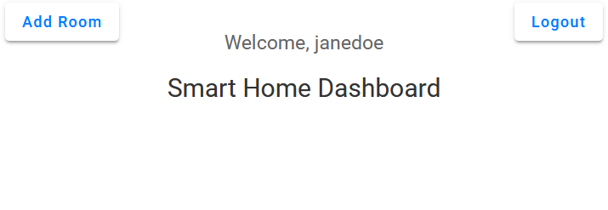

6. Log out

If you want you can log out by clicking in the top-right corner button, this will redirect you to the login page. If you quit the page without logging out and then come back, you don’t have to reconnect you. But if you go on the login page url while being connected, it will not redirect you to your dashboard.

6. Manipulation from the Arduino Simulator side

If in your Arduino Simulator you decide to add a room, add a device, turn on/off a device, delete a room or delete a device, this change will be automatically being handled by the website! You can manipulate it via the following URL : <https://wokwi.com/projects/416895952379742209>

In the actual Arduino Simulator they are only hardcoded rooms and devices, but if you want you can change the code.

To send data, start the simulation and wait that it is connected to wifi. Then you can click on the different buttons on the remote control to turning on/off the devices, as you can see in the legend.

To be sure that your action was successful you can check the console below the simulator and see if you have sent or received a message.

7. Bugs

Unfortunately, when using the app, you have to be careful as they are some bugs. Indeed after that the Arduino Simulator send a message, the rooms and devices can appear as blank, but it is not the case everytime. This is due to the fact that in the code some variables have not the same name as the variables in the database. But the app is still working and everything except this bug works.